PSY2301 - Exam Review

Lectures 13, 14 and 15
How Do Drugs and Hormones Influence the Brain and Behaviour?
————————————————————————————————
PRINCIPLES OF PHARMACOLOGY
Psychopharmacology: study of how drugs affect the nervous system and behaviour
Drugs: chemical compounds administered to produce a desired change in the body
Psychoactive Drug: substance that acts to alter mood, thought or behaviour and is used to manage neuropsychological illness

Drug Routes into the Nervous System
Routes of Drug Administration
- to be effective a psychoactive drug has to reach it’s nervous system target
- drugs can be:
  - administered orally
    - safest, easiest and most convenient way
  - inhaled into the lungs
    - few barriers en route to the brain
  - administered through rectal suppositories
  - absorbed from patches applied to skin
    - absorbed through skin into bloodstream
  - absorbed through mucous membranes
  - injected into the bloodstream
    - fewest barriers to the brain (must be hydrophilic)
  - injected into muscle
    - encounter more barriers than an inhaled drug
  - injected into brain
    - drug acts quickly in low doses due to no barriers
  - weak acid drugs pass from the stomach into the bloodstream
  - weak base drugs pass from the intestines to the bloodstream
- oral administration is easy and convenient but has the most barriers to the brain
  - first absorbed through lining in stomach or small intestine
  - liquid is absorbed more readily
  - solids have to be dissolved by acids in stomach
  - drugs may be destroyed or altered by enzymes in the gastrointestinal tract
- drug must next enter the blood stream
  - high water content so drug must be soluble in water
  - blood dilutes the drug
- there are fewer barriers for a drug destined for the brain if the drug is injected directly into the bloodstream, absorbed through the skin or inhaled
- fewest barriers are encountered if psychoactive drug is injected directly into the brain
- with each barrier eliminated en route to the brain, the dosage of a drug can be reduced by a factor of 10

Revisiting the Blood-Brain Barrier (BBB)
- the body presents a number of barriers to the internal movement of drugs
  - cell membranes, capillary walls, the placenta
- BBB helps prevent most substances incl. drugs from entering brain via bloodstream
- endothelial cells in capillaries located throughout the body are not tightly joined so it’s easy for substances to move in and out of the bloodstream
- endothelial cell walls in the brain are fused to form “tight junctions” so most substances cannot squeeze between them
- endothelial cells of brain capillaries are surrounded by the end feet of astrocytes attached to the capillary wall, covering about 80% of it
- glial cells provide a route for the exchange of food and waste between capillaries and the brain’s extracellular fluid and from there to other cells
- injury or disease can rupture the BBB letting foreign objects through
- capillaries in the brain have tight junctions and are covered with astrocyte feet
  - these properties prevent material from moving in and out easily
- capillaries in the body have few tight junctions
  - materials can move in and out quite easily
- small, uncharged molecules (CO², O²) are able to pass through the endothelial membrane
- certain other molecules are carried across the membrane by active transport
- large and electrically charged molecules are unable to pass out of the capillary

Gaining Access to the Brain
- two ways molecules can cross the BBB
  - (1) small uncharged molecules (ex: O² and CO²) can freely cross BBB
  - (2) larger charged molecules (ex: glucose, amino acids, fats) must be transported across the BBB
- difficulty developing drugs for the brain
  - estimated 98% of all drugs that may affect brain function and have therapeutic use cannot cross the blood brain barrier

BBB-Free Brain Regions
- pituitary gland
  - source of many hormones that are secreted into the blood stream
    - entry of chemicals that influence pituitary hormones
- area posterma
  - allows toxic substances in the blood to trigger a vomiting response
    - entry of toxic substances that induce vomiting
- pineal gland
  - enables hormones to reach and modulate the day-night cycles controlled by this structure
    - entry of chemicals that affect day-night cycles

How the Body Eliminates Drugs
- drugs are broken down (catabolized) in the kidneys, liver, and intestines
- drugs are then excreted in urine, feces, sweat, breast milk and exhaled air
- therapeutic drugs are designed to increase their chance of reaching their target and also to enhance their survival time
- some substances that cannot be removed may build up in the body and become toxic
  - ex: metal mercury
- liver is especially active in catabolizing drugs
- enzymes called the cytochrome P450 enzyme family are involved in drug catabolism
- liver is capable of catabolizing many different drugs into forms that are more easily excreted from the body
Drug Action at Synapses
- psychoactive drugs exert their effects by influencing synaptic chemical signalling
- Agonist: substance that enhances the function of a synapse
- Antagonist: substance that blocks/decreases the function of a synapse
- Synthesis of the neurotransmitter in the cell body, axon or terminal
- Storage of the neurotransmitter in granules or in vesicles
- Release of the transmitter from presynaptic terminal
- Receptor Interaction in postsynaptic membrane
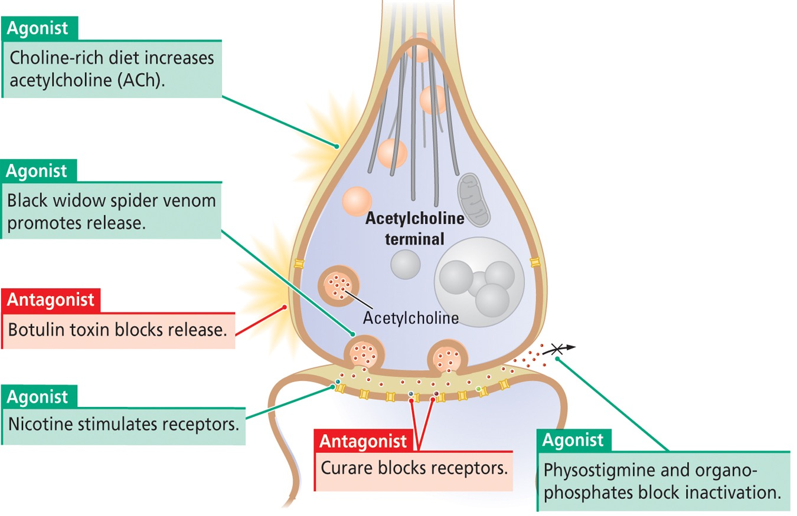
- Inactivation of excess neurotransmitter at synapse
- Reuptake into the presynaptic terminal
- Degradation of excess neurotransmitter

Example of Drug Action: Acetylcholine Synapse
- agonists excite muscles, increasing muscle tone
- antagonists inhibit muscles, decreasing muscle tone
- drugs affect synthesis, release, binding to the post synaptic receptor, breakdown or inactivation

Tolerance
- Tolerance: decrease in response to a drug with the passage of time
- as in habituation, a learned behaviour results when a response to a stimulus weakens with repeated presentations
- ex: blood alcohol levels and signs of intoxication fluctuated depending on day in the study (one did not always correspond with the other)

3 Types of Tolerance
- Metabolic Tolerance - increase in number of enzymes used to break down substance, therefore substance is broken down faster after consumption
- Cellular Tolerance - activities of brain cells adjust to minimize effects of the substance present in the blood
- Learned Tolerance - people learn to cope with being intoxicated
- all forms of tolerance are much more likely to develop with repeated drug use than with periodic drug use

Sensitization
- the occasional drug taker may experience an increased responsiveness to successive equal doses
- where as tolerance generally develops with repeated use of a drug, sensitization is much more likely to develop with occasional use
- Sensitization Experiment One
  - every 3-4 days investigators injected rats and found that their motor activities (sniffing, rearing and walking) were more vigorous with each administration of the same dose of the drug
  - not due to test situation
  - long lasting effects
- Sensitization Experiment Two
  - sensitization is not always characterized by an increase in an emitted behaviour but may also manifest as a progressive decrease in behaviour
  - flupentixol - blocks dopamine receptors
  - given to rats well trained on a swimming task

Neural Basis of Sensitization
- changes at the synapse
  - (1) more neurotransmitter released from presynaptic terminal
  - (2) changes in numbers of receptors on post synaptic terminal
  - (3) changes in the rate of neurotransmitter metabolism in the synaptic space
  - (4) changes in neurotransmitter reuptake by presynaptic membrane
  - (5) changes in the number and size of synapses

Sensitization Relevance
- for many drug therapies, a drug must be taken for a number of weeks before it has beneficial effects
- sensitization may underlie development of the drug’s beneficial effects

GROUPING PSYCHOACTIVE DRUGS
Classification of Psychoactive Drugs
- one can classify a drug by its most pronounced behavioural or psychoactive effect
  - (I) antianxiety agents and sedative hypnotics
  - (II) antipsychotic agents
  - (III) antidepressants/mood stabilizers
  - (IV) opioid analgesics
  - (V) psychotropics

Group I - Antianxiety Agents and Sedative Hypnotics
Barbiturates and Alcohol
- sedative hypnotic
- produce sedation and sleep
- can also produce general anaesthesia, coma and death
- alcohol also acts to inhibit glutamine release
Benzodiapines
- minor tranquilizers
- antianxiety agents
  - drugs that reduce anxiety (Valium, Xanax)
  - often used for temporary purposes (ex: coping with stress due to death in family)
Tolerance
- characteristic feature of sedative hypnotics
- larger dose required to maintain drugs initial effect
Cross-Tolerance
- response to a novel drug (ex: benzodiapine) is reduced because of tolerance developed in response to a related drug (ex: alcohol)
- suggests that the two drugs affect a common nervous system target
  - ex: barbiturates and benzodiazepines affect the inhibitory neurotransmitter GABA
The GABA_{A} Receptor
- activation produces an influx of chloride ions which hyper polarizes the neuron (IPSP)
- the GABA_{A} Receptor has 3 binding sites:
  - GABA binding site
  - sedative-hypnotic site - alcohol and barbiturates
    - directly influences Cl influx
    - increases binding of GABA - maximizes the time the pore is open
  - antianxiety site - benzodiapines
    - influences the frequency that the ion pore opens in response to GABA
    - effect is dependent upon amount of GABA present
      - harder to overdose
- sedative-hypnotic drugs (alcohol and barbiturates) act like GABA causing increased Cl conductance
- antianxiety drugs (benzodiazepines) enhance the binding of GABA
- because of their different actions, these drugs should not be taken together
  - barbiturates -> cause channels to open longer
  - benzodiazepines -> increase frequency of channel opening

Group II - Antipsychotic Agents
- psychosis is applied to behavioural disorders such as schizophrenia, characterized by hallucinations and delusions
- antipsychotic drugs have improved functioning of schizophrenia patients and reduced the number of patients housed in institutions
- incidence of schizophrenia is high (1/100 people)
First-Generation Antipsychotics (1950s)
  - such as chlorpromazine and haloperidol
  - drug that blocks the D₂ dopamine receptor
  - produce symptoms reminiscent of Parkinson’s disease
Second-Generation Antipsychotics
  - such as clozapine
  - weakly block D₂ receptors but also block serotonin 5-HT₂ receptors
  - affect motivation and reduce agitation but may result in weight gain
- antipsychotics now in generation will likely form a third generation
- therapeutic actions of these drugs are not understood fully
Dopamine Hypothesis of Schizophrenia
- proposal that schizophrenia symptoms are due to excess activity of the neurotransmitter dopamine (especially in the frontal lobes)
- evidence:
  - antipsychotic drugs block D₂ receptors
  - amphetamine promotes release of dopamine and can also produce symptoms similar to schizophrenia
Other Neurotransmitters Involved in Schizophrenia
- another drug model of schizophrenia is the psychotropic stimulant LSD promotes hallucinations - it is a serotonin agonist
- two other psychotropic drugs that produce schizophrenia like symptoms including hallucinations and out of body experiences are phencyclidine (PCP/angel dust) and ketamine (special K)
  - both drugs exert part of their action by blocking glutamate receptors suggesting the involvement of excitatory glutamate synapses in schizophrenia

Group III - Antidepressants and Mood Stabilizers
Major Depression
- mood disorder characterized by
  - prolonged feelings of worthlessness and guilt
  - disruption of normal eating habits
  - sleep disturbances
  - general slowing of behaviour
  - frequent thoughts of suicide
- common
  - ~ 6% of adult pop
  - 30% may experience at least one episode
  - twice as common in women as in men
- what causes major depression?
  - inadequate nutrition
    - folic acid and other B vitamins
    - omega3 fatty acids
    - vitamin D
  - stress from difficult life situations
  - disruption of normal eating habits
  - sleep disturbances
  - acute changes in neuronal function
  - damage to neurons
- pharmacological approach to treatment
  - normalizing stress hormones
  - modifying neuronal responses
  - stimulating neuron repair

Antidepressants
(1) Monoamine Oxidase (MAO) Inhibitors
- block the enzyme MAO from degrading neurotransmitters such as dopamine, noradrenaline and serotonin
- provides more serotonin for release with each action potential
(2) Tricyclic Antidepressants
- first generation antidepressants with a chemical structure characterized by three rings that block serotonin reuptake transporter proteins
- (1) & (2) act as agonists but mechanism of action is different for increasing availability of serotonin
(3) Second Generation Antidepressants
- action is similar to first generation antidepressants but more selective in action on the serotonin reuptake transporter proteins
- also called atypical antidepressants
- selective serotonin reuptake inhibitors (SSRIs)
  - block the reuptake of serotonin into the presynaptic terminal
- although antidepressants affect synapses very quickly their antidepressive actions take weeks to develop
- could be due to SSRIs stimulating second messengers in neurons to activate repair of those damaged by stress
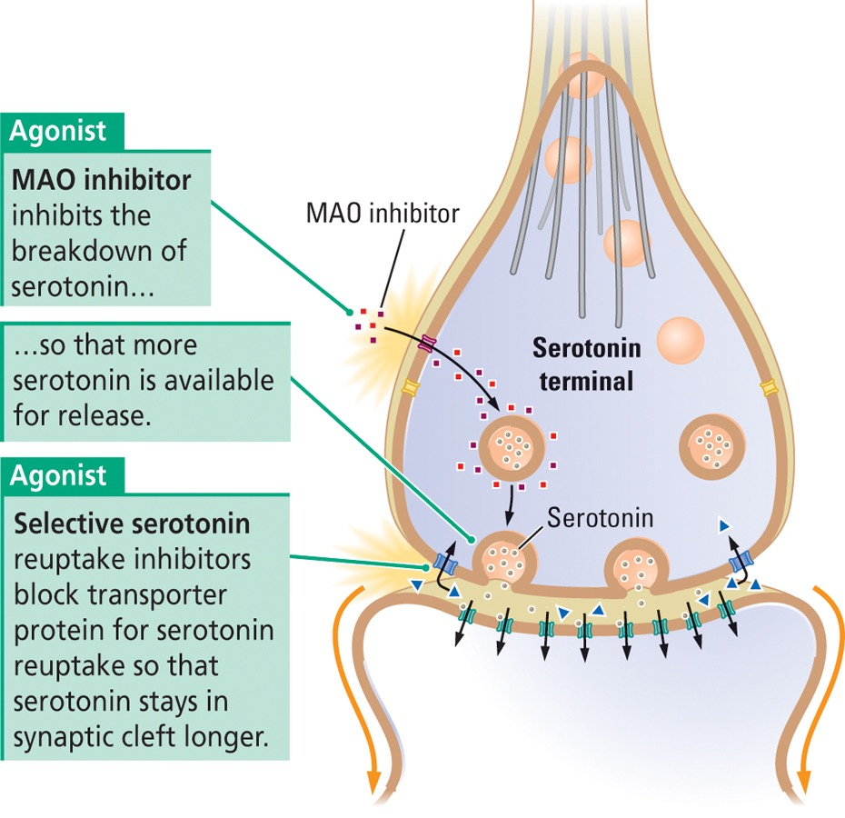
- fluoxetine (Prozac) an SSRI, enhances neurogenesis
- ~20% of patients with depression fail to respond to antidepressants suggesting that depression can likely have many causes
Mood Stabilizers
- used to treat bipolar disorder: characterized by periods of depression alternating with normal periods and periods of intense excitation
- difficulty in understanding how a disease produces symptoms that appear to be opposite often treated with a number of drugs
- mood stabilizers mute the intensity of one pole of the disorder, making the other pole less likely to occur
- mechanisms are not well understood
  - lithium may stimulate neuronal repair, production of growth factors
  - drugs effective at treating epilepsy (Valproate) have positive effects
    - may stimulate GABA activity - mute activity

Group IV - Opioid Analgesics
- Opioid: compound that binds to a group of brain receptors also sensitive to morphine
- two natural sources of opioids:
  - (1) opium
    - used for thousands of years to produce euphoria, analgesia, sleep, relief from diarrhea and coughing
    - two chemicals are synthesized from opium (codeine and morphine)

  - (2) the brain
    - peptides in the body that have opioid like effects are collectively called endorphins (endogenous morphines)
- Endorphin: peptide hormone that acts as a neurotransmitter and may be associated with feelings of pain or pleasure
  - causes release of dopamine by blocking inhibitory neurotransmitter release
  - endorphins and their receptors are found in many regions of the brain and spinal cord and other parts of the body
  - three classes of endorphins
    - endomorphins
    - enkephalins
    - dynorphins
  - three types of receptors
    - mu, kappa and delta
  - natural (morphine) and synthetic (heroine, methadone, fentanyl) opioids mimic the endorphins
    - bind most selectively to the mu receptors - critical for morphine’s effect on pain and for its addictive properties
- heroin is synthesized from morphine, is more fat soluble and penetrates the BBB more quickly but shorter acting
- most synthetic opioids are prescribed for clinical use in pain management
  - potentially addictive
Nalorphine and Naloxone
- drugs that act as antagonists at opioid receptors
- competitive inhibitors: compete with opioids for neuronal receptors
- can block the action of morphine - used for treating morphine overdoses
- repeated use of opioids can produce tolerance resulting in greater amounts of the drug for the desired effect
- opioids also produce sensitization and so an addicted person cannot simply stop using the drug
- therefore users are always flirting with the possibility of overdose

Group V - Psychotropics
- stimulants that affect mental activity, motor activity, arousal, perception and mood
- 3 groups of psychotropics
  - 1 - behavioural stimulants
  - 2 - psychedelics and hallucinogenic stimulants
  - 3 - general stimulants
Behavioural Stimulants
- increase motor behaviour and elevate a person’s mood and level of alertness
- rapid administration of behavioural stimulants is most likely to be associated with addiction
- two behavioural stimulants are amphetamine and cocaine
  - Amphetamine
    - blocks dopamine reuptake transporter leaving more dopamine available in the synaptic cleft
    - stimulates release of dopamine from presynaptic membrane
      - both mechanisms increase the amount of dopamine available in synapses to stimulate dopamine receptors
    - uses
      - to treat ADHD
      - treatment for asthma
      - used to help troops and pilot stay alert, increase confidence and aggression
      - weight-loss aid
    - amphetamine derivative: methamphetamine (meth, speed)
      - relatively inexpensive yet potentially devastating drug
  - Cocaine
    - obtained from coca plant
    - blocks dopamine reuptake!!
    - powder is sniffed or injected
    - vaporizes at low temperatures and the vapours are inhaled (smoked)
    - once widely used in the manufacture of soft drinks
    - derivates such as Novocaine are used as local anesthetics
        - reduce a cell’s permeability to Na+ ions and so reduce nerve conduction
Psychedelic Drugs
- alter sensory perception and cognitive processes and can produce hallucinations
- grouped by their actions on specific neurotransmitters
- 5 groups
    - (1) Acetylcholine Psychedelics
      - atropine (blocks), nicotine (facilitates) transmission at acetylcholine synapses
    - (2) Anandamide Psychedelics
      - neurotransmitter plays a role in enhancing forgetting, prevents the brains memory systems from becoming overwhelmed
      - THC (tetrahydrocannabinol) is the active ingredient in marijuana
        - agonist at receptors for anandamide
    - (3) Glutamate Psychedelics
      - phencyclidine (PCP), ketamine produce hallucinations and out of body experiences. part of their action is to block glutamate NDMA receptors
    - (4) Norepinephrine Psychedelics
      - mescaline - induce a sense of boundlessness and visual hallucinations
    - (5) Serotonin Psychedelics
      - LSD, psilocybin, ecstasy - stimulate serotonin receptors and block the activity of other serotonergic neurons through autoreceptors
General Stimulants
- drugs that cause a general increase in the metabolic activity of cells
- Caffeine
  - inhibits the enzyme the normally breaks down the second messenger cyclic AMP
  - increase in cAMP leads to an increase in glucose production within cells which makes more energy available and allows for higher rates of cellular activity

FACTORS INFLUENCING INDIVIDUAL RESPONSES TO DRUGS
Behaviour on Drugs
- alcohol is associated with many harmful behaviours that are costly both to individual people and society
  - driving while intoxicated, child or spousal abuse, other forms of crime

Disinhibition Theory
- alcohol has a selective depressant effect on the cortex, the region of the brain that controls judgment, while sparing subcortical structures (limbic system) those areas of the brain responsible for more primitive instincts such as desire
  - too drunk to know better
- limitation:
  - behaviour under the influence of alcohol often differs depending upon the context (home vs. bar)

Alcohol Myopia (Nearsightedness) Theory
- under the influence of alcohol people respond to a restricted set of immediate and prominent cues and ignore more remote cues and potential consequences
- immediate and prominent cues will differ according to the context
Addiction and Dependence
- Substance Abuse: pattern of drug abuse in which people rely on a drug chronically and excessively allowing it to occupy a central place in their lives
- Addiction (aka Substance Dependence): persons are physically dependent on a drug in addition to abusing it
  - they have developed tolerance for the drug -> an addict requires increased doses to obtain the desired effect
Withdrawal Symptoms
- physical and psychological behaviours displayed by an addict when drug use suddenly ends
  - ex: muscle aches, cramps, anxiety attacks, sweating, nausea, convulsions, death
- time course:
  - withdrawal symptoms from alcohol and morphine start within several hours of last dose and intensify over several days before subsiding
Psychomotor Activation
- increased behavioural and cognitive activity
- at certain levels of consumption, the drug user feels energetic and in control
- occurs with many drugs
Important Role of Dopamine in Drug Abuse
  - drugs that are abused increase mesolimbic dopamine activity directly or indirectly
  - drugs that blunt abuse and addiction decrease mesolimbic dopamine activity

Sex Differences in Addiction
- females twice as sensitive to drugs on average
  - smaller body size, hormonal differences
- females only slightly less likely to become addicted to some drugs
- females more likely to abuse certain drugs
  - nicotine, cocaine, amphetamine, opioids, cannabinoids, caffeine, PCP
  - could be due to the role of the dopamine system plays in nurturing behaviour

Explaining and Treating Drug Abuse
- pleasure and dependence - habitual drug users initially experience pleasure but then endure psychological and physiological withdrawal symptoms as the drug wears off
  - dependency hypothesis
- however an addict may abstain from a drug for months long after any withdrawal symptoms have abated yet still be drawn back to using
Wanting and Liking Theory
Incentive-Sensitization Theory
- wanting (craving) and liking (pleasure) may be produced by different parts of the brain
- wanting
  - sensitizes with repeated drug use - craving increases
  - mesolimbic dopamine system
- liking
  - tolerance develops with repeated drug use - pleasure decreases
  - opioid neurons
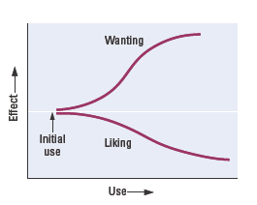
- wanting a drug and liking a drug go in opposite directions with repeated drug use

Neural Basis of Addiction
- decision to take a drug is made in the frontal cortex
- drug activates opioid systems related to pleasurable experiences
- wanting drugs springs from activity in the dopaminergic system
- voluntary control of drug taking gives way to unconscious processes -> a habit (striatum)

Why Doesn't Everybody Abuse Drugs?
Genetics?
- 3 lines of evidence
  - 1 - if one identical twin abuses alcohol, other twin is more like to abuse
  - 2 - people adopted shortly after birth more likely to abuse alcohol if bio. parents did
  - 3 - selective breeding of animals can produce strains that will consume large quantities of alcohol
- despite some evidence of a genetic contribution, no gene or set of genes related to alcoholism have been found
- any satisfactory explanation of drug abuse will require genetic and learning components
Personality Traits?
- unusual risk taking may be trait common to drug abusers

Epigenetics
- addictive drugs can influence gene regulation
- addictive drugs can selectively turn off genes related to voluntary control and turn on genes related to behaviours susceptible to addiction
- changes are relatively permanent and can be passed along, perhaps through the next few generations

Treating Drug Abuse
- best approaches recognize that addiction will be a lifelong problem for most people
- thus addiction must be treated in the same way as other individual and medical problems are treated
- alcohol is the most used drug, then tobacco, marijuana, Rx drugs, pain relievers
  - two most common are legal

Can Drugs Cause Brain Damage?
- many substances even natural ones such as glutamate can be neurotoxins
  - MSG resembles glutamate and can kill neurons in culture and animal models
  - glutamate allows calcium into the cell to activate second messengers which in turn can activate a “suicide gene” to cause cell death
- it is difficult to determine if recreational drugs are harmful
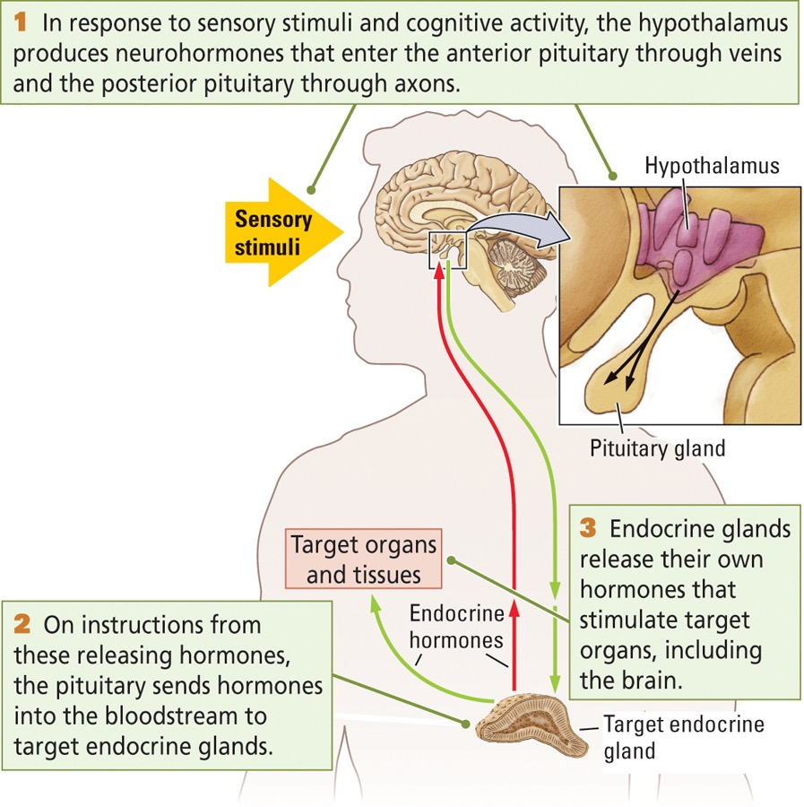
  - chronic alcohol use is associated with damage to thalamus and limbic system
    - not due to alcohol, due to other complications (ex: dietary deficiencies - thiamine)
- however there is increasing evidence that rec. drugs can cause brain damage
- drugs that have been associated with brain damage or cognitive impairments:
  - amphetamines
    - MDMA (ecstasy) is a hallucinogenic amphetamine that degenerates very fine serotonergic nerve terminals
  - cocaine
    - blocks cerebral blood flow and neuronal death
Ecstacy
- doses of ecstasy approximating those taken by human users result in the degeneration of very fine serotonergic nerve terminals
  - in monkeys, the terminal loss may be permanent
- drugs that have not been associated with long-lasting brain damage
  - LSD, marijuana, opiates

HORMONES
Hierarchal Control of Hormones
- hormones affect almost every neuron in the brain
  - hormones —> neurons —> genes —> proteins
- in response to sensory stimuli and cognitive activity
- hypothalamus
  - produces neurohormones to stimulate the
- pituitary gland
  - secretes releasing hormones to influence the
- target endocrine glands
  - release appropriate hormones into the blood to act on
- target organs and tissues
  - including the brain

Pituitary Gland
- posterior pituitary is neural tissue
  - hormones are produced in the neurons and axons carry the hormone into the bloodstream where they affect other regions of the body
  - ex: oxytocin
- anterior pituitary is glandular tissue
  - hormones are (1) synthesized and (2) released
  - these stimulate or inhibit other hormones, master gland!
  - ex - growth hormone, prolactin, thyroid stimulating hormone, ACTH, follicle stimulating hormone, lutenizing hormone

Classes and Functions of Hormones
- can be used as drugs to treat or prevent disease
- can take synthetic hormones as replacement therapy if the glands have been removed or malfunction
- can take hormones to increase strength
- as many as 100 hormones are classified chemically as either:
  - steroid or peptide hormones
Steroid Hormones
- fat soluble chemical messenger synthesized from cholesterol
- produced in glands such as the gonads, thyroid, adrenal gland
- easily cross the cell membrane and act on the cells DNA to increase or decrease production of proteins
- examples: cortisol, testosterone
Peptide Hormones
- chemical messenger synthesized by cellular DNA that acts to affect the targets cells physiology
- influence their target cells activity by binding to metabotropic receptors on the cell membrane - generating a second messenger
- examples: insulin, growth hormone, endorphins
- steroid and peptide hormones fall into 3 main functional groups with respect to behaviour:
  - (1) Homeostatic Hormones
    - maintain a state of internal metabolic balance and regulation of physiological systems
  - (2) Gonadal (Sex) Hormones
    - control reproductive functions; sexual development and behaviour
  - (3) Glucocorticoids
    - secreted in times of stress - important in protein and carb metabolism

Homeostatic Hormones
- homeostasis of intracellular and extracellular environments are essential to life
- an appropriate balance of sugars, protein, carbs, salts and water is required in the bloodstream, brain and cells
- diabetes mellitus
  - caused by failure of pancreas to secrete enough or any insulin
  - insulin tells liver to start strong glucose rather than releasing it and instructs cells to increase glucose uptake
  - hyperglycaemia
    - high blood glucose levels
    - cells are not using glucose and therefore are not able to function properly
  - hypoglycaemia
    - low blood glucose levels

Gonadal Hormones
- sex hormones begin to affect us before we are born and continue to affect us throughout our life
Organizational Hypothesis
  - proposal that actions of hormones during development alter tissue differentiation
  - ex: testosterone masculinizes the brain by being taken up by the cells where it is converted to estrogen
    - this acts on receptors to activate genes which contribute to the male brain
  - females have a blood enzyme that binds to estrogen and prevents its entry into the brain therefore hormones play a lesser role in producing the female brain
- sex hormones contribute to brain differences
  - male brain is slightly larger than female after correcting for body size
  - right hemisphere is larger than the left hemisphere in males
  - female brains have higher rates of cerebral blood flow and glucose utilization
  - parts of the corpus callosum are larger in women
  - language areas of the brain are somewhat larger in women
- 3 lines of evidence that show brain differences contribute to differences in cognitive performance
  - men tend to excel on spatial tasks whereas women tend to excel on verbal tasks
  - performance of women differs during the course of the menstrual cycle
    - low female sex hormones - better spatial performance
    - high female sex hormones - better verbal performance
  - differences between pre and post menopausal women and during various stages of pregnancy show hormones affect cognition

Anabolic-Androgenic Steroids
- a class of synthetic hormones related to the male sex hormone testosterone that have both muscle building (anabolic) and masculinizing (androgenic) effects
- health risks
  - body reduces production of testosterone reducing male fertility
  - increased aggression
  - increased risk of heart attack and stroke
  - compromised liver and kidney function
  - masculinization of female users - hair growth, deeper voice

Glucocorticoids and Stress
- Stressor: a stimulus that challenges the body’s homeostasis and triggers arousal
Stress Response
- the physiological and behavioural arousal and any attempt to reduce the stress
- stress response is the same no matter if the situation is exciting, sad or frightening
- two sequences
  - fast acting: primes the body immediately for fight or flight (epinephrine)
  - slow acting: both mobilizes the body’s resources to confront a stressor and repairs stress-related damage (cortisol)
- pic: CRH (corticotropin releasing hormone) ; ACTH (adrenocorticotropic hormone)

Ending a Stress Response
- normally stress responses are brief
- stress responses are turned on and off in the brain
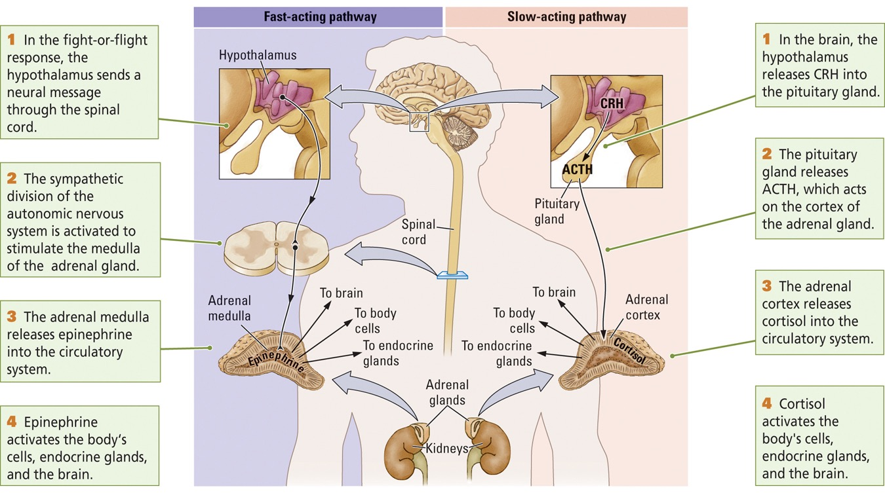
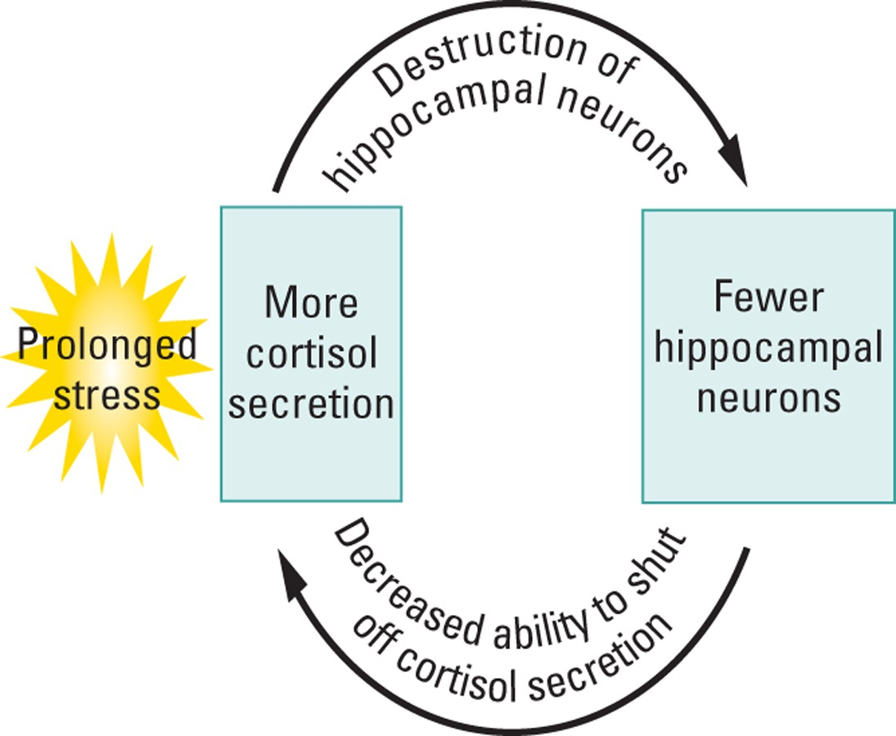
- Sapolsky (’05) argued that hippocampus turns off stress response
  - hippocampus has a high concentration of cortisol receptors and has projections to the hypothalamus
  - hippocampus is well suited to detecting cortisol in the blood and instructing the hypothalamus to reduce blood-cortisol levels
  - too much cortisol will damage neurons in the hippocampus
  - vicious cycle involving prolonged stress, high cortisol levels and reduced hippocampal functioning
- glucocorticoid receptor density in the hippocampi of suicide victims who had been sexually abused in childhood was decreased compared to control subjects
- decrease in receptors and in glucocorticoid mRNA suggests that childhood abuse induces epigenetic changes in the expression of glucocorticoid genes
- decrease in glucocorticoid receptors presumably renders the hippocampus less able to end stress responses
Lectures 16, 17 and 18
How Does the Nervous System Develop and Adapt?
—————————————————————————
THREE PERSPECTIVES OF BRAIN DEVELOPMENT
- as brain develops neurons become more connected and the complex connections underlie increasingly complex behaviour
- this enables the study of brain and behavioural development from three perspectives
  - (1) structural development can be studied and correlated with the emergence of behaviour
  - (2) behavioural development can be analyzed and predictions made about what underlying circuitry must be emerging
  - (3) factors that influence both brain structure and behavioural development such as language or injury can be studied

(1) Predicting Behaviour from Brain Structure
brain development —predict—> behavioural development
(ex: frontal lobe) (ex: social development)
- neural structures that develop quickly (visual system) exhibit their functions sooner than structures that develop more slowly (Broca’s area)
- cognitive behaviours controlled by the frontal lobes are among the last to develop (plan efficiently)

(2) Correlating Brain Structure and Behaviour
behavioural development —predict—> brain development
(ex - language) (ex: brain areas involved in language)

(3) Influences on Brain and Behaviour
-> behavioural development
hormones, genes, experience, injury <
->brain development

NEUROBIOLOGY OF DEVELOPMENT
- preformation -> 2000 years ago, believed that a human embryo was a miniature adult
- mid 1800s - early in development all vertebrates look alike
Embryonic Vertebrate Nervous System
  - forebrain, midbrain and hindbrain are visible in the human embryo at about 28 days
  - neural tube forms spinal cord

Gross Development of the Human Nervous System
- neural plate
  - 3 weeks after conception
  - thickened region of the ectodermal layer that gives rise to the neural tube
- neural tube
  - structure in the early stage of brain development from which the brain and spinal cord develop
- neural tube development in a mouse embryo
  - cells that form the neural tube can be thought of as the nursery for rest of CNS
  - open region in the center of the tube remains open and matures into the brains ventricles and the spinal canal
Major Events in Development of HNS
- day 49 -> embryo begins to resemble a mini-person
- day 60 -> sexual differentiation
  - neural cells respond to testosterone
  - genitals and brain regions
- day 100 -> brain looks distinctly human
- 7 months -> gyri and sulci begin to form
- 9 months -> brain looks like an adult brain

Improper Neural Tube Closure
- Spina Bifida
  - one of the most common forms of birth defect (1/1000 births)
- 3 main types
  - spina bifida occulta
  - spina bifida cystica with meningocele
  - spina bifida cystica with myelomeningocele
- Spina Bifida Occulta
  - mildest form
  - vertebrae is not completely fused
  - skin at sight of lesion may be normal or have some hair growing on it
- Spina Bifida Cystica with Meningocele
  - least common form
  - meninges are forced into the gabs between vertebrae
- Spina Bifida Cystica with Myelomeningocele
  - most severe complications
  - both the meninges and spinal cord protrude
- Anencephaly
  - baby is born without parts of the brain and skull
  - results in a baby being born without the forebrain/cerebrum
  - remaining parts of the brain are often not covered by bone or skin
Reducing Neural Tube Defects
- Folate (Folic Acid) - B vitamin
  - required for the production and maintenance of new cells for DNA synthesis and RNA synthesis
  - if women who could become pregnant were to take a multi vitamin with folic acid, the risk of neural tube defects like spina bifida could be reduced by up to 70%
  - in 1998 fortification with folate in many cereal products became mandatory in Canada -> has reduced rate of NTD by more than 50%
- early detection

Origins of Neurons and Glia
Neural Stem Cells
- a self renewing multi-potential cell that gives rise to neurons and glia
- line the neural tube and have an extensive capacity for self-renewal
- when stem cell divides, it produces two stem cells, one becomes a progenitor cell and the other lives to divide again
- this process repeats again and again throughout a persons lifetime
Subventricular Zone
- lining of neural stem cells surrounding the ventricles in adults
Progenitor Cell
- precursor cell derived from a stem cell - it migrates and produces a neuron and glial cell
- produce non-dividing cells known as neuroblasts and glioblasts
How do stem cells know what to become?
- chemical signal —> turns genes on (gene expression) —> specific proteins are made—> specific cells
- Epigenetics: methylation alters gene expression dramatically during environment
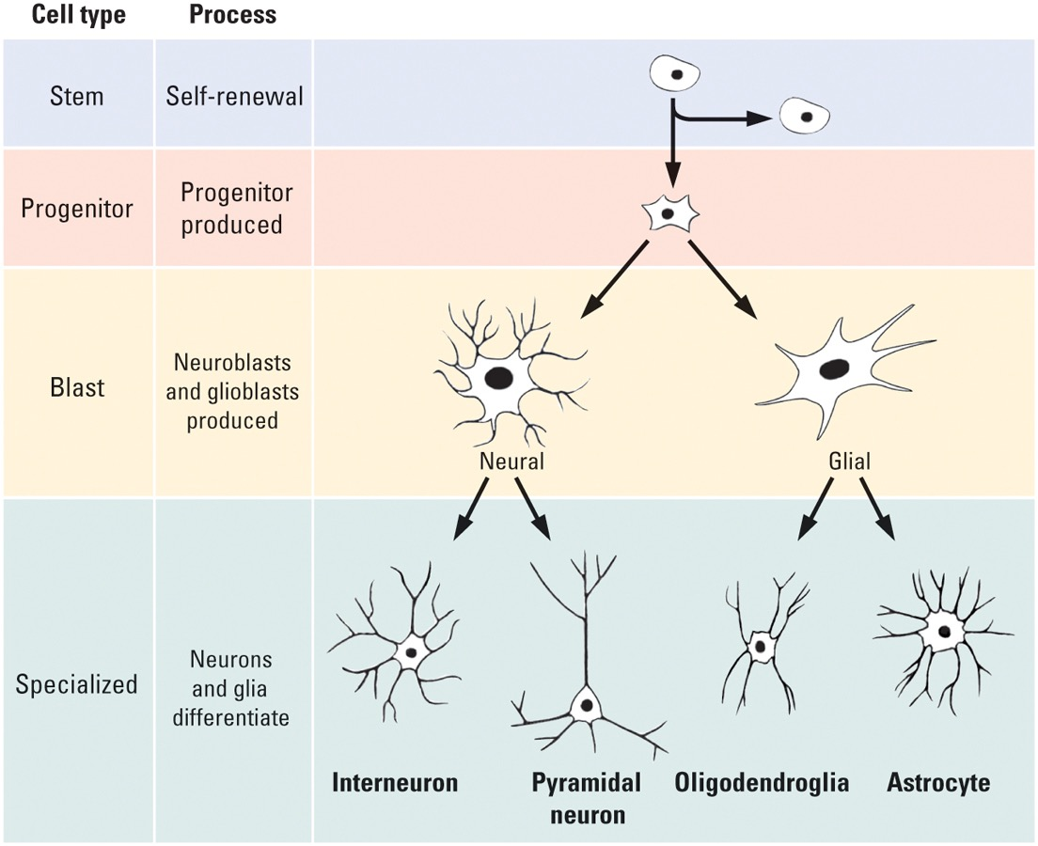
- chemical environment in the brain is different from skin so different genes in these cells are activated producing different proteins and different cell types
Neurotrophic Factors
- a chemical compound that acts to support growth and differentiation in developing neurons
- may help keep certain neurons alive in adulthood
  - epidermal growth factor (EGF)
      - stem cell —> progenitor cell
  - basic fibroblast growth factor (bFGF)
      - progenitor cell —> neuroblast

Growth and Development of Neurons
Stages of Brain Development
- Cell Birth (neurogenesis)
- Cell Migration
- Cell Differentiation
- Cell Maturation (dendrite and axon growth)
- Synaptogenesis (formation of synapses)
- Cell Death and Synaptic Pruning
- Glial Development and Myelination

(1) Cell Birth
- a chemical compound acts to support growth and differentiation in developing neurons (begins about 7 weeks after conception, largely complete by 5 months)
- exception: hippocampus makes new cells throughout life

(2) Cell Migration
- begins shortly after first neurons are generated
- continues for 6 weeks in cortex and longer in hippocampus
- Radial Glial Cell: path making cell that a migrating neuron follows to its appropriate destination

Cell Migration and Differentiation
- cells migrate to inner layers and then to outer layers (layers 6—>1)
- differentiation is dependent upon genetic instructions, timing and signals from other cells in the local environment

(3) Cell Differentiation
- neuroblasts become specific types of neurons
- begins after cells have begun to migrate
- essentially complete at birth
  - although neuron maturation which includes the growth of dendrites, axons, synapses, goes on for years and in some parts of the brain may continue throughout adulthood

(4) Neural Maturation
- after neurons migrate to their final destinations and differentiate into specific neuron types they begin to mature
- mature in 2 ways:
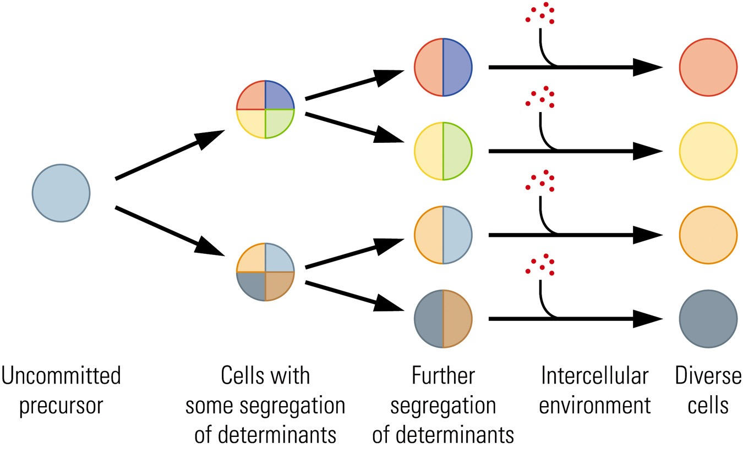
- Dendritic Growth - grow dendrites to provide surface area for synapses w other cells
- Axonal Growth - extend axons to appropriate targets to initiate synapse formation
Dendritic Growth
- arborization - branching
- growth of dendritic spines where most synapses occur
- slower (micrometers/day) than axonal growth (mm/day)
Axonal Growth
- growth cone - growing tip of an axon
- Filopod: process at the end of a developing axon that reaches out to search for a potential target or to sample the intercellular environment
- cell adhesion molecule (CAM)
  - cell manufactures molecules
  - on the target cells surface or secreted into the intercellular space
  - provide surface for growth cones to adhere
  - serve to attract or repel growth cones
- tropic molecule
  - produced by targets being sought by the axons
  - tell growth cones to come over here
  - likely they tell other growth cones seeking different targets to keep away
  - only entrains have been identified
  - do not confuse tropic guiding molecules with tropic nourishing molecules

(5) Synaptic Development
- 100,000 trillion (10¹⁴) synapses in the adult human cerebral cortex
- combination of genetic programming and environmental cues and signals
- 5th gestational month - simple synaptic contacts
- 7th gestational month - synaptic development of deep cortical neurons
- after birth synaptic development increases rapidly during the first year of life

(6) Cell Death and Synaptic Pruning
- the brain chisels away pieces by using cell death and synaptic pruning
  - chisel could be genetic signal, experience, reproductive hormones and even stress
  - cortex becomes measurably thinner in a caudal-rostral (back to front) gradient, a process that is probably mostly due to synaptic pruning
- we are born with an overabundance of neurons and synaptic connections
Neural Darwinism
- hypothesis that cell death and synaptic pruning are (like natural selection in species) the outcome of competition among neurons for connections and metabolic resources in a neural environment
- Apoptosis: genetically programmed cell death
- synaptic connections that are not part of a functional network are pruned away in a experience-dependent manner

Gray Matter Thickness
- major language regions of the cortex actually show an increase in gray matter

(7) Glial Development
- birth of astrocytes and oligodendrocytes begins after most neurogenesis is complete and continues throughout life
- oligodendrocytes form myelin in CNS
- myelination provides a useful rough index of cerebral maturation
- myelination of cortex begins after birth and continues until at least 20 years of age
  - some areas are myelinated earlier (those that perform simpler functions) than others (that perform more complex functions)

Babinski Reflex
- in newborns and infants, shows that portions of the corticospinal tract are still unmyelinated
- the Babinksi sign can vanish as early as 12 months of age or as late as 3 years of age as the corticospinal tract matures
- this test is used in infants to determine if the CNS is developing normally
- if it returns later in life = indication of neurological problem

CORRELATION BEHAVIOUR WITH NERVOUS SYSTEM DEVELOPMENT
- behaviours cannot emerge until the requisite neural machinery has developed
- when that machinery is in place, related behaviours develop quickly through stages and are shaped significantly by epigenetic factors
- researchers have studied these interacting changes in the brain and behaviour, especially in regards to the emergence of motor skills, language and problem solving in children

Motor Behaviours
2 months -> orient hand toward object and gropes to hold it
4 months -> grasps appropriately shaped object with entire hand
10 months -> uses pincer grasp with thumb and index finger
- axons from motor cortex neurons myelinate about the time that reaching and grasping develop
- group of motor cortex neurons known to control finger movements myelinate about the time pincer gasp develops
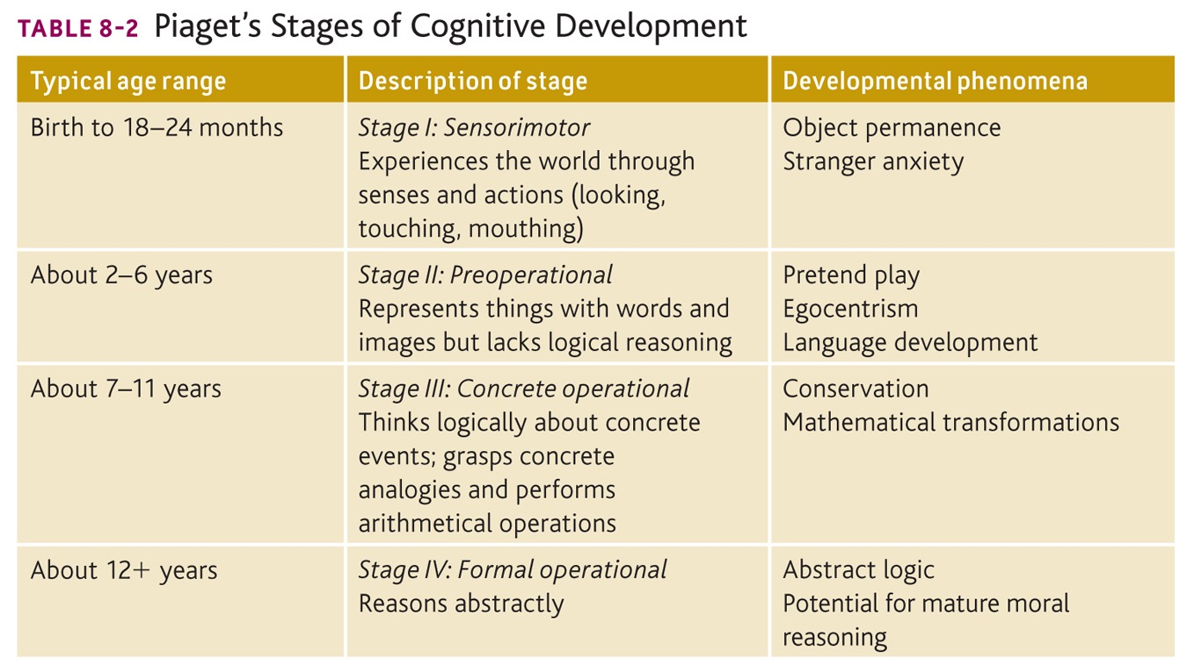
- increased motor dexterity is associated with a decrease in cortical thickness in the hand region of the left motor cortex of right handers

Language Development
- language onset is usually between 1 and 2 years of age
  - 12 months (5-10 words)
  - 2 years (200-300)
  - 3 years (1,000)
  - 6 years (2,500)
    - understand more than 20,000
  - adult (50,000)
- language acquisition is largely complete by age 12
- neural changes during this time
  - increased dendritic complexity and interconnections
  - increased myelination of speech areas

Development of Problem Solving Ability
Growth Spurts: sporadic period of sudden growth that lasts for a finite time
Epstein (1979)
- identified 5 spurts in brain growth during development
  - between 3-10 months; age 2-4; 6-8; 10-12; 14-16
- first four coincide with onset of Piagets stages and last occurs around 14 to 16 years
- likely due to growth of glial cells, blood vessels, myelin and synapses
Overman and Colleages (1992)
- children can learn a concurrent-discrimination task believed to depend on the basal ganglia around 12 months
- children can learn a non matching to sample task believed to depend on the temporal lobe around 18 months

BRAIN DEVELOPMENT AND THE ENVIRONMENT
- brains exposed to different environmental experiences are moulded in different ways
- culture is an important aspect of the human environment so culture must help to mould the human brain
- people raised in widely different cultures may acquire differences in brain structure that have lifelong effects on their behaviour

Experience and Cortical Organization
Hebb 1947
  - cognitively stimulating environments help maximize intellectual development
- compared with rats raised in standard lab cages, those raised in enriched environments have (1) larger and more synapses, (2) larger and more astrocytes

Experience and Neural Connectivity
- prenatally
  - chemoaffinity hypothesis: neurons or their axons and dendrites are drawn toward a signalling chemical that indicates the correct pathway
- postnatally
  - fine tuning of connections proceeds in an activity dependant manner
- amblyopia
  - condition in which vision in one eye is reduced as a result of disuse - usually caused by a failure of the two eyes to point in the same direction
  - visual input from the lazy eye does not contribute to the fine tuning of neural connections

Critical Periods for Experience and Brain Development
Critical Periods
- developmental window during which some event has a long lasting influence on the brain; often referred to as a sensitive period
- example - imprinting
  - process that predisposes an animal to form an attachment to objects or animals at a critical period in development
  - enlargement of synapses in chick forebrain
Abnormal Experience and Brain Development
- early deprivation of sensory experience (ex; being placed in dark)
  - has opposite effect of cognitively stimulating environments
  - atrophy of dendrites
- early deprivation of social experience (ex: raised without maternal contact)
  - has a profoundly negative effect on later intellectual and social behaviours
- human cases
  - if deprivation is relatively short (ex: less than a few months), the child may be able to overcome some of the negative effects
- stress in early life has been associated with
  - amygdala increases in size
  - hippocampus decreases in size
  - later development of depression and anxiety disorders

Hormones and Brain Development
- testosterone (androgen)
  - released during a brief period in the course of prenatal brain development and subsequently acts to alter the brain much as it alters the sex organs
- estrogen
  - sex hormones responsible for the distinguishing characteristics of the female
- the presence of testosterone and estrogen both affect the development of the brain
  - affects the number of neurons formed
  - reduces the number of neurons that die
  - increases cell growth
  - increases or reduces dendritic branching
  - increases or reduces synaptic growth
  - regulates the activity of synapses
- not just areas of brain related to sexual behaviour: these hormones can affect higher functions such as cognition
- Bachevalier and Colleagues: postnatal effects
  - monkeys
    - male and females showed different patterns of performance on tests at 2.5 months old
    - males that had testes removed at birth performed more like females
  - humans
    - similarly males and females showed different patterns of performance around 15 to 30 months of age
    - sex differences disappeared at 32 to 55 months of age
- Juraska 1990: postnatal effects
  - rats reared in complex environments
    - males showed more dendritic growth in the visual cortex than females
    - females showed more dendritic growth in the hippocampus than males
  - summary: sex diffs in brain structure exist throughout development
- humans
  - worst time for brain injury: last half of intrauterine period and first few months after birth (during critical periods)
  - better time for brain injury: few years after birth , more resilient to deficits (ex - language impairments) than when damage occurs in adults

Drugs and Brain Development
- precise effects of drugs on prenatal brain development are poorly understood
- there is some evidence that
  - prenatal exposure to psychoactive drugs may increase the chance of later drug use
  - prenatal exposure to drugs such as nicotine and caffeine increase the chance of learning disabilities and hyperactivity

Other Kinds of Abnormal Brain Development
- abnormal cell migration and differentiation
  - faulty connections may produce a range of problems
  - ex - schizophrenia
    - disorganized pyramidal neurons in the hippocampus
- too many synapses (failure of pruning) can also produce neural dysfunction
- behavioural effects of brain damage to a certain area are often not seen until the time at which that particular area matures
  - example - the frontal lobes continue to develop into adulthood, therefore the behavioural effects of frontal lobe damage may not be seen until adolescence
Developmental Disability
- impaired cognitive functioning due to abnormal brain development
Purpura 1974
- examined children with developmental disabilities who died from accidents or diseases unrelated to the nervous system
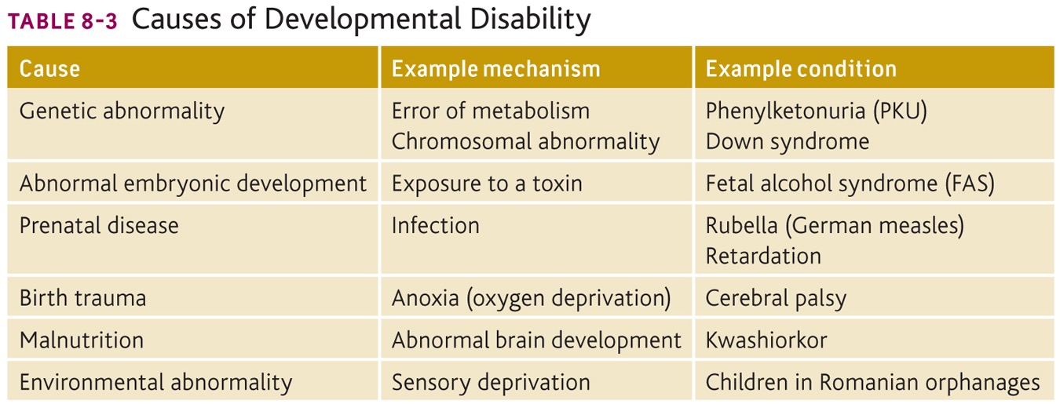
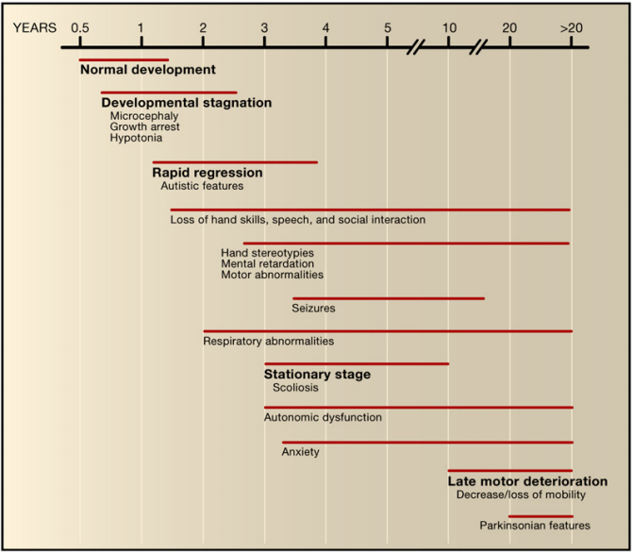
- compared with normal children, dendritic growth was reduced in children with various forms of mental retardation
  - suggests that there were fewer connections in the brain

Rett Syndrome
- neurodevelopmental disorder almost exclusively found in girls
  - males with RS generally die in early infancy or before birth
- first described by Andreas Rett in 1960s
- incidence of 1/10,000 female births
  - in US ~16,000 cases
- currently no identified cure

Neuronal Symptoms
- smaller brain size
- EEG recordings are disorganized and abnormal
- epileptic seizures very common
- learning memory and cognition difficult to evaluate
  - overall severely impaired (ex: no object permanency) due to poor and abnormal hippocampal and neocortical circuitry
- autistic behaviours (notably poor eye contact, lack of appropriate interest and facial expressiveness, sudden laughter or crying)
- emotional and behavioural problems
    - sudden screaming and laughing
    - self injury (ex - nail and hand biting)
    - anxiety and distress
- neuromuscular control is deficient
  - loss of purposeful hand movement
  - incapacity to walk properly
  - breathing difficulties
  - scoliosis
  - constipation
- however no sign of major degeneration unlike Parkinsons or Alzheimers

Genetic basis of RS
  - caused by a mutation in the MeCP2 gene
  - MeCP2 is a transcription factor found in the nucleus of neurons
- MeCP2 is an X linked gene
- generally only heterozygous individuals survive in humans
  - males cannot be heterozygous so Rett only affects females
- usually is a de novo mutation (not passed down)
- MeCP2 expression and function
  - MeCP2 expression pattern
    - strongest expression in brain
    - strongest expression in neurons after 1 year of age
    - expression increases during development after birth
  - MeCP2 inhibits and promotes the production of many proteins
    - ex - important neuronal growth factors (ex - BDNF) involved in neuronal growth and plasticity - stress response proteins
- treatments
  - mice with a MeCP2 mutation display R like symptoms
    - over expression of neuronal growth factors (ex -BDNF) has been shown to reverse R symptoms
  - IGF is under clinical trials as a possible treatment
    - improves Rett like symptoms in mouse models
    - clinical trials on human Rett patients ongoing at the Boston Childrens Hospital

HOW DO ANY OF US DEVELOP A NORMAL BRAIN?
- brain has a substantial capacity to repair minor abnormalities that may occur during development (plasticity)
- by overproducing neurons and synapses the brain has the capacity to correct errors
- there is a range of normality with respect to brain development
  - most of us develop a brain that falls within a certain range of normality
- plasticity occurs into older adulthood
Lectures 19 and 20
Brain Aging and Neurodegeneration
——————————————————
- our aging population has grown and is expected to grow
- birth rates are declining
- baby boomers are now reaching 65+ ; most will be 65 and older by 2020
- life expectancy has increased

What is aging?
- aging is a complex biological process in which changes at molecular, cellular and organ levels result in a progressive, inevitable and inescapable decrease in the body’s ability to respond appropriately to internal and/or external stressors

Can we live forever?
- genetic studies have revealed genes which are involved in longevity and aging
  - FOXO
  - WRN (mutated in Werners syndrome)
  - Progerin (mutated in Hutchinson-Gilford progeria)
- genes account for only 25% of what determines longevity
  - lifestyle choices
    - smoking, food intake, activity level
  - environment factors
    - toxins/chemicals
- smoking, obesity decrease longevity/lifespan
- aging due to a combination of effects
  - genetic makeup
  - lifestyle choices
  - environmental influences

Healthy Brain Aging
- ~10% neuron loss by age 90
- ~15% brain shrinkage
- no large scale addition of new neurons in the mature human brain
  - some addition of new neurons in some brain regions (hippocampus, olfactory, etc.)
  - function unknown
- new synapses are formed throughout life, can modify your brains capacity to do this
- brain weight decreases with age
- don’t just lose neurons, also
  - loss of dendritic processes
  - loss of dendritic spines
  - demyelination
  - astrogliosis
- dural thickening with age

Changes in Cognition with Normal Aging
- improve until 20s
- start to decline in late 20s to early 20s
- changes in attention, working memory, long term memory and info processing speed
- however
  - not all memory declines such as habitual forms of memory
  - healthy aging -> there is not a dramatic loss of memory

Difference Between Normal Brain Aging and Dementia/Alzheimer’s disease?
- normal age related memory problems
  - forgetting where you put your car keys, glasses
  - not remembering names of people you haven't seen in years
  - forgetting item or two on memorized shopping list
  - forgetting why you went into a room
- may be abnormal memory changes
  - forgetting relationships of close family members - ex grandchildren
  - putting things in odd places
  - forgetting an upcoming appointment, special event, etc and still not remembering after it is pointed out to you
  - getting lost in a familiar place when driving

Complications with Brain Aging
- stroke
- vascular dementia
- Alzheimers disease
- Parkinson’s disease
- Huntington’s disease
- amyotrophic lateral sclerosis

Stroke
- 3rd leading cause of death in Canada after cancer and heart disease
- syndrome caused by disruption of blood flow to part of the brain
- deprives neurons and other brain cells of glucose and oxygen leading to cell death
- results in impaired function or lost function
- two types (ischemic and hemmorhagic)
Ichemic (80-85%)
- cerebral thrombosis
  - blood clot formed in the brain
- cerebral embolism
  - blood clot that forms in another area of the body and travels to the brain
  - most common source is from an abnormality with the heart
- decreased systemic perfusion
- systemic hypoperfusion
  - reduction of blood flow to all parts of the body
  - most commonly due to heart failure from cardiac arrest or reduced cardiac output

- ischemic areas
  - core
    - blood flow below 10-25%
    - loss of O2 and glucose results in cells dying by necrosis
  - penumbra
    - blood flow is reduced to 25-50%
    - cells here may be viable for hours - can eventually die by apoptosis
Excitotoxicity and Ionic Imbalance
- lack of blood flow sets off a cascade of events that will cause cells to die
- lack of oxygen and glucose causes the neuron to have reduce energy (ATP)
- the Na/K pump that requires ATP to function will fail allowing Na to enter into the cell and become depolarized
- allows calcium to rush into the cell and pumps are unable to transport it back out
- calcium in the axon terminal will cause more excitatory neurotransmitter glutamate to be released
(Effects of Stroke)
- Glutamate stimulates both the AMPA and NMDA receptors and allows more calcium to enter into the postsynaptic cells
- over excitation of the cells causes the generation of harmful chemicals and enzymes (proteases, phopholipases) this is termed excitotoxicity!!!
- these enzymes degrade membranes and proteins
- membrane becomes more permeable and more harmful chemicals will flow into the cell

Hemorrhagic (15-20%)
- intracerebral hemorrhage
  - blood vessel in the brain bursts and spills into the surrounding brain tissue, damaging brain cells
- subarachnoid hemorrhage
  - artery on or near the surface of your brain bursts and spills into the space between the surface of your brain and your skull
- brain hemorrhages can result from many conditions that affect your blood vessels including
  - uncontrolled high blood pressure (hypertension)
  - weak spots in your blood vessel walls (aneurysms)

Common Effects of Stroke
FACT
  - face drooping, arm weakness, speech difficulty, time to call 911
  - last step: if someone shows the above symptoms
- vision problems
- incontinence (loss of bladder control)
- changes in how a person perceives or interprets the world
- personality changes
- depression or loss of emotional control
- inability to remember, solve problems and communicate with others
Risk Factors for Stroke
- risk issues you can do something about
- up to 80% of strokes can be prevented
  - high blood pressure (hypertension)
  - high blood cholesterol
  - diabetes
  - being overweight
  - excessive alcohol consumption
  - physical inactivity
  - smoking stress
- factors you cant control
  - age
  - gender
  - family history
  - history of stroke or TIA

Transient Ischemic Attack (TIA)
- transient ischemic attack is a warning sign of a future stroke - up to 40% of TIA patients will have a future stroke
- symptoms of TIAs are the same as stroke
- TIA symptoms can resolve within minutes or hours

Constraint Induced Therapy
- intact limb is held in a sling for several hours per day forcing the patient to use the impaired limb
- an important component of these treatments is a post treatment contract in which the patients continue to practice after the formal therapy is completed

Stroke Recovery
- 10% of stroke survivors recover almost completely
- 25% recover with minor impairments
- 40% experience moderate to severe impairments
- 10% require care within either a skilled care or other long term care facility
- 15% die shortly after stroke

Dementia
- the general term used to describe loss of previous memory of thinking function
- de = loss of ; mentia - thinking power
- Alzheimers is a specific type of dementia
- in 2011 - 747,000 Canadians were living with cognitive impairment including dementia
  - thats 14.9% of Canadians over 65
- by 2031 - if nothing changes in Canada this will increase to 1.4 million

Vascular Dementia
- 2nd most common form of dementia after Alzheimers disease
- caused by problems to the blood supply to the heart
- due to high blood pressure, heart problems, high cholesterol and diabetes
- can lead to larger strokes
- Fazekas score for white matter
  - 0 no lesions; 1 normal in elderly; 2 some people show D symptoms ; 3 D is evident

Alzheimer’s Disease
- most common form of dementia
- associated with selective damage of brain regions and neural circuits critical for memory and cognition
- the pathogenesis of this disease is complex and involves many molecular, cellular and physiological, pathologies
- the neurons in the neocortex, hippocampus, amygdala and basal forebrain cholinergic system are the most affected brain regions

Epidemiology
- at least 50-80% of dementia patients have AD
- there is a higher rate of dementia in women over men - may be due to males not living as long
Risk Factors
- most important
  - advancing age
  - family history of dementia
- other risk factors
  - poor childhood health or nutrition; low socio-economic status
  - diabetes and hypertension confer risk for AD
- possible risk factor
  - head injury but data is incomplete
  - link between boxing and AD

Lab Evaluations in Suspected AD
- structural neuroimaging
  - MRI - demonstrates hippocampal atrophy associated with much higher rate of progression to dementia due to AD
- amyloid imaging
  - PIB-BET (pittsburgh compound B) shows high amyloid binding in the frontal lobes and other cortical structures

Neuropathology of AD
- lobes of brain in AD
  - weight of individual lobes was evaluated in AD and compared to control brains
  - decrease in weight is:

    - 41% for temporal lobe
    - 30% parietal lobe
    - 14% frontal lobe
    - occipital lobe generally preserved

AD and the Brain: Gross Pathology
Preclinical AD
- signs of AD first noticed in the entorhinal cortex then proceed to the hippocampus
- affected regions begin to shrink as nerve cells die
- changes can begin to occur 10-20 years before symptoms arise
- memory loss is the first sign of AD
Mild to Moderate AD
- AD spreads through the brain
  - the cortex shrinks as more neurons stop working and begin to die
- mild AD signs can include memory loss, confusion, trouble handling money, poor judgment, mood changes, increased anxiety
- moderate AD signs can include increase memory loss and confusion difficulty with language and thoughts, agitation, wandering, repetitive statements
Severe AD
- extreme shrinkage occurs in bran. patients completely dependent on others for care
- symptoms can include weight loss, seizures, moaning and grunting, increased sleep, loss of bladder control
- death usually occurs from pneumonia or other infections

Cortical Degeneration
- cerebral atrophy may be due in large part to the loss of dendritic arborization
- loss of neurotransmitters
  - acetylcholine, noradrenaline, dopamine, serotonin, NMDA and AMPA glutamate receptors

Hypotheses of AD causes
- brains histological features are well characterized however the actual cause of AD is still unknown
- there are three major hypotheses put forward regarding the primary cause of AD
  - cholinergic hypothesis
  - amyloid hypothesis
  - tau hypothesis

Cholinergic Hypothesis of AD
- first theory proposed to explain AD
- led to development of only drugs currently approved to treat mild and moderate AD
  - acetylcholinesterase inhibitors
- experimental studies in humans and non human primates have demonstrated a role for ACh in learning and memory

- the brains of people with AD have an abundance of 2 abnormal structures
- amyloid plaques
  - located mostly in the cerebral cortex
  - also found in nonAlzheimer dementia patients
  - dense deposits of protein and cellular material that accumulate outside and around nerve cells
- neurofibrillary tangles
  - found in the cerebral cortex and the hippocampus
  - also found in patients with down syndrome, Parkinson’s disease and other types of dementia
  - twisted fibres that build up inside the nerve cell

Normal Structure and Function of APP
- amyloid precursor protein (APP) is a cell surface receptor
- plays a role in synaptic formation and repair, signalling and cell adhesion

Secretase enzymes in the degradation of APP
- the AB (B=beta) region of the APP spans the cell membrane
- APP is cleaved by 3 enzymes
  - alpha secretase
  - beta secretase
  - gamma secretase
- can be cleaved in 2 ways
  - normal cleavage
  - abnormal cleavage of APP leads to excess amyloid accumulation

Tau Hypothesis of AD
- tau hypothesis states that excessive or abnormal phosphorylation of tau results in the transformation of normal adult tau into neurofibrillary tangles

Physiological Functions of Tau
- tau protein interacts with tubulin to stabilize microtubule assembly
- thereby aiding axonal transport

How Can our Brains Age Gracefully
- Social Connections and Intellectual Activity
- a number of studies indicate that maintaining strong social connections and keeping mentally active as we age might lower the risk of cognitive decline and Alzheimers
- experts are not certain about the reason for this association
  - could be increases in synapse formation
- Heart-Head Connection
- risk of developing dementia appears to increase as a result of many conditions that damage the heart or blood vessels
  - high blood pressure, heart disease, stroke, diabetes and high cholesterol
  - some autopsy studies show that as many as 80% of individuals with Alzheimers disease also have cardiovascular disease
- Physically Active Lifestyle
- reduces risk of heart disease, cancer, diabetes, stroke
- linked to longer life and less disability
- recent studies also suggest reduce risk of AD and slower progression of AD
- improved mood and reduced risk of depression
- reduced risk of falls
- improved capacity to pay attention and problem solve
- improved sleep
- improved blood flow to the brain
- reduced oxidation
- reduced inflammation
- reduced toxicity of misfiled proteins that are thought to cause AD, PD
- improved neurogenesis and synaptogenesis

