Cisico chapter 1
LANs, WANs and the Internet
Components
Network infrastructure categories:
- Devices
- Media
- Services - Services include many of the common network applications people use every day, like email hosting services and web hosting services;

Devices symbols
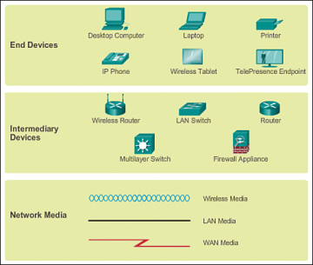

End devices – Desctop, laptop, printer, IP phones, wireless tablet, Telepresence ;
Intermediary devices – connect end devises to the network and networks to the internetwork;
- regenerate and retransmit data signals;
- Maintain information about pathways exits through the network an internetwork
- Notify other devices of errors and communication failures
- Direct data along alternate pathways when there is a link failure
- Classify and direct messages according to priorities
- Permit or deny the flow of the data, based on security settings;
Network Media - provides the channel over which the message travels from source to destination.
Criteria for choosing network media:
- What is the maximum distance that the media can successfully carry a signal?
- Into what type of environment will the media be installed
- What is the amount of data and speed at which it must be transmitted?
- What is the cost of the media and installation?
Topology diagrams
Physical topology – identify the physical location of the devices, configured ports and cable installation;
Logical topology – identify devices, ports and IP addressing scheme.
Types of Network

LAN – small geographic area, managed by organization of individual high speed between devices, security and access on network level (home, small business, school);
WLAN – same as LAN by wirelessly;
WAN –wide area, usually owned and managed by multiple telecommunication service provider, interconnect LANS between cities, counties and continents, slower speed between LANS
MAN – metropolitan area network, larger then LAN but smaller then WAN, owned by a single organization.
SAN – storage area network, designed to support file servers and provide data storage
The Internet – worldwide collection of interconnect LANs and WANs, not owned by anybody, managed by organization (IETF), (ICANN), (IAB)

Intranet – Company Only
Extranet – Suppliers, Customers, Collaborators;
The Internet – The World;
Internet Access Technologies
Home and Small office connections – through Internet Service Providers (ISP)
- Cable – tv cable, provides a high bandwidth, always on;
- DSL – telephone line, Digital Subscriber Lines, high bandwidth, always on,
- Cellular – low speed, access only when reception, limited by tower;
- Satellite – for the area without Internet connectivity; require clear area, expensive;
- Dial-up – phone line, low bandwidth, not stable (for mobile access)
Business Internet Connections
- Dedicated Leased Line – leased lines, reserved circuits;
- Ethernet WAN – is extend LAN into the WAN.
- DSL - SDSL, symmetric
- Satellite
Network as platform
Separated Nw – old, networks separated, 30 years ago, each network has own roles
Converging Network – modern, capable of delivering data, voice and video between different devices over the same network infrastructure. Same set of rules.
Network architecture
Network architecture – technologies that supports the infrastructure and the program services and rules or protocols that move data across the network.
4 basic characteristics:
- Fault Tolerance – limits the impact of failure; allow quick recovery. Depends on multiple paths between the source and destination of a message. Redundancy connections allow for alternative paths if a device or link fails. The user experience is unaffected
- Scalability – additional users and whole networks can be connected to the Internet without degrading performance for existing users;
- Quality of Service (QoS) – managed by the router, ensure that priorities are matched with the type of communication and its importance to the organization (web pages can usually receive a lower priority, Streaming media will need to maintain a smooth, uninterrupted user experience;
- Security – admin can protect the network with software and hardware security and by prevention physical access to the network devices; Security protect the network from unauthorized access
Data Confidentiality - means that only the intended and authorized recipients can access and read data;
Data Integrity – means heaving the assurance that the information has not been altered in transmission from origin to destination;
Data Availability – means having the assurance of timely and reliable access to data services for authorized users;
New trends
Bring Your Own Device (BYOD) - means any device with any ownership, used anywhere
Online collaboration – “the act of working with another or others on a joint project”. Way to instantly connect, interact and achieve their objectives (Cisco WebEx)
Video communication -
Cloud computing – allows to store personal files, backups our hard drives on servers over the internet. We can use accessed through Cloud.
4 types:
-Public – apps and services available to the general population. May be free or pay-per use model;
- Private – apps and services intended for a specific organization or entity (government). Strict access security, expensive
-Hybrid – (privet +public)
- Custom – built to meet the needs of the specific industry (healthcare) can be custom or public.
Network security
Security Threats
Securing a network involves protocols, technologies, devices, tools and techniques to secure data and minimize threats. Threat vectors may be external or internal

Viruses, worms, Trojans - malicious software running on a user device
Spyware and adware - software that secretly collects information about the user
- Zero-day attacks, also called zero-hour attacks - an attack that occurs on the first day that a vulnerability becomes known
- Hacker attacks - an attack by a knowledgeable person to user devices or network resources
- Denial of service attacks - attacks designed to slow or crash applications and processes on a network device
- Data interception and theft - an attack to capture private information from an organization’s network
- Identity theft - an attack to steal the login credentials of a user in order to access private data
Security Solutions
Minimum:
- Antivirus and antispyware –used to protect end devices from becoming infected with malicious software.
- Firewall filtering –to block unauthorized access to the network. may include a host-based firewall system to prevent unauthorized access to the end device, or a basic filtering service on the home router to prevent unauthorized access from the outside world into the network.
For large network and corporations:
- Dedicated firewall systems – These are used to provide more advanced firewall capabilities that can filter large amounts of traffic with more granularity.
- Access control lists (ACL) – These are used to further filter access and traffic forwarding.
- Intrusion prevention systems (IPS) – These are used to identify fast-spreading threats, such as zero-day or zero-hour attacks.
- Virtual private networks (VPN) – These are used to provide secure access to remote workers.

Cisco network Architecture
CCNA
CCNA - Cisco Certified Network Association

Chapter 3
Network Protocols and communications
Computer communication
Message ->Transmitter->Transmission Medium->Receiver->Message Destination
Rule Establishment.
Protocols:
Message Encoding – is a process of converting information into another acceptable form for transmission.
Message ->Encoding->Transmitter->Transmission Medium->Receiver->Decoder ->Message Destination

Message Formatting and encapsulation -
Message Size -
Message Timing
Message Delivery option – Unicast, Multicast, broadcast

Protocol Suite

Network protocols

HTTP -Hypertext Protocol, Layer Application. Governs the wat a web server and web client interact. HTTP defines the content and formatting of the requests and responses. HTTP relies on other protocols to govern how the messages are transports between the clients and servers.
TCP – Transmission Control Protocol – Layer Transport. Transport protocol. Divides the HTTP messages into smaller pieces – segments. They are sent between the web server and client. Also TCP responsible for controlling the size and rate at which messages are exchanged between server and client.
IP – Internet protocol (IPv4 and IPv6) Internet. Is responsible for taking the formatted segments from TCP, encapsulating them into packets, assigning them the appropriate addresses and delivering them to the destination host.
Ethernet - Network Access layer. Is a network access protocol that describes two primary functions: communication over a data link and physical transmission of data on the network media. Is responsible for taking the packets from IP and formatting them to be transmitted over the media.

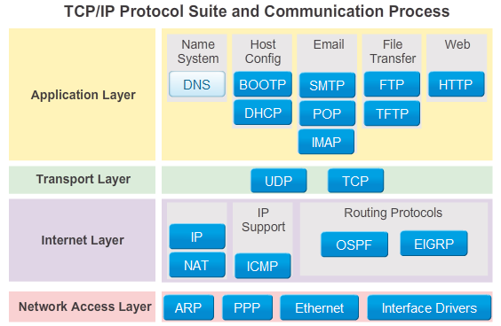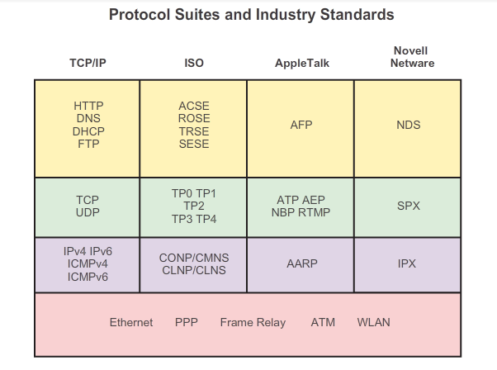

Protocol suits – set of protocols that work together to provide service.

TCP/IP protocol is an open standard, freely available to the public, 1969,

The benefits of Using Layered Model
The benefits to using a layered model to describe network protocols and operations include:
- Assisting in protocol design because protocols that operate at a specific layer have defined information that they act upon and a defined interface to the layers above and below.
- Fostering competition because products from different vendors can work together.
- Preventing technology or capability changes in one layer from affecting other layers above and below.
- Providing a common language to describe networking functions and capabilities.

OSI MODEL
OSI – Open system Interconnection extensive list of functions and services that can occur at each layer. It also describes the interaction of each layer with the layers directly above and below
7. | Application | Contains protocols used for process to process communication, HTTP, POP, SMTP, FTP, DSN
6. | Presentation | provides for common representation of the data transmitted between application layer services
5. | Session | provides services to the presentation layer to organize its dialogue and to manage data exchange.
4 | Transport | defines services to segment, transfer, and reassemble the data for individual communications between the end devices. (segments, transfers and reassembles the data)
3 | Network | provides services to exchange the individual pieces of data over the network between identified end devices (Provides data path)
2 | Data Link | The data link layer protocols describe methods for exchanging data frames between devices over a common media. (exchange frames between devices)
1 | Physical | The physical layer protocols describe the mechanical, electrical, functional, and procedural means to activate, maintain, and de-activate physical connections for bit transmission to and from a network device. (Bit transmission)
TCP/IP protocol model and OSI model.
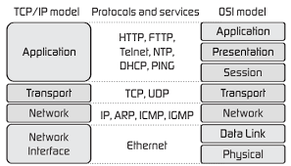
Message Segmentation
Segmentation - division of the data stream into smaller pieces.

Two primary benefits:
- By sending smaller individual pieces from source to destination, many different conversations can be interleaved on the network, called multiplexing;
- Segmentation can increase the efficiency of network communications. If part of the message fails to make it to the destination, due to failure in the network or network congestion, only the missing parts need to be retransmitted.
The challenge is the level of complexity that added to the process.

Protocol Data Units

PDU – Protocol Data Unit – the form that a piece of data takes at any layer. During encapsulation, each succeeding layer encapsulates the PDU that it receives from the layer above in accordance with the protocol being used
Encapsulation
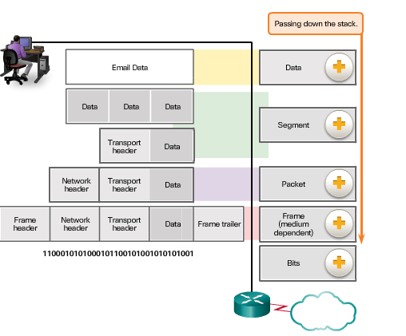

Data – the general term for PDU used at application layer

Segment – Transport layer PDU

Packet – Network layer PDU

Frame – Data Link layer PDU

Bits – A Physical layer PDU used when physically transmitting data over the medium

Network Addresses and Data Link

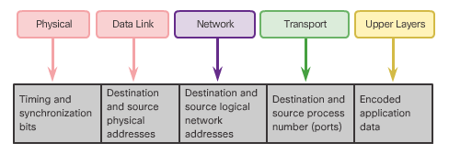
- Network layer source and destination addresses - Responsible for delivering the IP packet from the original source to the final destination, either on the same network or to a remote network.
- Data link layer source and destination addresses – Responsible for delivering the data link frame from one network interface card (NIC) to another NIC on the same network.

The IP packet contains two IP addresses:
- Source IP address - The IP address of the sending device, the original source of the packet.
- Destination IP address - The IP address of the receiving device, the final destination of the packet.
Devices on the Same Network
The network layer addresses, or IP addresses, indicate the original source and final destination. An IP address contains two parts:
- Network portion – The left-most part of the address that indicates which network the IP address is a member. All devices on the same network will have the same network portion of the address.
- Host portion – The remaining part of the address that identifies a specific device on the network. The host portion is unique for each device on the network.
Devices on Remote Network

Note: The subnet mask is used to identify the network portion of an address from the host portion

Summary:

Chapter 3: Network Protocols and Communications
Data networks are systems of end devices, intermediary devices, and the media connecting them. For communication to occur, these devices must know how to communicate.
These devices must comply with communication rules and protocols. TCP/IP is an example of a protocol suite. Most protocols are created by a standards organization such as the IETF or IEEE. The Institute of Electrical and Electronics Engineers is a professional organization for those in the electrical engineering and electronics fields. ISO, the International Organization for Standardization, is the world’s largest developer of international standards for a wide variety of products and services.
The most widely-used networking models are the OSI and TCP/IP models. Associating the protocols that set the rules of data communications with the different layers of these models is useful in determining which devices and services are applied at specific points as data passes across LANs and WANs.
Data that passes down the stack of the OSI model is segmented into pieces and encapsulated with addresses and other labels. The process is reversed as the pieces are de-encapsulated and passed up the destination protocol stack. The OSI model describes the processes of encoding, formatting, segmenting, and encapsulating data for transmission over the network.
The TCP/IP protocol suite is an open standard protocol that has been endorsed by the networking industry and ratified, or approved, by a standards organization. The Internet Protocol Suite is a suite of protocols required for transmitting and receiving information using the Internet.
Protocol Data Units (PDUs) are named according to the protocols of the TCP/IP suite: data, segment, packet, frame, and bits.
Applying models allows individuals, companies, and trade associations to analyze current networks and plan the networks of the future

