Chapter 2
Recognizing opportunities in generating ideas.

Chapter Objectives
- Explain why it’s important to start a new firm when its “window of opportunity” is open.
- Explain the difference between an opportunity and an idea.
- Describe the three general approaches entrepreneurs use to identify opportunities.
- Identify the four environmental trends that are most instrumental in creating business opportunities.
- List the personal characteristics that make some people better at recognizing business opportunities than others.
- Identify the five steps in the creative process.
- Describe the purpose of brainstorming and its use as an idea generator.
- Describe how to use library and Internet research to generate new business ideas.
- Explain the purpose of maintaining an idea bank.
- Describe three steps for protecting ideas from being lost or stolen.

BenchPrep case for the GMATapp.

I. Identifying and recognizing opportunities
Opportunity: a favourable set of circumstances that creates a need for a new produc, service, or business.
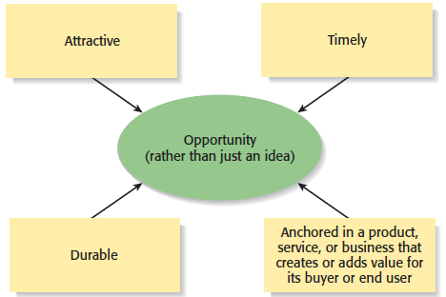

Venture can be motivated one of two way:
- Externally stimulated: entrepreneur decide to launch a business and searches for an idea; as Jeff Bezos when creating Amazon.
- Internally stimulated: recognize a problem or gap ad creates a business to fill it.

However recognizing an opportunity is difficult. A common mistake is trying to pick up an existing product or service and start a business around a slightly better version of it.

And opportunity has four essential quality: attractive, durable, timely & anchored in a product, service, or business that creates or adds value for its buyer or end user. To capitalize on it, a entrepreneur has to open a window of opportunity; which is the time period a firm can enter a new market.

It is important to understand the difference between idea and opportunity:
Idea: thought, impression or notion. An idea may or may not meet the criteria of an opportunity.

A. Observing trends
Observing trends and study how they create opportunity: economic, social, political, technological, cultural changes must be observed. FIGURE.

- Economic forces: Economic trends help determine areas that are ripe for new start-ups and areas that start-ups should avoid. A weak economy favors start-ups that help consumers save money. An example is GasBuddy.com, a company started to help consumers save money on gas.
- Social features: Social trends alter how people and businesses behave and set their priorities. These trends provide opportunities for new businesses to accommodate the changes. Aging of baby boomer, diversity in workforce, increase interest in social network (FB & Twitter), proliferation of mobile phone and apps, increasing focus on health and wellness, emphasis on clean form of energy, increasing number of people going back to school, increasing interest on healthy food and green products.
- Technological advances: Advances in technology frequently create business opportunities. Computer industry ; Internet, Biotechnology, Digital photography
- Political action and Regulatory changes: Political action and regulatory changes also provide the basis for opportunities. Laws to protect the environment have created opportunities for entrepreneurs to start firms that help other firms comply with environmental laws and regulations. Company created to help other companies comply with a specific law. The No Child Left Behind Act of 2002 requires states to develop criterion-based assessments in basic skills to be periodically given to students in certain grades. Kim and Jay Kleeman, two high school teachers, started Shakespeare Squared, a company that helps high schools comply with the act.

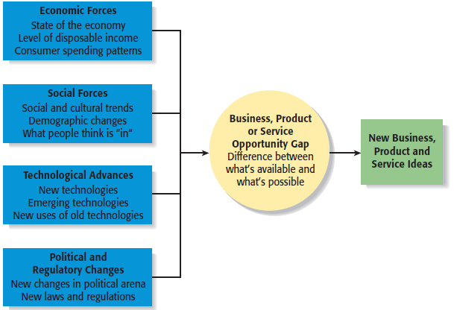

B. Solving a problem
Second approach to identify an opportunity: “Every problem is a brilliantly disguised opportunity”. Sometimes identifying opportunities simply involves noticing a problem and finding a way to solve it.
These problems can be pinpointed through observing trends and through more simple means, such as intuition, serendipity, or change.

Advances technologies often result in problems for end users. For instance, older people tend to find it to small etc., GreatCall Inc. designed cell phones especially for them.
Entrepreneurs who frame a problem differently than it’s been thought of before, and then offer a solution solve some problems. Example of mirrors and waiting time.

C. Finding gaps in the marketplace
A third approach to identifying opportunities is to find a gap in the marketplace. A gap in the marketplace is often created when a product or service is needed by a specific group of people but doesn’t represent a large enough market to be of interest to mainstream retailers or manufacturers.
Daisy Rocks Stars: guitare specifically designed for women.
Common way that gaps in the marketplace are recognized is when people become frustrated because they can’t find a product or service that they need and recognize that other people feel the same way.

III. Personal characteristics of the entrepreneur
1. Prior Experience
Prior Industry Experience: Several studies have shown that prior experience in an industry helps an entrepreneur recognize business opportunities. By working in an industry, an individual may spot a market niche that is underserved. It is also possible that by working in an industry, an individual builds a network of social contacts who provide insights that lead to recognizing new opportunities.
Corridor principle: once an entrepreneur starts a firm, new venture opportunity become apparent.

2. Cognitive Factors
Studies have shown that opportunity recognition may be an innate skill or cognitive process. Some people believe that entrepreneurs have a “sixth sense” that allows them to see opportunities that others miss. This “sixth sense” is called entrepreneurial alertness, which is formally defined as the ability to notice things without engaging in deliberate search.

3. Social Networks
The extent and depth of an individual’s social network affects opportunity recognition. People who build a substantial network of social and professional contacts will be exposed to more opportunities and ideas than people with sparse networks. Research results suggest that between 40% and 50% of people who start a business got their idea via a social contact. Solo vs. Network entrepreneur.
Strong Tie Vs. Weak Tie Relationships: All of us have relationships with other people that are called “ties.” (See next slide.) Strong-tie relationship are characterized by frequent interaction and form between coworkers, friends, and spouses. Weak-tie relationships are characterized by infrequent interaction and form between casual acquaintances.
Result: it is more likely that an entrepreneur will get new business ideas through weak-tie rather than strong-tie relationships. (See next slide.)

4. Creativity
Creativity is the process of generating a novel or useful idea. Opportunity recognition may be, at least in part, a creative process. For an individual, the creative process can be broken down into five stages, as shown below:
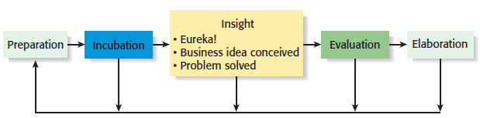

Full View of the Opportunity Recognition Process

IV. Techniques for Generating Ideas
A. Brainstorming
Is a technique used to generate a large number of ideas and solutions to problems quickly. A brainstorming “session” typically involves a group of people, and should be targeted to a specific topic.
Rules for a brainstorming session:
- No criticism.
- Freewheeling is encouraged.
- The session should move quickly.
- Leap-frogging is encouraged.

B. Focus Group
A focus group is a gathering of five to ten people, who have been selected based on their common characteristics relative to the issues being discussed. These groups are led by a trained moderator, who uses the internal dynamics of the group environment to gain insight into why people feel the way they do about a particular issue. Although focus groups are used for a variety of purposes, they can be used to help generate new business ideas.

C. Library and Internet Research
Libraries are an often underutilized source of information for generating new business ideas. The best approach is to talk to a reference librarian, who can point out useful resources, such as industry-specific magazines, trade journals, and industry reports. Simply browsing through several issues of a trade journal or an industry report on a topic can spark new ideas.

Internet Research: If you are starting from scratch, simply typing “new business ideas” into a search engine will produce links to newspapers and magazine articles about the “hottest” new business ideas. If you have a specific topic in mind, setting up Google or Yahoo! e-mail alerts will provide you with links to a constant stream of newspaper articles, blog posts, and news releases about the topic.

D. Other Techniques
Customer Advisory Boards: Some companies set up customer advisory boards that meet regularly to discuss needs, wants, and problems that may lead to new ideas.
Day-In-The-Life Research: A type of anthropological research, where the employees of a company spend a day with a customer.

V. Encouraging New Ideas
A. Establishing a Focal Point for Ideas
Some firms meet the challenge of encouraging, collecting, and evaluating ideas by designating a specific person to screen and track them—for if it’s everybody’s job, it may be no one’s responsibility.
Another approach is to establish an idea bank (or vault), which is a physical or digital repository for storing ideas.

B. Encouraging Creativity at the Firm Level
Creativity is the raw material that goes into innovation and should be encouraged at the organizational and individual supervisory level.

C. Protecting Ideas From Being Lost or Stolen
Intellectual property: any product of human intellect that is intangible but has value in the marketplace.
Step 1: The idea should be put in a tangible form such as entered into a physical idea logbook or saved on a computer disk, and the date the idea was first thought of should be entered.
Step 2: The idea should be secured. This may seem like an obvious step, but is often overlooked.
Step 3: Avoid making an inadvertent or voluntary disclosure of an idea, in a manner that forfeits the right to claim exclusive rights to it.

