Renal System (Topic 4)

- Gross Anatomy of the Kidneys
- Bean-shaped; retroperitoneal (sup. Lumbar region; 12th T vertebra to 2nd L vertebra); right kidney pushed lower by liver
- Protection from back muscles
- Adrenal glands on top of kidneys (“suprarenal glands”)
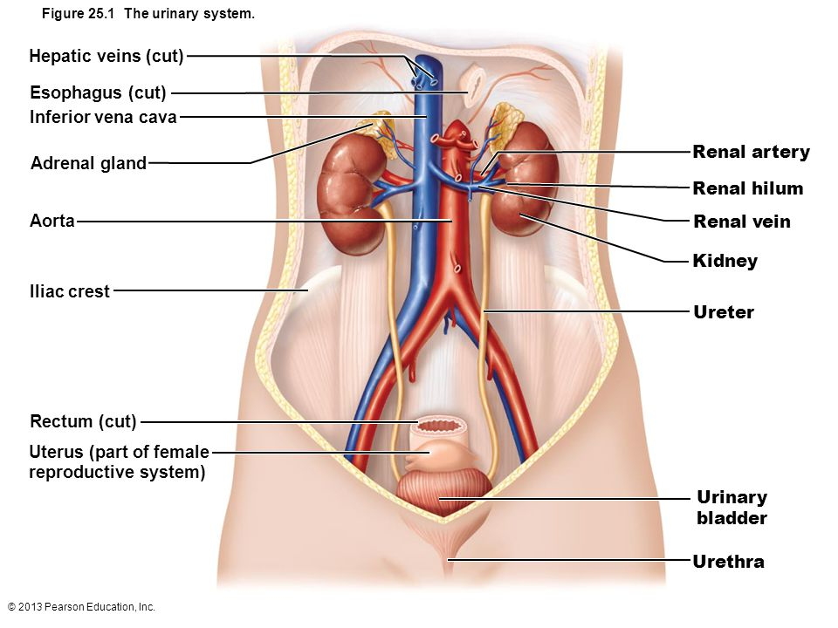

- 3 layers of supportive tissue…

- Renal Capsule: fibrous, adheres directly to kidney surface (prevents infections from spreading to kidneys)
- Adipose Capsule: fatty mass surrounds kidney/cushions
*renal ptosis: no more fat > kidney drops (urine accumulates)
- Renal Fascia: dense CT surrounds adrenal gland & kidney and anchors to surrounding structures
- Internal Anatomy of the Kidneys

- Cortex: site of blood filtration

- Medulla:
  - contain cone-shaped tissue masses called medullary/renal pyramids (base faces cortex, papilla face inwards)
  - pyramids formed of parallel bundles of urine-collecting tubes/capillaries (appear striped)
  - Renal columns (extensions of cortical tissue) separate the pyramids (8 lobes approx.)

- Renal Pelvis:
- Funnel-shaped tube; continuous w/ ureter (>bladder)
- Branching extensions form calyces (minor/major) which collect urine draining from the papillae and drain into the pelvis
- Made of smooth muscle + propel urine by peristalsis
*pyelitis: an infection of the pelvis/calyces (pyelonephritis affects entire kidney)
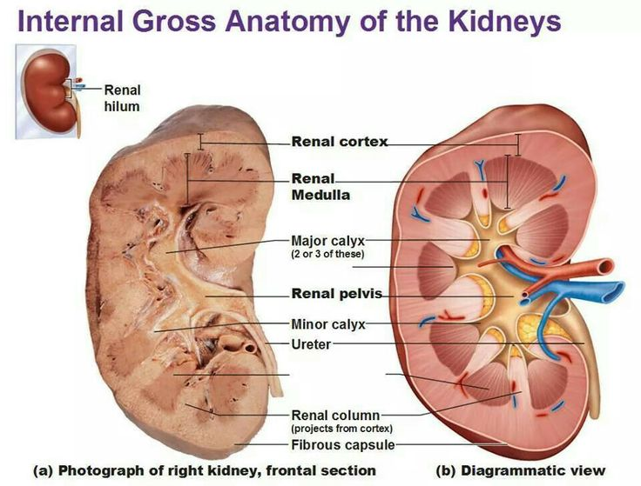

Renal vein = bigger (lower resistance)

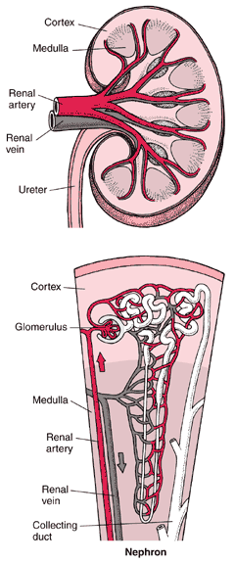
- The Nephron
- Structural & functional unit of kidneys
- Each nephron consists of a renal corpuscle (cortex) & a renal tubule (cortex > medulla > cortex)

- Renal Corpuscle
- Glomerulus: knots of capillaries (fenestrated; allows solute-rich filtrate into capsule to be processed)
- Bowman’s (Glomerular) Capsule: surrounds glomerulus *Podocytes in the visceral layer of Bowman's capsule. The foot processes/pedicels extend from podocytes/ wrap around capillaries of the glomerulus to form the filtration slits

- Renal Tubule & Collecting Duct
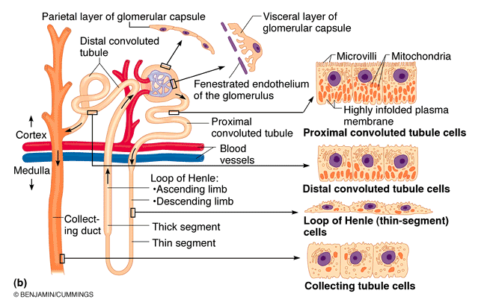
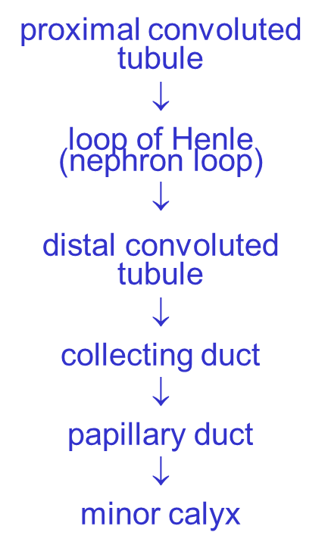

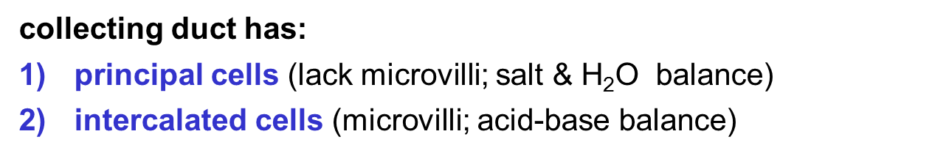
- Types of Nephrons
- Cortical (85%): located primarily in the cortex
- Juxtamedullary: close to cortex-medullary junction (ability to produce concentrated urine); loop enters deep into medulla

- Microcirculation of the Nephron
- Glomerulus: specialized for filtration (fed/drained by arterioles
*afferent have low R + are larger than efferent arterioles
- Peritubular Capillaries: arise from efferent arterioles; absorb “good” filtrate and drain into renal venules
- Vasa Recta: straight capillaries; extensions of peritubular capillaries
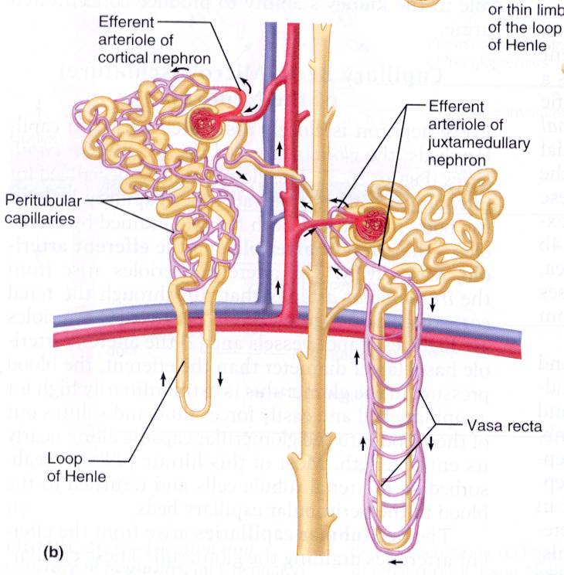

- Structure of the Juxtaglomerular Apparatus
- Specialized structure formed by distal convoluted tubule & afferent arteriole that regulates renal function (filtrate form. + systemic bp)

- Arteriole walls: JG cells (granular cells); enlarged smooth muscle cells (mechanoreceptors, secrete renin)
- Tubule wall: macula densa cells; chemo/osmoreceptors, monitor filtrate/adjust glomerular filtration rate accordingly
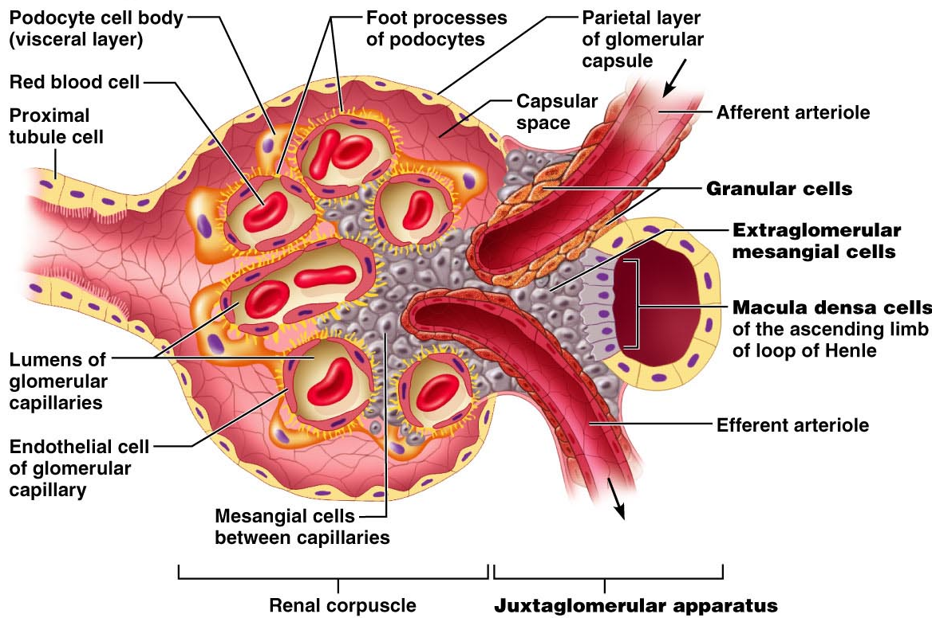

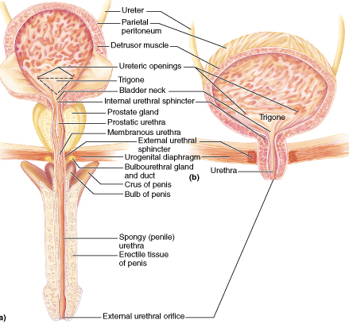
- urethra long in males, short in females
- Trigone: a smooth triangular region of the internal urinary bladder formed by the two ureteral orifices and the internal urethral orifice. The area is very sensitive to expansion and once stretched to a certain degree, signals the brain of its need to empty
- Internal urethral sphincter constricts the internal urethral orifice. It is the junction of the bladder & urethra. It is made of smooth muscle, so therefore it is under involuntary control
- External urethral sphincter: the opening of the urethra where urine or semen exits; skeletal muscle (voluntary)

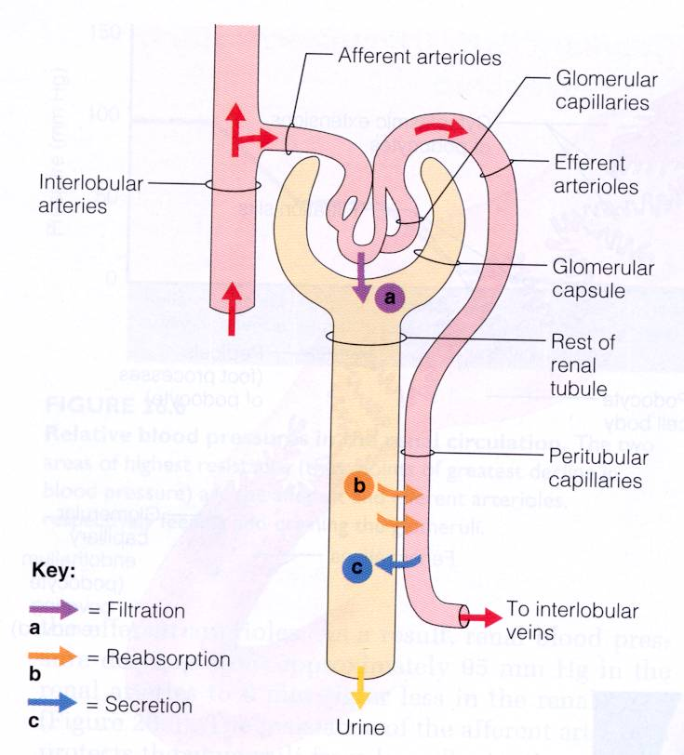
Renal Physiology

- Filters bloodstream (toxins, metabolic waste, excess ions)
- Regulate blood volume/composition (water & ions)
- Produce renin (regulates BP/kidney function)
- Produce erythropoietin (regulates blood cell production)
- Metabolizes vitamin D to its active form

- Filtrate: plasma minus protein
- Urine: filtrate minus nutrients, essential ions & h2o

- Glomerular Filtration
- Passive, nonselective; fluids/solutes forced through by hydrostatic pressure forming filtrate (GFR = 120 ml/min)
- Very efficient because…
- Membrane very permeable (1000x more than others)
- Glomerular blood pressure higher than other cap beds (maintained by efferent arterioles regulating efflux of blood)

- Between blood and interior glomerular capsule (3 layers)…
- Fenestrated Capillary Endothelium: capillary pores allow all blood components except RBC to pass through
- Basement Membrane:
- Composed of other layers fused basal laminae
- Allows small proteins + solutes to pass through
- Glycoproteins make layer negatively charged (repels negatively charge d molecules like plasma proteins)
- Visceral Membrane (Podocytes): slit diaphragms prevent rest
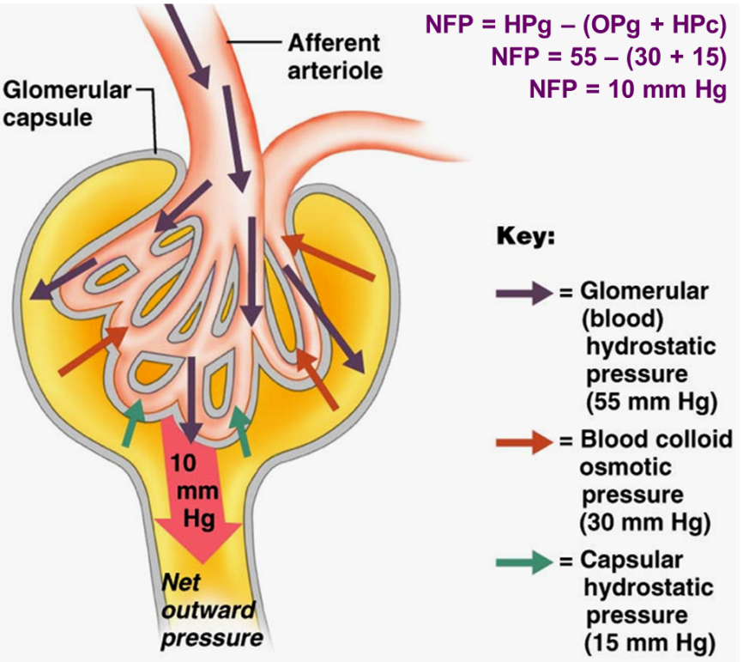
- Net Filtration Pressure
- Pressure responsible for filtrate formation
- HPg – pushes out of blood
- OPg – pulls back into blood
- HPc – pushes back into blood

- Regulatory Influences on Glomerular Filtration Rate

- Renal Autoregulation (intrinsic)
- Kidney keeps GFR constant by determining & adjusting its own rate of flow (nephron blood flow)
- Regulates diameter of afferent/efferent arterioles

- Myogenic Mechanism
- Responds to changing BP in renal blood vessels
- Rising = stretch (afferent arterioles constrict)
- Declining = relaxed (afferent arterioles dilate)
- Tubuloglomerular Feedback Mechanism
- Directed by macula densa cells of JGA (in walls of distal tubes); responds to filtrate NaCl concentration
- Slow filtrate/low NaCl > vasodilation
- Fast filtrate/high NaCl (low absorp.) > vasoconstriction
*renal autoregulation can maintain constant GFR w/ 80-180 mm Hg systemic BP (less 70 mm Hg = hypovolemic shock)

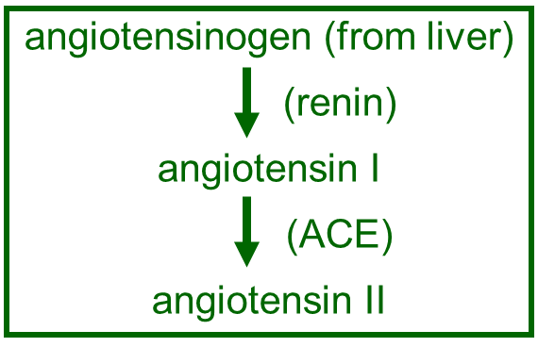
- Extrinsic Mechanisms

- Neural Controls
- SNS during times of extreme stress (overrides renal autoregulation & shunts blood to heart, brain, skeletal muscles at expense of kidneys)
- Direct SNS-induced vasoconstriction of afferent a
- Renin-angiotensin system: low BP > renin > high BP
- JG cells = mechanoreceptors
- Macula densa cells = chemoreceptors

- Angiotensin II:
- potent vasoconstrictor (increased BP)
- stimulates release of aldosterone (reabsorption of Na+ & water > increased blood volume > increased BP)
*afferent have fewer angiotensin receptors than efferent
- What triggers renin release?
- bp < 80 mm Hg = decreased stretch of JG cells
- direct stimulation of JG cells by macula densa cells (↓ATP, ↑ PG)
- Direct stimulation of JG cells by renal symp. nerves
*Renin-angiotensin system is involved in renal regulation, but main purpose is to stabilize systemic bp & ECF volume

- Active tubular reabsorption
- Most transport is active
- Basolateral membrane: substance moves passively into tubule cell, but must be actively moved into interstitial space)
- Actively reabsorbed: glucose, amino acids, lactate, vitamins, ions
- transport usually linked to Na & fairly specific
- Passive tubular reabsorption
- Active reabsorption of Na+ pulls anions
- Obligatory water reabsorption due to Na+ transport
- Solvent drag creates gradient for solute absorption

- Non-Reabsorbed Substances (+ H+, K+)
- Either no carriers, not lipid soluble or too large; primarily nitrogenous end products of protein/nucleic acid metabolism
- Urea: main nitrogen-containing end product of metabolism; amount excreted dependant on protein in diet; small enough to diffuse through pores
- Creatinine: large, lipid insoluble nitrogenous waste molecule; not reabsorbed by kidney
- Uric acid: end product of purine metabolism; some excreted and some reabsorbed; too much can lead to gout

- Important functions of tubular secretion
- Disposing of substances, such as certain drugs and metabolites, that are tightly bound to plasma proteins. Because PP are generally not filtered, the bound substances are mot filtered and must be secreted
- Eliminating substances absorbed by passive processes. Urea and uric acid are handled in this way.
- Ridding the body of excess K+. since virtually all K+ in filtrate is reabsorbed, nearly all K+ in urine comes from aldosterone-driven active tubular secretion in late DCT & collecting ducts
- Controlling blood pH. When pH drops low, renal tubules secrete more H+ into filtrate and retain HCO3-. Controversially, when pH rises, Cl- is reabsorbed.

- Counter-current multiplication system
- How nephron concentrates urine
- How water and sodium are extracted from filtrate in tubules (due to difference in flow directions of ascending/descending limbs)
- This difference creates a gradient creating a net diffusion of salt into descending limb and net diffusion of water out
- Ascending limb is impermeable to water, actively moves NaCl out
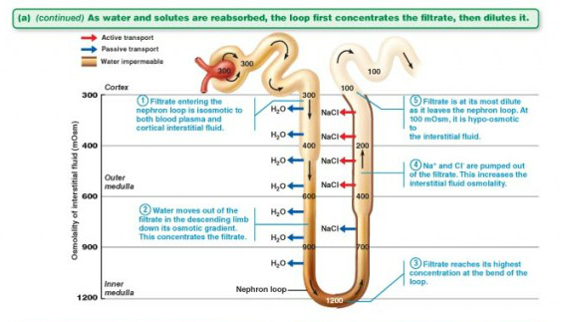
- Collecting ducts impermeable to urea (urea stays in filtrate)
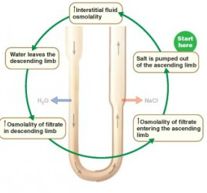

- Urea Recycling and the Medullary Osmotic Gradient
- Urea enters filtrate by facilitated diffusion in ascending limb
- As filtrate moves, cortical region of CD impermeable to urea
- When filtrate reaches medullary region, urea moves into interstitial fluid, forming a pool of urea that recycles back into the ascending limb. In this way, urea contributes to the high osmolarity of the medulla
*vasa recta maintain the osmotic gradient; highly permeable to water/solutes so it remains isosmotic w/ fluid & are able to absorb water/solutes w/o effecting the osmotic gradient

- Formation of Dilute Urine
- filtrate at top of ascending limb is dilute due to salt removal
- absence of ADH (diuretic hormone) collecting ducts remain impermeable to water & very dilute urine produced
- osmolarity of urine can be as low as 65 mOsm

- Formation of Concentrated Urine
- ADH-dependant; amount secreted based on body hydration
- ADH (vasopressin)is produced by the hypothalamus (supraoptic nucleus) and released from the posterior pituitary
- ADH acts at collecting ducts > increases number of water channels in principal cells > increased water into interstitial space (important in extreme dehydration)
- Osmolarity can be as high as 1200 mOsm
Urea can leave the collecting ducts in the deep part of the medulla, and when it does, it contributes to the high osmotic pressure there (1200 mOsM). when someone is protein malnourished, they don't produce much urea and the contribution of ura to the osmotic pressure is lost. As a result, it is impossible to achieve osmotic pressures of 1200 mOsM and consequently it is impossible to concentrate urine to the same degree. Protein malnutrition results in dilute urine, total body water loss, and dehydration.
- Diuretics
- Enhance urinary output
- Not reabsorbed, exceeds renal reabsorption ability
- Alcohol: inhibits ADH
- Caffeine: inhibit Na+ reabsorption (i.e. water reabsorption)

- Renal Clearance
- Volume of plasma that is completely cleared from a specific substance/time in ml/min (tests kidney function)
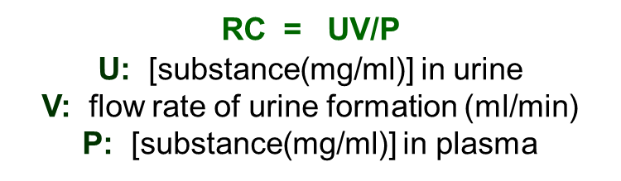
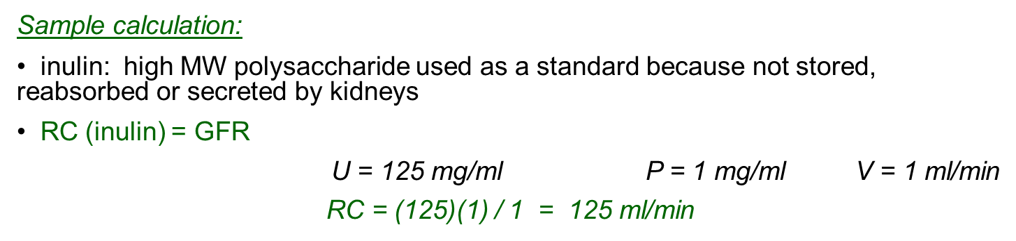

- What if RC (substance) < RC (inulin)? eg: urea ⇒ RC = 70 ml/min
Some urea is reabsorbed into blood stream
- What if RC (substance) = 0? [name 3] glucose
All of the substance is reabsorbed
- What if RC (substance) > RC (inulin)? eg: creatinine ⇒ RC = 140 ml/min; also drug metabolites
No substance is reabsorbed + secretions

- Physical Characteristics of Urine

- Color & transparency
- Clear to deep yellow (urochrome= from heme/bilirubin)
- Dark yellow urine = high concentration (dehydration)
- Cloudy urine = UTI
- Abnormal color (pink, brown, etc.) = foods (beets), bile/blood in urine, drugs/vitamins
- Odor
- Will develop ammonia odor if left (bacteria metabolize urea)
- Vegetables, drugs, diseases alter odor (e.g. uncontrolled diabetes causes fruity smelling urine from acetone)
- pH
- urine is usually slightly acidic; ~6 (diet = 4.5-8 variance)
- high protein + whole wheat = acidic urine (acidic-ash diet)
- vegetarian + vomiting + bacterial infection = alkaline
- Specific gravity
- Ratio if the mass of a substance to the mass of equal volume of distilled water
- Urine = water + solutes, i.e. has a greater mass/v than water
- SG of ~1.001-1.035 (depending on solute concentration)

- Chemical Composition of Urine
- 95% water, 5% solutes
- Urea is the most prevalent solute (metabolism of AA)
- Other solutes: uric acid (metabolism of nucleic acids) & creatinine (metabolism of phosphate)
- From highest to lowest; urea, Na+, K+, phosphate, sulfate, creatinine, uric acid (some Ca++, Mg++, HCO3-)
- High solute concentrations + presence of blood proteins, WBC, etc. indicate pathology
- Renal Failure
- Not enough functioning nephrons > no filtrate formation (caused by kidney infections, damage, inadequate blood delivery, etc.)
- Nitrogenous wastes accumulate > blood becomes acidic (uremia/”urine in blood” > diarrhea, vomiting, edema, coma, death)

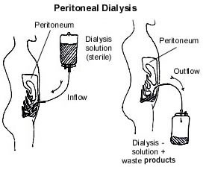
- Peritoneal Dialysis
- Uses peritoneal membrane (from home/work)
- Dialysate is infused in peritoneal cavity through catheter to encourage filtration through peritoneum (extra fluid/wastes drawn from blood)

- Continuous Ambulatory Peritoneal Dialysis (CAPD): 4-5 /day dialysate into peritoneal cavity through catheter (stays there for 4-5 hours) > drained back in bag > thrown out (new bag used each time)
- Continuous Cycling Peritoneal Dialysis (CCPD): usually at home using cycler (special machine); each cycle lasts 1-1.5 hours while pt sleeps
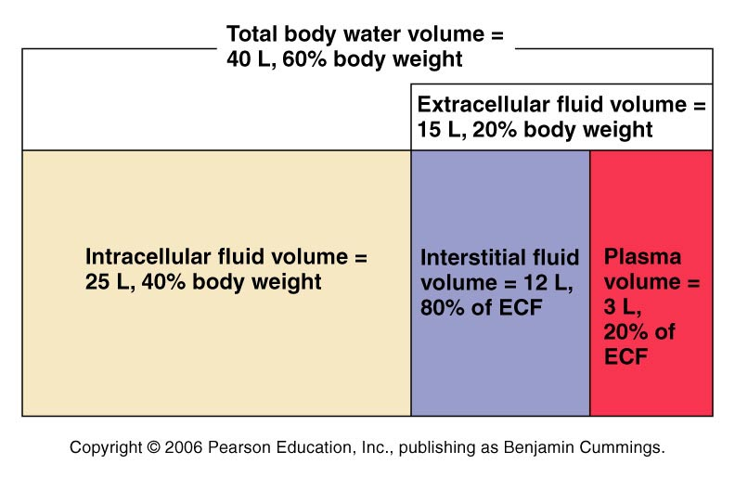

- Electrolytes and Non-electrolytes
- Electrolytes have a greater osmotic power than non-electrolytes; electrolytes have more of an osmotic effect because when they are in solution, they dissociate into ions, creating more particles (each particle contributes to osmotic pressure)
*e.g. Calcium phosphate – Ca3(PO4)2 would dissociate into 5 ions
- ECF: chief cation is sodium, chief anion chloride
- ICF: chief cation is potassium, chief anion is phosphate
- ATP-dependent Na/K pumps keep intracellular [Na⁺] low and maintain high intracellular [K⁺]
- renal mechanisms can reinforce these ion distributions by secreting K⁺ as Na⁺ is reabsorbed from filtrate
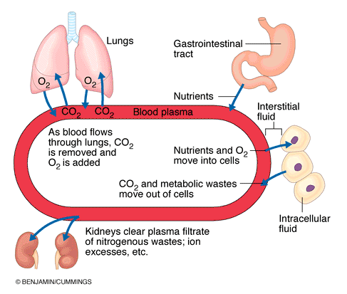
In order to maintain the excitability of cells and produce action potentials, ion gradients are needed across membranes in order to carry charge. This is accomplished by keeping the sodium concentration much higher outside and the potassium concentration much higher inside. Na-K-ATPase is required to maintain. When K levels increase in the ECF, the kidneys increase excretion of K to help keep ECF K low.

- Water Balance
• Water intake must = water output
Intake: liquids, foods, cellular metabolism
Output: ~60% via kidneys; also lungs, skin, sweat, feces
Increased plasma osmolality (usu 285-300 mOsm):
- thirsty > increase water intake
- ADH stimulates renal water reabsorption
Decreased plasma osmolality:
- thirst not stimulated
- ADH secretion not stimulated

- Thirst Mechanism
- ↓ in plasma volume of > 10% or 1-2% ↑ in plasma osmolarity ⇒ dry mouth
- osmoreceptors of hypothalamic thirst centre lose water to hypertonic ECF >>> become irritable & depolarize
- dampening of thirst begins once mucosa of mouth/throat moistened > prevents overdrinking while water moves into ECF

- Obligatory Water Losses
- Insensible water loss via lungs/skin
- Via feces
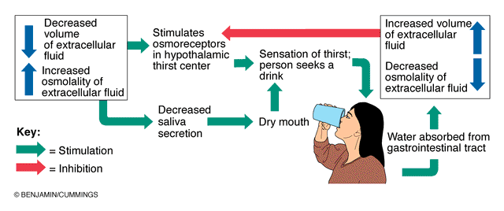
- Min sensible urinary loss = 500 ml/day
- Disorders of Water Balance
- Dehydration (fluid loss): common sequel to hemorrhage, burns, vomiting/diarrhea, sweating, diuretic abuse, & diabetes
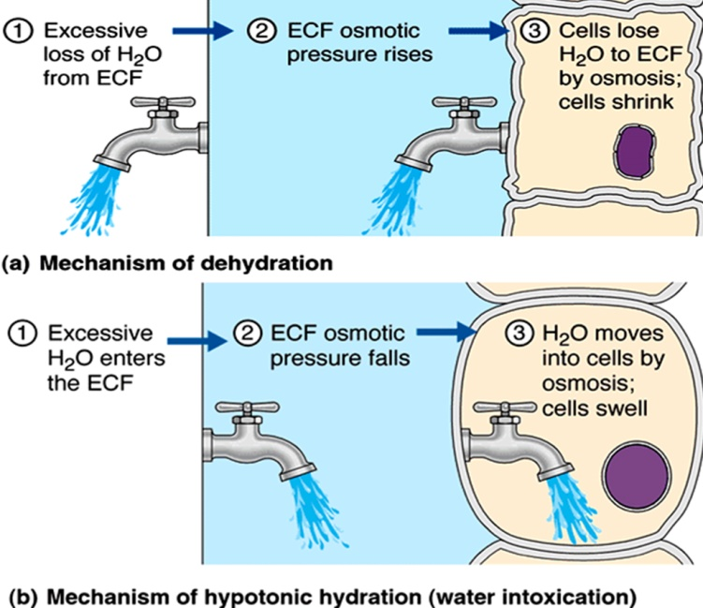
- Hypotonic hydration (overhydration): renal insufficiency or drinking a lot of water (ECF is diluted, “normal” [Na+]); hyponatremia (low ECF Na+) promoting net osmosis into tissue cells causing them to swell
- Edema: atypical accumulation of fluid in only interstitial space causing swelling (increases distance oxygen/nutrients must diffuse from blood to cells = impair tissue function)
- Sodium balance
Water follows salt!!!
- 90-95% of ECF solute; NaCl & NaHCO₃ contribute 280/300 mOsm solute concentration; only solute exerting sig. osmotic pressure
- Regulating Na⁺ balance one of most important functions of kidneys
- Sodium content of body may change, but its concentration in ECF remains stable due to immediate adjustments in water volume (what happens to bp after salty meal? Blood volume increases to accommodate for increased Na+ >>> increased BP)

Factors influencing [Na+]

- Aldosterone (essential to life)
- Most influential agent (acts slowly)
- Even w/o aldosterone, 65% Na+ reabsorbed in PCT, 25% in loop of Henle
- High aldosterone: virtually all remaining Na+ actively reabsorbed by DCT & collecting ducts
- 2 pathways: renin-angiotensin system or direct effect of high K+ or low Na+
- Renin secretion in response to: symp NS, decreased filtrate osmolarity, decreased stretch (bp)
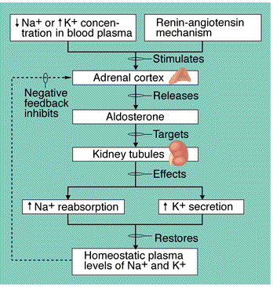
Addison’s disease
Hypo secretion of aldosterone; excess loss of Na⁺ & water in urine

- Cardiovascular Baroreceptors
- Pressure diuresis: when blood volume ↑, symp input to kidney ↓ ⇒⇒ result is dilation of afferent arterioles & ↑ GFR (Na+/H2O output increases reducing bp)

- ADH
- Water reabsorption in collecting ducts relies on ADH
- Osmoreceptors in hypothalamus…
- Low Na+ = excess fluid >>> reduced ADH/dilute urine
- High Na+ = decreased bv >>> ADH/decreased urine v

- Atrial Natriuretic Factor
- Released by certain cardiac cells when bp is high
- Potent diuretic & natriuretic hormone…
- Inhibits Na+ reabsorption by DCT/collecting duct
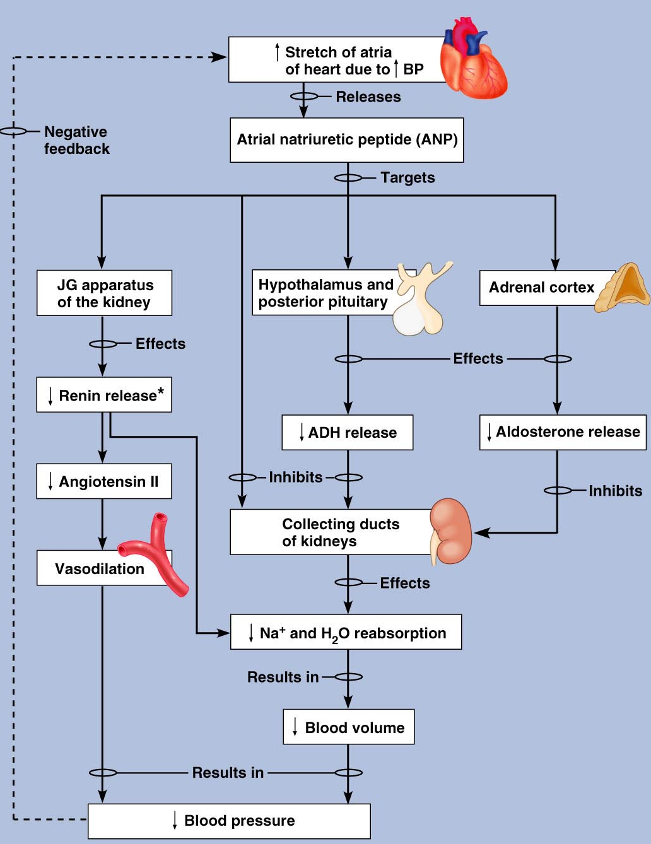
- Decreased ADH, renin & aldosterone
- Induces vasodilation (overall reduces bp)

- Other hormones
- Estradiol
- Progesterone
- Cortisol

- Potassium Balance
- High K+ in ECF is toxic (reduces membrane excitability); low K+ causes hyperpolarization/nonresponsiveness
- K+ required for normal neuromuscular functioning & involved in acid-base balance
- Plasma [K+] and [aldosterone] determine rate/extent of K+ excretion

- Calcium & Phosphate Balance
- Bony skeleton provides a dynamic reservoir from which calcium/phosphate can be withdrawn/deposited to maintain balance of electrolytes in ECF
- Ca++ important for normal blood clotting, cell membrane permeability, and secretory behaviour
- PTH: parathyroid glands; increases blood Ca++
- Calcitonin: parafollicular cells of thyroid gland; decreases b Ca++

- PTH
- Stimulus for secretion is drop in blood Ca++
- Activates osteoclasts (release Ca++)
- Increases Ca++ reabsorption by renal tubules which decreasing phosphate absorption
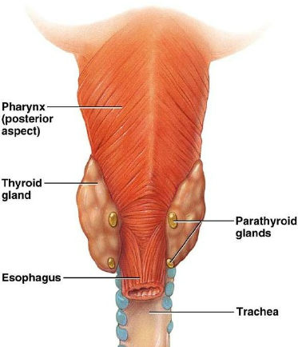
- Enhances intestinal absorption of Ca++ by stimulating kidneys to transform vit D to active form (essential for absorption of Ca++ in sml intestines)
- Most filtered phosphate reabsorbed
- No PTH: phosphate reabsorbed
- High PTH: reduced reabsorption
- Calcitonin: stimulus for secretion is rising blood Ca++
- Mechanisms of Acid-Base Balance
- Alkalosis: an excessively alkaline condition of the body fluids that may cause weakness or cramps
- Acidosis: excessive blood acidity caused by overabundance of acid, loss of bicarbonate, or by a buildup of carbon dioxide in the blood

- Sources of Acid
- Breakdown of phosphorus-containing ptns > pyloric acid
- Anaerobic metabolism of glucose > lactic acid
- Fat metabolism > fatty acids + ketone bodies
- Loading/transport of CO2 as bicarbonate > H+ ions
- HCl released during digestion in GI tract must be buffered

- Regulation of Blood H+
- Chemical buffer systems: (H₂CO₃ ⇔ HCO₃⁻, Na₂HPO₄ ⇔ NaH₂PO₄, protein buffers)
- Pro: respond immediately to changes in pH
- Con: body has limited amounts of buffers
- Respiratory system:
- Pro: responds quickly
- Con: depends on availability of bicarbonate
- Renal mechanisms:
- Pro: unlimited capacity to neutralize
- Con: responds slowly

