Child Development- Chapter 1
Scientific method
- Scientific method: Gathering and analyzing data; drawing conclusions from this data
  - Description:
    - When do babies recognize their mother’s face?
    - Grammatical constructions in 3 year olds
    - Stages of friendship in adolescence
  - Explanation:
    - How does early experience affect brain development?
    - What causes children to understand concept of false belief?
    - Why are there differences in temperament?
Issue 1: Nature vs. Nurture
- Nature: Biology/genes
- Nurture: Environment
- Nature/nurture debate: Extent to which each of these affects development
Issue 2: Continuous vs. Discontinuous Change
- Continuous: Measurable along a continuum
  - Memory: Young child can remember 3 items, older child can remember 7
  - This is quantitative change
- Continuous/quantitative change: Fits with idea that individual skills are added one by one due to learning and experience
- Discontinuous/qualitative change: Fits with idea that development is influenced by biological factors
  - Abrupt changes reflect discontinuous nature of underlying processes in the brain and in the body.
Discontinuous/Qualitative Change
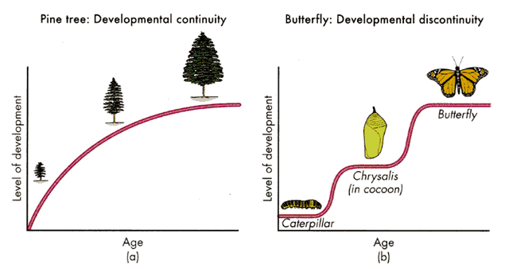
Rousseau: “Childhood has ways of seeing, thinking, and feeling peculiar to itself” (Children are different creatures compared to adults).
Issue 3: Critical Periods
- Sensitive periods: “A period of development during which certain behaviours are more easily learned”
  - Example of attachment
- Normative vs. Idiographic development
  - Commonalities vs. Individual differences
Theories and Research Methods
- Cognitive-developmental approach
  - Piaget
  - Information-processing
- Sociocultural Approach
  - Vygotsky
  - Bronfenbrenner
- Environmental/learning approach
  - Skinner and social-learning theory
- Experimental Research
  - Hypotheses
  - Experimental and control groups
  - Independent and dependent variables
- Correlational research
- Measuring change
  - Longitudinal
  - Cross-sectional
- Data collection
  - Naturalistic Observation
  - Structured observation
  - Self-reports
- Ethics
Cognitive- Developmental Approaches
- What children know, how this knowledge is organized, how it develops
- Genetic Epistemology: Study of the nature of knowledge and how it develops
- Stages of development
  - Sensorimotor
  - Preoperational
  - Concrete operational
  - Formal operational
- Information-processing
  - Input to the system
  - Processes that operate on this input
  - Output
- Which aspect do you think changes most with development?
Sociocultural Approaches
- Vygotsky
  - Children’s interactions with others lead to new forms of thought, language, and reasoning
- Piaget Development uniform across children (largely reflects biological changes)
- Vygotsky Development culturally-bound (can be different across cultures)
Bronfenbrenner’s Ecological Model
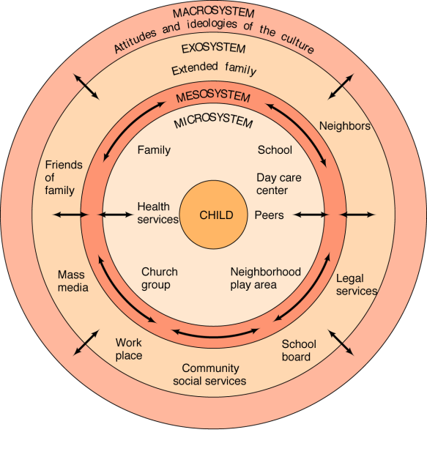
Environmental/Learning Approaches
- Skinner
  - Behaviours are acquired rather than inborn
  - Respondent behaviours: Completely controlled by stimulus that elicits it (ex: Reflexes)
  - Operant Behaviours: Voluntary behaviours that are controlled by their consequences
  - Social Learning Theory
    - Observational Learning: Learning in which the observer’s behaviour changes as a result of observing a model
- Research Designs
  - Descriptive
  - Experimental
  - Correlational
- Experimental Design: Examining fear of heights in infants (Campos & colleagues)
  - Hypothesis 1: Fear of heights is innate (only becomes apparent once infants start to crawl)
  - Hypothesis 2: Crawling causes fear of heights.
Artificial Locomotor Experience
- Campos’ Hypothesis
  - Experience with locomotion causes fear of heights
- Predictions
  - Experimental Group: Has had locomotor experience
  - Control group: Has not had locomotor experience
Summary of Experimental Design
- Hypothesis: Fear of heights caused by the experience that infants acquire when they start to crawl
- Groups:
  - Experimental Group: Artificial locomotor experience
  - Control Group: No locomotor experience
- Variables
  - Independent variable: Infants’ exposure to locomotion
  - Dependent variable: Infants’ reaction to the visual cliff
- Predictions:
  - Experimental Group: Will show fear
  - Control Group: Won’t show fear
Correlational Design
- Does not allow us to make conclusions about causality
- Allows us to measure how 2 factors are associated
How do we measure relation between 2 factors?
- Correlation coefficient: Number that describes how 2 measures or variables are related
  - Value: Range from +1 to -1
  - Positive (+) sign: As 1 variable increases, so does the other.
  - Negative (-) sign: As 1 variable increases, the other decreases.
  - If there is a third variable, there Is suggestion for the need for an experiment
Approaches for studying development
- Longitudinal
  - Attrition: Loss of individuals under study
  - Improvement due to practice effects
- Cross-sectional
Data Collection
- Systematic Observations
  - Naturalistic Observation
  - Structured observation
- Self-Reports
  - Clinical interview
  - Structured interviews
  - Questionnaires
- What do we do with our results/findings?
  - Journal article: Original source (peer-reviewed)
    - In class notes: Repacholi (1997), etc.
  - Media article: “Based” on original source (not peer-reviewed)
    - Here, “consumer” has to be more cautious
Ethics
- “One afternoon, my colleague Ron crossed the street between his academic department and our laboratory school, the expression on his face reflecting a deep sense of apprehension. After weeks of planning, Ron was ready to launch his study on the development of children’s peer relations. Thinking back to his own school years, he recalled the anguish of several classmates, who were repeatedly taunted and shunned by peers. Ron wanted to help rejected children, many of whom go on to lead troubled lives. In view of the importance of his research, Ron was puzzled by a request from the school’s research committee that he appear before them. At the meeting Ron met with teachers and administrators charged with evaluating research proposals for their ethical integrity. A third-grade teacher spoke up: Ron, I see the value of your work, but frankly, I’m concerned about your asking my students to indicate which classmates they like most and which they like least.”
- Solution
  - Evidence that asking children to identify disliked peers doesn’t cause them to interact less frequently or more negatively with them
  - Confidentiality of comments
  - Study conducted before a school vacation
- Can withdraw participation at any time
- Informed consent
  - “The right of research participants, including children, to have explained to them, in language they can understand, all aspects of a study that may affect their willingness to participate”
- Issue of confidentiality
Cognitive Development: Piagetian Perspective
Piaget’s concept of stages
- Constructivist approach
- 3 important characteristics of stages
- Piaget’s terminology
- 6 sensorimotor sub-stages and their characteristics
- Mechanisms of development
Object Permanence
- Piaget’s observations
- Research by Baillargeon & DeVos
- Cognition: Higher order mental processes by which humans attempt to understand and adapt to their world
Constructivist Approach
- An approach to cognitive development in which children discover virtually all knowledge about their world through their own activity.
- Infant does not possess cognitive capacity to mentally represent solution
- For infant: Knowledge= action
3 important characteristics of stages
- Important characteristics of stages
  - General Theory
  - Stages are invariant
  - Stages are universal
Piaget’s 4 stages of cognitive Development
- Sensorimotor stage: Birth-2 years
- Pre-operational stage: 2-7 years
- Concrete operational stage: 7-11 years
- Formal operational stage: 11 years and older
Piaget’s Terminology
- Schemes= Psychological structures
- Mental representations: Internal depictions of information that the mind can manipulate
Sensorimotor Stage of Development
- Substage 1
  - Birth to 1 month
  - Simple reflexes
    - “Beth reported an amusing example of indiscriminate sucking at 2 weeks of age. She lay on the bed next to her father while he took a nap. Suddenly he awoke with a start! Rachel had latched on and begun to suck on his back.
- Substage 2
  - 1-4 months
  - Sensorimotor scheme
    - Skilled and generalizable action patters by which infants act on and understand the world- the “cognitive structures” of infancy
  - Primary circular reaction
- Substage 3
  - 4-8 months
  - Secondary circular reactions
- Substage 4
  - 8-12 months
  - Coordination of secondary circular reactions to achieve a goal
  - Intentional problem-solving!
    - “Now at once, Laurent takes possession of the tin, holds out his arm and drops it over the basin. I moved the latter as a check. He nevertheless succeeded, several times in succession, in making the object fall on the basin. Hence, this is a fine example of the coordination of 2 schemas of which the first serves as a “means”, whereas the second assigns an end to the action”
- Substage 5
  - 12-18 months
  - Tertiary circular reactions
- Substage 6
  - 18 months-2 years
  - Capable of true mental representation or symbolic thought
    - “He screamed as he tried to get out of his playpen and pushed it backwards, stamping his feet. J. stood watching him in amazement, never having witnessed such a scene before. The next day, she herself screamed in her playpen and tried to move it, stamping her foot lightly several times in succession. The imitation of the whole scene was most striking. Had it been immediate, (the imitation) would naturally not have involved representation, but coming as it did after an interval of more than twelve hours, it must have involved some representative or pre-representative element”.
      - Example of “deffered imitation”
  - Substage 6 signals the “end of infancy” and the sensorimotor stage
  - Infants no longer limited by their physical actions on the world; can engage in true “mental action”
  - First 5 substages: Knowledge as a process/repertoire of actions
  - Substage 6: Representational form of knowledge emerges
Mechanisms of Development
- Adaptation: Building schemes through direct interaction with the environment
  - Assimilation: Existing schemes are used to interpret the world
  - Accommodation: Creation or modification of new schemes
Object Permanence
- The understanding that objects continue to exist when they are out of sight
- Emerges during substage 4 (between 8-12 months of age)
- A Not B Error: Babies look for an object in the last place they found it, even after they’ve seen it moved to a new location
- Criteria for showing object permanence
  - Piaget
  - Baillargeon & DeVos
  - Baillargeon’s method: can be thought of as being a more “sensitive” measure of object permanence
    - In line with infants’ motor capabilities
  - BUT, this does not mean that a 3 ½ month old has the same concept of object permanence as a 9-month old.
Some Challenges to Piaget’s Theory
- Idea that object permanence emerges around 9 months of age
- Idea that mental representation/symbolic thought doesn’t emerge until the last stage of the sensorimotor period
- Perception studies: Babies will habituate to a repeated stimulus and then recover to a new one
- Violation-of-expectation paradigm
  - Babies habituate to physical event
  - Next, babies are presented with an “expected” and “unexpected” event
- Daillargeon & DeVos (1991)
  - Do infants show object permanence earlier than Piaget believed?
  - Rationale: Infants should look longer at event that is surprising to them (or violates an expectation)
  - Results: Infants as young as 3 ½ months dishabituated (looked longer) at the impossible event
- Thought Question
  - How can Piaget have proposed that infants do not have a concept of object permanence until 9 months of age, whereas Baillargeon and colleagues have shown evidence for it in infants as young as 4 months of age?

- Research that extends and challenges Piaget’s findings
  - Deferred imitation
    - Meltzoff (1988)
- Preoperational stage (2-7)
  - Language and thought
  - Pretend play
  - Symbol-real world relations
- Limitations of pre-operational thought
  - Egocentric thinking
    - 3 mountains task
  - Inability to conserve
- Follow-up research on pre-operational thought
  - 3 mountains task
- Concrete operational stage
  - Ability to conserve
  - Seriation and transitive inference
Deferred Imitation
- Deferred imitation
  - Meltzoff (1988)
    - 2 groups of infants 9 months old
      - Group 1 (experimental group): Children watched a model perform actions on 3 different objects.
      - Group 2 (control group): Infants just saw the objects.
    - 24 hour delay for both groups
      - Both groups come back to laboratory
      - Infants in group 1 engaged in more imitative behaviour than infants in group 2
Pre-operational Stage
  - Increase in mental representation
- Language and thought
  - Words = symbols
- Pretend Play
  - Precursor to understanding of mental states
    - Pretend that dolls are “tired”, “happy”, “sad”, etc.
- Symbol Real-world relations
  - DeLoache research
    - Child watches as “little Snoopy” is hidden in model
    - Child told that “Big Snoopy” is hidden in same place in big room
    - Child asked to retrieve toy
    - Child has to understand symbolic relation between model and big room
      - 2 ½ year olds don’t succeed on this task- they don’t know where to look for Big Snoopy in the big room
      - Dual representation: Model is an object in and of itself as well as a representation of the big room
Scale Errors
- Why do children make scale errors?
  - Momentary breakdown in use of visual information for action planning
  - Child sees replica from familiar category
  - Visual input activates mental representation of category of object
  - Normally, visual info. About size will inhibit motor plan
  - But, this process can fail.
Educational Implications of Symbolic understanding
- Symbolic objects have dual nature
  - Object in and of itself
  - Representation of something else
- Is it possible that using letter and number toys as representational tools leads to children focusing more on their “toy-like” properties and less on what they actually stand for (ex: The letter “A”)?
- Does experience playing with symbolic objects as toys affect the ability to use them symbolically?
  - Group of 3- and 4-year old children
  - Experimental group
    - Played with symbolic materials
  - Control group
    - Played with non-symbolic materials
  - Children in experimental group knew significantly less numbers and letters
- Limitations of pre-operational thought
  - Egocentric thinking: The tendency to focus on one’s own viewpoint and thus ignore others’ perspectives ≠ Selfish.
    - 3 mountains problem
- Centration
  - Piaget’s conservation task
    - 2 identical beakers filled with water
    - Liquid from one beaker poured into taller, narrower beaker
- Follow-up research on pre-operational thought
  - 3-mountains problem (Borke, 1975)
Concrete Operational Stage (7-11 years)
- Stage during which thought is logical, flexible, and organized in its application to concrete information- capacity for abstract thinking not yet present
- Operation: Involves some form of action
  - But, action is internal not external (as in sensorimotor period)
Conservation Tasks
- “They were equal to start off with and nothing was added, so they are the same”
- “The liquid is higher, but the glass is thinner”
- “If you pour it back, you will see that it is the same”
Contrast With
- “There’s more because it’s higher”
- “There’s more because it’s bigger”
- “There’s more because you poured it”
Class Inclusion problem
- “Which are there more of, yellow flowers- or flowers?”
- Preoperational would go for the subclass- and say that there are more yellow flowers than there are flowers.
- Concrete operational kids will know that there are more flowers than yellow flowers.
Seriation Tasks
- The ability to arrange items along a quantitative dimension, such as length or weight
  - Example: Arranging sticks from shortest to longest
- Stick A is longer than Stick B; Stick B is longer than stick C: Understands that A is longer than C
- Transitive inference: Ability to seriate mentally
- Why does children’s reasoning improve during the concrete operational stage?
  - Ability to engage in mental operations
  - Ability to perceive multiple aspects of a problem
    - “Susan is taller than Sally, and Sally is taller than Mary. Who is the tallest?”
Brain Growth
- Brain at birth is 25% of adult size- by age 2: 75% of adult size
- Babies and children have more neurons and synapses than adults
  - Neurons: Nerve cells that store and transmit information in the brain
  - Synapses: Connection between neurons
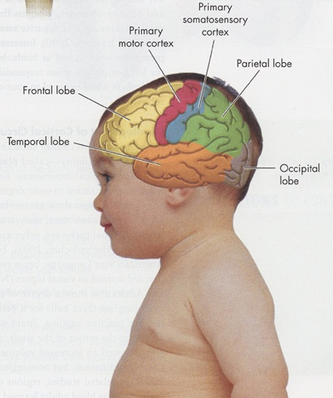
What accounts for brain growth?
- Glial cells: Responsible for myelination
- Myelination: Process in which neural fibres are coated with an insulating fatty sheath (called Myelin) that improves the efficiency of message transfer
- Glial cells multiple rapidly from 4 months (gestational age) to 2 years of age
Brain Plasticity
- Few brain cells are fixed at birth
- Subsequent structure influenced by experience
- Brain becomes less plastic over time
  - May be due to loss of extra neurons that occurs over childhood
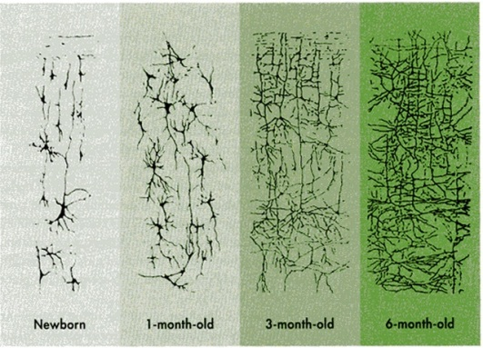
Low-Birth-Weight babies
- Pre-term (before 38 weeks)
- Small for gestational age
  - May be born at 38 weeks or earlier
  - Weight places them in the bottom 10% of babies born at that particular gestational age
  - May be due to chromosomal abnormalities, infections, poor maternal nutrition, etc.
- High rates of neonatal morbidity
- 20-50% rate of neurodevelopmental impairments
Major impairments in low birth weight babies
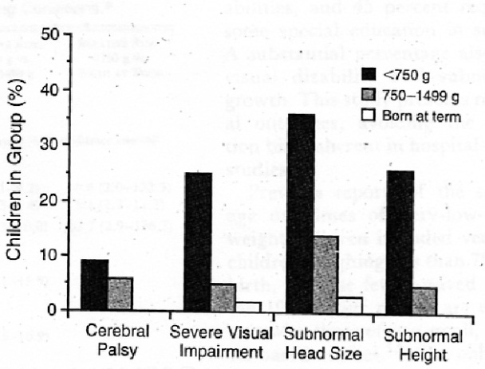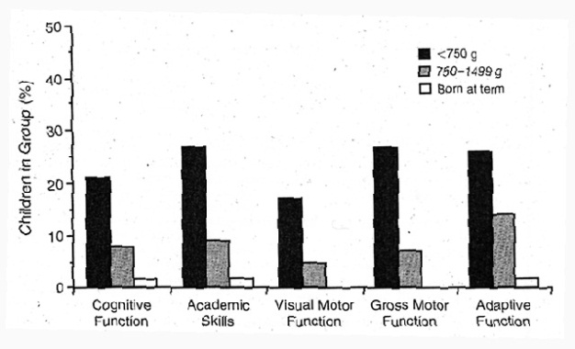
- “These children are at a serious disadvantage in every skill required for adequate performance in school”
- Main idea: Babies find themselves in a very different environment than that of the mother’s womb
  - Goal: Make baby’s environment more like the womb
- Effects of IDC (Individualized developmental care)
Important facts about the brain
- Early experiences are essential to brain development are largely unknown
  - Early experience has an effect but we don’t know which experiences are crucial and when they must occur
  - Background info:
    - Brain overproduces connections, or synapses, early in development (brain has many more synapses and neurons than it needs)
  - Period of retraction: Period of synaptic overproduction
  - Time course of “blooming and pruning” varies enormously by brain region (ex: visual cortex vs. prefrontal cortex)
  - Blooming and pruning is determined by genetic guidance and experience (ie: Nature and nurture)
  - Purpose of overproduction is to capture experience in early brain development.
  - Different types of experiences influence different brain regions
  - Makes it very difficult to provide parents with guidance about necessary experiences
    - Early experience matters but exactly what kind of experience needed is not fully known
  - BUT, parents (and policymakers), rest assured!
    - Needed experience is the kind that most children receive (and not likely flashcards, for example) just by living in the world. It’s not necessarily high tech experience.
- “The stimulation children need during critical periods to fine-tune their neural circuitry are everywhere around them- at home with mother, or in a Montessori preschool, in the inner city, the suburbs, rural areas, in the hills of New Guinea, or on Manhattan’s Upper West Side” (Bruer, p.110)
- “Can it be true that babies must have specific early experiences to become normal adults? Hardly. If our species had evolved to require scarce or unusual experiences for normal development to occur, humans would be extinct. Cultural variations in child-rearing practices around the world demonstrate that normal human development occurs in many different environments. Reading is one way to interact with babies, but it’s not the only right way.” (Bruer, p. 189)
Critical Periods are exceptional, not typical, in brain development
- Exposure to normal speech
- Exposure to patterned visual stimuli
- Cognitive and socio-emotional development?
- Overall quality of early experience, rather than timing of specific influences, may be important.
Brain Development is Lifelong
- Prenatal brain development
  - Neural tube; formation of neurons
  - Myelination
  - Vulnerable to intrinsic hazards (ex: errors in cell migration) Dyslexia, schizophrenia
  - Vulnerable to extrinsic hazards (ex: Drug/alcohol exposure, malnutrition)
- At 2 weeks and 9 months of age:
  - More control over motor movements; better self-regulatory behaviours; higher levels of attention
  - Also enhanced brain functioning and changes in brain structure
- Development after age 3
  - Higher cognition and frontal cortex
  - Plasticity in adulthood
    - Neurogenesis in hippocampus (There is now evidence of formation of neurons in hippocampus- which is important in forming new memories- and even in the parietal and prefrontal cortex.)
Infancy: Reflexes, Physical Growth, & Motor Development
- Reflex: Inborn, automatic response to a particular form of stimulation
  - Most infant reflexes disappear by 6 months (result of control of voluntary behaviour, and brain maturation). If they don’t disappear by 6 months, it can signify brain damage.
  - Paediatricians usually test reflexes.
  - With brain damage, the reflexes will be exaggerated and overly rigid.
  - Won’t show the habinsky reflex if they’ve injured the lower part of their back
Congenitally Organized Behaviours
- Are behaviours that don’t require specific external stimulation and are more adaptable than simple reflexes
  - Looking: Infants will engage in examining their surroundings even when they’re not externally stimulated (ex: light)
  - Sucking: Infants suck spontaneously, when not hungry- serves as an exploration tool and to buffer pain and overstimulation.
  - Crying: Serves not only to convey hunger, but also emotions. An unusual cry can signal problems with the baby.
    - Should you respond to a baby’s cry promptly, or should you show some restraint?
To Respond or not to respond? That is the Question!
- Bell & Ainsworth (1972)
  - Responding promptly vs. responding when parent (society at the same time?) thinks it’s “appropriate” to do so
    - Responsiveness didn’t lead to spoiling
    - At 1 year: Cried less and were more independent, if the parent did respond promptly to crying.
Apgar Scale
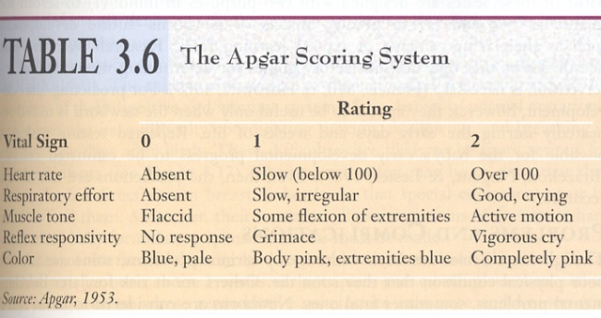
- Standard test almost as soon as baby is born (1min and 5 min), and it measures vital signs. 7 or above, the baby’s in good physical condition. Between 4-7, you’ll want to keep watching the baby just to make sure. Between 1-3, the baby needs immediate medical attention.
Brazelton Neonatal Behavioural Assessment Scale (NBAS)
- Only given to babies where there’s reason to suspect there’s a problem (ex: premature babies)
- Assessing the strengths and abilities of the baby
- Sharing the baby’s behaviour with the parents
- Validating the parent’s observations
- Providing information on development and discussing care giving methods for the particular baby
- Forming a collaborative relationship between health professional and parent
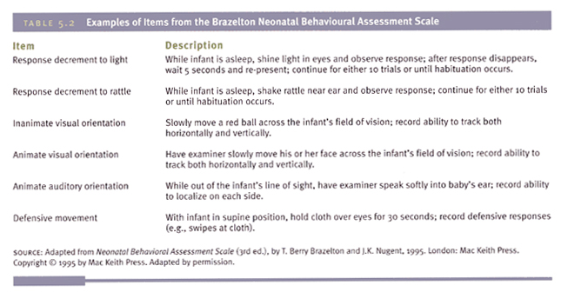
Physical Growth
- Most babies triple in weight, and grow 10 inches after first year of life
- At birth, baby has strange proportions. Babies always have challenges because their body’s are always changing.
Motor Development
- Postrual Development and locomotion (Gross motor skills): Refers to control of trunk, and arms and legs for movement
- Prehension (Fine motor skills): Refers to the ability to use the hands and fingers as tools for grasping
- Motor skill development proceeds in
  - Proximodistal direction: Body parts near the center of the infant come under control before distant parts (arms before hands)
  - Cephalocaudal direction: Body parts near the head are controlled first
- As each new skill develops, babies master their bodies and their environment in a new way
- Motor skills aren’t simply programmed genetically
  - Differences across cultures
  - Differences in how motor milestone is achieved (ex: different forms of crawling)
Difficulties encountered in studying infants
- Restricted methods of investigation
- Keeping infants interested
  - Meltzoff and Moore (1989)
  - Imitation study: Only 40/93 infants finished
- Keeping infants attending to what you want
- Interpretive problems
Preferential Looking Paradigm (Robert Fantz)
- Called “Preferential looking paradigm” because it assesses whether the infant will show a preference between 2 stimuli
- Rationale of preferential looking paradigm: If babies look longer at one display/stimulus as compared to another, then they must be able to tell the difference between the two.
What Infant Preference can tell us:
- What the system can perceptually distinguish/discriminate
- What the infant is more, or less, disposed to attend to.
Habituation Method
- Habituation: A gradual reduction in the strength of a response due to a repetitive stimulation
- Recovery/Dishabituation: Following habituation, increase in responsiveness to a new stimulus
Habituation Paradigm
- Baby will initially be interested in a picture of a baby, but they’ll eventually get bored.Then, you would present the stimuli of the old man picture as well as the baby picture, and if the baby can tell the difference, he’ll look longer at the old man than the baby picture. If they look equally, they’re either not habituated long enough, or they can’t tell the difference between the two.
Infancy: Perceptual Development
Why Study Perception in Infants?
- Nature/nurture question
- Sheds light on other aspects of development (ex: language)
- Perception lays foundation for cognition/cognitive development
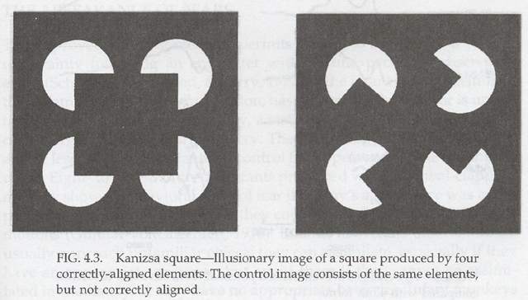
Touch
- Infants can acquire information about objects through touch (haptic perception)
- Newborns feel pain

Hearing
- 3/1000 babies are born with hearing loss
DeCasper & Spence (1986)
- Hypothesis: Babies can obtain speech information in utero
- Mothers tape-recorded 3 separate passages
- Recited 1 “target” passage aloud during last 6 weeks of pregnancy
- At age of 3 days, babies exposed to familiar and unfamiliar passage
- Hypothesis: Babies would recognize and hence prefer passage that they had heard in utero
- How do we determine if baby has preference?
  - Using infant sucking to find out about infant perceptual abilities
- Baby is hooked up to pacifier and dependent measure is rate of sucking (pacifier is hooked up to computer)
  - Baseline phase: Initial rate of sucking
  - Stimulus presented (ex: sound): How much does sucking rate increase?
    - Infants will suck at a faster rate (which is more work for them) to hear/see stimuli they enjoy
  - Babies sucked at a faster rate to hear familiar story.
What Sounds can Babies Discriminate?
- Complex sounds vs. pure tones
- Emotions conveyed in speech
- Phonemes: A sound difference that changes the meaning of a word (ex: ‘buh’ vs. ‘puh’ (bat vs. pat)
- English-speaking adult= difficulty. (ex: ‘ou’ vs. ‘u’)
- Japanese babies= no difficulty (ex: ‘ra’ vs. ‘la’)
- Ability disappears between 10-12 months
- Ability to make distinction can persist
  - 9 month old American babies exposed to Mandarin Chinese (control group heard English)
  - Infants then tested with Mandarin phonemic contrast
  - Infants exposed to Mandarin outperformed control group.
Vision
- Visual acuity (clarity with which visual images can be perceived)= 20/400 to 20/800- what the baby sees at 20 feet is what an adult would see at 400-800 feet.
- Reasons for poor acuity:
  - Immaturity of the fovea (area responsible for our central, sharpest vision)
  - Poor coordination of the eyes
  - Incompletely developed visual cortex
- Testing an infant’s vision
  - Babies prefer complex patterns to plain ones
  - Stripes become more narrow and compressed
  - Eventually, looking is equal across both stimuli- baby can no longer tell the difference.
- Colour?
  - Newborns distinguish between red and grey
  - 4 months: Colour vision approximates adults’
- Babies like to focus on high-contrast edges
  - Activates cells of the visual area of the brain
  - These edges also provide babies with lots of information (ex: indicate object boundaries)
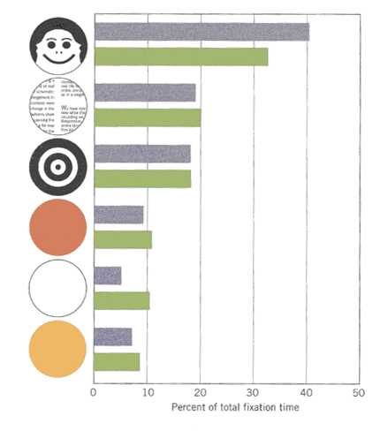
Infant’s preference for faces
- Within days of birth, infants can discriminate mother’s face
- Recognition disappears if hairlines are covered with scarf
- At 5 weeks of age, infants can recognize mother when she’s wearing scarf
Object Perception
- Perceptual Constancy
  - Size constancy
  - Shape constancy
Do Infants have Size Constancy?
- Familiarization trials
  - Familiarization trial for small cube
- Test Trial: Infant sees small cube close up and large cube far away= same size on retina.
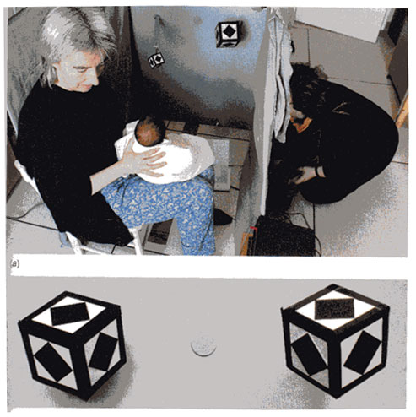Small cube= near, large cube= far. Retinal images on bottom.
- Infants looked longer at the large cube (this is the one they hadn’t seen in familiarization trials)
- Newborns differentiated 2 cube sizes despite similarities of retinal sizes
- Indicates that they distinguish objects based on actual size, not the size of the retinal image.
Object Unity
- Infants (2 months and older): Dishabituate to C ( ; )
- Newborns: Dishabituate to B. ( \ )
- Intermodal perception
  - Use of sensory information from more than one modality (ex: vision and hearing) to identify/make sense of stimulus
  - Apprehension of stimulus across modalities (ex: knowing that an object is the same if you touch it or see it)
- Is intermodal perception present at birth?
  - No: Sensory models are largely separate at birth Experience is key
  - Yes: Coordination of different perceptual systems is present at birth
- Use of sensory information from different modalities to make sense of a stimulus
- Recognize that object is the same regardless of sensory modalities in which it’s encountered
Meltzoff & Borton (1979)
- Can babies transfer experience from one more (haptic) to another (visual)?
- 32 full-term infants between 26-32 days
- Phase 1: Infants given object to explore orally for 90 seconds
  - Half of the infants explores the smooth sphere- half explored the nubby sphere
  - Object was then removed
- Phase 2: Infants presented with both objects for a 20 second visual test
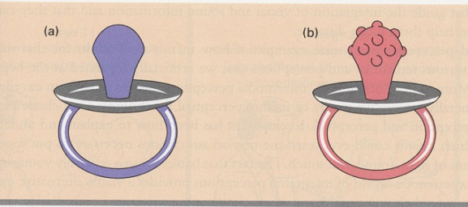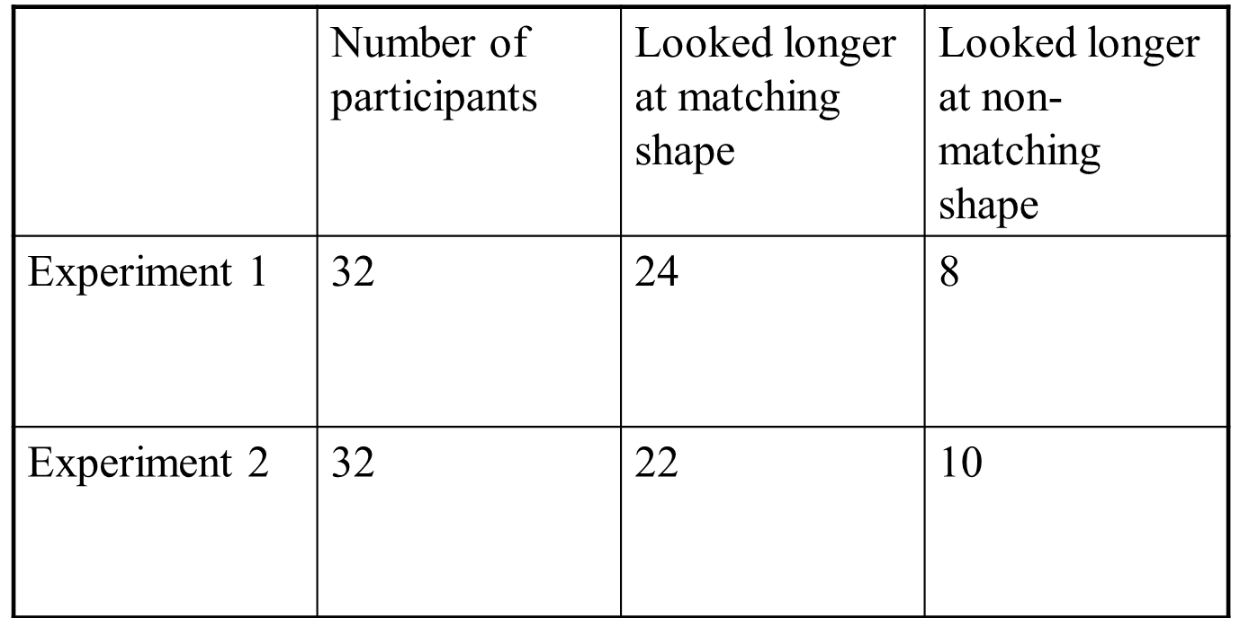
Can Infants Detect a correspondence between sound and a visual event?
- Spelke (1976)
- Infants shown 2 films side-by-side
- Loudspeaker played sounds appropriate to one of the events
- Where do babies look?

How do Babies Achieve Intermodal Perception?
- Amodal sensory properties: Information that is not specific to a single modality but, rather, overlaps 2 or more sensory systems
  - Ex: Sight and sound of bouncing ball; face and voice of speaking person, etc.
Newborn Imitation
- Babies actively try to match body movements they see with ones they feel themselves make- quite a feat, really!
- Infants don’t imitate every act they see
  - Has to be relevant to child’s current “concerns”
- Imitation is important for:
  - Communication
  - Learning
  - Building early relationships
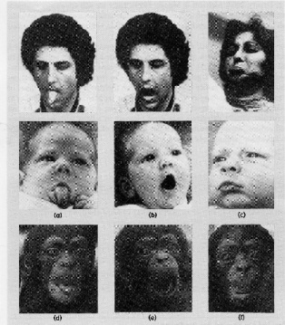
Heredity, Environment, and Behaviour
- Behavioural genetics
  - Adoption studies
  - Twin studies
  - Reaction range
  - Niche-picking
- Behavioural Genetics
  - Devoted to uncovering the hereditary and environmental origins of individual differences in human traits and abilities
  - Researchers are interested in how both nature and nurture make us different.
- Adoption studies
  - Adoptive child Adoptive Parent

Biological Parent
- Adoptive child: (1) shares environment with adoptive parent or siblings and (2) shares genes with biological parents or siblings
- Colorado Adoption Project
  - Increased corrolations between adoptive child and biological parent/sibling
- Origins of developmental problems
  - Hypothesis: Hostile and antisocial behaviour is a product of both the biological and adoptive parents- but, both involve child’s genes
- Hostile and AS (antisocial) adolescents more likely to have Biological Parents with psychiatric disorder
- Hostile and AS adolescents more likely to have Adoptive parents who use harsh and inconsistent disciplinary styles
- (+) relation between adoptive parents’ disciplinary practices and biological parents’ history of psychiatric illness
- Why this relation?
  - Child inherits behaviour problems from biological parents
  - These behaviours result in harsh discipline from adoptive parents
  - Harsh discipline maintains problem behaviour
- Major role of heredity in mental illness (ex: Schizophrenia)
- Twin studies
  - Studies which compare the characteristics of 2 different types of twins
    - Monozygotic/identical twins share all genes
    - Dizygotic/fraternal twins share half of genes
    - Logic of studies: Each type shares the same environment therefore, if monozygotic twins are more similar in a trait (ex: Intelligence), than dizygotic twins, then heredity clearly plays a role.
- Are identical and fraternal twins really treated the same?
- Compare identical twins raised apart with fraternal twins raised apart
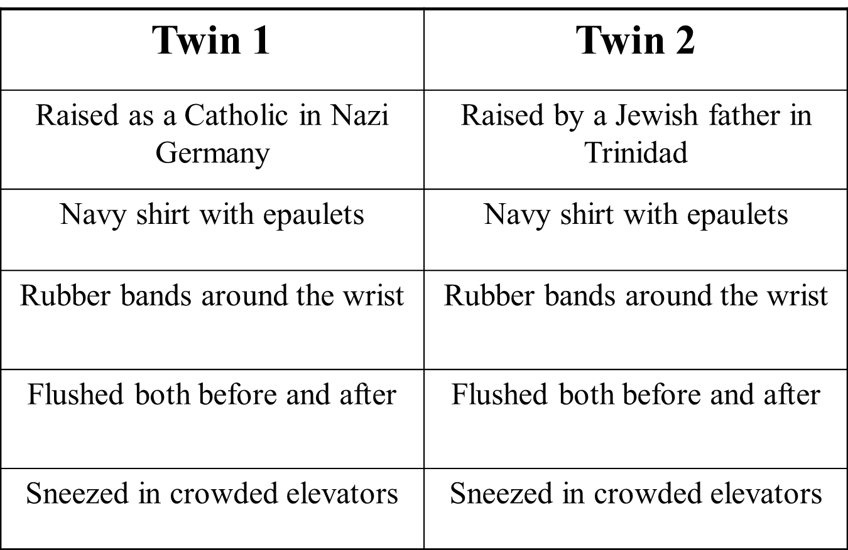
Gottesman’s Limit-Setting Model
- Reaction Range: The term for the range of ability or skill that is set by the genes. The value achieved within this range is determined by the environment
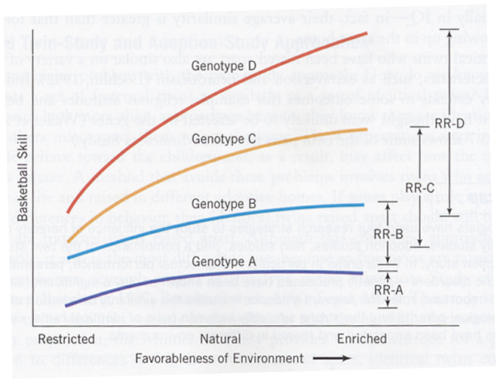
Scarr’s Niche-Picking Model
- Genetic-environmental correlation: Genes influence the environments to which we’re exposed
- Passive: Child has no control over it
- Evocative: Children evoke responses influenced by their heredity
- Active: Children actively seek environments that fit with their genetic tendencies
  - “Niche- Picking”
- Another example: Shy parents both pass on a tendency towards shyness genetically and provide an environment that encourages shyness.
Theory of Social Development
Piaget and Education
- Educational philosophy: Learning comes from within the child
- Readiness to Learn
  - Gearing instruction to child’s level
  - Fractions example
  - United States example
- Motivation for cognitive activity
- Wealth of information about development
- Emphasis of intelligence as action
Theory of Mind
- Understanding of our own and others’ mental states, such as “desires”, “beliefs”, and “intentions”, as well as how these mental states influence behaviour
- A lot of interest in this topic stemming from Piaget’s work on children’s thinking
- Why a Theory?
- Mental states aren’t directly observable, so theory about them must be formed
- Can be used to make predictions about the behaviour of others- can also be used to make explanations about others’ (and our own) behaviour
- Do young children have a theory of mind?
- Important aspect of theory of mind is understanding that other minds are different from our own
- Repacholi & Gopnik (1997)
  - Tested children’s ability to infer another’s desire
  - 18 month olds
  - Experimenter has 2 bowls: Broccoli = “mmm”; goldfish= “yuck”
  - Child is told “give me some”
    - This is an ambiguous request (can only figure out what the E wants by inferring her desire)
- Why is children’s intention to deceive others viewed as an important cognitive feat?
- Beliefs don’t always map onto reality (beliefs ≠ reality), but are a representation of the world as we perceive it (beliefs = representation of reality)
- Deception: Causing someone to believe something that we know not to be true- thus we’ve created in them a “false belief”
Premack & Woodruff (1978)
- Chimpanzees capable of understanding others’ mental states
- Chimpanzee shown video clips of human actors experiencing difficulty
- If chimpanzee understood the human’s intention (belief state), she should choose the key
- Sarah Succeeded She has theory of mind
- Premack & Woodruff argued that understanding behaviour as a function of mental states is a primitive act
  - But… not enough to show that individual A can predict the action of individual B
    - Need to attribute a false belief to someone (can’t do this by assessing actual state of the world)
    - To show a true theory of mind, chimpanzee would have to be able to predict someone’s behaviour in situations in which the person did not share chimpanzee’s belief
Change in Location Task
- To arrive at the correct answer, we must:
  - Set aside our belief about the world (ie: That marble is in box)
  - Understand that Sally does not know true state of affairs, and thus holds a “false belief”
  - Understand that beliefs are mental representations that need not correspond to reality
    - 3’s fail at this task, whereas 4’s and 5’s tend to pass.
- Representational change task
  - Children shown crayon box and asked to state what they think is inside
  - Box opened to reveal candles
  - Box closed up, and children asked to state what they had first thought was inside: “When I first showed you the box, what did you think was in there?”
  - Can also ask the child what another person (who hasn’t looked inside the box) thinks is inside
Atance & O’Neill
- Atance & O’Neill (2004)
  - Tested 3’s on the following tasks:
  - Action Task:
    - Crayon box
      - “What do you think is inside?”
      - “You know what? There’s some paper over there. Why don’t you get it to draw on with the crayons?”
      - “Oh look, there are candles in here”
      - “When you first saw the box all closed up like this, what did you think was inside?”
      - “Why did you go get the paper?”
- Planning + Action Task (Smarties Box)
  - Prior to acting on their false belief, children are asked to plan what they will do with the contents of the box
  - “How many Smarties are you going to eat?”
  - “What color are you going to eat first?”
  - “When you first saw the box all closed up like this, what did you think was inside?”
  - “Why did you go get the bowl?”
- Also gave children the Representational Change Task
- Results:
  - Children’s ability to retrieve their false belief increases (see graph)
  - But, in general, children have difficulty explaining the cause of their action
- How do children develop an understanding of false belief?
  - Theories vary along dimension of nature and nurture
  - Interesting theory is that maternal mental state talk influences theory of mind development
  - How do parents react to “false belief” situations? Are these teaching opportunities for them?
- Atance (In Progress)
  - Mother and child come into the lab and experience false beliefs together (ex: Crayon box, picture book, and deceptive objects)- show items
  - Sessions are recorded and mothers’ reactions are noted
  - How do mothers react to these unexpected situations?
- Appearance-Reality Task
  - Show child an item
  - Ask them to state what it looks like
  - Show them its true identity
  - Then ask them: “What does this look like to your eyes right now?” (Appearance question) and “What is it really and truly?” (Reality Question)
  - Performance on this task is virtually identical to performance on false belief tasks
Cognitive Development: The information-processing Approach
Information-processing
- Development ≠ stages
- Ability to take in, manipulate, and store information
- Flowchart metaphor
- Computer metaphor
- Attention
  - Sustained Attention: Paying attention “in general”
  - Selective Attention: Paying attention to the important features of a problem, or information that we’re presented with
    - What factors contribute to the development of selective attention?
      - Cognitive inhibition: Ability to control distracting stimuli so that it doesn’t “clutter” working memory
- Card Sorting task
  - Blue + Pink boats and blue + pink rabbits
Attentional Strategies
- Method
  - Children told that they’re going to get a memory test
    - Their job is to remember the location of the animals
  - Time to prepare for memory test
  - Memory for location of animals is tested
- Most effective attentional strategy: Only open doors with animals on them and learn these
  - 3 year olds: Opened all doors
  - 5 year olds: Inconsistently applying strategy
  - 6 and 7 year olds: Consistently applying strategy, but low performance (utilization deficiency)
  - 8 and 9 year olds: Consistently applying strategy, and high performance
Memory in Infancy
- Evidence in support of memory processing in infants
  - Sensorimotor infant uses a familiar scheme (sucking, grasping) when presented with a familiar object
  - Infants search for objects that have been hidden from view
  - Infants show a preference for their mother’s voice
Varieties of Memory
- Recognition memory
  - Refers to the understanding that a current stimulus has been encountered in the past
    - Ex: The recognition that a person has seen a photograph in the past
- Recall Memory
  - Refers to the retrieval of some past stimulus when the stimulus is not present
    - Ex: Answer the following question: “Describe 3 examples of evidence for memory processes in infants…”
- Operant Conditioning
  - Form of learning in which the likelihood of an operant behaviour changes as a result of its reinforcing or punishing consequences
- Baseline phase: Ribbon isn’t attached to mobile and rate of kicking is measured
- Reinforcement phase: Ribbon and mobile are connected; once baby learns connection, rate of kicking is measured
- What happens when infant comes back hours or days later?
  - Kick at same rate?
  - Kick at baseline rate?
- Recognition memory tested as follows
  - Compare infant’s response to a new mobile with response to familiar one
    - Does baby only kick rapidly in response to familiar one?
  - Compare infant’s response at varying delays (days, weeks, etc)
Recall Memory
- Evidence supporting recall memory in infancy
  - Deferred imitation in which infant imitates a behaviour seen on the prior day for the first time (as young as 6 months)
  - Infant search for hidden objects
  - Infants can imitate (recall) sequences of actions
    - Ex: Those required to bathe a doll
Infantile Amnesia
- Lack of long term memory for the first 2-3 years of life- why lack?
  - Brain development
  - Differences in memory (ex: Non-verbal vs. verbal)
  - Lack of sense of self
  - Lack of social system for sharing and rehearsing memories
- Memory in older children
  - Use of mnemonic strategies
  - Knowledge about how memory works
  - Knowledge base
- Mnemonic strategies: Techniques that help us to remember
  - Organization
    - Picking out meaningful relationship between categories
    - Cat, fork, bowl, bird, dog, glass
  - Elaboration
    - Fish + Towel = fish wrapped in towel
- Metamemory: Knowledge about memory
  - Knowledge about memory in general
    - We know that recognition tasks are easier than recall (ex: list of words)
  - Knowledge about our own memory processes
    - How well do I remember? (Grocery list example)
- Children act differently when told to remember something
- Know that some memory tasks are harder than others
- Difficulty with assessing their own memory skills
- Stream of Consciousness
John Flavell
- Preschoolers: Understand that an “internal” mental life exists- but, view mind as passive container of information
- Middle childhood: View the mind as an active, constructive agent
  - More chances to “observe” the mind
  - More language about the mind
    - “I was thinking a lot”
    - “My mind wandered”
The Role of Knowledge
- In Chi’s study, better memory was due to having a larger knowledge base
- Also evidence that experts have more elaborately structured knowledge
  - Experts or novices in soccer knowledge
  - Lists of soccer and non-soccer items to learn
  - As in Chi’s study, experts remembered more soccer items
  - And, experts’ listing of items was more organized (ex: Clustering of items)

