Nursing research:
- Expands the discipline’s unique body of scientific knowledge
- Forms the foundation for evidence-based practice
- Does not necessarily have to be conducted by a nurse
- All of the above
Evidence-informed practice involved all of the following except:
- Critiquing research articles
- Identifying questions from clinical practice
- Collecting data from subjects
- Applying study findings
** collecting data is a part of the research process, not a role of research consumer

The Evidence hierarchy - Levels of Evidence: Study Design
- Level 1: systematic review or meta-analysis of randomized controlled trials (RCTs), evidence-based clinical practice guidelines based on systematic reviews
- Level 2: A well-designed RCT
- Level 3: Controlled trial without randomization (quasiexperimental study)
- Level 4: Single nonexperimental study (case-control, correlational, cohort studies)
- Level 5: Systematic reviews of descriptive and qualitative studies
- Level 6: Single descriptive or qualitative study
- Level 7: Opinion of authorities and/or reports of expert committees
The “levels of evidence” hierarchy:
- Can be used to grade the inadequacy of a research design used in a study
- Is important for judging the quality of a researcher
- Lists the best kinds of studies for nursing
- Is a guide that can be used as one criteria for deciding when to apply a study’s findings in practice
** The rest of the answers are judgmental in that they favor only a post-positivist perspective about the nature of knowledge and the criteria for quality in scientific research.

A meta-analysis and meta-synthesis are different techniques used to research. Which of the following would involve meta-analysis:
- Systematic reviews of RCT’s
- Randomized Control Studies (RCTs)
- Quasi-experimental studies
- Systematic reviews of descriptive and qualitative studies
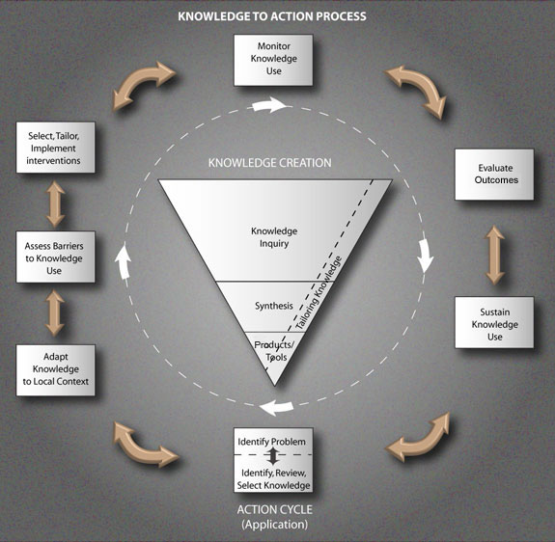
Which of the following is not demonstrated in the model of the “Knowledge to Action Process”?
- The knowledge creation process can be initiated by the process of applying knowledge.
- Knowledge creation and research utilization are two separate but interlinked cycles.
- The creation and use of knowledge in nursing involves a collaboration between nurse scientists and research consumers.
- The knowledge creation process is central to nursing while the application process is peripheral or secondary.
**The Model shows that the two cycles of knowledge creation and application of knowledge in practice depend on each other. Knowledge creation tends to occur within the core of the discipline and involves dissemination to practice settings for action. This does not meant the action cycle is peripheral or less important, but rather an essential part of a dynamic and iterative cycle.
In research, replication of studies promotes:
- Depth
- Generalizability
- Both a and b
- Neither a or b
**Understand the definition and important of “replication” and “generalizability”.
FIND THE BEST MATCH
6. A responsibility of a Research Ethics Board: evaluating inclusion and exclusion criteria
7. An element of informed consent: ensuring subjects understand they are free to withdraw from a study at anytime
8. A criteria for REB approval: establishing that privacy and confidentiality measures are in place in a study
9. An element of critical appraisal: critiquing a study’s design

Which of the following is NOT typically associated with a quantitative research design?
- Hypotheses
- Power analysis
- Thematic analysis
- Statistical analysis
**thematic analysis is a data reduction technique for texts or transcripts involving words that used for qualitative research

Which of the following is considered important for maintaining objectivity in a quantitative research design?
- Using an open-ended questionnaire that helps capture the personal perceptions of the study participants
- Operationalizing the concepts of interest
- Exploring participants’ experiences in depth
- Using a small number of study participants
**the remaining answers are important for soliciting subjective responses in qualitative research

Research based on the assumptions of positivism:
- Are concerned with deductive reasoning
- Moves from the particular to the general
- Often includes an hypothesis
- All of the above

Qualitative research: Inductive reasoning

Research based on the assumptions of constructivism:
- Typically employs qualitative designs
- Is aimed at describing power imbalances
- Is concerned with constructing experiments
- All of the above
Research based on the assumptions of critical theory:
- Fits well with a participatory action design
- Utilizes the ‘researcher as instrument’
- Often employs reflexivity and member-checking
- All of the above

What is the general order of steps for finding research results about a clinical issue?
- Define your clinical question
- Search the library data bases
- Refine the search terms
- Scan the reference lists of relevant articles for additional sources
The aim of a literature review includes: see box 5-1, p. 93
- Generating useful research questions and hypotheses: TRUE
- Discovering concepts used to examine the problem: TRUE
- Uncovering one or more new practice interventions: TRUE
- Determining the need for replication of a study or refinement of a study: TRUE
Identify which of the following is a primary sources and a secondary source:
- Journal article published by a researcher: PRIMARY SOURCES
- Textbooks by the original author: PRIMARY SOURCES
- An education pamphlet by the Diabetes Association: SECONDARY SOURCE
- An unpublished thesis by a master’s student: PRIMARY SOURCE
Which of the following is NOT typically found in the introduction of a research report?
- The problem being presented
- The central concepts or variables
- The underlying theory or conceptual framework
- The reliability of the data collection instrument
**usually in the Methods section

Which of the following is NOT associated with ensuring the reliability of validity of a data collection tool in quantitative research?
- Psychometric testing
- The results of a pilot study
- The mean, median and mode
- The r value of two raters observing the same behaviour (inter-rater reliability)
In sampling, a homogenous group:
- Is a group with a number of dissimilarities
- Is a group with limited variation
- Increases the generalizability of the findings
- Inhibits the researcher’s ability to interpret the findings
Which of the following is NOT a function of inclusion and exclusion criteria: see page 261
- They are established to mitigate against bias.
- They help control extraneous variables.
- They enhance the generalizability of the findings.
- They contribute to the accuracy of the findings.
If 70% of the population in a study of childrearing practices consisted of women and 40% were full-time employees, a representative sample should:
- Include 70 women of which 40 are full-time employees.
- Have at least 110 participants.
- Reflect these characteristics in the same proportions.
- Be determined by a power analysis.
Probability sampling is a form of sampling that:
- Is the least rigorous sampling strategy used in quantitative research.
- Is the most rigorous sampling strategy used in qualitative research.
- Involves non-random selection strategies to choose sampling units.
- Can be time-consuming but subject to low bias.
In a study about the role of peer support in decreasing the length of hospitalization of youth with eating disorders, Shahal et al. (2009) included the first 25 patients admitted to a large teaching hospital with a diagnosis of anorexia. The sampling strategy they used is known as:
- Convenience sampling
- Quota sampling
- Theoretical sampling
- Simple random sampling
Which of the following is NOT an advantage of random sampling:
- It controls for bias by increasing self-selection.
- It increases the probability that any differences found are unlikely a function of chance.
- It maximizes the representativeness of the sample.
- It provides greater confidence that the sample closely reflects the population of interest.
**It decreases self-selection and selection bias

Simcoe et al. (2001) observed participants from behind a one-way mirror. This technique is an example of:
- The ‘researcher as instrument’
- A data collection method that helps decrease the risk of reactivity
- A data collection method that increases the risk for the Hawthorne effect
- Participant observant
Rigour is: the strictness with which a study is conducted to enhance its quality
Reliability is: the extent to which a method or instrument yields the same results on repeated measures
Validity is: the proportion of accuracy in a measurement
Credibility is: a measure of trustworthiness in a qualitative study

In qualitative data analysis, codes are:
- A form of data reduction.
- Tags or labels that are used to identify themes.
- Part of thematic analysis.
- All of the above.
In grounded theory study, you would expect to see:
- A theoretical framework based on the literature review
- A power analysis to determine the sample size
- The constant comparative method used for data analysis
- A description of potential intervening variables in the “Discussion” section
Ethnography is qualitative research design that:
- Is concerned with theory-building
- Informs the research methodology developed by Margaret Leininger in nursing transcultural care
- Involves bounding a case
- Avoids triangulation
In qualitative data analysis, codes are:
- A form of data reduction
- Tags or labels that are used to identify themes
- Part of thematic analysis
- All of the above
Which of the following is an example of a study design that involves manipulation of the independent variable:
- An after-only non-equivalent control group design
- A retrospective study
- A cross-sectional longitudinal design
- A correlational study
The hypothesis, “Nurses with high levels of social support from coworkers have low perceived job stress”, is NOT:
- Testable
- Directional
- Experimental
- A research hypothesis
In a quantitative study, an investigator records the confidence interval results as a 95% degree of certainty. This means:
- The result is true for 5% of the population.
- The result is representative of 95% of the population.
- There is a 95% chance the true value can be found within the reported range of values.
- The investigator is not very confident that the result did not occur due to chance alone.

An example of _________ was provided by Solieraj et al. (2009): “The greatest predictors of child distress were age (t= -4.017, P<0.01), with younger children being more distressed than older children.”
- Descriptive statistics
- Inferential statistics
- Measures of central tendency
- The standard deviation
Which of the following is NOT a criteria used to make a decision about the applicability of research findings for a practice setting?
- The credentials of the researcher(s)
- The consistency of the results across several studies
- The potential benefit to patients
- The sample and setting are similar to the patient population
Which factors foster the use of research in clinical practice?
- Requesting opportunities to attend nursing conference: TRUE
- Attending grand rounds in the hospital: TRUE
- Obtaining access to a library database: TRUE
- The formation of a journal club in a workplace: TRUE
- Sharing practice concerns with opinion leaders: TRUE
- Critically reading nursing new and professional journals: TRUE
** They all foster a culture that encourages critical thinking, developing searchable questions, and exploring the literature as well as knowledge of colleague and other experts to base clinical practice on the latest evidence.

90 multiple choice questions
2.5 hours
Worth 35%

