EPSC 201 – LECTURE 2 – JANUARY 14, 2016
- Formation and evolution of the Universe (the Big Bang!)
- The Solar System, the planets and the structure of the Earth (continuing to zoom in…)
The Universe is really big – measured using light years. The vastness of the Universe is staggering!
- Earth is a planet orbiting a star on the arm of a galaxy (the Milky Way)
- The Sun and over 300 billion stars form the Milky Way
- Over 100 billion galaxies exist in the visible Universe
The Big Bang Theory (theory guiding the formation of the Universe): 13.8 x 10⁹ (13.8 billion) years ago, all mass and energy was contained in an infinitesimally small point. It was unimaginable hot, and expanding unimaginably rapidly (like an explosion - Expansion occurred at a speed faster than the speed of light), and cooling. The modern Universe is still expanding.
Space-Time Expanding Analogy – Raisin Bread: unbaked dough is smaller and more compact, as you heat it and bake it, the whole thing expands. Raisins can be thought of as planets and stars and they are all moving away from each other.
How do we know the Universe is expanding? The Doppler Effect (Sound waves compress or relax with relative motion). E.g. When a train is moving towards an observer, the sound waves are being compressed, and behind the train, the sound waves are being relaxed. When sound waves are closer together, it is a higher frequency, making a higher pitch. When the sound waves are further apart, the sound waves have a lower frequency, making a lower pitch.
The same is observed with light (as waves). Visible spectrum of light is a small fraction of the electromagnetic spectrum.
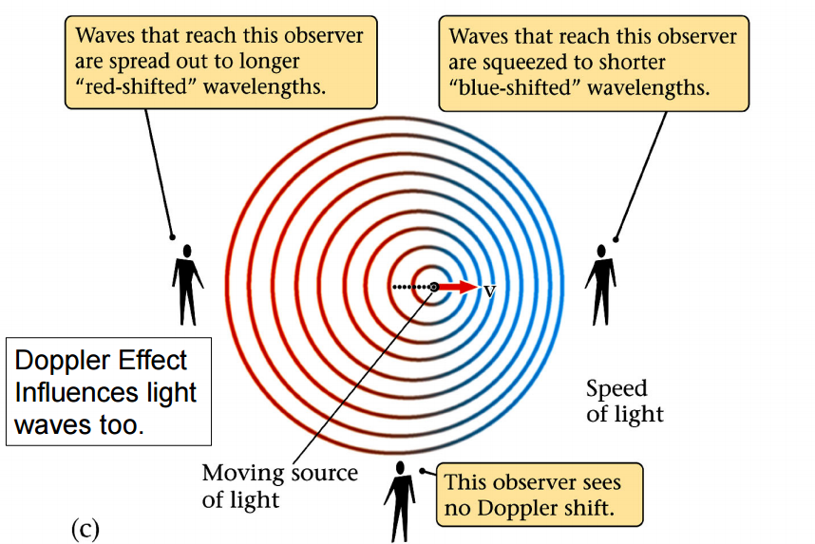
Frequency: Time interval between the numbers of waves passing through a fixed point.
Wavelength: Distance between successive waves (peak-peak, trough-trough).
Red light has a lower frequency than blue light.
Radio waves (one end of the spectrum) have a low frequency and long wavelength. X-rays and gamma rays (other end of the spectrum) have a high frequency and short wave length. Telescopes collect radio waves as opposed to visible light.
Summary: high frequency = shorter wavelength, high pitch, blue-shifted = moving toward us
low frequency = longer wavelength, low pitch, red-shifted = moving away from us
We know things about stars by collecting the light that is emitted from them by using telescopes. Hydrogen atoms in stars absorb light at certain specific wavelengths. We see these wavelengths as dark lines on a light spectrum below when referring to our sun.
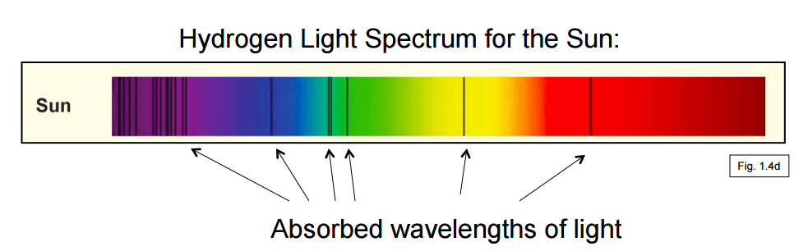
We can also collect light from other sources and the dark lines in the spectrum will vary and be in different places on the light spectrum for different stars and galaxies depending on the source (for example a different star) and whether the star is moving away or towards us. We use the Sun’s light spectrum as a reference to know that the Universe is expanding.
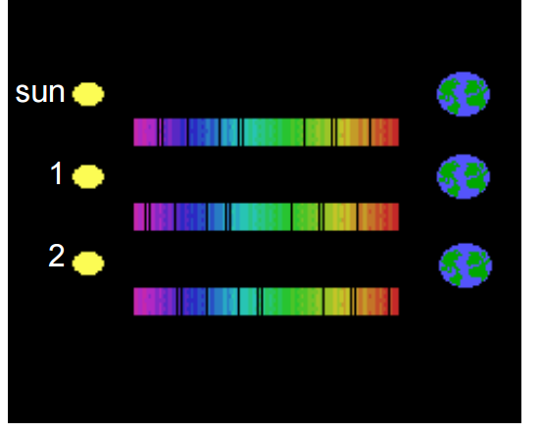
Practice Question: Galaxy 2 is moving away from us and 1 is moving towards us.
Lines from galaxy 1 are shifted to the left relative to our sun – blue shifted (towards observer) – galaxy is probably close to us.
Lines from galaxy 2 are shifted to the right relative to our sun – red shifted (away from observer)
Galaxies far from us are all moving away from us.

This is how we discovered the expanding universe: Edwin Hubble (1929) used a telescope to analyze hydrogen light spectrums of different galaxies and he discovered that the most distant ones were moving away from our own galaxy. At one point, scientists thought that the Universe was fixed, meaning if one galaxy was moving away from us, another was moving towards us. However, they looked around at other galaxies and found that they were all moving away (galaxies with red-shifted light).
Age of the Universe: Distance of galaxies is estimated from the size and brightness. Hubble plotted retreat velocity (cm/s) vs distance of galaxy (cm) to find time. The time is actually the age of the universe, where t = 13.4 x 10⁹ years = HUBBLE CONSTANT.
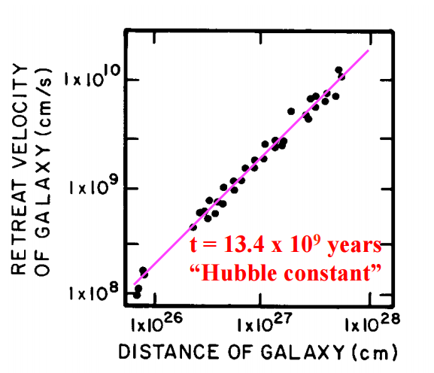
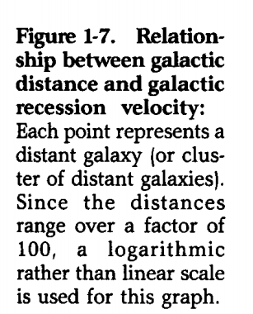
The number has been refined to 13.82 x 10⁹.
How do we know how far away, how big, and how old things are in the Universe?
- We look at the light
- Light years…distance ~ time

We use telescopes: ALMA radio telescope in Chile, Hubble space satellite telescope, a telescope you can buy on amazon. The Hubble Space Telescope took deep space images and told us a lot about the expansiveness of the Universe and the relationship between distance and time.
Relationship between distance ~ time: Light is emitted at a particular time, say 12 billion years ago, and then takes all of that time to travel to us, and so the light that we see today is a package of light that was created 12 billion years ago. So looking through distance (looking at light coming from galaxies far away) is the same as looking back in time when you’re thinking about space.
The Big Bang: all matter and energy condensed into an infinitesimally small point that exploded 13.8 billion years ago.
Forces appeared:
- Gravity
- Strong force (nuclear force – holds nuclei of atoms together)
- Magnetic force (holds atoms together, drives electricity and magnetism)
- Weak force (not important for this course)
Inflation occurred (extremely brief period of very rapid expansion of the Universe):
- In 10⁻³² seconds after the Big Bang, the Universe (fabric of space-time) expands faster than the speed of light, from the size of an atom to the size of a galaxy.
At 10⁻¹⁰ seconds after the big bang – still expanding (but not faster than the speed of light). It is approximately 10¹⁵ Kelvin (it is cooling from 10²⁷ Kelvin). There are only quarks, subatomic particles that eventually will form protons and neutrons. These quarks appear and they collide into each other, annihilating each other so only a billionth of it actually survives and continues to cool.
At 10⁻⁵ seconds after the Big Bang it is approximately 10¹⁰ Kelvin. Quarks join together to form protons, electrons, and neutrons. Protons and electrons collide and annihilate each other. Subatomic particles that “survive” continue in time.
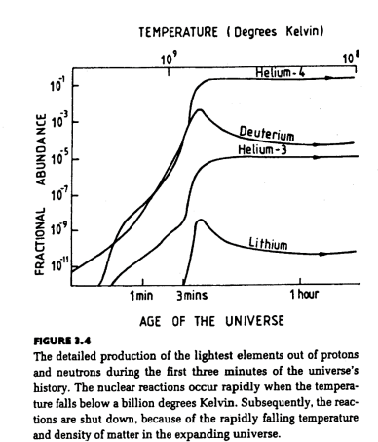
3 minutes after the Big Bang, expansion and cooling continues – 10⁹ Kelvin. The conditions are right for nucleosynthesis – Hydrogen nuclei (1 proton) fuse together to form Helium nuclei (2 protons), Lithium nuclei (3 protons), and Deuterium nuclei (1 proton and 1 neutron – hydrogen isotope). Hydrogen and Helium were essentially the only elements present in the early Universe, and remain to this day, the most abundant elements in the Universe.
After 380 000 years of expansion and cooling, atoms begin to bond (Universe is ionized):
- Electrically charged (ionized) nuclei and negatively charged electrons fuse together – matter becomes electrically neutral (Universe is no longer ionized)
- Neutral H atoms and He molecules form – fuel of stars
- Photons are free (can make light)! They form the cosmic microwave background (CMB) – the earliest light in the Universe
- H atoms and He molecules begin to coalesce (come together and form one mass or whole) into gaseous nebulae under the influence of gravity – formation of stars
Cosmic Microwave Background (CMB) – on the spectrum of light:
One piece of evidence supporting the Big Bang Theory: There is a background energy coming from everywhere in the Universe from when matter went from ionized to electrically neutral. CMB was discovered by Arno Penzias and Robert Wilson (1963) – they were trying to build a radio antenna to communicate with satellites and trying to eliminate all the noise to be able to get a really clear signal. They eliminated almost everything except this left over hum sound that they couldn’t figure out to eliminate. Then someone proposed it was related to the Big Bang Theory.
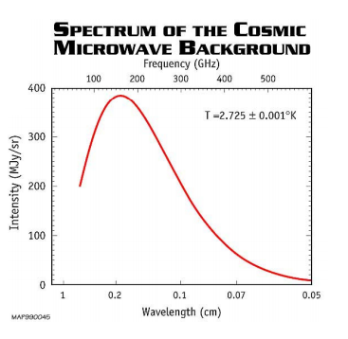
Black Body Radiation: Light emitted from the process of cosmic microwave background: the shape and intensity of the radiation spectrum is characteristic of a given temperature.
Planck Mission Telescope: detected oldest light in the Universe, called the cosmic microwave background. It shows tiny temperature fluctuations of areas with different densities, representing the seeds of all future structure: the stars and galaxies of today.

380 000 years after the Big Bang, we have He and H atoms (lightest elements). Heavier elements have more nuclear particles in its nucleus. Universe couldn’t make heavier elements at this time because it requires a lot of energy to add nuclear components to a nucleus. To produce elements heavier than H and He, nuclear particles had to be added to their nucleus in order to increase the number of protons in the nucleus. In contrast to chemical reaction which involve sharing of electrons in different atoms and can readily occur at room temperature, nuclear reactions require more extreme temperatures (>50 million degrees) and pressures to fuse nuclei (e.g. to overcome the electrical repulsion exerted between protons). At this point, the Universe has cooled enough that it doesn’t have this amount of energy needed to add nuclear particles to a nucleus. So how did the Universe find this energy if it had already expended it and cooled enough to not have it?
To form heavier elements, the Universe had to wait for stars to form (called the dark period). This wouldn’t happen until ~200 million years after the Big Bang. Formation of stars: Gravity was able to initiate the collapse of huge volumes of H and He into more concentrated areas of gas. The collapse of the H and He clouds (called gaseous nebulae), resulted in increases in:
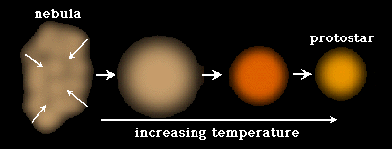
- Temperature
- Density
- Rate of rotation (start to spin)
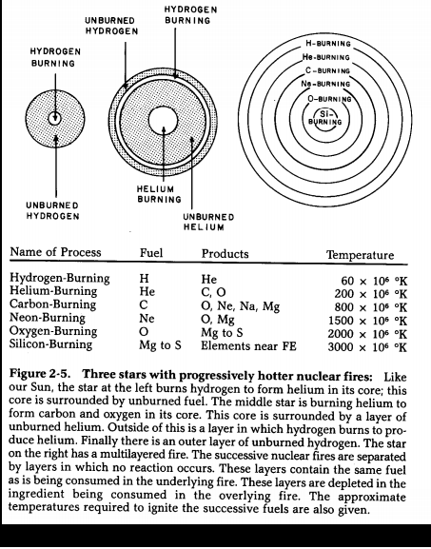
Gravity molded the early Universe:

Mass in nebular was not equally distributed. An initially more massive region of the nebula began to pull in gas (H and He) due to gravity and became the center.
- This region gained mass and density
- Mass compacted into a smaller region and began to rotate
- Rotation rate was increased, developing a disk shape
- The central ball of the disk became hot enough to glow (heated things enough for the Universe to become ionized again: H nuclei formed – getting back energy)
- A protostar was born (when it starts to be ionized)!
- The protostar continues to grow, pulling in more mass and creating a denser core
- Temperatures reached 10 million degrees
- At these temperatures, H nuclei fuse to create He
- With the start of nuclear fusion, the protostar “ignited”
- Nucleosynthesis occurs (starting with H burning to form He)

When Si burns, you get Fe, however Fe doesn’t release energy, it absorbs energy when heated up, therefore no more energy is being created. While this burning is occurring, gravity is pulling inwards and the fusion reaction is pushing outwards. When the fusion stops occurring, everything collapses = death of a star: supernova. Huge explosion is created which releases more energy to create heavier elements again. Our sun is still burning H and He with the rest of the processes still having to go through. A second generation star contains all the elements formed in the first generation (after the death of the first generation star).
- First generation stars left a legacy of heavier elements
- Second generation stars incorporated leftover heavy elements and repeated heavy element genesis
- Succeeding generation contain heavy elements
- The sun may be a third-, fourth-, or fifth-generation star
- The mix of elements found on Earth include: primordial gas from the Big Bang and disgorged contents of exploded stars
- We are made of stardust
Evolution of the solar system
Forming the solar system according to the nebula hypothesis: A second- or third-generation nebula forms from hydrogen and helium left over from the Big Bang, as well as heavier elements that were produced by fusion reactions in stars during explosion of stars.
The nebula condenses into a swirling disc, with a central ball surrounding rings.
The ball at the center grows dense and hot enough for fusion to begin (> 5x106⁰C). It becomes the Sun. Dust (solid particles) condenses in the rings.
The nature of the matter condensed depends on temperature. At a distance of Earth from Sun, temperature ~1500⁰C. Iron (MP 1538⁰C), and olivine ((Fe,Mg)₂SiO₄; MP 1500-1700⁰C) condense. At distance of Jupiter, water ice (MP 0⁰C) and ammonia (MP -78⁰C) condense, and at a distance of Neptune, methane (MP -182⁰C) condenses.
Dust particles collide and stick together, forming planetesimals (beginnings of planets). Planetesimals grow by continuous collisions. Gradually a proto-Earth develops. Gravity re-shapes the proto-Earth into a sphere. The interior heats up and becomes soft because of collisions and gravity pushing in. The denser elements sink to the bottom and the lighter stuff stays on top. The interior differentiates into: a central iron-rich core (heavy) and a rocky outer shell – a mantle (lighter). Notice that smaller objects in the universe do not have a spherical sphere (relationship between size and gravity). For example, the moons of Jupiter: Almathea (270x166x150 km) has an irregular shape, and IO – diameter 3600 km is spherical.
Formation of the moon: All the planets except those 2 closest to the sun have moons – Earth has 1 moon and Jupiter has ~63 moons. Soon after Earth forms, a small planet collides with it, blasting debris that forms a ring around the Earth. The debris is captured by the force of gravity and starts to orbit around the Earth. Eventually, the moon is formed from the ring of debris.
Formation of atmosphere and Oceans: Earth was a very hot planet, thus there was a lot of volcanic activity. Eventually the atmosphere developed from volcanic gases (mainly H₂O and CO₂). As the Earth cooled, moisture condensed out of the atmosphere, it rained, and the oceans formed.

