EPSC 201 - JANUARY 19 2016 - LECTURE 3
Formation of solar system by nebula, ~4.6 billion years ago. The nebula is not completely uniform. The denser clumps form the sun, and the less dense clumps form the planets. Different elements melt and condense at different temperatures, therefore the characteristics of planets vary depending on their location relative to the sun (ice, gas, terrestrial, rocky).
The nature of our solar system:
-Our sun is a medium-sized star, orbited by 8 planets (Mercury, Venus, Earth, Mars, Jupiter, Saturn, Uranus, and Neptune).
-The sun accounts for 99.8% of our solar system mass.
-A planet: is a large solid body orbiting a star (the Sun), has nearly a spherical shape, has cleared its neighbourhood of other objects (by gravity) – a lot of empty space near a planet
-Moon: a solid body locked in orbit around a planet, which then orbits a star
-Millions of asteroids, trillions of icy bodies orbit the sun (have not formed into planetismals).
2 groups of planets occur in the solar system
-Terrestrial planets – small, dense, rocky planets (Mercury, Venus, Earth, Mars)
-Giant/Jovian planets – large, low-density, gas and ice giants (Gas giants = Jupiter, Saturn (Hydrogen and Helium); Ice Giants (materials that make up these gases can condense and form ice) = Uranus, Neptune (frozen water, ammonia, methane)).
-The solar system is held together by gravity.
FYI: Jupiter is 318x the mass of the Earth
1 AU = mean distance between Earth and Sun = ~150 000 000 km (=1.5x10⁸ km)
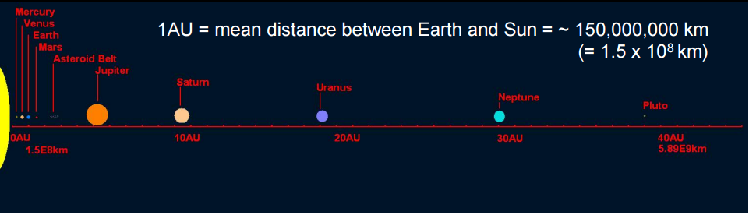
Asteroid belt (between Mars and Jupiter) – belt of rocky chunks that did not form into planets. Most are concentrated in this belt. The reason they are there is because Jupiter fed a lot of energy when it formed and caused many collisions. These asteroids are bits of these collisions which are left over. Most meteorites are pieces of rocks broken off asteroids during their collision with one another. As a result of collisions, their orbit around the Sun is modified and some of these pieces can enter the Earth’s gravitational field. Many tons of these rocks fall on Earth every year, moving at speeds of 20-70km/sec (??).
Meteorite = solid extraterrestrial material that survives passage through the Earth’s atmosphere and reaches the Earth’s surface as a recoverable object.
We can see when a meteorite enters our atmosphere – they leave a streak. The friction between the meteorite and the atmosphere causes it to heat up, leaving behind this streak called a meteor or shooting star. Many heat up a lot and dissociate before reaching Earth, and some do impact Earth but very few, forming craters.
There are 3 different types of meteorites:
-Iron meteorite (core of planetismals, 6%)
-Stony meteorite (mantle of planetismals, 93%)
-Chondritic meteorite (undifferentiated, oldest, rarest): meteorite from before the core and the mantle separated. Can tell scientists what the composition of the Earth was before and how the Universe was formed. Made up of chondrules.
*Carbonaceous chondrites are believed to represent the initial composition of the material from which the Sun and the planets formed.
The Earth System
-Atmosphere: the gaseous envelope
-Hydrosphere: the blue liquid water
-Biosphere: the wealth of life
-Lithosphere: the solid Earth
The interaction of these components compromises the Earth system. Heat from radioactive decay fuels internal processes (loses neutrons cooling down the element and heating up the surroundings, forming isotopes). The center of the Earth is radio-decaying, continuously releasing heat. Sunlight powers atmosphere, biosphere, and hydrosphere.
Earth’s Magnetic Field
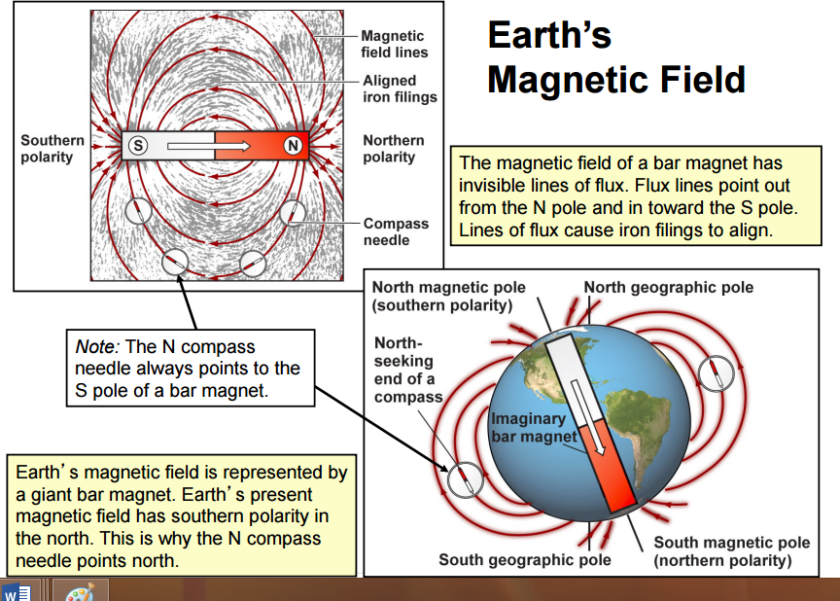
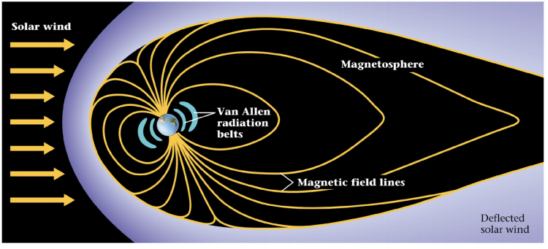
The Earth has an outer core which is fluid with a lot of metal in it. It is moving around and the movement of the charged particles in this fluid outer core are creating this magnetic field. The polarity of Earth’s magnetic has flipped over time. The magnetic field can get in the way of satellites. The magnetic field also protects our atmosphere from the solar wind.
Solar wind distorts the shape of the magnetic field
-Shapes it into a teardrop, forming a magnetosphere
-Magnetic field deflects most of the solar wind, protecting Earth (solar wind will diffuse across the magnetosphere)
The strong magnetic field of the Van Allen belts intercepts dangerous cosmic radiation that strike the Earth’s upper atmosphere.
Mars has a weak magnetic field, resulting in its atmosphere being stripped away by solar wind. Its core has solidified and no longer has moving liquid outer core to generate a strong magnetic field like Earth.
Northern/Southern Lights: Expression of the interaction of cosmic particles with the Earth’s magnetic field. Some charged particles make it past the Van Allen belts. These are channeled along magnetic lines. They cause atmospheric gases in Polar Regions to glow – Aurorae. They occur in the Polar Regions because these magnetic field lines direct particles to the North or South Pole.
Formation of the atmosphere and oceans: eventually the atmosphere develops from volcanic gases (mainly H₂O and CO₂). As the Earth cools, moisture condenses, it rains and oceans form.
The Atmosphere
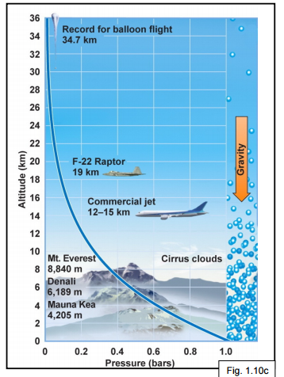
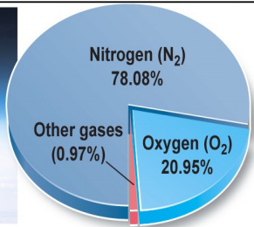
-Our atmosphere is mostly nitrogen, N₂, and oxygen, O₂.
-The remaining gases (totalling less than 1%) include: Argon (0.93%), carbon dioxide (0.039%), neon (0.0018%)
-Other less common gases (helium, methane, and krypton)
-The atmosphere thins away from Earth
-The atmosphere is denser closer to Earth.
-Sea-level atmospheric pressure: 14.7 pounds per square inch (psi) = 101.3 kPa (kilo Pascal); 1Pa = 1N/m² = 1.01 bar = 1 atm.
-With increasing elevation: pressure decreases, density decreases, oxygen content decreases.
-99.9% of the atmosphere lies below 100 km elevation.
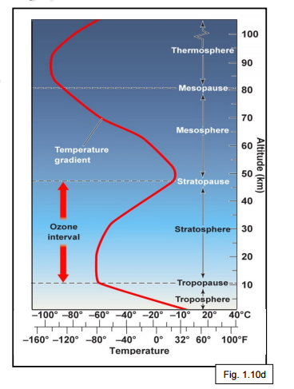
Atmospheric layers are separated by pauses.
-Troposphere (0-11 km): Wind and clouds are found here, weather is confined to this layer. Temperature decreases upward – makes sense because we have a gas expanding, and as a gas expands, it cools.
-Stratosphere (12-47km): warms
-Mesosphere (47-82 km): cools
Thermosphere (+82 km): Outermost layer: warms
Practice Question: Near the Earth’s surface, air gets cooler the higher you climb? T or F
Answer: True (the highest mountain is only 8km high, still in the troposphere – gases are expanding and getting less dense)
Practice Questions: Air cools with distance from the Earth’s surface throughout the whole atmosphere: T or F
Answer: False
Even though the thermosphere and stratosphere are warming while the air is less dense, it is doing so for different reasons:
In the warming of the thermosphere, nitrogen and oxygen atoms absorb incoming solar radiation. Between the tropopause and stratopause (ozone interval), ozone absorbs UV radiation from the sun, which in turn increases the motion of the ozone molecules, warming the air.
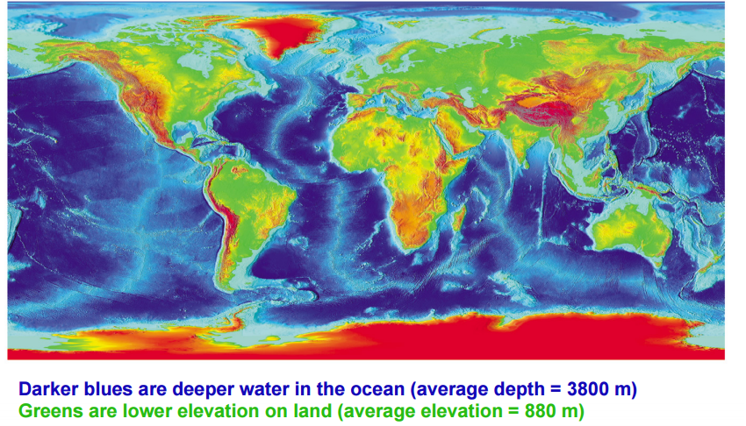
Earth’s Surface
There is more blue than green, red and yellow. Ocean covers more the surface of the Earth than the land. 70% is ocean, 30% is land. There are bands of higher elevation in the center of the oceans and it deepens on either side of the bands (related to plate tectonics). If a line is drawn through the equator, there is more land in the Northern hemisphere than Southern hemisphere (not necessarily always the case).
Calculating global average of sea level depth is bias towards where the instruments are located since measurements are made on coast lines. The depth varies from area to area, thus it is complicated to get an accurate average.
The solid part of the Earth goes much deeper below the surface than above, relative to sea-surface.
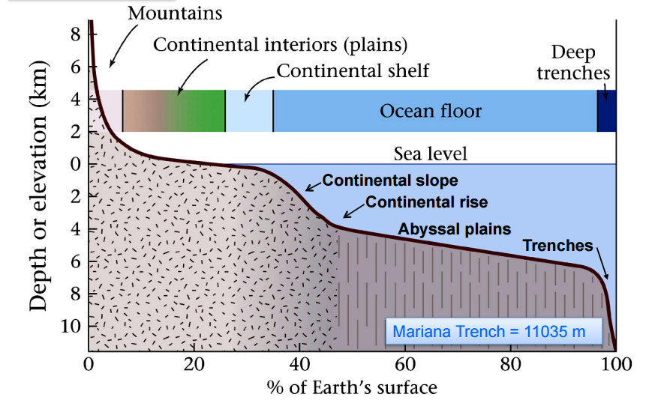
The highest mountain on Earth is Mount Evert, 8.8 km above sea-level. Deepest part of the ocean is Mariana Trench, 11 km deep.
Hypsographic Curve of Earth’s Surface
Mountains have steeper land surface. The land surface is the continental interiors (plains). In terms of surface area, mountains are much smaller than the “flat parts” of the land. Continental shelf – water levels are above the continent but are still part of the continent. Moving away from the land, the oceans get deeper much more quickly. So the continental shelf is still part of the continent and much shallower than the rest of the ocean, but still under water. Continental slope describes where the ocean bottom is. Abyssal plains is where it is not too deep and not too shallow (average depth). Trenches are the deepest parts of the ocean. Mountains and Trenches, the most extremes, are most uncommon in terms of surface area.
Prominent features such as the Grand Canyon, the Himalayas (including Everest) and the Rocky mountains did not exist 1 Ga (1 billion) years ago. Furthermore, the continents had different shapes and were located in different positions than today.
Earth’s Interior
Earth is made of Silicate (SiO₄) Minerals.
-Most common mineral in the Earth, contain silica, a compound of oxygen and silicon
-Classified on the basis of their silicate //(iron + magnesium)// ratio
-In decreasing order of silicate content: Felsic (or silicic), Intermediate, Mafic, Ultramafic. As the silicate content decreases, the density increases. Felsic rocks are less dense (high silicate content, less heavy) than mafic rocks (low silicate content, more heavy).
Outside layer of the Earth: Crust
-98.5% of the crust is composed of 8 elements (in decreasing order: oxygen, silicon, aluminum, iron, calcium, sodium, potassium, magnesium, others)
-Oxygen is the most abundant element in the crust
-crust is high silicate, low density
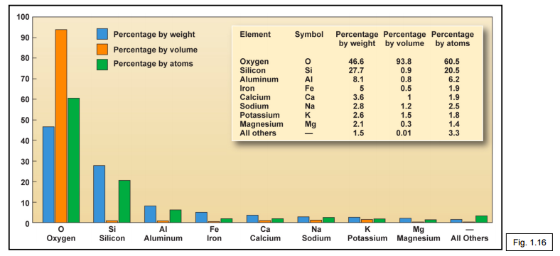
Composition of the WHOLE Earth: dominated by Oxygen and Iron
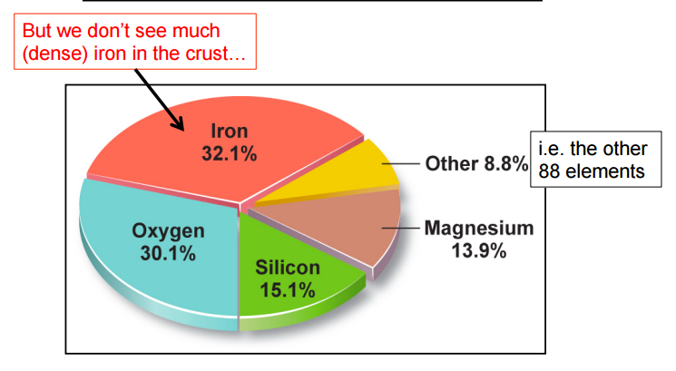
How do we know the Earth has layers? Because of differences in densities (crust vs. core)
The first key to understanding Earth’s interior: density. Because of the gravitational impact, scientists could assume that the Earth’s core was denser. When scientists first determined Earth’s mass they realized:
-Average density of Earth >> average density of surface rocks
-The Earth is round and rotating
-Deduced that metal must be concentrated in Earth’s center
These ideas led to a layered model (Earth is like an egg)
-Thin, light crust (eggshell)
-Thicker, more dense mantle (egg white)
-Innermost, very dense core (yolk)
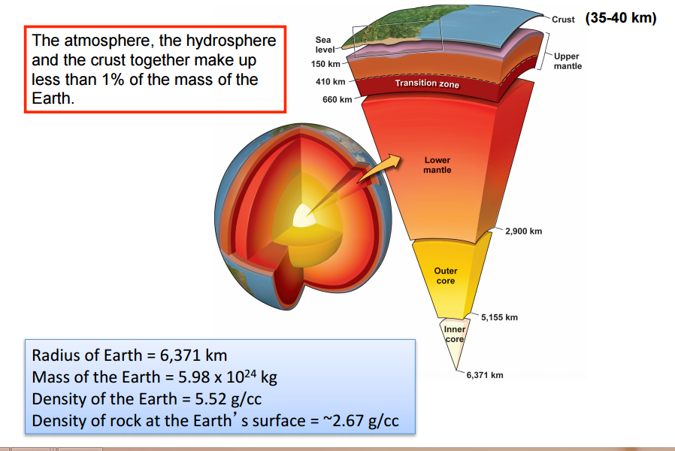
Crust: layer we can see and touch and very thin. Upper and lower mantle are distinct but work similarly. The outer core is fluid. The inner core is solid.
Kola Superdeep Borehole in Russia is the deepest hole we have drilled = 12 km deep. Pressure increases very strongly with depth so we cannot go that far.
How do we know what the layers are like?
Earthquakes can tell us a lot of information about the layers of the Earth. An earthquake occurs when rocks in the subsurface break and slip along a fault, they generate shock waves that travel outward to form an earthquake. The strain released from the buildup of pressure during an earthquake is like the snapping of a bent stick. Seismic waves are waves propagating away from the Earth. We can measure the travel times of the waves to determine what happens in the interior. Seismic waves of type S cannot travel through the fluid outer core of the Earth.
A layered Earth:
-Changes with depth
- Pressure (P): The weight of overlying rock increases with depth
- Temperature (T): Heat is generated in Earth’s interior. T increases with depth
-Geothermal gradient (temperature vs depth)
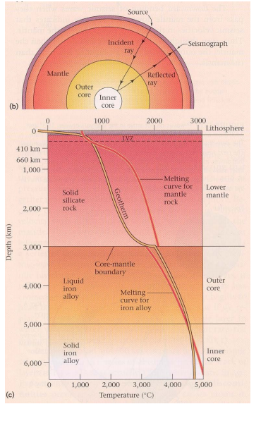
- The rate of T changes with depth
- The geothermal gradient varies: ~20-30⁰C per km in crust; <10⁰C per km at greater depths; Earth’s center may reach 4700⁰C.
-At the Earth’s center: Pressure = 3 600 000 atm, Temperature = 4700⁰C
*Pressure and temperature increases with depth.
*There is a steep geothermal gradient in the first 400 km, and then less steep in the lower mantle.
*Geotherm is the line itself on the graph.
Notice that there is a gradual increase within a layer and a more distinct increase at the boundaries between layers.

