EPSC 201 – JANUARY 21 2016 – LECTURE 4
Practice Question: The Earth produces a _________ that shields the planet from ____________.
Answer: Magnetic field / Solar Wind: Magnetic field repels charged particles from the Sun.
Practice Question: Approximately how much of the Earth’s surface is covered by ocean? / What is the average depth of the ocean?
Answer: 70% / 3.7 km
Practice Question: Zero elevation on a topographical map represents the average elevation of the whole solid (land + water) surface of the Earth. T or F
Answer: False: Zero on a topographical map means you are at sea surface.
-Average elevation, % of surface area of Earth
-land: +0.88 km, ~30%
-Ocean: -3.7 km, ~70%
From this we could make an estimate of the average elevation of the whole solid surface as: 0.88*0.3 + 3.7*0.7 = -2.3 km.
Practice Question: Is the temperature the same everywhere inside the Earth?
Answer: No. The temperature increases with increasing depth. The core is much hotter. During planet collisions, the core was building up, so there is much more pressure and energy in the core.
Practice Question: Do seismic waves travel at the same velocity throughout the Earth and why?
Answer: No. The velocity changes with depth, and at certain depths the change is abrupt. Seismic waves are produced by earthquakes and they do travel through the Earth at different speeds. The velocity that a wave travels depends on the material it is travelling through. We know that the Earth is layered and it is not the same material throughout (different density, temperature). Seismic waves of type S can’t travel through the outer liquid core of the Earth.
Practice Question: What properties are too high where they (movie: the core) are for the scenario in this clip to be plausible (reasonable)?
Answer: (1) Pressure: 1 km into the Earth, there is too much pressure for there to be open space. There would not be the crystals. (2) Temperature: too high for them to be able to survive. Equipment on the surface of the Earth is not sufficient to handle those conditions.
The Crust
The Earth’s crust floats on a denser mantle.
Continental crust = crust under land. Thicker and less dense, and more varied. 35-40 km
Oceanic crust = crust under oceans. Thinner, more dense. 7-10 km
-Density of continental crust = 2.7 g/cc
-Density of oceanic crust = 3.1 g/cc
-Density of the mantle = 3.3 g/cc
The Moho marks the boundary between the mantle and the core.
The Mantle
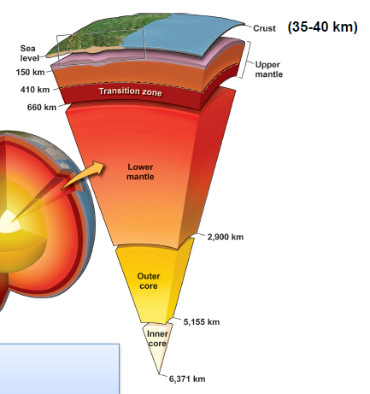
The mantle is a much deeper layer. It is made of solid Mg and Fe silicate rock, 2885 km thick, ultramafic peridotite (most dense, less silicate than crust). It is convecting (slowly! ~15cm/year) = The Earth is heated from below, and it starts to convect, where less dense bits are floating up, and more dense are moving down. Convection occurs at temperatures >1280⁰C. Upper mantle is not convecting; only lower mantle has temperature for convection.
80% of the mass of the Earth is in the mantle. Mostly, we do not see peridotite rock on the surface, it is in the mantle. The atmosphere, the hydrosphere, and the crust together make up less than 1% of the mass of the Earth.
-Radius of Earth = 6370 m
-Mass of the Earth = 5.98x10²⁴ kg
-Density of the Earth = 5.52 g/cc
-Density of rock at the Earth’s surface = ~2.67 g/cc
We know that there needs something to be dense in the center of the Earth, and that is the core.

The Core
An iron-rich sphere with a radius of 3471 km (outer core) and 1220 km (inner core). Seismic waves show that the core is divided into two parts. The outer core is liquid; inner core solid (greater pressures keep it solid).
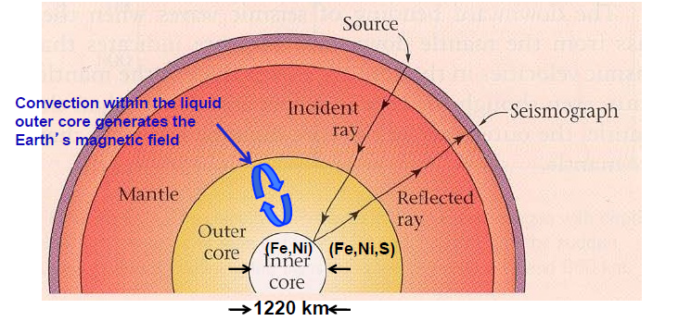
The core is divided into the inner and outer core. The outer core has convection whereas the inner core does not have convection, it is solid. This has to do with the mix of pressures and temperatures. In the outer core, the temperature and pressure are so high, but the pressure is not enough to overcome the heat, so it remains fluid. In the inner core, pressure wins over the temperature, so it is in solid form and cannot be fluid. Convection within the liquid outer core generates the Earth’s magnetic field. Seismic waves will travel differently between the inner and outer core. Some types of waves cannot travel through the fluid outer core and stops abruptly.
Lithosphere-Asthenosphere
-Relates to whether or not a material can flow
Lithosphere: the outermost 100-250 km of Earth
- Behaves rigidly, as a nonflowing material
- Composed of two components: crust and upper mantle (not hot enough to flow)
- This is the material that makes up tectonic plates
Asthenosphere: the upper mantle below the lithosphere
- Shallow under oceanic lithosphere; deeper under continental lithosphere
- Flows as a soft solid (BUT does not convect!)
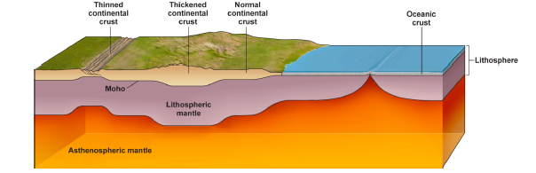
Two types of Lithospheres:
Continental (older): ~150-250 km thick. Felsic to intermediate crustal rocks.
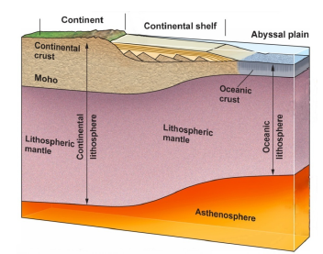
- 25-70 km thick of the crust that is part of the lithosphere
- Lighter & less dense
- More buoyant – floats higher
Oceanic (younger): ~100 km thick. Malfic crust: basalt & gabbro
- <10 km thick of the crust that is part of the lithosphere
- Heavier (more dense)
- Less buoyant – sinks lower

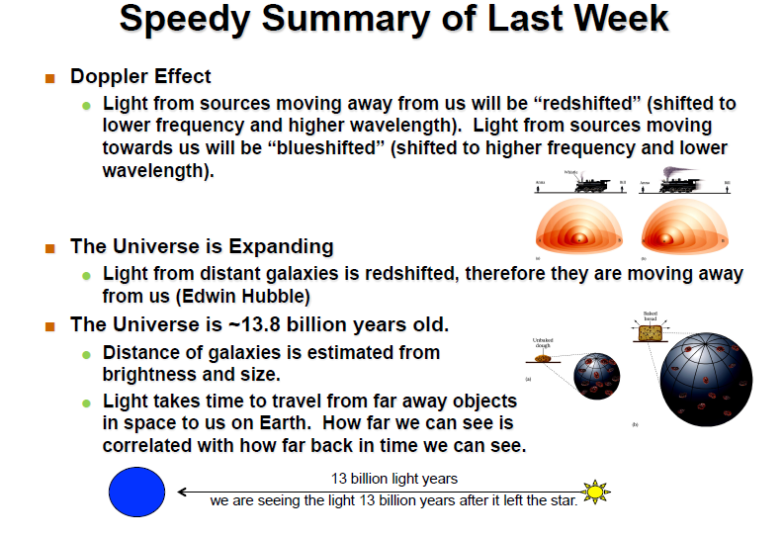
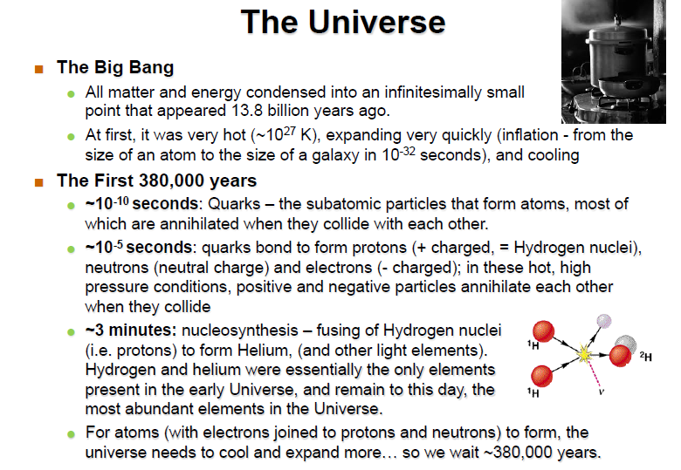
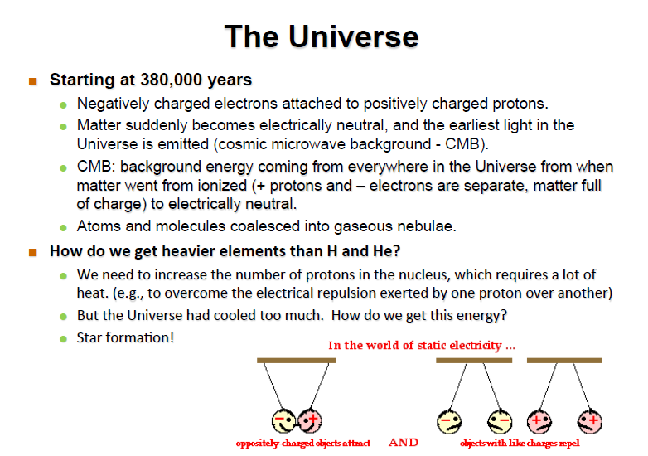
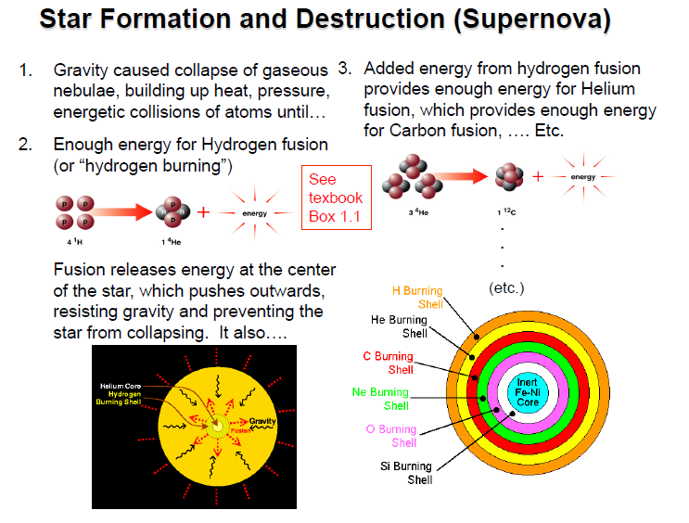
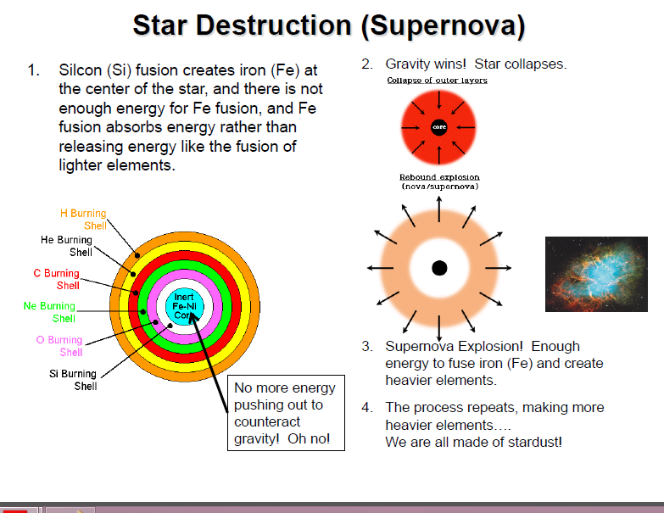

The Plate Tectonics System

Earth’s lithosphere is broken into ~20 plates that interact. (12 major, many microplates). Each plate is a piece of lithosphere and can have both continent and ocean environments.

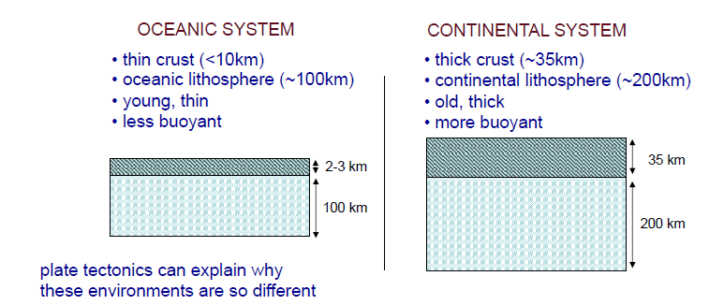
John Tuzo Wilson (1968) put the idea of tectonic plates forward.

Oceanic and Continental Lithosphere Systems
- Broken into many pieces or “plates”
- Character is different in continent and ocean environments
- A plate can contain both environments

The theory of Continental Drift: a precursor to the theory of Plate Tectonics.
Past: One big continent called Pangea. Present: multiple continents
Tectonics: the study of large scale movements and deformation of the Earth’s crust.

German meteorologist, Alfred Wegener, proposed the theory of continental drift but it was not accepted because he did not mention “why” this would happen.

- Glacial Evidence: Evidence of glaciers found on five separated continents from 180 million years ago.
Ice sheets have grown and covered many continents of the Earth over time. When an ice sheet grows and collapses, it scrapes the land as it retreats and melts – glacial striations. Striations along Southern tip of South America, South Africa, Southern India, Southern Australia. Having an ice sheet in the equator is pretty unlikely. But if we map these ice sheets all together, the striations line up together. These continents must have been together at the Poles 180 million years ago.

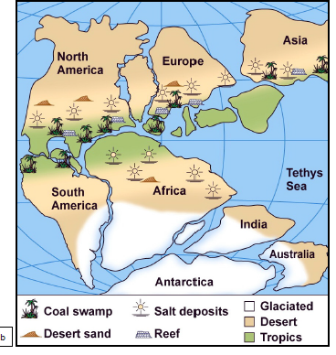
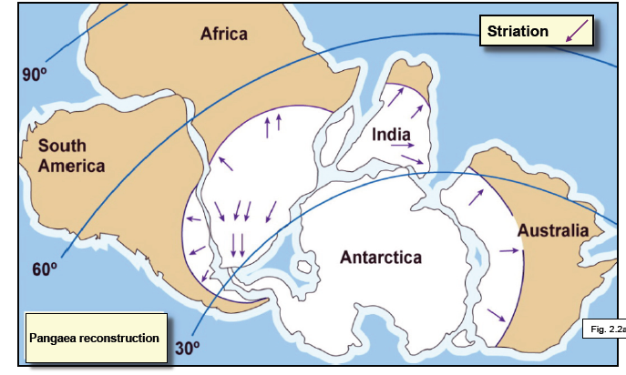
- Paleoclimatic Evidence: when plant life dies and gets buried, it turns into coal. There are also coral reef formations – characteristic of warm equatorial regions. We find matching coal features and reef features in places that are not equatorial today. If you placed all the continents together, a band would line up well for these characteristic features:
- Tropical coals
- Tropical reefs
- Subtropical deserts
- Subtropical evaporates

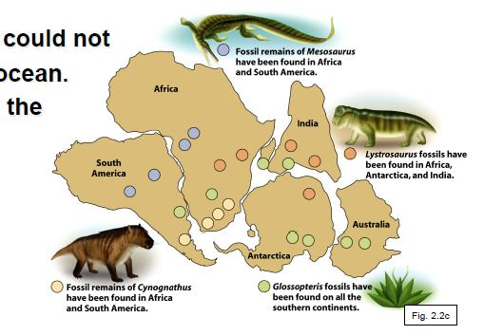
- Fossil Evidence: Identical fossils found on widely separated land.
- Lystrosaurus – a non-swimming, land-dwelling reptile
- Cynognathus – A non-swimming, land-dwelling mammal-like reptile
These organisms could not have crossed an ocean
Pangea explains the distribution

- Matching Mountain Belts: Distinctive rock assemblages and mountain belts match across the Atlantic (e.g. South America & Africa).


