fEPSC 201 – JANUARY 26 2016 – LECTURE 5
Criticisms of Wegener’s Ideas
-Wegener had multiple lines of strong evidence, yet, his idea was debated, ridiculed, and ignored – why?
- He couldn’t explain how or why the continents moved
- Wegener died in 1930 on a Greenland expedition
- Over the next 3 decades, new research, new technology, and new evidence from the oceans revised his hypothesis.
We needed new technology and exploration to be done.
Earth’s Magnetic Field
Flow in the liquid outer core creates the magnetic field (made of iron) – outer core is convecting creating a magnetic field. Because the Earth is moving, the convecting is happening in spiral shapes, which means the magnetic field is roughly aligned with the rotation axis.
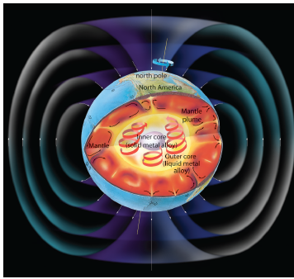
-It is similar to the field produced by a bar magnet
-Currently, the magnetic pole is tilted ~11.5⁰ from the axis of rotation

Magnetic Poles
The magnetic poles move with respect to the Earth’s surface (i.e. geographic and magnetic poles are not parallel)
-Magnetic poles are located near the geographic poles
-Magnetic poles move constantly
The magnetic pole is not a consistent field, it wanders through time, but does not wander too far.
Outer core is liquid iron which generates the magnetic field.
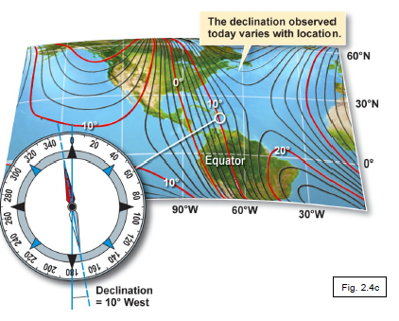
The Earth’s Magnetic Field
-A compass points to magnetic N, not geographic N.
-The difference between geographic N and magnetic N is called declination. Difference in position from the axis of rotation and magnetic pole. It depends on:
- Absolute position of the two poles (geographic north, magnetic north)
- Longitude

-Curved field lines cause a magnetic needle to tilt.
-Angle between magnetic field line and surface of the Earth is called inclination. It depends on:
- Latitude
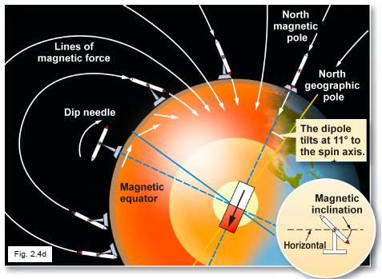
At magnetic pole, we get an angle of 90⁰
A compass needle will show direction of magnetic field line.

Paleomagnetism
We can use what we know about the magnetic field to understand the magnetism in rocks we see in different continents. Certain rocks, as they cool, trap in the magnetism from when they formed. We can determine where the magnetic pole was at the time that it cooled.
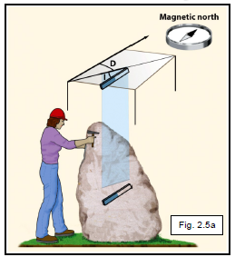
Over a long time scale, if we average the positions of the magnetic poles, it is aligned with the axis of the Earth.
-Rock magnetism can be measured in the laboratory
-The study of fossil magnetism is called paleomagnetism
-Iron (Fe) minerals in rock preserve information about the magnetic field at the time the rocks were formed
- Declination and inclination preserved in rocks often vary from present latitude/longitude
- Instruments used in paleomagnetism record changes in position
- The data are used to trace continental drift

-Iron minerals archive the magnetic signal at formation
-Hot magma
- High temperature – no magnetization because thermal energy of atoms is very high and magnetic dipoles are randomly oriented.
-Cool magma
- Low temperature – permanent magnetization because thermal energy of atoms slows. The dipoles align with Earth’s magnetic field and magnetic dipoles become frozen in alignment with the field.

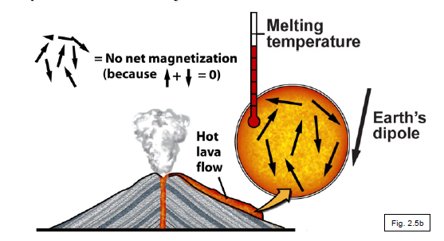
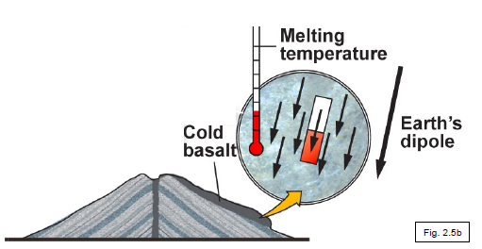
This happens all over the Earth where rocks are forming and cooling.
Polar Wandering
Layered basalts record magnetic changes over time. Inclination and declination indicate change in position.
-Apparent Polar Wandering: You would go to a continent and get a lot of information about the magnetic direction, which would be roughly consistent and predict the path the pole has wandered.
-Polar wandering paths were initially misinterpreted:
- Not the signature of a wandering pole on a fixed continent
- The signature of a fixed pole on a wandering continent
People thought the continents were fixed in place so the poles were wandering in respect to the continents. Theoretically, if the poles are wandering and the continents are fixed, you should be able to go to different continents and get the same answer, so it should be consistent, but that’s not what happened. So researchers did this, they went out on different continents and measured the magnetic pole on different continents and they tried to line up but the paths were not consistent with each other.
-Each continent had a separate polar wandering path. Now understood to represent that:
- The location of the magnetic pole is fixed
- The continents themselves have moved – which supports continental drift
Sea-Floor Bathymetry from Echo-Sounding – Evidence for plate tectonics and continental drift
We started to get measurement of what the ocean floor looked like. Before WWII, we got our information on the ocean floor by submarines to collect data.
-Ships send sonar waves. We know how fast sound waves travel in water and so they hit the ocean floor and come back up and we can measure how long it took for them to get there and so we know the distance of the ocean floor. Sea floor looked very complicated: trenches vs. flat floor. Mid-Ocean ridges which were higher in topography in terms of the rest.
Many bathymetric features were discovered by sonar. These include: deep-sea trenches, oceanic islands, seamounts (almost islands), and guyots.
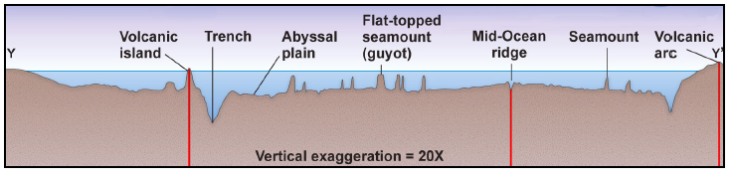
In addition, it was noted that marine sediments, minerals eroded from the continents and shells of dead micro-organisms, thicken away from the mid-ocean ridge. These sediments and minerals can be found by drilling into the ocean floor. These sediments and minerals are found to get thinner as we move towards the mid-ocean ridge (mountain belts).
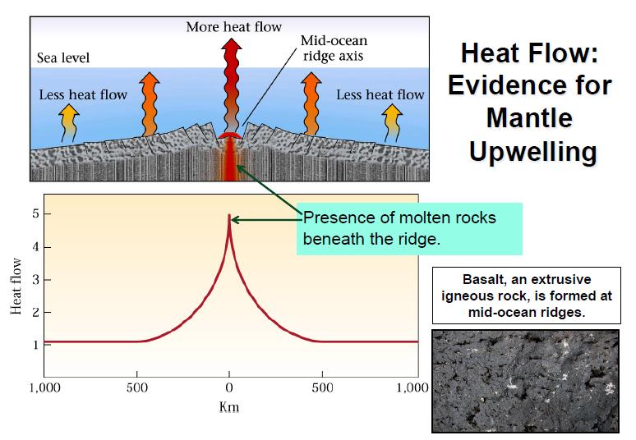
Another thing that can be measured from the ocean floor is the heat flow.
There is a strong peak in heat flow in the center of these mountain chains, and less as you move away.
*Basalt is an igneous rock which is characteristic of the mantle. So we see mantle rock in these mid-ocean ridges.
Today’s view of the ocean floor reveals the location of:
- Mid-ocean ridges
- Deep ocean trenches
- Oceanic fracture zones
Earthquakes and the Oceanic Crust
Earthquakes in the Oceanic crust limited to:
- Parts of the oceanic fracture zones
- Mid-Ocean ridge axes
- Deep ocean trenches
If we compare the world maps of Earthquakes and locations of ridges and trenches, we see an overlap (see slides in 2b).
Harry Hess’ concept of Sea-Floor Spreading (a mechanism to explain continental drift)
The ocean floor is formed at the ridges, drifts away from them on both sides and then plunges into the mantle at the trenches.
The seafloor viewed as a conveyor belt for marine material (marine sediments and oceanic crust), explaining the absence of old oceanic rocks and the thinness of marine sediment.
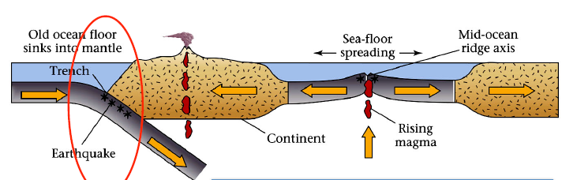
Sea-floor spreading: where we saw high heat flow and signs of mantle rock and ridges, this is where mantle rock is upwelling and new lithosphere are being created (hot rocks are being created here). Everything is upwelling and lifting the surface. Then it is cooling and spreading, like a conveyor belt. We know it has to go somewhere. The new material is created, it spreads, and then sinks back under.
Is the plate causing the convection? Or the convection causing the plates to move? (Chicken or egg question)
Line of evidence: we see sediments thinning (new material being created did not have time to form thick sediments)
Evidence of Sea-Floor Spreading
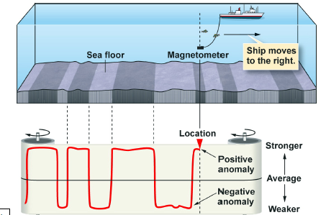
-Magnetism in sea-floor rocks varies farther from MOR (paleo-mag data). Boats can drag a magnetometer along the ocean floor and collect data of what the magnetic field is at that location – collects data for local magnetic field (position of the rocks locked as they cooled down) & the Earth’s magnetic field.
- Stripes of positive (stronger) and negative (weaker) magnetic intensity
- Recorded in sea-floor basalts
Magnetic anomaly: difference between the expected strength of the Earth’s magnetic field at a certain location and the actual measured strength at that location.
Magnetic Reversals
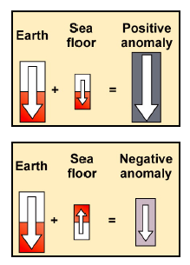
Newly created material, hot mantle rock coming up, can lock in Earth’s magnetic field and so if we look through layers, we can record this magnetic field (e.g. rocks on ocean floor).
Positive anomaly: when the rocks locked in their magnetism, those rocks must have had their own magnetism in the same direction as the Earth’s magnetic field.
Negative anomaly: when the rocks locked in their magnetism, those rocks must have had their own magnetism in the opposite direction as the Earth’s magnetic field.
This implies we potentially have a reversal of the Earth’s magnetic pole. Reversals in Earth’s magnetic field are recorded in iron-rich rocks, such as basalts. Dating the formation ages of layered basalts yields the timing of the archived magnetic reversals. In the past, Earth’s magnetic poles have flipped, and we do not know why this has happened.

Sea-Floor Spreading
What we see are positive and negative anomalies, and it turns out that if we look away from a mid-ocean ridge, the pattern we see is symmetric.
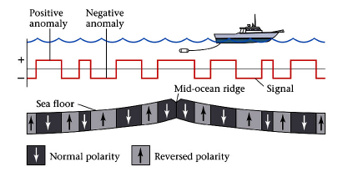
Sea-floor spreading predicts that magnetic anomalies should be mirror images across the mid-ocean ridge. This data is evidence for sea-floor spreading. There is new material coming out, it’s reaching the surface, it’s cooling, it’s locking in Earth’s magnetic field at that time. Then this material moves away and new material is coming out, but maybe this time, the pole is moving in another direction. Moving away from the ridge, the materials get older.
-Sea-floor spreading explains the stripes
- Magnetic polarity reversals are imprinted in sea-floor rock as the sea floor continues to spread
-The width of the magnetic anomaly stripes is related to the spreading rate
- Faster spreading = wide stripes
- Slower spreading = narrow stripes
Magnetic Stratigraphy – dating magnetic reversals
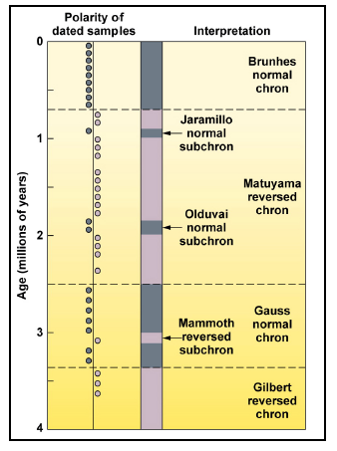
A magnetic reversal chronology for the last 4 million years (Ma) reveals differing durations of normal and reverse magnetic polarity.
Chrons or epochs: Periods of predominately normal or reversed polarity.
Subchrons or events: short-term magnetic reversals (1000-200 000 years).
Whereas the cause of reversals remains to be elucidated, the record of magnetic reversals can be used to date thermoremanent magnetization in geologic cross-sections. As such, we can date how old sections of the sea-floor are.
The sea floor acts like a tape recorder that encodes, by magnetic imprinting, the history of the opening of an ocean basin in terms of the history of reversals of the geomagnetic field.

Relative Rates of Seafloor Spreading
We can use what we know about the dating of magnetic reversals to determine the relative rates of sea-floor spreading today and in the past. Using the magnetic stratigraphy established on land (data lava flows), geophysicists were able to determine how fast the ocean opened up.
Isochrons: are contour lines on a map of equivalent age of the seafloor. They show the time that has elapsed and the amount of spreading that has occurred since the magnetized rocks were injected as lava into a mid-ocean rift. The more widely spaced isochrones of the East Pacific reflect a faster spreading rate than those in the Atlantic.
Practice Question: Using what you know about the sea floor spreading, approximately how old is the oceanic crust at “A”?
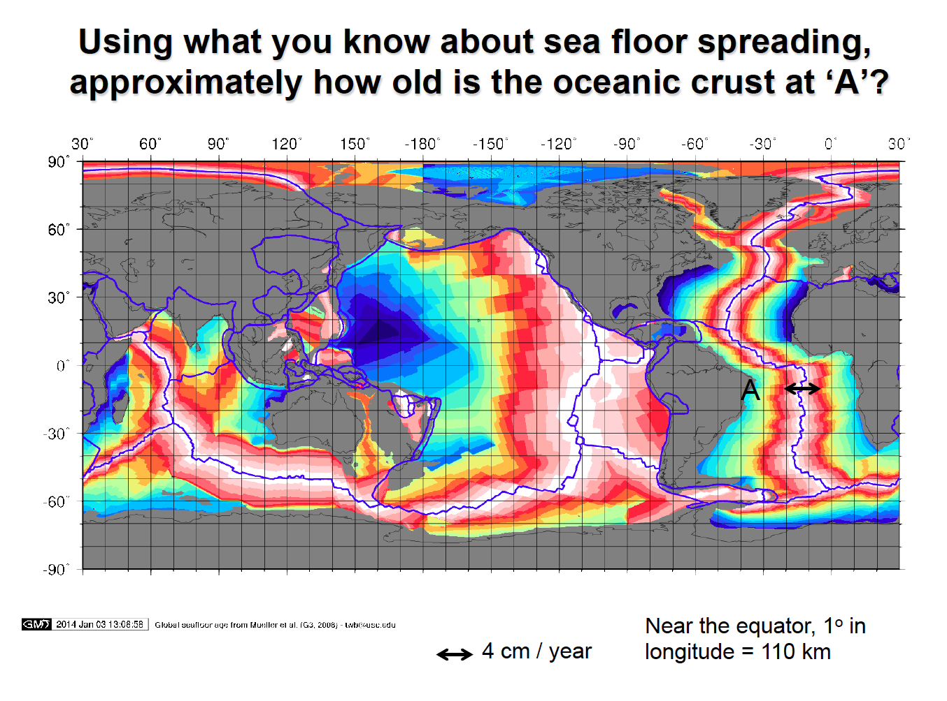
*One clarification/hint: 4 cm/year gives the rate at which one side of the mid-ocean ridge is moving with respect to the other side.
Answer: Assumption that spreading rate is constant over time, 4 cm/year
- Rate that plate moved relative to ridge (v)
v = (1/2)*Spreading rate
- Distance from A to center of ridge (d) (~20⁰ on the map = 20*110km = 2200 km = 2 200 000 m
- Time it took sea floor at A to travel distance d (t)
Equation:
- v = d/t, so t = d/v
Quantities:
v = (1/2)*(4 cm/ year) = 2 cm/ year = 0.02 m/ year
Calculation:
t = d/v
= 2 200 000 m / 0.02 m
= 110 000 000 years = 110 Ma

