EPSC 201 – JANUARY 28 2016 – LECTURE 6
Practice Question: Based on the distribution of color on the map, which ridge is spreading faster, the mid-Atlantic Ridge or the East Pacific Rise (ridge and rise are both nicknames for a mid-oceanic ridge)?
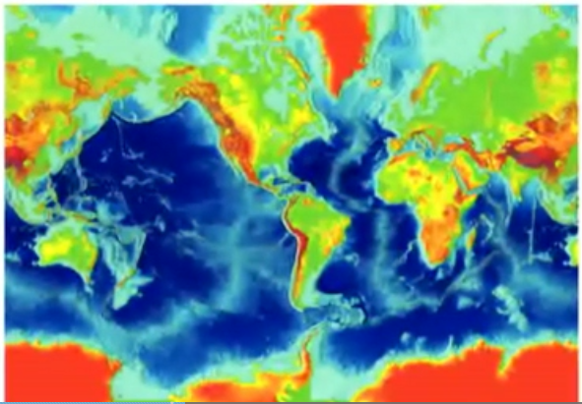
Answer:
East Pacific Rise – as new crust spreads, it cools and sinks down. So if it goes faster, it will spread further before it sinks down, therefore there is more light blue. Whereas in the Atlantic, there is a steeper slope – a quicker transition from light blue to dark blue topography.

Practice Question: In the Eastern Pacific, why are oceanic rocks no older than 120 million years?
Answer: Subduction zone, where plates are being destroyed as they are travelling faster.
Practice Question: Where is the youngest ocean floor located?
Answer: New crust is being created at mid-ocean ridges.
Practice Question: Where is the oldest ocean floor located?
Answer: Farthest away from the mid-ocean ridges.
Plate Tectonics
Earth’s outer shell is broken into rigid plates that move around and interact into 3 different types of plate boundaries. Plate tectonics explains the origin and distribution of earthquakes and volcanoes, mountain belts and seamount chains, mid-ocean ridges and deep-ocean trenches, and changes in past positions of continents and ocean basins.
- Divergent boundaries
- Convergent boundaries (subduction zones)
- Transform boundaries
Continental Margins
-Where land meets the ocean
- Margins near plate boundaries are “active” (near subduction zones)
- Margins far from plate boundaries are “passive” (ocean and continental crust are on the same lithosphere plate)
- Earthquakes are common along active margins
-Passive-margin continental crust thins seaward. The idea is that oceanic crust flows into continental crust and you might have compression, or shelves that form, so you’ll have piling up of continental crust because of the pressure. So this is why the continental crust gets thicker as continental crust keeps piling up on it.
- Traps eroded sediment
- Develops into the continental shelf
Plate Boundaries
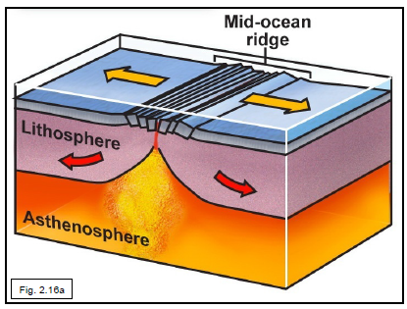
-Lithosphere is fragmented into ~12 major tectonic plates.
-Plates move continuously at a rate of 1-15 cm/year (slow on the human time scale; extremely rapid geologically)
-Plates interact along their boundaries
-Locations on Earth where tectonic plates meet – area with a lot of stress – so they can be identified by concentrations of earthquakes and may be associated with many other dynamic phenomena
-Plate interiors are almost earthquake-free
-Tectonic plates display a variety of sizes and shapes. They change size and shape throughout their history. Today’s configuration is not necessarily the same as in the past.
(1) Divergent boundary (mid-ocean ridge)
-Tectonic plates move apart
-Lithosphere thickens away from the ridge axis
-New lithosphere created at divergent boundary
*Place where new crust is created and flows outward. Usually these happen in the ocean, but sometimes through land (Iceland)

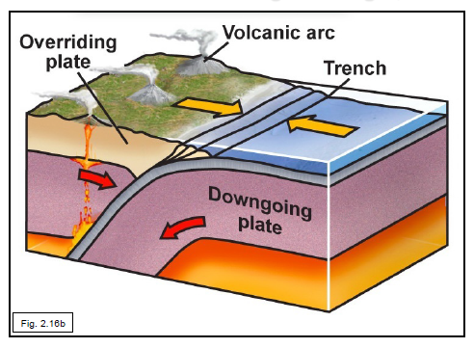
(2) Convergent Plate Boundary
-Tectonic plates move together
-The process of plate consumption is called subduction
-Also called: convergent margin, subduction zone, and trench
*Denser plate subducts under lighter, more buoyant plate.

3 different convergent margins (sites of lithospheric destruction):
- Oceanic-Oceanic
- Oceanic-Continental
- Continental-Continental (converging margins – NO subduction zones, continental is too buoyant to subduct down)
*During subduction, it is always the oceanic plate that is going down. Continental plate is too buoyant to go down.
Convergent Margin Map Convention
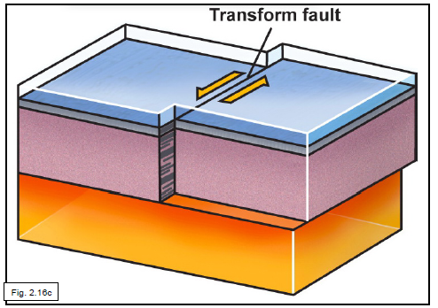
Teeth/arrows on convergent plate margins on maps point towards the overriding plate.
(3) Transform Boundaries
-Tectonic plates slide sideways.
-Plate material is neither created no destroyed.
-Also called: transform fault, transform.
*One plate sliding along another plate. A lot of Earthquakes happening on these boundaries because of the movement happening here.
Transform boundaries are seen the most where there are spreading ridges.
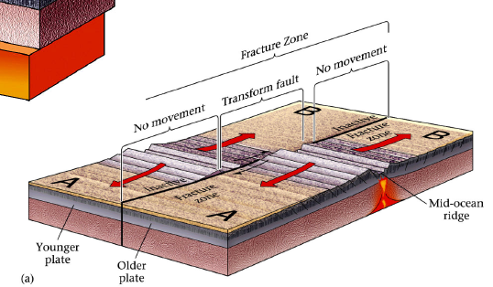

Hypothesize: If the mid-ocean ridges active today continue to produce new sea-floor for another 100-200 million years, how will the appearance and location of oceans and continents be changed?
Divergent Boundaries (Continental Rifting and Mid Ocean Ridges)
-Continental Rifting: how new ridges are formed
The birth of a divergent margin or continental rifting
-Continental lithosphere can break apart.
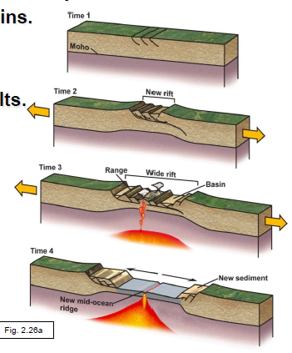
- Lithosphere stretches and thins (plate is under stress and is being pulled out)
- Brittle upper crust faults – as it gets thinner, magma is getting closer to the surface
- Ductile lower crust flows
- Asthenosphere rises and melts
- Magma erupts
-Continuation can create a new mid-ocean ridge
-This process led to the breakup of Pangea
-Rifting arises from tensional forces that break the crust along a complex jumble of normal faults
*If you see a cliff with flat part in the middle of it, that is really characteristic of continental rifting (e.g. second diagram from the top in picture below)*
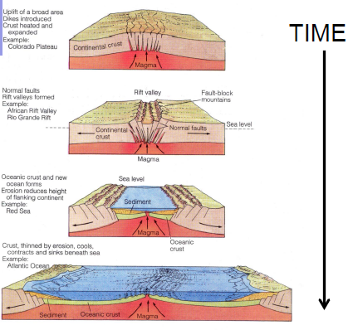

Continental Rifting: The Colorado Plateau
-Western U.S. Basin and Range Province is a rift
- Narrow north-south mountains separated by basins
- Rifting tilted blocks of crust to form mountains
- Sediment eroded from blocks, filling adjacent basins
Divergent Boundaries
-Sea-floor spreading progression
At the early stage:
- Rifting has progressed to mid-ocean ridge formation
- Before substantial widening of the ocean
- Forms a long, thin ocean basin with young oceanic crust
- E.g. the Red Sea – eventually the Red Sea will widen up and become much larger
A new mid-ocean ridge would be very narrow, and an older mid-ocean ridge would be wider, more spreading.
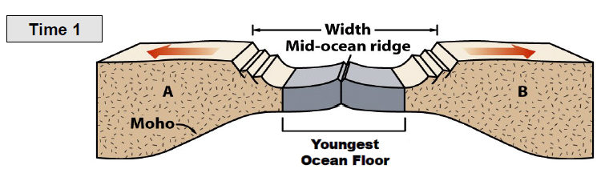
Continental Rifting + Divergent Boundary
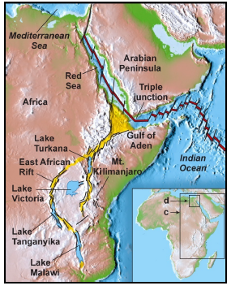
East African Rift:
- The Arabian plate is rifting from the African plate
- Rifting has progressed to sea-floor spreading in: the Red Sea, the Gulf of Aden
- Stretching continues along the East African Rift: elongate trough bordered by faulted high cliffs; volcanoes – Mt. Kilimanjaro (located at a plate boundary)
- The rift and two spreading ridges comprise a triple junction
Divergent Boundaries
-Sea floor spreading progression
Mid-Stage:
- Ocean begins to widen
- New sea-floor is added at the mid-ocean ridge
- Continents move farther apart
- E.g. Greenland and the North Atlantic
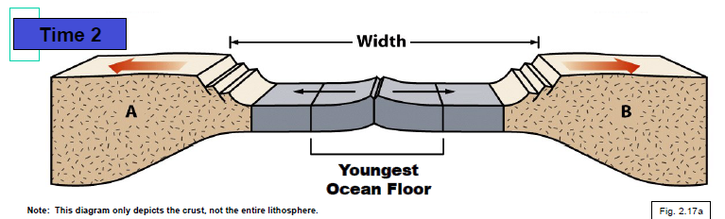

Late stage:
- Mature, wide ocean basin
- Linear increase in age with distance from central ridge
- Edge of ocean basin – oldest; ridge proximal – youngest
- E.g. Atlantic Ocean
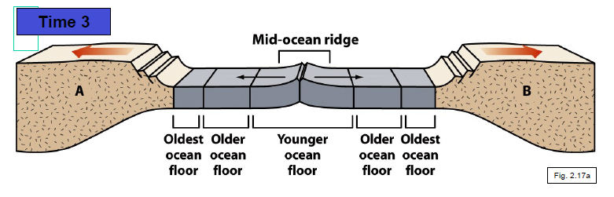
Oceanic Lithosphere
-The hot asthenosphere is at the base of the MOR (mid-ocean ridge)
-As ocean crust is formed, it moves away from this heat sources and cools, increasing in density and sinking. Because it is denser, this is actually pulling/weighing down the surface of the crust that is further away from the MOR. Older, thicker lithosphere sinks deeper into mantle.
Mid-Ocean Ridges
-A place where we see very interesting life forms
-“Black Smokers” are found at some MORs
- Water entering fractured rock is heated by magma
- Hot water dissolves minerals and cycles back out of rock
- When water reaches the sea, mineral precipitate quickly

Convergent Boundaries (Subduction zones)
-Lithospheric plates move toward one another
-One plate sinks back into the mantle (subduction) – always the oceanic crust
-The subducting plate is always oceanic lithosphere (denser oceanic plate goes down)
-Continental crust cannot be subducted – too buoyant
-Subduction recycles oceanic lithosphere
-Subduction is balanced by sea-floor spreading
-Earth maintains a constant circumference
Subduction
These boundaries often move through space across the Earth…
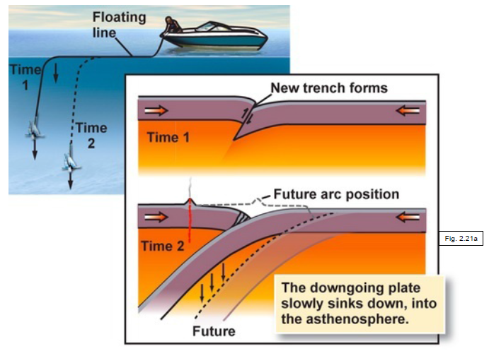
The subducting plate “rolls back” as it is going deeper (see figure).
As a plate is being subducted into the mantle, there is a lot of stress on it which results in earthquakes. Earthquakes happen when the plate is rigid. When the plate reaches 660 km in depth in the lower mantle, the plate melts so the earthquakes stop.

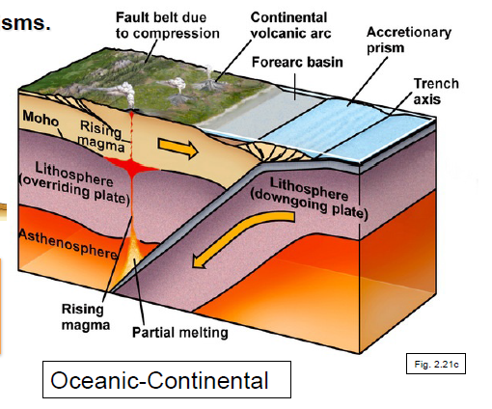
Subducting Features
- Deep-ocean trenches
- Accretionary prisms: wedge-shaped mass of sediment scraped off the subducting oceanic plate – scraping off material; the bulldozer is the overriding plate and it is scraping off material as it goes down.
- Volcanic arcs
- Forearc basins – a dip in the topography after the accretionary prism where there is often water.
There is volcanic activity a little away from the boundary along the overriding plate. You have a plate being pulled down and it’s dragging water it and it is going through different temperature and pressure conditions as it goes down, and you are also brining water into it, so it is changing the characteristics of how it melts. What you end up with is when you get down to a particular depth, you get a partial melting of the plate. So little bits of the subducting plates melts and rises up and makes its way up through the crust and creates a chain of volcanoes a little away from the boundary.
Ocean-Continental Boundary (a convergent margin): The Andes volcanic mountain chain. Ocean crust subducts under the continental crust, forming a mountain volcanic chain.
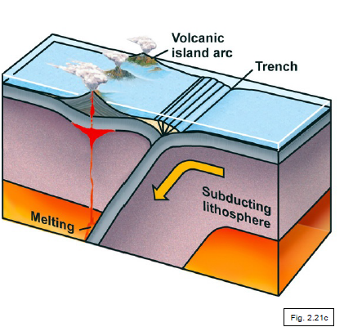
A similar scenario happens when two oceanic plates meet. In this case, it takes some time for the volcanoes to form. It starts with the volcanoes under the water, so we can’t see them. But they erupt and they spread out, erupt and spread out and grow until they peak through the water.
Example: Convergent margin: oceanic-oceanic: Japanese Island Arc

Convergent Margin: Continental-Continental
Because continental crust is less dense than oceanic crust and cannot subduct, colliding continental lithospheric plates ram each other. Since the rocks cannot readily be pushed down, they have nowhere to go but up! When plates meet and “roll-back” happens in, the plates compress and crunch together, and piling up of material results = mountain chains. E.g. The Himalayas formed by the collision of the Indian plate with the Eurasian plate. E.g. The Alps formed by collision of a microplate (including Italy) with the Eurasian plate.
Orogeny: mountain building, as continents ram into each other.
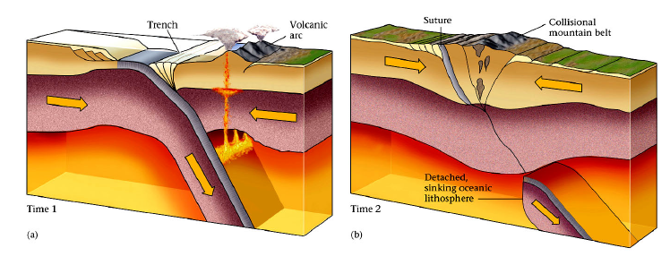
Transform Boundaries
Sliding between 2 plates, no destruction. Lithosphere fractures and slides laterally:
- No new plate forms; none consumed
- Many transforms offset spreading ridge segments
- Some transforms cut through continental crust
Characterized by:
- Earthquakes
- Absence of volcanism (not pulling lithosphere crust down into the mantle)
Might see faulting that extends beyond the ridge, but would not see volcanoes in this area because there is no deformation happening. Relative motion is only in-between the 2 ridges. E.g. The San Andreas Fault, California – at northern end, there is a trench, and then a really long sliding motion between 2 plates until the southern end, which is a mid-ocean ridge. E.g. Haiti and the Dominican Republic are on a transform boundary with about 20 mm per year of relative motion.

