EPSC 201 – LECTURE 7 – FEBRUARY 2 2015
Hypothesize: If the mid-ocean ridges active today continue to produce new sea-floor for another 100-200 million years, how will the appearance and location of oceans and continents be changed?
Look at spreading rates on one side of an ocean versus the other side. Will the continents move away or closer together based on the arrows? There are computer models to predict where the plates are going to go in the future. (see link in slides)
Plate motion is now determined by GPS measurements.
- Global Positioning System (GPS) uses satellites
- Knowledge of plate motion is now accurate and precise
Triple Junctions
- The point where 3 different plate boundaries intersect
- Multiple boundary combinations occur
- Usually areas with a lot of activity – earthquake and volcanic activity
- E.g. 2 triple junctions near each other in west coast US.
Hot Spots
Also evidence for plate tectonics. Came from looking at chains of mountains in the ocean – Hawaiian Islands.
Hot-spots are a localized region of material coming from the mantle. It’s coming up in the same location through time. Mantle plume is coming up and heating the surface, creating a volcano on the surface. The mantle plume stays in the same place over time, but the continent is moving, so you have hot jets of mantle plume coming up as the plate slides over the mantle plume, creating a series of mountain jets.
- Hot-spot seamounts age away from originating hot spot
- Age trend defines rate of plate motion
- Lines of seamounts indicates direction of plate motion
- 1963 – Tuzo Wilson proposed hot-spot volcanoes develop over long-lived magma source originating deep within the mantle
- Hot spots perforate (pierce and make a hole in) overriding plates
- Volcanoes build above sea-level
- Plate motion pulls volcano off plume: volcano goes extinct and erodes; chain of extinct volcanoes called “hot-spot track”
- Hot spots reinforce (support) sea-floor spreading
- Pluton: dead mantle material
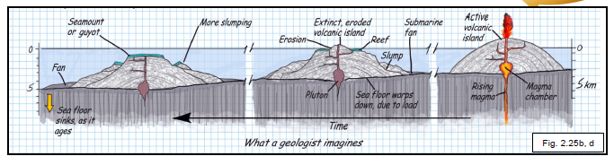
Distribution of volcanoes: concentrated at subduction zones where plates are subducting under, and parts are melting, and coming back to the surface.
Hot spots are relatively stable locations, stationary. So we can use the location of hot spots to say how the plates are moving relative to the hot spot: hot spot reference frame.
Driving Mechanisms for Plate Tectonics
Two forces drive plate motions:
- Ridge-push – elevated MOR pushes lithosphere away: hot material is buoyant and is upwelling and new mantle is being created and this can be driving the plates outward. Driven by MOR (divergent boundaries).
- Slab-pull – denser subducting plate is pulled downward: subduction zones where plates are destroyed so we have denser plates sinking into the mantle. The fact that they are sinking will pull the rest of the plate along.
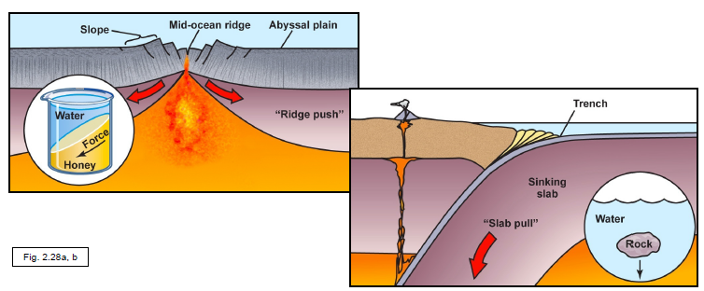
- Convection in the asthenosphere speeds or slows motion: allows for plate to slide along it more easily

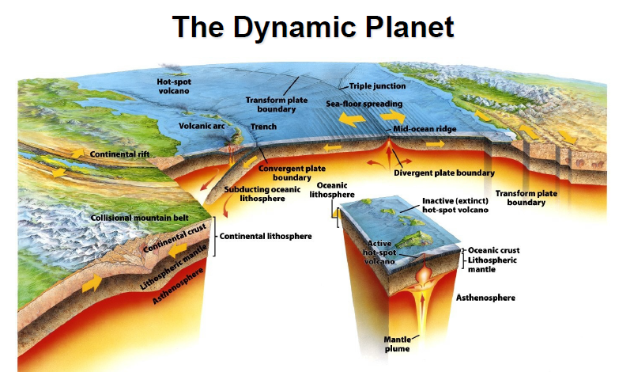

Earthquakes (vibration of the Earth produced by the rapid release of energy)
The energy released by atomic explosions, large landslides or by volcanic eruptions can produce an earthquake, but the sudden movement along faults is the cause of most earthquakes. Faults are produced when stress is applied to rock (by the clamps). Stress causes deformation of rock – strain. When the strength of the rock is exceeded there is a failure – fault.
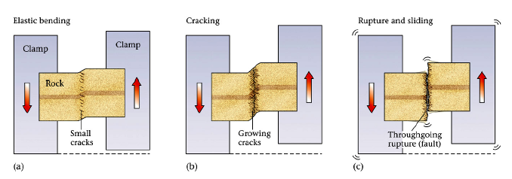
The formation and movement of faults causes most destructive earthquakes. When the strength of the rock is exceeded, there is failure and release of the strain by sudden dislocation or fracture along the fault plane. Earth shaking is caused by a rapid release of energy, most of which is due to tectonic forces (moving the plates around creates stress between the plates). E.g. when applying pressure to a stick, it cracks, and the sticks vibrate a little.
Process: Apply pressure to weak area in the plate. A little deformation happens. Apply more pressure and a fault forms. There is a release of energy. Seismic waves from the fault reach the surface and shake the Earth.
- Earthquakes are common on this planet. They occur every day. There are more than a million detectable earthquakes per year.
- Most earthquakes result from tectonic plate motion.
- Most earthquakes are quite small and only a few are very large and cause destruction (seen in the news)
- Large earthquakes destroy buildings and kill people. There have been 3.5 million deaths in the last 2000 years due to Earthquakes. There are several hundred large earthquakes per year.
- When building buildings and cities, we need to understand earthquakes. Most earthquake damage is due to ground shaking.
- Earthquakes also spawn (release) devastating tsunamis. December 26, 2004 – Indian ocean Tsunami. March 11, 2011 Eastern cost of Japan.
- Liquefaction: The earthquake causes the Earth to become like quicksand for a moment, causing buildings to sink into the Earth due to the shaking of the land.
- Earthquakes can trigger landslides (the sliding down of a mass of earth or rock down a slope) and fire.
What causes Earthquakes?
- Seismicity (earthquake activity) occurs due to:
- Sudden motion along a newly formed crustal fault
- Sudden slip along an existing fault
- A sudden change in mineral structure
- Movement of magma in a volcano
- Volcanic eruption
- Giant landslides
- Meteorite impact
- Nuclear detonations
- *Fault slip is the most common cause*
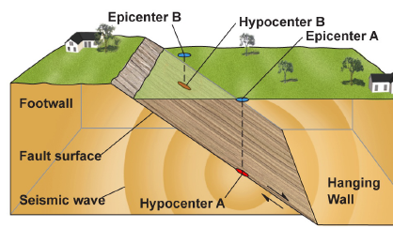
The epicenter is the land surface directly above the hypocenter. Maps often portray the location of epicenters. On the map, the size of the circle represents the magnitude of the earthquake. The hypocenter (or focus) is the location where the fault slip occurs. It is usually on the fault surface. The piece of land or plate that is below the fault is the footwall and the plate on top is the hanging wall.

Faults in the Crust
Faults are crustal breaks where movement occurs.
- Displacement is a measure of movement.
- Fault trace is the ground surface expression of a fault
On a sloping fault, crustal blocks are classified as:
- Footwall (block below the fault)
- Hanging wall (block above the fault)
- The fault scarp is the deformation that occurs at the surface
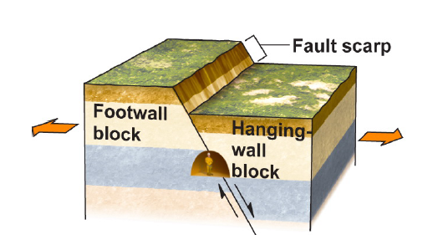
The fault type is based on relative block motion.
Normal Fault
- Due to a stretching force – extension
- The hanging wall moves down relative to the footwall

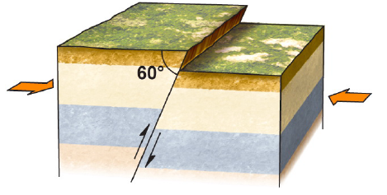
Reverse Fault

- The hanging wall moves up relative to the footwall (overriding block rises up) – dip towards underlying block
- Results from compression (squeezing or shortening)
- The slope (dip) of fault is steep

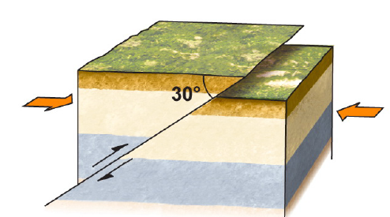
Thrust Fault (special kind of reverse fault)
- Due to compression forces
- The slope (dip) of fault surface is much less steep
- Shallow angle of fault plane (30⁰)
- Common fault type in compressional mountain belts
Strike-Slip Fault
- One block slides laterally past another block
- There is no vertical motion across the fault
- The fault surface, however, is nearly vertical
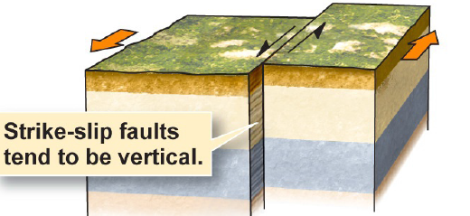

The displacement (or offset) is the amount of movement across a fault. Displacement is sometimes evident by offset of fences, roads, streams, etc.
Faults are found in many places in the crust.
- Active faults – ongoing stresses produce motion (currently under stress which is producing motion)
- Inactive faults – motion occurred in the geologic past (no longer under stress or having motion along them)
A fault trace shows the fault intersecting the ground (evidence of a fault happening along the surface, etc. displacement of a fence).
- Displacement at the land surface creates a fault scarp
Not all faults reach the surface. Blind faults are invisible on the surface, but still are happening under the surface (not expressed on the surface with a broken fence for example).
Generating Earthquake Energy
Tectonic forces add stress (push, pull, or shear) to rock.
- The rock bends slightly without breaking (elastic)
- Continued stress causes cracks to develop and grow
- Eventually, cracking progresses to the point of failure (dislocation/fracture of the rock)
- Stored elastic energy is released at once, creating a fault
- Rocks slide past one another along a fault
- Fault motion cannot occur forever
- Fault motion is arrested by friction
- Friction is the force that resists sliding on a surface
- Friction is due to bumps along the fault

