EXCI 251 STUDY GUIDE

CHAPTER 2: BASIC PRINCIPLES OF PHYSICAL FITNESS

Canadian Activity levels
- Overall, 52% are moderately actve
- Contributing Factors: gender, age, income level

Physical Activity – Continuum

Physical activity: any body movement carried out by the skeletal muscles and requiring energy
Exercise: Planned, structured, repetitive movement of the body deigned to improve or maintain fitness
Physical fitness: A set of physical attributes that allows the body to respond or adapt to the demands of stress of physical effort

Physical Fitness
Based on:
- The hearts ability to pump blood
- Capacity of the cells to produce energy
Determined by:
- Genetic potential
- Training of physiological system

Lifestyle Physical Activity
For health promotion:
- Expend about 150 calories = equivalent to 30 minutes of brisk walking (on most days)
For health promotion + weight management
- Engage in 60 or more minutes of activity per day to prevent unhealthy weight gain.
- Engage in 60-90 minutes of activity to maintain weight loss
Canadian physical activity guidelines
- Children aged 5-11 and youth 12-17 should accumulate at least 60 minutes of moderate-to-vigorous intensity of physical activity per day
- Adults 18+ should accumulate at least 150 minutes of moderate to vigorous intensity of physical activity per week
Canadian Society for exercise physiology
- Recommends activities that strengthen muscles and bones
Brain health + Ecercise
- Improves cognitive function
- Neutralizes negative effects of poor nutrition
- Neurogenesis new nerve cells
- Neuroplasticity: adapted abilities to transmit
- Delayed onset of disease
- Mental health contributor
Health promotion – Canada
Health Canada:
- Recommends all Canadians expend an average of 3 kcal.kg/day for optimal health benefits.
- This average expenditure can be accomplished by engaging in endurance, flexibility, and strength activities
- Vary activities, including; light, moderate and vigorous activities according to health status

Exercise to develop physical fitness
- Lifestyle physical activity may improve health but not fitness
- Issues of overload must be considered – what level of overload will cause adaptation
- A structured, formal exercise program improves physical fitness and provides even greater health improvements.

How much physical activity is enough?
- Moderate-intensity vs. high intensity exercise
- Continuous vs. intermittent exercise
- Low intensity: improves health but may not improve physical fitness.

Health related components of physical fitness
- Physiological capacities that contribute to maintaining and improving health
- Includes 5 components related to major systems of the body
- Cardiorespiratory endurance: the ability of the body to perform prolonged, large-muscle, dynamic exercise at moderate to high levels of intensity
- Muscular strength: the amount of force a muscle can produce with a single maximum effort (1 repetition RM = 100% effort)
- Muscular endurance: the ability of a muscle or group of muscles to remain contracted or to contract repeatedly
- Flexibility: The range of motion in a joint or group of joints (joint structures and functions vary, so they have different ranges and types of movements)
- Body composition: The proportion of fat compared to fat-free mass (muscle, bone, an d water) in the body. Fat is needed but is not a working tissue.

Skill related components of fitness
- Speed, power, agility, balance, coordination, reaction time

Specificity: Adapting to a TYPE of training
- The body adapts to the particular type and amount of stress placed on it.
- To develop a specific fitness component, perform exercises that are specifically designed for that component.
- Some transfer is possible but incomplete. It will not produce equal effectiveness across different systems and actions.

Progressive overload: Adapting to an AMOUNT of training
- Placing gradually increasing amounts of stress on the body causes adaptations that improve fitness; progression is critical.
- FITT principle for overload

Adaptability
- Specific Adaptations to Imposed Demands (S.A.I.D) combines concepts of adaptability and specificity
- Exercise as a positive stressor
- Homeostasis: The body’s natural adaptive response. A new steady state is established according to new demands.
Reversibility: adapting to a reduction in training
- Fitness improvements are lost when demands on the body are lowered (the body adapts to reduced demand)
- If you stop exercising, up to 50% of fitness improvements are lost within 2 months. CV fitness may decline in about 2 weeks, muscular fitness a little later.
- Skill components tend to remain and technique tend to remain but may later need refinement – will be affected by disuse, lack of practice, and reduced fitness.

Individual Differences
- Everyone is not created equal from a physical standpoint
- There are large individual differences in ability to improve fitness, body composition, and sport skills
- O2 transport and use may improve only about 5 – 25% through training.

Designing your own exercise program
- Get medical clearance
- Fitness assessment identify the situation
- Setting goals (make a plan)
- Specific
- Measurable
- Attainable
- Realistic
- Time frame specific

Get Active: Tips for adults (18-64 years)
- Be active at least 2.5 hours per week to achieve health benefits.
- Focus on moderate to vigorous aerobic activity throughout each week broken into sessions of 10 minutes or more
- Get stronger by adding activities that target muscles and bones at least 2 days per week

Choosing activities for a balanced program
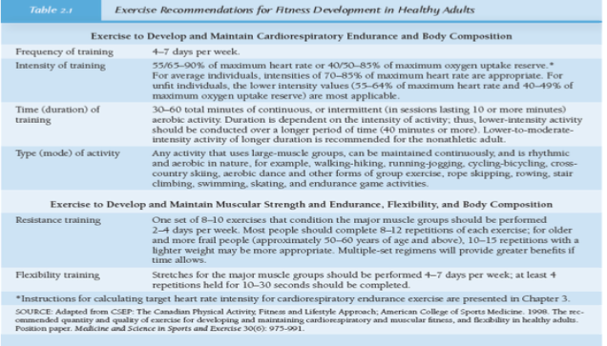

Designing your own exercise program
- Choose activities for a balanced program
- Consider motivational (enjoyment) and practical factors (time, money, skill, convenience)
- Include activities to develop all health related components of physical fitness

Guidelines for training
- Train the way you want your body to change, type of exercise must match results desired
- Train regularly – follow research guidelines
- Start slowly, and get in shape gradually; do not over-train
- Warm up before exercise/cool down after exercise
- Exercise safely (technique, equipment)
- Listen to your body and get adequate rest
- Cycle the volume and intensity of your workouts
- Train your mind (nurture habits, commitment)
- Fuel + hydrate your activity appropriately
- Have fun, be patient, and prioritize enjoyment and gradual achievements of results
- Track your progress, for effective management and motivation

Choosing a fitness center
- Convenience, atmosphere, safety, trained personnel, cost, effectiveness

Identifying and overcoming barriers to becoming active
- For issues that seem to be reasons/excuses: comprehensive self-analysis
- Suggestions for overcoming perceived barriers – strategies connected to perceived barriers.

Tracking your physical activity
- Use of a pedometer to track amount of exercise and related conditions.
- Use information to: set goals, set strategies to increase activity, track progress/improvements.

