Task 1: Knowledge and Understanding questions
1.

a) f(x)=$9x^{2}-4x$
$$f\left(2\right)=9{\left(2\right)}^{2}-4\left(2\right)$$
$$=36-8$$
$$=28$$

b)$f\left(-4\right)=9{\left(-4\right)}^{2}-4\left(-4\right)$
=$9\left(16\right)+16$
$$=144+16$$
$$=160$$

c)$f\left(-2h\right)=9{\left(-2h\right)}^{2}-4\left(-2h\right)$
$$=9\left(-2h\right)\left(-2h\right)+8h$$
$$=36h^{2}+8h$$
$$Simplified further if needed:$$
$$=4h\left(9h+2\right)$$

d)$f\left(a+b\right)=9{\left(a+b\right)}^{2}-4\left(a+b\right)$
$$=9\left(a+b\right)\left(a+b\right)-4\left(a+b\right)$$
$=9(a^{2}+ab+ab+b^{2}-4a-4b$)
$$=9\left(a^{2}+2ab+b^{2}\right)-4a-4b$$
$$=9a^{2}+18ab+9b^{2}-4a-4b$$
$=9a^{2}+9b^{2}+18ab-4a-4b$ √

2.

a)$f\left(x\right)=5x^{7}+6x$
$$f\left(a\right)=5a^{7}+6a$$
$$f\left(-a\right)=5{\left(-a\right)}^{7}+6\left(-a\right)$$
$$=-5a^{7}-6a$$
$Therefore, this function is odd for which f\left(-a\right)=-f\left(a\right).$

b)$g\left(x\right)={\left(2x+3\right)}^{2}$
$$g\left(a\right)={\left(2a+3\right)}^{2}$$
$$g\left(-a\right)={\left(2\left(-a\right)+3\right)}^{2}$$
$$={\left(-2a+3\right)}^{2}$$
$$g\left(-a\right)=-g(a)$$
$Therefore, the function is neither odd nor even$ $f(-a)≠-f(a)or f\left(a\right)≠f\left(-a\right).$

c) $h\left(x\right)=-2xsinx$
$$h\left(a\right)=-2\left(a\right)\sin\left(a\right)$$
$$h\left(-a\right)=-2\left(-a\right)\sin\left(-a\right)$$
$$=2a\left(-sina\right)$$
$$=-2asina$$
The function is even for which f(a)=f(−a) √

3.

$$f\left(x\right)=\log_{4}x^{5} g\left(x\right)=3\log_{4}x h\left(x\right)=2\log_{4}2$$

$$a)(f-g)(x)$$
$$\log_{4}x^{5}=3\log_{4}x$$
$$5\log_{4}x=3\log_{4}x$$
$$5\log_{4}x-3\log_{4}x=2\log_{4}x$$

b)(g+h)(x)
$$3\log_{4}x+2\log_{4}2$$
$$\log_{4}x^{3}+\log_{4}2^{2}$$
$$\log_{4}\left(x^{2}\right)\left(2^{2}\right)$$
$$\log_{4}4x^{3}$$
$$\log_{4}x^{3}+1$$
$$3\log_{4}x+1$$

c)$(f+g-2h)(x)$

$$\log_{4}x^{5}+3\log_{4}x-2(2\log_{4}2)$$
$5\log_{4}x+3\log_{4}x-2(2\log_{4}2$)
$$8\log_{4}x-2(2\log_{4}2)$$
$$8\log_{4}x-4\left(\frac{1}{2}\right)$$
$8\log_{4}x-2$ √

4.

a) x= 4 $f\left(x\right)=\frac{2}{x-3}$

First Point
4-0.01=3.99

$$f\left(3.99\right)=\frac{2}{\left(3.99-3\right)}=2.0202020$$

First point: (3.99,2.0202020)

Second point:
4+0.01=4.01

$$f\left(4.01\right)=\frac{2}{\left(4.01-3\right)}=1.98$$

Second point:
(4.01,1.98)

Slope:$m=\frac{y^{2}-y^{1}}{x^{2}-x^{1}}$
$$\frac{1.98-2.0202020}{4.01-3.99}=-\frac{0.04}{0.02}≅-2$$

Therefore, the instantaneous rate of change is -2. √

b) The point of tangency is (4,2) m=-2

Substitute $x^{1}=4 y^{1}=2$
M=-2

$$y=m\left(x-x^{1}\right)+y^{1}$$
$$y=-2\left(x-4\right)+2$$
$$y=-2x+8+2$$
$$y=-2x+10$$

Therefore, the equation of the tangent line is $y=-2x+10.$ √

Task 2: Thinking questions
5.

f(x) $=2x^{4}-9x \left(2,14\right)$

First point:
$$X=2-0.01=1.99$$
X=1.99

=2($1.99)^{4}-9(1.99)$
$$=13.454784$$

First point: (1.99,13.454784)

Second point:
X=2+0.01=2.01
X=2.01

$$2{\left(2.01\right)}^{4}-9\left(2.01\right)$$
=14.554816

Second point: (2.01,14.554816)

$$\frac{14.554816-13.454784}{2.01-1.99}$$

=$\frac{1.100032}{0.02}=55$ √

Therefore, the instantaneous rate of change at (2,14) is positive therefore, the point is neither maximum nor minimum point. The graph is increasing at this point. The graph is increasing therefore, the slope of the tangent line is positive. √
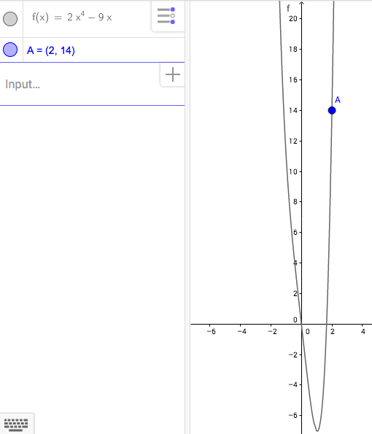

6.

$$2x^{3}-7x \left(1,-5\right)$$

First point:

X=1-0.01=0.99

=$2{\left(0.99\right)}^{3}-7\left(0.99\right)$
=$-4.989402$

First point: (0.99,-4.989402)

Second point:

x=1+0.01=1.01
$$=2{\left(1.01\right)}^{3}-7\left(1.01\right)$$
$$=-5.009398$$
Second point: (1.01,-5.009398)

Slope: $\frac{(-5.009398-\left(-4.989402\right))}{1.01-0.99}$

$$=\frac{-0.019996}{0.02}=-0.9998≅-1$$

Therefore, the slope of the line is -1. √

$$y=m\left(x-x^{1}\right)+y^{1}$$
$$=\left(-1\right)\left(x-1\right)+\left(-5\right)$$
$=-$1x+1-5
$=-x-4$ √

Therefore, the equation of the tangent line at (1,-5) is $y=-x-4$

$$y=2x^{3}-7x y=-x-4$$
$$2x^{3}-7x=-x-4$$
$$2x^{3}-7x+x+4=0$$
$$2x^{3}-6x+4=0$$
Factor 2
$$2\left(x^{2}-3x+2\right)$$
$$\left(x-1\right)(x-1)(x+2)$$

$Therefore, x=1 or x=$−2

To find the y-value substitute $x=-2$

$$y=-x-4$$
$$y=-\left(-2\right)-4$$
$$y=2-4$$
$$y=-2$$

Therefore, the other point of intersection is (-2,-2) √

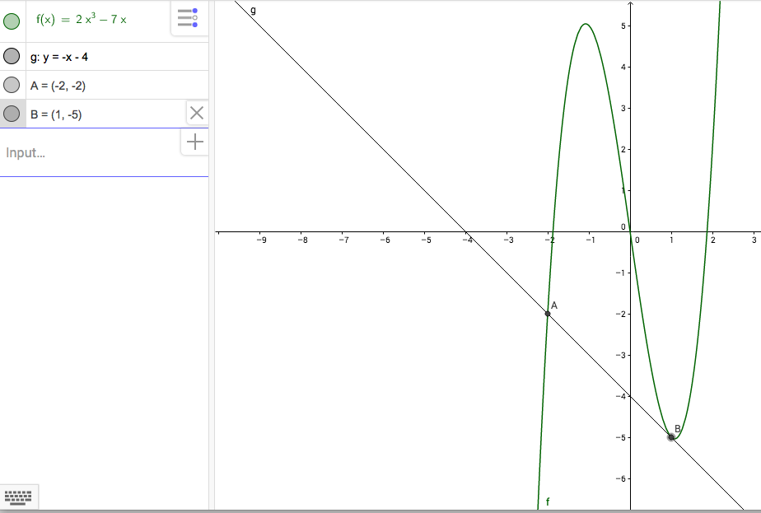

7. 11/12

a)
t(seconds) | h(metres)
0 | 1
1 | 11
2 | 17
3 | 19
4 | 17
5 | 11
6 | 1
7 | -13

b)
$$Δt$$ | $$Δh$$ | $$v=\frac{Δh}{Δt}$$
1-0 | 11-1 | 10
2-1 | 17-11 | 6
3-2 | 19-17 | 2
4-3 | 17-19 | -2
5-4 | 11-17 | -6
6-5 | 1-11 | -10
7-6 | (-13)-1 | -14

Therefore, this represents that the ball continues rising until 3 seconds, where it stops until the after 4 seconds and begins its descent back down. This represents a quadratic equation. √

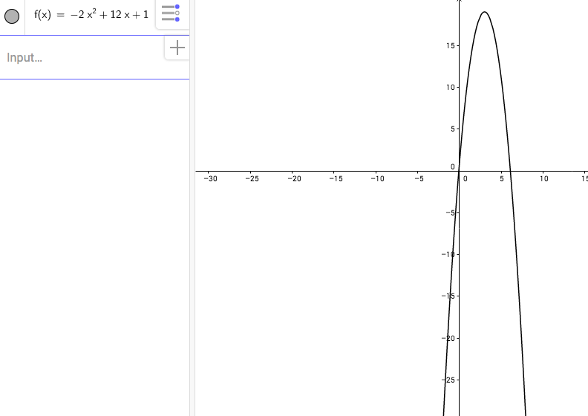
c) When the velocity is positive the baseball is rising, when it is negative, the baseball is falling back down to the ground. The velocity changes because the ball begins to fall and stops rising. Until 3 seconds the graph is increasing and the function’s slope is increasing. At (3,19) the graph has its maximum point.

d)The velocity is 0 m/s between 3 and 4 seconds [..at exactly 3 seconds. This is half-way between the intervals 2-3 and 3-4. This is also where the vertex of the parabola is.] This means the ball has stopped rising and is preparing to fall to the ground, where the negative velocity will begin. The slope of the function is 0. It represents the maximum height, (3,19) of the ball where velocity is temporarily 0 m/s.

e) At h(t)=7 $-2{\left(x-3\right)}^{2}+19$
$$-2{\left(x-3\right)}^{2}+19$$
$$=-2\left(x-3\right)\left(x-3\right)+19$$
$$=-2\left(x^{2}-6x+9\right)+19$$
$$=-2x^{2}+12x-18+19$$
$$=-2x^{2}+12x+1$$

a=-2 b=12 c=1

$$\frac{-b±\sqrt{b^{2}-4ac}}{2a}$$

$$t=\frac{-12±\sqrt{{\left(12\right)}^{2}-4\left(-2\right)\left(1\right)}}{2\left(-2\right)}$$

$$t=\frac{-12\sqrt{144+8}}{-4}$$

$$t=\frac{-12±\sqrt{152}}{-4}$$

$t≅-0.082207 or t≅6.08$ √

Second point:
6.08-0.01=6.07
t=6.07

h(t):$-2{\left(x-3\right)}^{2}+19$
$$h\left(6.07\right)=-2{\left(\left(6.07\right)-3\right)}^{2}+19$$
=$-2{\left(3.07\right)}^{2}+19$
$$=-2\left(9.4249\right)+19$$
$$=-18.8498+19$$
$=0.$1502
$$Second point is \left(6.07,0.1502\right)$$

$v=\frac{y^{2}-Y^{1}}{x^{2}-x^{1}}=\frac{0-0.1502}{6.08-6.07}=-15.02$m/s

Therefore, the ball hits the ground at 6.08 seconds and the instantaneous speed when the ball hits the ground is -15.02 m/s downwards. [Using a point on either side of 6.008 will give the exact speed, which is 12.32 m/s downwards.]

Task 3: Communication questions
8.

Rate of change: The rate of change is the rate at which one variable changes in comparison to another.

An example of rate of change would be the interest added to a principal amount compounded each year with a set amount of interest over a number of years. The new amount in relation to the previous amount, the difference is the rate of change. √

Amount of $5000 invested at 4% compounded annually.

Year 0 5000 $\frac{5200-5000}{1-0}=\frac{200}{1}=200$
Year 1 5200 $\frac{5408-5200}{2-1}=\frac{208}{1}=208$
Year 2 5408 $\frac{5624-5408}{3-2}=\frac{216}{1}=216$
Year 3 5624

9.

a) When the average rate of change is zero it means the growth, increasing or decreasing has stopped. When the value or x increases, the value of y remains the same.

Example: When a person is walking to a destination their speed in relation to time can be calculated with average rate of change. When that person stops for a period of time and they are not moving. Their zero movement would be modeled by zero rate of change. The x-value of time would continue however, the y-value of distance and speed would be zero.

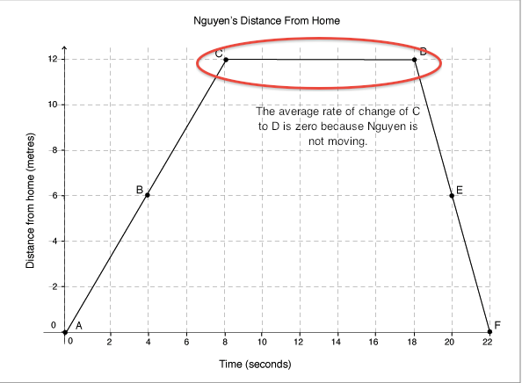

b) When the average rate of change is constant, it is a linear equation and it increases or decreases with a constant rate of change.

Example: The average rate of change of which a bathtub drains is constant. The height of the water decreases in relation to the mount of time at a constant rate.
Height of water = – 20 cm $\frac{0-20}{30-24}=\frac{-20}{6}=-3.3\frac{cm}{m}$
Time it take to drain = – 6 minutes

c) When the average rate of change is variable it means the rate of change is not constant or zero. The x and y values constantly change over time. The rate of change varies.

Example: A bacteria culture that grows at a rate of 20% per hour over four hours is an example of variable rate of change. The growth is compounded, when the initial amount grows, and there are more bacteria present, the growth accelerates at a faster rate. √

Time Bacteria
- 1000 $\frac{1200-1000}{1-0}=\frac{200}{1}=200 bacteria per hour$
- 1200 $\frac{1440-1200}{2-1}=\frac{240}{1}=240 bacteria per hour$
- 1440

10.

Three factors that influence the domain of a combined function are whether the function has a denominator, whether the function includes a radical sign and the restrictions on the domains of the individual functions. The restrictions on the domains of the individual functions affect the domain of combined functions because you can only add or subtract y-values where y-coordinates for both functions exist.

Example: Restrictions- The domain of f(x) is 0$≤x≤8 and the domain for g\left(x\right)is-3≤x≤6 then the domain for \left(f+g\right)\left(x\right)or \left(f-g\right)\left(x\right) is 0≤x≤6.$

Example: Denominator- This influences the domain of a combined function because there is a restriction on the value of the variable that makes the denominator equal to 0.
$\frac{6x+1}{x+4}$ is the sum of f(x):$\frac{1}{x+4}$ and g(x):$\frac{6x}{x+4}$ Therefore, the value that makes the denominator equal to 0 is x=-4.
Therefore, the domain is D:$\{ x∈R|x≠-4\}$
Example: Radical- The expression within the radical sign must be either 0 or positive for the solution to be real.

$$h\left(x\right)=8+\sqrt{x}+6 g\left(x\right)=\sqrt{x+6}$$
Therefore, (x+6) must either be 0 or positive, the value for x must be equal or greater than -6.
$x+6≥0 x≥-6$ √

11.

Even functions: Functions are even if the graph of f(x) is symmetric in relation to the y-axis. Algebraically, f(x) is even if f(-x)=f(x) for all x in the domain of the function. Whatever the graph is doing on one side of the y-axis is mirrored on the other side. F(a)=f(-a) means x-coordinate becomes negative, the y-coordinate remains the same.

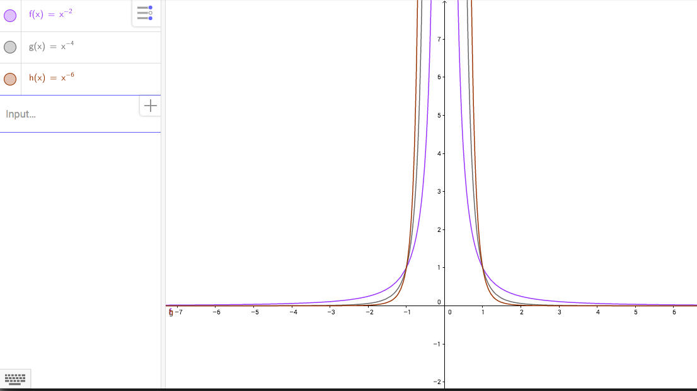

Odd function: If a function is odd it is symmetric about the origin meaning if you begin at a point on the graph on one side of the y-axis and draw a line from that point through the origin and extend the same length on the other side of the y-axis, you will get to another point on the graph. Algebraically, if you end up with the opposite of what you began with, the function is odd.
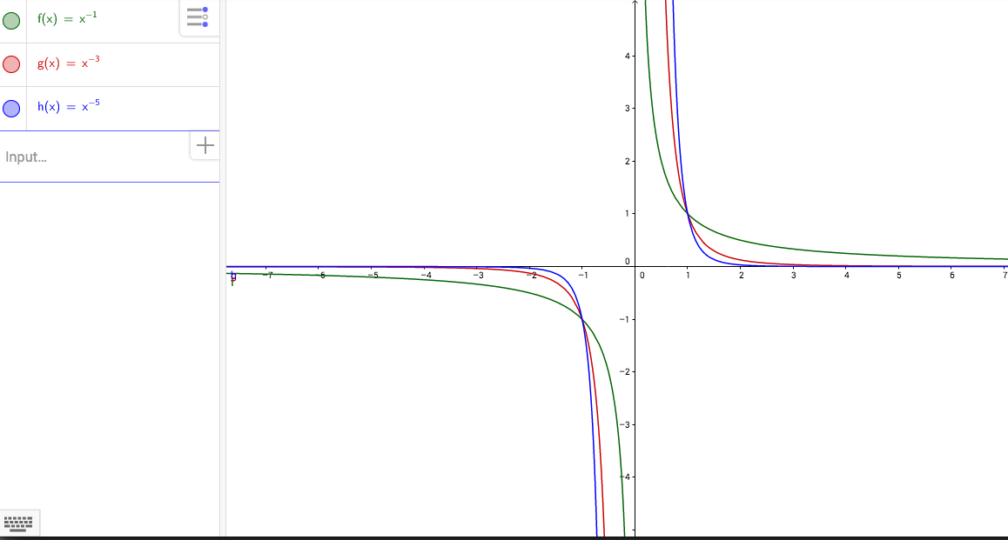

12.

Composite functions: A composite function is the combining of functions in a manner where the output from one function becomes the input for the next function. The range, y-value, becomes the domain, x-values, of the next function.

h(x)$=3x-5 and f\left(x\right)=2x^{2}-7x find \left(h*f\right)\left(x\right)$
$$\left(h*f\right)\left(x\right)=g(h\left(x\right))$$
$$=2{\left(3x-5\right)}^{2}-7\left(3x-5\right)$$
$$=2\left(9x^{2}-30x+25\right)-7\left(3x-5\right)$$
$$=18x^{2}-60x+50-21x+35$$
$$=18x^{2}-81x+85$$
$$\left(h*f\right)\left(x\right)=18x^{2}-81x+85$$

Combined functions: A combined function is a collection of functions to find the sum, difference, product and quotient. The order does not matter. Combining a function creates a new function using the operators in one of the ways listed below:

h(x)=f(x)+g(x)=(f+g)(x)
h(x)=f(x)-g(x)=(f-g)(x)
h(x)=f(x)$×g\left(x\right)=\left(f*g\right)\left(x\right)$
h(x)=$\frac{f\left(x\right)}{g\left(x\right)}=\frac{f}{g}\left(x\right) g≠0$

The domain of the new function h(x) is the intersection of the domains of g(x) and f(x). Restrictions on the domain of f/g are any value of x that makes g(x)=0. √

Task 4: Application questions
13.

$f\left(x\right)=3\sqrt{x} and g\left(x\right)=2^{x}$

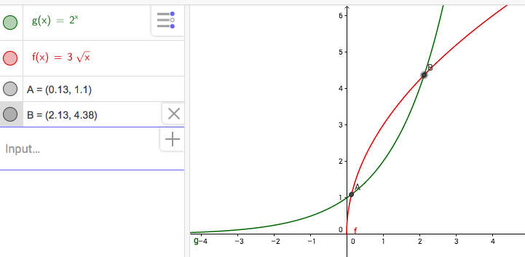

Therefore, the combined function is $3\sqrt{x}-2^{x}$
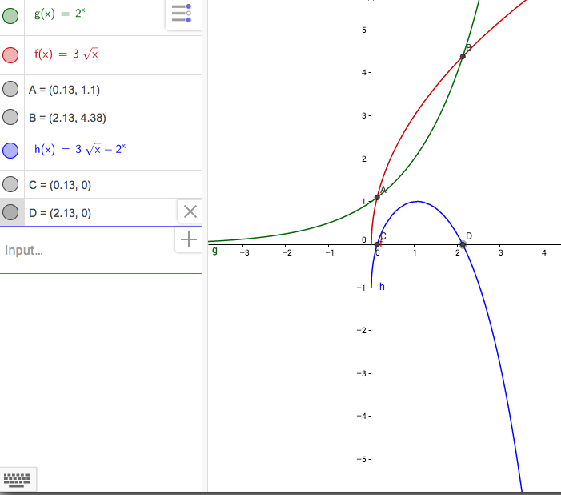

The roots of the combined equation are x=0.13 and x=2.13 √

Substitute x-values of points of intersection into one of the original equations to find y-value.

$$f\left(x\right)=3\sqrt{x}$$
$$f\left(0.13\right)=3\sqrt{0.13}=1.1$$

$$f\left(x\right)=3\sqrt{x}$$
$$f\left(2.13\right)=3\sqrt{2.13}=4.38$$

Therefore, the points of intersection are (0.13,1.1) and (2.13,4.38).

Examining the graph you can determine that for the interval $0.13≤x≤2.13$, $3\sqrt{x}≥2^{x}.$ √

14.

a) 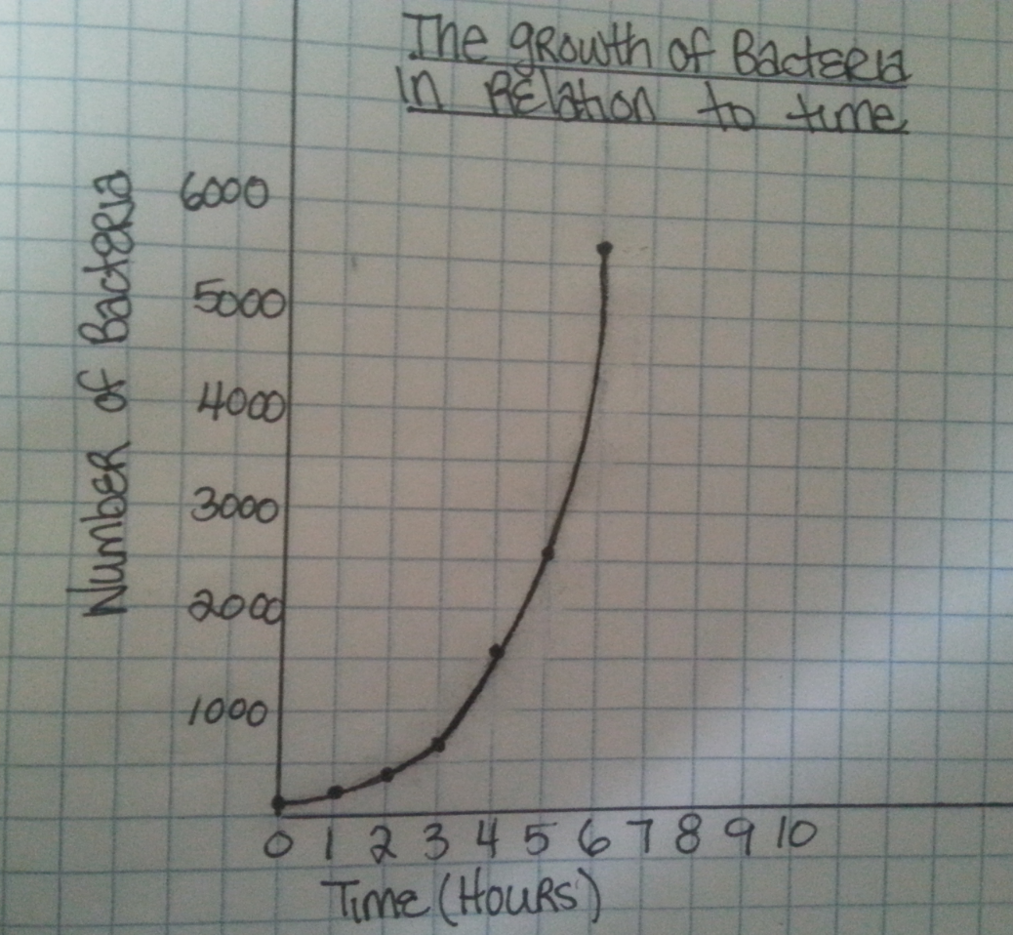

b)Linear model:
Equation: f(x):798.89x-797.82
Correlation coefficient: r=0.8742

Quadratic model:
Equation: $233.85x^{2}-604.18x+371.4$
Correlation coefficient: r=0.9801

Exponential model:
Equation:$104.08e^{0.6608x}$
Correlation coefficient: r=0.9989 √
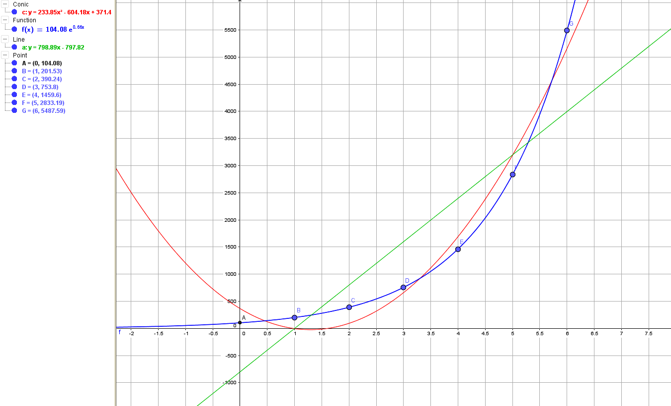

c) Linear:
f(x)=798.89x-797.82
f(0)=798.89(0)-797.82=-797.82

Quadratic:
f(x):$233.85x^{2}-604.18x+371.4$
f(0):$233.85{\left(0\right)}^{2}-604.18\left(0\right)+371.4=371.4$

Exponential:
f(x):$104.08e^{0.6608x}$
f(x):$104.08e^{0.6608\left(0\right)}=104.08$ √

d) The linear model is unsuitable because it predicts a negative number, the quadratic predicts that there were 371.40 initial bacteria, which is too much, and the exponential model predicts that there were 104.08 initial bacteria. The exponential gives the most realistic answer because it is the closest to the initial number of bacteria we are given.
e) The exponential function is the best model for this data because it more accurately predicts the amount of initial bacteria at 104.08 compared to the amount we were given at 98. The correlation coefficient is closer to one, which represents a strong positive correlation between the variables compared to the linear and quadratic functions. √

Final mark = 99%

