INTERNATIONAL DEVELOPMENT REVIEW

DEFINITION OF GLOBALIZATION: Must memorize for test
“The intensification of world wide social relations that must 1) link distant localities that 2) in such a way that local happenings are shaped by events many miles away and vice versa”

CANADA IS:
- A wealthy industrialized and advanced country

Development involves more than economic assistant to foreign Countries it is a multidimensional idea: Social, economic, cultural and political

Globalization in Canada has lead to foreign restaurants coming to Canada making it easy for us to experience other cultures in our own Country.

Ideas (thought) turn to conceptions (base is created to define human beings) turn to theorization

THE PROTESTANT REFONISM - MARTIN LUTHER

Religious conformity: Not being able to express ones self as an individual and comfortable way, giving your free will to those of others in the name of your faith

Ascribed status: The social status that pre modern times were born into; no room to improve
Martin Luther believed that true faith works through the individuals. Everyone should guide their own religious study. Working hard will improve ones standard of life. So you must take faith in to your own hands and work hard. This was the beginning of individualism.

What did Luthers theories and the protestant reform accomplish?
- paved way for the emergence of new perspectives on the conception of development
- emphasis on an ordinary, hardworking and productive life
- Work hard to better ones life
- Liberation from ascribed status
- Hardworking is ethically right because it is blessed by god
- A social virtue that accounts for the common good

ADAM SMITH 1723-1790

- Protestant believer
“All human beings are free because they have the capacity to understand and reason which makes them free”
- self-interest seekers
- self controlling
- Free to do their own business
- People are capable of governing themselves
- He suggests that there should be no monopoly and no intervention
- Father of Classical Liberalism
- His beliefs took off in the 19th century

LIBERALISM BECOMES DEVIDED 19th century:
Neoclassical (or business) liberalism vs social (welfare) liberalism
- Neoclassical liberalism leads to a prosperous life
- Social liberalism leads to a good life

THOMAS GREEN 1836-1882
- Believed that good development in society is associated with some level of government protection. A believer in welfare socialism and linked his economic ideas to that of John Maynard Keynes.
- Government is a protector of individuals plan for a better life
- Public education should enrich self realization and moral character to become self responsible citizens

JOHN KEYNES
John M. Keynes argued that during the great depression the markets were not automatically adjusting so there was a need for government intervention. Keynes economic plan was a response to the failing invisible hand theory.
Keynes Triple R theory
- Recovery: Turn the economy back to normal levels
- Reduce: Stimulate production so that the economy can return to normal
- Relief: For unemployed and poor citizens

What ended the kenesian era?
- Vietnam war
- oil crisis
- too much money chasing and too few goods
- sense of instability and the resurgent right wing

LESSON # 4 - economic growth

WALT ROSTOW: ECONOMIC GROWTH 1960

Walt Rostow only presents development based off of high mass consumption and how economically sound a country is

- Traditional society
- precondition to take off
- Take off (movement from countryside to city)
- Drive to maturity (Country is economic develop, middle class)
- High mass consumption (economy that is driven by consumption)

What Rostow believes
- traditional, undeveloped societies follow steps until they reach high mass consumption which is believed to be developed and modernized countries
- The traditional societies can not move or find their own way to development unless external forces assist them (to prepare them for the transitions)
- High mass consumption is only viewed at ones ability to produce GDP there was no relevance of social or political development

Positive dimensions of his theory:
Can improve quality of life through assistance from developed countries and accumulation of capital

He believed workers must transfer from agriculture to industrial centre to equate goods and services, once the country begins to create goods and services they are beginning to become developed and they must grow their production of these products to accumulate more capital, then they must distribute these goods and services world wide which will lead them to become a developed country.

ROSTOWS DEFINITION OF DEVELOPMENT:By enhancing economic wealth and growing supply of product will result in a society that will accumulate and fairly distribute capital which will lead to economic growth, resulting in a developed country.

THE THEORY OF BASIC HUMAN NEEDS

This theory goes beyond economics and begins to account for social factors, such as, the need for education, shelter, food, and health.

Although more effective, this system is still capitalist-based. Development is understood for the theory of economic development and meeting some social requirements, however the societies are still in need of western intervention.
**THEORY PRESENTED BY THE INTERNATIONAL LABOUR UNION***

NEO MARXIST APPROACH TO CAPITALISM
2 parts

This is a radical social approach: The two branches of dependancy theory (lower case for theory) HANS SINGER AND PAUL PREBISH
- More developed countries are keeping less developed countries with them
- Without the less developed countries developed countries can keep low rates on their raw materials

- The Dependancy Theory (1960s): This looks at country to country dependancy
Development means the underdevelopment of poor societies. This being said, the throw believes that dependancy of the countries began long before recent times. Developed countries are dependant on undeveloped just as much as the undeveloped are dependant on the developed. The developed use international trading law to maintain this relationship. The metropoles (or developed) rely heavily on the raw materials from the underdeveloped.

****PAUL PREBISH: Related to the Dependancy Thoery: The “haves” and “have nots”- the socially constructive nature of dependancy

(b) World system theory: The second theory of the dependancy theory

Wallerstien agrees with Prebish’s theory but takes a deeper look claiming that everything works off of dependancy: international system, law and politics

PART 4:ALTERNATIVE APPROACHES / HUMAN DEVELOPMENT AND CAPABILITY APPROACHES

MAHUB UL HAQ: Worked with the human bank, created the name “Human development”
AMARTYA SEN: He suggest that we must put great emphasis on human rights and freedoms . This is an individualistic based approach.

AMARTYA SEN: The Capability Approach
- Development must be understood by the capability of the people (the actualized freedom)
- Difference between freedom and capability: freedom in the real life where you can practice ON YOUR OWN FREE WILL. The capability approach to development is viewed as from a humans perspective which involves cultures and all kinds of non economic components
What we can learn from this theory:
- Income (GDP, GNP) is only instrumental for the means of development
- Human beings are not just mere economic beings
- Everything must be linked to human beings if the emphasis is on happiness of humans
- Development involves widening of the choice: give humans the ability to choose

PART 5: NEOLIBERALISM, WASHINGTON CONSENSUS, MILLENIUM DEVELOPMENT GOALS

1979-1980: A group of decision and policy makers concocted a new theory called new neo liberalism
What is the difference between the first and second neo liberalism??
Accelerated deflation, widespread unemployment and decrease in tax on incomes

- Thinkers began to saw a weakness in capitalism
- This goal came to birth by american right wings, the wold bank and large companies
- Cut state spending: no investment
- Margaret thatcher, ronald reagan
- Don't allow wage raises to stop deflation

WASHINTON CONSENSUS
JOHN WILLIAMSON 1989-1990 of the world bank
Policy reforms: Rejected ISI, openness to work economy
- fiscal discipline (Price stability)
- narrowing public expenditures (should be rationalized, other spending besides education should be avoided)
- Tax reform (create uniform tax code)
- Cut tax rate (promote foreign investment making economy global effective)
- maintaining competitive exchange rate (value of one currency expressed in another, lowering currency values to promote exports)
- deregulating the economy

MELLENIUM DEVELOPMENT GOALS
the year 2000
8 different countries set in place a motion that specified 8 goals for developing Countries:
- Eradicate poverty and hunger
- Achieve universal primary education
- Promote gender equality and empower woman
- reduce child death
- Improve maternal health
- Combat HIV/Aids/ diseases
- Ensure environmental sustainability b b by
- Global partnership for development

LESSON #5: Definitions, paridgm shifts in international life

- Globalization attempts to raise human understanding

WHAT IS GLOBALIZATION?
- Bringing cultures together
- Removing barriers for countries
- Global integration of goods and products
- Creating a global economy
- Reference to something beyond boarders
- Process of deterritorialization
- Global interconnectedness

International refers to the relationship BETWEEN borders (borders are still there). When we speak of global interconnectedness the only border left in the world is the globe.

MANFRED

GLOBALIZATION must be defined as world wide social relations which will link link distinct localities in such a way where local happenings are events occurring many miles away, vice versa.

- Increase social networks beyond borders, world wide
- Expansion and stretching of social relations by intensifying and stretching exchange and activities
- Macro structures of global community and micro structures of global personhood
- The end of the westephalian system
- To destroy the beginning go the world we live in today (starting in 1648)

WESTAPHALIAN WORLD/SYSTEM
- The term Westiphalian came to term from the peace treaty signed in 1648 which was after the 30 year war in Europe
- Commonly referred to as the pact of international relations

ELEMENTS TO THE WESITPHALIAN WORLD CREATED IN 1648:
- Creation of independent nation-states; where nations are independant
- All states of the world are created no matter how big or small
- Recognizing sovereignty (power of one over a group) within each boundary
- No state can interfere with another state
- Emergence of modern international law

WESAPHALIAN CONCEPT:
- Once again, the important concept of this concept is to understand that it was based on borders, the right for countries to operate individually

GLOBALIZATION.. directly question these borders put in place in 1648 and now, once again, borders are becoming less distinctive.

Distinction between Globalization and Globality

GLOBALIZATION: A process which moves you towards something with the help of technology and innovations and a new way of thinking.
GLOBALITY: This is the “something” in which we are moving to. The world without borders.

2 CONTRADICTORY DIRECTIONS FOR OUR FUTURE
- More Individualism: competition, and search for self benifits.. this is a negative direction
- Emerging into a global community (the cosmopolis)

So what is cosmopolis?
The whole state living together in a globe.

APPADURAIS THEORY:
Condition of globally must be understood through these 5 main ideas:
- Ethnoscapes - the migration of ethnic groups, tourists across the world
- Technoscapes- The use of technology created in one country to assist another
- Financescapes- The free market of trade world wide
- Mediascapes- the media of images transferring all over the world
- Ideoscapes- Ideologies can separate from their homes but be carried on

DEBUZINSKIS ANSWER:
**negative**

Ask for help

LESSON # 5
Process and condition of globalization:

Process was instrumental and moving towards globality
Condition of globally is the end goal

1. HYPER GLOBALISATION AND NEO LIBERALISM
- FIRST neo liberalism arrived in the 19th century to WW1 this was known as classical liberalism and broke into two branches
- SECOND came Hayek and Perelin society who reconstructed the economics of it
- THIRD was the new neo liberalism which occurred from 1979-1980 with scholars such as Margaret thatcher
- FOURTH was the Washington consensus which occurred from 1989-1990 led by John Williamson and to open the market up and become more accessible to trade

Classical liberalism/birth of neo liberalism:
The decision to leave the gates open with the end goal of profit and human happiness

New neo liberalism/neo conservatism:
1979-1980 Policy makers wanted the ultimate goal to be to do business and extend capitalism

Washington consensus:
1989-1990
Tax reform, trade liberalization. Open the gates further to extend trade, and ultimitaly, result in more profit

THEORY #2: Skeptic view of globalisation
- There are a lot of ways to enhance life
- There is no unified global economy - there is a multipolar world with many different sides in the market
- Cultures can improve beyond and away from capitalism
- BENJAMIN R. BARBER was a skeptic to neoliberalism, believed hyperglobalisation was responsible for not only material obsessiveness but political problems. Believed the problems were too big for the individual and there should be mayors to control and make decisions.

THEORY #3: Transformationalist theory
- Mix of opportunities
- Glocalization: understood in terms of its direct impact for development and how it can go in many ways
- Glocalization has winners and losers
- Globalization will reduce levels brought on by hyperglobalisation

MIDTERM REVIEW: DVM
3 Paradigms of international operations:

- Realism: The 3 “s”

Security: Search for security of ones own state
Sovereignty: The state is the international actor
Self-interest: Each international decision is made for the benefit of the state

There is no room for morality with this theory. The international goal of this paradigm is to find power through conquest, influence other economies, and create alliances for military use to preserve security.

(2) International Liberalism

The state is still the international actor, however, there is a universal law, states operate rationally and cooperatively. They see the importance of a long-term friendships to promote sharing of technology, culture and lessen conflict globally.

(3) Cosmopolitanism

The International actor is us, as humans, we are all equal regardless of political stance, religion, color, age, sex, ect. We all have the responsbility to help and everyone deserves an equal chance at living.

THE 1960’s
- CIDA (Canadian international development agency)
This was created when Pierre Trudeau was the Prime Minister. It focused on social development, economic well being, environmental stability, and human rights, Gender equality. Canadian aid is typically distributed through CIDA. This was a shift for Canadians to become actors in foreign aid and separate itself from the U.S.A. (1968-1976)

THE 1970’s
- SHIFT back to international liberalism: Canada wanted to become a strong economic player internationally. Capitalism became the forefront of making this possible. There was a weakening in humanitarian concerns. (1977-1995)

THE 1990’s
- THE NEW ERA was born when citizens in Canada became more focused on human security and the security of international programs (1996-2000)

OECD
ORGANIZATION FOR ECONOMIC COOPERATION AND DEV.

- Created in 1948
- Original job was the marshell plan (used to reconstruct european countries)
- Canada joined the organization in 1960

Promote economic and social well being around the globe by:
- Committing to democracy
- Finding solutions to common problems
- Mutual learning

This was a capitalist group specifically International Liberalists because:
- Economic cooperation is useful for political acheivments
- It creates good policies from mutually sharing ideas
- By improving prosperity there is a reduction in povery

1931: The Statute of Westminister
- Signed by the british on December 11th
- This was when Canada was granted legal freedom from British rule (except for the colonies subordinate to Britain)
- Britain gave up over riding authority of Canada
- Canada could now engage in the world as a country

1945: The UN and Canada
- Canada was the founder and creator of the united nations

1948: The UNDHR and Canada
- Universal Declaration of Human Rights
- This gives rights and freedoms to all human beings
- In Canada, it was a primary shift to justice & equality
- The declaration was proclaimed by the United Nations General Assembly in 1948
- For the first time, fundamental human rights are to be protected

1949: International Convention Against Human Torture: This was created by the UN aimed to prevent acts of torture, or other cruel or degrading acts
International Convention against gender discrimination: Created by the UN to be rid of human trafficking, gender discrimination.

The Geneva convention: Regulation the conduction of armed conflict and seek to limit its affects.

ALL OF THE 1949 CONVENTIONS WERE AIMED AT PROMOTING HUMAN RIGHTS AND WERE CREATED BY THE UN

Canada did lack attention to developing countries in the 1940s:
- Canada was still strengthening the formation of its own Country seeing as it just gained its independence in 1931
- Canada was never a colonizing country
- Canada wanted to show that they were different than the USA

Factors that impacted Canadians position in the developing world:

#1: THE UN
By creating the UN, Canada had joined a group that promoted internaitonal cooperation in economic, social and cultural issues. The UN stated that all joined members have an obligation to promote social progress and provide a better standard of life.

#2: THE UNDHR
Members are obligated to assist developing countries in humanitarian causes, promoting them to focus on human equality.

THE COLOMBO PLAN OF 1950
- Created to prevent the spread of communism
- Provided support to South Asia
- This was during the cold war and was strictly a political angle
- The USA wanted to show its leadership over USSR
- This was a realist plan, not a “good development”

In the 1950’s and early 1960’s Canada was still developing and was cautious of its involvement with third world countries. However, in 1968 CIDA was born and Canada began to get more involved, marking a NEW ERA. Canada became more independent with trade policies and began to adopt a humanitarian stance in the globe.

ECONOMIES: DEVELOPED ECONOMIES ARE MIXED (MELANGED ECONOMIES)

Socialist/Communist: (social welfare, centrally planed, state owned)
Neoliberal/Capitalist: (Private enterprise, free market)

EMERGING ECONOMIES are “A society transforming from a dictatorship to a free-market-orientated-economy, with increasing economic freedom, gradual integration with the global market, an expanding middle class, improving standards of living, social stability and tolerance, as well as an increase in cooperation with multilateral institutions”

Emerging countries are progressing to becoming advanced but still do not have the market efficiency/strict standerds of a developed society. They are still suffering from political instabilities.

In order to emerge these countries typically:
- Have entrepreneurial decision making
- Realize the na ture of technology
- Well-educated work force
- Increase in exports

FACTORS OF RAPID GROWTH FOR E.E
Physcial financial infrastrcture, higher GDP for foreign investors, political stability, factors preparing them to join the global market.

Import Substitution Industrialization
Developing countries did not want to get expoited so they began to produce their own products. They were trying to be self-sufficient. This lead to a fall in export earnings, which lead to a fall in national income. Not an effective method.

Trade liberalization
Post WW2 1945: Liberalizing trade meant the reduction of trade barriers by reducing tariffs and opening the market up to underdeveloped countries. This created international peace. It enhanced global access to goods, services and investments. Raised living standard around the world.

Maturity of the private sector
Investing in “capital stock” to fuel economic growth through bank loans, portfolios, ect.

INDICATORS OF SUCCESS IN E.E

IN SOUTH ASIA (1) THE ACCUMULATION THEORY (2) THE ASSIMILATION THEORY

- THE ACCUMULATION THEORY: Capital investment
- ASSIMILATION THEORY: Learned through western cultures and the innovation, technology. Allowed them to adopt and adapt and earn more money.

South Asia: Fastest growing economy in the world. The governmental policies and private sector
INDICATORS OF CHALLANGES IN E.E
- LATIN AMERICA
- THE MIDDLE-INCOME TRAP

- Latin America: The government and the private sector did not talk enough, no communication leads to slow economic growth

(2) The Middle-Income Trap: In a labour intensive work field there is a need for people to produce, so in order to hire workers, raises must be given. This adds to the cost of production, which leads to an increase in cost of goods. Then there are cheaper items on the market for people to buy, so you get trapped in the middle income.

How to fix?
- Protect ideas
- Create technology and machines to hep do the job

GOOD DEVELOPMENT AND HUMAN DEVELOPMENT
Everything is created by humans and should be for the humans in the world

INTERNATIONAL BILL OF HUMAN RIGHTS
made up of 3 documents
1948: UNDHR
- defined human rights and the fundamental rights
- All humans, regardless of their differences must be able to enjoy their life
- A cosmopolitan view

1966: INTERNATIONAL COVENANT ON CIVIL & POLITICAL RIGHTS
- Justice and peace in the world
- rights of self-determination
- no one shall be held in slavery
- Must be told why you are being arrested and receive a fair trial

1966: INTERNATIONAL COVENANT ON ECONOMIC, SOCIAL AND CULTURAL RIGHTS

THESE ARE EXAMPLES OF “GOOD DEVELOPMENT”

1998: Human right considerations
- no aid to repressive regimes
- universal programs for development
- foreign aid for the least developed

CANADA WILL ONLY HELP IF THE FOLLOWING CRITERIA IS MET:
- Freedomg from arbritary arrest and detention without out trail
- Freedom from torture/other inhumane treatments
- Freedom from deliberative denial of sustaining life
- Freedom from extrajudicial execution

CANADA & HUMAN RIGHTS BEFORE 1987

1950: Aid was focused on the effects of the cold war, the colombo plan assisted south asia.

1987-1991: A NEW STRATEGY:

- Suspension of the aid programs to countries which violate human rights
- Reward incentive for improving Human Rights
- Emergency humanitarian aid - We will help a country no matter what when there is an emergency

Canada and the promotion of human rights and democracy

DEMOCRACY: is vague conception, democracy is not necessarily any specific kind of political regime or government, to understand democracy as an idea. This idea might be employed, used by different political ideologies for their different purposes.

THE THEORY OF DEMOCRATIC PEACE
International society will be managed in a kind of peaceful order as long as members of international community become members of the democratic society. Democracies never wage war against each other because democracies are rational societies, liberal democracies especially (those societies in which all citizens have been able to move away from their own selfishness and have become reasonable people, they can ration together). Liberal democratic societies are the peaceful societies.

Theory suggests that as long within societies - by the democratic behaviour extends from inside to outside. Liberal democratic states are open to listen to others and have a dialogue and cooperation with other nations in a peaceful manner.

- Westiphalian international system must be replaced by a democratic international system.

What is the essence of the idea (Main Idea) of Theory of Democratic Peace?
- Liberal democracies prefer negotiation and talking together, interested in each other.

Democracy is not a clear, straight forward conception. It is a kind of tool or instrument in the hands of politicians to figure out they political objectives. New democracies are politically less stable than the original ones. Why is that? It slowly becomes the belief system of people over an extended period of time, but it does not happen over time.

2 LOGICS REGARDING DEMOCRACY:

Supporting: we can not prescribe the same size for all, it takes a longer time for smaller states, it takes a long history and transformation within the minds o that people

Against: Sometimes we must be indifferent for democracy,

Difficult to agrue that democracy is the key to everything

WHAT OPTIONS ARE AVAILABLE FOR US?

- We are indifferent (no this is bad)
- Demonstration of democracy, rely on the power of their own choice, (good)
- Proactively definiton: impliment/create opportunity for others to be active. (good)
- Forecabally put democracy on people (no this is bad)

What have we done for democracy in the support of development in other countries?

(1st period 1980-2004)

- For the first time Canada is directly engaging democratization in the international affairs in 1988, when we created ICHRDD (more advanced than CIDA), be proactive to implement new ideas/opporuntites in the other countries to be able to democratize themselves without the directly engaged in defining our link in our own development policies
- 1996 (cold war is collapsed, a time when human rights is globally growing and spreading around the world, multiple channels of interaction with other countries beyond the limitations and ideological factors of the cold war)
- When we refer to democracy, it is a critical point, politically correct other countries. A political reform in institutions of other societies, WE WANT TO EMPOWER THE OTHER STATES TO BE ABLE TO DEVELOP THEMSELVES. But we must remember democracy must be created in the mind set instead of institutions

(2nd period 2004-2011)

- Axworthy redirected programs to a NEW PERSEPCTIVE
- He has done a very good job at the movement (remember him, prof likes this dude)
- Human rights, democracy and good governance is a good development
- We need good planning to develop the south based in accordance with HR and democracy
- That time/period ended quickly because……

(3rd period 2012-now Conservative to close down all Canadian programs :( )
- Canadian government follows specific foreign policy that must be followed by EVERYONE. Even NGOS. No room to raise objection.
- Harper is a mean man according to prof**
- All rights for democracy pretty much shut down

HUMAN SECURITY AND INTERNATIONAL DEVELOPMENT

From a westaphalia world to a post westiphalia world.

TRADITIONAL SECURITY ——-> International peace and security
HUMAN SECURITY ————-> Human wellbeing

There are threats that go beyond borders and a need for a new understanding of security, they affect everyone, these things included:

- Chronic and persistant illness
- Climate-related disasters
- Organized crimes
- Human trafficking
- Pandemic crisis
- Sudden economic/financial problems
WESTAPHALIAN WORLD: National/international security, Economic growth, international law, national/international security

POST-WESTAPHALIAN WORLD: Human wellbeing, multidimensional development, International human rights laws, Human security

INSECURITY (WESTIPHALIAN WORLD):
- Lack of development
- Absence of global justice
- Lack of human rights and democracy

SECURITY (POST WESTIPHALIAN WORLD):
- Human development
- Millennium development goals
- Human rights and democracy at the forefront
- Social development
- Global social justice

WHAT IS HUMAN SECURITY ACCORDING TO THE U.N?

Human security is the right for individuals to live freely and with dignity, free from poverty and despair. All people, especially vulnerable people should have the freedom from fear and freedom to want. All individuals deserve and equal opportunity to enjoy all of their rights.

BETTER DEFINITION FOR TEST:

Human security is a dynamic and practical framework that addresses threats on a greater scale that face both individuals and governments. Recognizing that threats to security vary from within and across borders, the assessment of human security may address human insecurities, specifically, people-centered, comprehensive, context specific and preventative. This approach will focus on both current and emerging threats of the individual and communities.

Human security recognizes the interdependency of humans that are fundamental to all lives:
  - FREEDOM TO LIVE IN DIGNITY
  - FREEDOM FROM FEAR
  - FREEDOM FROM WANT

Human security acknowledges that each of the following are dependant on each other:
  - Security
  - Human rights
  - and Development
WHO SHOULD RECEIVE SECURITY:
    - All human beings, everywhere in the world
    - Security for community
    - Security for all subaltern groups
    - National security
    - International security

??SECURITY FROM WHAT??
- FREEDOM FROM WANT

Every individual should have social, political and economic stability as well as a job and income security to protect from bankruptcy. They should be safe in their home at a young age, so should have access to social services. Education is a must.

(2) FREEDOM FROM FEAR

Freedom from torture or arrest without reason must be banned, freedom from being in a war stricken area and free from conflicts.

(3) FREEDOM FROM ENVIRONMENTAL CONCERNS

Freedom from becoming ill to environmental concerns which can be raised from deforestation or pollution.

HUMAN SECURITY BY WHAT MEANS??
We must reach a state of acceptance and wellbeing for each other by working on becoming interdependant, working together to solve interdependent threats, use of the multidimensional means (political, social, cultural, economic), and work through humanitarian means.

3 POINTS TO NEW SECURITY:
- Personal security: Freedom from oppression, freedom to express ones own identity, radical change in the violent atmosphere
- Community security: The importance of community, a need for humans to work together
- Political security

WHAT IS A FRAGILE STATE?
A fragile state has low income, no economic growth, high poverty and low human development. Since the government is weak it is incapable of protecting the citizens and as a result there is not political stability. There tends to be conflict in affected areas because there is not a strong enough force of authority to prevent it, they are heavily dependant on aid programs. This is a serious problems in the eyes of development because they do not want to provide a reliance on economics.

WHAT ARE THE CAUSES OF FRAGILE STATES ?
There are a few causes for the fragility of states which include the following:
- STRUCTURAL AND ECONOMIC FACTORS
Natural resources and unearned state income
POLITICAL AND INSTITUTIONAL FACTORS
Elite incentives and predation, multiple claims to power, weak political transitions

SOCIAL FACTORS
Weak state society, there is not form of government to protect against conflicts. Lack of social cohesion.
INTERNATIONAL FACTORS
The international political economy of a state is weak, vulnerability to external shocks, colonial heritage
DYSFUNCTIONALITY AND FRAGILITY
TERRORISM:
  - Afghanistan, Pakistan, Somalia, Nigeria, Iraq, Yemen, Chechnya.
- Ethnic conflicts and civil wars
  - Nigeria, Sudan, Haiti, Bosnia and Herzegovina, Liberia, Pakistan.
- Drug and other flows
  - Afghanistan, Columbia

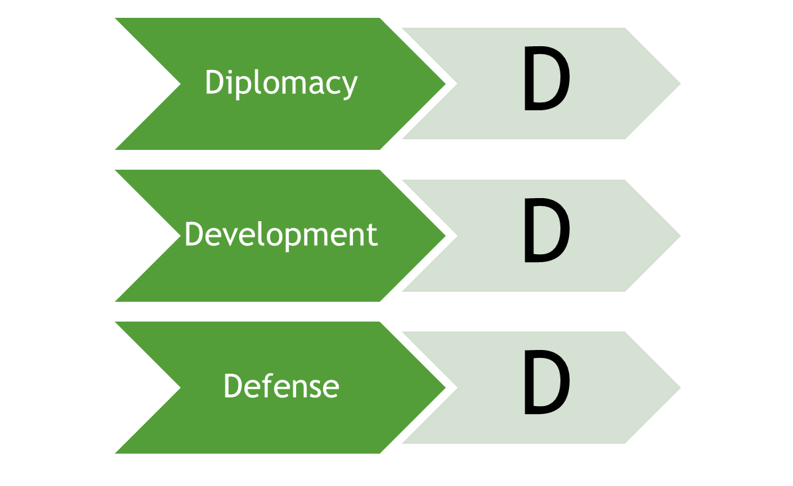
SOLUTIONS TO FRAGILE STATES:
- End of the Cold War: a link between aid programs and peace,
- Multi-dimensional/liberal peace-building,
  - Relief to development,
  - Human security,
  - Canadian Peacebuilding Coordinating Committee (CPCC),
  - Canadian Council for International Cooperation (CCIC),
  - Anti-personal land-mine treaty,
  - Protecting children and women in conflicts,
  - International Criminal Court (ICC).
  - Good government
  - Reconstruction of social, political, and economic institutions
  - Poverty reduction

- International indication of WOG
  - 2005 - The Paris Declaration of the Aid Effectiveness,
  - 2007 Paris declaration on Good Engagement in Fragile States and Situations.

WOG AND ITS ROOTS BACK TO HISTORY
- Peloponesian war
- Mix of realism and liberalism internationalism
- POST WW1: The 3 D’s : Development, defence, and diplomacy
- Colombo plan
- Peace-making initiative
  - Prevention of local wars
  - Controlling post colonial conflicts
  - An impartial zone for humanitarian decisions

WOG AFTER SEPTEMBER 11th TERRORIST ATTACK
- The reconstruction of war waged areas
- Engagement in Haiti
- There was an international political statement (stabalization and reconstruction taskforce (START)
- Global peace and security fund was created
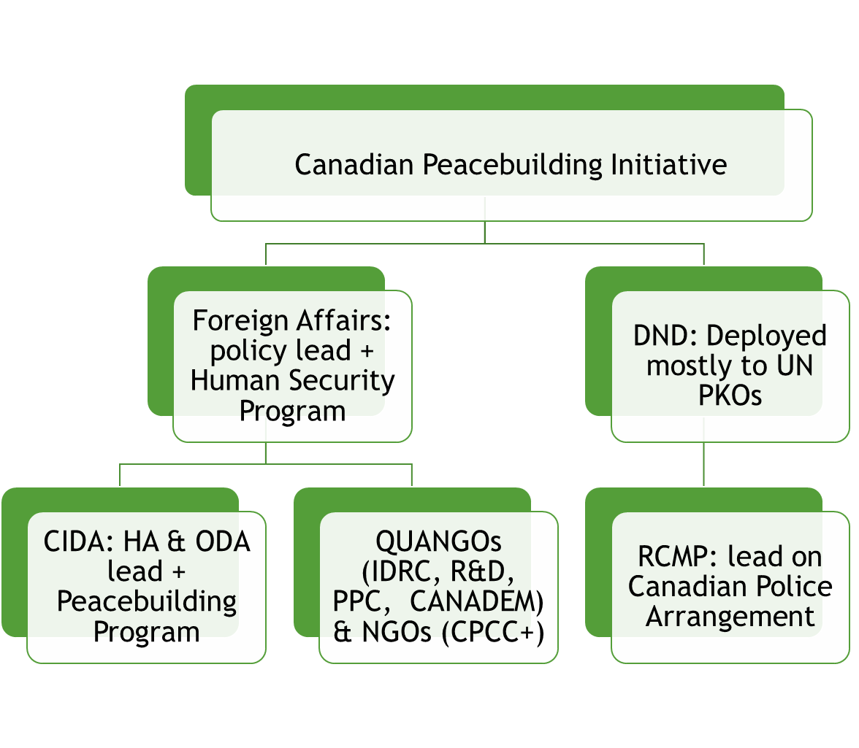
- Engagement in the dark crisis

A move toward the third generation of peace enforcement
1st generation | Traditional peace-keeping
2nd generation | Civilian task
3rd generation | Peace enforcement
4th generation | Peace-building
5th generation | Hybrid mission
Cold War | Liberal internationalism,  Realism,  Dependency theory,  Nationalistic movements,
Post Cold War | Liberal peace-building,  Move toward a new development-security nexus,  Peace-building and human rights,  Challenges of neo-realism
After September 11 | Post-colonial theory:  - Western domination, “governmentality”  - “biopolitical control”,  Peace enforcement and the new humanitarianism
- Development and humanitariann programs such as Westbank and Gara

AFGHANISTAN AND ITS FRAGILITY
  - STRUCTURAL FACTORS:
    - Ethnic fragmentation
    - Weak government and corruption
    - the centre of the opium production
    - Civil war
  - CULTURAL FACTORS
    - Classic centre of religious terrorism
    - Human underdevelopment
  - FOREIGN INVENTIONS

CANADA IN AFGHANISTAN:

CANADAS BUDGET IN AFGHANISTAN:
- 2001 Bonn Agreement on reconstruction, reform, and development of Afghanistan.
- Incentives behind Canada’s engagement in Afghanistan.
  - Security issues.
  - Governance.
  - Rule of law and human rights.
  - Economic and social development.
  - Eradication of narcotic industry.
- Obscure and vague information on the .evaluation of the success.
- Canada Bypassing Afghanistan’s success in performing of the governmental tasks.
- Counter insurgency strategy.
- A week approach to democratic government

=0

