Final Exam: April 20, 2016
ENV1101B

Week 1 Slides: January 11
Environmental Studies – relationship between people and nature

Week 2 Sides: January 18
Topics: Environmental past, Modern Stressors on the environment, Environmental change, Complexity, Evolution of environmental studies

There are many views on the environment

Are we doomed to collapse? – The Easter Island example
Factors:
- Island environment
- Overexploitation
- Erosion
- Degradation of soil and water
- Highly stratified society

Other examples of environmental collapses:
Pitcairn and Henderson
Sumer
Fatehpur Sikri, India
Chernobyl, Ukraine

Contemporary human stressors on the GLOBAL environment
Similar to Easter Island
- Population growth
Since 1830, the human population has been growing exponentially.
- Consumption of resources
Example: Commercial fishing
- Production of wastes
Example: Landfills

Additional stressors
- Alternation of global-scale biophysical processes
Example: Global Surface Air Temperature
- Introduction of alien chemicals & organisms into the environment
Example: Purple loosestrife, Highway 7; Emerald ash borer (Ottawa)

Tragedy of the commons: A problem that occurs when individuals exploit a shared resources (independently and rationally) to the extent that demands overwhelms supply and the resource becomes unavailable to some or all.

Two categories of modern global environmental change:
- Cumulative
Examples: Deforestation, Biodiversity loss, desertification, land degradation, freshwater quality and availability, toxicity
- Systemic
Atmospheric systems, ocean circulation

Complexity:
- The earth functions as a set of complex, interconnected systems
- Changes in one system can cause changes in other systems
- Example: Topography of Vancouver island

Historical Context of Environmental Studies:
- Ancient civilizations were all keenly interested in how environmental process affect human activities and well-being
- Example: Peru-Terraced slopes (How to protect soil from erosion on steep slopes in Peru?)

Environmental/Climatic Determinism:
- Human behavior and activities are dictated by the physical environment

Post-war quantitative science:
New technologies = increased scientific measurement of environmental features

Quantitative revolution
- Away from description and more towards empiricism
- Empiricism: a theory that states that knowledge comes only or primarily from sensory experience

“Environmental Social Science”
- Understanding of feedbacks
- Resurgence of Malthusian views
- Sustainable development
- Political ecology, natural hazards
- Climate change impacts & adaption

Traditional Environmental knowledge: TEK, TK, IK
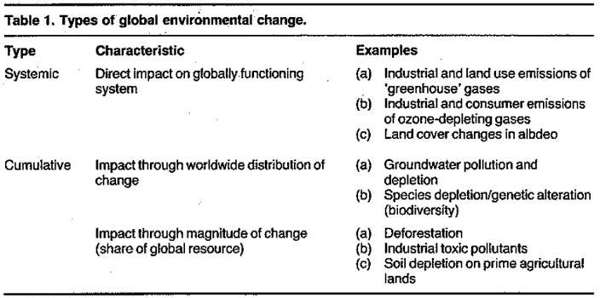
Environment & Western Culture

Week 3 Slides: January 25
How the World Works: Ecosystems

Ecosystems key concepts and terms:
What is an ecosystem?
- A distinctive biotic community and the abiotic systems with which it interacts
- Reproduction and perpetuation

Abiotic factors - distinguish between:
Conditions:
e.g., temperature, pH, wind, salinity, etc.
Resources:
e.g., water, minerals, light, oxygen,

Biomes*

What is Evolution? What is Species?
Evolution: The gradual change in species over time
Species: group of similar organisms that can mate with each other and produce fertile offspring
- Specific traits that enhance survival & reproduction tend to be passed on genetically to future generations and become more prevalent in the population
- Groupings of similar organisms that produce fertile offspring when they interbreed

What is a habitat?
- Particular physical and biological (or abiotic and biotic) conditions to which a species is adapted
What is an ecological niche?
- A species’ use of resources (habitat use, and consumption of certain foods), and its functional role in its community (its role in the flow of energy and matter, and its interactions with other organisms)
Ecological niche: specialists and generalists
Some species are:
  - Specialists have very specific requirements, so are only found in certain conditions
  - Generalists have a broad tolerance to different conditions, thus can survive in a range of habitats with different resources

Associations between species; Species do not live in isolation
What is an ecosystem again?
- A distinctive biotic community and the abiotic systems with which it interacts

Ecosystem Concept: Systems
System: a network of relationships among components that interact with and influence one another through the exchange of energy, matter or information
Open systems: interact with elements outside the system – Energy and matter are freely exchanged with surroundings.
Closed systems: Energy is free to come and go but matter is contained. Lack material inputs and outputs.

Biosphere: A cycle
Cycles are subject to: feedback loops
Positive feedback loop
Energy passes between trophic levels (feeding ranks)

Who eats who: trophic category 1
- Autotrophs (producers): organisms that create organic matter via photosynthesis
(plus some chemosynthetic bacteria)

Trophic categories 2
- Heterotrophs (consumers): must consume organic material produced by other organisms
- Includes herbivores, carnivores, parasites, detritus feeders, decomposers
Food webs show feeding relationships of a community
Trophic pyramid is level of energy or biomass (organic matter) at each trophic level in a given ecosystem
Ecological limits exist for all species

Which factors limit ecosystems? Local or micro-climates
Climate: temperature, humidity, atmospheric pressure, wind, rainfall
- Geology
  - Nutrients available from weathered rock/soil
  - Is the physical surface conducive to growing plants? (e.g. soil vs. rock)
- Water availability
- Altitude
Vegetation changes with altitude and latitude in similar ways
Simplified environmental chemistry

Photosynthesis role is huge: Provides energy that may be utilized (metabolized) by other living organisms
- No plants, no photosynthesis, no you

1st law of thermodynamics: Matter is neither created nor destroyed – fundamental building blocks are assembled, disassembled, reassembled
Organic material stores energy

Key points about energy
- Sun!
- Energy can take a variety of forms
- Energy needed to create organic matter, to cause things to move around, to cause substances to change state

Entropy = a state of disorder
When you stop adding energy to a system, entropy increases and eventually the system stops
Recap few more points:
- Energy transfer from autotrophs to heterotrophs
Decomposition
- Deer produces solid waste
- They die too
- Insects, fungi, bacteria, etc. are specialists in capturing unused energy

Week 4: Animal Populations & Environment
Topics: Natural cycles and human interference, Population growth models, Carrying capacity, Extinctions, Disturbance & Recoveries

Carbon Cycle: Nitrogen cycle:
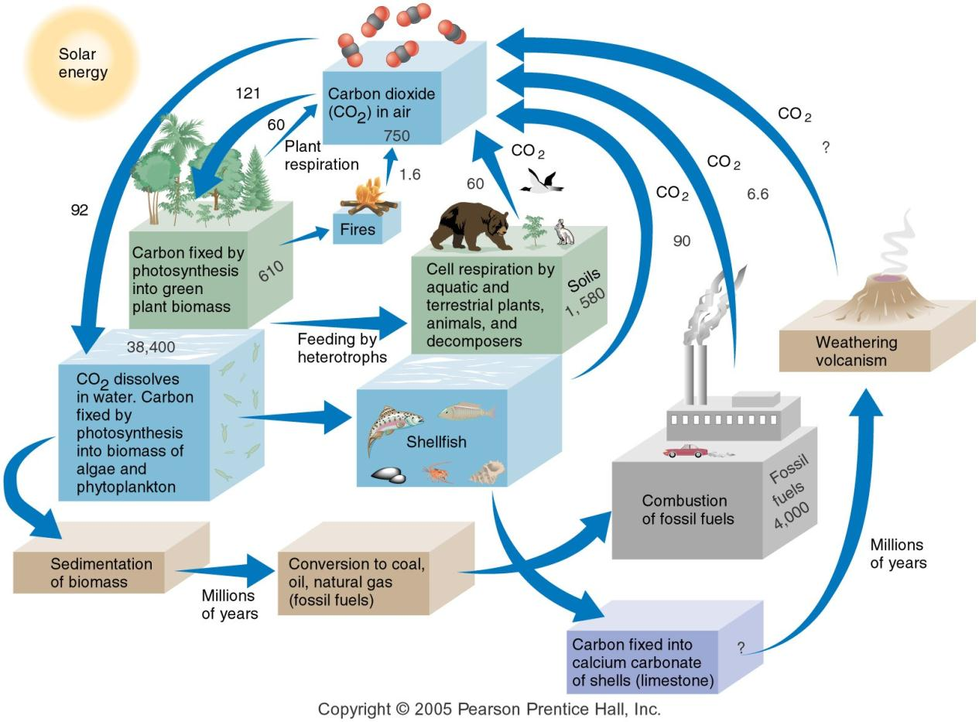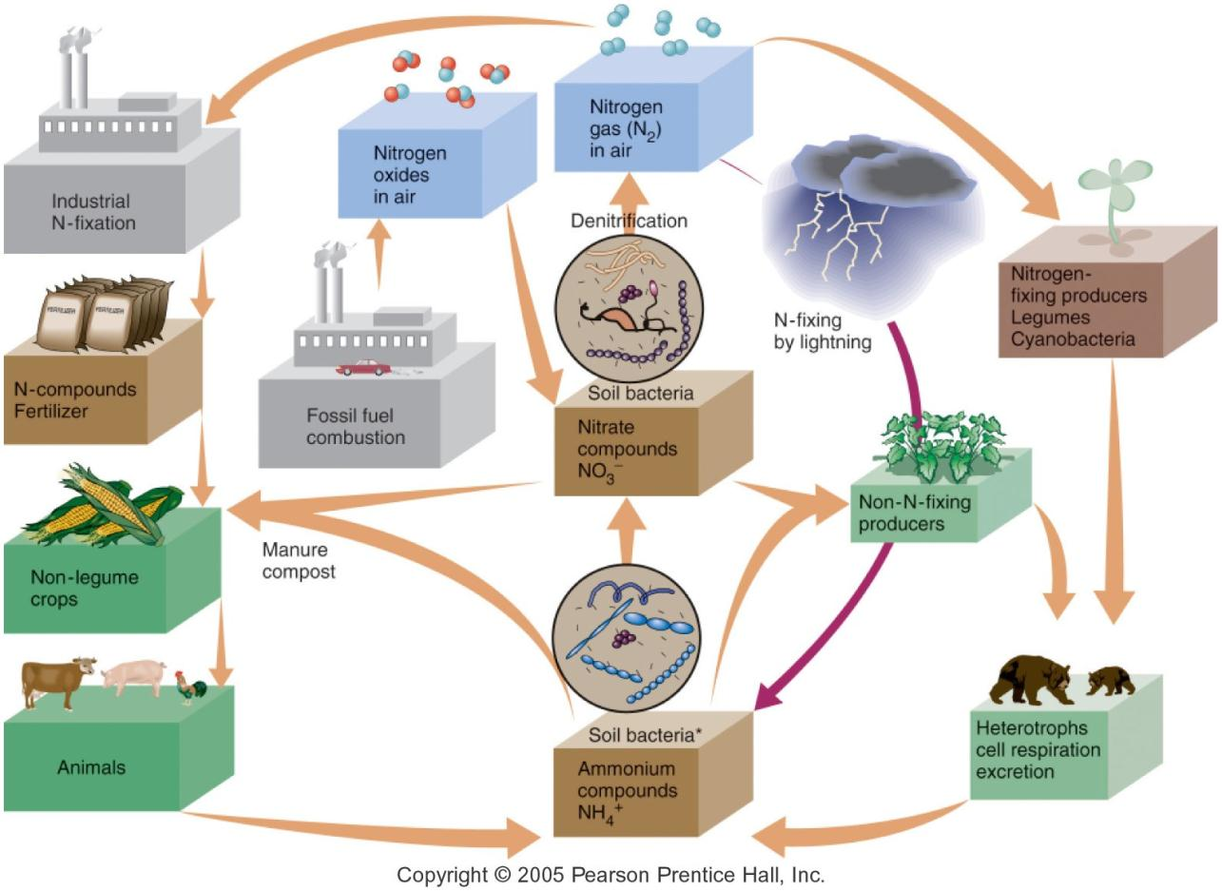

Phosphorous cycle and eutrophication
Example: Lake Winnipeg watershed

We are externalizing costs to the environment
https://www.youtube.com/watch?v=swtYy80B-LE

Amphibians: Golden Toad (Extinct)
- Dramatic declines in amphibian populations since 1980s
  - Mass localized extinctions
  - Locations around the world
Possible causes of its extinction
- Disease
- Habitat destruction & modification
- Exploitation
- Pollution
- Pesticide use
- Introduced (alien) species
- Increased UV radiation

What do we mean by changes in population?
- # of organisms of any given species is not stable
- Fluctuation with environmental conditions
- Shifts may be dramatic

Biotic potential definition: The capacity for a given species to increase its numbers given optimum conditions, through reproduction, geographical expansion of habitat or both

Environmental resistance definition: The total sum of factors that limit the potential for a species to increase its numbers or its geographic range

Carrying capacity: Describes the upper limit of the number of organisms that an ecosystem can support over the long term

Critical number definition: The lowest number of organisms required to ensure that a population may reproduce and continue *Don’t confuse with “critical mass”*
Example: Trumpeter swans, Whooping crane

Checks on population numbers: available habitat, availability of forage or prey, predation, disease, parasitism
Example: Isle Royale?

Keystone species are critical for the ecosystem and its diversity
Example: Sea stars

Fire in western forests are a crucial part of this ecosystem
- Yellowstone fires 1988

Week 5: Human Population & Environment
Stable state = resilient system

Human population growth: observation
- Due to our biotic potential, humans would continue reproducing at an exponential rate if there were no environmental resistance.

Limits to human population growth: Thomas Malthus’ (1798) interpretations
- (Unchecked) human populations increase exponentially
- Food production increases arithmetically
- ‘positive checks’ and ‘preventive checks’

Interpretation of human population growth: Karl Marx (1818-83)
- Argued that human social behaviour can be understood in the context of the capitalist economy, which creates social classes that compete with one another for resources.
- Real problem isn’t too many people or too little food but that: private capitalists own the means of meeting human needs

Malthusian and Marxian influences on today’s population science
Neo-Malthusians: Believe we are approaching, or have already surpassed, the earth’s carrying capacity
Neo-Marxists: Believe eliminating oppression and poverty through social change is key
Who are the cornucopian’s (boomsters)?
- All major economic, social and environmental problems can be fixed with technology and innovation

Example: Improvements in food production technology
- Hybridization and genetic modification of crops
- Mechanization of agriculture
- Transition to monoculture production
- Agrochemistry
- Food storage technology
- Food distribution technology

Green (Agricultural) Revolution
- Agricultural productivity increased across globe

What has led to human population explosion?
- Nutrition
- Improvements in medicine
- Sanitation

How do Marx and Malthus’ ideas fit into these ‘reasons for population growth’?
Cornucopians: technology
Malthus: positive checks
Marx: where is growth happening?

Global human population:
What influences population growth rate?
- Fertility
- Death rate of humans under 40
- Human longevity

Births, Deaths & Fertility
- Crude Birth Rate (CBR): # births per 1000 living people per year
- Crude Death Rate (CDR): # deaths per 1000/yr

Births, Deaths & Fertility
- Total Fertility Rate (TFR): # children born to an average woman in a population during her lifetime
- Replacement-level Fertility: a fertility rate that will replace 1 woman and her partner (2 people)

Why do people choose to have fewer children?
- Maternal health-care
- Reduction in childhood morbidity (incidence in disease)
- Household economic security
- Female education
- Male education
- Contraceptive availability
- Living in a stable political/social/economic environment

Calculating population doubling-times
Rate of Natural Increase (RNI) – caused by births and deaths only, not migration.

Population pyramids:
- Visual representations of the age and sex composition of a population
- % of each age group (generally 5-year increments) shown as a horizontal bar – younger ages on the bottom
- Population pyramids are useful for visualizing growth (or decline)
Population pyramids:
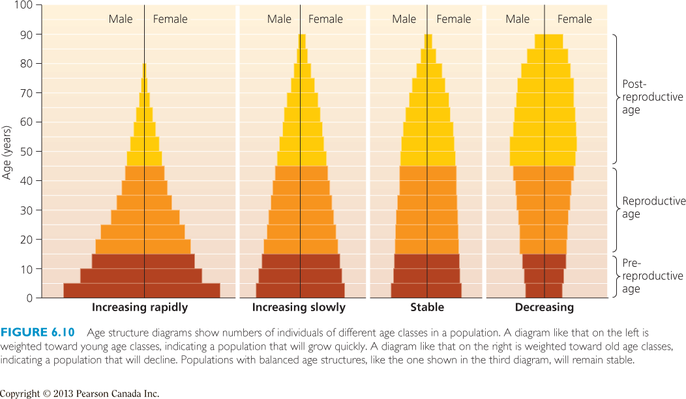 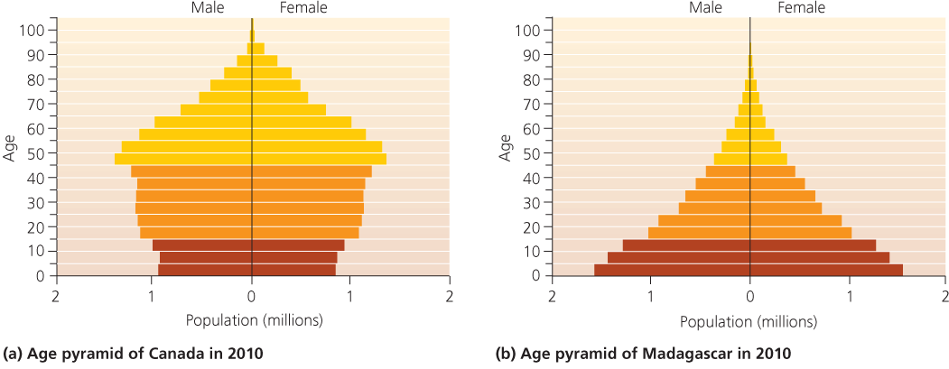

The Demographic Transition Model
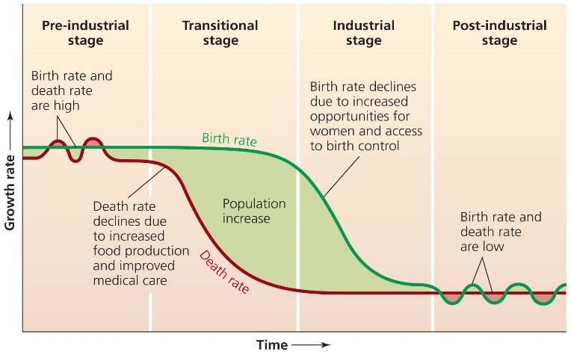
1867; 1927; 1967; 2016 – World 1867; Congo, Bangladesh, Canada & Italy

Key ingredients to a population stabilization program
- Provide reliable, affordable basic health care
- Provide education opportunities for all
- Diversify employment opportunities
- De-stigmatize contraception

Summary of Notes Past Midterm II

Week 7: Environmentalism
Calculating human impact
- The number of humans
- Their level of consumption
- Technology and use
- The sensitivity of the environmental in question

What is environmentalism?
- A movement to preserve the health of Earth and its ecosystems
- Both values and spirituality
- Social movement to protect the natural world

3 basic principles of environmentalism
Environmentalism: all forms of collective behavior that aim to correct destructive forms of relationship between human action and its natural environment
- Ethical ecological stewardship (responsibility for planning and management of resources)
- Respect for other species
- Wilderness as spiritual haven

Ecology: set of beliefs, theories and projects that consider humankind as a component of a broader ecosystem and wish to maintain the system’s balance in an evolutionary perspective.

Key western figures and time periods
Henry Thoreua – wrote Walden to describe his experience/philosophy which was contrary to the mentality of the day

Mary Hunter Austin – scientific in nature; supremacy and divinity of nature; disconnect/harmony between humans and nature

John Muir – linked the living in the wild with spiruality

Gordon Hewitt – first entomologist employed by the Government of Canada; active conservation of bird and wildlife

Archie Delaney – wrote popular books about wilderness life and need for conservation of wild places under name “Grey Owl”

Aldo Leopold – agricultural economist; pioneer of ecology; known for essay The Land Ethic

Rachel Carson – marine biologist, fought against widespread aerial spraying of DDT to control fire ants

Criticism
Developments in environmentalism:
- Sustainability management
- Deep ecology
- Ecofeminism
- Ecothelogy
- Voluntary simplicity
- Climate change

Elitism – increased understanding of environmentalism; changed from education; used to be only for the rich; climate change

Corporations and environmentalism
Criticism: change is inevitable; humankind’s exaggerated sense of importance; pseudo-science

PART II: Air Pollution and Global Climate Change
What is the atmosphere?
Human modification of the stratosphere
- Dynamic interactions between oxygen and UV radiation are continuity occurring in the stratosphere
- UV radiation splits apart CFCs to produce chlorine, which destroys the ozone.
- Ozone depletion is a non-linear phenomenon

Human modification of the troposphere

Week 9: Air Pollution and Global Climate Change
Weather vs. Climate
Atmosphere: atmospheric pressure, relative humidity, temperature; ultimately drives the weather
Warm vs. cold front

Connective Cells
Hadley, Ferrel, and Polar cells – large scale circulation systems produce global climate patterns

Thermohaline circulation and oscillations
Thermohaline – the large-scale ocean circulation that is driven by global density gradients created by surface heat and freshwater fluxes; controlled by temperature and salinity (haline)
- Earth’s Polar Regions have very cold water; forming sea ice. The surrounding sea water gets salter, therefore its density increases, and starts to sink.

Climate trends
Anthropogenic climate change – we are increasing the levels of GHG in the atmosphere, thus increasing the greenhouse effect
Water vapour, carbon dioxide, methane, nitrous oxide, CFCS

Key forces that affect climate: incoming solar radiation, circulation of air, circulation of ocean water, long-term oscillations, presence of GHG

Additional influences in climate system
Milanovich cycles
- The angle of Earth’s tilt varies over time
- The earth wobbles on its exis
- Oribital variation cause the distance between the Earth and sun to vary over time, thereby influencing amount of solar radiation received.

Albedo – absorbing solar radiation

Volcanic activity – emits a mixture of gases and particles into the air, such as ash sulphur dioxide; this has a cooling effect because they reflect sunlight away from the Earth; carbon dioxide is also released, which acts as a warming effect to addition of GHGs.

PART II: Climate Change Impacts & Adaptations
- Warmer days and nights over most land areas
- Fewer colder days
- More heat waves
- More areas exposed to droughts
- Increased frequency of extreme storms
- Continued rise of sea levels

Vulnerability to climate change
- Potential for harm and loss
- Exposure and sensitivity are similar to Holland and Bangadelsh

Public and scientific debate
Climategate scandal – collection of emails, data files and data programs were leaked from a research unit in the UK, revealing scientific fraud and data manipulation by scientists concerning the Global Warming Theory

Responding to Climate Change:
- Adaptation – adjust and reduce vulnerability (carpooling)
- Intervention – large scale technological modifications (new biogeochemical technology)
- Mitigation – reduce GHG
UNFCCC – United Nations Framework Convention on Climate Change

UNFCC & Kyoto Protocol
UNFCC: Keep track of GHG levels, prevent dangerous accumulation of GHG, and assist vulnerable countries in adapting to the impacts of climate change

Kyoto Protocol: reduce levels of GHG from 1990
Montreal Protocol | Kyoto Protocol
Sets target for reducing emission of ozone-depleting substances | Sets targets for reducing emission of GHG
All nations have mandatory targets; industrialized countries required to act first | Industrialized nations have mandatory targets
There are readily-available substitutes for CFCs | There are presently no alternative to fossil fuels that can produce similar amounts of energy
Changes in ozone layer are measureable | Changes in carbon dioxide and other GHG concentrations are measureable
The public health impact of failure to act are certain; all countries would suffer | Failure to act results in climatic changes that are difficult to forecast; impact will not be felt by all countries
High level of compliance; emissions are falling globally; stratospheric ozone levels appear stable | Poor level of compliance; GHG emissions continue to rise globally; impacts of climate change beginning to emerge

Week 10: Water Resources
- Water is distributed unequally between nations, with differences within nations
- Global precipitation (differs)

Threats to water:
- Overuse
- Pollution
- Climate change

How we use water:
Consumptive uses – irrigation, industrial, residential
Non-consumptive uses – electric power production, some industrial, some residential

Water sources: Surface water vs. ground water
- Highly variable by region/nation
- Reflects environmental and economic circumstances
- Dams, canals, diversions, channelization (harness surface sources for human use)

Benefits of Dams: Power, flood control, navigation
Negative Impacts of Dams: methane, ecosystem, heritage, people

98% of all liquid fresh water is groundwater.
Groundwater slowly recharges, but overdrawing is a growing global problem

Consquences of Overdrawing Groundwater:
- Depleted resources
- Saltwater intrusion
- Diminshin surface waters
- Loss of wetland ecosystems
- Land subsidence

Desalinization – removal of salt from sweater

Real price of water: price and cost does not reflect the full value

Solutions: reduce consumption and demand
- Agriculture
- Municipal uses
- Industry

PART II: What’s in your drinking water?
Undesirable things: excess nutrients, pathogens & waterborne diseases; toxic chemicals, suspended matter, thermal pollution

Point vs. non-point sources

Global environmental challenge – sanitation
- Direct linkages to public health, increased disease
- Links to environmental degradation, more toxins in environment

Social impacts of inadequate sanitation

Abortion vs. Tornado Politics
Abortion – decision context characterized by either lack of values consensus or high uncertainty
Tornado – decision context characterized by both values consensus and low uncertainty

Values and Science are both important, but science can help resolve uncertainty but not conflicting values

Rights-based ethics – there are some rights, both negative and positive, that all humans have based only on the fact that are human.
Utilitarian ethics – the best moral action is the one that maximizes utility

Week 11: Soil and food
Food security – exists when all people, at all times, have physical and economic access to sufficient safe and nutritious food that meets their dietary needs and food preferences for an active and healthy life.

Food security – 4 dimensions
- Availability
- Access
- Utilization
- Stability

Green Revolution – introduction of high yield hybrid varieties (wheat, rice, corn)

Threats to food security:
- Soil degradation (deforestation, over cultivation, construction, over irrigation)
- Changing diets (food choices are energy choices)
- Food to energy
- Climate change
- Technology (GMOs)

Part II: Energy Challenges
Resources vs. reserves
- Coal, oil, crude oil, natural gas, biomass
Biodiesel, methane, ethanol, jet fuel, biogasline

Week 14: Garbage and Waste Management

Categories of Waste:
- Municipal solid waste
- Industrial waste
- Hazardous waste
- Wastewater

What’s in our garbage? Paper, organics, plastics, wood, metals, glass

What are the two main options for waste disposal?
- Landfills
- Inceration

Options: Reduce, Reuse, Recycle/Compost, Recover, Dispose/Landfill

Electronic Waste: used computer, cell phones, etc; contains heavy metals; volume is growing; difficult to recycle

Waste management is far simpler and cheaper than other options (to be sustainable)

PART II: Sustainable Futures
Anthropocene – humans as agents of fast global change
Technocratic worldview – humanity’s problems can be solved with technology, energy is at the core of socio-economic development and well-being

Optimistic vs. Pessimistic views

Example of the banana spilt

Socio-ecological systems

Approaches to Sustainability:
- Refine our ideas about economic growth and quality of life
- Reduce unnessecary consumption
- Limit population growth
- Encourage green technologies
- Mimic natural system by promoting closed loop industrial processes
- Think in the long term

“In the end we conserve only that which we love,
We love only that which we understand,
We understand only that which we are taught.”

