Globalization

Has several definitions
Narrowly defined it can refer to the trend towards:
- Ever greater international economic integration
- Interdependent world economy
Broadly defined it can speak to both:
- Economic and social convergence
- Greater homogeneity amongst national systems
Business opportunity vs. Cultural threat

Trade integration
- Regional and global institutions/agreements
  - NAFTA, BRICS, EU, AU, WTO, etc.
- Standardization of products & production process
Greater access to worldwide markets, free trade
Political stability and global cooperation
- Establishment of trust between nations
New international division of labour

Growth in GDP (Gross Domestic Product)

Manifestation of globalization
- Emergence of global institutions
- Globalization of markets
- Global production designs
- Emergence of global competition

Drivers of Globalization
- Declining barriers of trade/investment
- Technological change and online/digital business
- Innovation, research and development
- Global knowledge transfer

Contrasting views on globalization
- Case of climate change policies, recent COP-21
  - Industrialized vs. emerging countries
- Globalization implications on:
  - Jobs
  - Income
  - Poverty/Inequality
  - Labor policies
  - Environment
  - National sovereignty, etc.
So, is globalization good or bad?
Pros | Cons

Will this continue?
- Digital Revolution
  - Facebook
  - Uber
  - AirBnB
  - WordRemit
- Global risk of Climate Change
- Re-industrialization

Contextualize globalization
- Globalization is a result of various revolutions/innovations:
  - Technological

Culture

- Difficult to define because different people see it differently
  - What is part of your culture?
- Impact on how we see the world, how we operate in the business world
- “That complex whole which includes knowledge, belief, art, morals, law, custom and other capabilities acquired by man as a member of society”
- Shared values, norms, attitudes & beliefs: the society’s (group’s) design for living
  - Values: abstract ideas and good, right, desirable
  - Norms: social rules and guidelines
  - Attitudes: behaviour, interactions
  - Beliefs: preconceptions on the other, faith
Cultural Artifacts
- An item or anything that evidences social, political, economic or religious organization of the people whom they belonged to
- Visible “tip of the iceberg”
- Reveal valuable information about the society that made/used it
  - Apps, cloth, painted pottery, telephones
Social Class & Caste
- Class consciousness: a tendency for individuals to perceive themselves in terms of their class background
Alternative Levels of Culture
- Popular Culture
  - Television programs
  - Clothing
  - ‘Pop’ music
    - What is the message?
- High Culture
  - Film festivals
  - Clothing designers
  - Classical music
- Folklore or Indigenous Culture
  - Storytelling
  - Hand-made garments
Spread of Culture
- Bill Clinton shortly before leaving the presidency said “In the new century, liberty will be spread by cell phone and cable modem”
  - Culture is values
- Do you agree with this?
Nation and National Culture
- Nation could be a useful definition of society
  - Similarity among people a cause – and effect – of national boundaries
- Nation is a useful way to understand business culture
  - Culture differs significantly across/within national borders
  - Laws are established along national lines
  - Culture is both a cause and an effect of economic and political factors
- Nation and language
  - Does language define national culture or does national culture define language?

Cultural Distance
- Geographic and cultural (or psychic) distance among countries may not be the same
- Key concept which affects IB strategy and conduct

Culture and the Workplace (Hofstede)
- Hofstede’s study: 64 national subsidiaries, 116,000 workers
- Researcher bias? Western stereotypes and culturally biased conclusions?
- Many recent studies validate Hofstede’s dimensions
- Hofstede groups national cultures along dimensions meaningful to business:
  - Work related values not universal (e.g. Siestas, 6 weeks of vacation, etc)
  - National values may persist over MNC efforts to create culture
  - Local values used to determine HQ policies
  - MNC may create morale problems if it insists on uniform moral norms
- Starting point for understanding of business situations across cultures
- MUST understand own culture and other cultures

Hofstede’s Dimensions
- Power Distance:
  - Degree of social inequality considered normal by people
  - Distance between individuals at different levels of a hierarchy
  - Scale from small power distance to large power distance
- Individualism versus Collectivism:
  - Degree to which people prefer to act as individuals rather than in groups
  - The relations between the individual and his/her fellows
- Uncertainty Avoidance:
  - More or less need to avoid uncertainty about the future
  - Degree or preference for structured versus unstructured situations
- Masculinity versus Femininity:
  - Division of roles and values in a society
  - Masculine values (assertiveness, competition) vs. Feminine values (quality of like, harmony, care for the weak, solidarity)
- Long term versus short term orientation

Culture and Greed
- John Kay of the Financial Times in his 2004 book titled “Culture and Prosperity” writes:
  - “only saints and fools would deny that self-interest plays an important role in economics…”
Religion, Culture and IB
- Difference in religious heritage in modern cultures
  - What is the basis of trust in IB?
  - Demand for greater secularity in all government activities
Education and Culture
- Education
  - Medium through which people are acculturated
  - Language, myths, values, norms taught
  - Teaches personal achievement and competition
Important Issues to Consider
- What is the link between culture and thought?
  - Does culture conform us to its way of thinking?
  - Do we shape

Determinants of Culture
- Religion, etc

Ethics

Definition: The accepted principles of right or wrong that govern the conduct of a person, the members of a profession, or the actions or an organization
- Business ethics: accepted principles of right or wrong that govern the conduct of business people
- An ethical strategy: set of coordinated actions that do not violate these accepted principles
Managers and Ethical Dilemmas
- Why would students of IB be worried about revelations being recounted in media in Canada and throughout the world?
- There are situations in which none of the available alternatives seem ethically acceptable
  - Can you give an example?
    - Syrian war

Ethical Issues in IB
- Rooted in the fact that political systems, law, economic development, and culture vary significantly across cultures and nations
  - What is considered normal practice in one culture may be considered unethical in others
  - Managers in multinationals need to be sensitive to these differences and choose the ethical action

Circumstances with Ethical Considerations
- Political environment: laws and regulations
- Social-cultural environment: migrations, urban areas
- Technological environment: communication, productivity
- Economic environment: currency fluctuations
- Corporations competitiveness: management pressure
- Competitive environment: global context

Ethics - Influences
- Effect of advances in communication technology
- Competitiveness of global news media
- Huge pressure to behave ethically: Mistakes of an executive have global repercussions, such as on CNN, headline, YouTube, Twitter, Facebook, reaching millions

Opening Case Discussion, p.124
- Canada as a global leader in mining business
- Talisman faces ethical issues in Sudan
- “Global competition led Canadian business executives to do outside Canada what they could not do at home”
Ethical Issues – Employment Practices
- 12-hour workdays, very low pay, failure to protect workers against toxic chemicals may be common in some developing nations
Ethical IB Decision Making
- Hire and promote people with a well-rounded sense of personal ethics
- Build an organizational culture that emphasizes ethical behaviour
- Make leaders articulate the rhetoric of ethical behaviour and act consistently
- Make decision-making processes consider ethical dimension of business
- Develop moral courage

5 Step Process to Solve Ethical Problems
- Identify which stakeholders a decision would affect and in what way
- Judge the ethics of the proposed strategic decision
- Establish moral intent
- Engage in ethical behaviour
- Audit decisions, review to insure consistency with ethical principles

International Trade Theory I & II

Trade Theories
- Classical Trade Theories: focused on concepts of mercantilism, absolute advantage, and comparative advantage
  - Theory of Mercantilism: the wealth of the world (measured in gold and silver) was fixed, and that a nation that exported more and imported less would enjoy net inflows of gold/silver and is thus richer
    - Mercantilism weakens a country in the long run and enriches only a few segments (compared to absolute advantage)
  - Protectionism: governments should actively protect domestic industries from imports and vigorously promote exports
  - Factor Endowments: extent to which different countries possess various factors (labor, land, technology, etc)
  - Factor Endowment Theory (Heckscher-Ohlin theory): the proposition that nations will develop comparative advantage based on their locally abundant factors
  - Resource Mobility: assumption that a resource can be removed from one industry to another
  - Free Trade: free market forces should determine how much to trade with little (or no) government intervention
  - Theory of Absolute Advantage: economic advantage on nation enjoys that is absolutely superior to other nations
    - Theory by Adam Smith: The Wealth of Nations, 1776
    - A country should specialize in, and export, products for which it has absolute advantage; import others
    - A country has absolute advantage when it is more productive than another country in producing a particular product
  - Theory of Comparative Advantage: relative advantage in one economic activity that a nation enjoys compared with other nations
    - Countries should specialize in products they can produce most efficiently
  - Opportunity Cost: given the alternatives, the cost of pursuing one activity at the expense of another activity

Absolute Advantage
- A country has an absolute advantage in the production of a product when it is more efficient than any other country in producing it

Comparative Advantage
- David Ricardo: Principals of Political Economy, 1817
- Country should specialize in production of those goods in which it is relatively more productive… even if it has absolute advantage in all good it produces
- Absolute advantage, a special case of comparative advantage

Theory of Relative Factor Endowments (Heckscher-Ohlin)
- Factor endowments vary among countries; product differ according to the types of factors (resources) needed as input
- A country has a comparative advantage in producing goods that intensively use production factors it has in abundance
  - While importing goods that make intensive use of locally scarce factors
- Production Factors: labour, capital, land, HR, technology, etc.
- Climate and natural-resource endowments explain why
  - Ghana exports cocoa
  - Brazil exports coffee
  - Saudi Arabia exports oil
  - China exports ginseng

Heckscher-Ohlin Theory and the Leontief Paradox
- Heckscher-Ohlim
  - Produce goods that use factors a country has in abundance
  - Importing goods that make intensive use of locally scarce factors
- US has relatively more abundant capital yet imports more capital intensive goods than those it exports
  - Explanation?
    - US has special advantage on producing new products made with innovative technologies
    - These may be less capital intensive till they reach mass-production state

Benefits of Trade
- The gains of trade arise because international trade allows a country to specialize in the manufacture and export of products that can be produced most efficiently in that country, while importing products that can be produced more efficiently in other countries
- The great strength of the theories of Smith, Ricardo, and Hecksacher-Ohlin is that they identify with precision the specific benefits of international trade
- Theories of Smith, Ricardo, and Heckscher-Ohlin show why it is beneficial for a country to engage in international trade even for products it is able to produce for itself
- The theories of Smith, Ricardo and Heckscher-Ohlin tell us that a country may gain if its citizens buy certain products from other nations that could be produced at home
- Many citizens believe that to help save national jobs from foreign competition national consumers should buy nationally-made products by domestic companies

Trade Theories (cont’d)
Modern Trade Theories: focused on concepts of product life cycle, strategic trade, and national competitive advantage
- Product Life Cycle Theory: emphasizes on changes in the patterns of trade over time
- Strategic Trade Theory: strategic intervention by governments in certain industries can enhance their odds for international success
- First-Mover Advantages: advantages that first entrants enjoy and do not share with late entrants
- Strategic Trade Policy: economic policies that provide companies a strategic advantage through government subsidies
- National competitive advantage of industries: Porter’s diamond theory
  - Micheal Porter’s Theory (The Competitive Advantage of Nations, 1990): key attributes that promote or impede competitive advantage
  - Four aspects that form a “diamond”

Implications for International Business
- Location Implications
  - Different countries have particular advantages in different productive activities
  - It makes sense for a firm to disperse its productive activities to those countries where, according to the theory of international trade, they can be performed more efficiently
- First mover Implications
  - Firms that establish a first-mover advantage with regard to the production of a particular new product may subsequent dominate global trade in that product
  - It pays to invest huge financial resources in trying to build a first-mover, or early mover, advantage, even if that means several years of substantial losses before a new venture becomes profitable
- Policy Implications
  - Theories of international trade also matter to international business because firms are major players on the international trade scene
  - Because of their pivotal role in international trade, businesses can influence government trade policy, lobbying to promote free trade or trade restrictions

Trade Policy (missed lecture)
What is trade policy?
- Government’s orientation that defines how it selects and applies trade theory within its national borders as well as in its commercial exchanges with other foreign parties
- Trade policies tend to differ across nations and sometimes across provinces or states

Realities of International Trade
- Import Tariff: a tax imposed on imports
- Non-tariff Barriers (NTBs): restrict imports but are not in the usual form of a tariff
  - Subsidies, import quotas, export restraints, local content requirements, administrative policies, antidumping duties, over-elaborate or inadequate infrastructure, “buy national” policy, bribery and corruption, unfair customs procedures, restrictive licenses, etc.

Why did Doha negotiations stagnate?
- In 2013, Trade Facilitation Agreement reached in Bali
  - Provisions for expediting the movement, release and clearance of goods
  - Measures for effective cooperation between customs and authorities on trade facilitation and customs compliance issues

Realities of International Trade
- Import Quotas: restrictions on the quantity of imports for specific period of time
- Voluntary Export Restraints (VRAs): superficial policy to show that exporting countries voluntarily agree to restrict their exports
- Local Content Requirements: a requirement that a certain proportion of the value of the goods made in one country originate from that country
  - Example: Brazil adopted a policy of “everything which can be done in Brazil should be done in Brazil”
    - Petrobras has a 65% requirement of local content in contracts
- Antidumping duties: costs levied on imports that have been “dumped” (selling below costs or below exporter’s home market price to “unfairly” drive domestic firms out of business)

Prominent Economic Arguments Against Free Trade
- The need to protect domestic industries – the older and most frequently used economic argument against free trade is the urge to protect domestic industries, firms, and jobs from “unfair” foreign competition – in short, protectionism
- The necessity to shield infant industries – belief that if domestic firms are as young as “infants”, in the absence of government intervention, they stand no change of surviving and will be crushed by mature foreign rivals

Political Arguments against Free Trade
- Political arguments against free trade advance a nation’s political, social, and environmental agenda regardless of possible economic gains from trade
- Arguments include:
  - National security
  - Consumer Protection
  - Foreign Policy
  - Environmental and Social Responsibility

What is Government’s Role in a Globalized World Economy?
- Police officer?
- Firefighter?
- Arbitrator?
- Programmer?
- Promoter
- Protective
- Producer

Classical Theories vs. New Realities
- Classical theorists and their modern-day disciples argue that the United States and India trade by tapping into each other’s comparative advantage
- India leverages its abundant, high-skill, and low-wage labour. Americans channel their energy and resources to higher skill, higher paying jobs
- Certain Americans will lose jobs, but the nation, as a whole, benefits
  - Is this a problem?

Current Challenges in IB

Changing Trade Patterns
- Oil price dropping

Geo-Political Tensions – Russia/Ukraine Crisis
- Territorial dispute and geopolitical stakes: NATO vs Russia
- Disruption in energy supplies (Russia is a major supplier)
- West’s economic sanctions against Russia? Does it work?
- Canada embarked with US on sanctions without comprehensively assessing the global consequences of sanctions

Iran’s Nuclear Deal
- Till 2015, tough sanctions to force Iran to end its nuclear projects
- In 2016, sanctions are being lifted
  - What implications for IB?
  - Who wins? Who loses?

Consolidating BRICS
- A global economic order is emerging
- Changes in global trade and global alliances
- Brazil, Russia, India, China, South Korea

China-Japan-Taiwan-South Korea- DPRK (North Korea)
- Renewed hostilities from old conflict
  - China is major economic power is Asia
  - Renouncement of Japan’s pacifist constitution
  - Territorial disputes
    - East China sea dispute
    - China-Taiwan dilemma
    - China’s first aircraft carrier
- China, an emerging giant vs Japan, a nationalistic/economically frustrated
- South Korea, another emerging power with pro-US policies
- North Korea and nuclear threat (launched long-range rocket this week)

ISIS/ISIL
- Islamic State of Iraq and the Levant (Al-Sham) ISIL/ISIS
- Threatens international oil supply and global trade
- Now ISIS/ISIL rises global concerns in Iraq, Syria, Afghanistan, Libya and beyond

Tensions in Middle-East
- Israel/Palestine: decades of regional conflict
  - Debates about where the borders should be
- Difficulty in realizing a “Two State” Solution
- UN, West, Arab League: still unable to build long term solution
- Both parties suffer from obstacles/boycott in international trade

Regional Challenges
- EU’s needs for younger workforce
- German opportunism in dealing with migrant crisis
- Global terrorism vs EU’s and West’s economic interests
- France’s unemployment struggles and human rights breach in migration crisis
- UK’s and Switzerland’s games vis-à-vis the EU

Challenges in Emerging Countries
- IB challenges differ across emerging regions/countries
- The business game offers more loopholes in emerging nations
- Multinationals’ challenge of staying globally consistent in ethics and CSR
- Other challenges include finding ways to operate within free trade areas and compete efficiently

Country Differences in Political Economy
Country Differences
- Political, economic, and legal systems from the political economy of a country
- Countries have different systems
  - Political
  - Economic
  - Legal
- Systemic interactions affect nation’s economic wellbeing
- Cultural practices can vary dramatically across countries as can the education and skill level of the population
- Countries are at different stages of economic development

Democracy and Totalitarianism
Democracy | Totalitarianism
Political system in which the people elect representatives to form the government  Democracy demands:  - Freedom of expression  - Free media  - Regular elections  - Limited terms for representatives  - Fair court system  - Non-political – police/army | Political system based on collectivism, which advocates that socialism can be achieved only through a totalitarian dictatorship

Economic Systems
- Market Economy: interaction of supply and demand determines price and production (Pro deregulation)
- Command Economy: government determines the allocation of resources including the determination of production and prices
- Mixed Economy: certain sectors are left to private ownership and free market mechanism, while other sectors are owned and managed by the government

Legal Systems
- Common Law: based on traditions, precedent and custom
- Civil Law: detailed set of laws organized into codes
- Theocratic Law: based on religious teachings
  - Sharia law
  - Ontario’s 1991 Arbitration Act

Property Rights
- A resource over which an individual or business holds a legal title, meaning it owns the resource
  - Land and real estate
  - Equipment
  - Capital
  - Mineral rights
  - Businesses
  - Intellectual property (patents, copyrights, trademarks)

Trade Related Aspects of Intellectual Property Rights (TRIPS)
- TRIPS Agreement (1995): agreement amongst member states of the World Trade Organization (WTO) to oversee the enforcement of stricter intellectual property regulations

Product Safety and Product Liability
- Product safety laws set safety standards to which products must adhere, where it is going to be commercialized
- Product liability involves holding a firm and its officers responsible when a product causes injury, death or damage

Human Development Index (HDI)
- Measures country’s quality of human life in terms of:
  - Life expectancy
  - Education attainment
  - Average incomes
- Top 10 countries: Norway, Australia, Switzerland, Denmark, Netherlands, Germany, Ireland, US, Canada and New Zealand

Benefits
- In the most general sense, the long-run monetary benefits of doing business in a country are a function of:
  - Size of the market
  - Present wealth (purchasing power) of consumers in that market
  - Likely future wealth of consumers
  - First-mover advantage

Costs
- It depends on the degree of sophistication of a country’s economy
- It may be more costly to do business in relatively primitive or undeveloped economies because of the lack of infrastructure and supporting businesses

Risks
- Political risk: likelihood that political forces will cause drastic changes in a country’s business environment that adversely affect the profit and other goals of a business enterprise
- Economic risk: likelihood that economic mismanagement will cause drastic changes in a country’s business environment that adversely affect the profit and other goals of a business enterprise
- Legal risks: likelihood that a trading partner will opportunistically break a contract or expropriate property rights
The overall attractiveness of a country as a potential market and/or investment site for an international business depends on balancing the benefits, costs and risks associated with doing business in that country

What is global country-risk?
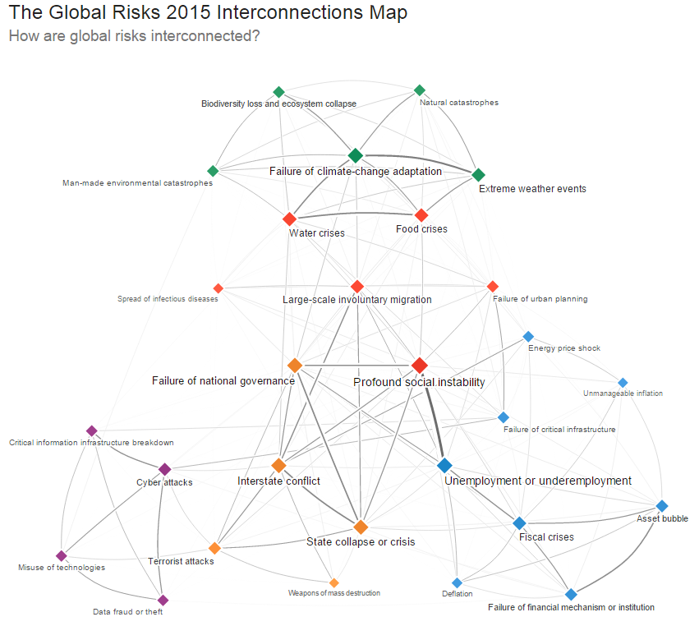

Country Differences – Ethics
- Country differences give rise to some important and contentious ethical issues
  - Three important issues in recent years:
    - Ethics of doing business in nations that violate human rights
    - Ethics of doing business in countries with very lax labour and environmental regulations
    - Ethics of corruption

Foreign Exchange Rates and Global Markets
- What happens in the foreign exchange market can have a fundamental impact on the sales, profits, and strategy of an enterprise
- Accordingly, it is very important for managers to understand how changes in currency exchange rates might affect their business

Definitions
Foreign Exchange: market for converting the currency of one country into that of another country
Exchange Rate: rate at which one currency is converted into another
Foreign Exchange Rate: adverse consequence of unpredictable changes in the exchanges rate

Foreign Exchange Risk
Currency Conversion
- International businesses use foreign exchange markets when:
  - Paying a foreign company for its products or services in its country’s currency
  - Possessing spare cash that they wish to invest for short terms in money markets
- Currency speculation typically involves the short-term movement of funds from one currency to another in the hope of profiting from shifts in exchange rates

Functions of the Foreign Exchange Market
- The foreign exchange market has two main functions:
- To convert the currency of one country into the currency of another
- To provide some insurance against foreign exchange risk

- International businesses have four main uses of foreign exchange markets:
- The income a company receives for exports, investments, and licensing agreements abroad
- Payments for products/services coming from abroad
- Short/long-term investments in foreign markets
- Currency speculation

Canadian Dollar and the world
- The Canadian dollar is a currency linked to the raw materials, including oil and natural gas, that Canada exports
- The movements of the Canadian dollar have become increasingly correlated with price of oil
- Small Canadian businesses can be highly susceptible to exchange rate fluctuations when exporting to the US and fear that a rise in the Canadian dollar will increase the cost to the US consumer and damage export related profits

Ensuring Against Foreign Exchange Risk
Spot exchange rates
- The spot exchange rate is the rate at which a foreign exchange dealer converts one currency into another currency on a particular day
- When a Canadian tourist goes to a bank to convert their Canadian dollars into pounds, the exchange rate is the spot rate for that day
Forward exchange rates
- A forward exchange occurs when two parties agree to exchange currency and execute the deal at some specific date in the future
- Exchange rates governing such future transactions are referred to as forward exchange rates
Currency swaps
- A currency swap is the simultaneous purchase and sale of a given amount of foreign exchange for two different value dates

London
- World’s largest centre for global banking
- London’s central position between Tokyo and Singapore to the East and New York to the West has made it the critical link between the East Asian and New York markets
- Due to time zone differences, London opens soon after Tokyo closes for the night and is still open for the first few hours of trading in New York

Big Mac worldwide prices and the theory of Big Mac index
- Law of One Price: sell in same price based on fixed Exchange Rate (ER)
- Purchasing Power Parity (PPP): prices are relative and shape changes of ER
- Money supply and price inflation: inflation occurs when the quantity of money in circulation rises faster than the stock of goods and services

Exchange Rate Forecasting
- The Efficient Market School
  - Prices reflect all available public info
- The Inefficient Market School
  - Forward exchange rates will not be the best possible predictors of future spot exchange rates

Currency Convertibility
- Free Convertible Currency
  - A country’s currency is freely convertible when the government of that country allows both residents and nonresidents to purchase unlimited amounts of foreign currency with the domestic currency
- Nonconvertible Currency
  - A currency is not convertible when both residents and nonresidents are prohibited from converting their holdings of that currency into another currency
- Externally Convertible Currency
  - Nonresidents can convert their holdings of domestic currency into foreign currency, but the ability of residents to convert the currency is limited in some way

Countertrade
- Countertrade refer to a range of barter-like agreements through which goods and services can be traded for other goods and services

Emerging Powers in Global Trade
World’s Top 10 Economies
- Why top economies list tends to stay the same over years?
  - First mover advantage
- China just overtook the US as the world’s largest economy

Toward a new economic order
- Some emerging powers include China, India and Brazil
- Korea, Mexico, Saudi Arabia and Turkey also emerging
  - China
    - 1,367,485,388 people (customers)
    - Top partners: US, China, Japan, Korea, Germany
    - Exports:
      - Manufactured goods (94%)
      - Other (6%)
  - India
    - 1,251,695,584 people (customers)
    - Top partners: US, UAE, China, Saudi Arabia
    - Exports:
      - Food items (11%)
      - Fuels (20%)
      - Manufactured goods (55%)
      - Other (14%)
  - Brazil
    - 204,259,812 people (customers)
    - Top partners: China, US, Argentina, Netherlands, Japan
    - Exports:
      - Food items (36%)
      - Agricultural materials (4%)
      - Ores and metals (16%)
      - Fuels (9%)
      - Manufactured goods (34%)
      - Other (1%)

International Institutions and Global Monetary System

Economic Integration and Major Trading Blocs
Determinants of National Competitive Advantage: Porter’s Diamond

Economic Integration
Approaches to economic integration may be:
- Bilateral integration: two countries cooperate closely, usually in the form of tariff reductions
- Regional integration: a group of countries located in the same geographic proximity decide to cooperate, i.e. the European Union
- Global integration: countries worldwide cooperate through the WTO

Economic Integration – Is it good or bad?
- Absolute & Comparative Advantage
- Trade Creation: increase of trade between partner nations
- Political Cooperation: a group of nations is less likely to be pushed around
- Avoid armed conflict

Levels of Regional Integration
- EU has now moved from economic to political union

It can be Messy
- Trade Diversion: reduction of trade with non-members
- Increased competition: opposite of protectionism
- Partner inequalities
- Loss of sovereignty for individual nations
Legislated Equality
- Consumer Price Inflation must be below 3.2%
- Consumer Price Inflation must not exceed that of high performing countries by more than 1.5%
- Government Debt < 60% of GDP
- General Government deficit < 3.0%

Major Trading Blocs

The European Union: Political Structure
Five main institutions:
- The European Council
- The Council of Ministers
- The European Commission
- The European Parliament
- The Court of Justice

The Euro €
- Created in 1951, by January 1, 1999, the EU adopted the Euro as a common currency

Benefits | Costs
- Individuals and businesses will realize significant savings from having only one currency  - A common currency makes it easy to compare prices across Europe  - European producers will be forced to look for ways to reduce their production costs to maintain profits  - Supports the development of the pan-European capital market | - National authorities have lost control over monetary policy  - The Maastricht Treaty called for establishment of an independent European Central Bank  - ECB has the responsibility to set interest rates and determine monetary policies for the euro zone

NAFTA (going to be a thing of the past in the next two years because it’s being replaced by the TPP)
Pros: an opportunity to create an enlarged and more efficient productive base for the entire region (because it forces the country to focus on their comparitive advantage – ex. Canada focusing on it’s mining industry) | Cons: US and Canadian firms may move some production to Mexico to take advantage of lower labour costs

Trans-Pacific Partnership (TPP)

Trading blocks comparison
 | GDP (in trillion $) | Population (in million)
NAFTA | 16.2 | 439.8
TPP | 27.64 | 796.7
EU | 18.51 | 508.3

BRICS (Brazil, Russia, India, China and South Africa)
- The 5 largest economies outside of OECD
- Unlike G7, there are big differences between BRICS countries
MERCOSUR (MERCOSUL)
- Originated in 1988 as a free trade pact between Argentina and Brazil
- The pact was expanded in March 1990 to include Paraguay and Uruguay

Caribbean Community: CARICOM
- Established in 1973, however, it has repeatedly failed to progress toward economic integration
- A customs union was created in 1991 between the English-speaking Caribbean countries under the auspices of the Caribbean Community
- In early 2006, six CARICOM members established the Caribbean Single Market and Economy (CSME). Modeled on the EU’s single market, the goal is to lower trade barriers

ASEAN – Association of South East Asian Nations
- Does not include the big economies of
  - China
  - Japan
  - South Korea

Political Economy I & II
As discussed previously…
- In a world without trade barriers, trade patterns are determined by the relative productivity of different factors of production in different countries
- Countries will specialize in products that they can make most efficiently, while importing products that they can produce less efficiently

Free Trade
Free Trade: a situation where a government does not attempt to restrict 1) what its citizens can buy from another country or 2) what they can sell to another country
- The political reality of free trade is that while many nations are committed to free trade, they tend to intervene in international trade to protect the interests of politically important groups

The political and economic reasons that governments have for intervening in international trade
- When governments intervene, they often do so by restricting imports of goods and services into their nation, while adopting policies that promote exports
- Normally their motives are to protect domestic producers and hobs from foreign competition while increasing the foreign market for products of domestic producers
- When governments intervene they use what we call “Instruments of Trade Policy”
  - Tariffs
    - Ad valorem tariffs
    - Specific tariffs
  - Subsidies
  - Import quotas and voluntary export restraints
  - Local content requirements
  - Administrative policies
  - Antidumping policies

Instruments of Trade Policy
- Tariffs
  - Ad valorem tariffs are levied as a proportion of the value of the imported good
  - Specific tariffs are levied as a fixed charge for each unit of a good imported (for example, $3 per barrel of oil)
- Subsidies
  - A government payment to a domestic producer
  - Can take many forms including
    - Cash grants
    - Low interest loans
    - Tax breaks (very common in Canada)
    - Government equity participation
  - By lowering production costs, subsidies help domestic producers in two ways:
    - They help them compete against foreign imports
    - They help them gain export markets
- Import quotas and voluntary export restraints
  - A direct restriction on the quantity of some good that may be imported into a country
  - The restriction is usually enforced by issuing import licenses to a group of individuals of firms (especially in emerging countries)
  - For example, the US has a quota on cheese imports
    - The only firms allowed to import cheese are certain trading companies
- Local content requirements
  - Demands that some specific fraction of a good be produced domestically
  - The requirement can be expressed either in
    - Physical terms (e.g. 75% of component parts for this product must be produced locally)
    - Value terms (e.g. 75% of the value of this product must be produced locally)
  - Buy America Act, specifies that government agencies must give preference to American products when putting contracts for equipment
- Administrative policies
  - Bureaucratic rules designed to make it difficult for imports to enter a country
  - FedEx has had a tough time expanding its global express shipping services into Japan because Japanese customs inspectors insist on opening a large proportion of express packages to check for pornography, a process that can delay an “express” package for days
  - It also gives the Japanese competitor to FedEx an advantage
- Antidumping policies
  - Dumping is selling goods in a foreign market at below their costs of production or as selling goods in a foreign market at below their “fair” market value
    - Like buying Nikon Cameras in New York for a cheaper price then in Japan – where they make them
  - Antidumping duties
    - Often called countervailing duties
    - If a domestic producer believes that a foreign firm is dumping production in the local market, it can file a petition
    - In Canada, companies can complain to the CBSA
      - Canada Border Services Agency
    - The CBSA may investigate and, if appropriate, initiate a tax on the imported item
      - In 2005 CBSA concluded an antidumping re-investigation concerning women’s leather boots imported from Chine
      - There was a suspicion that women’s leather boots were being shipped into Canada, from China, at very, very low prices and this was creating an unfair competitive situation for Canadian boot manufacturers
        - CBSA investigated the Chinese manufacturers
          - The Chinese manufacturers did not co-operate so the CBSA slapped a 72% tariff on the incoming boots from China

The Case for Government Intervention
Political Arguments for Intervention
- Protecting jobs and industries
- National security
- Retaliation
- Protecting consumers
- Furthering foreign policy objectives
- Protecting human rights

Economic Arguments for Intervention
- The infant industry argument
- Strategic trade policy

- The infant industry argument
  - New manufacturing industries cannot initially compete with well-established industries in developed countries
  - To allow manufacturing to get a toehold, the argument is that governments should temporarily support new industries with
    - Tariffs
    - Import quotas
    - Subsidies
  - Until they have grown strong enough to meet international competition
- Strategic trade policy, which consist of two components:
  - Government can help raise national income
  - Government might intervene in an industry if it helps domestic firms to overcome the barriers to entry created by foreign firms
    - Bombardier in Quebec has benefitted greatly from support from the federal government and the Quebec provincial government

Development of World Trade System
- From Smith to Great Depression
  - In 1846, Great Britain officially embraced Free Trade as government policy
  - In 1930, the US Congress passed the Smoot Hawley Tariff to protect domestic industries
- 1947-1979: GATT, Trade Liberalization and Economic Growth
  - From 1953 to 1963, world trade grew at an annual rate of 6.1%
- 1980-1993: GATT under pressure
  - During the 80s and 90s GATT came under pressure due to:
    - Economic success of Japan
    - Persistent trade deficit in the world’s largest economies
    - Countries found ways to get around GATT regulations, such as VERs (Voluntary Export Restraints)
- The Uruguay Round and the World Trade Organization
  - 1995 the agreement was formally signed
  - The World Trade Organization (WTO) was created to implement the GATT agreement

The Future of WTO: Unresolved Issues
Three issues at the forefront of the WTO agenda:
- The rise of antidumping policies
- The high level of protectionism in agriculture
- The lack of strong protection for intellectual property rights
- Bali agreement signed in 2013 but challenges remain
  - Cutting tariffs on industrial goods and services
  - Phasing out subsidies to agricultural producers
  - Reducing barriers for cross-border investment (FDI)
  - Limiting the use of antidumping laws

WTO: Protectionism in Agriculture
- In Canada, agriculture is one of the top export categories therefore
  - It is important that Canadian farmers can export their products at a reasonable price without having to go up against competition from other countries were the farmers are heavily subsidized

Government Control of Assets
- Privatization: the process of selling government assets to private buyers
  - Divestiture: a process by which a government or business sells assets
  - Contract management: a process by which an organization (such as the government) transfers operating responsibility of an industry without transferring the legal title and ownership
- Nationalization: a process by which the government takes control of business assets, with or without remuneration of the owner

Political Economy and Economic Progress
- It has been argued that a country’s economic development is a function of its economic and political systems
- Generalizations regarding the nature of the relationship between political economy and economic progress
  - Innovation and entrepreneurship are the engines of growth
  - Innovation and entrepreneurship require a market economy
  - Innovation and entrepreneurship require strong property rights
  - The required political system is in place
  - Economic progress begets democracy

Global Value Chain in International Business
(key concept in international business – for maximal profit: do what you do best yourself and outsource what you need to)

Definitions
Materials Management: activity that controls the transmission of physical materials through the value chain
Logistics: procurement and physical transmission of material through the supply chain from suppliers to customers
Total Quality Management (TQM): management philosophy looking to improve the quality of a company’s products and services
ISO9000: certification process that requires certain quality standards that must be met

Production and Materials Management Functions
- Production and materials management functions of an international firm have a number of important objectives
  - Lower costs
    - By dispersing production activities to various locations where each activity can be performed most efficiently
  - Increase product quality
    - By eliminating defective products from both the supply chain and the manufacturing process

Where to Produce
- An essential decision facing an international firm is where to locate its manufacturing activities to achieve the goals of minimizing costs and improving product quality
Country Factors
- Political economy, culture, and relative factor costs differ from country to country
- Differences in political economy and national culture influence the benefits, costs, and risks of doing business in a country
- A firm should locate its various manufacturing activities where the economic, political, and culture conditions, including relative factor costs, are conducive to the performance of those activities
Technological Factors
- The type of technology a firm uses in its manufacturing can be pivotal in location decisions
  - For example, because of technological constraints, in some cases it is necessary to perform certain manufacturing activities in only one location and serve the world market from there
- Minimum Efficient Scale
  - The scale of output a plant must operate at to realize all major plant-level scale economies

***Exam question: why do developing countries often fail when trying to move up the curve? Ex. iPhone
- they want to take the knowledge from developed countries and bring it back home, but only 2% of the value of iphone ends up staying in China

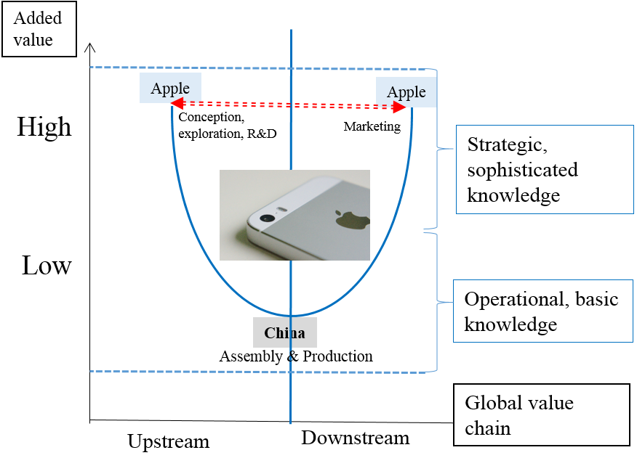

To Make or Buy the Product?
Advantage of Make | Advantage of Buy
Lower costs  Facilitate specialized investment  Protect proprietary product technology  Improve scheduling | Strategic flexibility  Lower costs  Offsets

Outsourcing – Just in Time (JIT)
- In Japan in the 1980’s, space was a premium
- Manufacturing processes had to deal with space restrictions for warehousing, assembling, etc.
- One way companies saved money was to have their suppliers send the components just when it was time to use them – meaning no need to store supplies in advance, they’d be delivered just in time to put them into the product being assembled.

Organizational Design for International Enterprise

Types of Companies (What’s the difference?)
- International (selling outside of it’s home country)
- Multinational (physical presence in more than one country – ex. Japanese subsidiary of an American company)
- Global (international activities – it buys and sells outside of its home country and it has a physical presence in many countries – product moves from country to country to be made ex. iPhone designed in US, manufactured in China, screen from South Korea, etc.)

Structure by Product and Market

Structure by Function

Structure by Product and Market

Structure by Region

Boeing has multiple operating groups & functional areas
- Research & Technology: Research and development organization
- Test & Evaluation: Test and evaluation to meet the highest standards of quality
- Enterprise Technology Strategy: strategy for long-term technology planning
- Environmental, health and safety: strategies for environmental performance and workplace safety
- Information technology: creates, transforms, stores, secures, exchanges and uses information
- Intellectual property management: protecting ideas, specialized knowledge and inventions
- Engineering, operations and supplier management functional excellence: technical excellence in engineering, operations and global supply chain
- Engineering: delivery of world-class solutions with quality within budget and on schedule
- Operations: functions discipline in common metrics, processes and replication of best practices
- Supplier management: developing, assisting and coordinating partners effectively in product development, sourcing, production, logistics and information systems

Inside Embraer…
- Intense security to ensure information (strategic knowledge) is not stolen and shared with competitors

Organizational structure and global knowledge management
- Coordinated structure: knowledge centrally developed and transferred to units abroad
- Centralized structure: knowledge developed and retained at the headquarters
- Decentralized structure: knowledge developed and retained within each unit
- Networked structure: knowledge jointly developed and shared worldwide

Global Manager

Value Creation: a group of activities that increase the value of goods and services to consumers

Reasons for Going International
- Realize location economies
- Realize greater cost economies
- Earn a greater return from the firm’s distinctive skills or core competencies
- Earn a greater return by leveraging any valuable skills developed in foreign operations

The Role of Strategy
Strategy: identifying and taking actions that will lower the costs of value creation and/or will differentiate the firm’s product offering through superior design, quality, service, functionality, etc.
- Make things cheaper than the competition
- Make things good enough to be of interest to consumers

Multinational Business Strategy (Policy)
- Fundamentally about how you add value
  - For international business the competition is typically greater
    - Can you overcome the deficiency of being foreign, and still win business?

Core Competencies and Competitive Advantage
- Core competencies are the things that you, and hopefully only you, can offer to customers
  - Innovation
  - Efficiency
  - Superior customer service
- Valuable, rare, inimitable, non-substitutable

The Experience Curve
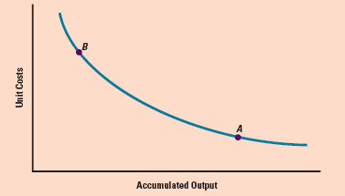

Classic Organizational Design
- Differentiation – the company is composed of different units that work on different tasks with differing degrees of authority
- Vertical Differentiation
  - Centralization – the degree to which high-level managers make strategic decisions
  - Decentralization – the degree to which lower-level managers make and implement strategic decisions
- Horizontal Differentiation – deals with the separate tasks or skills that run across units (ie. Functional silos) in the organization

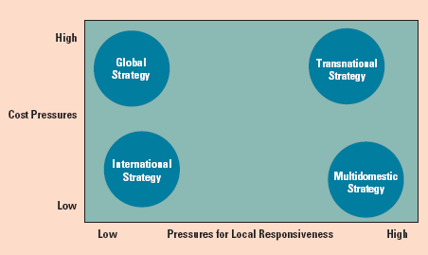

Global Strategy – configures and coordinates value activities worldwide
International Strategy – transfer of expertise from parent company to international units
Transnational Strategy – supports efficiency, compels effectiveness and leverages learning to serve global and local markets
Multidomestic Strategy – reduces need for central support

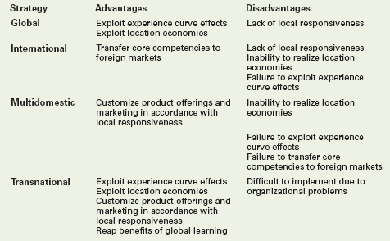

Strategic Alliances: cooperative agreements between potential or actual competitors (firms between different countries)

How to Become Global Manager?
- Power Distance
- Uncertainty avoidance
- Masculine – feminine
- Individualism – collectivism
- Confucian dynamism

Skills of Global Managers
- Develop and use global strategic skills
- Manage change and transition
- Create flexible structures
- Communicate
- Learn and transfer knowledge within organization
- Work with others and in a team
- Manage cultural diversity

Comparison of Staffing Approaches
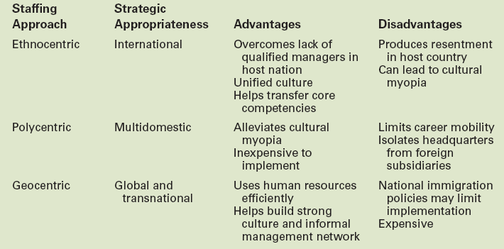

Training and Management Development
- Training for Expatriate Managers
  - Cultural training
  - Language training
  - Practical training
- Repatriation of Expatriates

Direct Foreign Investment

Foreign Direct Investment in the World Economy
- Foreign Direct Investment (FDI): the acquisition or construction of physical capital by a firm
- Flow of FDI: the amount of FDI undertaken over a given period of time (normally a year)
- Stock of FDI: the total accumulated value of foreign-owned assets at a given time
- Outflows of FDI refers to the flow of FDI out of a country
  - This would mean Canadian companies buying property and/or setting up operations in another country
- Inflows of FDI refers to the flow of FDI into a country

United Nations Conference on Trade and Development (UNCTAD)
- UNCTAD, a United Nations entity, is the most authoritative and reliable source of information about global FDI by country and by activity and its statistics and diagrams are quoted equally by the right and left wings

Direction of FDI
- Historically, most FDI has been directed at the developed nations around the world, as firms based in these countries invested in each others markets
- During the past few decades, the US has been the favourite target of FDI inflows
  - The US is the only country in the world with a population over 200 million and a comparatively high GDP per capita
    - Which simply means there are a lot of Americans and they have a lot of money to buy stuff

Source of FDI
- Since WWII, the US has been the largest source country for FDI
  - A position it retained during the late 1990s and throughout the 2000s
  - Meaning American companies are going to other countries and buying up other companies and resources
- Other important source countries include:
  - The UK, France, China, Japan

Forms of FDI
- Acquisition of, or merger with, an existing local firm in the destination market
- Green Field Investment in a new facility in the destination market
  - Slang expression which originally referred to the fact that many of these types of investments involved buying real-estate and building something
- The majority of cross-border investment is in the form of mergers and acquisitions rather than Green Field Investments

Canada – US
- In international trade, until 2007, Canada and US shared the largest bilateral flow of goods, services, people, capital and investments between any two countries in the world
- In 2008, China passed Canada as top exporter to the US
  - A large part of Chinese exports to the US are in fact from American companies in China, like Nike exporting to Nike USA, and subsidiary companies of Walmart exporting to Walmart USA
- Today, Canada-US trade is more than $700 Billion per year

Why Foreign Direct Investment… when exporting and licensing are available?

Limitations of Exporting | Limitations of Licensing
Exporting is constrained by transportation costs and trade barriers. When transportation costs are added to production costs, it becomes unprofitable to ship some products over a large distance  Products of low value-to-weight ratio can be produced in almost any location. Examples: cement, soft drinks  Products with a high value-to-weight ratio: transport costs are normally a very minor component of total landed cost. Examples: electronic components, personal computers, medical equipment | Internalization theory explains why firms often prefer FDI over licensing as a strategy for entering foreign markets  - Licensing may result in a firm giving away valuable technologies to a potential foreign competitor  - Licensing does not give a firm the tight control over manufacturing, marketing and strategy in a foreign country  - When the firm’s competitive advantage is based not so much on its products, as on the management, marketing, and manufacturing capabilities that produce those products

Why Foreign Direct Investment?
- FDI is expensive because a firm must bear the costs of establishing production facilities in a foreign country or of acquiring a foreign enterprise
- FDI is risky because of the problem associated with doing business in a different culture where the “rules of the game” may be very different
- Eclectic Paradigm
  - Location-specific advantage
- The Product Life Cycle

The “Political Environment” and FDI

How Political Ideology affects FDI
- Government policy toward FDI is driven by political ideology
- Historically, ideology on FDI ranged from a radical stance that is hostile to all, to the non-interventionist principle of free market economics
- Marxist political and economic theory:
  - MNE: instrument of imperialist domination by home country
- Free market view:
  - International production should be distributed among countries according to the theory of comparative advantage
- Pragmatic nationalism:
  - FDI brings capital, skills, technology, and jobs, but those benefits often come at a cost

Benefits of FDI to the Nation State

Host Country | Home Country
Resource-transfer effects  Employment: FDI brings jobs  Balance of payment effects  FDI is a substitute for imports of goods and services  MNE uses the subsidiary in the host country to export goods and services to other countries | Balance of payments from inward flow of foreign earnings  Positive employment effects when a subsidiary demands home country exports of capital equipment  Home country MNE learns skills transferable in technologies for use in the home country

Cost of FDI to the Nation State

Host Country | Home Country
Adverse effects on competition: foreign subsidiaries have strong economic power to put local competitors out of market  Adverse effects on balance of payments: against the initial capital inflow that comes with FDI must be the outflow of earnings to be repatriated  National sovereignty and autonomy | Balance of payments from outward FDI  Employment effect from outward FDI

Doing Business in Emerging Markets

Introduction
- Choosing a mode for entering a foreign market is a major issue which challenges international businesses
- They must decide
  - Which foreign markets to enter
  - Timing of entry
    - First mover advantages
    - First mover disadvantages
    - Pioneering costs
  - Scale of entry and strategic commitments

Uppsala Internationalization model
- Companies go international as they gradually acquire knowledge and by first engaging markets that are similar to their home market

Entry Modes
- Exporting
- Turnkey projects
- Licensing
- Franchising
- Joint Venture
- Wholly-owned subsidiaries

Exporting
Advantages:
- Avoids the often substantial costs of establishing manufacturing operations in the host country
- May help a firm achieve experience curve and location economies

Turnkey Projects
- A contractor handles all the details of a project for a foreign client, including the training of operating personnel
- At completion of the contract, the foreign client is handed the “key” to a plant ready for full operation

Licensing
- An arrangement where a licensor grants the rights to intangible property to another entity (the licensee) for a specified period, and in return, the licensor receives a royalty fee from the licensee

Franchising
- A specialized form of licensing in which a franchiser not only sells intangible property (normally a trademark) to a franchise, but also insists that the franchisee agrees to bide by strict rules as to how the business is conducted

Joint Venture
- Entails establishing a firm that is jointly owned by two or more otherwise independent firms
- Two types of JVs:
  - Co-operative joint venture: common with large sized companies seeking positions in emerging markets
    - Relationship does not include financial sharing of ownership in a 3rd entity
  - Equity joint venture: partners share ownership of a jointly held subsidiary
    - Used when it is expected that by holding a subsidiary, the partners can achieve a profit beyond what they could have done separately

Wholly-owned subsidiaries
- When a firm owns 100% of stock by establishing a subsidiary in a foreign market:
  - Either set up a new operation in the host country (Greenfield venture) or
  - Acquire an established firm in the host nation and use that firm to promote its products

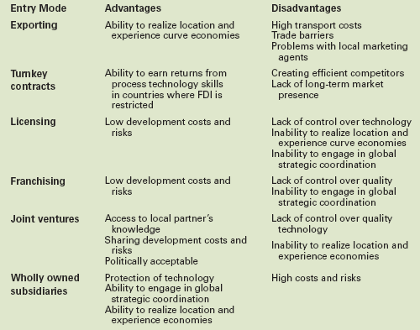

Selecting an Entry Mode
- Core competencies and entry mode
  - Technological know-how
    - If a firm’s competitive advantage (its core competencies) is based on control over proprietary technological know-how, licensing and joint venture, arrangements should be avoided if possible to minimize the risk of losing control over that technology
  - Management know-how
    - The competitive advantage of some firms is based on management know-how (e.g. McDonald’s)
    - For such firms, the risk of losing control over the management skills to franchisees or joint venture partners is not that great
    - These firms’ valuable asset is their brand name, and brand names are generally well protected by international laws pertaining to trademarks
- Pressures for cost reductions and entry mode

Wholly-Owned Subsidiaries
Acquisitions |  | Greenfield Ventures
Pros:  Firm can rapidly build its presence in the target foreign market  Managers believe acquisitions are less risky than Greenfield ventures | Cons:  Firms often overpay for the assets of the purchased firm  Clash between the cultures of the acquiring and acquired firm  Differences in management philosophy | Pros:  A firm’s greater ability to build the kind of subsidiary company it wants  It is much easier to establish a set of operating routines in a new subsidiary | Cons:  Greenfield ventures are slower to establish  Greenfield ventures are risky

Why Do Acquisitions Fail?
- Firms often overpay for the assets of purchased firm
- Target firm’s price gets bid up if more firms are interested in its purchase, as is often the case
- Clash between cultures of the acquiring and acquired firm
- After an acquisition, many acquired companies experience high management turnover, often because their employees do not like the acquiring company’s way of doing things

Export/Import

The situation facilitating more global trade
- The volume of export activity in the world economy is increasing as exporting has become easier
- The gradual decline in trade barriers under the umbrella of the WTO along with regional agreements
- Modern communication and transportation technologies have alleviated the logistical problems associated with exporting

Exporting – Promises and Pitfalls
Common pitfalls include…
- Poor marker analysis
- Poor understanding of competitive conditions in foreign market
- Failure to customize product to foreign customers’ needs
- Lack of an effective distribution program
- Poorly executed promotion in the foreign market
- Problems securing financing
Difficulties also include
- Novice exporters tend to underestimate time/expertise needed to cultivate business in foreign countries
- Few realize the amount of management resources that have to be dedicated to this activity
- Many foreign customers require face-to-face negotiations on their home turf
- An exporter may have to spend months learning about a country’s trade regulations, business practices and more before a deal can be closed
- Exporters often face voluminous paperwork, complex formalities and many potential delays and errors
- Information difficulties: one big impediment to exporting is the simple lack of knowledge of the opportunities available
- Often there are many markets for a firm’s product, but because they are in countries separated from the firm’s home base by culture, language, distance and time, the firm does not know of them
*The way to overcome ignorance is to collect information

Export Information Sources
There are several categories of information
Government
- Supplied by your home government
- Supplied by the government of the target region
- Supplied by governments other than yours’ and the target
Associations
- NGO’s (Non-Governmental Organizations)
- Bilateral associations
- Multilateral associations
- Industry associations
Corporate
- Membership lists
- Webpages of the individual companies
- Directories
- Stock market listings
- Annual reports

EMC Export Management Company
- More popularly known as “Trading Companies”
  - Known as “sogoshosha” in Japan
- EMCs are export specialists who act as the export marketing department or international department for their clients
  - They start exporting operations for a firm but the firm will take over operations after they are well established
  - In another type, start-up services are performed and the EMC will have continuing responsibility for selling firm’s products

Export and Import Financing
- The Business Development Bank of Canada (BDC)

Letter of Credit
- “Letters of Credit are guarantees of payment to help you make purchases or transact business with companies with whom you have limited trading experience or credit history”
- Basically, as an importer, you don’t want to send the money before you get the goods
- The exporter doesn’t want to send the goods to you unless they get their money
- So an LC tells a 3rd party in-between that “yes, the buyer has the money, they gave the money to me, once the stuff arrives safely at the other end, and is confirmed to be what it is supposed to be, I’ll give the money to you, the vendor”
- Usually banks play the role of the 3rd party since they are institutions recognized to be trustworthy for this
- Definition: issued by a bank indicating that the bank will make payments under specific circumstances

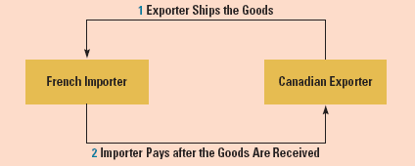

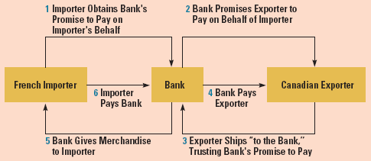

Draft and Bill of Lading
Draft: an order written by an exporter instructing an importer, or an importer’s agent, to pay a specified amount of money at a specified time; also called a bill of exchange
Bill of Lading: a document issued to an exporter by a common carrier transporting merchandise. It serves as a receipt, a contract, and a document of title
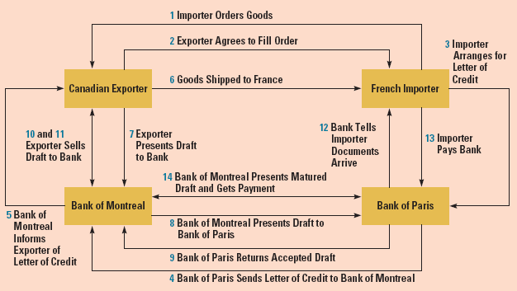

Countertrade
- The trade of goods and services for other goods and services
  - Example: Saudi Arabia agreed to buy ten 747 jets from Boeing with payment in crude oil, discounted at 10% below posted world oil prices
- There are several types of countertrade

