Chem 208
MODULE 2:
The scientific method is a set of organized steps used while conducting an experiment:
- Performing Experiments: is a set of steps (procedures) that are performed under controlled conditions to propose or test a hypothesis
- Making Observations: can be categorized as either qualitative or quantitative
- Proposing a Hypothesis: is a tentative explanation to account for the observations of an experiment
- Confirming the Hypothesis: the hypothesis needs to be confirmed through experiments
- Proposing a Scientific Law: by repeatedly performing experiments and modifying the hypothesis, one can propose a scientific law
Scientific Notation: N x 10 to the power of +/-n. N contains a nonzero digit to the left of the decimal and n is an integers. Example: 598.46 could be represented as 5.9846 x 10 to the power of 2.
Significant Figures: is a measured number that includes all certain digits and one uncertain digit. Used to predict the precision of a measurement, does not apply to counted things (5 cars, 3 flowers), it is used with decimals.
- All nonzero digits are significant figures (135.62g has 5, 23.6 has 3, 17.9871 has 6)
- Counting begins from the left with the first nonzero number (0.056 has 2, 0.000356 has 3, 0.0225 has 3)
- Zeros between nonzero digits are counted as sig figs (1.056 has 4, 30.78 has 4, 300.5 has 4)
- Terminal zeros count (23700 has 5, 17.50 has 4)
Rules for Sig Figs in Chemical Calculations:
- In +/- of measured quantities, the final answer should contain the same number as decimal places that are in the measurement with the least number of decimal places (25.0+22.41+1.234=48.6)
- In x/division, the final answer contains the same number of sig figs that are in the measurement with the least number of sig fig (9.20(3) x 2.450(4) =22.5(3))
- Involving exact numbers, the number of sig figs is dictated by the measured quantity involved
Rules for Rounding off Chemical Calculations:
- For multi-step calculations, all numbers are carried to the final result, which is rounded off to give the correct number of sig figs. Do not round until you get the final result.
- If the digit being rounded off is over 5, then you round up
- If the digit being rounded off is less than 5, then you round down
- If the digit being rounded off is 5, then you look at the number before. If the number before is even, you round it down to keep it even, if the number is odd, you round it up to make it even
What is SI? (systeme international d’unites)
- Length: meter
- Volume: cubic meter
- Mass: kilogram
- Density: kilogram per cubic meter. D=Mass over Volume
Elements: are composed of one type of atom either a metal, non-metal or metalloid.
Compounds: are a combination of elements in proportion. A chemical change can break down the compound.
A non-pure substance: is made of two or more elements or compounds that can be separated by physical procedures.
Atoms: are composed of protons, electrons and neutrons. The nucleus of the atom contains the protons and neutrons while the electrons surround them and are the same number is protons.
Atomic + Mass Numbers: the atomic number is equal to the number of protons and is the lower number. The mass number is equal to the number of protons + neutrons in the atom and is the higher number. To find the number of neutrons, you mass number – atomic number.
Molecules: are a combination of atoms in a definite proportion (H20; hydrogen: oxygen; 2:1)
Ions: are charged species formed by loss of gain of electron(s) from an atom:
Cation Ion: is an atom or molecule that has lost one or more electrons, thus possesses a positive charge. Usually generated by the removal of electrons and are typically metals.
Anion Ion: is an atom molecule that has gained one or more electrons and thus possesses a negative charge. Usually generated by the capture of electrons and are typically non-metals.
MODULE 3:
Periodic Table:
- Groups: are numbers 1-8 and letter A (main-group elements) or B (transition elements)
- Families: Alkali (Group 1A), Alkaline earth metals (Group 2A), Halogens (Group 7A) and Noble Gases (Group 8A)
- Physical State: Liquids, Gases and Solid.
- Metals/Non-Metals/Metalloid: 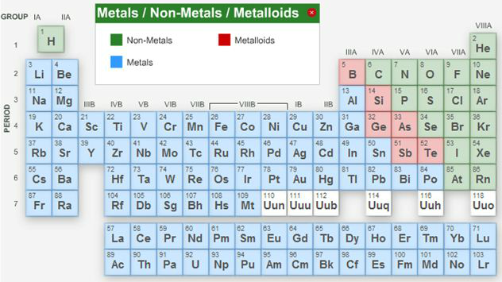
Vertical columns are called groups (have the same chemical properties), horizontal rows are called periods.
Acid: a chemical substance that produces protons (H+ ions) when in water and the pH is less than 7.
Base: a substance that produces hydroxide ions (OH_) when in water and the pH is greater than 7.
Atomic mass: the weighted average mass of the naturally occurring isotopes (an atom containing the same # of electrons and protons BUT differing in the number of neutrons).
Ionic compounds: a compound consisting of a cation and anion where the bond is formed through the electrostatic interaction between the two.
Mole: a convenient unit of measure, defined by the number of carbon atoms in 12g (1 mole) of pure 12C and corresponds to 6.022 X 10 to the power of 23 atoms. To convert atoms to moles.
Polyatomic ion: an ion composed of two or more atoms that are held together though a covalent bond.
Classifying compounds: organic (compounds that contain at least one carbon atom) or inorganic (compounds that contain atoms other than carbon) which are either ionic compounds (containing one metal and one non-metal) or covalent compounds (containing two non-metals)
Rules for Naming and Deriving Formulas of Ionic Compounds:
- For metals in groups 1A, 2A, 3A, the charge on the monatomic cation is equal to the group number. The cation has the same name as that of the metal and is always named first.
- For non-metal in groups 5A, 6A, 7A, the charge on the formed monatomic anion is equal to the group number minus 8. The anion is comprised of the root of the non-metal name and ends with –ide.
- Ions that consist of two or more atoms bonded covalently possessing a net positive or negative charge are referred to as polyatomic ions. For more than one, the ion is written in parentheses with a subscript indicating how many there are of the same polyatomic ion.
Rules of Naming Covalent Compounds:
- Name the first element in the formula first
- Name the second element as an anion
- Use prefixes to indicate the number of atoms in each element (mono-1, di-2, tri-3, tetra-4, penta-5, hexa-6)
- Do not use the prefix “mono” for the first element.
MODLUE 4:
Hazards in the Work Environment: workers have the right to work in a safe and healthy environment, know the processes and substances they are working with and know the potential hazards from these processes and substances. Hazard Assessments are usually conducted to study the workplace and the impacts on the surrounding environment and the workers.
Physical Agents: radiation, vibration, heat and noise. We are constantly exposed to such agents, their intensity and duration may be more significant in the workplace. They may cause immediate or cumulative health effects. Pressure and temperature extremes, excessive noise and vibration and radiation are the most common. The action of physical agents is when residual energy is transferred through the air or equipment that the worker is in direct contact with. Except for radiation, you can detect the others.
Pressure and temperature: hyperbaric pressure: pressure higher than normal atmosphere. Hypobaric pressure: pressure lower than normal atmosphere. Extreme heat can cause heat exhaustion, fainting and heat stroke. Extreme cold can cause frostbite and hypothermia.
Noise and vibration: excessive noise is conducted through gases, liquids or solids. Noise can make it hard for workers to hear anything and may lead to annoyance, poor job performance, loss of hearing and compromise the safety of the worker. Excessive vibration is known to cause serious health problems such as back pain, carpal tunnel and damage to bones and joints. There are two types of occupational vibration, whole-body and hand-arm-. Whole-body is transmitted through the supporting surface, feet and back (mining equipment). Hand-arm is transmitted though hands and arms (hand-held tools).
Radiation: two types of radiation. Ionizing radiation which is high and can damage cells and DNA (x-ray machines, alpha/beta/gamma rays (radioactive materials) and high-energy ultraviolet rays (from germicidal lamps)). Non-ionizing radiation is not as strong but still a lot of exposure can cause serious harm (visible light, microwaves, radio waves, tanning lamps).
Chemical Agents: vapor, gas, fume and dust. They often appear in operations involving:
Compressed gases: in the workplace, any hazardous chemicals are not only a chemical hazard but also associated with a pressure extreme such as chlorine gas is compressed and stored in cylinders.
Flammable and combustible materials: some materials burn readily and in the presence of sources of ignition such as gasoline and solvents fall into this category.
Oxidizing materials: are fire hazards and destroy biomolecules in the living systems. Some examples would be potassium permanganate and hydrogen peroxide.
Poisonous and Infecting materials: dangerous in very small amounts like potassium cyanide and mercury.
Corrosive materials: these can cause deterioration of materials including tissues on contact like sulfuric acid and potassium hydroxide.
Dangerously Reactive materials: certain chemicals may undergo certain reactions under certain conditions like alkali metals reacting with water produces a highly flammable hydrogen gas.
Fine particles: these have an effective entry into our bodies and are retained in the lungs for a long time. Some of these include spray paint mist and fumes from welding.
Gases and Vapors: may be generated from various operations and move rapidly throughout the workplace. They can enter the bloodstream through your lungs. Some of these include solvent degreasing, spray painting and welding.
Biological Agents: are living substances that cause illness and disease in humans. These can range from allergic reactions to serious medical conditions including death. These include bacteria, fungi, viruses, food poisoning, rabies, tuberculosis and hepatitis. These reproduce very quickly and survive with minimum resources.
Ergonomic Stresses: the science of work, it is a way of designing a work environment to fit people. It is to reduce workplace injuries and illness, improve productivity and quality of work, increase job satisfaction and satisfy government regulations.
Toxicology: is the science that involves the study of properties and interactions within physical, chemical, or biological agents.
Toxicity: is the degree of danger that the material can cause to injure a living organism. Some factors of toxicity are physical/chemical properties, intensity of exposure, mode of handling, routes of entry and susceptibility of the worker.
Dose: is defined as the amount of toxicants actually delivered to the organ and is expressed in mg/kg (mass of the toxicant/body mass)
Exposure: is the total amount of toxicants in the work place. Expressed in mg/mCUBED for particles and ppm, ppb or % for gases and vapors.
Threshold Limit Values: the lower the number, the more dangerous it is.
The effects of Toxicants: the over exposure to the toxicant is based upon the duration of the effect and the organs affected and physiological action.
Acute Effect: the effect of the toxicant appears soon after the exposure. Brief exposure to a high concentration.
Chronic Effect: much later after the exposure and effects from low, repeated exposure over a longer period of time. More difficult to study.
Physiological Actions: change the normal functioning of one organ or a set of organs in a system.
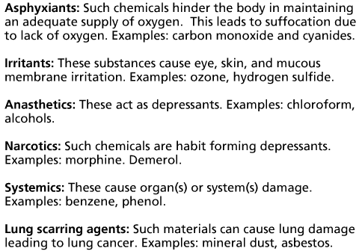
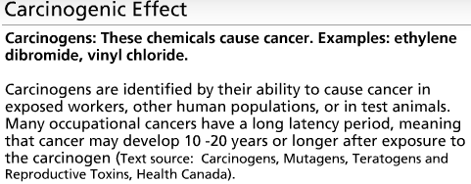
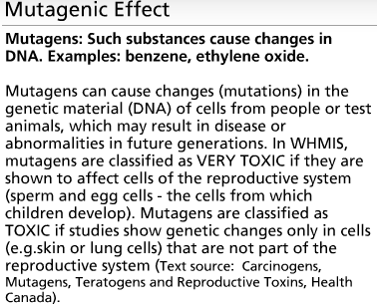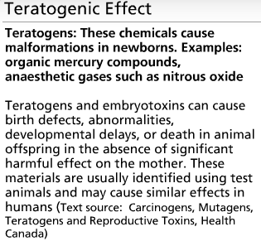
WHMIS: Due to the seriousness of such health & safety problems, it was agreed to implement an information system with the goal of reduced incidence of illnesses and injuries caused by the hazardous materials in the workplace. The system consists of three elements, labeling the containers of the materials, providing a MSDS sheet which provides details about the nature of the material and a provision of worker education program.
Safety Date Sheet: must contain basic information about the chemical product such as the properties, the potential hazards, safety use and emergency procedures.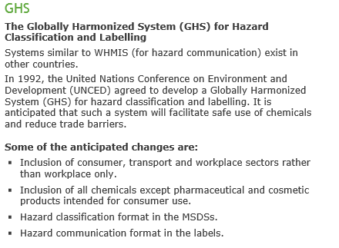
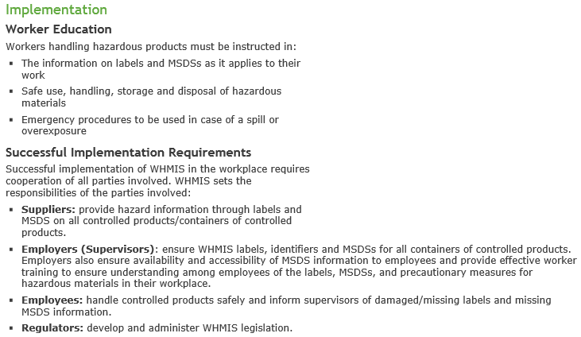

MODULE 5:
Air is a mixture of gases, fine particles and vapors. Dry air consists of 21% oxygen, 78% nitrogen.
Major components of air:
- Nitrogen (N₂)
- Oxygen (O₂)
- Water (H₂O)
- Carbon dioxide (CO₂)
Some minor components of air:
- Carbon monoxide (CO)
- Ozone (O3)
- Oxides of Sulfur (SOx)
- Oxides of Nitrogen (NOx
Pollutants in the air may produce adverse environmental and health effects. Emitted during combustion and production processes. Fossil fuels (petroleum, natural gas, and coal) can be used to generate energy (electricity, gas, steam), transportation (combustion engines) and in industrial processes (pulp and paper mills ore smelters, petroleum refineries, power generating stations and incinerators).
The atmosphere is divided into 4 layers, the troposphere, stratosphere, mesosphere, ionosphere/thermosphere. The atmospheres’ layers are divided because of their altitude, pressure, temperature, electrical nature, and chemical composition and concentration.
Carbon Monoxide (CO): when there is an adequate supply of oxygen, there is a complete combustion of fossil fuels thereby forming the major b-products: carbon dioxide and water. Most CO is produced in this process is immediately oxidized to carbon dioxide. However, when there is an insufficient supply of oxygen, there is incomplete combustion of fossil fuels and carbon monoxide gas is released. CO is also produced when organic matter combusts. Natural sources of CO include forest fires and volcanoes. ***when a person inhales CO, it glues to the oxygen on the red-blood cells causing a reduction of oxygen in the body. This results in cell and tissue death. Health effects include an impaired ability to use oxygen, decreased athletic performance and cardiac problems.
Ground Level Ozone (O3): naturally happens and forms a layer in the atmosphere that is predominantly in the stratosphere. The ozone protects the Earth from the sun and absorbs the ultraviolet rays. O3 is produced during photochemical reactions between volatile organic compounds (VOCs) released in car exhaust and oxides of nitrogen (NOx) in the presence of sunlight. Also in arc welding. Human health effects include damaged biological tissues and cells, reduced lung function, breathing difficulty, itching/burning/watery eyes.
Oxides of Sulfur (SOx): released during smelting of mineral ores and the combustion of fossil fuels. Pulp and paper production and petroleum refining also generate SOx. Also, sulfur dioxide (SO2) which are most common in volcanoes, and sulfur trioxide (SO3) are released. Further reactions in the atmosphere may lead to the formation of sulfuric acid (H2SO4) and sulfate (SO42). Human health effects are problems breathing and respiratory illness.
Oxides of Nitrogen (NOx): fuel combustion, transportation, home and industrial use. They form in the air because fuel is burnt at high temperatures but is mostly in the form of nitric oxide with a small amount of nitric dioxide. Once nitric oxide (NO) is oxidized, it becomes nitrogen dioxide (NO2). Nitric oxide is most present in the atmosphere, then nitrogen dioxide and nitrous oxide. Natural emissions of nitrogen oxide include lightning and microbial activity of soil bacteria. Human health effects include serious lung damage and shortness of breath and chest pains.
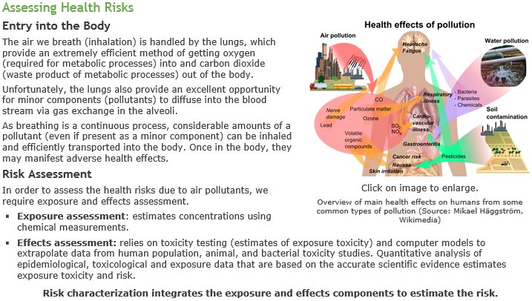
Threshold limit values: CO-25ppm, NO2-3ppm, O3-0.1ppm, SO2-2ppm
Indoor Air Contaminants:
Asbestos Fibers: have been used in a variety of building construction materials for insulating and fire proofing. Deteriorating, damaged or disturbed insulation because the source of the fibers in the air.
Biological contaminants: bacteria, dust mites, insects, mold, pet dander, rodents, viruses.
Combustion by-products: include gases like carbon monoxide, carbon dioxide, nitrogen dioxide, unburned hydrocarbons, and small particles. These are created by burning of fuels such as wood, gas, coal in appliances such as wood stoves, gas stoves and fireplaces.
Formaldehyde: pressed wood products such as hardwood, plywood, furniture combust with tobacco smoke, textiles and glues.
Pesticides: these originate from the products used to kill household pests and when used outdoors can be tracked indoors.
Radon Gas: it is slowly released from the ground, water and some building materials. Some items such as concrete, bricks and tiles may even release uranium. Radon can enter a house through cracks in the foundation walls, floor drains and sub pumps.
Respirable Particles: depending upon the size they can be inhaled all the way into the lungs. Some sources include fireplaces, wood stoves, oil heaters, tobacco.
Volatile Organic Compounds: include a variety of air fresheners, aerosol sprays, disinfectants, dry cleaned clothing, hobby supplies, paints and solvents.
Water: Polar covalent bonds: The electron pair forming the covalent bond (between the oxygen atom and each of the two hydrogen atoms) is more strongly attracted by the oxygen atom due to its higher electronegativity (the ability of an atom in a molecule to attract shared electrons over another atom in the molecule). This leads to a partial positive charge on each of the two hydrogen atoms (represented as ⁺ ) and a partial negative charge on the central oxygen atom (represented as ⁻ ) making the water molecule behave like a dipole. Molecular shape: A water molecule has a bent (V-shape) shape (H-O-H bond angle of 104.5°). This, in combination with the polar covalent bonds, leads to a resultant dipole and hence the polarity of the water molecule.

Surface Properties: the high surface tension and capillarity of water is due to the presence of hydrogen bonds. Water is the liquid with the highest surface tension. Plant debris rests (rather than sinks) on the surface of water bodies due to its high surface tension. This provides aquatic life with much-needed shelter and nutrients. Capillary action (also due to high surface tension) makes water in soil available to plants.
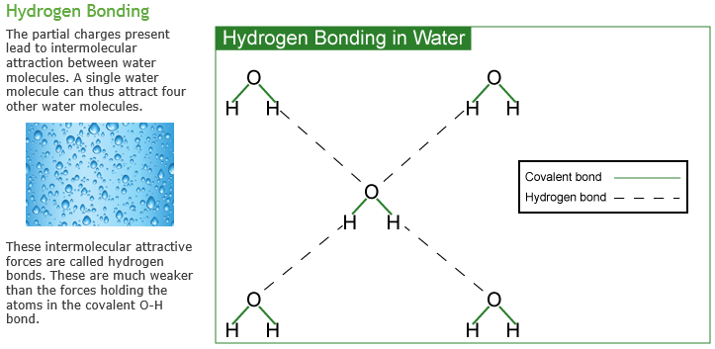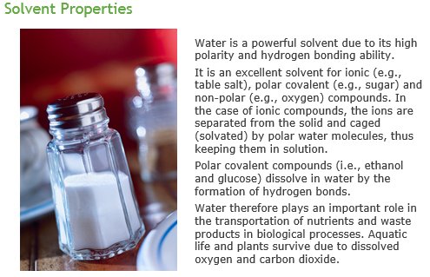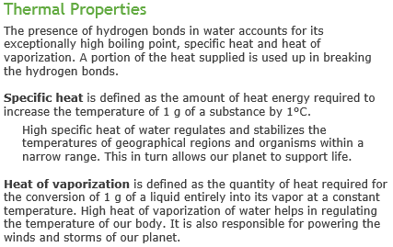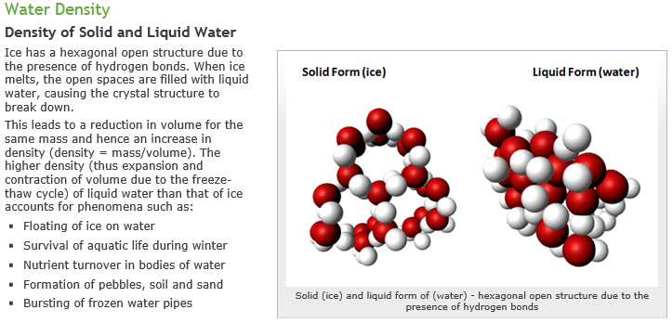
MODULE 6:
Cleaning products contain compounds called surfactants which make things cleaner, healthier and pleasant. Surfactants are composed of a hydrophilic head and hydrophilic tail. There are anionic surfactants that have a negative charge, cationic surfactants which have a positive charge, non-ionic surfactants with no charge and amphteric surfactants with both positive and negative charges.
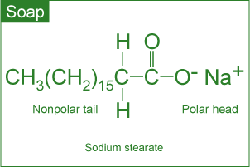
All about soap: consist of hydrocarbon tails of fatty acids and the polar heads are composed of either sodium or potassium salts. Advantages of soap include renewable resources and are biodegradable and do not pollute. Disadvantages leave soap scum and leave behind Ca2+ and Mg2+ which create visible dirt
All about detergents: are made from petrochemicals. Advantages are that they are better cleaning agents and eliminate the film formation as they are less affected by calcium, and are adaptable to diverse fibers, temperatures and conditions. They re not made from renewable sources and are not biodegradable. 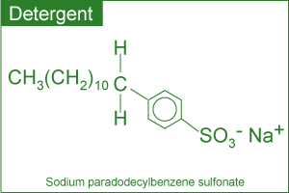
The soap/detergent chemical interaction:
- Chemical interaction: traps the oily and greasy soil molecules
- The hydrophobic tails are attracted to the grease and hydrophilic head to the water forcing the grease away from the soiled surface
- The grease is then removed
- Thermal interaction (hot water) helps dissolve oil and grease and mechanical interaction (rubbing) releases oil and grease from the fabric.
The safer detergent stewardship initiative (SDSI) tries to make more companies into non-polluting ones and use safer chemicals to protect aquatic life.
Oxidizing agents: are a substance that oxidizes another substance in a chemical reaction and in turn donates electrons.
Reducing agents: are a substance that reduces another substance and in return gets more electrons.
Influencing facts of personal care products: to help the aging population, change attitudes of men, more women are in the workplace to judge, and concerns about exposure to UV rays. They also contain more microcapsules which are in many shampoos, lipsticks and face creams.
- Shampoos: contain anionic surfactants
- Conditioners: contain cationic surfactants
- Styling agents: must treat the hair with a reducing agent that breaks certain covalent bonds, setting the hair in the desired shape, treat the hair with an oxidizing agent to reform the previously broken covalent bonds into a new shape.
- Colorants: hair coloring is an oxidation of natural hair pigments to colorless products using a bleaching agent then applying the organic, synthetic dye. Major development in the field of hair coloring include colors, improved delivery of desired hair color and more effective conditioners to neutralize the harsh effects of dye chemicals.
- Moisturizers are used to increase the water content in the skin, they treat dry skin and protect it. Humectants: absorb moisture and holds it in the skin (glycerin, urea), emollients: lubricate and smooth the skin (lanolin and mineral oil)
- Sunscreens: protects against the harmful effects of UV rays which consists of UV-A and UV-B. it is believed that exposure to UV rays can cause painful sunburns, damage to skin and lead to skin cancer. Inorganic ingredients are used to reflect and scatter the UV light. Organic ingredients absorb the UV light and dissipate the heat.
- Pharmaceuticals: are products that affect the structure or function of the body and cover a deficiency or defect. Alpha hydroxyl acids became important in the 1980s to reduce the signs of aging, sun-damaged skin and wrinkles. They break down and lift off the layer of dead skin cells. These include botox, vaniqa and propecia.
- Perfumes are alcoholic solutions where the ingredients are blended based on their molecular size and volatility. Three different stages, top (which is experienced immediately after opening the package), middle (experienced next) and base (last the longest).
- Deodorants: conversion of certain compounds to unpleasant odors by bacteria.
MODULE 7:
Single bond: is a covalent bond in which one pair of electrons is shared by the two atoms participating in the covalent bond.
Double bond: is a covalent bond between two atoms involving the sharing of two pairs of electrons (total of four)
Triple bond: is a covalent bond between two atoms involving the sharing of three pairs of electrons (total of six)
Functional group: a specific grouping of atoms that are considered to be a chemically functioning part of the molecule. The properties are transferable to one molecule to another.

Organic chemistry: deals with the study of carbon containing compounds and their reactions. Can form a large number of organic compounds. Covalent single/double/triple with some other elements. Covalent bonds with other carbon atoms to build chains and cyclic structures. Covalent bonds with elements such as hydrogen, nitrogen, oxygen and halogens. Alcohol, Aldehyde, Amine, Carboxylic Acid, Ester, Ether, Ketone.
The treatment of infections and diseases: there were plants, minerals and animal sources to make concoctions and the use of plants alone is medication.
Antibiotics: used to fight bacteria such as meningitis, pneumonia, tuberculosis. There are several categories of antibiotics such as penicillins, cephalosporins and tetracyclines.
How do antibiotics work:
- Cell wall synthesis: prevent new bacteria from entering
- Cell membrane permeability: kills bacteria cells by causing a breakdown of the outer membrane
- Protein synthesis: prevents bacteria from converting proteins to energy thus causing starvation and ultimate cell death
- Nucleic acid synthesis: attacks the bacteria DNA to keep it from growing
- Competitive inhibitor: mimics the growth of the bacteria so it does not spread itself
Penicillin: treat infection and do not cause infections caused by viruses. They affect the development of the bacterial cell walls
Cephalosporins: similar to penicillin, treat a much more broader range of infection, effect the development of the bacterial cell walls
Tetracyclines: consists of four rings, treats penicillin-resistant infections and inhibits the synthesis of required bacterial proteins
The superbug: they show resistance to antibiotics. Ways to decrease this resistance is to monitor when you use antibiotics so you do not become immune to them and develop new antibiotics.
Antiviral drugs: are used to cure or to control viral infections like AIDS, herpes or polio because they do not respond to antibiotics. There are two main strategies to fight these infections:
- Prevention through vaccination: when you get a vaccine the medicine is stored in your body, called antibodies, and become available to fight future infection
- Use of antiviral drugs: there are three types:
- Nucleoside derivatives: inhibit the growth of DNA thus preventing the spreading
- Protease inhibitors: interfere with the proteins and stop their reproduction
- A three-drug cocktail: mixes different types of nucleosides and protease inhibitors. It is also known as Highly Active Antiretroviral Therapy (HAART) and the success is common because it attacks the virus at each different stage but it is very expensive and patients must live by the dosing schedule.
Chemotherapeutic Agents: cancer involves an uncontrolled division of some cells of the body due to DNA mutation. These cells invade nearby tissue and spread through the body via the bloodstream or lymphatic system. These chemicals are targeted at diving the cells to kill the cancerous ones
- Alkylating Agents: kills the cells and multiplication, high reactivity but also affect the growth of normal cells and cause mutations
- Antimetabolites: organic compounds which are recycled, synthesized or broken down and stops cell replication. They compete for binding sites of enzymes and incorporate themselves into the nucleic acids.
- Topoisomerase inhibitors: damage DNA cells which causes the cell to die and prevents the cancer from growing.
- Hormone therapy: is used when there is a certain cancer that depends on hormones to grow. Most commonly used with breast cancer and that of the sexual organs. This stops the cells from growing and stops the production of certain hormones or change their mod of function completely.
Antidepressants: they help restore the brain’s chemical balance and include selective serotonin reuptake inhibitors (SSRIs) (Prozac, Paxil, Zoloft), Monoamine Oxidase Inhibitors (MAOIs) (Nardil, Marplan and Parnate), Serotonin and Norepinephrine Reuptake Inhibitors (Effexor), Tricyclics. SSRIs target the serotonin levels, tricyclics affect the brain levels of other neurotransmitters as well.
Anti-Inflammatory Drugs: inflammation is the first response of the immune system to infection. Swelling occurs from the rapid transport of blood proteins and other substances to the damaged tissue attacking foreign organisms. Certain steroids are used.
Aspirin: relieves minor pain, lowers fever and reducing swelling. It is also used to treat heart attack and stroke. It is believed that it reduces the production of prostaglandins and thromboxane in the body. Possible side effects include stomach irritation, ringing in the ears, allergy and reye syndrome (brain disorder in children)
Drug Delivery Systems: Active pharmaceutical ingredient (API) in medicine is delivered to the body in many different forms such as tablets, liquids, etc. They are advantageous because they are convenient for the user, improved drug performance and better patient compliance.
- Pulmonary delivery: rapid absorption into the lungs and is then rapidly put into the bloodstream
- Skin absorption: skin patches are useful at providing people with medication
- Nanocrystals: this reduces the drug particle size to nanoscale making it more soluble in body fluids
The disposal of drugs is important and effects the environment. Old/expired medications are put into the environment mostly through raw or treated sewage. Feminization of male fish due to estrogenic compounds: The signs of feminization in male fish have been concluded as a response to estrogen (in birth control pills) exposure. Slow development of fish and frogs due to certain antidepressants: Profound effects on spawning and other behaviors in shellfish can occur with antidepressants such as Selective Serotonin Reuptake Inhibitors (SSRIs).
Drugs should not be considered risk-free chemicals. You should read drug labels carefully, learn about the warnings of the drug taken, inform health care providers of all prescription and OTC drugs taken and keep a record of all medications taken.
MODULE 8:
Acid Rain: rain that is simply more acidic and is more acidic because of the oxides of sulfur and nitrogen which dissolve in the rain droplets and react with the water to form strong acids. When atmospheric carbon dioxide dissolves in water it forms carbonic acid. CO₂ (g) + H₂O (ℓ) H₂CO₃ (aq) The acid formed dissociates partially generating small amounts of hydrogen ions.H₂CO₃ (aq) H⁺ (aq) + HCO₃⁻ (aq) The hydrogen ions formed are responsible for the weakly acidic nature of rain. If the pH is less than 7 acid, more than 7 base, is 7 neutral. Based on the concentration of carbonic acid and small amounts of other natural acids, the pH of rain should be 5.3.
- Material damage: such as marble and limestone (CaCO3) react with acid in the rain. The reaction then leads to the formation of calcium salts.
- Corrosion of Metals: iron rusts quicker when there is more acid rain. The reaction occurs in two steps with hydrogen ions being involved.
- Forest Damage: considerable damage to trees is more apparent now. Acid rain has been implicated with slower growth or forests and also contributes to a decline in the growth of healthier trees. Acid rain attacks the leaves whose protective coating has already been damaged due to pollution and mobilized metals in the soil which attack the roots.
- Aquatic life: quite susceptible to changes of pH. That has led to lakes with no fish. We need to lower the pH level to around 6.5 for healthy aquatic life. aluminum levels are directly toxic to fish and causes them to become smaller.
Some control strategies:
- Reduction of SOx emissions by using emission control technologies, use coal with lower sulfur content, remove sulfur before the use of the coal, and using chemicals to neutralize acidic sulfur dioxide.
- Reduction of NOx emissions by using control technologies: catalytic converters are now in use in cars to reduce the emission of nitrogen oxides.
- Using cleaner energy sources in transportation: such as alcohol or hydrogen.
- Developing and/or using alternate energy sources: such as wind, hydroelectric or nuclear power. The development however is slow due to the high initial costs.
Global Warming: is the increase in the Earth’s average temperature this is the result of increased absorption by the atmosphere of heat and is due to an increase in concentration of gases that trap heat in the atmosphere. These are called greenhouse gases
- Carbon dioxide: due to the burning of fossil fuels, waste materials and as a result of other chemicals
- Methane: production and transportation of fossil fuels, livestock, agricultural practices and organic waste decay
- Nitrous oxide: agricultural and industrial activities as well as the combustion of fossil fuels and waste materials
Fossil Fuels: believed to originate from the natural decomposition of organisms and trapped in rocks. This contains coal, petroleum and natural gas.
Possible environmental effects include:
- Climatic change: human activities such as the burning of fossil fuels, deforestation and etc are releasing greenhouse gases. These gases trap energy in the atmosphere and that is what is heating the planet.
- Changes in sea level: the north pole is warming up the fastest out of everywhere in the entire world.
- Increase in droughts and heat waves: dry conditions may be encountered across much of the globe.
- Change in ecosystem: some species are shifting towards higher elevations because of the narrow range of climatic conditions and some even face extinction.
- Effects on human health: temperature-related illness, air pollution and the spread of some infectious diseases.
Reduction of CO2 emissions: promoting that alternate non-fossil sources such as hydroelectricity, wind should be developed, capturing the CO2 generated by burning fossil fuels, supporting new fuels and technologies aimed at producing new fuels. Also encouraging energy conservation and replanting trees will help.
Key events to limit global warming:
- UNEP: in 1988 established Intergovernmental panel on climate change to focus on the assessment of scientific knowledge, examine the social and economic impacts and response strategies. In 2007 it stated that global warming is clearly evident from diverse observations such as the increase in average air and ocean temperatures, melting of snow and ice and rising of sea level. It could cause irreversible damage to the planet.
- Kyoto: in 1997 is a document that called for industrialized nations to cut out their emissions of greenhouse gases.
Ozone depletion: it acts as an air pollutant contributing to smog in our atmosphere and in the stratosphere it filters the UV rays to protect us from their harmful effects. High exposure to ozone may occur in high-intensity UV light, high-voltage electrical equipment and welding. 3 O₂ (g) + Energy 2 O₃ (g)
Ozone formation:
When ultraviolet light strikes oxygen molecule, individual oxygen atoms are produced. | O₂ + Energy 2 O
The combination of atomic oxygen with oxygen molecule leads to the formation of ozone. | O₂ + O O₃
The interaction of ozone molecule with ultraviolet light splits it into a molecule of oxygen and an atom of oxygen. | O₃ + Energy O₂ + O
Recombination of ozone molecule with an oxygen atom leads to the formation of oxygen molecule. | O₃ + O 2 O₂
Environmental Concern: the ozone is depleting the stratosphere, which is leading to less efficient filtration of harmful UV rays from the Sun. The depletion is caused by both natural (water, vapour) and human-made (chlorofluorocarbons) sources which are called ODS (ozone-depleting sources). Chlorofluorocarbons (CFCs) have been used as foam-flowing agents, fire-extinguishing agents, solvents and refrigerants. Unfortunately since they last a long time, they reach the stratosphere and that leads to the generation of chlorine and bromine which destroy it.
Effects of increased intensity of ground-level UV radiation:
- Humans: higher probability of sunburns, skin cancer and skin aging, as well as cataracts, eye diseases, blindness and the weakening of the immune system.
- Agriculture and Forestry: physiological and developmental processes of major crop species may be affected.
- Materials: increases the degradation process
- Marine ecosystems: damages marine life by decreasing plankton which disrupts the food chain and leads to decreased reproductive capacity reducing fish yields.
Control Strategies: the global response to the threat of ozone depletion came with the signing of the Montreal Protocal in 1987 and was set out to reduce and ultimately ban the manufacture and use of chlorofluorocarbons (CFCs) and other ozone depleting substances.

