Lecture 2

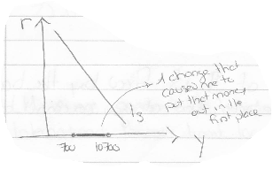
The Curves
- IS, LM, and BOP curves put together equal aggregate demand
- Y= C + I + G + X – M , this is a consequence of spending
- Consumption + investment + government spending + exports – imports
- Focus on Y = C + I (holding all other variables at 0), implying that
Y = C+S, where savings is equal to investments, depicted in the IS curve.
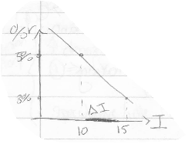
- The IS curve is an equilibrium statement: tells us what will be the interest rate & the income so that I = S
- This curve can be shifted if G doesn’t equal X or M or 0, causing a parallel shift

Investment Function
- Relationship between interest and investment
- When R decreases, then investments increase
- A change in I is caused by the multiplier, which then causes the change in Y from one amount to another.
IE. A change of 5 x 10 = $50, so you would go from 100 to 150
- If the slope of the original investment function changes, then the multiplier will change.
- A steeper curve causes a decrease in R, and a substantial increase in I

Other Curves
- The LM curve, where L = demand and M= supply
- Note that the quantity of money is fixed by the bank
- Keynesian belief that the Canadian Government can control Canadian Dollars
- They also believe they we can only hold money or buy bonds
- When interest rates are high, demand is low (and vice-versa)
- Demand is affected by both interest rates (a downward sloping convex curve) and income (upward slopping curve)

Lecture 3

Role of Money
- Claim that as M increases (by/if $ is created by the government)
- Real money cannot really be created out of thin air
- Real money is purely power, which must be earned by having something real to offer in barter
- If new money is mere paper?
- LM curve moderates/diminishes the spending process
- International factors limit government
- As interest rates decrease, spending (aka demand) increases
- In simple terms, the LM is like the demand curve and the IS similar to the supply curve. However, INCOME is on the X-AXIS and INTEREST RATES on the Y-AXIS

Re-spending Causes Income to Increase (KEYNESIAN STORY)
- 2 Factors: income & interest rate influence the demand for money
- An increase in demand, causes transactions to balance
- We assume a fixed amount of money in the system which is determined by the central bank
- Speculative/Idle Balances: demand for money shows that we want less money when there is an increase in interest rates (a shift in IS curve, full multiplier effect)
- Monetary conditions in LM curve make for higher I%
- IS and LM are statements of what must occur
- Aggregate Demand: comes about when we speak of prices
- If the policy of prices fall, we call this expansionary, and the LM curve shifts outwards
- This adds to the quantity of money, so we don’t get a big increase in income as it was diminished due to the low % (because we want money to balance)
- Shift LM outwards, and where it newly intersects the IS curve is new equilibrium
- There is a need for stable allocation of resources
- Inflation would eat away at the values of savings
- It is important to remember, inflation is bad (at best it is neutral)
- Investment decisions are made on a speculative basis
- Asset price inflation is the worst

Aggregate Supply
- Inflation produces profits for firms – businesses are profiting
- Keynesians only assume that the price of items increase, not the raw resources too
- A productivity curve, an S SHAPED curve, shows diminishing returns

Lecture 4

Aggregate Supply
- Price level falls, purchasing power increases (as if there is a greater supply of money)
- This effects monetary conditions/policies
- An exaggerated expansion in income is reduced through aggregate supply
- When prices rise we have inflation – stimulative
- WRONG. It is possible that aggregate supply will bend backwards and be destructive
- Increased employment at lower real wages only, not at higher wages.
- Labor is only a factor of production, it is not held constant, therefore, there are diminishing returns
- If you pay a worker their marginal product, then with more workers you will get a diminishing wage and a downward sloping demand curve
- Isoquant Utility Functions (Indifference Curves)
- Always slope downwards and are convex to the origin
- We always assume that more is better, therefore, always want to be on higher indifferences curves
- We get an equilibrium, where the utility function is tangent to the wage line
For this week please read BOB DUN CHAPTERS 13-18 on My Courses about the BOP Curve
- Do world interest rates exists?
- Or are there vertical, fixed amounts of income one can earn?

Lecture 5
½ page for weekly letters as a minimum, but 2 pages with charts/diagrams for a standard performance.

Recap
- Limited the power of crude Keynesian’s, where you can throw money into the economy which keeps getting re-spent.
- Every time re-spent it bumps up income.
- Imports can be an extra leap as the money going around the economy, and limit the final ability of crude Keynesian’s
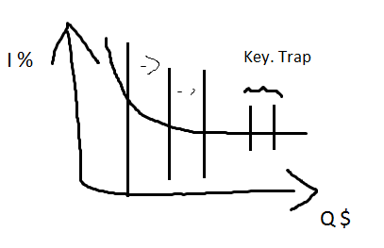
- As the crude process goes forward expanding income, the demand for money for income purposes expands – since we just assumed that quantity of money supplied by central bank is fixed, therefore, to finance the expansion in the demand for money in respect to income requires that the money be drawn away from speculative balances.
- To do this it requires a rise in interest rate. This cuts back on some investment (some of the re-spending business is diminished a bit).

Schools Briefs (Defining Demand)
- One more element that constrains the crude story, appearing on the monetary side (LM curve) = Keynesian Trap.
- Interest rates cannot be pushed low enough during bad times to provide enough investment to overcome recession. (shown on the curve to the right)
- wanted to drive interest rates as close as possible to zero
- At least before people worked out quantitative easing ideas, there was a belief that interest rates couldn’t be pushed below 2-3%; that is what’s behind the curve depicting the Keynesian Trap
- On the graph, the interest rate cannot go below some level (many reasons why this could happen)
- There can be an extreme case where you can have a vertical line at the beginning of the curve, called the classical range, the interest rate could be almost anything and it would not change the amount of money demanded
- Believed, interest rate could be almost anything and demand would not change (classical theorists)

Chapter 14-16 Bob Dunn
- International factors (2) that are limiting/constraining crude Keynesians
- Exports, especially for a small open economy, is something determined in the world at large
- Imports, it could possibly be that we are doing stimulating things in order to help the economy and we are successful for a while (income rises), but maybe it causes us to buy more things from foreigners (we import more).
- Capital Flow Story – investment money in and money out
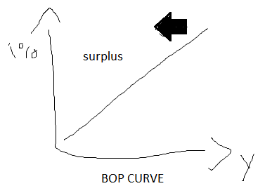
- How do you read the BOP curve?
- IS and LM curves adjust to this
- It is an equilibrium curve about the BALANCE OF PAYMENTS
- Combination of money going in/out of country for trade and investment purposes
- Purchases have to be financed, the way we manage to buy things from other places is that they will lend us the money
- For BOP to be in balance, it is an equilibrium state of affairs, not behavioral
- To be in balance, the extra money that flowed in would have to be used up buying things from the rest of the world. That can only occur if income is greater.
- The right side of the BOP curve is the deficit area
- Left side is the surplus area
- Economics economy must change towards the international reality

Lecture 6
Read Bob Dunn material, most of the key material in the boxes

Open trading economy
- What you end up by way of assigning policy powers –
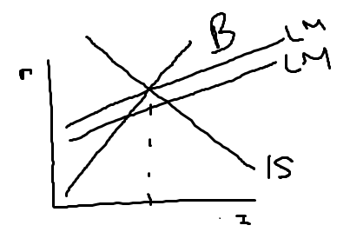
- assign a fiscal policy (government spending/taxing) to troubles such as recession
- assign a monetary policy to national problems like surplus/deficits on trade accounts
- Will do something to help with the stone wall problem , that we cannot move the BOP curve around
- Over time the proposition is that the bop curve was steep after WW2 meaning that the world’s financial markets were not well integrated
- Bop curve steeper than LM curve
- If BOP curve is steep, you use monetary policy to correct, and shift IS curve to the left along with the LM curve to the left
- A restrictive policy on the monetary side helps out with both of the problems (inflation, because you’re taking money away, and interest rate, as you’re increasing it)
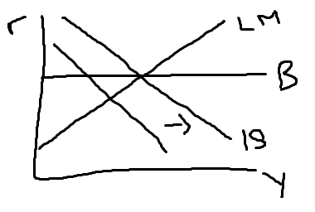
- If you just constricted fiscally by cutting government spending, would cause lower interest rates which compounds your BOP problem (international money doesn’t come in), and before you get rid of the BOP problem you really have to cut income way back. This reduces income, and imports (imports are what is giving you the problem on the BOP).
- When you have a deficit problem, you assign monetary instruments to the BOP problem, and you don’t use fiscal policy yet
- What happens when BOP is flatter than LM? (EXAM QUESTION, either this or what happens when BOP is steeper)
- Further stimulate the economy, ongoing stimulation
- Use fiscal policy to shift IS to the right, further up the BOP curve
- Stimulate the economy by way of government spending (Fiscal policy) which cause interest rates to increase. Oddly enough, this cures the payments problem because the interest rate goes up and so much money comes in from abroad that you have no problem – you end the payments deficit

Newer Versions of Policy Assignments
- James Meade, describes 4 possible situations, evolved in the time of the steep BOP curve
- 1&2 are easy cases, 3&4 hard with policy assignment

- BOP surplus and a domestic recession
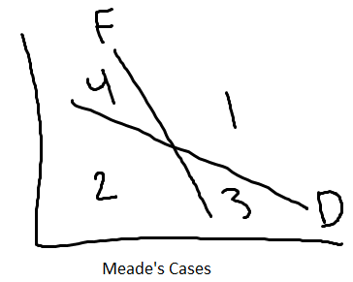
- use universal constrictions (de-stimulate both on fiscal/monetary side), when BOP is still steep.
- BOP deficit and domestic inflation
- solve that with stimulus on both sides – gov spending and money stock increase (depresses interest rate, less money comes in which gets rid of surplus)
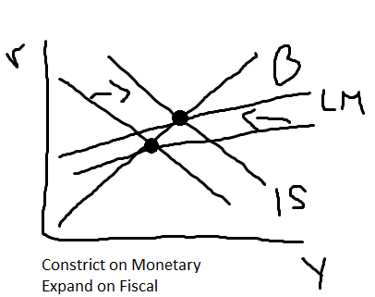
- BOP surplus and domestic inflation
- Suggesting monetary and fiscal policies need to work in opposite directions
- Monetary restriction (get away from surplus so capital doesn’t come in) and increase domestic economy
- BOP deficit and a domestic recession
- Suggesting monetary and fiscal policies need to work in opposite directions
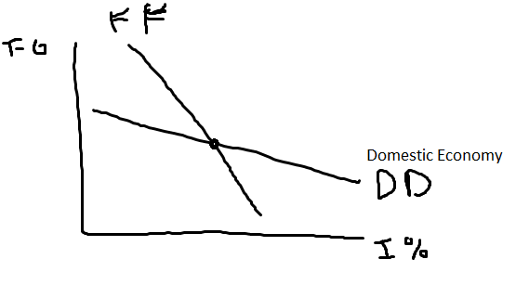

What Else?
- Greater interest rate is a tighter monetary policy, greater T-G is a tighter fiscal policy.
- Move downward with fiscal policy, but offset with increasing interest rate
- FF = equilibrium type curve, where anywhere along the curve you have a balance in terms of payments.
- Neither surplus/deficit in international side of things.
- Monetary policy is the strong thing. Of move downwards you juice the economy on the fiscal side by moving towards a budgetary deficit (net government spending), which increases income/imports/threatens to move the BOP into the deficit direction – belief BOP is flat enough so a small increase in interest rates corrects the problem meaning you can finance the inflow of imports with an easily obtained inflow of foreign capital.
- FF curve is fairly steep.
- Aiming to achieve a situation where you are at equilibrium with FF and DD at a mutually agreeable level of fiscal and monetary stimulus

Lecture 7
Don’t read chp 17-18 Bob Dunn yet.

Utility Maximizing Macroeconomic Making (MyCourses)
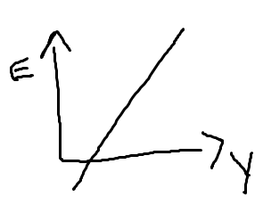
- Macroeconomic equilibrium, talking about income as total of all spending
C + I + G + X + M = Y
- Spending is divided into little groups (C + I + G = EXPENDITURES)
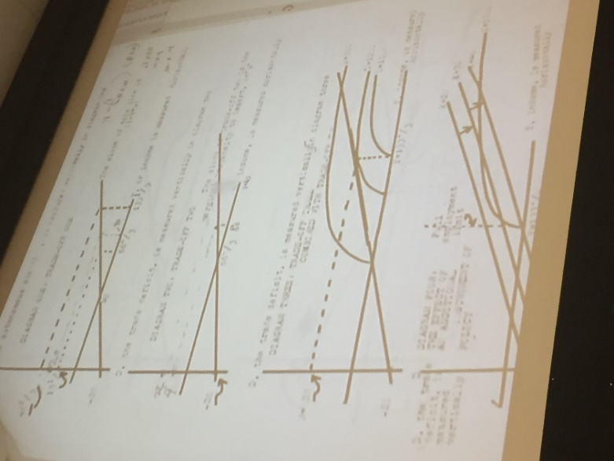
- The spending is just a function of income
G determined by choice, X by world, and M by choice.
- Y = E + X – M
E = A + BY E on vertical axis, A is the intercept (can be changed by the government), B is slope
M = muY (has no intercept, it does through origin)
D = M – X
KNOW THESE EQUATIONS
!!! Multiplier is (1-B+mu)^-2
- B = marginal propensity to spend
mu = marginal propensity to import
X does not change as Y changes, X remains constant
- Y = (1-B+mu) ^-2 (A+X)
(1-B+mu) = withdrawal rate
- A = (1-B + mu) Y-X
- Need to control A and X (autonomous spending and exports)
- Government needs more power

Graphs

- First graph on right (vertical axis = A), you have an income of 0 which means (A+X) has to be 0 .
When A = 0, X times the multiplier is the only determinant of Y
- Second graph on right, vertical axis is now D (deficit) and horizontal axis remains income
- Add Welfare into the equation
W = 12y – D^2 (shown on the right, 3rd graph)
- Adding control over exports gives you the effect of taking the line of possibilities from graph 2, moving it southeast towards higher levels of income and lower deficits (Keynesian)
(graph 4) – until you have just income and no deficits
- There is a case of policy assignment happening in the sense that we need to get the deficit down to 0, using X as our instrument – assign export stimulus job to the problem of fixing the trade deficit and then when use autonomous spending to manage domestic economy to get the rest of A+X we need
- If had ability to use A or X (not both) to an infinitely high value, which is the best one to use given you can make A or X any value?
Pg 12 on document online, you can see that you get a higher level of utility (2100) if you are using X instead of A

Lecture 8

Goldberger & Tinburgan (MyCourses)
- Point 1: In our simple model when we alter equilib by altering A
Multiple A on income or expenditure or deficit or imports (4 different effects)
All different numerical effects
- Point 2: of the two possible instruments that we might want to use A or X, there is a better one (happens to be X). With the helicopter level, easy to explain why – unfortunately, we will have to use the numerical example on the exam.
- Stimulate economy out of recession problem using exports, yes you are dealing with income defined as income as C + X + I – M; injections C,I,G,X getting spent/re-spent and expanding income; the thing is if you do this with X – income & imports expand, the extra exports used to expand the economy moderate the impact on the trade balance
- a problem you get using A is that it now becomes moderated, which causes the BOT unbalance, if you increase imports when exports are fixed (where you stimulate with A), very quickly you get a trade imbalance
- Third point: we understand the nuances of the policy assignment model – when we have both instruments in our hands (using A and X) we can juice the economy and solve the problem of unemployment with assigning fiscal policy (G) control of domestic economy and trade policy assigned to subsidize export industries
- Fourth point: gives interesting looking diagrams to help understand why X is the better instrument over A
Example (Good Exam Q)
Plug in original A = 20, solve using equations given from last class. Then re-do using A = 30, and solve.
- A change in A by 10, increases income by 20 to 100. What happens to expenditure? It goes from 84 to 110 – a change of 26 – multiplier of A on E is 2.6 not 2 like was on Y. What happens to M? Imports went from 24 to 30, multiplier is 0.6. What happens to D? 6 to 10, multiplier is 0.6.
- What happens if we choose X now instead of A?
- X becomes 30 instead of 20 now. Level of income (Y) is 100. Expenditure increases from 84 to 100 – multiplier of X on E is 1.6. Imports increase from 24 to 30, multiplier of 0.6. Deficits goes from 4 to 0.
- This example shows how changing X, is better than changing A
- Graphs may be given, where knowing the equations and numerical numbers, you may be asked to find points. (If X is ______, given _______, what is Y)?
4 different graphs to match the 4 different conditions.
May ask to draw curve by calculating a few points
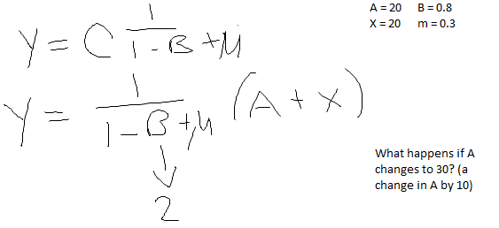

Lecture 13

Edgeworth Box
- The two people can only consume a total of 10 units of each good combined
- Utility contours fill the edgeworth box
- The curves of person A cannot cross each other; likewise for person B
- However, the curves of A and B can cross each other
- You need more of one good to make up the loss of another good
- Only 2 Situations
- At a tangency between Person A and Person B
- When the utility contours of Person A and Person B cross
- When curves are tangent you cannot redistribute the goods voluntarily
- When you connect all points of tangencies in an Edgeworth Box you get an indifference map full of all pareto optimum points
- Exam Q: you have not established a single price ratio, why?

Barter Equilibrium
- Consumer has a basket of goods, in equilibrium you are indifferent on what you spend your last dollar on
- The change in MUx/$1(p) is equal to the change in MUy/$1(p)
- Important:
- Everywhere there is diminishing marginal utility of additional units of any good
- You need to know the prices of everything and their availability in the market
- You cannot be a price marker, in this situation we are only price takers – like as if we were in a perfect competition
- We assume there is no lying, cheating, or misinformation – essentially everyone plays fair

Produces Equilibrium
- How to allocate capital?
- Do it so that the last dollar produces the same value added
- Measured by how much consumers buy
- Producers are essentially delivering utility
- The value of marginal products must be the same across all industries

Theory of the Firm
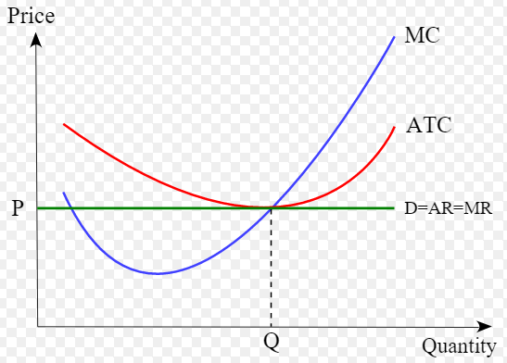
- Cost curves of the firm (such as ATC – average total cost, AR – average revenue, MR – marginal revenue)
- ATC, the average total cost curve, displays the cost per unit of output
- Graphically displayed as a U-shape
- We want the supply curve to intersect the minimum point of the ATC curve
- The demand curve (a horizontal straight line), cannot be below the ATC curve or else you are not covering all the costs of the firm
- If the curve is above the minimum point, more people will thus enter the market which will in turn cause the price to decrease.
- This happens because, if demand is such that it is above the costs you face – more people will see this. The fact profit > costs, means more people will want to enter the industry. This causes supply to increase, which means a surplus of goods, which then in turn causes the prices to decrease.
For this, please read Ace’s book online pages 118-143

Lecture 14: Microeconomics & Game Theory
- Producer’s economic energy is allocated in such a way that the addition to the value of the marginal product is the same, no matter where he delivers his last dollars’ worth.
- Theory of the firm? The world of competition causes it to be true that every producer with a firm, is at the lowest point of his long run average total cost curve (due to the force of competition)
- He faces a completely horizontal demand curve, so in that way when he reaches equilibrium, the consumers are running around allocating their spending – it has been produced at the lowest possible resource cost
- Game theory?
- The trouble is that there are lots of little stories (prisoner’s dilemma, chain story, stag hunt) – each make their own point:
- best outcome sometimes not chosen
- can be more than one equilibrium
- sometimes the players cheat on each other

Grim Theory (Read “Economics: A Very Short Introduction – Partha Dasgupta)
- To understand this theory, you need to understand present-value
- Rate at which things grow and/or shrink
- Example: If you have 100$, put in bank with 10% interest rate, then it would pay you a 10$ dividend every year
- If you had a financial instrument that paid you a dividend forever, you could sell this to somebody for a certain fee
- PV: take 100$ over interest rate to determine the present value (100$/.1% = 1000$)
- You always have a smaller value today, than you would in the future due to discounting
- Interest grows things coming forward, but shrinks things coming backwards
- Type of economic trade where players are separated in time
- If the interest rate is big enough, it causes things to shrink today really quick (i.e. things in present value become smaller and smaller)
- Under certain conditions people cheat – these conditions have to do with interest rate
- Story:
- Albert is the boss, Betty is the worker.
- Albert has a bunch of capital/land, and all Betty is a farmer.
- Albert advances the value of his economic energy worth 4000$ to Betty.
- She in turn uses the equipment to produce 8000$ worth of crops.
- Albert is the only guy who knows how to sell it (assumption).
- Albert sells all of the crops and gets the 8000$, giving back to Betty 3000$ of it.
- Before Betty started working for the farmer, made her own income of 2000$
- By working together both of them are better off by 1000$
- Betty will not cheat on this arrangement with Albert
- If Albert cheats Betty – she will never work on him again (rule of grim theory)
- He is tempted to cheat some times
- Problem? How would he cheat? – Deciding to keep all the money & firing Betty
- That scenario is considered a one-time gain
- Under what conditions would someone give up all additional gains for an upfront value? Need to know present value of the stream of payments – AND THE INTEREST RATE.
- In this case any interest rate below 25% would provide Albert an incentive to cheat
- At an interest rate of 25%, the present value is 4000$ so Albert is currently indifferent

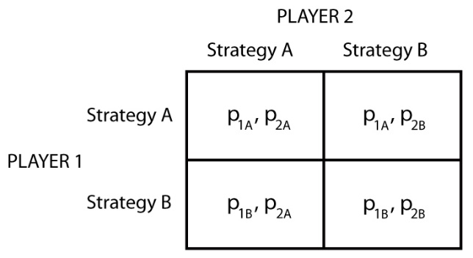
Prisoner’s Dilemma
- Two people get caught doing a bad thing – but both must confess
- Best outcome? Can only get to through rule of law
- Nash Equilibrium: set of strategies, such that neither player has an incentive to change their stratgey given what the other player is doing
- With a mixed strategy there are 3 equilibria, where only some of which are good whereas other ones are inferior – the problem is you may get locked in an inferior one and there is no way to escape if so
- Stag Hunt:
- two people going out to catch meat (one of 2 animals)
- they only have equipment to catch one of the two animals – must decide which equipment to bring but cannot coordinate with one another.
- The stag has more meat than all the hares combined.
- In this circumstance there would be two Nash equiliria: both go for stag or both for for hares
- Mixed Strategies:
- When there is no dominant strategy (i.e. you don’t always pick strategy A regardless of your opponent)
- This means that 50% of the time you would pick strategy A and the other 50% of the time you pick strategy B.
- In this situation there are no Nash equilibria or even an equilibrium
- Know how to explain why there is no Nash equilibria in an exam & mixed strategy
- Mixed Strategy Algorithm:
- Find one strategy for player 1 that leaves player 2 indifferent between both of his two strategies
- EUa = EUb
- EU a = f(mixed strategy – probability of picking up/down) (or f(ou))
- EU b= f(mixed strategy – probability of picking down/down) (or f(ou))
- Three equations, three unknowns – SOLVE
- Player 1: eu a = f(o)
- Some percentage of time he goes up, others down
- Eua= ou(probability of picking up) + (1-ou)(probability of picking down)
- Eventually you make eua = eub to solve for the solution where you are indifferent between your two strategies

Lecture 15: Review (Midterm)
- 4 questions, pick 3 out of the 4 (do not do all 4)
- Essay type questions, keep short & to the point (prefer bullet points)
- Questions are graded on A-F standard (based on GPA point standard)
- Each part of a question is typically weighted (but each question doesn’t have an equal number of parts – i.e. question 1 may have 4 parts, whereas question 2 may have 3 parts)

Main Parts
- School Briefs
- Understanding aggregate demand & supply curves
- Where does aggregate demand come from?
- Intersection IS/LM and how it moves around when price levels change
- Classical Keynesian story: income = c + I + g + x – m
Marginal propensities keep running around until everything is absorbed (savings/taxes/etc). Injection forces are C + I + G + X.
- Demand for labor comes out of the S shaped curve (supply) that shows diminishing returns
- Intersection demand/supply of labor gives quantity exchanged put back into production function, put back into income which becomes one point on the aggregate supply curve
Can get many points because of inflation
- Keynesian story: inflation prices are seen as profits by employers, and they are not seen as higher prices by workers as diminishing their purchasing power, so all they are being offered is money wages (which is falling because of diminishing productivity) causing an upward sloping supply curve for a certain period of time until it becomes vertical.
Evident to employers/employees that mere inflation cannot produce true profits or increases in wages

- Goldberg & Tinbergen
- Macroeconomic policy making
- Argument that policy is to be employed to change level of income or change mix of incomes, you get stories having to do with a family of multipliers, instructing you that more government is better than less.
- Told that the algebra of the model (Income = E + X – M, plus other equations). You then solve, that income can become any number as long as you control A (autonomous spending)
- Income can increase, but at the same time you get a vector of outcomes (the family of multipliers) so not only do you bump Y up but you will also increase the deficit (D)
- Introduces welfare function that tells you that you feel better when income goes up, but worse when D is anything different that 0.
- How to handle this? Export growth, let the government control government spending and exports.
- Using A + X together allows you to have an infinitely large level of welfare because you can make income anything you want it to be – by adjusting them, you use A to give you any income you want and X to kill off the deficit
- Which of the two instruments (A/X) is better? You get a welfare hill displayed as a graph shown on the notes online.
- Export growth is better strategy because you can control the deficits (which is important because you don’t want a deficit greater than 0)

- Bob Dunn (chp 15-18)
- BOP curve – drew in same dimensions as IS/LM
- BOP – international considerations that force you as a policy maker to understand that you must accept that the international markets have a great deal in setting interest rate & income
- Read BOP curve – draw it showing it sloping upwards at a middle level says start at the interest rate, at a certain R you go over from the vertical axis and when it hits the BOP curve, at that interest rate (in the background), there is a relationship with R domestically & internationally motivation for money to come in or not
- If R is attractive more money will come in BUT BOP has to be in balance. So if money comes in, it must go out again for the BOP to be in balance. It goes out again by way of imports. Imports are associated with income.
- Read this curve as showing that 5% brings 1 billion in, 1 billion is then associated with what level of income? Meaning how much would we import? This is all implied in the BOP curve.
- Income levels may be either inflationary/recessionary
- Left of curve BOP is surplus area, where income level is inflationary (economy being asked to produce more income than possible) or recessionary.
- 4 Meade Cases: (IMPORTANT)
- Inflation & deficit (to the right of BOP) – raise the intersection until it hits the BOP curve, meaning you are raising interest rates (more money coming in). Alternatively, you drive income down to bring imports down (import less). Or you do both, and deficit is solved.
- Inflation & surplus
- Deflation & deficit
- Deflation & surplus
- FF curve – stability situation in BOP, maintain that with monetary policy expressed as interest rate which is on horizontal axis
- DD & FF curve problems, especially with #3 & #4, solve it by having manipulative exchange rate – using a policy assignment case
- Use monetary & fiscal policy in contrary directions, stimulating domestically with fiscal where you moderate interest rate with monetary to achieve a case where you cycle if you do it right
- Marshall Learner – question of whether or not it makes sense to manipulate exchange rate
- Condition: sum of elasticities of demand of imports/exports are equal to 1, devaluation has a neutral effect. Greater than 1 devaluation works, less than 1 it wont work.
- Goes through these cases where you ask yourself under what elasticity conditions will a country get better off after devaluation.

- Bob Dun (Chp 2 -5)
- Can increase everything as a result of specialization
- Edgeworth box – voluntary redistribution can make everybody better off.
- Utility contours cross-over, once at tangency you have one point on the contract curve
- At that point, by voluntary redistribution, you cannot move anymore without making someone worse off
- Equilibrium condition, the last dollar you direct (economy energy) as a consumer/producer, must yield same utility regardless of where you spend it
- If this is true, you are in an equilibrium
- Game Theory
- May be several equilibriums, possible with different values
- Unsatisfactory equilibriums can exist, even when you know that there may be another solution (prisoners dilemma)
- Stag Hunt: more than one equilibrium, leads to a Nash equilibrium
- Four possible outcomes of pure strategy Nash equilibrium, however, also the possibility in the coin-matching game, where you have a mixed strategy outcome
- Rules of Nash Equilibria? THERE IS ALWAYS A SOLUTION TO A GAME
- Grim Theory: in trading situations, very often that one of the players has a reward immediately whereas the other trader must wait over time. In that situation always sets up the possibility of cheating on the guy who is waiting, because waiting involves the interest rate (which under certain conditions, a profitable game that goes into the future, may very well be halted by one of the players even though he realizes it will be quite expensive – but if the player that does the halting/cheating does not value the future very much then he will cheat)

Lecture 16

Game Theory: Chain Store & Duel
- Economics of these stories?
- Problem? Equilibrium statements we make in perf. competition are troublesome because they are both unrealistic and don’t make logical/theoretical sense
- Competitive Model: tons of sellers, all anonymous from one another, competitive pricing (lowest level it can be), etc.
- Issues of guarantees
- In Game Theory, they are all little stories about imperfections
- These current stories main points:
- Reputation (chain store)
- Timing (duel)
- Backwards Induction
- Dominant Strategy (a strategy you will exhibit regardless of what the other person does)
- People “shoot” too soon – you rush to introduce your new item to the market before fixing up any imperfections

Chain Store
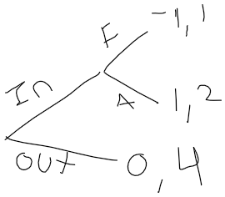
- Behavior you have when you play a game once, might be different from the behavior you will observe if you played it many times
- Small firm decides whether or not he wants to enter the market
- If he stays out, he earns pay off of 0 and big market gets 4
- If he enters market, big market could fight or accept him
- Fight? Both lose -1
- Let him in? Little firm gets +1, Big firm gets +2
- What if this was a sequential game (yet finite)
- Use Backward Induction
- Maybe if you start fighting for those first few times, you wouldn’t have to continue to keep fighting – the little firms might just stop coming in
- The last time the game is played, the reputation for fighting won’t change anything, the little firm will still come in because he knows it doesn’t make sense for the big firm to fight him
- Dominant strategy in round 10 – little firm comes in! therefore big firm realizes fighting won’t every pay off.
- Two kinds of big Firms (tough or weak)
- Tough kind, will change the pay offs and will gain pleasure in fighting. Meaning fighting is now worth 10 points to the big firm, changing the payoff from -1 to 9.
- Weak kind, is disguising himself as the “tough” – presents a problem to the small firms, because the small firms take no information from the previous rounds
- Youtube Chain Store

Importance Lecture 17

Welfare Economics
- Market failures
- Standard story just lists market failures and says need government
- Doesn’t happen as often as people think

List of Failures (know each failure & definition, EXAM Q)
- Public goods
- Free riders
- Externalities
- Tech.
- Path dep.
- Network ex.
- Moral Hazard
- Foreclosure
- Barriers to Entry
- Speculative Bubbles

Public Goods
- 2 characteristics:
- Once provided to one person, it is difficult to exclude others access to the good
- Consumption of the good by one person, doesn’t stop the consumption of another person
- Lighthouse Example: built by private operators, was originally unprofitable when the government took over the operation.
- People don’t think that they need to watch their $ because the government is charitable (ex: health care, etc.

Public Good Exam Q w/ numbers
- 3rd Characteristic: make sure that if a good can be paid for, then the good should be brought into production. Sometimes we need to break the rule of one price per good.
- Examples: the total WTP for a school is 40%, however you only need 25$ to pay for it. You have five different people, how much do you charge each person
Player | WTP | Plan A | Plan B
1 | 20 | 5 | 12.50
2 | 12 | 5 | 7.50
3 | 4 | 5 | 2.50
4 | 2 | 5 | 1.25
5 | 2 | 5 | 1.25
Total | 40$ | 10$ | 25$
- Under plan A we would not be able to finance the project, as only 2 people would pay the 5$.
- Under plan B, using price discrimination, we obtain the 25$ needed to pay for the school.
- Price discrimination is against the micro model, but it is a solution to the public good problem.
- Exam? Might ask for multiple pricing schemes which would work.
- Conclusion? If you have a public project that is worthwhile, there is a private pricing scheme that gives 100% support to it.
- Benefits > Costs – ALWAYS

Externalities
- Can be either positive or negative
- It is how your consumption of a good impacts someone else either positively (ex: not littering – clean environment) or negatively (using gas and causing CO2 emissions)
- Regulations are necessary to help avoid negative externalities.
- of backward induction
- Reading -- watch video – numbers will be on the exam (possibly)
- http://oyc.yale.edu/economics/econ-159/lecture-16 -- DUELING (important)

Lecture 18: Continuation of Fables

Lock ins & Negative Externalities
- Effects of critical mass on many types of economic behavior
- Technology lock in: markets select inefficient technologies as an almost inescapable standard
- Markets get locked into inferior technologies
- Bad because successful companies may be using inefficient resources
- Main example of a technology is the QWERT keyboard, when found that the DYORAK keyboard may be more efficient (however, later proven to be false)
- Sometimes choose bad things, and are unable to switch to the better options
- Transactions costs associated with switching

Contract Hold up
- Costly to enforce, and sometimes infeasible to write one up
- Contracts are not often a good thing
- Vertical integration is seen as a market solution
- Fisher Body Story
- General Motors acquired Fisher Body
- Fisher Body refused to locate its plants next to GM
- Each company didn’t want to agree
- Later proved that this never happened, and both companies were amicable with each other

Moral Hazards (The Principal-Agent relationship)
- Principal delegates responsibility to the agent
- Assumed that the principal has less information than the agent
- Either the agent’s actions or his characteristics are unobservable to the principal
- Effort is costly to the agent, so if his wage is fixed he will shirk
Better to reply on performance based incentives (only drawback is you place risk on the agent)
- Predicted that you must provide a low base salary, plus performance based rewards for best results
- Shirking is known as a moral hazard.
- This happens a lot in insurance companies – people know they are insured therefore they become carless, this is why companies use deductibles.

Predation: Standard Oil
- Predation: unfairly excluding their competitors from the market – by discouraging rivals, the market becomes inefficient
- Requirements to Predation
- Incumbent firm’s competitive actions must be profitable to show that the firm is pursuing a rational strategy
- Predatory actions must potentially exclude rivals
- Action must be shown to reduce economic efficiency – so predation is considered a market failure
- Predatory Pricing = dropping prices extremely low, to drive out rivals but make up for losses due to becoming a monopoly
Cannot distinguish from competitive pricing
- Wanting to lower prices to drive out rivals is not a credible threat
- Could a firm successfully raise the costs of another firm?

Learning by Doing
- Can lead to a first mover advantage
- Dates back to Adam Smith’s pin factory
- Can relate to either production, or the workers
- More investigation on this is required

Speculative Bubbles
- Speculative excess, referred to concisely as a mania, and revulsion from such excess in the form of a crisis, crash, or panic can be shown to be at least historically common
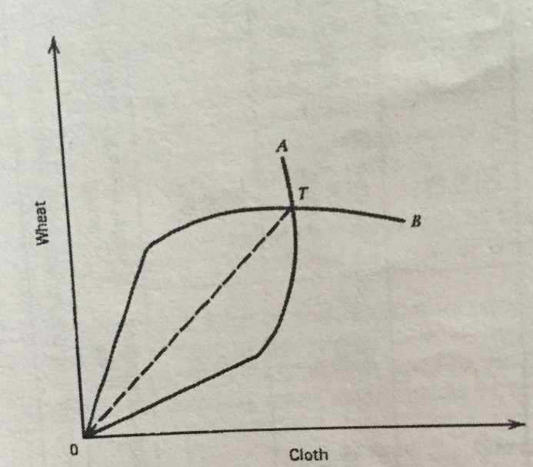
- Many of people who want to identify speculative bubbles have public policy ideas in mind

Offer Curve
- Two countries reciprocal demands must be equal and opposite to one another
- Countries will produce the item which they have a comparative advantage in (thereby, trading that good for more of the good which the other country has the comparative advantage)
- By putting together the two offer curves for each country (as shown on page 57 in Dun Chapter 3), we get one point where the two curves cross each other.

Readings for this week are the “Fables” chapter 1 and Bob Dunn Chapter 3 (the offer curve).

Lecture 19

Stable Matching
- Gale Shapley Algorithm for Stable Matching (EXAM)
- Imagine a group of N men and N women that are looking to find partnerns for a dance.
- Can we match them up in a stable match?
- Unstable Match?: you have A&B and C&D matched, but A would rather be with D, and D would rather be with A. so you have the issue of a break in the matching.
- Stable Matching: if a man M and a woan W are paired together then one of the following is true:
- 1) M prefers W over every other women going to the dance
2)
- Problem: given an equal sized group of men women, finding a stable match
solution? Matching can always be found, and the matching Is stable – 2 properties with Gale Shapely Algorithm.
- Example: 10 men and 10 women – want stable matching
- Each man ranks the women in order of preference
- Each women ranks the men in order of preference
Know how to build the table!
- 1) Each man proposes to the woman on the top of his list of preferences
- 2) Once this is done, the women look at the proposals received (if only 1 proposal they say yes, if they receive more they reject all but their top suitor)
- Next step? Every man who is not matched proposes to his most preferred women who has not already rejected him
She accepts if she is unmatched, or if she prefers him over her current partner, or she will reject him.
- We continue this until all men find a partner, and this algorithm dominates showing that there are stable matching.
- Example – EXAM
- Frank prefers: Kate > Mary > Rhea > Jill , etc.
- So Frank proposes to Kate, Dennis to Mary, Mac to Kate, and Charlie to Rhea.
- You go through the process until all is matched & stable
- Time complexity
-- there are n men and n women
-- at each step in the algorithm from start to finish a man makes a new proposal
-- at most n^2 proposals
Exam: create 2 tables, then men go first and then women go first. Compare the two solutions to see if there was an early mover advantage – typically yes there is.

Stable Marriage Problem
- Not Stable: unmarried couple will run off an elope
- If a women has more than one suitor, she picks the best one out of all the proposals
- In an exam you would show all the steps – you need to lay out the solutions in detail (day1, day2)
- National Resident Matching Program: medical students graduate, and then must enter residency. Used to be that the application process was very chaotic. This is a real life example.

Who Gets What
- When we think about markets, we think of commodity markets
- Small enough trades in a big enough market – you don’t care who you are dealing with
- Kidney exchange is a market where no money is used
- More people in need of transplants than are available
- 2 way exchange involves 4 simultaneous surgeries
System only works with simultaneous transplants
Without this you get something similar to the prisoner’s dilemma.
- Sometimes you cant find this type of situation
- Cheating? Day 1 given kidney, day 2 something goes wrong and donation doesn’t happen, tragedy for pair 2 – had a surgery that didn’t help them
- Hard to match means you have a lot of antibodies, and you cant accept that many kidneys

Lecture 20
- Financial community allocates money, and is dominated by banks, as in the central bank.
- Today = central banking, and the degree to which the banking system does the job of allocating capital rationally. Does the central bank actively control the banking systems? Does it work well?
- Exam: subsection of this called “currency board institution” – semi kind of bank which occupies a half way point between two points of view of banking and central banking
- Troubles in current banking is due to evolution of the financial markets

Read: Should we reduce the role of banks in the monetary policy process
- Government regulation of shifting LM curve doesn’t really work
- Bank lending is not really important anymore
- Bank no longer is a principle when you go to look for money, rather an entity that helps you find somebody who has money to lend
- New role of central banking?
- Currency Board (EXAMS)
- How to help allocate capital in the best way?
- Senior banks should keep deposits, for making exchanges
- How do you describe that value? Well, you could describe its value as a collection of commodities.
- If you have ½ bushels of wheat, barrel of oil, etc – adds up to some kind of value, calculated however you want, or it could even been exchanged for a different basket
- Collateralized Mortgage Obligation – instrument involved in the 2008 crisis, where the process of making mortgage loans was nationalized (economically).
- Make markets, you diversify opportunities of smaller banks, keep records, provide data, enforce discipline, withhold service
- Create more/less reserves by either buying or not buying
- We regulate banks, by telling them what to do with respect to loans
- You create money in the sense you are helping the banks maintain their balance sheets in a proper way – creating diverse banking products such as CMOs
- Means of payment, store of value, unit of account
- Problem? Telling this story has become a broker-job operation. The central banks of the real world abuse procedures. They end of creating inflating by the end of the day

Austrians Say that Central Banks
- Abuse of the legal tender law: only kind of money that can be legally used is the money of your own country (ie. Canada can only use Canadian money)
- Say that this is wrong, and it is just to monopolize
- Change charter rules
- Manipulation of interest rate, exchange rate, inflation rate
- Lending to the government

Austrians Want
- Get rid of central banks all together, and let nature run its course
- Get rid of legal tender laws – if want to pass a law, say that banks never lend directly to government
- Steven Hanky: collection of articles put together at time of the Asian crisis

Steven Hanky Requirements Currency Board
- Issues domestic money bought against this hoard of foreign exchange which is in dollars
- Absolutely fixed rate of exchange
- Anybody can have 100% reserves
- Cash in BOP at window any time
- The entity, currency board, does not hold any reserves for anybody in the banking system, but the banks might use domestic currency themselves over the counter.
Currency Board has nothing to do at all with the local banking systems
Local banks/government cannot borrow from this currency board
Money gets out in form of ordinary demand for currency
- Don’t bail out banking system or the government
- Management of currency board is independent of local government
- Earn interest rate profit by investing foreign exchange in the government bill market – earn rate of return – this profit is called seniorage = paper money earns seinorage
Benefit of issuing paper money is that there is no interest rate
- Tiny staff and low costs
- High fix on exchange rate – it simply does not change
- Does not buy any local government debt, do not support local prices for local debt
- Profit is straight seniorage

Lecture 21

Summary
- Talking about central banking, because we are talking about the nuances and complications of the simple microeconomic statements
- Banking allocates capital
- Microeconomic statement of equilibrium, is that the last dollar spent/invested by an economic player has to yield the same utility regardless of where it is spent
- Capital allocation is performed by the financial community – the banking system
- The bank system has a senior player, the Central Bank
- Operations of typical Central Banks are criticized by some people. What has happened is that the Central Banks have moved away from the most simple Keynesian Story (bank alters quantity of money) to a focus of itself concerning itself with macro credential policy (preventing panics/severe instability) –
- to be able to do bail outs & rescues, as well as quantitative easing (combination of extremely low interest rates, very large increase in liquidity, and improvement of quality of financial paper)
- Central Bank buys a worthless mortgage from a useless bank, so that bank now has reserves to use (this is a part of quantitative easing)
- Didn’t erase the bad paper, rather the tax payers are now taking the terrible loss of the mortgage
- But can pretend that the markets themselves are now full of good paper – the reserves
- Because of the criticism, the Central Banks have seriously changed how they operate and are more focused now on macro credential policy

Steven Hankey – starting on page 295
- Part of a group of people who is critical of the Central Banks’s behaviors, and wish to limit the extent of Central Bank power
- Robert Mundell – guy who would want to go back to using a gold standard
- Others are believes in commodity monies – senior financial entities would issue paper that would supported in the old fashion sense by gold, or by other standards where a unit of one money has stabilized purchasing power in terms of some basket
- Currency board – shrunken version of the Classic Central bank – a very short list of Central Bank functions remains for the currency board. In short, the currency board does very little
- EXAMINABLE MATERIAL OF THE ESSAY
- List of what Central Banks do VS Currency Boards VS Extreme Case (do away with both Central Banks & Currency Boards)
- The extreme case is basically a Privatized Bank
- Range of discussion on economists
- NOTE: wont be tested on “extreme case” unless he finishes it in class.

Central Banks | Currency Boards | Extreme Case
Supplies coins, notes, deposits | Supplies coins and notes | Issues notes against their net worth
Flexible exchange rate | Fixed exchange rate | Unlikely to have targets with respect to exchange rates
Base money is the money of the Central Bank (their own coin/currency/bank reserves) | Mass of foreign exchange reserves (foreign reserves of 100%) | Have net worth position, your own equity (assets VS liabilities). Against that net worth you can issue paper
Limited Convertability | Full convertibility
Not limited at all in how much additional money it may create annually to manage the economy (discretionary monetary policy) | Rule-bound monetary policy
Lender of Last Resort | Not a lender of last resort
Often regulates commercial banks | Does not regulate commercial banks
Opaque | Transparent
Politicized | Protected from political pressure
Low credibility | High credibility
Earns seigniorage from interest and inflation | Earns seiniorage only fro interest
Can create inflation | Cannot create inflation
Can finance spending by domestic government | Cannot finance spending by domestic government
Requires preconditions for monetary reform | Requires no preconditions for monetary reform
Slow monetary reform | Rapid monetary reform
Large Staff | Small staff

Lecture 22 – Chapter 6 Bob Dunn
- Currency board story was about how central banks when badly managed, alter prices, allow inflation to proceed.
- Not so much pure inflation the problem (that all prices would be rising equally)
- Modern inflation – various sets of prices, change at different rates & these alterations in the structures of prices are creative of allocative problems
- Today is the story about tariffs, subsidies, and quotas – government produced alterations in the prices of goods & these alterations diminish the efficiency of the outcomes
- What we will be able to do when talking about this things, is show exactly deadweight loss (something we will experience in all of these cases, as prices get screwed up)

Tariffs: Partial Equilibrium Analysis

Small-Country Case
- No effect on world availability of the product
- Domestic demand and supply curve
- Cant go above the world price (that which is supplied)
- On the bottom line, that is the amount we import (before tariffs).
- Once we add a tariff, that horizontal line shifts upwards. The foreign suppliers must take over, because the domestic supply does not equal the demand.
- Early discussions about consumer/producer surplus – in any demand curve, there are certain buyers who would be willing to pay a lot more than the actual set price. These people, who would pay those high prices, are lucky because they get to pay a lower price.
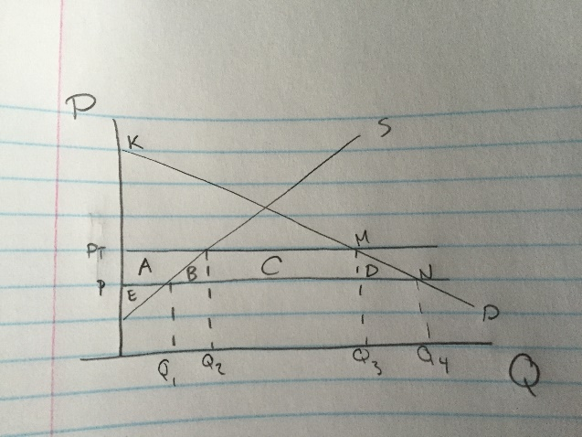
- Those people who would be willing to pay more than they have to, are considered to be getting a consumer surplus. Which is the triangle above the price, below the demand curve.
- The triangle below the price level, but above the supply curve is called the producer surplus. Those who would be willing to sell for less, but manage to get more money due to the market.
- New assignment of the total surplus that follows after a tariff, and we will find that some of the surplus gets reassigned, but we also find that some potential gain (if we had left the market alone) gets lost entirely – deadweight loss
- In the Free Trade Case, we have the situation where there is no unassigned surplus in this situation, except that the shape which shows the surplus is a bit more complicated
- With a tariff, imports fall from Q1 to Q2, and the price increases.
- Consumers lose the surplus, from the tariff, of the rectangle P1/P2 Q1/Q2
Some of it is given to the producers (area A)
The box between the two curves, is what is given to the government/producers. (area C)
Areas B & D are deadweight loss
- Prohibited Tariff = No Tariff Revenue for the Government (exam) – consumer surplus is entirely lost to the consumers

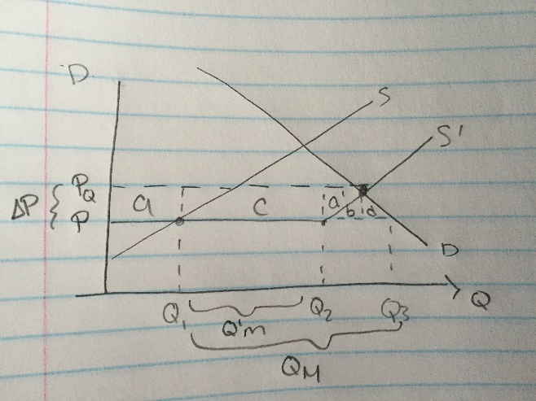
Quotas
- Effect of shifting the supply curve to a new position.
- Quota alters the amount of material that can come in.
- Q1-Q2 represents the volume that is allowed in the country. Then the kink, represents the domestic supply curve.
- Consumer surplus gets diminished (due to the domestic economy kicking in, raising the price to that above the quota price), and the producers get more benefit
- A and A’ are increase in producer surplus
- Area’s B and D are DWL
- Area C goes to whoever is lucky enough to have the right to ship the product

Subsidy Case
- Imports reduced to the subsidy
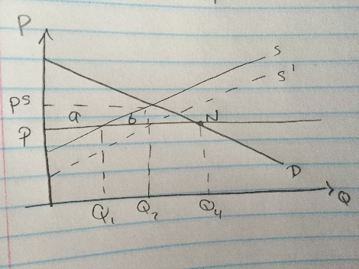
- Subsidy equal to the difference between the two curves
- After subsidy, domestic economy moves from Q1 -> Q2
- Consumers pay this subsidy by taxes
- The price remains where it was originally, at Pw
- Quantity imported remains constant at Q4 (from Q2)
- Consumer surplus loss is moderated (a part of the loss does not occur)
- The subsidy must be included in domestic expenditures (to producers from the rest of the economy)
- Preference to subsidy because smaller DWL, and it leaves consumption unchanged

(This is all we have to read out of chapter 6 – SMALL COUNTRY CASE)

Lecture 23
- Consumer surplus, producer’s surplus, and deadweight loss
- Consumer surplus is everything about the price, that is below the demand line.
- Producer surplus is everything below the price, that is above the supply line

Small Country Case

Free Trade Case (Tariff)
- Originally P2 supply is below the demand. The different between where P2 intersects supply and where it intersects demand, is the amount of that good imported.
- When the tariff is implemented, the P2 shifts to P2(t) causing an increase in price. This increase in the price, causes the consumer surplus to decrease (as some people are now unable to buy goods at this price)
- Some of the consumer surplus gets given to producers (the rest, is dead weight loss)
- A producer surplus grows, as this increase in price, means more producers are willing to sell at this new high price
- The two blue areas on the graph, is what is lost from the original consumer surplus. This is the deadweight loss under the tariff.
- Trick exam question: intersection domestic of supply & demand (ex: 8$ a bushel). If you implement a tariff of 3$ a bushel (world price is 5). Then it would just hit the intersection. If this happened, how much would government revenues be? Zero dollars. (this is called a prohibitive tariff)

Quota
- Situation where government says we will not out an obvious tariff on this stuff but we wont let much in.
- We get a certain amount that the country lets in, but it is less than the amount we actually consume.
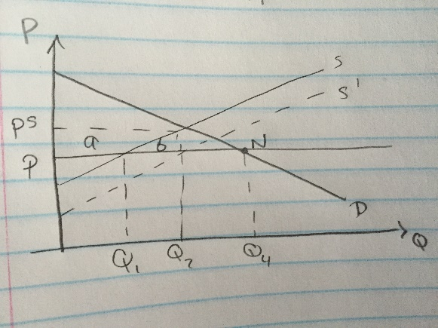
- In the absence of the quota, we would be at Q1 all the way to the demand line (which we will call Q3). However, the quota is implemented at Q2 (meaning we cannot import more than that).
- Box C is the benefits which goes to the person who holds the right to ship the goods.
- A’ is the redistribution of the CS to new local producers (the extra PS)
- Areas B & D are DWL (losses to the economy)

Subsidies
- P1 = $5 where Q1 is produced – with a subsidy Q2 is produced
- The difference between Q2-Q3 must be imported after the subsidy
- Domestic production has increased from Q1 – Q2
- You have diverted resources now towards producers
- Area A is transfer from taxpayers to producers
- A + B is the area of the subsidy
- Area B is deadweight loss
- Subsidies are preferred to tariffs based on welfare, as DWL is smaller.

Lecture 24

Explanation of Grading
- Everything based on GPA
- Imagine exam with two parts (50/50)
- Question 1 part A = 4.0 x .25 = 1.00
Question 1 part B = 3.0 x .25 = .75
- Question 2 part A = 4.0 x .25 = 1.00
Question 2 part B = 3.0 x .25 = .75
GPA = 3.5 (for that exam)
- Carrying all GPA marks to three decimals.
- Also add in on a 4 point scale all your other marks (midterm, final, etc.)
- It is only rounded after all grades have been added.

Review for Final
- On entire course.
- Expect something from the first half of the course (safe to say, final is weighted toward post-midterm stuff)
- “Easier” than the midterm (apparently – according to velk)
- According to online final reading sheet there are 5 questions, which we must answer 4 of

Bob Dunn
- Comparative Advantage – talks about cloth & wine out of Portugal & the big problem with trade is that after trade what is final price ration?
- J.S. Mill developed “reciprocal demand”
- Solve the J.S. Mill problem by the use of offer curves (never covered in class, but we are responsible for the reading on OFFER CURVES)
- Also about elasticity of offer curves
- Chapter on understanding isoquants & productivity lines, and interpreting the price lines
- Factor proportions (?), establish single price, production function of “family 1 and family 2”
- Edgeworth boxes
- Chapter 6 – tariffs, partial equilibrium, subsidies, and quotas (only responsible for SMALL COUNTRY – according to VELK)
- Hecksher-Olen (?)
- Know you have P and Q types of measures, and PxQ type of measure
- What’s useful in a lot of the Material is Dunn takes you through the algebra of everything, and will “hammer” into your head the macro model (C+I+G+X-M)
- Know how to do all the multipliers (calculations)
- Know all the things in the boxes (in the readings)
- Presentation of the BOP curve (IS/LM) – helpful to re-read “School Briefs”
- Left side = surplus, right side = deficit
- What happens if BOP steeper than LM or if it is flatter?
- Specie-flow mechanism (Hume) && Bretton Woods System
- Know the 4 James Meade Cases
- Wants more power in the hands of government – should be able to manipulate both government spending and the exchange rate
- In this section he doesn’t allow you to shift BOP yet, instead we can just shift the IS/LM curves (in either stimulating/de-stimulating directions)
- Case 3+4 requires shifting/manipulating BOP
- Devaluation of moving the BOP curve – famous case is the Marshall Learner (small/medium/large country)
- Absorption process (another way of looking at the situation of moving the BOP curves)
- Chapter 18 – on exchange rates (flexible/fixed) – you want to fiddle with monetary policy to deal with external, and fiscal policy to deal with internal problems
Even when BOP is shift-able, it still may be troublesome.

Game Theory
- Mixed Strategies
- Pure Strategies
- Prisoner’s Dilemma
- Coin Matching
- Stag Hunt
- Stoplight game
- Dueling (http://oyc.yale.edu/economics/econ-159/lecture-16) recommended to watch video, wasn’t fully covered.
- Stable Matching
- Chain Store
- Regular Nash Equilibrium
- Dominant Strategies

Currency Board Reading
- John Boschen reading IS NOT ON THE EXAM (said Velk)
- New challenge for bank regulation – how much of it can be left to the market?

Goldberger & Tinbergen

Microeconomics (Greenbook)

Grim Strategy

Famous Fables

