LIN3325- Phonetics Winter 2016
Prof: Ian McKay

January 21

I2speak.com IPA converter
Internationalphoneticalphabet.org

1. All influenced by language we speak
- example if 2 different sounds mean the same thing in our language we associate as same phoneme- cant tell difference between the 2
2. Level of detail in transcription
- usually use detail when you want to communicate a specific difference or change
3. Phonetic or phonemic
- are we trying to write a narrow or broad transcription?
4. Theoretical viewpoint
5. Difficult symbols
- tend to perceive things that aren’t there, our brains make us conform to what we think structure should be

Consonants
Peter Ladefoged
- popular linguist, came up with idea that articulation of speech involves moving active articulators (tongue) to make a gesture- doesn’t have to be fully completed, meaning we don’t usually fully complete sounds.
- Articulatory targets: aiming for a certain sound but sometimes we do not fully reach it
-Usually middle term is known as a passive articulator where the tongue has hit, doesn’t actually do anything, just the place.
-More than 1 middle term means not typical- aka not using the usual part tongue- eg. Voiced bilabial (two lips) plosive, eg. Voiced apico-palatal plosive—using tongue but not usual part- the apex.

Stops- certain ambiguity whether it includes nasals because technically they are in the same class. Use plosive instead to reject nasals.

Vowels can be nasalized velo-pharyngal port is closed- the term nasal vowels are phonemic- nasalization is a property

January 25
Reading review/discussion

- Large amount of languages gives opportunity to infer things about language in general- if 90% language shares one thing chances are it is important and universal to native language
- Generally one culture per language
- A language is a dialect with an army and a navy- language is highly based on politics

Phonetics the science of speech- reading

Phonetic and phonemic transcription
- Generally transcribe phonemically day to day and phonetic when drawing attention to something
- In IPA consonant chart- blank gray blocks mean not possible and white means possible but not found yet- or used but combination of another symbol and a diacritic

Explaining columns and rows on consonant chart
- Trill- causing vibration (no difference)
- Flap-ballistic movement- initial push but no pull back after
- Retroflex- tip of tongue bent back
- Approximant- tongue being close to roof of mouth [j] [w], typically voicing, but not as close as fricatives to make less noise/less air flow

January 28

Explaining consonant chart continued
- Plosive- blockage in oral cavity, but excludes nasals- close velar pharyngeal port
- Front vowels are palatal, back are velar
- Uvular- make articulator vibrate- mostly always voiced
- Fricatives- air forced through narrow passage- close velar pharyngeal port

Don’t usually show whether to make sound voiced or voiceless except in words like thy and thigh, either and ether.

[w]- both bilabial and velar

airstream mechanisms- speech generally has airflow, all lang are pulmonic egressive (means going out)- means lungs pushing air out. Pulmonic ingressive is not impossible, but not in any language
lungs are a mechanism for airstream (pulmonic)
Glottalic mechanism- using vocal folds to trap and pressurize air- called glotallized plosives and ejectives
Velaric- the tongue as a mechanism

Feb 1

Airstream Mechanisms (cont)
- No lang uses ingressive airflow as a regular part of speech
- Plosives trap air and compress it, release and create sound
- Implosives move pharyngeal all the way up, and glottis downwards, lips closed and when lips open air is pulled in, tend to be voiced and less common than ejectives
- Clicks occur within oral cavity- nothing to do with lungs or pharyngeal port being open/closed. Make closure with apex of tongue in dental or alveolar and back of tongue in velar areas- air pressurizes in pocket of tongue against roof of mouth- mostly used in speech in African languages
- Some languages that contain clicks must choose different words when whispering that don’t contain clicks- phonetic element
- ‘donald duck’ speech- cupping tongue to roof of mouth and pushing air out

Esophagus
- has sphincter muscle at top
- sound of burp is vibration of tissue in sphincter muscle
- can speak with esophageal sphincter instead of vocal folds

Pseudo voice
- combination of alcohol and smoking causing cancer and resulting in removal of larynx (laryngectomy)
- removal of larynx makes it hard for body to tell when food/liquid or air is going down esophagus and which tube to put it down
- solution was stoma: hole in neck to breathe- no longer have ability to use vocal folds, no phonation
- use vibrator to simulate vocal fold vibration
- stunt- alternative to help with speech, making a hole in esophagus wall

Cardinal Vowels (fig. page 215)
- Cardinal means the basic and important reference point- what everything else hinges from
- Base point for finding all vowels
- Cardinal vowel basis- when tongue is curved, highest point of tongue is what the cardinal vowel chart refers to- front vowels palatal, back are velar
- May not sound like our traditional vowels, ours may be more front/back/nasalized, etc.
Deciding cardinal vowels by:
- How common they are – looking at world languages, primary vowels (back/velar) are much more common than secondary (front palatal)- not many that have just front with no back
- Implications that if lang has particular secondary vowel- will most always have counterpart of primary
- Order of learning- universally always learn primary before secondary vowels

February 4

- Phonetics differentiates in degrees of roundedness eg. Spread – neutral – round
- Sound of vowel is influenced by how spread/rounded—there is not just one or the other, can be in between

Formants
- Frequencies of resonant within oral cavity
- measurement of sound
Typology
- classification of languages- kinds of patterns seen
- most languages have between 3-7 vowels (phonological)
- English and French have about 15 (including diphthongs)
- No distinction between vowels in cot and caught in Canadian English
Advanced Tongue Root (ATR)
- Moving tongue root front and back (+/-)
- Degrees of how much tongue is pulled forward or back
- [i] is advanced and [I] is pulled back
- tongue must be far enough up in order to do ATR
tenseness
- pairs: i vs I and u vs. horseshoe u
Terminology
- terms ending in –ize, usually refer to secondary articulation
- nasalized high front vowel
- rhofacized vowels- vowel that sounds like an r— r-coloured vowels
- used a lot in british English- hint of an r in vowels
- vocalic- like a vowel
Semivowels
- mostly glides- like vowels because vocal tract is open and voiced
- glides are unpronounceable without vowel
- j – i
- w-u
- glides are just non syllabic vowels
- syllabicity- eg. Button- when pronouncing going straight from the t to n, called a syllabic n
- must have nucleus
Secondary Articulations
- palatalization- small j symbol
- velarization- squiggly line through
- pharyngealization- pharyngeal symbol
- labialization- small w

Feb 8

- in some instances may be syllabic but non vocoid (vowel) eg. ‘psst’
- semivowels are never without a vowel after it- that vowel is the nucleus of the syllable
Speech Dynamics
- when you just say a sound you go from neutral tongue position to the sound and back to neutral, when speaking you do not start or finish at neutral when saying a sound which may effect how the sound is produced
- dynamics is the moving tongue through speech
- accommodation- 2 sub forms are assimilation and co-articulation
- assimilation- phonemic change: change from one phoneme to another that people do not usually realize:
- eg. N, ing, and m are all different phonemes in English, but when saying phone (n), phone call (ing) and phone booth (m) we integrate these phonemes without realizing it
- Key, coo, caw—all different phonemes but not differentiated in English—this is co-articulation

H and H theory
- Hyperspeech and hypospeech
- Lindblom created this theory- hyper speech is very carefully articulation, hypo is less careful- takes short cuts
- Has nothing to do with social constructs
- Lindblom believes speech is not special- speech production follows same constraints like any other muscular movement
- Believes speech is ‘output oriented’- eg. When walking only lift legs up higher than usual when walking over rocky terrain or danger of falling- when the variable is gone we go back to walking normally. This saves energy from constantly walking as if something would cause a fall—this is the same idea as in speech, talker adjusts way of speech based on hearer and their needs of communication- use hyper or hypo speech based on hearer

Accommodation in direction
- If sound affects the following it is progressive/left to right
- If sound affects the preceding it is regressive/left to right eg, phone call example above
- Double when both before and after have an influence
Synchronic vs. diachronic
- Synchronically the word phone can use more than one phoneme in place of /n/
- Diachronically—words changing over time
- Contiguous: meaning in contact sound undergoing change is in contact with sound causing change
- Noncontiguous: sound that’s undergoing change is not in contact with sound causing change

Nasal plosion- releasing a plosive through the nasal cavity eg. ship vs. shipmate

Feb 11

Readings done up until now & included in midterm
1, 4, 6,7, 8, 9, 10, up until segmentation
--allowed a cheat sheet for midterm

Segmentation
- Insertion of plosives through the development of language in English and French in between Vowel Nasal Plosive Vowel. Plosive comes and goes through time of inserting and deleting.
- Eg. Of ‘Twenty’ pronounced as ‘twenny’—deletion of the plosive
- Not due to simplifying or getting rid of t for ease of moving from n to y
- Not actually anything easier about doing this through articulatory gestures
- In example “Bambab” no overlap in pharyngeal port and lips being open at the same time, in “Bamab” there is a overlap where air is released through mouth and nose at the same time- synchronization of 2 gestures
How to pronounce d—raise apex and sides of tongue to alveolar ridge to block are and close of pharyngeal port, build air and release by lowering tongue

Devoicing
- H has a voiceless [i] along with it, example when saying ‘heat’ it is actually /hiit/ the first i being voiceless
- T mostly used with more air pressure than d and usually perceived as a stronger consonant
- Fortis and lenis- terms used to describe stronger and weaker respectively, has nothing to do with voiced and voiceless

Noncontiguous
- non contacting each other
- noncontiguous accommodation is also interchangeable with distant accommodation or dilation
- metaphony means noncontiguous vowels
- example of distant accom. is saying ‘uninted’ instead of ‘united’—the n in the beginning of word causes insertion later on of an n
Umlaut
- productive process
- CV(back)C—adding a front vowel (may not be there anymore) turns into CV(front)C
- Eg. ‘Bach’ /bax/ plural is ‘Bacher’ with a front vowel (backwards 3)
- Goose vs geese is from umlaut

Feb 22
Contiguous and Non-contiguous
- Not many noncontiguous consonants, mostly vowels
- Vowel harmony is not the same
- Umlaut is a process of noncontiguous vowels- metaphony. Suffix vowel affects vowel before it
- Reflects on English- foot vs feet, long vs length
- Not productive, no longer in use, just traces left
- Eg goose and geese, gos and gosi—o in gosi is pronounced differently, in history I in gosi was dropped but change in the o stayed, the change from those and modern English is not due to umlaut

Vowel Harmony
- Change/accommodation in vowel so they make a noncontiguous similarity
- Difference is that there’s a systematic pattern that changes wide array of vowels
- Effects everything in a phonological unit- eg could be one word but also could be a whole noun phrase
- Some part determines what vowel will be- eg, if a noun has a particular plural ending it might effect which vowel is used
- Degree may be complete: becomes same vowel, or partial: takes a particular feature- eg. becoming a front/back vowel, or becomes rounded, etc.
- Example in reading- Turkish plurals

Stress
- Emphasis on certain syllables
- Can be phonemic- eg. Incite vs. insight—where you put the stress determines the meaning
- The greater the stress, the less accommodation

Citation form
- Form of the word that is in the dictionary
- Eg. asking how to say the word ‘to’- you say it much differently than how you would say it in conversation
- The proper form you would say is the citation form
Sandhi
- A juncture—2 words coming together
- Accommodation that occurs over 2 separate words
- Eg. ‘a car’ and ‘an apple’, or in British English the pronunciation of ‘r’
- The addition or deletion of these units is due to sandhi
Loosely related to accommodation:

Metathesis
- Reversing of sounds
- Not exactly accommodation but close
- Many examples include r’s
- Eg, through and thorough, Orlando and Roland, ask and aks (in old English the word for ask was axian)

Dissimilation
- Similar vowels and one changes to become different or cause emphasis-
- Eg. colonel- first l is pronounced as an r
Speech errors
- Not the same as Freudian slip
- Creating the wrong sound
- Basis of tongue twisters
- Errors demonstrate how we plan our motor activity on what we’re about to say

March 3rd

Sent the reading material—on Voice Onset Time

- Most languages have a binary choice on voice—voiced or voiceless
- Not actually true in application—its on a scale of how much voicing one uses
- English has voiceless plosive (phonologically), and a “whole bunch” of voiceless plosives (phonetically)
- Because of the speech dynamic and how its used in a sentence or real life
- Short lead: voicing starts a short time before release of plosive
- Long lead: voicing starts long before release of plosive
- Figure on emailed reading that explains this moving plosive through time
- English tendencies: voiced plosives usually have zero to short lag, voiceless plosives usually have long lag
- European tend.: short lead on voiced plosive, zero to short lag on voiceless plosives
- Laurentian French: intermediate values between eng, and euro French in both voiced and voiceless
- A lot of difference in release between sound position in word eg. spa and pa, p is pronounced very different in each

March 7th
VOT
- Different lang use, diff degrees of voicing, all with contrast but individual
2-way distinction:
- Pot (long lag)
- Spot (zero lag)
- Bought (zero/slight lag)
- But speaker considers long and zero lag the same
3-way distinction
- Ba (nasalized a) (voiced)
- Pa (nasalized a) (voiced)
- Pha (voiceless aspiration)
O distinction: Atha baskan—P
Aspiration: flow of air without voicing, long lag voicing=generally aspirated
Intervocalic voiced plosives: physical barrier to length, air continues to flow through vocal folds, retained by closure=limited space
Voice Quality
- Way in which vical folds vibrate
- Modal voicing
- No leakage of air not becoming voice
- Not wasting energy of flowing air
- Loss of voice
- Vocal folds swollen after overuse, change in mass, size, properties, changing ability to voice
- Breathy voice
- Allowing leakage of air because vocal folds never fully close
- Vocal murmur: a little breathiness in regular voice
- Women’s voice usually breathier than mens
- Creaky voice
- Strained voice, irregular vocal fold vibration
- Falsetto
- Usually used be men, not commonly used in phonological distinction
Tone
- The pitch/frequency of voice carries meaning (word-level)
- Different speeds of movement

March 10th
Videos showed in class
- Taking breath—the arytenoid cartilage are open making triangle in vocal folds,
- Breathy voice—vocal folds are vibrating but there is still a gap in the back end
- There’s movement rippling in multiple dimensions at the same time—very important in voice
- Reducing flexibility compromises parts of voice, eg. Scar tissue
- Higher pitch, more stretched vocal folds
- Acid reflex effects the vocal folds with age
- Mucus and saliva are very important to the movement of the vocal folds
- Mucosa- layer of mucus/saliva in the mouth
- Breathy voice, never closes—common in regular speech
- Nodules: calluses on vocal folds that effects voice
Voicelessness
- Able to make rapid changed in voiced/voiceless through speech
- 10-12 phonemes per second (probably not articulated well)
- virtually all mammals can voice, but only humans can switch between voiced/voiceless
Whisper
- no voiced sounds
- don’t start hearing ‘voiced’ sounds as the voiceless counterpart, this is because there are more differences in them than just voicing
- rapidity, force in which its said, etc
- fortis-lenis distinction—sounds that are harder and softer which determines
(end of section)

5 multiple choice questions due next week**

Acoustics Chapter
- looking at how you actually create sound, how sounds differ from each other
- refers to sound (form of energy), can be produced in one place and move to another place to cause work/something to happen (sending and receiving speech)
- medium- stuff energy goes through (air, water, metal)
- sound cannot go through space without medium, does not exist in space
- sound interacts with medium which causes movement
- propagate: sound ‘propagates’—interaction between material carrying sound and the sound itself
- 2 kinds of waves
- longitudinal waves—molecules don’t move more than shifting back and forth, transferring the energy.
- This is how sound moves through the air, the medium propels the sound through it
- Pressure moves up and down, rising and falling through time
- When pressure rises it pulls on eardrum, when it lowers it pulls
- Transverse waves (nothing to do with us)
- The time between one pressure to the next is the period
- The wavelength is the time to complete one cycle
- Frequency of sound is how many cycles occur in a unit of time
- Young and healthy human can hear between 20 and 20,000 cycles per second
- Lower the frequency, better travel power
- Hertz= cycles per second (Hz)

Resonance
- Cavity resonator: throat and mouth in this course’s case
- Resonance occurs in mouth and throat the same as blowing over the top of a bottle
- It’s a kind of property of physical objects, effects how something resonates with it and makes a specific frequency. Change the properties; get a new sound—eg. Guitar strings
- Resonant frequency is the natural point that it wants to oscillate, in order to change it, requires a lot of energy—eg. The kid on the swing

Source Filter theory of speech production
- 2 elements (source and filter)
- Resonance

March 14

Damping
- Whenever you have a physical system, anything that’s moving will continue to move until energy stops
- This idea applies to sound energy
Filter
- Allows some things to pass and blocks others—determines the size of the material to pass through
- With sound, due to resonance, tubes act as filters for sound
- If many different frequencies are introduced at one end of tube, some frequencies it boosts and some it removes
- Those that match the length of the tube will be loud at the other end, and those that do not match the length of the tube will be damped and be soft/quiet at the far end of the tube
- Different sizes and shapes of cavities resonant with different frequencies
- Change in voice is due to change in resonator/cavity which changes what frequencies are released
- A tube can resonate at multiple frequencies because maybe ¼ of a wavelength in one frequency has the same length as ¾ of a wavelength in another frequency
- One sound is multiple tones happening at the same time

Formants
- Characteristic of a vowel
- Each given shape of vocal tract has different set of resonant frequencies
- Example—[i] has 294Hz, 2275 Hz, 2965 Hz—the combination of these cause the [i] sound
- We shape our mouth so to make these Hz
- Formants with higher amplitude are louder
- Each peak is a formant
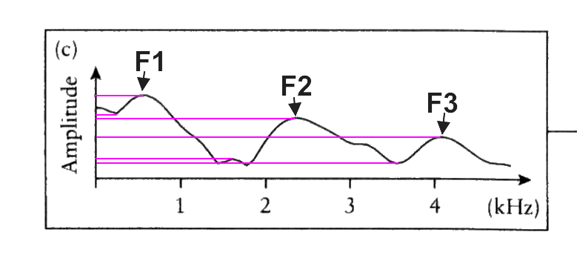
The Source
- The source of sound for vowel production is the sound of vibrating vocal folds
- The vibrating vocal folds produce a basic or fundamental frequency
- Also produce a wide range of other frequencies that are whole-number multiples of fundamental frequencies
- (in other words) When speaking, there is actually many other different frequencies than just the generalized frequency (eg. Men of 120 Hz)
- more than just basic frequencies
- this is due to the rippling effect of the vocal folds
- when an object is rigid it vibrates at one frequency, but when it is flexible it produces multiple (eg. Tuning fork vs. vocal folds)
- These varying frequencies are called Harmonics
- the spectrum of the source shows strong harmonics across the spectrum:
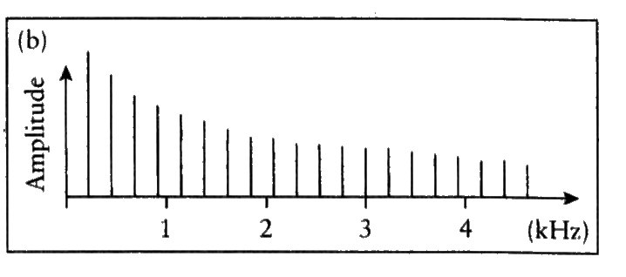
- it’s the fundamental frequency and a clean multiple—eg. If its 100Hz, then there will be x2, x3, x4, not x.5, not x3.2; they are always whole numbers
- fundamental frequencies in chart above is the outcome of sound through the tube (mouth, throat, etc)
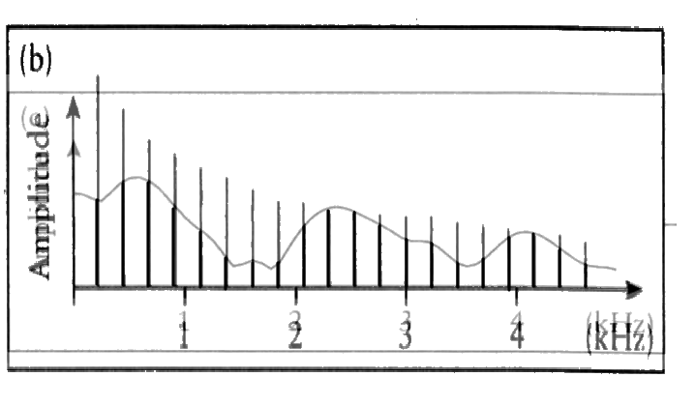
so therefore:
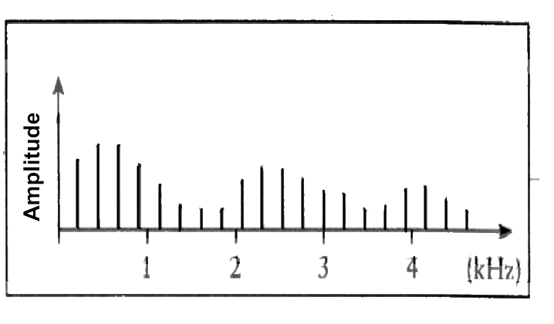

Acoustic Chapter
- figure 9.3 in textbook—explaining the area in the oral cavity between vowels and how much space is available—starts from back to front
- gives light into what frequencies will be produced

Patterns of Frequencies
- can distinguish vowels based on first 2 Formants
- Graph in textbook on women and men F1 and F2 for each vowel
- Broken line graph for women and solid for men—has to do with size of vocal tract on average
- Sound produced depends on size of resonator—large makes lower pitch sound (men) and smaller makes higher pitch (women)
- Frequencies produced between men and women are very different, but we still understand everyone’s speech through normalization—have to make allowance for difference in frequencies (multiple choice question?)

-missed lecture-

March 21
Suprasegmentals
- Affects multiple segments at the same time
Prominence
- Putting more emphasis to groups of sounds—minimum size is a syllable
- Can be used in grammatical level to distinguish words—eg, insight and incite
Primary Stress
- Longer, louder, more precisely articulated
- Less co-articulation
- Long vowels are diphthongized , i,e,u,o
- Tongue excursions are greater
- These characteristics are special to English
Secondary Stress
- Vowels/syllables get shorter and less loud
- More coarticulation and accommodation
- Long vowels lose diphthongization—eg. Boat vs. radio [o] is different, primary in first and secondary in second
Unstressed
- Vowelsschwa
- Shorter, more accommodation
Weak forms
- ‘to’ is almost always pronounced as “t” quickly in conversation
- words with low semantic content are usually said in a weak form

- Even stress
- French usually has even stress
- Predictable
- But systematically last syllable has little more stress—eg words English has taken from French, gentle vs. genteel, moral vs. morale, personal vs. personnel
- Variable—carries info
- ultimate- last
- penultimate- second to last
- antepenultimate- third to last
- stress carries info about word—eg. Conflict and conflict, one is a noun and one is a verb—“there was conflict”, and “the two conflicted”
Contrastive stress
- putting unusual amount of stress on syllable to make it clear
- allusion vs. illusion—never would say them differently unless trying to differentiate

Fundamental Frequency
- intonation
- tone mixed with duration—mandarin uses this to differentiate words
- tone sandhi—

March 24
Tone

Intonation:
- signals a lot of information through speech, such as asking questions, finishing speech, etc
- generally because signals you use are different in writing and speaking, things come across with different meanings
- intonation is to make clear in speech what would not usually be clear—emotion, etc
Prominence
- putting emphasis on a word
- applying prominence and intonation together can provide different interpretations of same set of words—ambiguous sentences
Rhythm
- syllable-timed
- stress-timed
- language is not purely one or the other
- English is closer to stress-timed and french is syllable timed
- Every syllable takes approximately the same time to say as the next (syllable-stressed language)
- Equal time for each stressed syllable is English
- Takes three times as long to say a longer word in French than in English
- Eg. The dog barked vs. the Doberman barked in regular speech ‘doberman’ doesn’t take a long time to say
- Eg. L’homme a rit vs. le professeur a rit ‘professeur’ takes 3x as long to say in regular speech

Next Chapter—Speaker and Hearer
- Interactions between the 2 and how a message is sent and perceived
- Referring ear diagram in chapter
- TM= tympanic membrane
- Air pressure in middle ear should be the same as outside
- Equal loudness contour graph

March 31
Speaker and Hearer Cont’d

Cochlea: snail shaped, filled with fluid, which allows vibrations to pass through it, and vibration happens at different places in cochlea which effects brain processing

Threshold: point at which you go from hearing to not hearing, or vice versa, defined by hearing something half the time
Humans hear from 20-20,000 Hz

Equal Loudness Contour Graph:
- Left to right is frequency in Hz
- Up and down is intensity level in decibels
- Small dip (at lowest point) in graph near the bottom is threshold
- Bottom line is normal for young, healthy hearers
- Logarithmic scale: 0,1,2,3,4,5,6, etc= 10 to the power of 0, 10 to the power 1, to the power of 2, etc
- Simplify the graph in order to understand and identify practically hearing loss (audiogram)
- what would be very mild hearing loss in adults would be vastly important in the learning of language in children

April 4
Writing Systems

- must look at phonetic and phonological structure in order to determine if writing style makes sense
- Chinese languages use idiographic writing system
- Don’t find purely alphabetic vs idiographic systems
Pictographic writing
- Can be called pictogram or pictograph
- Make picture to get across an idea
- Has to be iconic—resemble idea trying to communicate
- Wont contain reference to the actual words/grammatical features of a language—more universal
- Difference between picto and ideo is that pictographs are spontaneous
- Example is cartoons (modern)
- Historically, pictographic lead to ideographic
Ideographic
- Group decision on what a symbol will mean
- Iconic and non-iconic
- Iconic: closely resembles the actual idea
- Non-iconic: conventionalized—these symbols represent things as we know it. The symbol for no smoking is using symbols that is agreed upon, not arbitrarily representing
- Eg the heart <3—does not look like a heart
Rebus principle
- A way of making use of ideograms
- A kind of visual pun
- Example of using a picture on a name tag because pronouncing it is similar to the sound of a name (using a picture of a bee for their name which is bea”
Syllabic writing
- Works if small amount of syllables
- Wouldn’t work for English
- Syllabary: each symbol represents an entire syllable
- Hybridization: texting language, summarizing words eg. You=u
Consonantal writing
- write consonants alphabetically and ignore vowels
- eg. Ahugida and ahjad—Arabic languages
- properly written Hebrew has no vowels
Alphabetic writing
- English is quasi alphabetic—write things with ideograms (numbers)

April 7
History of alphabet
- Started out as form of making inventory
- Writing may only have come into existence once, no proof it was developed before
- Happened about 5 thousand years ago—an intellectual feat
- Phoenician
- first writing system, greeks took this idea, borrowed some characters from this writing system eg, upside down A
- Was purely alphabetic
- Etruscans, important historically in writing systems, but know little about them because of romans wiping them out
- Romans took over Etruscan alphabet and modified
- Runic alphabet was derived from roman alphabet
- Futhark—first 6 sounds that came from that language
- Used in limited fashion- not much of it, not used for stories
- Spelling
- Mechanical writing became more popular, caused writing to become standardized
- English is conservative with using symbols past the alphabet (!,.)
- Resulted in messy spelling in English
- Took words and spelling techniques that made sense for other languages
- So why cant we spell phonemically?
- Is it true we should write as things sound? Wouldn’t work with Chinese, so many words that sounds similar
- Morphophonemic alternation: English has many morphemes that are pronounced in many different ways (plural s—pronounced s,z)
- Example—magic and magician only 2 sounds stay the same
- To change this and make it phonemic we would have to spell magician completely different—lose the visual similarity to closely related words

Forensic phonetics
- Forensic- means legal aspect
- Speaker recognition—if you have a recording of a voice, can you identify the person?
- When people speak with different emotion it changes many aspects of voice
- Within person variance- you say the same thing 5 times, you say it 5 different ways
- Between person similarity: recording men of similar age, relatively small range of fundamental frequencies
- Comparison group: how do you define who you are comparing a voice recording to?

April 11th

Forensics Phonetics cont’d

- Individuals have different shapes and sizes of generators-- depends on physical characteristics of the resonator
- They vary slightly but isn’t very reliable because others may have similar characteristics
- Idiolect: certain differences in speech pertaining to one person
- Eg. 2 people who grew up in same environment-- similar grammar, but not exactly the same. Quirks in each person which causes repeated phrases or other personalized characteristics in speech
- Can be used in forensic phonetics
- Outside the normal range: if there’s anything characteristically or idiolectically different about their speech
- Ear witness: identifying the voice of a suspect that one is very familiar with-- but not a lot of vocabulary to describe voices
Voice stress analyzer
- A machine processes voice and tests whether they’re being truthful- based just on voice, not physiological cues(classic lie detector test)
- Not reliable enough to be used in court
- But can cause people to admit because they think it will tell if he’s lying
- Same level of trust as a Ouija board

Final Exam
Most multiple choice, short answer (maybe)
Can bring a cue card cheat sheet
Cumulative- but more of second half
Content= amount of time we’ve spent on it

