3.1: Define/identify the principal characteristics of homeostasis
3.2: Introduction to the Nervous System
3.3: Introduction to the Endocrine System
Homeostasis
3.1.1 Define homeostasis
Ability of the body to maintain relatively stable internal conditions even though there is continuous change in the outside world
- Dynamic state of equilibrium involving many systems
  - Adequate blood levels of vital nutrients
  - Heart activity/blood pressure monitored and adjusted as needed
  - Waste must not accumulate
  - Body temperature
3.1.2 Essential components of a homeostatic control mechanism
3 essential characteristics:
- Receptor: senses change (stimulus) and sends info (afferent pathway) to…
- Control centre: determines set point for variable maintenance; analyzes info and determines correct response
- Effector: provides means for response (output along efferent pathway)
  - Feedback (negative/positive) allows for regulation within a range/enhanced response
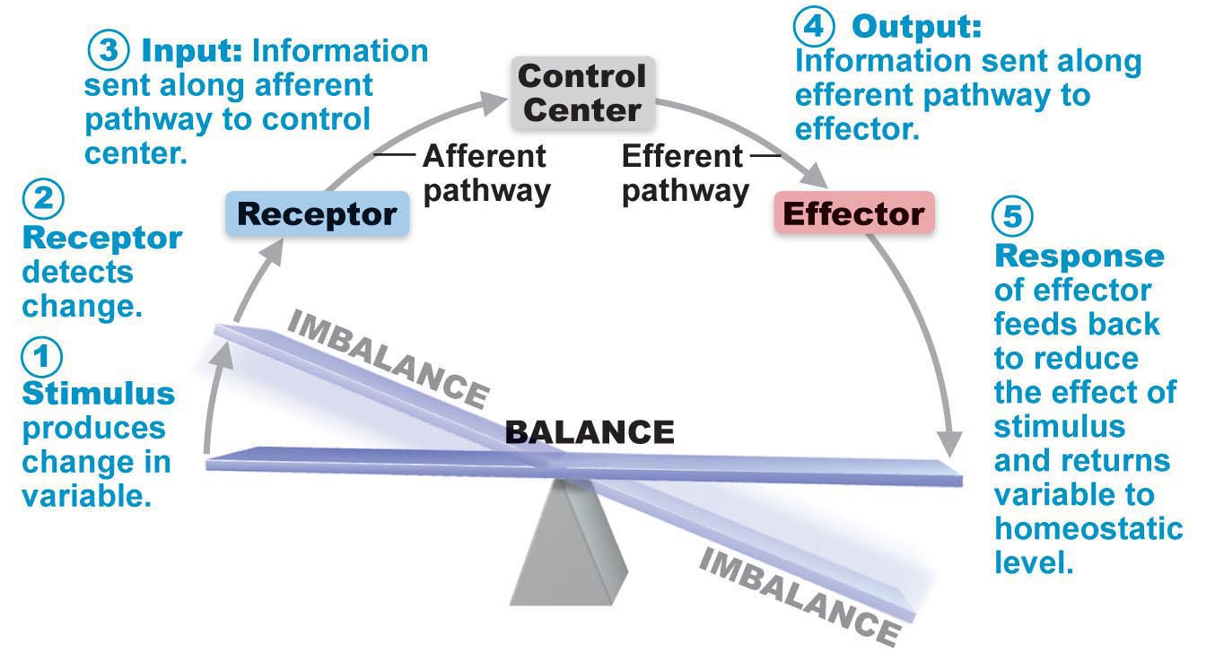

3.1.3 Positive and negative feedback
Negative feedback mechanisms
- Output reduces or shuts off stimulus
  - 1 hormone or neural pathway regulating a process (ex: secretion)
  - Process regulated in opposite directions by 2 different hormones or neural pathways (ex: blood glucose)
- Goal of negative feedback:
  - Prevent sudden/severe changes
Positive feedback mechanisms
- Response of mechanism enhances original stimulus, output is further stimulated
- Change occurs in same direction as original response
- Goal of positive feedback:
  - To be attained
- Ex. Blood clotting
Homeostatic imbalance
- Most disease seen as a disturbance of homeostasis= homeostatic imbalance
- Aging associated with progressive decrease in our ability to maintain homeostasis= greater risk for illness
The Nervous System
3.2.1 Autonomic and somatic nervous systems
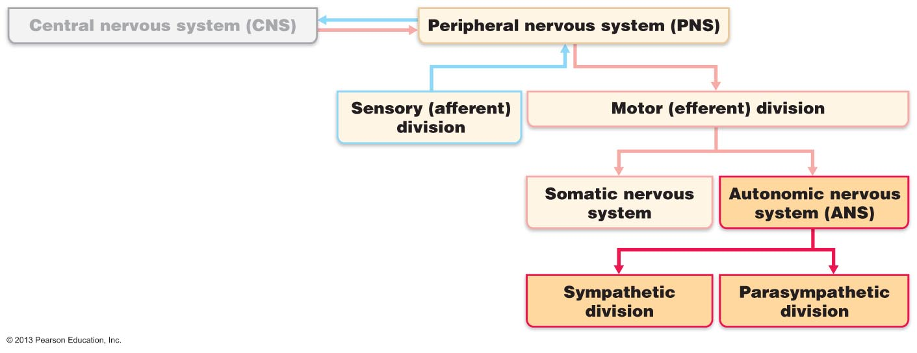
ANS: system of motor neurons to smooth and cardiac muscle and glands to allow responses usually without our awareness (auto= self, nom= govern)
- Move blood to more needy areas
- Speed/slow heart and respiratory rates
- Adjust blood pressure, body temperature
- Increase/decrease gastric secretions
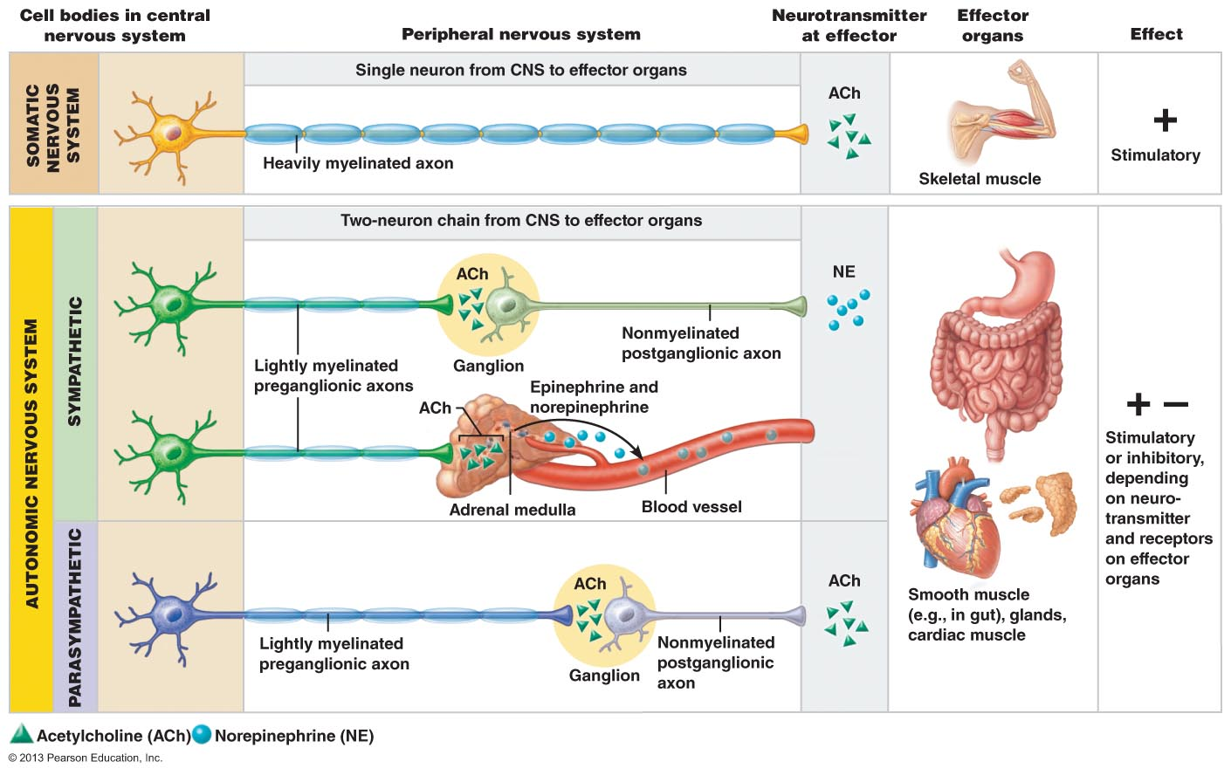
Effectors:
- Somatic: skeletal muscle
- Autonomic: smooth muscle, cardiac muscle, glands
Pathways and Ganglia:
- Somatic: thick, myelinated axon from spinal cord to skeletal muscle; rapid conduction of impulses (no ganglia)
- Autonomic: two-neuron chain
  - Preganglionic neuron: (thin and lightly myelinated); originates in brain or spinal cord; preganglionic axon synapses with…
  - Postganglionic neuron: (thinner and unmyelinated); second motor neuron in ganglion outside CNS; postganglionic axon to effector organ
  - Conduction is slow
3.2.2 PNS and SNS
Parasympathetic division
- Active in non-stressful situations (resting and digesting system)
- Keeps body’s energy use low while regulating housekeeping activities (digestion, elimination of feces and urine)
- “D” system: digestion, defecation, diuresis
PNS and tone
- Tonic slowing effect on heart
- Regulation of contractile activity of smooth muscle of GI and urinary tracts (can be overridden by SNS)
Sympathetic division
- Fight or flight system
- Important during exercise: increased heart rate, rapid, deep breathing, cold sweaty skin, dilated pupils
- “E” system: exercise, excitement, emergency, embarrassment
SNS and vascular tone
- Blood vessels kept in a state of partial vasoconstriction
- Blood shunting (movement) possible via variations in sympathetic output to specific vessels
Unique roles of SNS
- SNS regulation only
  - Adrenal medulla, sweat glands, arrector pili muscles of skin, kidneys, most blood vessels
  - Thermoregulatory responses to heat
  - Renin release from kidneys; results in increased blood pressure
- Metabolic effects
  - Increase metabolic rate of body cells
  - Raises blood glucose levels
  - Stimulates mobilization of fats
  - Increases mental alertness
  - Increases speed/strength of muscle contraction
Interactions of the autonomic divisions
- Most visceral organs receive dual innervation
- Antagonistic interactions:
  - Activity of the heart
  - GI system
  - Respiratory system
- Cooperative effects:
  - Regulation of external genitalia during intercourse
    - PNS: dilation of blood vessels in penis
    - SNS: ejaculation, reflex peristalsis of female’s vagina

How the PNS and SNS differ
- Sites where nerves originate
- Relative lengths of pre/post-ganglionic fibers
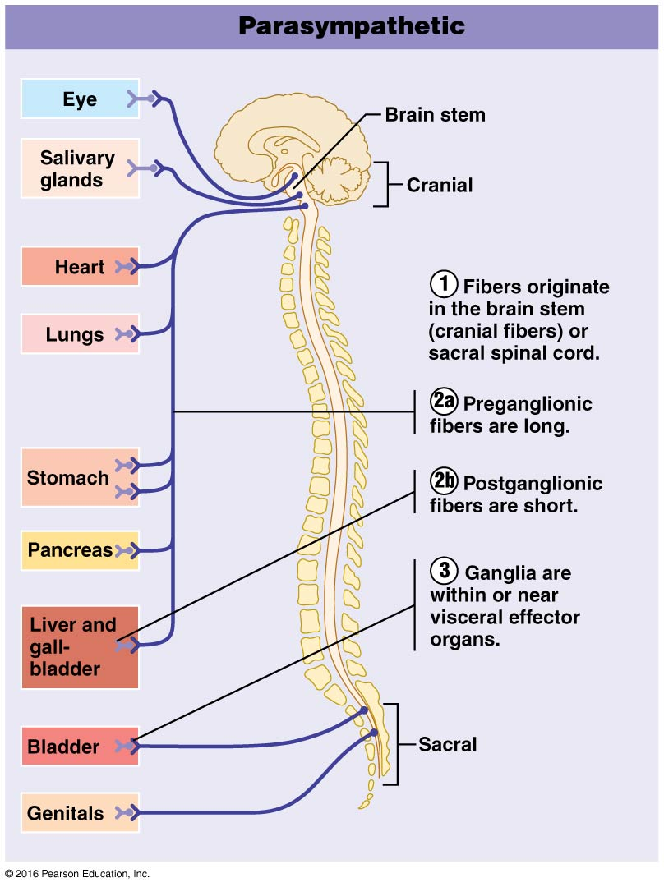
- Locations of ganglia
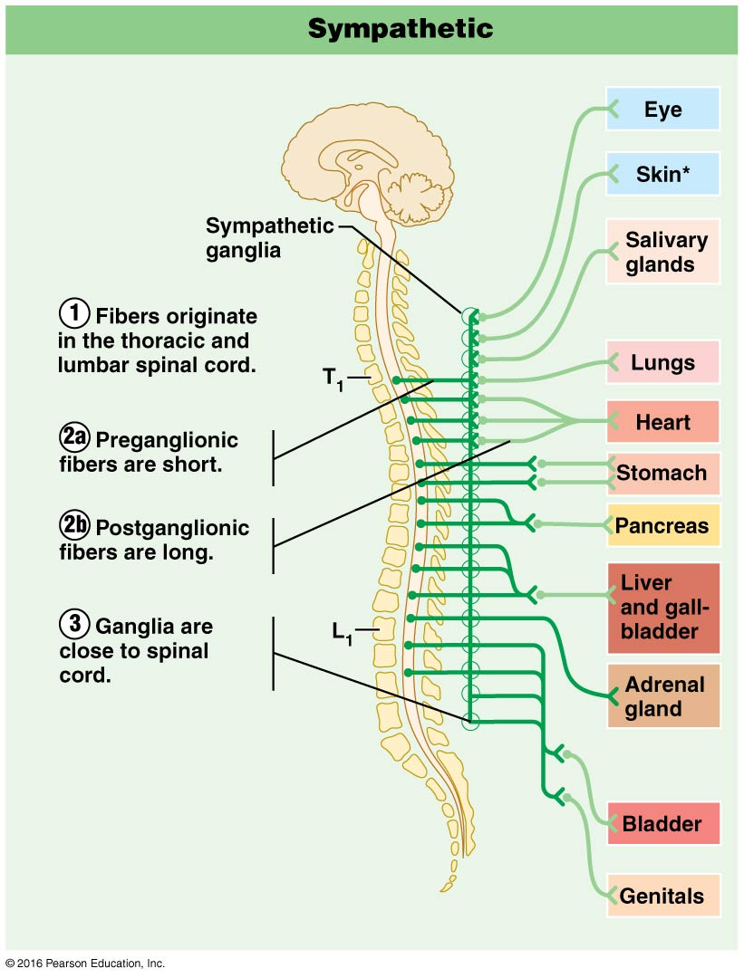

3.2.3 Levels of regulation of autonomic function
Brain stem and spinal cord controls
- Significant direct effects on ANS-regulated activities
- Motor centers in ventro-lateral medulla (ex: cardiovascular centre: heart rate, blood vessels; also GI, respirator centres)
Hypothalamic controls
- Hypothalamus= integration centre of ANS
  - Anterior regions: parasympathetic
  - Posterior regions: sympathetic
- Hypothalamus contains centres to coordinate:
  - Heart activity
  - Blood pressure
  - Body temperature
  - Water balance
  - Endocrine activity
  - Help mediate emotions and biological drives

Cortical controls
- Ex: mediation and biofeedback allow some conscious control over visceral activities
- Ex: during mediation, can lower heart rate and breathing rates, oxygen use, metabolic rate
- Biofeedback to improve management of migraine headaches, stress and cardiac function
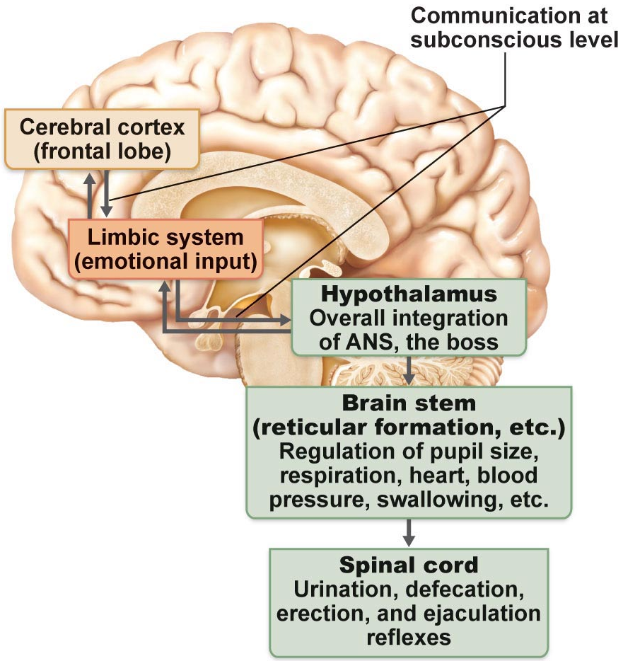

Homeostatic imbalances of ANS
- Ex: hypertension
The Endocrine System
3.3.1 Hormones
Hormone: A chemical substance released into the ECF that regulates the metabolic function of other cells in the body
- Hormones must bind to specific receptors to influence target cell function
- Hormones are specific; level of target activity depends on:
  - Hormone concentration
  - Target cell receptor content
  - Affinity of hormone for receptor
Mechanism of hormone activity
- Hormones alter levels of cell activity:
  - Membrane permeability/potential (channels)
  - Synthesis of enzymes within cells
  - Enzyme activation/deactivation
  - Induction of secretory activity
  - Stimulation of mitosis
3 structural groups of hormones
- Amino acids, peptides, proteins
- Steroid hormones (derivatives of cholesterol)
- Eicosanoids (from arachadonic acid)
2 main mechanisms of action
- Peptide/protein hormones
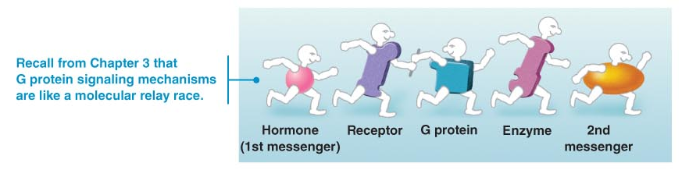
  - Bind to cell surface receptoractivation of membrane-bound G proteinproduction of 2nd messenger (ex: cyclic AMP (cAMP), calcium)
  - Activation of protein kinases to regulate activity of key enzymes
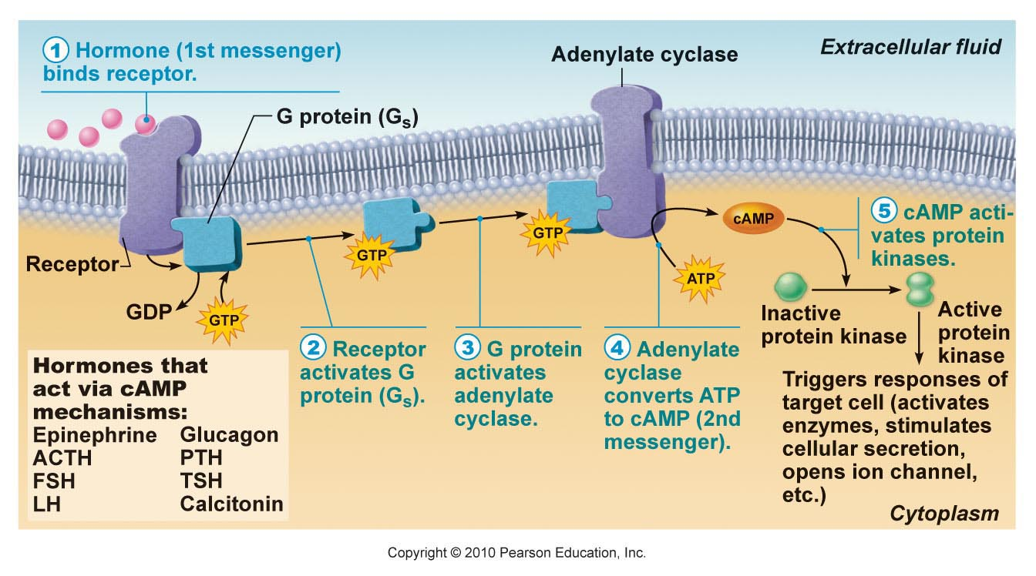
Cyclic AMP second messenger mechanism of water-soluble hormones
Steroid hormones: entry into nucleus and activation of gene transcription
- Hormone diffuses through the PM and binds to intracellular receptorreceptor-hormone complex enters the nucleusreceptor-hormone complex bind a hormone response-element (specific DNA sequence)binding initiates transcription of gene to mRNAmRNA directs protein synthesis
3.3.2 Positive/negative feedback & humoral/neural/hormonal regulation of hormone release
Half-life, onset and duration of hormone activity
- Hormones are potent
- Blood level of hormone depends on:
  - Rate of synthesis
  - Rate of degradation/clearance from blood
- Half-life: persistence of a hormone in the blood (usually <1 min to 30 mins)
- Time to onset of hormone action variable:
  - Enzyme activation: rapid (minutes)
  - Enzyme synthesis: hours to days
- Some hormones secreted as prohormones; activated once reach target cell
- Duration of hormone action also variable (hours to days)
Control of hormone release
- Usually negative feedback (setpoint); sometimes positive feedback (goal)
- 3 types of stimuli:
  - Humoral stimuli: hormone secretion in direct response to change in blood level of a nutrient, ion (ex: parathyroid hormone (PTH) and blood calcium; insulin and blood glucose)
  - Neural stimuli: not as common (ex: SNS and epinephrine release by adrenal medulla, hypothalamic neurons and oxytocin release)
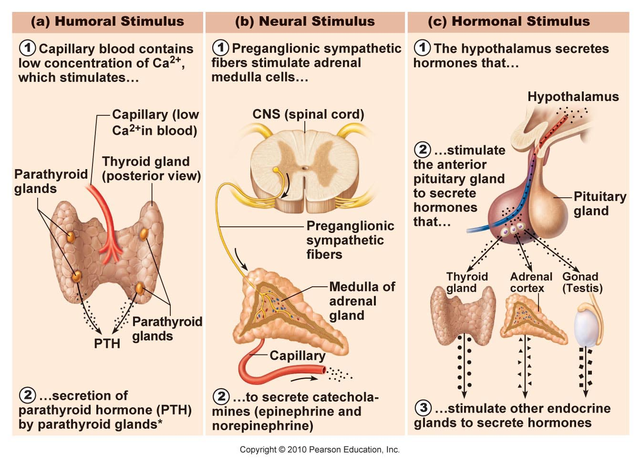
  - Hormonal stimuli: 3-tiered involving hypothalamus, pituitary and target endocrine gland; concept of hypothalamic-pituitary axis

Hormonal stimulus (cont.)
Thyroid-releasing hormone (TRH) (hypothalamus)

Thyroid-stimulating hormone (TSH) (anterior pituitary)

Thyroid hormones (T₃ and T₄)
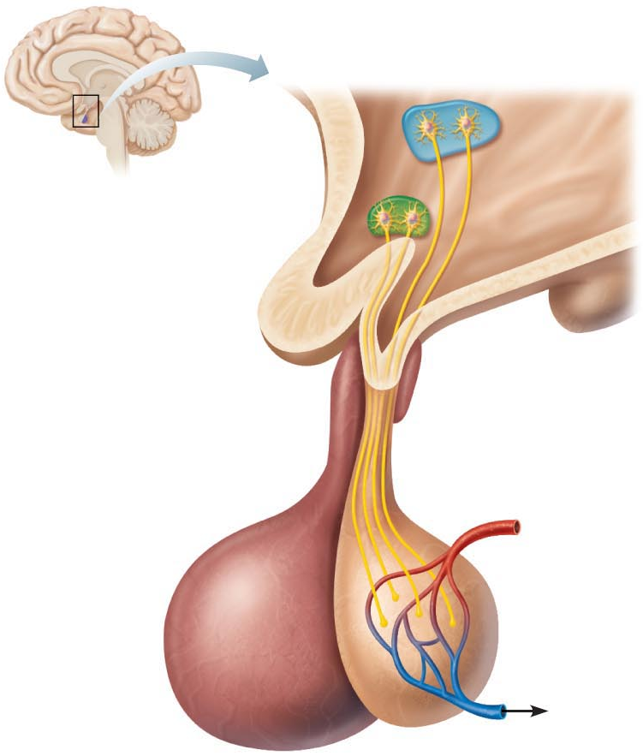
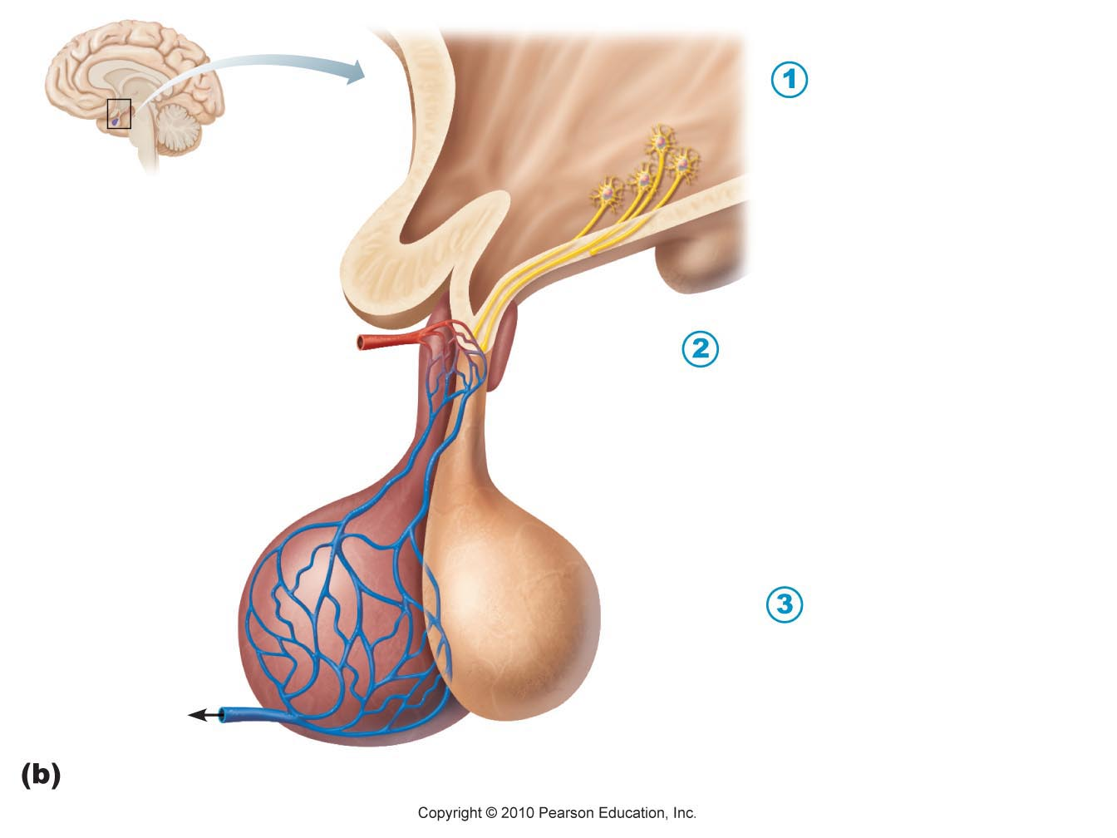
- Hypothalamus in neural; produces a number of releasing factors (hormones) which travel to anterior pituitary via hypophyseal portal system

Posterior pituitary
Supraoptic
Paraventricular
Anterior pituitary
Hypothalamus

Pituitary gland
- Size and shape of a pea
- Infundibulum connects pituitary to hypothalamus
Posterior lobe
- Axon terminals
- Hormone storage area
- Antidiuretic hormone (SON)
- Oxytocin (PVN)
*Both structurally similar (nonapeptides), but very different functions
Antidiuretic hormone: neurohypophysial hormone, two primary functions are to retain water in the body and to constrict blood vessels
Oxytocin:

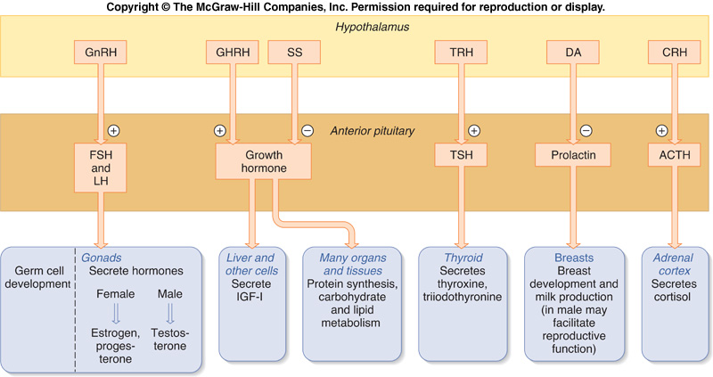

To summarize the 2 key homeostatic regulatory systems
- Autonomic nervous system
  - Sympathetic vs. parasympathetic
  - Sensory and motor neural pathways
  - Fast response
- Endocrine system
  - Hormones released into extracellular fluid, often travel to target organs via bloodstream
  - Slower response time but more long-lived
  - Different chemical classes of hormones with associated mechanisms of action

