- Epitaph of Seiklos is the oldest notated music in history. Around 1st Century A.D. Engraved in stone.

- 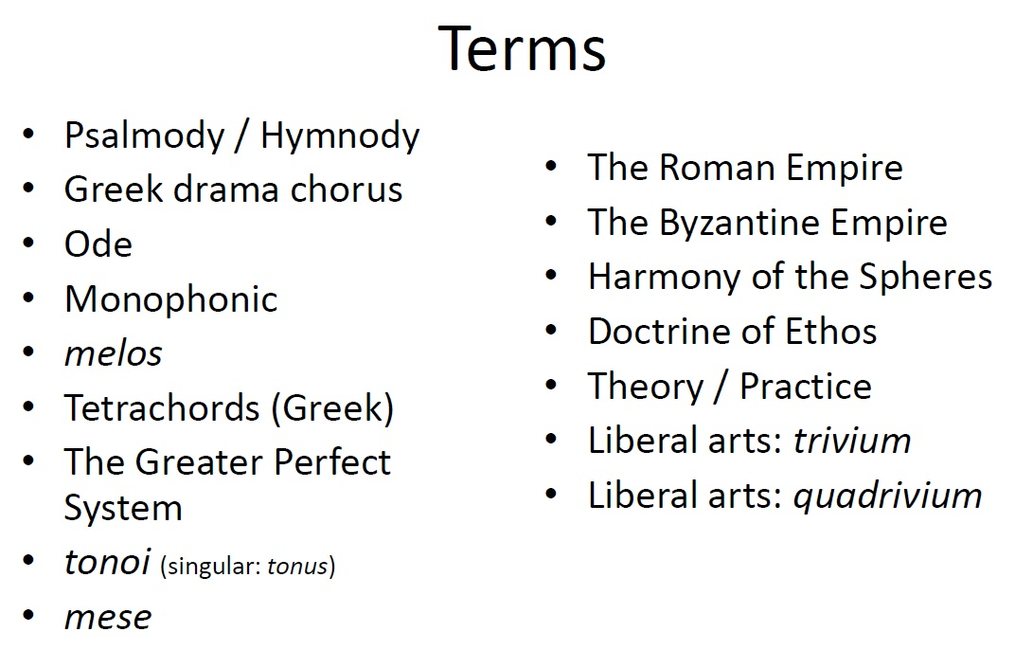

- Psalmody/Hymody: Body of psalms and hymns

- Greek Drama Chorus: Guys with the masks reacting to scenes. Happy and sad faces

- Odes: to honour heroes that the greeks wrote. It blurs the line between music and poetry.

- Monophonic: One single line of music

- Melos: ‘the song’ the words, music, melody.

- Tetrachords: arrangement of pitches and intervals in a melody. Three kinds, fourth that is divided into different ways.
Diatonic, Chromatic, enharmonic. All descend.

- The Greater Perfect System: 4 tetrachords +1 pitch. Consists of two octave range.

- Tonoi (singular tonus) : Similar to minor major tonalities. The way the melody sounds, GREEK.

- Mese: “Mean” as in middle. The ‘tonic’ or resting point in the middle of the melody.

- The Roman Empire: ‘nough Said.

- The byzantine empire: ‘nough said.
Harmony of the Spheres:

- Doctrine of Ethos: music has the power to change people’s humors and change their attitude. Basically manipulation

- Theory/ Practice:

- Liberal Arts: Trivium

- Liberal Arts: Quadrivium

- Questions

- What is the oldest instrument?: Voice

- When do we begin to know anything about music history? Emporers in the old testament. From the bible

- How do we know this? Images, testaments of events. Archeology. Instrument parts. Relics. Traditions and word of mouth.

- Roles music play in ancient society? Entertainment. Religious rituals. Education in becoming a richer human. Dancing and sex.

- Music in the Biblical World
- The old testament mentions: celebratory music, ceremonial music, religious music, music ‘therapy”

- PSALMS AND HYMNS were sung
- Antiphonally ( one side sings, the other side sings)
- Responsorially (leader sings, people respond)
- Always monophonically.

- Music in Ancient Greece
- Beginning in the 8th century BC, thinks less about war and more about philosophy. They think about civilians, justice and fair, courts come in etc.
- Democracy and individual rights.

- -5th cent BCE is the apex of ancient Greek cultural thought: philosophy
- -45 existing fragments of music from ancient Greece
- -music used in drama, ceremony and poetry.
- -Monophonic accompanied by string instrument maybe.
- -Melos=song: melody/words/rhythm.

- Greek Music Theory
- There are three types (genera) of Tetrachords. (4 descending notes)

- Diatonic: whole tone, whole tone, half tone

- Chromatic; minor third, half tone, half tone

- Enharmonic: major third, quarter tone, quarter tone.

- All of these form a fourth.

- The Greater Perfect System:made up of four, interlink Tetrachords plus one pitch. Constitutes 2 octave range

Depending on what the Tetrachords are used the ‘scales’ for melodies can be defined by their ‘tonus’ (plural: tonoi)

The pitch in the middle of the tonus is called the ‘mese’ and melodies should always return to this. (like our tonic)

Ancient Greek Instruments:

-Lyre- harp-like.

-Aulos

-Syrink

-Drums

-Cymbals

Music in the Roman Empire

We have no fragments or pieces from this era.

-rome is a military power that spreads from the Mediterranean to Britain bty the 2nd century AD

-Roman instruments: tuba. Cornu(horn) hydraulic organs (running the bellows on water pressure.

Musical Legacies of Antiquity

Rome falls into two sections: East and West

Music and the Cosmos (Harmony of the Spheres)

Ratios are intervals.

Planetary movement can be ratios, so they can be sound systems that are inaudible to the ear.

Music is the organizing force that would otherwise be chaos. Some of that music is in a spectrum where humans can hear, some is not. (Pythagoras)

Music and it’s power of the soul (Doctrine of Ethos)

-lots of Greek myths about this. Music is a power, that can make oyu do things. (guy with lyre)

Doctrine: music has the power to change people’s humors and change their attitude. Basically manipulation.

Music and the State:

Power of music over a body of people.

People will do better

Education

Lighters in the air (peipole reacting the same way to music_

Theory and Practice:

-Greeks invent the idea of music as math. (ratios) and not simply entertainment.
  - -they take the liberal arts and that is the theory of music. From the Quadrivium. It is different that playing music.

- Vocal Music/ Instrumental Music:

- Vocalists can tell a story because of words.
- Instrumentalists cant.
- However, instrumental music can create different feelings for everyone. It gives mystery to instrumental music. You can’t say it’s about something.

- 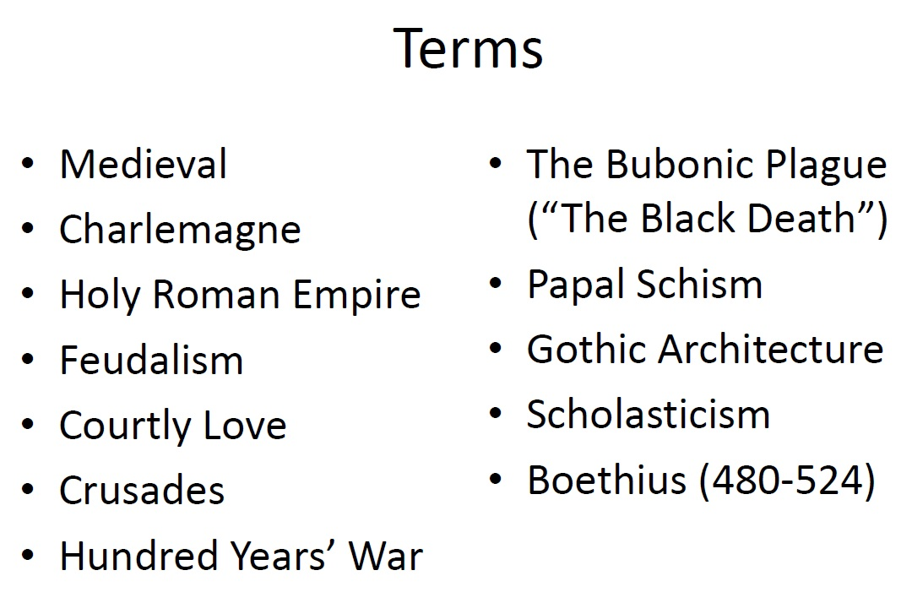

- Medieval: Means ‘between’ (classical antiquity and the Renaissance) The Dark Ages’: after Rome fell, war and poverty took over in many parts of Europe, leading to a decline in education.
- -Medieval isn’t exactly a period. It’s a thousand years and theres nothing that follows all the way through because it is so long.
- There is a cultural decline after rome fell.
- In the middle of the dark ages, you get the guys who are going to preserve everything from antiquity till then. A guy named Anthony in Egypt who was a ‘monk’ a monk means mono (one) to be alone. A bunch of people joined him and it became a ‘monastery

- Monasticism: beginning in the 5th century, individual Christians would retreat to the destert on their own to become hermits. Lead by St. Anthony of Egypt. Scriptora in monastaries preserved much of Western culture for centuries while war waged around there. They created libraries of knowledge of preserved text.

- Skellig Michael (8th-12th)

- Charlemagne: (742-814 AD) King of the Franks, then crowned by Pope Leo III on Christmas Day 800 AD as emperor. Ruled most of the Germanic/Italian lands under the name of the HOLY ROMAN EMPIRE.
- It’s holy because the pope gave it to him, Roman because that’s the roman area and Emperor because it’s better than a king. Charlemagne means Big Charlie

- Holy Roman Empire: ^^^^^^

- Feudalism: In use in France by the Normans from about 900 AD. Instituted in England by William the Conqueror from 1066 AD onward. It’s a ‘you scratch my back I scratch yours’ idea. Kings make barons, barons make knights, knights have villeins. In turn the villeins give food and money to knoghts, which provides military service to the barons and to the king.

- Courtly Love: Time for leisure activities and art in secular society. The concepts of chivalry and courtly love was born. Troubadours and Minnesinger culture contributed to this way of life. They are singers and write songs.

- This is the first time women have power. They can manipulate men with their prowess.

- Crusades: 11th and 12th centuries. The first series of Crusades began in 1096. Cultural mixing and travel brought new awareness of other cultures.

- In the 12th century Europe experienced a small “renaissance” through trade and exposure to the Islamic World. The number zero was invented, the guitar (sort of) it was all because of exposure to this culture.

- Christains are trying to take and retake Jerusalem as ‘the promised land’ Crusades are religiously motivated to battle. People are moving to the middle east. And so they are getting exposed to new cultures.

- Hundred Years’ War: (1337- 1453) Joan of Ark is involved. England and France.

- The Bubonic Plague (The Black Death) Killed one in three people in Europe. 14th century. 25-50 million died. Arrived in Sicily by ship in 1347 from Caffa (Turkey) Bubonic Plague is spread by rats and fleas to humans.

- Papal Schism: (1378-1415) Shift of power from Rome with different popes. The Avignon Papacy (1309 to 1377) saw 7 popes, all French, reside in France.
  - Pope Gregory XI (1370-1378) returned to the papal residence in Rome
  - French cardinals set up two anti0popes in Avignon during the Schism
  - The English support the Roman Pope.
  - Resolved by the Council of Constance in 1417
  - All the music in the Avignon court was crazy dissonant and hard and meters are cray cray. It’s called Arsnosa? (SP?)

- Gothic: Mid-12th century. Romanesque building are replaced by Gothic style. Emphasis on height, light and feeling of weightlessness.
  - Universities: first universities founded in Paris (1160 ad) and Bologna (1088 AD)
  - Disciplines: Law, Medicine and Theology
  - Learning and education are now not entirely under the church’s control.

- Architecture:

- Scholasticism: Reason AND Faith.
- This idea has started to come back. There are a lot of new age types of medicine. Acupuncture, meditation, etc.

- Boethious (480-524)

- Plain Chant:
  - Jewish rituals of singing psalms and praying
    - central features of the new Christian religion was the reenactment of the last supper (also a Jew tradition: Passover)
    - psalms were the firsts texts to be set in plain chant, then biblical texts (such as poetry and prayers)
    - Early Church Fathers such as St. Basil and St. Augustine were skeptical about the role of music in the church.
    - Chant was born from this
    - Augustine believed that music in the church was too sensual, however he loved music more than anyone else.
    - Basil said that if there is music in the church, people will remember the text (such as humming it in the marketplace)

- Lack of Notation:
  - “because sound is a sense of impression, it vanished as time passes and is imprinted on the memory…if a man does not remember sounds, they perish , for they cannot be written down…” (Isodore of Seville 560-636)
  - Many different Christian rites developed in different geographical areas:
    - Roman chant (rome)
    - Abrosian Chant (in Milan and northern Italy, anmed afger St. Ambrose, bishop of Milan 374-397)
    - Gallican Chant (franks and Gauls in France and Western Germany)
    - Mozarabic/ Visigothic chant (Iberian peninsula)
    - Coptic Chant, until recently it was only sung by blind singers because they could become more intimate with the music.
    - Celtic Chant: we don’t know what is specifically Celtic in chants or not, sorry.
    - Charlemagne(sp?) is really involved in making people sing the Roman way of chanting.

Gregorian Chant:
  - Legend : pope greg I was given the roamn chant by the holy spirit in the form of a dove who sang it to him while seated on his shoulder. A sctibe, separated by a curtain wrote it down.
  - If the roman chant was given by god, all others were not.
  - John The Deacon’s Account:
    - Take 12 of your best singers and send them all over Europe to teach people the roman chant.
    - Charlemagne went to france to see if it worked and he was not a happy camper.
    - John the deacon is writing it from Rome’s perspective, the roman’s tried to teach everyone, but they said germans were too drunk to learn and others did not sound as good as the romans.
  - Notker of St. Gall’s Account
    - He agrees it didn’t work to learn the roman chant
    - He says the 12 were jealous of the Frankish.
    - He said they were purposefully teaching them the wrong chant
    - It wasn’t the german’s fault, it was the romans. So that when Charlemagne came to hear it, the 12 could blame the people.
  - Musical Education: Singing Schools
    - In the early days of Roman Chant transmission singing schools were set up in Metz and St..Gall, among other places.
    - Notation only appears in the mid 9th century
    - How was chant preserved and performed before notation?
    - Oral transmission: the medieval mind cultivated its memory such that knowing the chant repertory by heart was not impossible.
    - Notation: its possible that notation was invented as a way to preserve the chant as it was transmitted across the Alps. We have no books to support this theory, though.
    - Oral traditions are lined out to create a chant. Used with different fragments of already known chants.
- Liturgy:

- Eucharist Mass:

- Chant Types:

- Pope Gregory I (590-604)

- Pope Gregory II (715-731)

- Memory:

- Chant Transmission:

- Neumes:

- Unheightend/ Heightened
- Jan 20, 2012

- Sean Twomey

  - stwomey@uwo.ca

- what types of resources are theyre to facilitate your research?
  - Primary Materials:
  - Original works
  - Original documents

Secondary Materials:
    - Reprints
    - Facsimilies
    - Books, monographs
    - Periodicals, articles and festschrifts

- Paper: Have a clear understanding of what is expected from you. Have a clear idea of what YOUR goals are.

- I- Think about your paper topic
  - Consider your reater
  - Freewrite
  - Determine your purpose
  - Compose a preliminary thesis
- II:
  - Reasearch your topic
  - Books
  - Reriodicals
  - Online sources
  - Interview and questionaires
- III: devise a plan
  - Expository
  - Compare/contrast
  - Persuasive

- IV: write a draft
  - Effective intro para
  - Effective body para
  - Effective concl para
- V: Revise
  - Reconsider structure
  - Ensure content accommodates an audience and purpose
  - Check cohesion
  - Improve style
- VI: Edit
  - Check grammar and spelling
  - Check sentence structure
  - Check punctuation
- VII: Cite your sources
  - MLA method of parenthetical citation
  - APA
  - CHICACO

- METHODS OF RESEARCH
  - Where to begin? Pick a topic that interests you to stay motivated to complete and research the paper.
  - When doing research consuder
    - Acknowledgement of the author’s thesius
    - Identify arguments used to support this;
    - Indentify eveidece given to validate their arguments
    - Offer an assessment of the merits and/or weaknesses of the article.
    - Is there a s bias or limitation?

Proposals
  - Construct thesis like questions

- 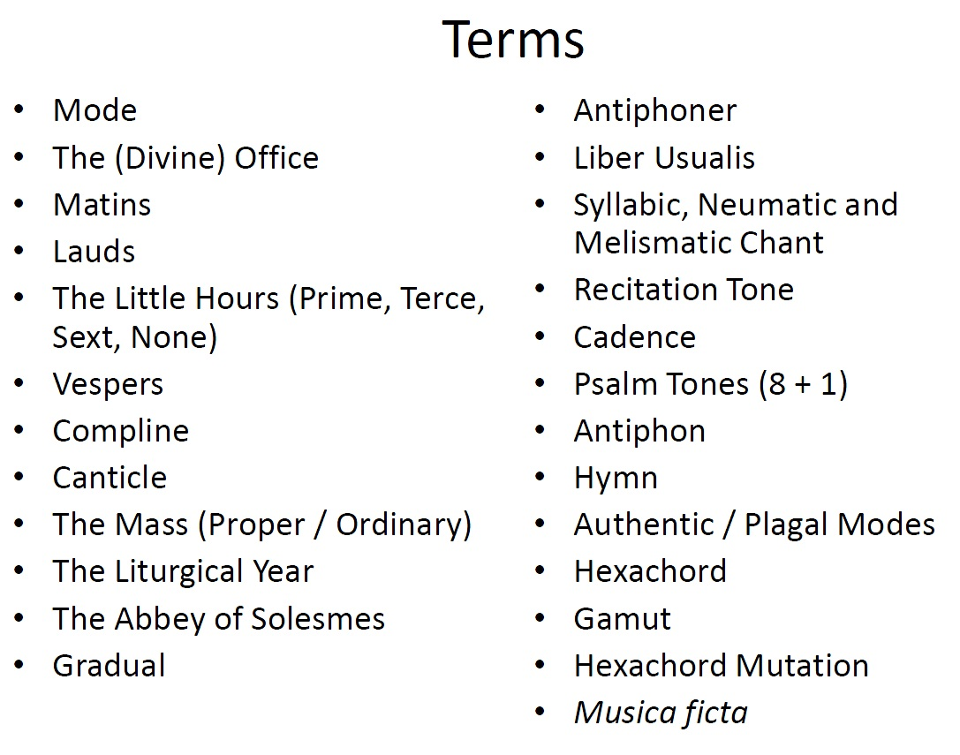
- Liturgical Functions
- THERE ARE TWO:

- The Divine Office (found in an Antiphoner)
  - Matins (3am)
  - Lauds (sunrise)
  - Prime (6am)
  - Terce (9am)
  - Sext (noon)
  - None (3pm)
  - Vespers (sunset)
  - Compline (before bed)
    - This is altered based on you’re global location
    - If you are hardcore you do all 150 psalms every day. You recite them all the time. Not hardcore. Once a week.

- The Mass (found in a Gradual)
  - Usually held between Terce and Sext

- (ERROR IN TEXTBOOK)- Antiphoner Matins is what takes up most of the antiphoner. Ooookaay?????

- The Mass
  - Two types of chants in the mass:
    - Unchangeable / Changeable chants

    - Sing the same text every time, they do not change

    - The second type of mass, the words can change. Like when words belong to the mass, not the day. I.e Christmas and Easter the words change.
  - The Ordinary: Unchangeable
    - Kyire
    - Gloria
    - Credo
    - Sanctus
    - Agnus Dei
    - Ite Missa Est
  - The Proper: Changeable
    - Introit
    - Gradual
    - Alleluia/ Tract
    - Offertory
    - Communion

- The Liturgical Year
  - Follows the biography of Christ
    - Advent (four weeks before Christmas)
    - Christmas
    - Epiphany (visit of the magi – jan 6)
    - Lent (40 days before easter)
    - Easter (first Sunday after the first full moon on or after march 21st)
    - Pentecost (50 days from easter to advent)
  - Manuscripts set are set up to follow the liturgical year
  - Saints days are listen throughout the year on the appropriate date. They operate on the normal calendar (jan 1st)

- Relationships: Words/ Music
  - Syllabic
    - One pitch per syllable of text
    - Examples in mass: Gloria and Credo Chants
  - Neumatic
    - Few bitches up to 4 or 5 per syllable of text
    - Examples in the mass: Introit, Offertory, Communion Chants
  - Melismatic
    - Upwards of 5 pitches per syllable of text
    - Examples in mass: Gradual and Alleluia Chants. Tend to be sung Responsorially (alternating soloist)
  - KNOW THESE FOR MIDTERM OKRRRR??!?!?!?

  - PSALM TONES
    - One for each mode (8) plus the tonus peregrinus
    - Consists of opening pattern, recitation section, closing cadential pattern

- Modes:
  - Refer to example 1/3 in text p 39 for
  - Eight scale that are different from each other in their intervallic relationships
  - The Final ‘home’ pitch
  - The Recitation Tone: reciting pitch
    - Mode 1 (authentic) and 2 (plagal) D is the Final
    - Mode 3 (authentic) and 4 (plagal) E is the final
    - Mode 5 (authentic) and 6 (plagal) F is the final
    - Mode 7 (authentic) and 8 (plagal) G is the Final

  - Authentic and Plagal modes distinguish themselves y their recitation tones and by their ranges
    - Examples: Mode 1&2 D is the final BUT
      - Mode 1 D-D is the range and A is the Recitation Tone
      - Mode 2 A-A is the range and F is the Recitation Tone

- Melodic Structure:
  - Chant is conservative in its ambitus (range) and intervallic leaps not more than a 5th
  - Early singers probably didn’t think in modes like we think in keys’, they thought in HEXACHORDS instead

    - Hexachords: a group of six pitches:
      - Do, Re, Mi, Fa, Sol, La
      - Semitone always falls between Mi and Fa
      - Moveable ‘do’ system
  - Gamut: the entire range of pitches available to the medieval composer

  - Made up of 7 interlocking hexachords
  - See example 1-5 pg 141
  - Gamut comes from ‘gamma’ (Greek G) + ‘Ut’ the medieval syllable for ‘do’

  - The Guidonian hand is the learning tool for singers trying to memorize hexachords

- Three different types of Hexachord
  - Hard (includes b natural) G A B C D E
  - Soft (includes b flat) F G A Bb C D
  - Natural( no b at all) C D E F G A

Sigjht reading a chant that went beyond 6 notes required a hexachord mutation (modulation)

Rule: Una nota super la semper est canendum fa = one note above la should be sung as a flat if you’re coming back to la

- Rhythm:
  - Text driven
  - Irregular rhythms probably
  - No one knows for sure
  - There would have been certain pitches stressed over others which may have had rhythmic consequences but these would have been for rhetorical reasons
- Short written assignment
- DUE FEB 3rd
- Annotated Bibliography
  - Each para represents one book/source
  - Each para begins with a bibliography correct citation of the book in question
  - After the bibliographical citation, a small para of 100-150 words about the book found
- Requirements
  - At least three sources
  - Can’t accept it if all three sources are encyclopedias.
  - All three have to be on my subject
  - Like new grove, my textbook and another text book is not okay.
  - Correct citation style use A manual for writers of term papers, these and dissertations
  - Between one and two pages
  - Dbl spaced
  - Regular font and margins
  - No titles page necessary but include your name and student number as a header/footer

Choosing sources
  - Know your topic
  - If you want to pick your own topic make an apt to see Dr. Helsen
  - If you do not want to pick one of the suggested theses on syllabus then your topic must be medieval , renaissance, or early baroque periods of music history. Start with books on reserve for this class
  - Tip: go to new grove and look up the topic, at the end of the topic, you will see more bibliographical sources to find MORE books and sources.

- Annotations
  - Should include
    - The main topic of the source (for example medival chant oral transmission)
    - The specific argument of the author about that topic (ex belivves it was aided by notation we no longer have)
  - DON’T
    - Musical examples. You will get thsese from musical scores (ime bonds anthology, your own scores etc) but they do not provide academic arguments about the scores
- TERMS
- Historiae (Newly Composed Saints Offices)
- Trope
- Prosula
- Sequence
- Musical Characteristics of Late Medieval Chant
- • Glossing
- • LiturgicalDrama
- • RhymedOffice
- • CouncilofTrent(1545- 1563)
- • HildegardofBingen (1098 - 1179)

- Fixity of chant
  - In the 9th cent, to ‘Romanization; of chant was establish in the west. This mostly applied to the complicated chants (i.e The Divine office)
  - The Mass Ordinary could be ornamented and embellish with TROPES
    - Trope: an addition to a fixed text / piece of music through extra text or music or both
    - Most are found in the mass ordinary

- Prosula
  - Added words to pre0ecxistign melisma in a chant
  - Text is usually syllabically set to melisma
  - Notker f St. Gall (840-912) writrs about composing some sequences in order to remember the melody of a long melisma
  - Prosulas probably first began in France
- Sequence
  - Presulas added to the end of alleluias (melismatic end called a jubilus gained a life of their own: SEQUENCES!!
  - Seq were performed on special feast days to heighten the occasion
  - Mostly syllabic often repeated melodic lines by two’s aabbccddeeff etc
- Characteristics of late chant
  - Emphasis on the final and fifth above it (examine Cadential goals)
  - Melodic repetition to reflect textual repetition especially in text like ‘kyrie’
  - Zigzag melodic lines
  - Larger ambitus
  - The “Gallican Cadence” – modes 1 or 2, or 7 or 8. Below the final, the final repeated twice
- Glossing/Embellishing
  - Marginalia which comments on the original text
  - This idea can be extended to anything : music (ie tropes) architecture (ie labyrinths) art (ie symbolic codes)
  - Picture in text book pg 45 has a great ex of this
  - Originality is dumb, add to something that already exits
- Liturgical Drama:
  - The dramatization of a dialogue from readings in scripture which takes place during church service
  - Quem Quaeritis (whom do you seek?) is the famous examples of this: angel as the three women whom they seek at the whom of jesus
  - Quem Quaeritis begins the applied to the Christmas story
- Hildegard of Bingen Ordi Virtutum
  - A play set to music (chant) where 16 virtues are tempted by the devil and over coe him attaining heaven
  - Listening example of discussed on p 48-9
  - A short bio of Hildegard is on p.50
  - WROTE THE FIRST OPERA about the 7 virtues to a church audience
- Historiae: late medieval saints offices
  - Newly composed saints offices were written for new saints added to the church calendar
  - The texts were usually metrical and they rhymed like poetry
  - The cant was usually written in the chants and often reflect the textual structure (but not always)
- Hymns:
  - A chant where a poem has been set to strophic music
  - Example in your text : pange liungua
  - Text was written by St. Thomas Aquinas in the 13th century set to music at that time
  - This is one way to date chants consider the sources of their text
- The end of chant story?
  - Even thou we move now to secular music in then middle ages the story of chant continues through the renaissance and baroque eras
  - Chant is harmonized and sing in churches thorough to the 20th century stopping with Vatican II (1960s)
- The council of Trent
  - A series of meetings between roman catholic leaders all over Europe to establish a ‘cleaned up’ liturgy for their church
  - Pressures from the protestant farmers happening at the time in Europe caused them to remove all the embellishments and ornaments from their services
  - This mean sequences, Prosula, many new and complex chant compositions are gone
- 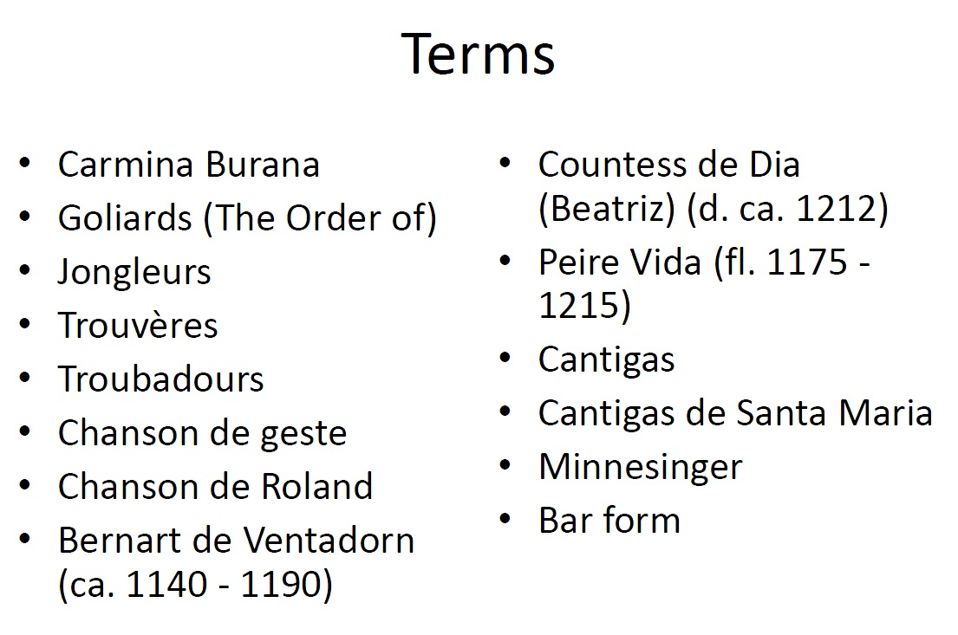

- Secular Song:
  - Words and music are not separate entities
  - Music we do have is mostly monophonic
  - Generally not written down
  - Tradition of performance more important that an sing authoritative version of the work
  - Songs may have also been accompanied but we do not have notational evidence (on descriptions and pictures of accompanied songs)

- Kinds of Secular Song:
  - Latin Song
    - Written by educated men
    - Usually originating in monasteries
    - Sources are often books associated with universities or abbeys
    - Topics are : love (erotic and sacred) gambling, drinking.
      - Carmuna Baruana (songs of Benediktbeuern) IT’S A BOOK
      - 13th century manuscript from a Benedictine abbey in Bavaria
      - contains 200 poems/songs about love drinking and gambling
      - written by monks. Educated laymen who were fluent in Latin
      - Carl Orff’s 1937 setting by the same name sets 25 of these poems
    - Singer’s of Latin Song
      - The Order of the Goliards
      - Named after Goliath (bible) who was known for his excessive drinking and careless behavior
      - Made up of wandering minstrels, usually partially educated in monasteries (i.e drop out monks)
      - Jongleurs were less educated than the goliards. Known or entertainment (singing, acrobatics and juggling- for which they are named)
  - Vernacular Song:
    - Man areas: France, Iberian peninsula and Germany
    - Court entertainment
    - Topics are: Courtly love, adventure, drinking, etc.
      - France
        - Trouvères: ‘singer-songwriters’ in northern france in the 12th and 13th centrures. Sang in medieval French
        - Approx 2100 songs are persevered (music and text)
        - Troubadours: Singer songwriters in southern France in the 12th and 13th centuries
        - Sang in Occitan (or provençal)
        - Approx. 200 songs are preserved (music and text)
        - Many more poems are preserved (2500)
    - Both the words troubadour and trouvere come from the french word trouver = to find or to invent
    - Songs were probably accompanies by instruments
    - Topics covered by both kind of singer/ poet :
    - Love
    - Laments
    - Pastoral descriptions (knight and shepherdess)
    - Dialogues (between lovers, arguers, fools, etc)
    - Epic Tales of great events/ battles
  - Chanson de geste
    - This is a song in the French vernacular which chronicles the story of great deeds ‘geste’ = deeds
    - Ex: chanson de Roland is a long poem, about 4000 lines describing the deeds of a knight of Charlemagne named Roland
    - Syllabic, with melismas
    - at cadence points
    - Sung to patters or formulas
  - Troubadours and Trouveres to know:
    - Bernard de Ventadron (ca. 1140-1190
      - Profilic poet and composer
      - Worked for several courts
    - Countess (Beatriz) de Dia (d. ca. 1212)
      - The only trobairitz (female troubadour) we know of whose work is still extant)
    - Pierre Vidal (fl 1175 -1215)
      - Wrote 50 poems, 12 of which have been set to anonymous melodies
      - Boasts of being wild and seductive
  - Bar form:
    - Basic form: A A B
    - A and B may be made up of internal phrases (limited number)
    - Poetry also usually structured this way (in terms of sense units)
    - Bar form is particularly important in German vernacular secular music.
- Secular music on the Iberian Peninsula
  - Cantigas (song)
  - Two sources:
    - Set of 6 songs by Maritn Codaz around 1230 in Toledo area of spain
    - Large, elaborate manuscript of Cantigas de Santa Maria
  - Cantigas de Santa Maria
    - 400 poems set to music about miracles attributed to the Virgin Mary
    - Composed for and perhaps partially by Alfonso el Sabio (“the wise”) king of Castille and Lon
    - Circa 1252-1284
    - Text is gallo-portugese
    - Possible Arab Influence? (4 centuries of arab rule)
- Vernacular Song in the German Lands:
  - Minnesinger = lust (mine = courtly love)
  - The german quivaent of the troubadours/ Trouveres
  - Topics: love, descriptions of the country, tales from wars and crusade, chivalry, and religion.
  - Probably performed with instrumental accompaniment
  - Songs/ poems usually in bar from
    - A- Stollen ( a chunk of something)
    - B- Abgesang
  - A few Minnesinger to know:
    - Tannhäuser (ca. 1230-1250
    - Walther von der Vogelweide (ca. 1170-1230)
      - Palästinalied describes the feeling of the crusader in Jerusalem syllabic text setting in bar from
    - Wolfram von Eschenbach (1170-1220)
      - Author of Parzifal

- 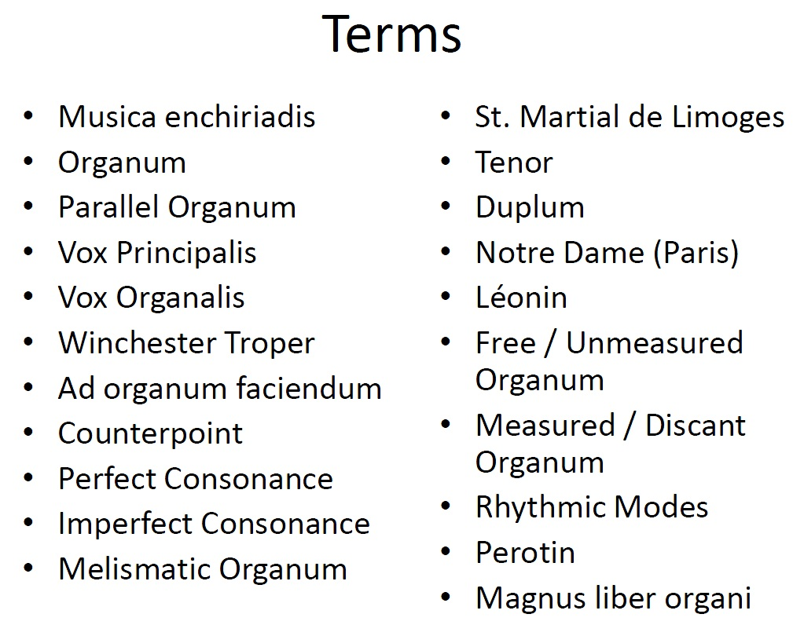

- The beginnings of Polyphony
  - We cant know when poly began
  - Probs best considered as a form of ‘troping’ or ornamenting
  - Books call this ‘vertical troping
  - First written down at the end of the 9th century in a musical instructional book from eastern France: THE MUSICA ENCHIRIADIS (it’s a music theory book)
  - the musica enchiriadis discusses ORGANUM
- ORGANUM
  - Terms comes from the latin which means ‘instrument’ or ‘harmonic working of parts’ like the word: organic
  - First type of organum discussed in the music enchiriadis is PARALLEL ORGANUM
    - Is one voice sings the plainchant melody and another voice isngs the same melody at a fourth or fith (parallel) below
  - Voice singing the plainchant is called VOX PRINCIPALIS
  - Voice singing at the fourth or fifth is called VOX ORGANALIS (is starts out below the principal voice)
- PARALLEL ORGANUM
  - Music enchiriadis also shows how the vox organalis might hold the same pitch as the starting of the vox principalis until it is a fourth or fifth away and the start the parallel motion (ex 2-3 of p 61)
  - The pitch sings used in the example in the musica enchiriadis shows that music theorists are already thinking about stratified pitches (even though the manuscripts from this time are adiastematic) (see p61)
  - One of the first books to notate organum is the Winchester Troper (1000) from the cathedral in that city
  - The troper only happens on the most elaborate and craycray chants, the ordinary chants are left as they are. They like to increase the already really elaborate pieces.

Different Types of Consonance
  - In a later musical handbook: AD ORGANUM FACIENDUM (1100, two rules are established:
    - The vox organalis should always be ABOVE the plainchant (new)
    - The two voices should move in contrary motion when leaping
  - This means we now have two independent melodic lines,, forming intervals at every step : COUNTERPOINT
  - Music theorists must categorize and organize intervals
  - Perfect consonance: Intervals that can be expresses as a ratio
    - Octave, (2:1) fifth, (3:2) fourth (2:3)
    - Important cadences must use these
  - Imperfect Consonance: the third and the sixth

- Melismatic Organum
  - Vox organalis sings many, rapid pitches for one every one pitch in the vox principalis
  - The first place where melismatic organum is sung is the abbey os St. Martial de Limoges (south western France, in a region called Aquitain)
  - S.t Matial de Limoges had a scriptorium and an impressive library were a collection of melismatic organum was housed
  - Melismatic organum is also called St. Martial Polyphony because of this association
  - Codex Calixtinus is a famous sources for the

St Martial Polyphony for Santiago de Compostela pilgrims

Terminology: Tenor/ Duplum
  - Melismatic organum requires that he vox principalis HOLD every pitch of the plainchant until the vox organalkus has finished the rapid pitches
  - The latin word ‘tenere’ means ‘to hold’ = the plainchant voice is called the TENOR
  - The vox organalis because known as the Duplum, above the Tenor

- Notre Dame Polyphony
  - In the late 12th cent, the community around N.D Cathedral in paris invented a new type of organum.
  - Compsoer: LÉONIN
  - Leonin would take responsorial chant and re-write the solo sections organum (and leave the choir sections in plainchant)
  - Two types of organum for Leonin
    - Free/ Unmeasured Organum: the duplum would move rapidly and freely against the plainchant
    - Measured/ Discant Organum: duplum and tenor are moving through pitches at appx the same rate. (this type was usually used to replace melismatic chant passages)
- Rhythmic Modes
  - For measured organum to work, you need to be able to render rhythm in notation
  - In the early 13h cent notes could either be ‘long’ or ‘short’
  - Rhythmic modes are six different ways of combining longs and shorts
  - Each rhythmic mode is made up of a small segment of a rhythm which is then repeated again and again. All pitches are set to that pattern, in the voice part
  - Tenor and Duplum are set to different rhythmic modes
  - Tenor is usually set to rhythmic mode 5

- Adding Voices
  - A younger colleague of Leonin at Notre Dame, Perotin, is credited with adding a third voice (TRIPLUM) to organum
  - Very special pieces for special occasions could get a fourth voice (Quadruplum)

- Notre Dame Polyphony
  - Can be long (some pices are 20 mins or more)
  - Can be complex to sing
  - Was compiled in a book that no logner exists: magnus liber organi (the big book or organum)
  - Is now found prinicapply in four manuscripts which are copies of various sections of the magnus liber organi:
  - F (countaints 1000 pieces was copied in 1245 in Partis, kept in Florence)
  - W1 (contains fewer pieces was copied in France in late 13th cent kept in Wolfenbuttel, Germ
  - W2 ‘’ ‘’ ‘’ ‘’ ‘’ ‘’ ‘’

  - Ma (contains fewest pieces, was copied in Spain, in the late 13th cent, kept in Madrid

- 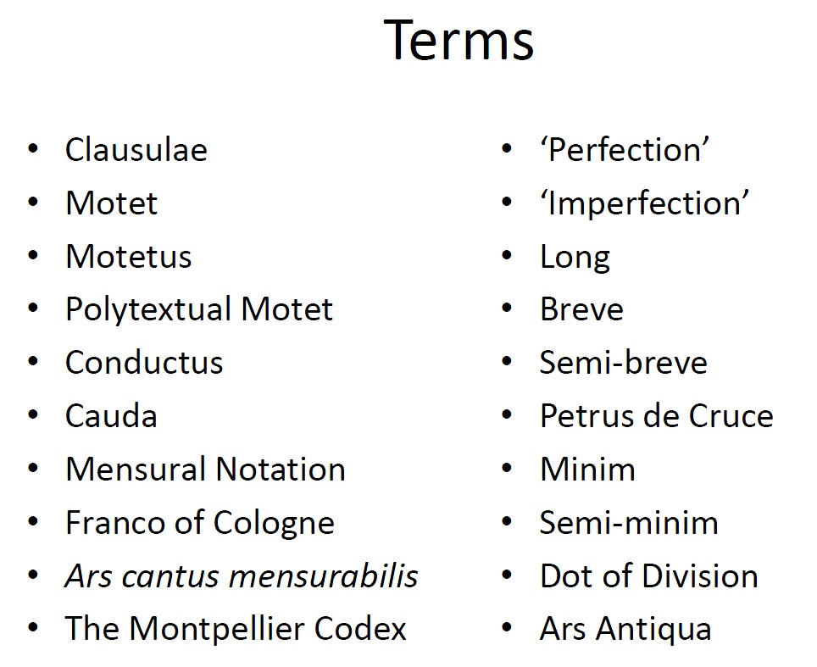

- Further developments from Organum
  - Clausula
    - Sections of organum pieces which were recomposed (in the same style) and substituted in for the original section
    - Composed in discant organum style
    - Some pieces have many different places where clausulae can be used
    - Some pieces have many different clausulae composed for one passage (ie word or several words)
  - Motet
    - The result of taking a longer clausulae on its own and setting a new text to the duplum voice
    - Remember this moment: you are meeting the first secular ( non churchy) polyphony we still have.
    - Motets become popular in the late 12th century and early 13th century
    - Motet = Mot (French for word) because the tests set I the duplum were often not Latin but French (or another vernacular)
    - The term motetus is now used to talk about the duplum voice that has this new text
    - Since the motet is not liturgical music, composers get away with more modifications
    - They modify the tenor (i.e riffs off f its plainchant origins) and then compose new ones altogether
    - When you have two texts going at the same time in different voices, you have POLYTEXTUAL MOTET
    - When those different texts are in different languages (i.e Latin and French) POLYLINGUAL MOTET
    - Text does not have to be secular (sacred)
    - A fairly exclusive art form, appreciated by the educated classes (clerics, noblemen, etc)
    - Sometimes the tenor is left without text. Perhaps instruments played these lines too?
  - Conductus
    - The free compositional landscape just got better!
    - Conductus are pieces which set metric (newly composed) poetry for 1 through 4 voices
    - We have about 200 conducti left to us
    - Polyphonic conducti move at a note-to-note- pace, but are not bound to measured , rhythmic modes like organum, clausulae or motets were.
    - Conducti have a a flourish at the end called a ‘cauda; (from Latin for ‘tail’ our ‘coda’
    - Most likely used as processionals for priests going to and from masses up to 1300 Ad
- Mensural Notation
  - The old system of Rhythmic Modes wasn’t working
  - Franco of Cologne wrote a book, proposing a new system of nation to indicate rhythm
  - Franco’s book, Ars cantus mensurabilis (written: 1260-1280) gives us note-shapes which indicated relative durations
- Franconian Notation
  - Three types of notes:
  - Longs:
    - can be divided into two or three
  - Breves
    - From ‘brief’ which can be divided into two or threes
  - Semi- Breves
    - The ‘tempus line (time) is connected to the duration of the breve
  - FOR ALL OF THESE, there is ALWAYS a triple feel.

  - If a long is divided into three Breves, thaty is a PERFECT TEMPUS
  - If a long is divided into two Breves, that is IMPERFECT TEMPUS
  - That is NOT a question of triple vs duple. The longs Is ALWAYS a triple feel
    - If there are only 2 breves, then the first one will be 1/3 of a long and the second with me 2/3 of the long
  - THE FINAL NOTE MUST BE PERFECT: A DIVISION OF THREE!!!!

- Reading Mensural Notation
  - Longs have stems

- Petrus de Cruce
  - In 128-, petrs refines franco’s system
  - Add twi smaller durations
    - The Minum (which could be one third or ONE HALF of the semi-breve)
    - The Semi- Minum (which could only ever be ONE HALF)
  - This gives us the ability to notate duple time
  - His ‘Dot of Division’ helps to calirfy what is a perfection (place the dot to the right of the group)

- Ars Antiqua
  - Even though the 13th century saw many new musical developments, it’s nothing to what’s coming coming
  - A generation after Mensural notation, and Conducti, musicians were referring to this music as ‘ars antiqua’ or the old art, as opposed to their ‘ars nova’ (new art)
- 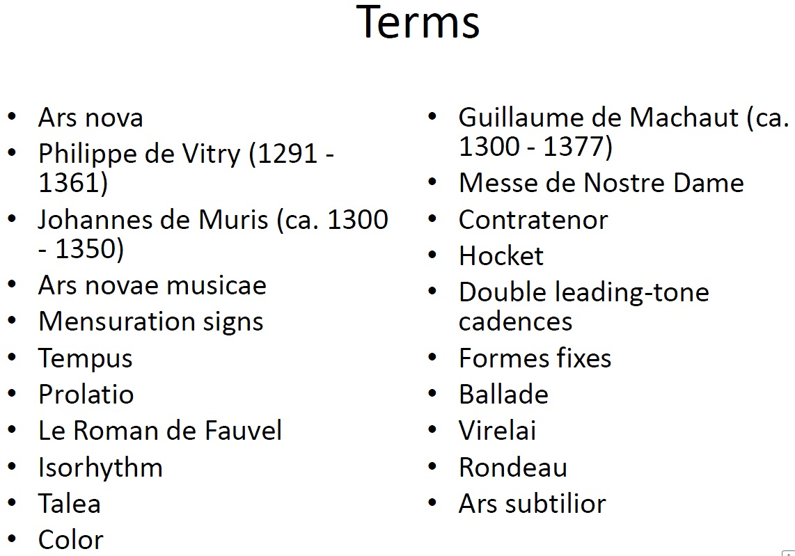

- Ars Nova
  - The new art style

- Main composer:
  - Phillipe de Vitry
  - De Vitry treatise on the style is called ars nova
  - It’s a new rhythmic style

- Johannes de Muris (ca.1300-1350)
  - Also wrote music theory treatise: ars novae musicae (the new art of music)

- What is ‘ars nova’?
  - Increased use of the minum and semi minums
  - Duple meter is as legitimate as triple
  - Imperfections created y notes not ‘next’ to each other in rhythmic value (i.e minimum imperfects as a breve, etc)
  - Using red ink (colouration) to imperfect a note value (makes it a third faster)

- Mensural Signs
  - Circle / Half circle:
    - Indicates how many semibreves in a breve.
    - Circle 3 perfection
    - Half Circle: 2 (imperfection)
  - Dot/ No Dot
    - Indicates how many minims are in a semibreve
    - Dot: 3 (major)
    - No Dot: 2 (minor)
  - The TEMPUS correspomnds to semibreve-breve ratio (ie circle/half circle sign)
  - The PROLATIO corresponds to the minim-semibreve ratio (ie dot/no dot signs)
  - See page 76 example 3-1

- The Roman de Fauvel (1316)
  - Satirical allegory about a donkey who rises fro the stable to be a ruler of a noble household
  - One of the 12 manuscript sources for this includes MUSIC
  - Some of this music was probably written by Phillipe de Vitry himself
  - Garrit gallus / In nova fert/ Neuma is in the Roman and is also used on de Vitry treatise
  - Relevant because it has music, n’okrrr?

- Isorhythm
  - Used between 1300-1450
  - Iso=same
  - Talea: rhythmic pattern, repeated through the voice part from start to finish
  - Color: melody usually repeated, not necessarily the same length as the talea

- Another rhythmic complexity
  - To reduce note values by 1.3, write them in red ink
  - When this happens in garret gallus, the modern edition switches from ¾ to 2/.4
  - This reduction of perfections to imperfections is an ideological problem for some

- Messe de Nostre Dome
  - The first through composed Mass (ordinary() by one composer, meant to be performed at the same service
  - Other earlier examples of this are mostly complications from cathedrals such as Toulouse or Barcelona.
  - Guillaime de Machaut (ca. 1300-1377) composed this mass in the 1360’s
  - All movements are based on a plainchant version of the melody
  - A contratenor (against tenor) voice is introduced int o the same range as the tenor =four voices for harmony /voice leading
  - Technique: Hocket (latin for hiccough) where one voice stops and another starts over short passages
  - Tenor/ contratenor are isorhythmic

- Double leading tone cadences
  - A popular sonority at the end of the 14th century polyphonic works
  - Sharp 7 to one, sharp four to five
  - Remember we don’t have major or minory keys yet
  - See ex 3-6 on p.81
  - These cadences are found in machaut’s meese de nostre dame

- French Secular Song
  - Thee types of forms fixes (fixed forms)
  - Ballade
    - Musical form AAB=refrain (music not text)
    - Each A or B section might set 2 or 3 lines of tet which have an ab or cd rhyme scheme within
    - Example in text aba b ccd +refrain
    - As A A A Refrain
  - Virelai
    - Musical form: AbbaA
    - Major difference between this and the ballade: the refrain is sung at the beginning AND ending of each strophe
    - Many virelais are monophonic, but could have been harmonized or accompanied by instruments
  - Rondeau
    - Music form ABaAabAB
    - The refrain AB is at the beginning and the end, and a half A in the middle
    - Sets eight lines of text
    - Example : machauts ‘Ma fin est mon commencement’
      - The cantus and the tenor are retrogrades of each other and the contratenor reverses itself halfway through the piece

- Ars Subtilior
  - Meaning ‘more subtle art’ more than the ars nova style!
  - Also referred to as the mannerist or mannered style
  - Characterized by
    - Special notes shapes with particular rhythmic meaning for one piece alone
    - Colouration and half coulouration
    - Verbal canons
    - Notations with double meanings

- The Great Schism
  - Ars subtilior style is connected culturally to the period the the great schism when there was more than one pope in eurpoe
  - The are subtilior composers were often employed the avignnon papal coutrs

- 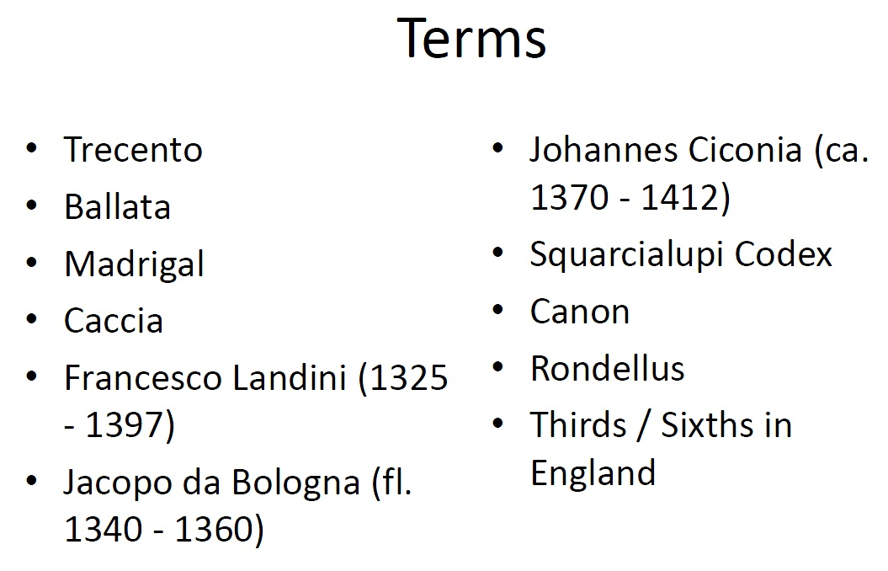

- Trecento:
  - In Italy in the period of ARS NOVA music in France, there was ‘trecentro’ music
  - Trecento=thirteen hundres

- Trecento Secular Forms
  - There are three secular song forms in the Trecento:
    - Ballata
      - Similar to French Virelai (not the Ballade)
      - Musical from AbbaA
      - Little a is the refrain with different words.
      - Refrain at both beg and end
      - Polyphonic
      - Landini comoised 140 of them, including ‘ecco la primavera’ from the listening list. (Blind Florentine organist)
    - Madrigal
      - First a literary poetic form, THEN set to music
      - Music form: 2 or 3 strophes (Each with three lines) plus two line ritornello (refrain) at the end of the whole piece
      - Usually written for two voices
      - Don’t confuse this with the 16th century Madgrical coming up later
    - Caccia
      - Three voice song
      - Upper two voices are in canon, over an independent tenor
      - Many end with a ritornello (refrain)
      - Depict hunting scenes or market scenes
      - Caccia=chase
      - Isorhythm is not just a French thang, n’okrr?

- Composeres of the Trecento
  - Francesco Landini (1325-1397)
  - Jacopo da Bologna (fl. 1340-1360)
  - Johannes Ciconia (ca. 1370-1412)

- Squarcialupi Codex
  - The largest and most important source for the 14th cent Italian Music
  - Beautifully decorated with images of the composers whose works are contained in the is collection
  - Giant book and full of gold

- England
  - WE don’t really have one term to sum up what was going on here soooo
  - England ins more remembered for a certain sonority:
    - Thirds
    - Sixths
  - Sumer is icumen in
    - The canon summer is icumen in’ was probs written around 1250 and is the oldest canon we know of
    - Form: two upper voices in canon (rota) over a two part rondellous (ground) which switches parts continually, providing a sont of harmonic drone
    - Another ex: Edi be thu, heven-queen (on listening list) listen to thirds and sixths
- 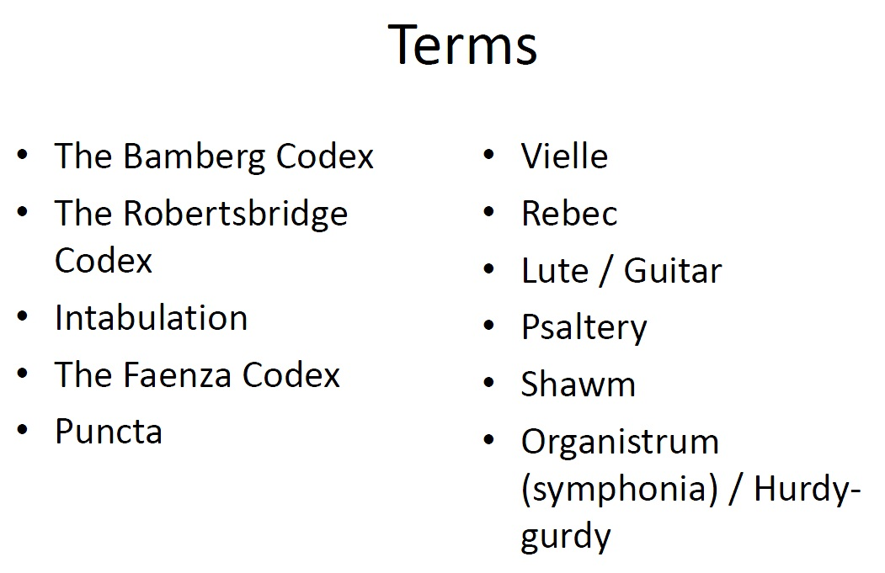

- What is ‘instrumental’:
  - It is difficult to say where purely instrumental music existed on its own for most of the middle ages
  - Instruments usually: doubled vocal lines, played with signers, accompanied or substituted for particular vocal lines in motes etc.
  - Also used for processions/battle calls/dances<- Mostly heard when

- Questionable Nature
  - The mysterious power of purely instrumental music (first seen with the greeks/romans) is not totally welcomed in the church
  - The purpose of vocal music is to communicate the sermon, and remembering liturgical text. Instrumental music can’t do that (has no purpose)
  - Music which does not ‘produce’ anything is questionable in its moral qualities
  - However, a lot of church iconography (carvings paintings etc) show instrumentalists accompanying singers in church (vielles, rebecs, lutes, bells, trumpets etc)

First Instrumental Notation
  - First: late 13th century intexted hocket passages in the The Bamberg Codex
  - Second: around 132, several folios of intabulation for motets in the Roman de Fauvel are found in The Robertsbridge Codex
    - Intabulation: Keyboard/ Stringed instrument reduction of vocal work
  - Third: early 15th century Faezna Codex contains 96 folios of intabulation of dances, Mass movements, chansons, and madrigals

Dance music: Puncta
  - Puncta are short sections of a piece that are repeated immediately one after the other
    - They can be ornamented the second time they are played
    - They have first and second endings (open and closed)
  - This structure reflects the structure if the dance they would accompany
  - (think the macarana) a herp derp

- Instruments to know:
  - Stringed instruments
    - Vielle (longer than a violin and a ‘drone string’
    - Rebec (pear shaped, quiet, nasal sounding)
    - Guitar (stolen from the crusades aka the halla hallas)
    - Lute (^)
    - Harp: (duh)
    - Psaltery: (a box, with bronze strings stretched over it, that you pluck, like a small box guitar)
  - Wind Instruments:
    - Shawm (predessor to the Oboe)
    - Recorder (duh)
    - Flute: (Pan pipes, etc)
    - Trumpet: (no valves, finger holes)
    - Slide Trumpet:(almost a trombone)
  - Percussion
    - Bells
    - Cymbals
    - Timbrel
    - Tambourine
    - Drums
  - Key Board
    - Organ
    - Organistrum / Symphonia (ie the hurdy gurdy)

  - Instruments were ‘high’ (loud) and ‘low’ (soft)

- Listenings
  - Epitaph of seiklos
    - sitar, the fist notated piece in recorded history
    - Unknown composer
  - Plainchant
    - Sequences were played on feast days to highten the occasion (aka easter)
    - Mostly syllabic, often repeated melodic lines by twos
    - Prosulas added to alleluias (the jubulus)
    - Type of trope (addition to text or music with more music and text)
  - Atiphone: pacciem relinquim vobis/ psalm 116:
    - The recitation Sung before or after another chant
  - Plainchant hymn
    - Pange linguia
    - St. thomans Aquinas in the 13th century
    - Hymn is a chant where a poem is strophic music
  - Hildegard de bingen
    - Ordo virtutem
    - A play set to music where the virtues are tempted by the devil and beat him and get into heaven.
    - This was a play for those who didn’t go to church the virtues.
    - Technically the first opera
    - CHURCH BELLS IN DIS ONE!
  - Beatrize de dia
    - A chanter
    - The only female troubaritz who has work in existence. ‘
    - GUITAR is in dis one!
    - Jigh voice toooooo
  - Elfanzo elsabio
    - Santa maria das dadas sejanloores
    - Part of a group of songs, 400 poems set to songs about miracles attributed to the virgin maria.
    - King of castil and leon
    - Possible arab influence.
    - Its in portugese
    - Catigas (set of 6 songs by martic kodax)
    - There is a guitar in this one too, jaunty
    - Multiple women.
  - Walther von der Volgelweide
    - Palastinalied
    - Describes the feelings of a crusader in Jerusalem
    - Syllabic text in bar form AAB
    - Arabic sounding, with a baritone, melismatic
    - Sounds like a violin
  - Anonymous 4
    - Cunctipotens Genitor
    - Harmony open fifths-evenescence
    - Lotr reference
    - IS A GROUP! PERFORMERS
- TERMS
  - Melos- the melody,music, and words
  - Roman empire, no notated music in this empire, but they do have cornu- up until 4th cent A.D
  - The byzentune: monks on islands
  - Music of the sphere’s: the music of the planets – music mundana
  - Doctrine of Ethos: music and it’s power over the soul
  - Theory of practice: looking at music as math, not just ratios.
  - Liberal Arts: Trivium (grammer, Rhetoric and dialectic) and Quadrivium.(music, geometry, astrology, arithmetic)

2nd Lecture

Medieval: the ‘between’ meaning the middle of the enlightenment and the renaissance. Also known as the dark ages
  - Charlemagne: or big Charlie lived from 8th centiury, was king oof the franks, crowned on Christmas day by Pope Leo. Was the first Holy Roman Emperor.
  - Holy Roman Empire 9th century
  - Feudalism: used in france by the normans, it’s the higherachy. There is a leisure class, where music comes in.
  - Courtly love: time for chivalry . Troubadouers contributed to this. Women have power with dem titties.
  - Crusades: religiously motivated war over Jerusalem. The number zero was invented. 11th and 12th century There was the guitar
  - 100 years war: England and france fight over territory for 100 years. 1337-1453
  - Black 1348-1350. (14th century) 25-50 million people died. Killed lots of people, spread by rats and fleas.
  - Papal schism: multiple popes, the Avignon papacy, and roman popes. They wanted to have the papal state in france.
  - Gothic: emphasis on height, light and make you feel inadequate in the eyes of god.
  - Scholasticism: reason AND faith
  - Boethious: executed because he was an alleged spy. Music of the spheres.
  - Plainchant mass for Easter Sunday: sequences were performed for important masses to heighten the occasion. It’s syllabic so you can remember the words.

- 3rd Lecture
  - Plainchant: same as Gregorian chant, mono phonic. Sacred purposes.
  - Litrugy: body of texts and actions prescribed for Christian worsip
  - Eaucharistic mass: renacting the last supper
  - Chant types:
    - Roman chant
    - Ambrosion- Milan and northin Italy named after bishop Ambrose.
    - Gallican: franks and gulls. In france ans western Germany.
    - Visagothic: Iberian Peninsula
  - Pope Gregory I wrote Gregorian chant. Came from a dove (7th century)
  - Mets and St. Gall: Singing schools that taught chant Transmission
  - Memory: since chants were memorized by monks for intense devotion of the texts in explants why notation was so slow to develop
  - Neumes: early form of notation
  - Unheightend /non heightend/non diastematic
    - These are neumes that say the relative relationship of notes according to their vertical placement on the page.

  - Atiphone: pacem relinquio vobis/ psalm 116:
  - The recitation Sung before or after another chant
- Lecture 4
  - Mode: 8 scales that are different from each other in their intercalic relationships
    - Mode 1,3,5,7 are authentic
    - Mode 2,4,6,8 are plagal
    - Mode 1 + 2 D is final
    - 3+4 E is final
    - 5+6 F is final
    - 7+8 G is final
  - The divine office: found in the antiphoner
    - Matins (3am)
    - Lauds (sunrise)
    - Prime (6am)
    - Terce (9am)
    - Sext (noon)
    - None (3pm)
    - Vespers (sunset)
    - Compline (before bed)
  - Canticle: hymn or chant typically a biblical text forming a regular form of church service.
  - Mass
    - Ordinary mass is unchangeable, it happens everyday
    - Proper is changeable: the words can change to heighten occasions you can use melismas and ornamentation
    - READ PLAINCHANT SLIDES AND TERMS
  - Liturgical year: follows the bio of Christ. Starts with advent, the Christmas, the epiphany, lent, easter, Pentecost,
  - Abby of solesmes: northern france, monks begin to recover early forms of the chant. By carefully comparing notation preserved in early medieval manuscrpits. Soon recognized as the official chant books of the roman catholic church.
  - Gradual: contains complete chants for the mass, both ordinary and proper
  - Antiphoner: the liturgical book containing the the texts of the mass proper, and if notated, the chant
  - Liber Usualis: the book of use. Anthology of may dif types of plainchant, both for the mass and the office.
  - Syllabic: one pitcher per syllable
  - Neumatic: 4-5 pitch per syllable
  - MEllisamtic: 5+ pitches per syllable. –sung responsorally
  - Recitation tone: pitch
  - Cadence: duh fuckigbn duh
  - Psalm tones: one for each mode, plus the tonus peregrinus, consists of opening patterns, recitation section closing cadentrail pattern.
  - Antiphone: type of plainchant, sung before and sometimes after the recitation of a psalm or other type of chant.
  - Hymn: setting of a sacred, but non liturgical text, usually strophic and predominantly syllabic
  - Authentic modes: any melodic modes within and ampitus (range) running an octave above the final note

Plagal: ‘’ ‘’ ‘’ ‘’ ‘’ running a 5th above, and a fourth below the final note

Hexachord: a group of six pitches (do-la) the semitone always falls between me and fa. There are three types.
    - Hard-B nat
    - Soft Bb
    - Natural- doesn’t have B
  - Gammit: the entire range of ptithces available to the midieval composer made up of 7 interocking hexachords . Comes from greek G, and medieval ‘do’
  - Hexachord mutation: when modualating from one note o the next. Hexachord mutation s required for sight reading a chant that went beyond 6 notes.
  - Music ficta: convetion of the late medieval and renaissance era. In which certain notes were sharpedn or falttend in performance according to daaoris convetions such as creating Cadential leading tones, or acovicedng cross reltations between voices
- Listening
- Matching- centuries and people
- Multiple choice
- Fill in the blank
- Short answer

- Know the names of forms, know which has a chorus at the end, the begin and end.

- ISORHYTHMIC MOTET: 14th cent, :PEOPLE: DE VITRY, WORKS: GARRIT GALLUS

- THE DIVINE OFFICE> KNOW DAT SHIT

- ORDINARY AND PROPER MASS, which is the one that happens all da time
- Ordinary happens al da time, obvi.

  - ARS SUBITILIOR:
    - A highly refined mannerist style which its complexity contributes to its definition
    - ISORHYTHM
    - SYNCOPATION
    - AUGENMUSIC

ISOMETRIC MOTET
  - Machaut-messe de nostre dam
  - De birty – garir gallus
  - Dufay-nuper rosarum flores

Jeopardy
  - Pope greg 1:
  - 1900 page book of chant by monks: Liber usualis?
  - Hand mneumonic device belonged to: guidonian hand
  - Antiphone is sung after or before the regular plainchant-pachen relinquo
  - What are neumes
  - Macho- the suitor, 14th century. Wrote lots of motets and ballads
  - Garret gallus- jaunty tune by De Vitry
  - Papal Schism- more popes being cray
  - No French neums, only roman. Roman, not Avignon.
  - Notker made melismatic chants easier to remember. He’s a monk of st.gall
  - Notre damn school. Leolin and
  - Fringe of society, 12^{th an} and 13th century counterparts to troubadours of aristocratic music makers. = janclair
- None =
- 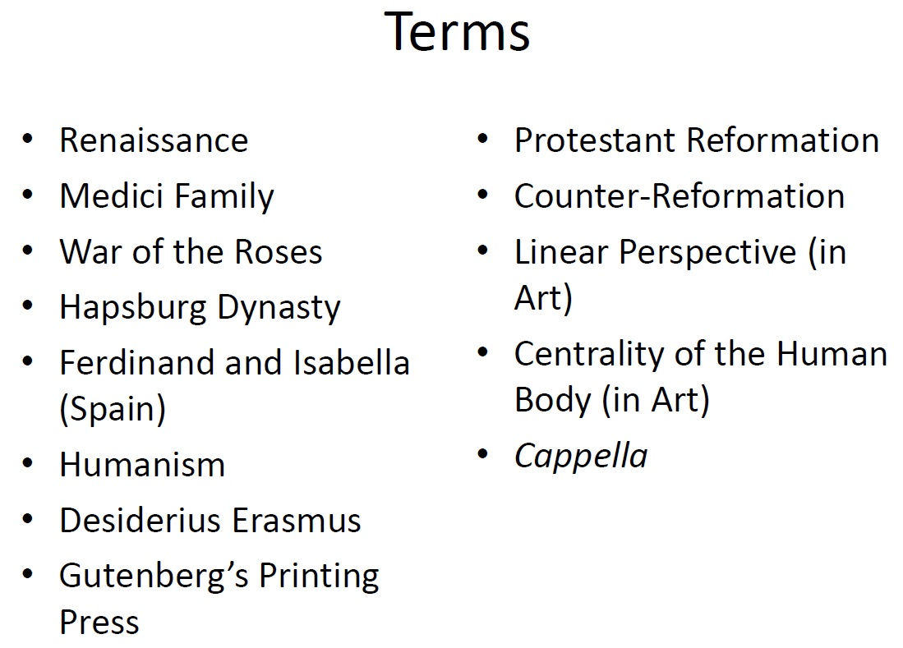

- Renaissance:
  - ‘rebirth’ of the culture of Greek antiquity in tow western culture (Greek texts being read again)
  - between 1420-1600
  - academic rebirth through relearning the Greek texts
    - extra texts come to the west when Constantinople (Istanbul) falls to the Turks in 1453, as many refugees flee
  - Financial strength comes to cities through trade increases between merchant towns. Banks and insurance companies are born from this.

- Florence
  - Most famous renaissance city with wealth and culture.artistic elites
  - Cosimo de Medici (1389-1464) used his wealth to influence politicians in the city (had the biggest library in Europe)
  - Grandson, Lorenzo de Medici, continued this.
  - The Medici family contributed to the arts in the city too
    - Founded the platonic Academy (modeled on and ancient Greek from Plato’s time)
    - Oatric of many artists sculptors, musicians.

- The Low Countries
  - North of the alps, cities that were centers of trade also became centers of wealth and culture
  - Mostly trading
  - Trade cities became places for cultural cross pollination
  - Important cities:
    - Antwerp
    - Ghent
    - Touranai
    - Liège

- And in France….
  - The 100 year war s over and France has won!
  - They’re tired but they’re even more French than ever

- Meanwhile…in England
  - The war of the Roses (betsween the houses of York and Lancaster) is decided at the Battle of Bosworth Field in 1485
  - Henry Tudor (later, Henry VII) beats Richard III
  - Tudors control England until 1603

- Holy Roman Empire
  - The Hapsburg family, who rule Germany, Austria, and northern Italy are gaining ground
  - Maximilian I marries Mary of Burgundy in 1477, gaining Burgundy (rich)
  - Later, in the 16th century, another Hapsburg (Charles V) will expand into Spain, Portugal, and the Low Countries

- Nobody Expencts the Spanish
  - Ferdinand of Aragon and Isabelle of Castille get married in the 15th century and rule spain.
  - 1492 is a busy year: they conquer Granada for Spain (pushing out the Muslims) and they fund Christopher Columbus
  - They are also responsible for expelling all Jews who refused to convert to Christianity, when they were found by the Spanish Inquisition (convert jews)

- Portuguese Navigators
  - Money and power backed many explorations to find quicker routes to Asia by the Portuguese
  - Manuel I, King of Portugal, built a monastery for the explorers to spend their last night in Portugal, praying for safe passage
  - Ferdinand Magellan, sailing with the Spanish fining, was the first to circumnavigate the globe in 1519, but died in the Philippines on his way back

- Humanism
  - Philosophical movement which places the HUMAN at the center of all things
  - Human measurements, values, rationale, becomes the ultimate reference
  - Characterized by room for scrutiny/skepticism
  - Empiricism (observation on human experience) /experiment is encouraged
  - Breaks away from Scholasticism, where ‘glossing’ ancient texts is used to gain new understanding.
  - Talks about human experience, you are a humanist. When you explain life as god and his universe, that is medieval. It doesn’t mean that humanists are not religious, because they are. N’okrr?

- Humanists to know
  - Lorenzo Valla (ca.1407-1457) researched the ‘donation of Constantine and found that this documented had been forged in the 8th century, and was not original with Constantine (4th c)

  - Desderius Erasmus (1466-1536) was a priest who nevertheless championed skepticism and inquiry into everything. Held to the Doctrine of Free Will (when when Protestants challenged it with Predestination)

- Literary Renassance
  - At the turn of the Medievel/ Renaissance period, you already have great authors choosing to write in their own language, and not in latin
    - Dante, Boccaci, Chaucer
  - Johannes Gutenberg’s Printing Press in Maiz, Germany in 1455 causes a revolution in the way information is handled.
    - By the end of the 15h century, 6 million books have been produced
    - First printed music: Venice, 1501

- Protestant Reformation
  - Scene: Wittenburg castle chapel door, 1517
  - Character: Martin Luther (1483-1546)
  - Problem: The roman catholic practice of selling indulgences
  - Solution: Protestant Reformation
  - Side Kick: Printing Press
  - Catholic Response: Counter Reformation

- Renaissance Art
  - Two main developments in painting and sculpture:
    - Linear Perspective, creating depth on a 2-dementison surface (this began in Italy and the Low Countries
  - Focus on Human Body and the perfection of all the proportion and technical genius. (think: da Vinci studies on the body, from an artistic and scientific perspective

- Music in the Renaissance
  - Happning in two places
    - Secular courts in cities where power and watch had been accumulated would have groups o musicians called the ‘cappella’ (little church/chapel) 12-20 instrumentalists and singers) (singing something a cappella means to sing it like you were in a church, without instruments) to entertain at banquets and sing / play in the court chapel
    - The church (catholic mostly) which was sponsoring settings of the Mass Ordinary and moments, Etc. for Their services and keeping composers on staff.

- Music’s Place
  - Music begins to be an essential grace for nobility
  - Properly educated gentlemen (and women) were supposed to be able to read, play, and sing music
  - This elevation mostly comes from Music’s place in the Greek work. Where it represented the movements of the universe, the proportions of man, as well as audible music to affect the emotions.
  - Henry the 8th was a composer, who knew?!

- 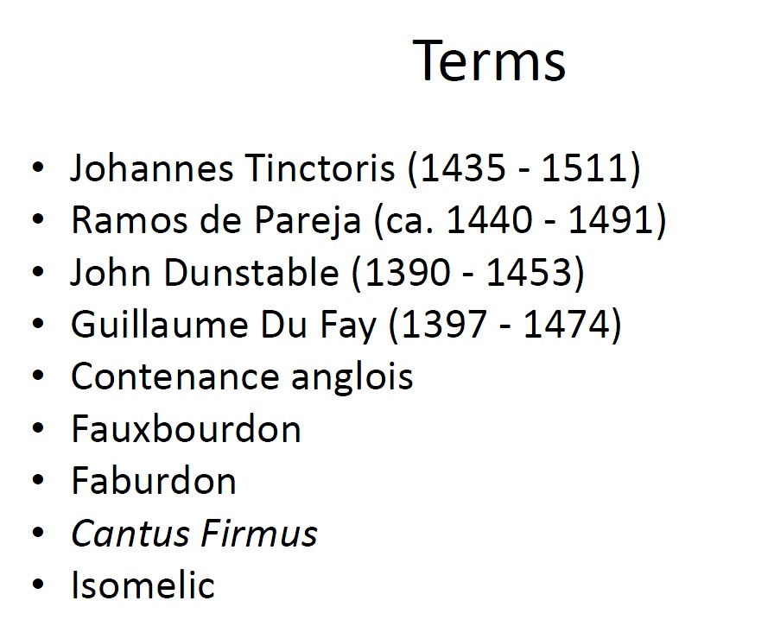

- Renaissance Inferiority Comples
  - The renaissance composers/ theorists lived in the shadow of what they thought was the great music of the ancients
  - But, if music was great, that means hearing that as a great, not just believing it was (Empiricism)
  - Humanists had to experience this music to think it was great, not because they are told it’s great. The proof is what we experience
  - Brings up questions about consonance, they are not happy about consonance as a ratio.
  - They want to experience consonance with their ear, if it sounds nice, they call it consonance

- Judgement Call
  - Johannes Tinctorius was a great music theorist and composer of the new renaissance style. Dismissive of medieval music
  - Ramos De Pareja another theorist, suggest that if the ear couldn’t tell that the third WASN’T a consonance, then it SHOULD be one. Pareja was an enemy of the church, because he was an enemy of Guido.
    - Major third: 5:4
    - Minor third: 6:5

- The New sounds: Contenance Anglois
  - The ‘contenance anglois’ (the English guise) is made up of a lot of thirds, instrad of fourths and fifths
  - John Dunstable (an Englishman) who works in france most of his life) write with this sonority
  - Example: Quam Pulchra Es

- On the Continent
  - Guallume Du Fay (franco-flemish composer) wrote in this new sonority too, with a technique called FAXBOURDON
  - Fauxbourdon = false bass
  - The fauxbourdon line is a melodic line funning parallel to an upper melody line, at a fourth below it

- English Equvalent: Faburden
  - The English take a melody line ma and then add a line a fourth higher and then one a third (or fifth) lower
  - This leans to a lot of triads in first inversion

- Nuper Rosarum Flores
  - Du fay wrote this for the celebration of Brunelleschi dome on the Florence cathedral (completed in 1436)
  - Tenor theme: Introit chant ‘terribilies est locus iste’ (awesome is this place) (also known as the Cantus Firmus)
  - Tenor II has this theme a fifth up with a different isorhythmic pattern
  - Two tenor lines mirror the inner and outer layer of the dome
  - Term: that theme is the chant is called the canuts firmus (fixed melody)
  - Proportions for cantus firmus in the tenor I line are 6:4:2:3 which are the same as the Florentine cathedral (and solomons temple in the bible)
  - Numbers 4 and 7 are also prominent
    - Text is four strophes of seven lines
    - Music has 4 sections each of which have a duration of 28 breves (4x7 = 28)
  - The sonority of TRIADS
  - Even if the Tenor on the bottom, doesn’t always have the bottom note sounding whatever voice DOES have the bottom note usually has the bottom triad
  - The repeated melody which gets embellished upon repetitions is an ISOMELIC technique (iso = same Melic=melody)
- 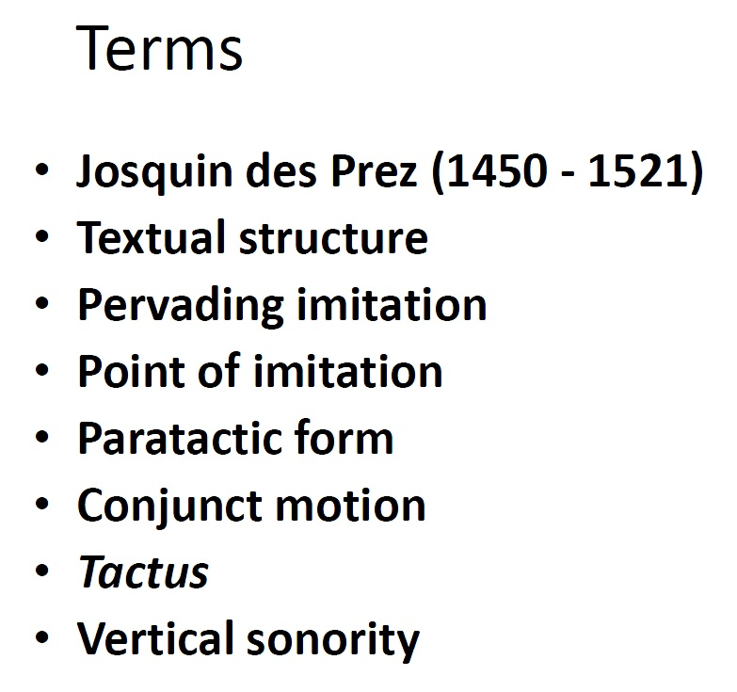
- Josquin Des Prez (ca.1450 – 1521)
  - Ave Maria (the Mona Lisa of Renaissance music) he uses this piece as a ‘poster child’ for fine music
  - 5 Sections (after the five important feats for the Virgin Mary) plus salutation and petition
  - Josquin’s Bio: p. 116-7 in text book
  - Terms all exemplified in his work
    - Textual Structure- creating a musical structure according the text you are setting
    - Pervading Imitation- all voices state a musical idea, imitationg each other
    - Point of imitation – the thing that is being echoed
    - Paratactic form – form that states something, then goes on to state something else and continuing.
    - Conjunct motion – stepwise motion
    - Tactus – the beat (sort of) you don’t hear 1 ,2 ,3 ,4; it’s a PULSE.
    - Vertical Sonority – harmony as a vertical motion in time. Not a harmony of 2 or 3 melodies.

  - Josquin was a verrrry famous composer. His last name isn’t actually Des Prez it was a nickname. WHO KNEW?!
  - TOTAL QUEEN

- Sacred Vocal Music
  - Time period from 1420-1520
  - Major musical development: Cantus Firmus Technique
  - Two types of Sacred vocal music
    - The Mass
    - The Motet

The Mass
  - Cyclic Mass: a setting of all five components of the Ordinary of the Mass by one composer which are unified musically
  - It is now about musicality, not liturgical purposes.
  - The first composer of cyclic masses:
    - Leonel Power (d.1445)
    - John Dunstable (1390-1453)
  - How did the composer unify the mass movements musically?
    - Cantus firmus

  - Cantus Firmus: a melody line that is used in at least one voice part repeated several times throughout the work.
  - Guillaume Du Fay: the first composer to use a Cantus firmus in two new ways:
    - Take a secular songs melody
    - Put the cantus firmus in the tenor, but put a lower voice underneath the tenor line
  - Result: Missa Se la Face Ay Pale

Canons:
  - A canon at the beginning of a mass is an instruction from the composer about how the cantus firmus is to be sung
  - Canon = rule or law
  - These are typically rhythmic instructions
    - Example: sing the cantus firmus thought twice, the second time doubling the length of each note.

- Head Motif
  - Along with the Cantus Firmus in the lower voices, in the upper voices, there are repeated melodic lines
  - These are ideas that are stated at the beginning and then developed throughout the piece
  - These are head motifs

- The Canonic Mass
  - Build voice parts on the technique of a canon (or round)
  - This is often done with the cantus firmus
  - Example: Ockeghem’s Missa Prolationum (cd 2:12)
    - There are four voices but only two are notated
    - The other two are supposed to be cans with the notated voices
    - Voices go at different prolations
    - Canons at various intervals

- A famous fantus firmus melody
  - Over 20 pieces of music have been based on the ”l’homme arme” tune
  - Many prominent Renaissance composers wrote a Miss L’homme arme (busnois, Okeghem, Tinctoris, Josquin etc)
  - Possible political reasons for the popularity of the tune?

- How to get your Cantus Firmus
  - Various ways of coming up with a melody
  - One interesting way which Josquin Des PRez likes is the “soggetto cavato” = carved subject
  - Using the solfege syllables that sound similar to the name of his patron, he makes his Cantus Firmus:
  - Her-cu-les Dux Fer-ra-ri-ae
  - Re-Ut-Re Ut Re-La-MI-RE

- The Imitation Mass (parody mass)
  - These incorporate all voices of a pre existing work into at LEAST at the beginning of the mass
  - Sometimes the incorporation is woven all the way through
  - CD 2 tr.13/14
  - Very popular technique at the beginning of the 16th century
    - Palestrina wrote half of his 104 Masses as parodies
    - De Lassus used the technique in about 2/3rds of this 74 Masses
- The Paraphrase Mass
  - Same principals as the Imitation Mass (or ‘parody mass’) but less strictly implemented
  - Themes is loosely based on a pre-existing theme, but sometimes difficult to see all the way through the piece
  - These can by cyclic and can have a cantius firumus

- The Motet
  - Prayers set to music
  - (biblical poetry, poems from the bible, or liturgical text set to music)
  - Normally 4 or 5 vocal parts, all singing the same text (now)
  - All the same language
  - Composed using any of the same techniques as the masses

Three Types of Motets
  - Liturgical: setting texts from the Proper of the Mass (a lot of offertory text)
  - Devotional: Writing compositions to be sung at meetings of fraternities or other social groups
  - Occasional: sommisioned for a special event (ex the completion of the Florentine dome, the death of a member of the royal family etc)

- Absolon Fili Mi

- 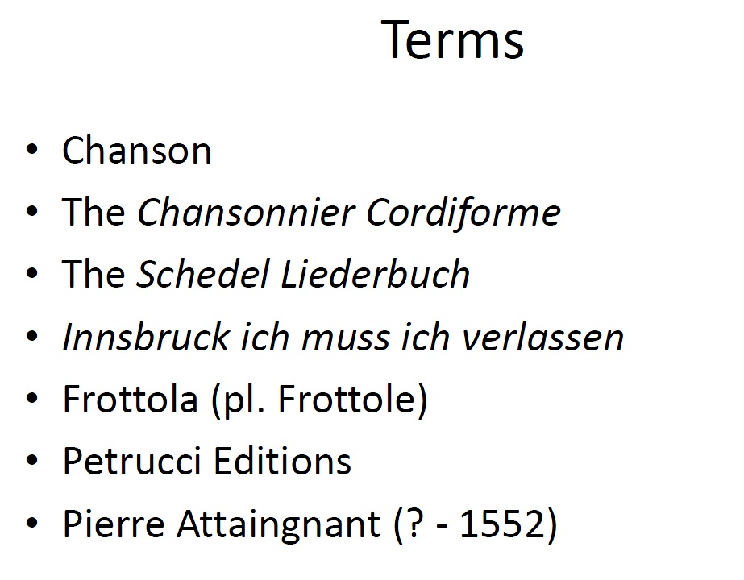

- 1420-1520

- Sources for the 15th/16th century Secular song

  - Very few musically noted sources
  - Some famous ones mentioned on pg 130
  - Only about 20 books in the whole world
  - However secular song was very popular
  - Performed by memory, improve etc
  - Secular music doesn’t have things written down because of illiteracy with the poorer people.
  - Comparable to 20th century music and jazz fake books.

- The Chanson (france)
  - The is a continuation of the ‘forme fixes’
  - The form which takes over popularity is the RONDEAU
  - Du Fay’s Adieu ces bons vins de lannoys
    - Top voice has text
    - Top and bottom voices are paired
    - Inner voices are fillers

- The Chansonnier Cordiforme
  - The most famous collection of Chansons
  - Compiled in Savoy (n/w Italy and s/e France)
  - 1470-1477
  - Contains works by Busnois, Du Fay, Dunstable, Hayne and Ockenghem
  - ‘song book in the shape of a heart’

- The Shedel Liederbuch
  - A song book for personal use
  - Owned by Hartmann Schedel
  - 1460s
  - Schedel became a famous author (the Nuremberg chronicles) so his book collection was taken by the Bavarian state library in Munich

- Popular Chanson Tune: Innsvrucj, Ich muss dich lassen
  - Heinrich Isaac set this tune twice in different chansons
  - He also set it as the fantus firmus in his mass, Missa carminim
  - Tune was so pop it was used as a Lutheran choral hymn, and back used it twice (in a cantata and in the St. Matthew Passsion)

- Frottola (pl. Forttole)
  - Italian
  - Appeasrts in the late 15th centuty
  - Challenges the Chanson for popularity
  - Main differences from the Chanson:
    - In Italian
    - Poetry could be freely structures (sometimes still structured)
    - Themes were frivolous about animals etc. Not about heart break, love etc
    - Up beat rhythms to make you want to dance
    - Include: HEMIOLAS

- Ottaviano Petrucci (1466-1539)
  - Major publisher of printed music in Venice
  - Invented a system where music was printed in three steps
    - First: the staff lines
    - Second: the text underneath the staff
    - Third: the notes on the staff (lined up with the text)
  - Example of Petrucci Edition on pg 141

- A New techniqiue: Pierre Attaignant
  - In the 1520s a new tech for printing music is invented
  - Pierre Attaignant (d.1552)
  - His segments of moveable type have both staff lines and a not on it so you don’t have to print staff and notes separately
  - This is faster, although it doesn’t look quite as nice

Frottola : el Grillo
  - Written by a Josquin (not sure if its des prez or the other one)
  - Written to imitate the sound of a cricket (repeating high and low short segments)
  - Two renditions of the piece as listening list examples (cd 3 tr 2 and 3)

- 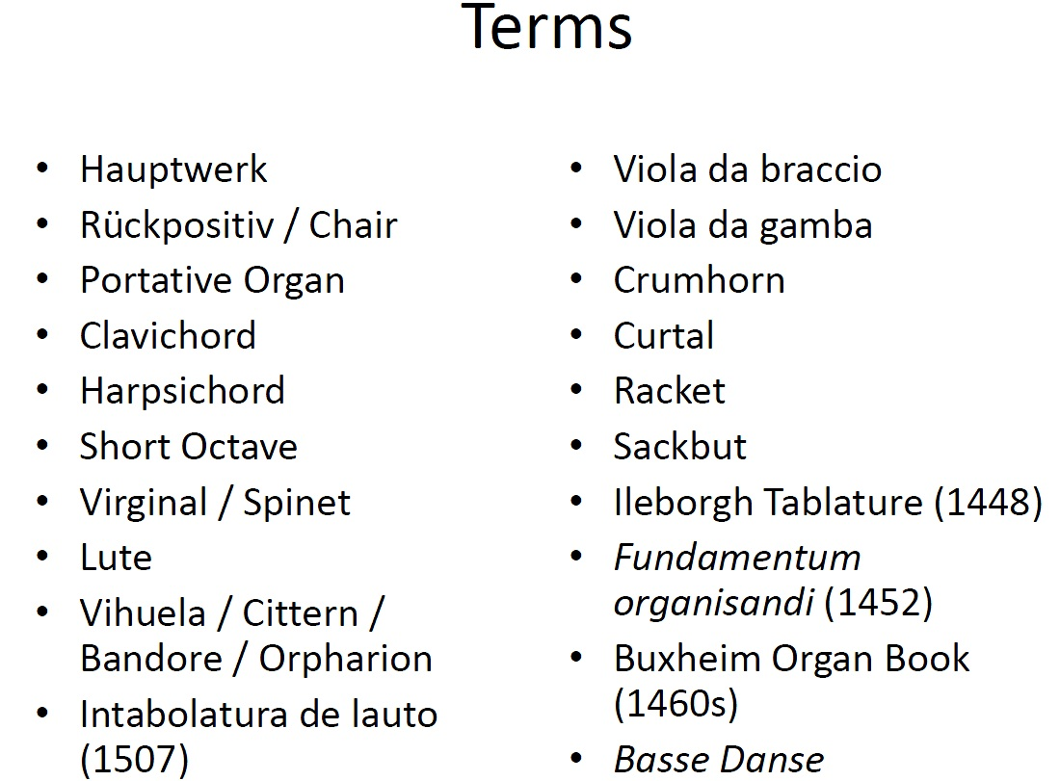

- Instrumental Music
  - There was probably more instrumental music around the realty renaissance than we know about
  - Most of it was improvised/Memorized
  - Instrumental groups did not exist as a concept
  - Great variety of instruments not very standardized
  - For example, if two people had a clarinet, one would be smaller than the other, resulting in different keys.

- Keyboard Instruments
  - The organ develops
    - Main register: Hauptwerk
    - Separate set of pipes behind or beneath player: Rückpositiv / Chair
    - Organ stops allow a variety of air flow to produce sounds of different timbres
    - Pedals also added for another register
  - The portative organ was popular for home
    - Either play one handed and pump bellows with the other hand, or get a friend to be your bitch.
  - The Clavichord evolved fro mthe ‘monochord’ in the early 15th c.
    - Could be played without help from a friend
    - A mental tangent hit the strings to make the sound
  - The Harpsichord
    - Becomes poplular in the late 15th c
    - Also called the Clavicymbalum (a key psaltery)
    - Mechanism plucks the string instread of hitting it
    - One manual for octaves
    - Lowest octave is a ‘short octave’ where they eave out accidentals
  - The Short Octave
    - Lowest notes on the harpsichord would not inclide accidentals like f# or G# etc
    - Keyboard lay out looks the same
    - Playing F# will not sound the pitch f#; it will sound the pitch D!
    - This extends the range of the keyboard without extending it’s length
  - Other varieties of smaller jeyboard instruments exist, where the strings , where the strigns run at right angles (or close) to the keyboard to save space
    - Virginal
    - Spinet

- String Instrument
  - The lute is king (most common plucked instrument of the renaissance)
    - Early lutes had four or five (pairs of) strings, called ‘courses’
    - Standard lutes in the early 16th c had 6 courses.
  - Spanish cousins of the lute
    - Vihuela: Gut strings
    - Guitar: Gut
    - Cittern: wire strings
    - Bandore: wire
    - Oprharion: wire
  - Mandoras and Mandolins- much the same as our day

Intabolatura de lauto (1507)
  - Petrucci published a series of scores for lute
  - The first of these was called Intabolatura de lauto
  - It contained chansons, motets and mass movements by Ockeghem, Josquin, and Isaacs
  - Arranged for lute by Francesco Spinacino

- Stringed Instruments: The Viol
  - Many shapes and sizes
  - Viola da braccio = held in arm
  - Viola da gamba = held on lap or between legs
  - Sloped shoulders, flat backs, fretted fingerboards are all difeerent from the violin
  - Bowed under handed (made a soft sound_
  - Popular is splain, England, and France

- Violin
  - Slower to develop than the viol
  - By mid0 6th c it was standardized by violin makers in Italy
  - Became the standard stringed / bowed instruments across Europe
  - Violin was bowed over hand to make more sound

- Winds
  - Recorders are areound ther 14th century and by the end of the 15th c they are standardized into 4 types:
    - Soprano
    - Alto
    - Tenor
    - Bass
  - Made of a single piece (tuning?!)

Double Reed
  - The Shawm
  - The Crumbhorn
  - The Curtal
    - The forerunner odf the bassoon- had various shapes and sized
      - Double reed
      - Tenor/ bass range
  - The Racket
    - Wound up cylindrical tube bent back on itself up to 9 times (in a foot)
      - Double reed
      - Tenor/bass range

Trumpet
  - Stil common by the end of the 15th c
  - Slide trumpets were still used bey they end up called sackbuts, abd becomes more and more like trombones
  - Trumpets without slides became easier to hold when their tubing was bent back on itself

- Percussion
  - Drums
  - Cymbals
  - Tambourines
  - Wooden xylophone
  - Hammered Dulcimer (psaltery)

- Sources for Keyboard music
  - Ileborgh Tabulature (1488)
    - Contains three differentveriosn (mensurations) of the same german song
    - Named for its owner , Adam Ileborgh
  - Fundamentum Organisandi (1452)
    - Means “the fundamentals of composition
      - Written by condrad Paumann
      - Contains cantus firmi and right hand embellishments
  - Buxheim Organ Book (1460’s)
    - Contains 256 sacred/ secular works by Dunstable, Du fay, and Binchois, etc.

- Dance Music
  - A notated form of dance music is the Basse Danse (Bonds p149-150)
  - Slow, Couples Dance
  - Completely choreographed
  - A Book of basse danse is essential like a jazz fake book
    - Contains melody
    - Would have been embellished by other instruments
    - Contains instructions for the dance step

Conclusions

Conority = Homogenous

Cantus firmus technique takes over from Isorhythm

Music printing has huge effect on distribution and music culture

- 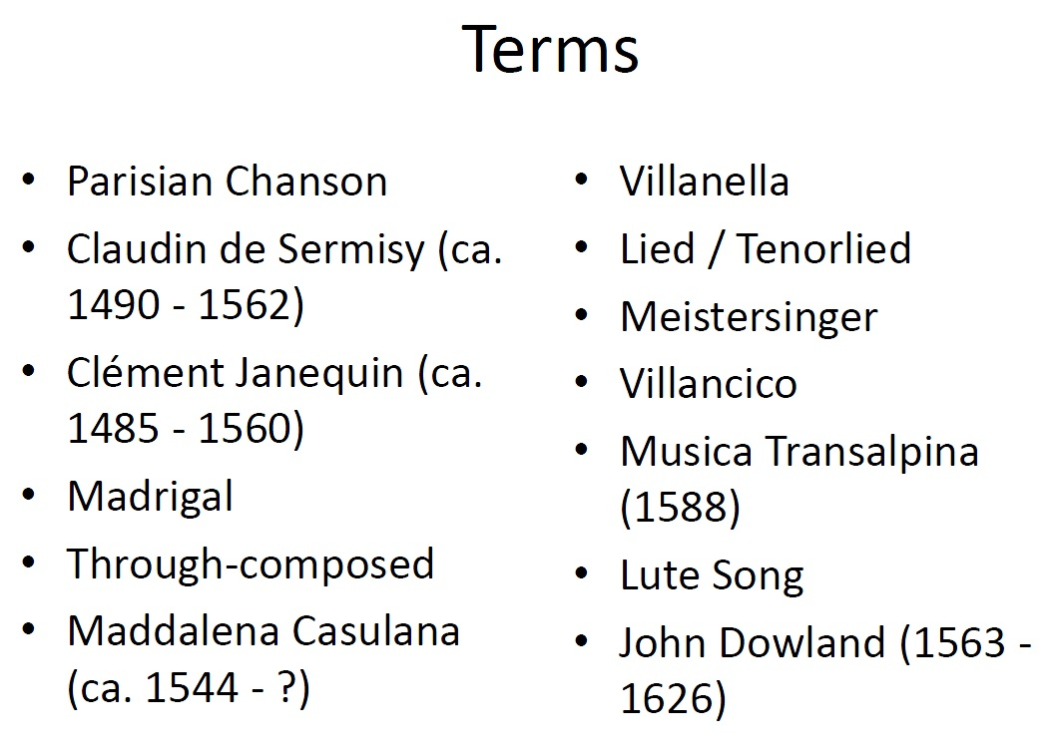

- Secualr vocals of 16th c
  - Various forms arise in various importance places in Western Europe at the time:
  - Paris: The Parisian Chanson
  - Italy (Venice): The madrigal and the Villanella
  - Germany: The Lied (tenorlied)
  - Spain: The Villancico
  - England: The Madrigal and the Lute Song

- Parisian Chanson
  - In the vernacular
  - Text-driven
  - Close to the Italian frottola homorhythm and vertical sonorities)
  - Musial forms mirros the form of the text (Cadences, cesuras, etc)
  - Main Composers: Claudin de Sermisy
  - Clement Janequin
  - Pierre Attaingnant, Parisian music publisher, championed Parisian Chanson (for good business)
  - Janequin = Rock star of Parisian Chanson
    - He wrote many onomatopoeic songs
    - La guree
    - Le chant des oiseaux
    - Les cris de Paris

- The Italian Madrigal
  - The term is taken form the 14th century form, but is otherwise UNRELATED
  - Grows out of the frottola but is different:
    - Madrigals are contrapuntal (and frottolas are chordal)(
    - Madrigals are through composed [no section is the same] (and frottolas are strophic [verses, but different text])
  - Major features of the Italian Madrigal is word painting
  - Word painting can only happen if you pay attention to the words and know what mean
  - Petrarch (1304-1374) is becoming popularized again by Pietro Bembo (1470-1547)
  - Bembo is also encouraging other Italian poets to write in the vernacular (see box on pg 155)
  - A good source for madrigal texts
    - No fixed textual form, free rhyming scheme
    - Typically 7 syllable lines are alternated with 11 syllable lines
    - There might be a ‘conceit’ at the end of the poem
  - VERY POPULARS,m sung everywhere as entertainment in the home or banquet hall
  - 2000 publications of madrigal collections between 1530-1600!
  - Many of the best composers were writing in the genre
  - Popularity if textual (racy) themes
  - By mid-16th century, standard madrigals are 5 voice

- Two Italian madrigals on your listening list
  - Morir no puo il mio cuore By Maddalena Casulana (ca.1544-?)
    - First professional female composer
    - Interesing and unladylike imagery
  - Solo e pensoso By Luca Marenzio (1553/4 – 1599)
    - Extreme word painting
    - Please listen to his with anthology open

- The Villanella
  - Madrigal ‘lite’
  - Comes from the word country girl
  - Three voice
  - Strophic
  - Syllabic
  - Unsophisticated/bawdy subject matter

- German Lied/Tenorlied

If the melody is on top, accompanied by other instruments, then it’s a lied

If the melody is in the tenor line, then it’s a tenor lied
    - This is like the cantus firmus practice in sacred music, except its secular
  - Meistersinger Guilds would hold competitions for the best rendition of an unaccompanied song (bar form AAB) like the Minnesingers before them

- The Spanish Villancico
  - This was textual, poetic form first
  - Fashioned like the Virelai AbbaA
  - Melody of the Villancico would ne sing as the upper voice and accompanied by the vihuela

- The English Madrigal
  - Everything Italian was popular in England at this time
  - The first book of Italian Madrigals to be translated into English and disturbed in England was the Musica Transalpina (1588)
    - An anthology of 57 madrigals
    - Many famous composers represented
  - English madrigals were written in their own right
    - Ex. From your listening list: John farmers Fair Phyllis

- The English Lute Son
  - Melody sung to a lute accompaniment
  - Sometimes two or three voices to lute accompaniment
  - John Dowland (1563-1626) is the most famous composer lute song composer
  - Read the anecdote on pg 164
- 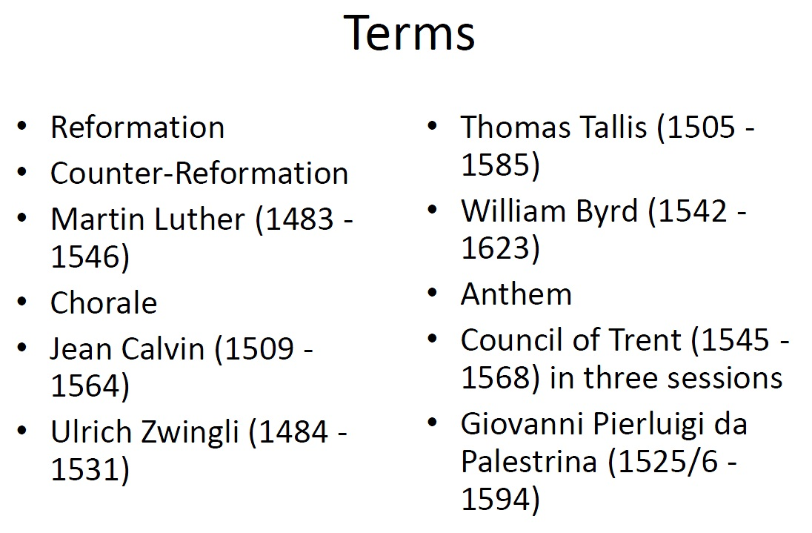

- DiviceL protestand music and the Romanc Catholic music

  - This divide started because sacred vocals muscila is sung in hthe church, so we have to know what king of church we’re singing in

- Martin Luther:
  - Lead what became the first protestant movement
  - Was a musician (played lute, flute, sand and composed)
  - Had no problem with music or polyphony in the protestant church
  - Wanted to encourage congregational involvement thought the music, how did he do that? CHORALES!

- Chorales
  - Hymns sung in the vernacular, by the congregation in a church
  - Mostly formed from preexisting melodies
  - Look at p 166
  - Chorales have a main melody but they can be harmonized

- What Luther has to say about music
  - Lither has NO prob with Chorales being harmz or elaboratied upon musically
  - Read 168
  - ‘Music os a ghift of god, not a gift of men’
  - ‘next to the word of god, music deserves the highest praise’

Calvin and Zwingli
  - J. Calvin and U. Zwingli also lead protestant movements
  - They were less happy about music in the church
  - Calvin only allowed music via unaccompanied psalm-singing
  - Zwingli didn’t allow music at all.

- In England- Henry VIII
  - The church of England is the upshot of a power struggle between Henry VIII and the Pope in Rome
  - Protestant movements in Europe at the time provided a model for Henry to found his own church with himself as the head
  - Two years after henry died, a book on services for the church of England IN ENGLISH was published in 1540: the Book of Common Prayer

- The English Anthem
  - Definition: a motet sung in English on a religious theme
  - Two types. Full and Verse
  - Full anthem: composed for a choir all the way through
  - Verse Anthem: composed for alternating choir and soloist
  - Thomas Tallis (1505-1585) is the name you should associate with Church of England Anthems in the Renaissance wrote ‘spem in allium?’ a 30 voice motet.
  - William Byrd- (1542-1623) a complicated figure in Church of England vocal music because he’s roman catholic
  - Tallis and Byrd had the first 21-year monopoly on polyphonic music with a patent to print and publish given to them by Elizabeth

- The counter-reformation
  - The council of Trent
  - Three separate sessions:
    - 1545-1547
    - 1551-1552
    - 1562-1563
  - musically a lot of culling was a accomplished in these sessions
  - No long allowed to base sacred works on secular themes
  - Music should be a vehicle for the text

- Palestrina Missa Papa Marcelli Myth
  - At the council they were about to take out polyphony all together
  - Palestringa save polyphony by showing them his Missa Papa Marcelli
  - His clear text setting and pure consonances convicen them to preserve polyphonty in the catholic church

Its sat that this story isn’t true

There’s a nice opera written about it though, Palestring by pfitzer (1917)

Palestrina’s Style
  - Even though the myth isn’t true, palestrina’s music does exemplify a lot of what the Counter-Reformation was going for:
  - Consonance (With lots of 3rds and 6ths considered as such)
  - Pure sonorities
  - Clear text setting
  - Read about Palestrina composing life on 171

- 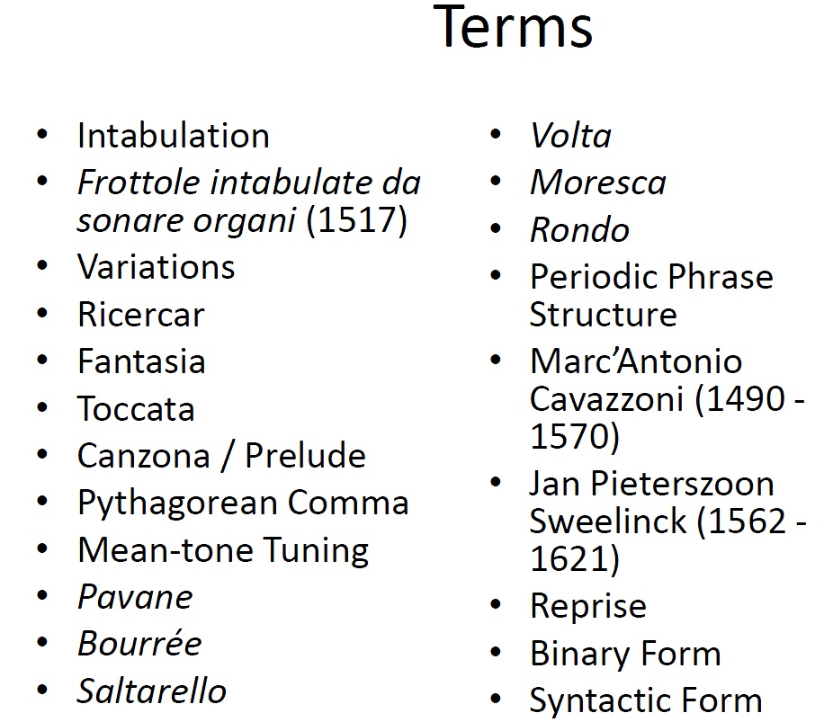

- For the first time, composers are writing for instruments

- Four Broad Categories
  - Intabulations
  - Variations
  - Free-Form Compositions
  - Dance Music

- Intabulations
  - Arrangements of pre-existing vocal music for plucked strings (either lute or keys)
  - The first intabulation publication totally devoted to keyboard music: Frottole intabulate da Sonare Organi, by Andrea Antico, In Rome. (1517)
  - Popular because you could hear polyphonic pieces with just one person playing

- Variations
  - Theme and various become very popular
  - Mainly for keyboard
  - Connection between the Renaissance ideal of Rhetoric (from classical antiquity) to the idea of music variations

- Freely – Composed Works
  - Various terms for what is essential the same concept
    - No structure or form imposed on the work
    - Often the theme is only ‘revealed’ near the end
    - The often act as intros to other works on the same modes which do have a stricter form

- The Ricercar
  - Italian for ‘To seek’
  - Early Ricercar are very ornamented and vague about what the melodic theme will be until the end
  - Later Ricercar become very influenced by counterpoint are quite imitative with tossing themes between voices

- The Toccata
  - Whop for ‘to touch’
  - Think of fingers just touching the keys or strings
  - Light, introductory, getting ‘warmed up/ on your instrument

- The Fantasia
  - ‘fantasy’
  - whatever comes to you as a composer, you write
  - Morley, in your text p174 -the composer is tied to nothing (except the key/mode)
  - Other terms Canzona and Prelude

- Two Keyboard Composers to know
  - Marc’ Antonia Cavazzoni (ca. 1490-1570)
    - Published the first EVER independently composed keyboard music in Venice in 1523
  - Jan Pieterszoon Sweelinck (1562-1621)
    - Was very influential organist and teacher in Amsterdam. He extended the use of the pedal into another voice and wrote the first expansive fugues

Renaissance Tuning Systems
  - Read the box on 175
  - You need to understand what the Pythagorean Comma is
  - Starting on a theoretical C and you tune fifths, and you reach C again, it will be sharp. Where it Is, and where if SHOULD be, is the Pythagorean Comma.
  - How is this solved? The most pop way was the Mean-tone tuning system, which haves a bit off all perfect fifths
  - Equal temperament comes along in the 18th century and throws everything a little out of whack

Dance Music
  - Pavane: Slow duple meter
  - Bourrée: fast in duple meter
  - Saltarello: Lively (especially after a slow one) and involves little jumps
  - Volta: ‘to turn’ in compound duple meter
  - Moresca: ‘moorish’ dance influence by the Arabs in Spain and northern Africa
  - Rondo ‘round circle’ dance for large groups

Periodic Phrase Structure
  - Definition: repeated phrases of equal length
  - This makes it possible to actually dance to these pieces in a group-dance sort of way.
  - Praetorius, Dances from Terpsichore (cd 3 track 23)

- The Reprise/Structure
  - Definition: a section that is repeated
  - Two reprises together from what kind of structure? BINARY FORM
  - This kind of structure is central to the idea of the opposite of paratactic form which is SYNTACTIC FORM (sections of a piece that are repeated)
- 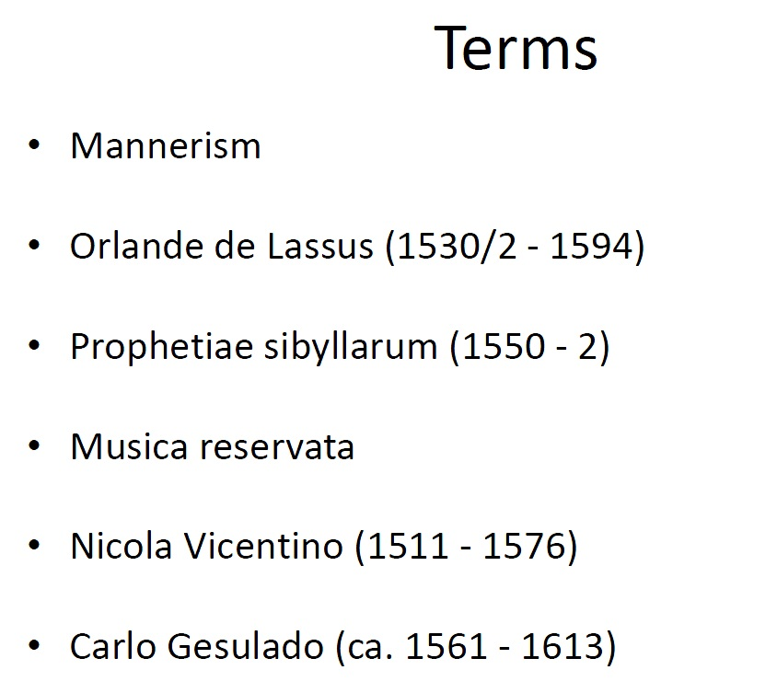

- Mannerism: Term taken from art history
- In art: use of exaggeration and distortion for emotional/ dramatic effect
- In music, use dissonance and rubato , dynamic contrast, chromatic and chordal progressions. Word painting. ( LIKE ARS SUBTILIOR)
  - Chromatic
  - Harmonically unusual
  - Composers of mannerist music write out the accidentals and don’t leave it up to the signers (Musica Ficta)

Orlando de lassus: Prohetiae sibyllarum
  - Idea? Ancient Greek prophetesses (sibyls) foretold the birth of Christ
  - De lassus used chromatics in the tenor to depict the sibyls song.

Revival of Greek ‘genera’

Idea: the ancient Greek music was said to have a strong emotional impact

Nicola Vicento writes a book about ancient music in the modern practice in 1555

The key is chromatics

Greek Genera are three version of the tetra chord which are diatonic, chromatic, enharmonic

Vicente not crates two keyboard instruments capable of playing these genera

Musica Reservata
  - Reserved music
  - Reserved for those who can understand and appreciate the chromatics and dissonances
  - Not published but kept in beautiful manuscripts dedicated to particular patrons
  - Prophetiae Sibylarum is and example of this. \

- Singing as Oratory
  - In order to create emotion in the listener treat the practice of singing like a dramatic art
  - 16th c. audiences were very keen on good rhetorical skills and oratory
  - Vincentino advises singers to perform ‘alla mente’ (From the mind) instead of from the page see p 181
  - First time music is directed TOWARDS an audience.

- Carlo Gesualdo (ca. 1561-1613)
  - Most representative composer of the mannerist style
  - Composer of six books of madrigals and three books of sacred worlds
  - Ex. Moro, Lasso, al mio duolo (cd4 tr 1 )
  - Written to cause real emotion reactions from listeners
  - Considered by many (contemporary and later) to be ‘shocking and disgusting to the ear’ (Burey, 1789)

Orlando de Lassus (1530/2 – 1594)
  - Born in Mons (Belgium(
  - Travelled first in Italy and then in Munich
  - Prolific composer 2000+ works
    - 70 masses
    - 500 motets
    - 100 settings of the magnificat
    - 200 whop madrigals
    - 150 french chansons
    - 90 german lieder

- Music doesn’t get this cray until 20th century music, nokrr?

- 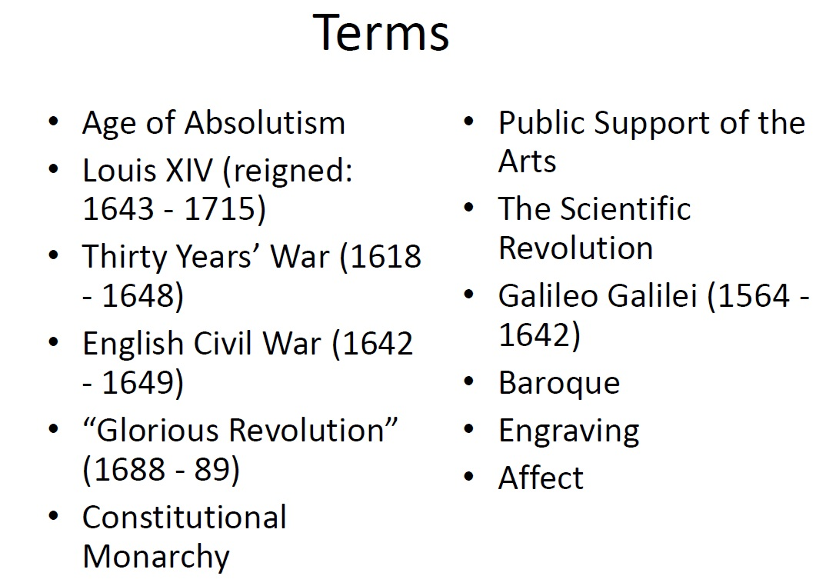

- Age of Absolutism
  - Louis XIV (reigned 1643-1715) ushered in the age of absolutism in France, and other places in Continental Europe
  - Absolutism: royalty claims complete dominance over the state
  - The Divine Right of Kings: the theory that God approves of the kingship of the ruler, therefore the people must also
  - Versailles remains a testament to his power.
  - GREAT FOR THE ARTS

- The Thirty Years War
  - 1618-1648
  - took place mostly on German soil
  - involved France, Spain, Sweden, Denmark, Holland and HRE states. (Germanic)
  - begun by catholic/protestant conflicts
  - sustained as a war over territory (Hapsburg vs Bourbon)
  - Effect: famine and disease and broken economy in German and environs for years

- Revoking the Edict of Nantes
  - France came out ahead after the TYW
  - The EON was a peace deal between Catholics and protestants in France in 1598
  - In 1685, France revokes the Edict
  - MANY protestants (Huguenots( had to flee France for protestant countries such as Holland and North American enclaves

- England
  - Absolutism never worked
  - History of parliament working with monarchy
  - Struggle between the two :English civil war, 1642-9 until Charles I, king, died
  - England ruled by Oliver Cromwell for almost 10 years
  - Cromwell died, monarchy reintroduced
  - Glorious Revolution (1688-9) relaces pro-catholic absolutist leaning James II with this daughter Mary,, and her husband William of Orange

- Public Support of the Arts
  - In places where absolutism doesn’t work, like England, and city states in continental Europe, like Venice and Hamburg
  - Art can now be written for the public and paid for by the public
  - Music can be written for church PR court OR the public street

- Colonization
  - European countries develp their holdings in the colonies
  - North America, Sout Americam AFtrica,
  - A ‘global economy’ is developing
  - Disadvantage for Native American peoples and Africans who are brought the America as slaves in the plantations

- Scientiveic Revoluton
  - mid-16-18th cent
  - astronomers lead (Tycho Brahe 1546-1601; Johannes Kelper 1671-1630)
  - Galileo Galilei (1564-1642) confirms the idea originally Copernicus’ that the earth is not the center of the universe
  - Francis Bacon (1561-1626) creator of the scientific method
  - Rene Descartes (1590-1650)philosopher
  - G.W Leibniz (1646-1716) mathematician
  - I Newton (16421-1727) physicist

Baroque Music
  - Baroque from Protugese ‘borroco’ = misshapen pearl
  - Used as an insult to mean distorted and gross by 19th century historians
  - Baroque covers many styles and these styles develop through the period

- Baroque Affect
  - The idea of AFFECT in Baroque music is : certain kinds of music will inspire scientific emotion responses in the listener
  - These emotions were achieved by the performer imitating those emptions through the music
  - Baroque Affect may be traces back to the extreme word painting by Gesualdo

- A new audience and it’s demands
  - Instead of just having the court and the church compete for the best musicians, a THIRD player has entered the scene : The Public
  - Music printing and selling increases in importance because of this
  - New tech: engraving on large sheets of metal for better, repeatable music prints

- Baroque Era focused on Newness
  - Very fast paces compositional world
  - Compositions and composers went I the and out of fashion quickly
  - Even great composers did not. Were not able to look to the past for inspiration and technique
  - Classes of people, inspire classes of music.
  - If music is respected if there is a printable score, if it’s not, it’s not serious

- 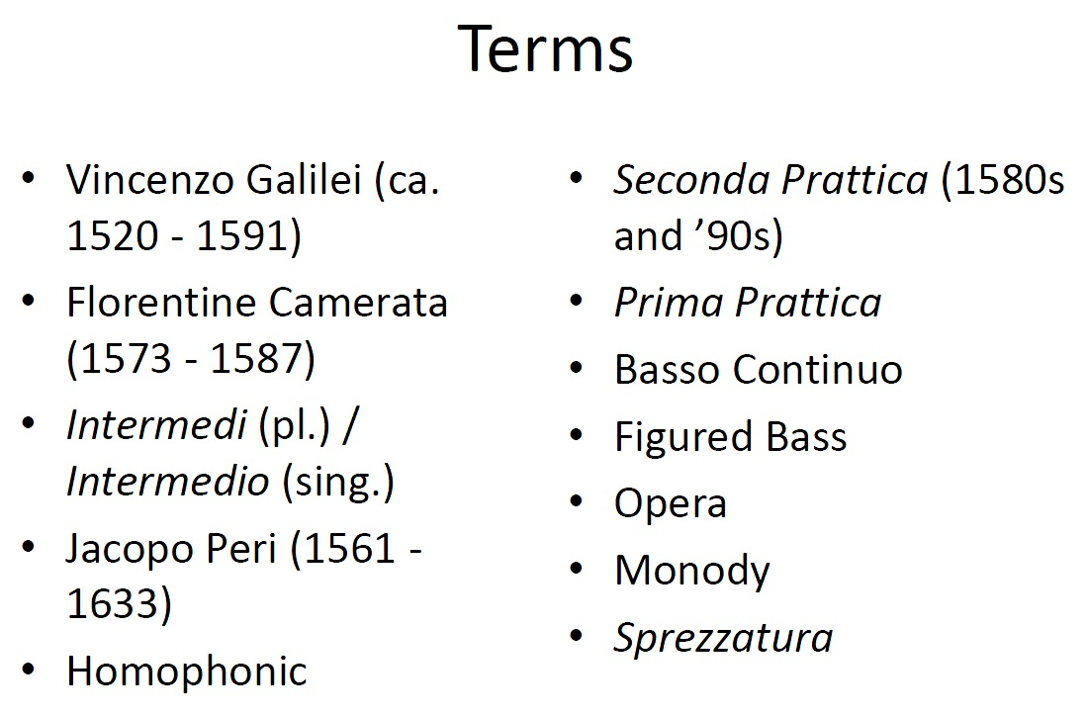
- Recreating Ancient Greek Music
  - The Ancient Greeks: music is heightened speech
  - Therefore, text should determine everything about the music setting it
  - Early 1600’s the policy: all aspects of music are subordinate to text
  - The ‘affect’ of the text must be heightened by the music setting it

Thinning out thick texture
  - Late renaissance word painting sometimes obscures the text
  - Vincenzo Galilei (ca 1520-91) composer and lutenist: music should be a single melody line with an accompaniment.

The Florentine Camerata
  - Poets and composers (and nobility) get together at count Giovanni de Bardi’s house in Florence (1573-87)
  - Discuss how to recreate ancient Greek music and its impact on its listeners
  - The birth place of opera? Why ?

Intermedi for de’ Medici Wedding
  - Ferdinando de Medici gets married to Christine de Lorrain (princess of France) in 1589
  - Maion entertainment was a play, The pilgrim Woman (la Pellegrina)
  - In between the acts of that play, the Florentine Camerata provided musical entertainment
  - These in between segments were called intermedi
  - All of these had to do with the powers of Greek mythology

- Intermedi
  - Topic: the power of music in ancient Greek myth
  - Form: each intermedio was 4 or 5 movements long
  - Style: miss of instrumental interludes some old style (ie renaissance polyphony) and new baroque style

Il Canto d’ Arione (The Song of Arion)
  - The fifth intermedio for the de’ Medici wedding in Florence
  - Composed my Jacapo Peri (1561-1633) who also sang the role of Arion
  - The is about arion who is about to be thrown into sea, but who sings to Apollo, who sends dolphins to rescue him from drowning
  - Cd:track 2

- Second Prattica
  - This new style of prominent melody line + accompaniments is called the second practice’
  - The fist practice is stil Renaissance polyphony
  - First and second here are chronological ideas, not priorities
  - Seconda Prattica: dominant melody line whose text delivery determines rhythm and pacing . Develops in the 1580s and 90s

- Basso Continuo
  - Continuous Bass
  - Bass line which never ceases to accompany the melody, helping to outline the implicit chords
  - New idea when compared to polyphony and renaissance counterpoint technique

Figured Bass
  - The basso continou is usually notated as a single line of music (bass line)
  - Above this there will sometimes be numbers
  - Read these like theory class
  - 6 means first inv
  - 6/4 means 2nd inv
  - 65 means suspension of a sixth, resolving to a fifth, over a held bass note.

Opera
  - when music focuses on text, we can tell a story,. We can have an opera!
  - Opera: reincarnation of the Greek Drama
  - Each singer plays their own role and expresses themselves through their text and vocal line
  - Peri’s Euridice (1600) generally thought to be the first opera to use this musical style

- Monody
  - Music has two ‘pokes’ in monody
    - North pole: melody
    - South Pole: Basso Continuo
  - Melody is allowed to by rhythmically free. Taking dramatic license
  - This freedom is called Sprezzatura
  - Sprezzatura thought by some to obscure the meaning of the text…uh oh

- Periodic Phrase Structure
  - In some types of vocal music at the time, poetry was set to music
  - This poetry is measured and versified
  - The form the music (often a dance form) would reflect this aspect of the poetry
  - Result: periodic phrase structure

Simplicity of Second Prattica
  - Chromatics and dissonance fell out of use as composers tried for simplicity of delivery

- Renaissance Counterpoint keeps on…
  - We’ve switches our focus to look at what’s NEW in the early 1600’s
  - However, Renaissance polyphony and the Style of the 16th century counterpoint does NOT die.
  - to be a consummate composer now, you need to know how to compose in BOTH styles

- 1) Modal vs Tonal Harmony

- 1500-1550 Renaissance Modal Harmony

- 1600 ?? The transition period

- 1650-1700 – Baroque Tonal Harmony

  - Many are reluctant to let go of medieval modes in favor of a sing diatonic scale that offered only major and minor forms
  - Johanne Buttstett defends modal in 1716 treatise Ut MI SOL , RE fa La: The Eternals of All Music and Harmony
  - 1717, Johann Matheson responds wth te tota musica which makes the case Buttstett is old fashioned and out touch

- Intervalic vs Chordal Harmony
  - In the ren, harmony was the byproduct of counterpoint , the intervallic relationships between voices in a work
  - by the 18th cen. Harm as a progression of chords had become dominant

Virtuosity
  - not just about ability, its reverence of a PERSON’s skill
  - with more performance opportunities, great consistency in the manufacture of instruments and the transmission of pedagogy there was progressive increase in virtuosic performance
  - the technical challenges of performance because a subject for delight unto itself

- Program Music
  - In 1700 amid the rise of instrument al music Johann Kuhnau wrote Biblical Sonatas. A musical; depiction of the battle between David an goliath this is the introduction to program music

Contrasting Timbres
  - Renaissance aesthetic priorities favoured families of like instruments such as a consort
  - This changes progressively with an aesthetic interest in contrasts of all types contributing the what we think of as the Baroque
  - I/.e Vivalti Four seasons

- The Italian Baroque Style
  - The fermenting of an Italian style in the Baroque is predicated on the emphasis of the melody
  - The use of embellishments are often improvisatory contrasting with the French style win which they were often notated

The French Baroque Style
  - When you think of Lous XIV you should think ‘dance’ When you think dance you should think prioritization of rhythm
  - French Baroque is characterized by words such as sprightly, bright, and lively

- The German Baroque Style
  - A mixture of the French and Italian styles, the German style has a greater emphasis on contrapuntal writing.

- The Age of Absolutism
  - Monarchs assert control
  - Power of the church is reduced
  - Louis XIV
  - Peter I the Great of Russia

The Age of Turmoil
  - Thirty years war
  - Cath vs prots
  - France and Germany

Age of Unrest
  - Chars I – Cromwell – Charles II
  - Magna Carta 1215
  - Constitutional Monarchy

Age of Scientific Revolution
  - Kelper – palnets orbits are not circular, but elliptical
  - Galileo 91564-1642) develops the telescope
  - Copernuicus 1543
  - Heliocentric vs Geocentric
  - THE INQUISITION!!
  - Francis Bacon
  - Descarts
  - Newton

- Age of Art and Literature
  - Milton Paradise lost

- An Age of Decadence
  - The term baroque was derived from the art world describing an AGE OF DECADENCE between Renaissance and Classical Eras

An aGe of Undefined
  - With so many practices and techniques in use the Baroque is hard to define
  - What are two characteristics
    - Affect
      - Composers and performers sought always to convey the passions? WHAT ARE PASSIONS, PRESCIOUS?! Love and hate and shit. Extremes of emotions. Nokrr?
      - In music, music wants you to feel these contrasting emotions
      - They are emotional states created within the listener
    - The NEW
      - Music was rarely repeated in the Baroque
      - What is significant consequence of this? Its hard to define the era, when everything changes
      - Composers faded into obscurity quickly

- The Age of Growth
  - THE church and the court supported the arts’
  - But, a rise in the middle class meant a dispose income and a market for printed music

- The Age of Ideas
  - Florentince Camerata
  - La Pellegrina

- Age of Change
  - Prima vs second Prattica
  - Prima: Renaissance polyphony
  - Seconda: solo vocal line above a subordinate instrumental line

- Age of low
- 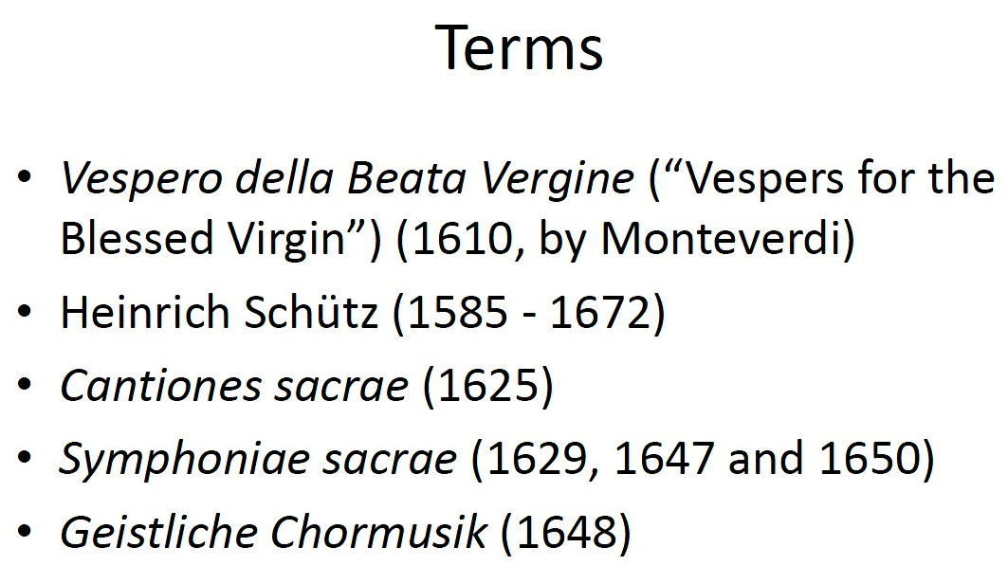
- The 1610 Vespers (Monteverdi)
  - 14 movements
  - Modeled after a Vespers service (catholic church in Italy)
    - Introductory material (I,e versicle, responses
    - 5 psalms pairs with 5 motets
    - hymn
    - magnificent
  - 90 mins
  - a variety of different settings, (solo duet , basso continuo or several instruments)
  - mixes prima and second Prattica
  - This is the biggest church piece before Bach.

Monteverdi Vespers Controversy
  - Where are the antiphons?
  - How are the motets supposed to be sung? Are they substitutes for antiphons? Supplements?
  - Is this really for the Virgin Mary only?
  - How should it be performed?
  - Transpositions?

- Heinrich Schütz (1585-1672)
  - Born in Germany
  - Educated in Italy (Venice) for three years
  - Took the job he had for his whole life in 1617 as a Kapellmeister at the Dresden Court (Saxony)
  - Composer of mostly sacred vocal works

Prima and Seconda Prattica in Schütz
  - Schütz advocated that young composers learn the PRIMA Prattica (i.e. polyphonic C.P )_ for a thorough education
  - His works mix both styles but he leans towards the 2nd Prattica with his word painting and his reliance on basso continuo and sparse texture

Schütz works to ,now
  - Geistliche Chormusik (1648)
  - First piece in the collection of motets
  - Cantiones sacrae

4 voice motets with the addition of the bassso continuo
  - Symphoniae sacrae (thee volumnes) 1629-47 an 50
    - Sacred songs with extensive instrumental accompaniment
- 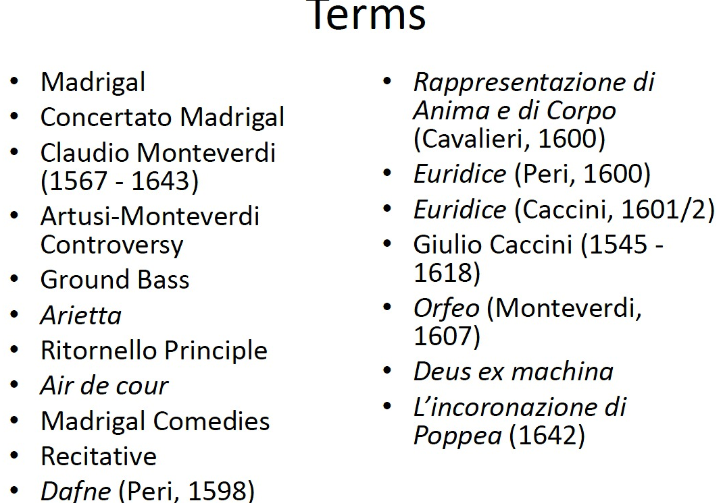

- The Italian Madrigal
  - Definition ‘any though composed setting of freely structured verse”
  - Style: varied from a cappella polyphonic style to solo voices with basso continuo
  - Concertato Madrigal: any number of voices with any number of instruments. A happy medium between monadic style and polyphonic style
    - Basso continuo required
  - Claudio Monteverdi (1567 -1643)
    - Bio on p 211
    - Wrote 9 books of madrigals the progression in style of which mirror the age in which he lived
    - Books 1-4: polyphonic writing (prima Prattica)
    - Book 5: introduces basso continuo
    - Book 6: full basso continuo technique
    - Books 7-9 Concertato Madrigals
    - They show the shift between Renaissance and Baroque
  - Artusi – Monteverdi Controversy
    - Giovanni Mara Artusi (ca. 1540-1613)
    - Was not a fan of mont new style
    - In his published pamphlet on the “imperfections of modern Music” he took issue with Cruda Amarilli (Monteverdi madrigal book 5)
    - The prob: dissonances and accidentals not treated in the tradition (zarlino) way
    - Mont replies ‘there is a different way’ of dealing with dissonance
  - Ground Bass
    - A short phrase in the bass line which is repeated over and over
  - Example: Mont’s Zefiro torna e di soave accenti
  - Use of ground bass reflects the emotional context of the text
  - TWO MORE TERMS
    - Arietta: a small song or aria
    - Ritornello Principale: the structure of a piece of music in which a musical idea form the beginning returns throughout the work, mostly contrasting other sections
    - Two Female Composers of the time
      - Francesca Caccini (1587-1641)
        - Daughert of a lutenist and composer was a singer and lutenist at the Medici court. Taught music to Florentine noble women. Wrote an opera, several madrigals, arias etc.
      - Barbara Strozzi (1619-77)
        - Composed 8 volumes of music, most of which still survives
        - Didn’t work for one court or patron
        - Possible image of her on pg 216
- The French Air de cour
  - Form: solo voice plus accompaniment
  - Emphasis on text
  - Background: various French attempts to bring its poetry closer to that of antiquity through accentuation
  - Ex: enfin la beauté que j’adore CD 4 t 9

- The Opera
  - Early Opera
    - Ancestors: Madrigal Comedies
      - Sets of madrigals which are thematically tied certain voices would have certain dramatic roles
      - Probably weren’t ever staged
      - Think of them as REALLY EARLY SECUALR KARTANAS? (sp?)
    - Recitative:
      - Getting through a lot of text in a short time
      - Syllabic
      - Sparse accompaniment
      - Early opera had a lot of this and it was BORINGZ
    - Early ops to know
      - Dafne (Jacopo Peri)
        - 1598, at the Medici court in Florence
      - Pappresentazione di Anima e di Corpo (Emilio de’ Cavalieri)
        - 1600, Rome
      - Euridice (Peri)
        - 1600, Florence
      - Euridice (Guilio Caccini)
        - 1601/2. Florence
  - NO ONE THOUGHT THESE WERE GOOD CAUSE RECITATIVES WERE LIKE CHURCH> WAS HELLA LAMEZ

  - Monteverdi’s Orfeo (1607)
    - Successfully finds the balance between recitative and aria
    - Calls for 40 insts
    - Pot centers on Orfeus, famous musician in Greek myth, and his quest for his wife, Euridice from the underworld
    - Insts are used to create various appropriate feelings and scenes/emotions

- Deus ex Machina
  - Popular method of getting out of plot problems at the ends of operas
  - A god (from ancient myth) descends from the ceiling riding in some sort of device (chariot or mirror)
  - The god decrees how life will be henceforth
  - Machines and special effects are big in early opera – another way to show how rich you are as the owner of a theatre

Roman Operas
  - Themes more biblical in capture
  - These would become what we know as oratorio but not yet
  - Special rules for opera in Papal States (i.e no women on stage…fuckers)

Public Opera Houses
  - The first public opera house : Venice 1627
  - subject matter for operas change: now its reality, comedy and scandal (not myth and nobility)
  - ex. Monteverdi’s Poppea (1642-3) season the Viennese public opera house about Nero’s love for poppea and her manipulation for evil.
- 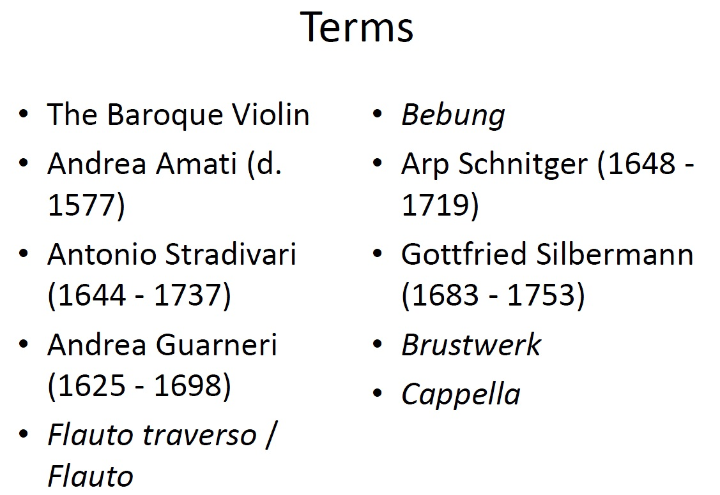
- The Baroque Violin
  - Difference between the b Violin and the modern one:
    - The bass bar (the wood underneath the violins surface) is shorter and lighter than the modern one
    - The neck / body angle is not as sharp as the modern one
    - The bridge is lower than the modern bridge
    - The finger board is shorter than the modern
    - The bow is shorter and would less tightly
  - This means that the sound o the baroque violin is softer and lighter and clearer than the modern
  - Vibrato is an ORNAMENT in the baroque. Not default like today.

  - Three violin makers of Cremona
    - Andrea Amati (d. 1577)
      - First violin maker in Cremona (Italy)
      - Establish the standard proportions for the violin fam including viola and cello
    - Antonio Stradivari (1644-1737)
      - Amati’s most famous pupil
      - Maker of some of the most famous violuns still today
    - Andrea Guarneri (1625-1698)
      - Another of Amati’s pupils
      - His grandson, Antonio Guarneri became even more famous than he was – violin makers were often family trades

- Winds:
  - Conical bore holes in the wood made tuning better
  - Flutes
    - Called flauto taverso and were not as popular as recorders
  - Recorders
    - Called flauto
  - Oboes
    - Oboe de caccias
      - Lower than the oboe will be replaced by the English horn
  - Clarinets
    - Evolved frin tge 17th century chalumeau
  - Bassoons
    - Evolved from the curtal
    - Part of the basso continuo section of the orchestra

Brass
  - Trumpets
    - No valves natural trumpet
      - Achtung: German Trumpet license Required
  - Trombones
    - Evolved from sackbut
    - Has a larger bell
    - Used to double voice parts in church and depict the underworld on stage
  - Horns
    - Entered the orchestra first around 1700
    - Were used in hunting etc before then

- Percussion
  - Thin the baroque orchestra, percussion means timpani (wit hvery few eeptiosn for mastetr tles pf oercyssion such aw the tambourine
  - Timpani parin with trumets = majestic

- Keyboards
  - Clavichord
    - Soft instrument used in himes
    - Special sound created by moving finger up and down on key once it has been pressed creates a trembling sound. CALLED BEBUNG
  - Harpsichord
    - Italian: one keyboard (manual)
    - Flemish: two keyboards (manuals)
    - Had stops to control timbre
    - Couldn’t control dynamic
  - Spinets / virginals
    - Household ints
    - Stings at right angles to key board to make the inst smaller
  - Organs
    - The baroque period is a great time for the organ
    - Two Organ builders to know
      - Arp Schnitger (1648-1753) North Germany
      - Gottfried Silbermann (1683-1753) central / south Germany
    - Had 60 stops at least
    - Had 4 or 3 manuals
    - 3 sets of pipes
    - Hauptwek: main set
    - Brustwek: at chest level
    - Ruckwek: under the organ or behind bench

- The orchestra
  - No public orchestra yet
  - Cappellas: groups of pro musicians on staff at churches
  - San Marco (Venice) 35 signers and 198 instrumentalists
  - Average was sligheter lower on both counts though
  - Court musicians often formed orchestras and played for rolay or court cuftions. These could include entertainment wushc as operas when performefd at court
    - 24 violins du roy
    - listen cd 4 tr 14
  - Public Concets
    - No publicly funded SO NO CONERS SERISES ETC
    - Rare: hospitals or prphanges have cnoncers to riase funds
    - Enteraintment sometimes offered to hotes guest or to partrons of Coffee houses
    - Kaffeehaus Zimmerman was a coffee house in Leipzig where JS bach lead groups of musicaians to entertain people there thought the 1730s and 40s
- What is H.I.P
  - Also known as ‘period performance’ or just HIP
  - The aesthetic of the time in which the work was created is used to recreate it in our time
  - Requires an educated audience
  - Began as am movement within the music but has now come to encompass the stage was well (with performances of baroque operas and shit.)

Instruments
  - Revival of rare, historical instruments (such as the harpsichord, recorder and the viol)
  - Instruments are made to historical specifications and sizes
  - Resulting music is through to be more historically informed if sometimes surprising to our ears

Early Music Ensembles in Canada
  - Les violons du roy

- Singing
  - Singers train from historical treatisies
  - Vibrato used as an ornament
  - Counter tenor is common up to the baroque, but it is still seen as a H.I.P instrument
  - Tuning must function as it does for instruments

Stylistic Considerations
  - Being familiar with contextual differences which makes a piece sound differently from how it appears in the score
  - Latin was pronounced differently in different countries
  - Scores idd not always indicate which instruments should play each part
  - Musicians should be familiar with other types of notation systems such as tabulature, figured bass etc.

Tuning
  - Pythagorean tunihg: used in Medieval and renaissance bands
    - All pitches are tuned as perfect fifths
    - Intrvals other than perfects fifths are badly out of tune (especially major thirds, which is why anicents used to think that M 3rds were a dissonant interval)
  - Mean Tone Temperment (quarter comma)
    - The perfect fifths is flatted one quarter of a comma in order to rescue the major thirds
  - Well Temperament: used in the later 17th century
    - Fifths are different sizes but no key sounds very out of tune

