MARKETING FINAL NOTES

- The Marketing Mix

- Product: goods-and-services the company offers to the target market

- Variety
- Quality
- Design
- Features
- Brand Name
- Packaging
- Services

- Price: amount of money customers have to pay for the goods and services
- List Price
- Discounts
- Allowances
- Payment Period
- Credit Terms

- Place: company activities that make the product available to target customers

- Channels
- Coverage
- Assortments
- Locations
- Inventory
- Transportation
- Logistics

- Promotion: Activities that communicate the worth of the product to persuade target customers to buy it

- Advertising
- Personal Selling
- Sales promotions
- Public Relations

- Product/market expansion grid:

- Helps companies manage a profitable growth by identifying, evaluating, selecting market opportunities and establishing strategies to capture them
= Companies will compete more effectively, they’ll satisfy their stakeholders and attract top talent
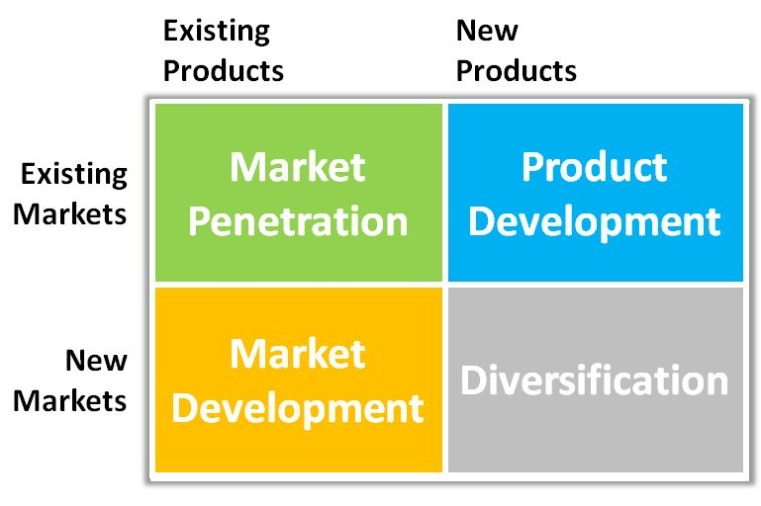
- Market Penetration: making more sales to current customers without changing the original product
- Add new stores in current market areas to make it more accessible to customers
- Improvements in advertising, prices, service, menu selection and store renovations
- Ex: Starbucks adding cheese, beer and wine to its original menu to boost business beyond just the breakfast rush

- Market development: company growth by identifying and developing new market segments for current company products
- International expansion, senior prices, etc.
- Ex: Starbucks opening stores outside of North America

- Product Development: company growth by offering modified or new products to current market segments
- Ex: Starbucks offering new coffee roasts to satisfy a larger variety of tastes

- Diversification: company growth through starting up or acquiring business outside the company’s current products and markets
Ex: Starbucks entering the “health and wellness” category by acquiring Evolution Fresh (fresh juices provider).

- SWOT ANALYSIS
- Overall evaluation of the company’s situation in order to:
- Find attractive opportunities and identify environmental threats and try to avoid or minimize them
- Determine which opportunities it can best pursue based on its strengths and weaknesses

- Strengths: internal capabilities that may help a company reach its objectives
- Advantages in the company

- Weaknesses: internal limitations that may interfere with a company’s ability to achieve its goals
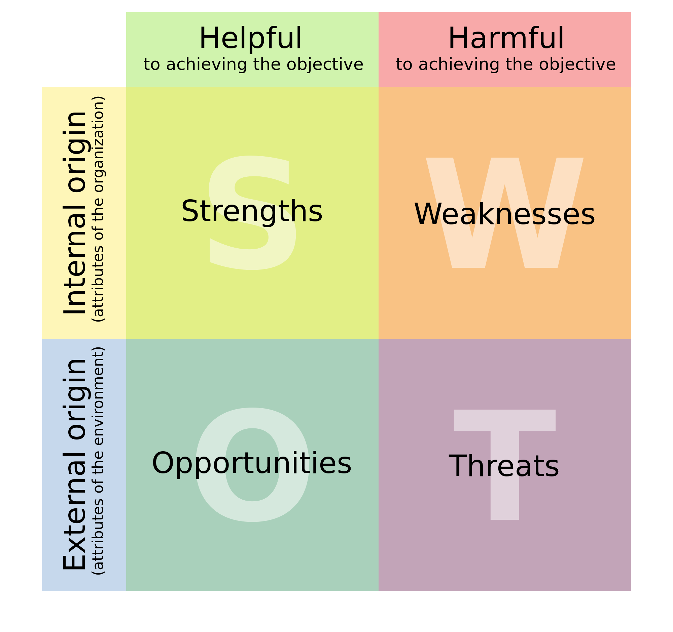
- What to improve, what to avoid in the company

- Opportunities: external factors that the company may be able to exploit to its advantage
- New trends, changes in government policy, local events, changes in social patterns, lifestyles, etc.

- Threats: Current and emerging external factors that may challenge the company’s performance
- Obstacles, competitors, technology threat, etc.

- Marketing Process and its Steps

- Create value for customers and build customer relationships

- BCG and the Growth-Share Matrix

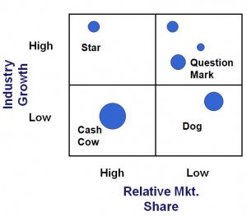
- Stars: high-growth, high-share
- Often need heavy investments to finance their fast growth
- When growth slows down, they become cash cows
Ex: iPads for Apple

- Cash Cows: low-growth, high-share
- If established, successful SBUs will need less investments to hold their market share
- Produce a lot of the money that the company uses to pay its bills and support other SBUs
Ex: iPhones for Apple

- Question marks: low-share, high-growth
- Require a lot of money to hold or increase their share
- Management has to decide which ones should be built into stars and which ones should be eliminated
Ex: Apple TV (do not dominate the TV industry market)

- Dogs: low-growth, low-share
- Generate enough money to maintain themselves
- Do not promise a large source of revenue
Ex: iPods for Apple

6. Selling and marketing concept

 | SELLING CONCEPT | MARKETING CONCEPT
Perspective | Inside-out | Outside-in
Starting Point | Factory | Market
Focus | Existing products | Customer needs
Means | Selling and promoting | Integrated marketing
Ends | Profits through sales volume | Profits through customer satisfaction
Example | Door-to-door selling | Automobile industry

7. Macroenvironment segmentation

Demographic forces | = Study of human populations that make up the marker in terms of:  - size - gender  - density - race  - location - occupation  - age
Economic forces | = Economic factors affecting consumer purchasing power & spending patterns. Must pay attention to trends & patterns  3 types of economies: industrial, developing, subsistence  - income  - boom in stock market  - increasing in housing values
Natural forces | = Natural resources that are needed as inputs by marketers or that are affected by marketing activities  - growing shortages of raw materials  - increased pollution  - increased government intervention
Technological forces | = Forces that create new technologies, creating new products and marketing opportunities  - be aware of regulations and new technologies
Political forces | = Laws, government agencies and pressure groups that influence or limit various organizations and individuals in a given society  - laws to protect companies  - laws to protect consumers  - laws to protect the interests of the society
Cultural forces | = Institutions and other factors that affect a society’s basic values, perceptions, preferences and behaviors  - core beliefs  - secondary beliefs  - cultural shifts

