Peace Keeping: The imposition of third-party military personnel to keep warring parties apart.
Widening school of internation security: Sometimes called the Copenhagen school, this refers to authors who extend the definition of security to include economic, political, societal, and environment policy areas.
Revolution in military affairs (RMA): This is the effect generated by the marriage of advanced communications and information processing with state-of-the-art weapons and delivery systems. It is a means of overcoming the uncertainty and confusion that are part of any battle in war.
Failed states: A state that does not command the primary loyalty of its citizen or subjects. Theses states have no monopoly of force at home and lack complete control over their own territory.
Asymmetrical warfare: In symmetrical warfare, armies with comparable weapons, tactics, and organizational structures do battle. Wars are fought on near-equal terms. When stakes are high and those actors in conflict are not equal in terms of weapons and technology, the weaker side adopts asymmetrical tactics. These include guerrilla warfare, roadside bombs, attacks on civilians, and other terrorist tactics.
Liberal account of rights: The belief that humans have inherent rights that the state has a responsibility to protect.
Human development: The notion that it is possible to improve the lives of people. Basically, it is about increasing the number of choices people have. These include living a long and healthy life, access to education, and a better standard of living.
Humanitarian intervention: The use of military force by external actors to end a threat to people within a sovereign state.
International Criminal Court (ICC): The first permanent, treaty-based, international criminal court, established to help end impunity for the perpetrators of the most serious crimes of concern to the international community.
Protectionism: Not an economic policy but a variety of political actions taken to protect domestic industries from more efficient foreign producers. Usually this means the use of tariffs, non-tariff barriers, and subsidies to protect domestic interests.
Washington Consensus: The belief of key opinion formers in Washington that global welfare would be maximized by the universal application of neoclassical economic policies that favor a minimalist state and an enhanced role for the market.
Most favored nation status: This is the status granted to most trading partners that says trade rule with that country will be the same as those given to a country’s most favored trading partner.
Sustainable development: This has been defined as development that meets the needs of the present without compromising the ability of future generations to meet their own needs.

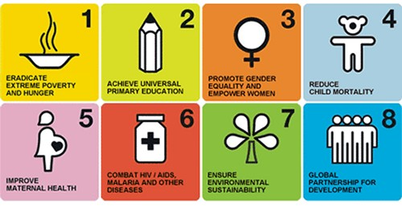
Millennium Development Goals:

Sustainable Development Goals:
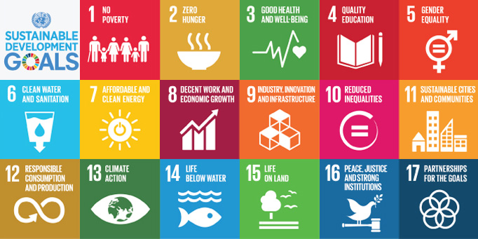

Essay questions:
1. Global Governance: Involves the regulation and coordination of transnational issue areas by nation-states, international and regional organizations, and private agencies through the establishment of international regimes. These regimes might focus on problem solving or the simple enforcement of rules and regulations.
Three problems:
- Coordinating global linkages: In this area, rules and laws are critical for managing the exchanges of information, products, services, money, and finance and even for managing collective responses to criminal activity.
- Responding to common problems: The global community faces common problems like global warming, poverty, human rights abuses, refugees, and pandemics, all of which require some form of coordination and collective policy response.
- Protecting core values: Institutions and laws are essential for protecting and promoting core values like equality, liberty, democracy, and justice across the world.

Castell’s 4th point: Globalization has increased inequality in many states and created a crisis of equity.

2. Supranational law: is a form of international law, based on the limitation of the rights of sovereign nations between one another. It is distinguished from public international law, because in supranational law, nations explicitly submit their right to make judicial decisions by treaty to a set of common tribunal. The United Nations Security Council and subordinate organizations such as the International Court of Justice are the only globally accepted supranational tribunals.
3. New Wars: Wars of identity between different ethnic communities or nations and wars that are caused by the collapse of states or the fragmentation of multiethnic states. Most of these new wars are internal or civil wars.
Mary Kaldor has suggested that these types of wars has emerged since the mid-1980s. Just as earlier wars were linked to the emergence and creation of states, the new wars are related to the disintegration and collapse of states, and much of the pressure on such states has come the effects of globalization. In the past decade, 95 percent of armed conflicts have taken place within states rather than between them. The new wars occur in situations where the economy of the state is performing extremely poorly, or even collapsing, so that the tax revenues and power of the state decline dramatically, producing an increase in corruption and criminality. As the state loses control, access to weapons and the ability to resort to violence are increasingly privatized. Paramilitary groups proliferate, organized crime grows, and political legitimacy collapse. One of the effects of the developments is that the traditional distinction between solider and the civilian becomes blurred or disappears altogether.
For some observers, the economic rationale, rather than politics, is what drives the new wars, so that war has become a continuation of economics by other means. It is the pursuit of personal wealth, rather than political power, that is the motivation of the combatants. In some conflicts, therefore, war has become the end rather than the means.
4. Terrorism: The use of violence by nonstate groups or, in some cases, states to inspire fear, by attacking civilians or symbolic targets and eliminating opposition groups. This is done for purposes such as drawing widespread attention to a grievance, provoking a severe response, or wearing down an opponent’s moral resolve to effect political change.
Terrorism and globalization share at least one quality – both are complex phenomena open to subjective interpretation.
Historically, the term terrorism described state violence against citizens, for example during the French Revolution or the Stalinist era of the Soviet Union. The term has evolved to mean the use of violence by nonstate groups or networks to achieve political change.
There is little doubt that the technologies associated with globalization have been used to improve the effectiveness and reach of terrorist groups.
5. Human Security: The security of people, including their physical safety, their economic and social well-being, respect for their dignity, and the protection of their human rights. Simply put, it is freedom from fear and freedom from want.
The concept of human security challenges the state-centric notion of security by focusing on the individual. Human security is about security for the people, rather than for states or governments. As such, it has generated much debate. Critics wonder whether such an approach would widen the boundaries of security studies too much and whether “securitizing” the individual is the best way to address the challenges facing the international community from the forces of globalization. On the other side, advocates of human security find the concept effectively highlights the dangers to human safety and survival posed by poverty, disease, environmental stress, and human rights abuse, as well as armed conflict. These disagreements not-withstanding, the concept of human security captures are growing realization that, in an era of rapid globalization, security must encompass a broader range of concerns and challenges than simply defending the state form external military attack.
Explain by reference to the 1994 Human Development Report’s 7 core areas of human security. (name at least 4 areas)
The origin of the concept of human security can be traced to the publication of the 1994 Human Development Report’s, issued by the UN Development Programme. The report defined the scope of human security to include seven areas.
- Economic Security
- Food Security
- Health Security
- Environment Security
…

6. World Trade Organization: Established in 1995 with headquarters in Geneva. Membership of 153 states. The WTO is a permanent institution to replace the provisional GATT. It has a wider agenda, covering services, intellectual property, and investments issues as well as merchandise trade. The WTO also has greater powers of enforcement through its dispute-settlement mechanism. The organization’s Trade Policy Review Body conducts surveillance of members’ commercial measures.
Member states of the WTO agree, among other things, to lower tariffs and to eliminate nontariff barriers to trade, but it is left to the member states to enforce the agreements. The principle that guides the WTO is that multilateral free trade pacts are better than bilateral deals. Another key principle is most favored nation status, whereby member states pledge not to discriminate against their trading partners.
Brazil v US Cotton Dispute:
- Brazil filed a complaint against the US for subsidizing its cotton production (US is 2nd largest producer & largest exporter of cotton)
- WTO ruled in favor of Brazil’s claim & authorized Brazil to lay up to $830 million in tariffs annually against US imports (cars, electronics, medicine)
- US agreed to pay Brazil $147 million per year in, but this was cut in 2013
- Brazil threatened tariffs again but another agreement was reached that saw the US make a one-time payment of $300 million to the Brazilian Cotton Institute
- In exchange, Brazil agreed to not litigate US cotton subsidies until the 2014 US Farm Bill expires in 2018
- This clears the way for the US to increase its exports of cotton (already 80% of cotton produced in the US is exported)
- Brazil can only spend the money on a list of permitted activities and must report to the US how it spends the money
- Why did Brazil give in?
- Possibility of retaliation by the US without WTO authorization in agri and non-agri sectors
- Attacking Brazilian currency through ‘dark market’ foreign exchange trading
- Using intelligence gathered against Brazilian officials, including the President, as revealed in the Wikileaks documents
- Broader business considerations such as Brazil’s even larger meatpacking interests (JBS)
Clear losers include African cotton farmers.

7. Poverty: Orthodox vs. Alternative Views:
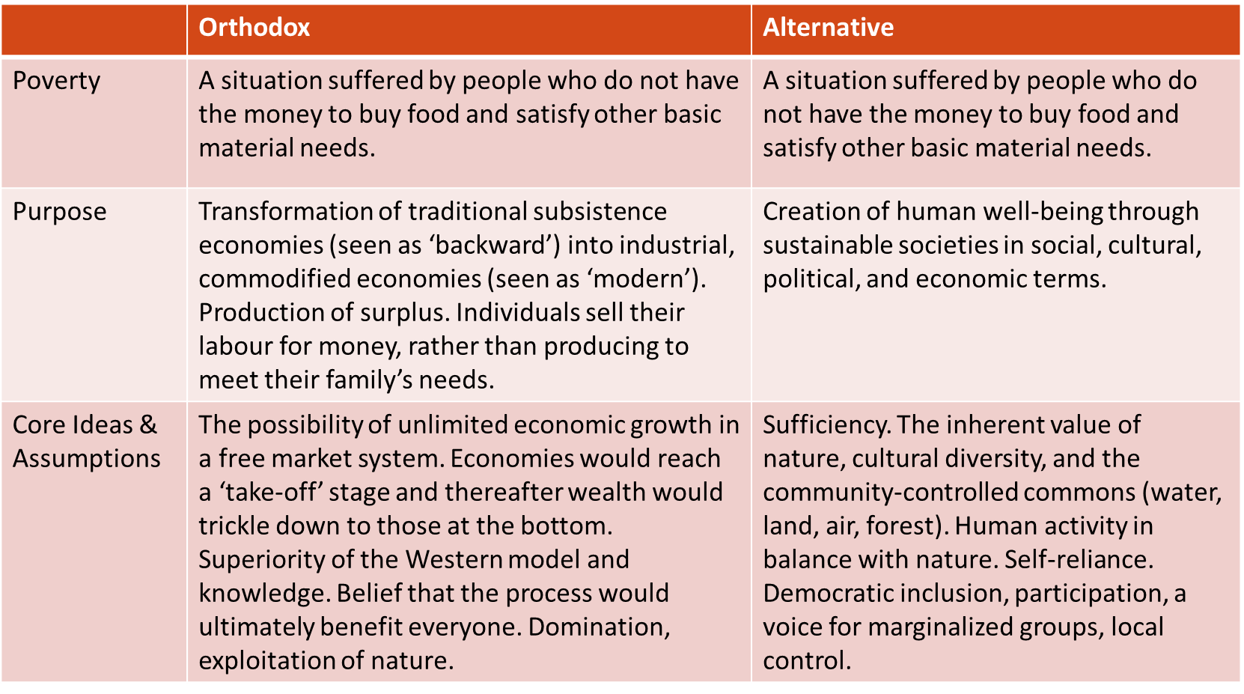
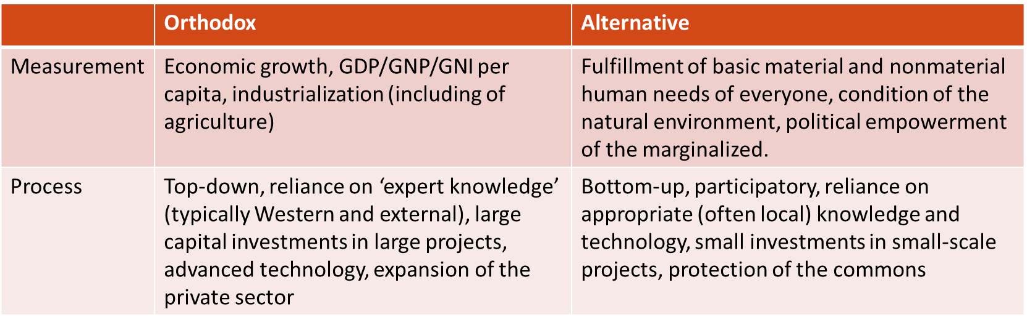

Orthodox Approach: Emerged out of Cold War views on ‘modernizing’ the post-colonial world through incorporating those countries into a system of liberal capitalism, free trade, and foreign aid. By the 1980s, this approach had taken on more of a hyper-liberal tone of deregulation, privatization, and liberalization of financial and investment markets, otherwise known as the ‘Washington Consensus’.
Results:
- Increased inequality
- But also growth for many developing countries in terms of GDP per capita and industrialization
- However, growth has been marked by regional diversity and unequal distribution within countries
- Few, if any, countries have moved up the ladder of economic and social well-being across the board (ex: uneven growth within China & India)
Responses which eventually led to the Alternative view:
- Orthodox views contend that the states that have integrated most deeply with the global economy have grown the most & that inequality exists but is not a problem, instead is a spur to competition and entrepreneurialism
- Critical views (Alternative views) argue that liberal growth strategies are often a part of the problem not the solution to poverty
- From this vantage point, development should be: need-oriented, endogenous, self-reliant, ecologically sound, and based on structural transformation
- This vision of development embraces democratic challenges to entrenched power and interest, as people stand up for their rights as they define them
- Local control and empowerment form the basis of development, which is conceptualized as a community-driven process, not a universal one
- The orthodox debate has shifted from growth to sustainable development
- It has begun to create social safety nets when implementing SAPs and promotes microcredit as a means of empowering women
- The Bretton Woods Project, Fifty Years Is Enough, Jubilee 2000, and Make Poverty History and other movements are at the forefront of calling for more open, transparent, accountable decision-making by global economic institutions, greater local involvement in project planning and implementation, and debt write off

