LESSON 2

Profile of the Canadian Environment
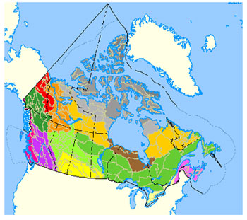 | Click on map to enlarge.  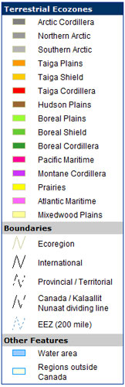
Canada has:
- 6.7% of the world’s land area - 9.2 million km²
- 9% of world’s freshwater
- 9% of the world’s forests
- 13% of the world’s wilderness
- The world’s longest coastline: 250,000 km
- The second-largest continental shelf
- The most extensive Exclusive Economic Zone (EEZ)

The History and Economics of the Canadian Environment
How has Canada’s resource-dependent economy and history shaped Canadian attitudes to the environment over time?

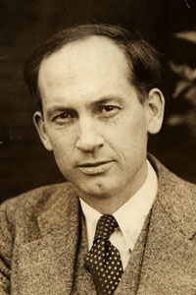 | Historical Context - Harold Innis (1894-1952)  - Staples Theory  - Canadian history defined by dominant staples and associated exploitation and technologies  - Staples-based economy as inherently unstable (hinterland)  - Depletion or exhaustion of a staple produced social and political upheaval  - No explicit concern for environment or sustainability  - Recognition of the existence of physical limits  - Natural Resources  - Renewable resources  - Non-renewable resources

A Profile of Fresh Water
In Canada...
- There are 755,180 km² of lakes and rivers  - There is 7% of the world’s renewable water supply  - Only 1.6% of the available freshwater is withdrawn and used  - 90% of the water withdrawn is used to support economic activity; only 10% is used directly by the residential sector  - Agriculture uses about 5% of total water withdrawals, mostly to irrigate crops | 
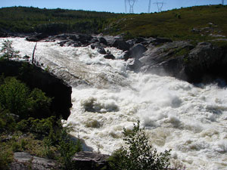 | 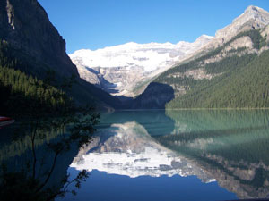

A Profile of Fisheries
In Canada...
- 95% of commercial fishing activities are marine and 5% are freshwater  - The commercial fishery contributes less than 1% of the Gross National Product (GNP)  - Fisheries provide employment for 150,000 and are the sole activity for 1,500 communities  - Recreational fishing contributes $7 billion and supports 150,000 full-time jobs  - Aboriginal subsistence fishing has a replacement value of $15 million | 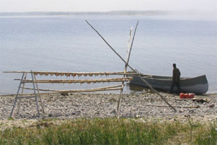
 | 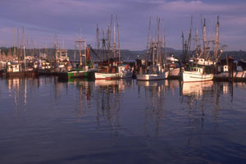

A Profile of Forestry
In Canada...
- There are 417.6 million hectares of forests (45% of total land area; 9% of world’s forests)  - 57% of forests are used for commercial production  - There are 165 tree species  - Forestry contributes $20 billion to Canada’s Gross Domestic Product (GDP)  - The forestry industry is the largest foreign exchange earner (exports $32.4 billion per year) | 
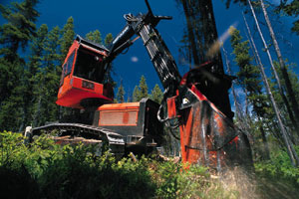 | 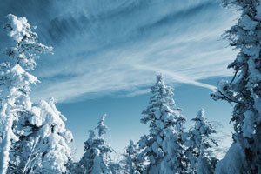

A Profile of Biodiversity
In Canada ......
- There are 71,500 of the estimated 1.5 million species in the world, but only 1,600 have data about them.  - There is 20% of world’s arctic regions; 9% of the world’s forests; 24% of the world’s wetlands; and 9% of the world’s freshwater.  - ‘Endangered’: 316, ‘Threatened’: 167, ‘Special Concern’: 205; Total (listed): 688 (COSEWIC 2015).  - There are 23 extirpated species (COSEWIC, October 2010).  - In 2015, 15 species are classified as extinct in Canada (COSEWIC 2015).  - 80% of species decline is related to habitat destruction or degradation. |   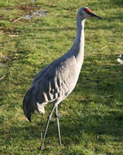
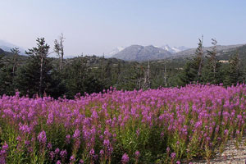 | 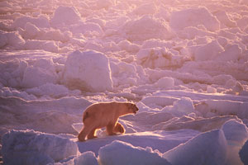

A Profile of Agriculture
In Canada...
- Only 7.3% of Canada’s total land area is suitable for agriculture  - The major agricultural commodities are meat and grains  - According to the Agriculture Canada website: as of 2013, agriculture and agri-food services (AAFS) account for 6.7% of Canada’s GDP.  - Canadian export sales grew by 5.5% in 2013 to $46.0 billion, maintaining its 3.5% share of the total value of world agriculture and agri-food exports¹  - In 2012, the AAFS provided one in eight jobs in Canada (12.5%), employing over 2.1 million people. Primary agriculture accounted for 1.6% of all Canadian jobs in 2012, employing 281,600 people²  - In 2011, there were 205,730 farms, representing a 10.0% decline since 2006. This followed a 7.3% decline between 2001 and 2006³ | 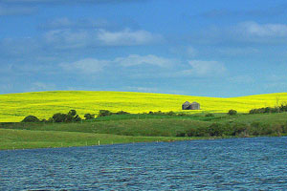
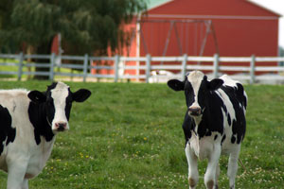 | 
Canada has... | 
- According to Statistics Canada, as of 2015, Canada's population is over 35 million people1
- According to Statistics Canada, the growth rate was 1.1% in 2014 2
- According to World Bank table, Canada’s population density was 4 persons per km2 in 20143
- According to the 2011 National Household Survey, there were a total of 1,400,685 aboriginal peoples in Canada, comprising 4.3% of the Canadian population4
- 81% of the population living in urban areas
- 90% of the population living within 160 km of the U.S. border
Canadian Population Density (click on map to enlarge)
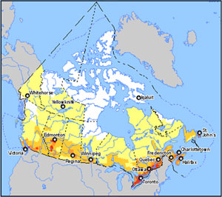 | 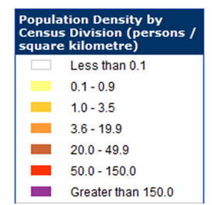

A Profile of Canadians’ Views on the Environment
According to the research polls, Canadians care deeply about the environment
2007 Decima poll | Canadians were more concerned about the environment than about health care.
2009  Nanos poll | In the context of the potential prosperity from oil sands versus the potential environmental harm, most Canadians put environmental protection above economic prosperity.
2009  Ipsos-Reid poll | 57 percent of the public favoured aggressive actions on climate change despite the economic situation.
2014  Nanos poll | According to a poll conducted by the Nanos Research in 2014, Eight in 10 Canadians say it’s urgent or somewhat urgent to have a national conversation about energy and the environment ¹  In another poll conducted by the Nanos Research in 2014, about two-thirds of respondents in Canada (62%) indicated that the environment was more important than energy prices. In the same survey, 53% of respondents said the government should impose carbon taxes on business²
2015  GFK  poll | According to a global poll conducted by the international survey firm GFK in 2015, 73 % of Canadian respondents, just below the 76% average globally, agreed that companies and brands should be environmentally responsible ³

Why do you think Canadians express a strong commitment to the environment?
Part 1: Overview of the Canadian Environment (cont'd)

A Profile of Canadians’ Uses of the Environment
Despite their expressed commitment to the environment:  - In 2011, Canadians’ usage of water per day was reduced to 251 litres¹  - According to Environment Canada, Canada emitted 726,000,000 tons of CO₂ in 2013.² For this year, the per capita CO₂ emission was at 20.7 tons.³  - In 2007, Canadians used 8,169 kg of oil equivalent energy per capita; the graph on the left compares Canada to the world.  To compare Canada to other countries:  - Energy use per capita: Primary energy use (before transformation to other end-use fuels) in kilograms of oil equivalent, per capita (Sources: World Bank, World Development Indicators, Google). | 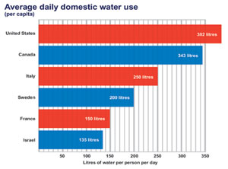  Click on image to enlarge  Image: Wise Water Use (Source: Environment Canada)

Measures of Canada’s Relative Performance
(1) | Environmental Performance Index (EPI)
(1) | Canada ranks 24th place out of 178 countries in 2014 ¹  - Strong scores: Health Impacts (1st), Water Resources (20th), Water and Sanitation (28th), and Air Quality (28th)  - Weak scores: Agriculture (105th), Forestry (104th) amd Biodiversity and Habitat (97th)  - For EPI current year information, visit: Canada EPI rank and score  (Source: Yale Center for Environmental Law & Policy)
(2) | How Canada Performs: A Report Card on Canada (Conference Board of Canada 2011)
(2) | Canada ranks 15th out of 17 peer countries. Environment: C Grade (very uneven performance)  - Canada’s performance is above average on seven indicators:  - Use of forest resources, low-emitting electricity production, Water Quality Index, urban particulate matter (PM10) concentration, urban nitrogen dioxide (NO2) concentration, threatened species, energy intensity  - Canada’s performance is below average on eight indicators:  - Forest cover change, urban sulphur dioxide (SO2) concentration, Marine Trophic Index, greenhouse gas (GHG) emissions, water consumption, organic farming, volatile organic compound (VOC) emissions, municipal waste generation

Part 2: Canadian Environmental Policy

Defining Characteristics
Policy is influenced by:
- General values of the government in place
- Lobby groups
- Public opinion (through the electoral process)
- Electoral campaign promises
- Previous policies (path dependency)
- Institutional context (Constitution)
The Canadian Constitution:
- No direct reference to the environment (British North America Act 1867)
- No guaranteed right to a clean and healthy environment
- No explicit clarification of distribution of powers
Defining characteristics of Canada’s environmental policy:
- Poorly defined jurisdiction over the environment
- Command and control rather than incentive-based approaches
- Guidelines in preference to specific standards
- Negotiation and moral suasion rather than legislative approach
- Enabling rather than mandatory legislation
- Lack of information
- Limited public input
Federal Government (Section 91) |  |  |  | Provincial Government (Section 92)
- Trade and commerce  - Criminal law  - Seacoast and inland fisheries  - Navigation and shipping  - Indians and land reserved for Indians  - Federal spending  - Federal property  - International obligations  - Peace, Order and Good Government (POGG) |  |  |  | - Provincially owned lands and resources  - Local works and undertakings  - Property and civil rights within province  - Matters of local or private nature  - Development, management and conservation of natural resources (Section 92a)  
Constitutional Amendments
- 1982 - Section 92a: provincial government powers
- Charter of Rights and Freedoms
- Section 35: aboriginal right to hunt, fish and trap in traditional ways
Arguments in favour of federal control
- Economies of scale
- Consistency and coherency in national standards
- Constitutional endorsement to deal with inter-provincial issues
- Greater authority concerning international/global issues
- Less conflict of interest with industry and hence less likely to compromise environmental regulations
- More democratically accountable
Political map of Canada (Click on map to enlarge)
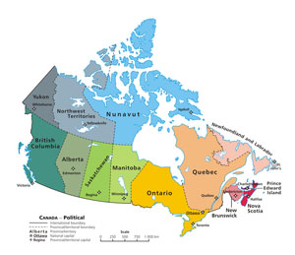
Historical trends in federal-provincial relations:  High public awareness: unilateralism (conflict)  - Aggressive environmental protection; both levels involved, some costly duplication, but otherwise healthy competition  - Characteristic of the late 1960s and the late 1980s  Lull in public attention: rationalization (harmony)  - Devolution of powers; greater federal/provincial cooperation and less public scrutiny  - Characteristic of much of the 1970s  Contemporary trends in federal-provincial relations:  Devolution of powers: principle of subsidiarity  - Provincial to municipal  - Federal to provincial - Canadian Council of Ministers of the Environment Agreement (Harmonization Accord), January 29, 1998 |  |  |  |  |  | 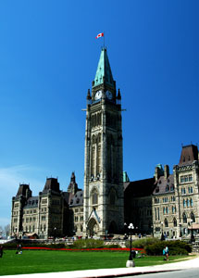

Impediments to the achievement of a sustainable environment:
- Constitutional tensions  - Legislative uncertainties  - Interjurisdictional wrangles  - Political compromises |  |  | - Delegation of responsibility  - Ad hocery and conflict  - Neo-liberal market rationalities |  | 
 | International Environmental Commitments | Examples  - Kyoto Protocol to the United Nations Framework Convention on Climate Change (UNFCCC)  - Montreal Protocol - Protocol for the Protection of the Ozone Layer  - Convention on Biological Diversity  - Convention on International Trade in Endangered Species of Wild Fauna and Flora (CITES)  - World Heritage Convention - Convention Concerning the Protection of the World Cultural and Natural Heritage  - United Nations Convention on the Law of the Sea of 10 December 1982 (UNCLOS)
 | Limitations of International Agreements | - Obligations lack legal teeth  - Sovereignty  - Federalism  - Other agendas  - Cost vs. benefits  - Perceived relevance |  |  |  |  | 
 | Merits of International Agreements | - Shift of 'environment' from periphery to core  - Redefinition of 'environment'  - Recognition of link to long-term competitiveness  - Enhanced role for non-governmental organizations (NGOs)  - Germination area for environmental policy ideas
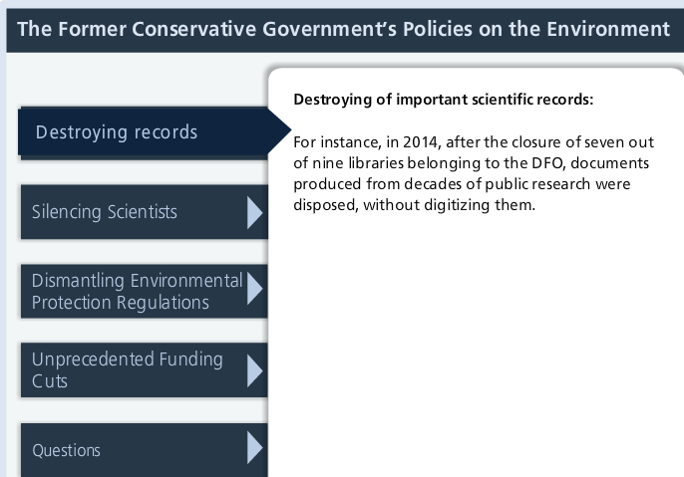
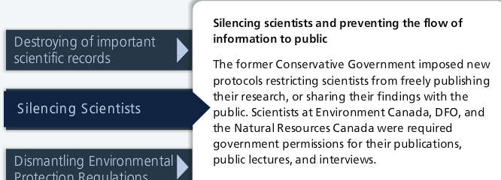
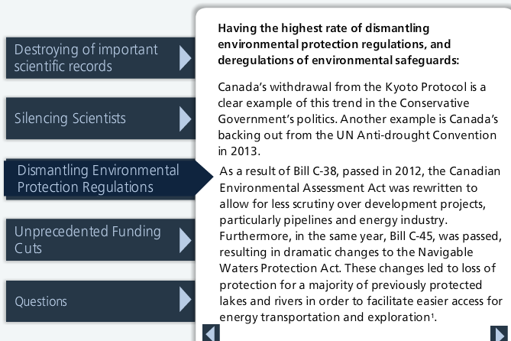
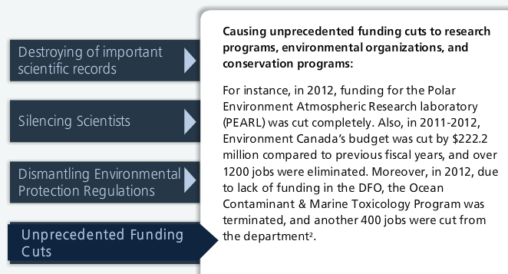
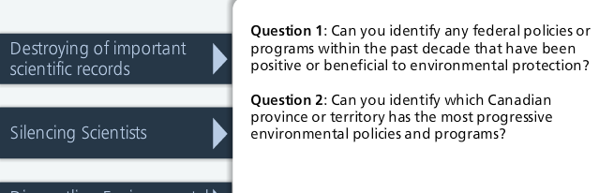

LESSON 3

The Global Crisis in Fisheries
- 70% of the global commercial fish stocks are in crisis.
- The World’s marine catch has quadrupled since the 1960s.
- Dramatic decrease in availability and average size of large commercially desirable species.
- Decline associated with a trend referred to as "fishing down the food chain".
- Unreliable anecdotal reports of decline, but science-based reports and film footage confirm extent of the decline.
- The world’s fishing fleet has expanded twice as fast as world catches in last 40 years.
- Massive fleets are in search of alternative less exploited fishing areas.
- There are impacts of overfishing on fish populations, marine mammals and the entire food web.
- The impact of destructive fishing operations on marine wildlife.
- Problems associated with by-catch.
- The demand for seafood has doubled since the 1980s.
- There are significant food security issues related to the importance of fish for developing world populations.
- The increasing economic dependence of developing world populations on fisheries raises concerns about the future.
Suggested Viewing and Listening: Check out these television and radio broadcasts from CBC Archives.
 | Fished Out:  The Rise and Fall of the Cod Fishery (1958-2004)
"It's greedy, it's ugly and it's built to last. For more than 500 years the Atlantic cod was the king of the global fish market, helping build empires, spark wars and found Britain's first colonies in North America.

(Source: Canadian Broadcasting Corporation)
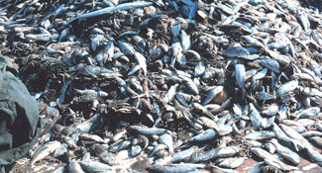
Image left: Shrimp by-catch (Source: Wikimedia); Image right: Fishing boat at dusk (Source: Microsoft Clip Art)

The Socioeconomic Significance of Canadian Fisheries
Beyond the economic value of Canadian fisheries, what is the broader social value of fishing activities to Canadian society?

Commercial fisheries
- Marine fisheries [Atlantic (65%) and Pacific coasts (30%)] comprise 95% of the total production value while freshwater fisheries makes up the remaining 5%.
- Make up less than 1% of the GDP (insignificant in the aggregate national economy).
- Primary and secondary production in commercial fisheries and aquaculture contribute about $3.2 billion to the economy and provide a surplus of $1.5 billion to Canada’s international trade balance.
- Over 80% of Canada’s fish production is exported to about 100 countries, but three major markets (the U.S., Japan and the EU) account for 90% of total fish.
- Provides important economic and social benefits to coastal provinces and northern communities:
  - Employment for over 150,000 Canadians (50:50 active fishermen: plant workers).
  - Sole economic activity in 1,500 communities.

Recreational fishing
- Involves an estimated 3.2 million people each year, generating approximately $7.5 billion for various local economies.
- Supports 150,000 full-time jobs.
- Significant declines in recent years in the number of fish being taken home.

Aboriginal subsistence fishing
- The replacement value is estimated at $15 million (i.e. replacement value: the amount aboriginal people would have to pay to replace the fish caught with other sources of proteins).
- There are no national figures on the size of the aboriginal fishing catch, but it is very important in BC (90,000 status Indians; 3% of the province’s total salmon landing).

The Canadian Fisheries Policy Regime
Under the Canadian Constitution (Section 91), the federal government has exclusive jurisdiction over all matters concerning the sea coast and fishing, including management of virtually all commercial fisheries.The Federal Fisheries Act provides the primary legislative base for fisheries management.
What are some of the constraints on the DFO’s approach to fisheries management?

The Federal Department of Fisheries and Oceans (DFO) is the primary agency responsible for the allocation and management of fisheries and oceans. It uses various fisheries management mechanisms, including:
Output controls:  - Total allowable catch (TACs), individual quotas (IQs), vessel catch limits | Input controls:  - Limited licenses, individual effort quotas, other gear and vessel restrictions | Technical measures:  - Size and sex selectivity, time and area closures
The scope of DFO's mandate was broadened significantly by the Canada Oceans Act 1997 which established federal responsibilities fisheries management within the broader context of other ocean activities, including the establishment of marine protected areas.

Federal and Provincial Relations
Under the Canadian Constitution (Section 92), provincial governments have responsibility for the majority of lands and natural resources, including freshwater fisheries. Provincial governments also have primary responsibility for the fish processing sector.
The federal government delegates certain additional responsibilities related to fisheries to the provinces through regulations under the Fisheries Act. In the wake of the fisheries crises of the 1990s, collaborative arrangements and a commitment to foster improvements in intergovernmental relations were formally established between the federal government and the provinces and territories through the Agreement on Interjurisdictional Cooperation with respect to Fisheries and Aquaculture (1999).
Fisheries policies in Canada are required by the Canadian Constitution (Section 35) to accommodate an aboriginal right to fish for food, social and ceremonial purposes. The Aboriginal Fisheries Strategy (AFS), developed in 1992, provides for management of aboriginal fisheries through negotiation of mutually acceptable agreements between DFO and aboriginal groups.

International Relations
- Extensive Canadian ocean estate
- Exclusive Economic Zone (EEZ):
  - Formally established by the 1982 United Nations Convention on the Law of the Sea (UNCLOS)
  - Implemented by Canada in 1977
  - Extends seaward to 200 nautical miles (370 km)
  - Sovereign and jurisdictional rights over its exploitation and management
  - Excludes foreign vessels beyond which "tragedy of the commons" can often occur
  - Limitation arises where the continental shelf extends beyond the EEZ (nose and tail of the Grand Banks and overfishing of "straddling stocks" by foreign vessels
- West coast interjurisdictional fisheries (Canada and the U.S.) involve complex bilateral catch-sharing arrangements

Part 2: The Atlantic Cod Fishery Collapse
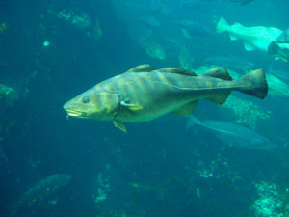 | The Atlantic Cod  - The Atlantic cod (Gadus morhua) is a well-known demersal (bottom dweller or groundfish) fish, commercially known as cod or codling.  - It can grow to 2 metres in length and weigh up to 96 kilograms (210 lb).  - It can live for 25 years and usually attains sexual maturity between the ages of 2 and 4.  - It is brown to green in colour with spots on the upper (dorsal) side, shading to silver on the lower side (ventrally).

Habitat Range
- The Atlantic cod's habitat ranges from the shoreline down to the continental shelf. It lives chiefly in cold water or temperate north seas, at depths of 180 to 360 metres.
- The most productive cod fishing area in the northwest Atlantic region was until recently located off southern Labrador where the cold Labrador Current meets the warm Gulf Stream at the Grand Banks, southeast of Newfoundland.
The combination of these two currents is responsible for creating one of the richest fishing grounds in the world, with an overall annual catch of about 250,000 tons for more than a century up until the mid-1950s.

Early History
More than 500 years ago, explorer John Cabot returned to Europe with stories of the Grand Banks, where cod appeared so thick that a person "could walk across their backs":
In the centuries that followed, the great fisheries of Newfoundland became the primary attraction for anyone to visit and stay. Such was the abundance of these fisheries that in 1883 T.H. Huxley, one of the most famous biologists of his day, proclaimed:
I believe, then, that the cod fishery, the herring fishery, the pilchard fishery, the mackerel fishery, and probably all the great sea fisheries are inexhaustible; that is to say, nothing we do seriously affects the number of fish. And any attempt to regulate these fisheries seems consequently, from the nature of the case, to be useless.

Introduction of Fisheries Legislation in Canada
It was not until 1857 that the first piece of fisheries legislation was introduced in Canada, and it was specific to salmon in rivers and estuaries. Management of marine fish species, such as cods, haddocks and pollacks, was not considered until the mid-twentieth century.
Prior to that time Canadians had traditionally fished mainly in waters relatively close to shore (inshore fisheries) in small crafts using traditional techniques such as traps, jigging from a dory or small inshore gill-nets, long-lines or small trawlers. They joined fishing boats from Spain and Portugal whose crews had also traditionally fished in the northwest Atlantic since before Newfoundland was colonized.
Following World War II, rapid development of fisheries technology (powerful long-range vessels with highly efficient harvesting gear, on-board processing, freezing and storage facilities) led to the establishment of a massive offshore fishery and a dramatic increase in catch.
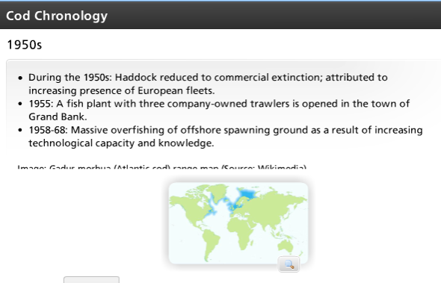.
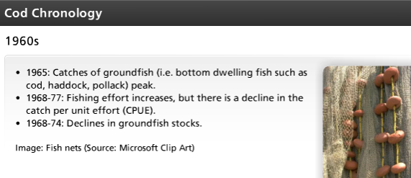
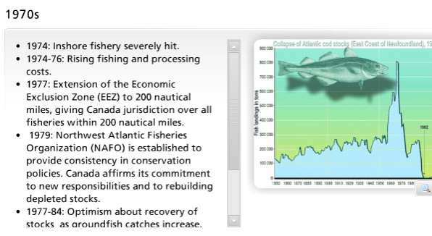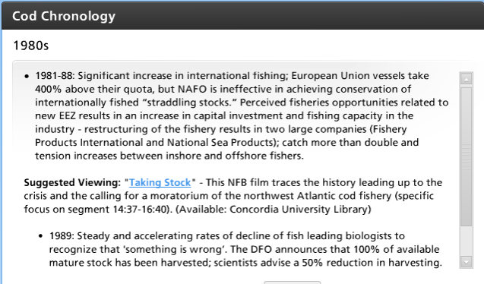
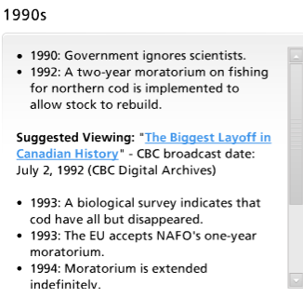
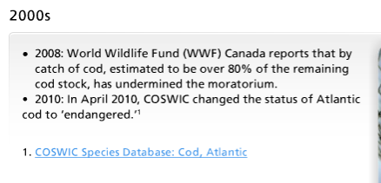

Contributing Factors: (1) The Role of the Fishing Industry
Various factors are believed to have contributed to the collapse of the Atlantic cod fishery.
The role of the major players and factors are outlined in the following slides.

Suggested viewing:
Cataclysm in the Fisheries
Broadcast Date: March 2, 1994, Length 16:03
"It's 1994. Cod fishing has been banned for two years and the cod stock is still declining. Newfoundland and Labrador Premier Brian Tobin is forced to widen the ban to include recreational fishing — which means it's illegal for fishermen to catch even one cod to feed their family ." (Canadian Broadcasting Corporation)
Domestic overfishing occurred due to an overcapacity in the fishing and processing sectors. In other words, fishing capacity was in excess of what was required to ensure a biologically sustainable harvest – i.e. too many fishermen chasing too few fish.
Foreign overfishing (particularly by Spain and Russia) contributed to a decimation of haddock in the 1950s. Particularly problematic was the Russian strategy of 'pulse fishing' used in the 1960's as this was an extremely destructive and unselective technique. The overfishing by international fleets of straddling stocks on the Grand Banks was a major factor in the depletion of cod; between 1985 and 1988, the EU took 400% above quota.
Destructive fishing practices included improper grading, discarding and dumping of immature or non-target species, with as much by-catch as landed fish. The unselective harvesting methods of offshore trawlers which continuously drag and scrape the ocean bottom also caused widespread habitat destruction.
Catch underreporting or misreporting contributed to misleading data for management.
Click on images to enlarge | 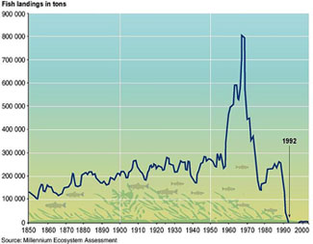
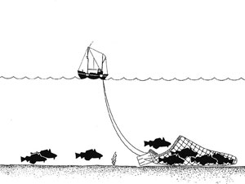
Above left: Trawling boat (Source: Wikimedia); Above right: Collapse of Atlantic cod stocks off the East Coast of Newfoundland in 1992. From the late 1950s, offshore bottom trawlers began exploiting the deeper part of the stock, leading to a large catch increase and a strong decline in the underlying biomass. Internationally agreed quotas in the early 1970s and, following the declaration by Canada of an Exclusive Fishing Zone in 1977, national quota systems ultimately failed to arrest and reverse the decline. (Source: Millennium Ecosystem Assessment, U.S. federal government)

Contributing Factors: (2) The Role of Government
The federal government failed to control the expansion of the domestic effort resulting in massive overfishing in the 1980s in response to the demands of a processing industry with excess capacity. The government was reluctant to implement the necessary changes to rationalize the industry and government support was biased in favour of the large offshore international fishing vessels, to the detriment of the local fishing industry. For example, 95% of fishermen worked in the inshore fisheries but were allotted only 15% of TAC.
What are the advantages and disadvantages of DFO’s dual responsibility for managing Canadian fisheries and protecting Canada’s marine environment?

Government failed to exercise the precautionary principle:
- The TAC was set too high based on scientific projections that were unrealistic and an inadequate understanding of population dynamics.
- Inaccurate data on commercial fishing activity: according to Noel Roy (1996), CPUE is usually a good indicator of stock abundance, but advances in fishing technology distorted the picture by compensating for what would otherwise have been a decline in catch per unit of effort. Under-reporting and by-catch further distort the CPUE, as does harvesting smaller and younger classes of fish.
- Over-reliance on quota-based management which depends on getting the TAC right is focused on economic efficiency rather than sustainable harvesting and encourages discarding and high-grading, resulting in increased by-catch, misreporting and dumping.

Roy (1996: 18) refers to "a fundamental policy failure" linked to poor policy choices (such as ignoring scientific advice and instead acting on "socioeconomic grounds") and unwillingness to accept fundamental uncertainties and errors associated with stock assessment (which scientists claim have an accuracy of +/-30%). William Schrank (1996) believes that the dual role played by DFO was a fundamental problem because it had a conflict of interest between the sustainable management of the fishery and employment maximization and rural economic development, with significant pressure from the provinces to support the latter over the former.
Part 2: The Atlantic Cod Fishery Collapse (cont'd)

Contributing Factors: (3) The Role of the International Community
- The international community in general was too tolerant of overfishing.
- General acceptance of abuse of the TAC regulations.
- Protection of own interests to the detriment of conservation concerns.
- Delimitation of Exclusive Economic Zone (EEZ) based on artificial lines rather than biological/ecological units; the extension of the EEZ to the nose and tail of the Grand Banks would have prevented the massive overfishing by international fishing vessels known to have occurred in the 1980s.

Contributing Factors: (4) The Role of Scientists
Why would too much reliance on biological models be problematic?
Scientists lacked an adequate understanding of the resource and the habitat due to the challenges of stock assessment and the complexity of the ecosystem itself.
Defective data, related to misreporting of catch, underestimation of by-catch and impact of destructive operations as well as failure to adjust CPUE for changes in technology and increase in fishermen’s knowledge resulted in overestimation of stocks in the 1970s and 1980s, and overly optimistic TAC levels.
Analytical methods (theoretical constructs and mathematical models) were based on average values and faulty hypotheses (increased over time). There was a reliance on biological models which focused on single species rather than multiple species and their interactions.
Part 2: The Atlantic Cod Fishery Collapse (Cont'd)

Contributing Factors: (5) The Role of Ecological/Environmental Factors
While overfishing has been identified as "the main culprit underlying the disaster" (Roy 1996: 19), there is some evidence to support the contributing impact of environmental fluctuations/change.
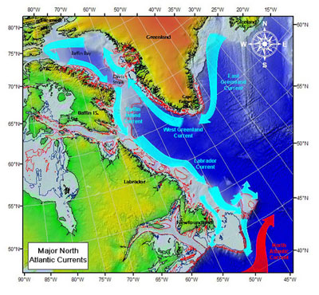
Click on image to enlarge
Map of Labrador Current
(Source: U.S Coast Guard International Ice Patrol, Wikimedia)
- Changes in ocean temperature, particularly bottom temperature, may be related to changes in groundfish biomass.
- The impact on cod and other species migration, reproduction and maturation of temperature change related to terrestrial weather, sea ice cover or lack thereof (e.g. Labrador Current and Gulf Stream: 80 to 100-year cycle).
- Changes in oxygen and salinity levels.
- Changes in current volumes and flow rates of the Labrador Current and Gulf Stream.
- Changes in predator-prey relationships (seals, capelin, crab, shrimp, whales).
- Habitat degradation (pollution, coastal development, fishing gear); e.g. bottom trawl impacts leave juvenile fish more vulnerable due to removal of cover.
- Natural variability or cycles in the abundance of fish stocks (cod are thought to operate on an 11 year cycle) which in combination with other factors could push the population below a critical threshold for recovery.

Lessons from the Cod Collapse
We have identified various contributing factors and there has certainly been a great deal of finger-pointing over the years as one group blames another for their part in the collapse. The following statement captures the complex interplay between a diversity of factors:
"What went wrong? Why have the cod and so many other species been fished to the point of extinction?
There is more than enough blame to be shared by all the fishing nations, but the disaster may be summed up in three words -- protein, profit and plunder. The fishing nations were greedy and overfished the stocks as they ignored the regulations that they themselves had put in place to maintain a sustainable fishery. Technology became devastatingly efficient, though we cannot blame the ecological disaster on technology. The blame must be shared by governments, fish processing companies, and fishers. Governments refused to implement tough conservation measures despite the mounting evidence of declining yields. Fish processor companies were driven by profits, and fishers, who wanted only the best quality fish, often underreported catches and discarded smaller fish as they sought to maximize the dollar value of each voyage to the fishing ground. The resulting devastation of the groundfish fisheries in Atlantic Canada has thrown thousands of people out of work. Today, we can only hope that the social dislocation caused by the collapse of the fishery will send a strong message to all involved in the exploitation of natural resources. Trusting to luck is not an option. Sustainable development requires disciplined cooperation and international responsibility".
The real tragedy of this case was that there was no action taken to address the overfishing of cod even though the signs were there for decades. As Journalist Michael Harris puts it in his book Lament for an Ocean: "The destruction of the northern cod was not a one-act play, but a pageant of greed that went on for decades before the curtain came down. At every step of the way, Cassandra wailed, but no one listened" (1998: 65).
Part 2: The Atlantic Cod Fishery Collapse (cont'd)

The Federal Response to the Collapse

Centre Block, Parliament Hill, Ottawa, Ontario, Canada (Source: Wikimedia)
A Fishery Assistance Program was set up, giving 25,000 Atlantic Canada fishery workers $280 per week from The Atlantic Groundfish Strategy program (TAGS), a four-year program worth $1.9 billion.
- A fisheries restructuring program was established to support license buyback, early retirement and economic development and training.
- Severe reductions in TAC were made, including the closure of many fisheries.
- A 1992 moratorium was implemented on cod fishing; it immediately affected 12,000 fishermen and 15,000 plant workers, with an additional 40,000 jobs lost in the years that immediately followed.
- An incentives program to develop shrimp fishery was set up, but the rationale for this was questionable since cod feed on shrimp!
- The Coastal Fisheries Protection Act 1994 was passed to give DFO authority over straddling stocks on the Grand Banks.
- Measures were implemented to improve the compliance of foreign and domestic vessels with NAFO regulations.
The Science Management Board (SMB) was established in 2005 to provide strategic direction to DFO's Science program, identify issues that affect DFO's ability to meet mandated objectives and select priorities in need of scientific support. The primary objective identified was for DFO Science to provide scientific support for ecosystem-based management.

Part 3: Wrap-up

Aquaculture: A Solution?
For some, the development of aquaculture (i.e. fish farming) is increasingly seen as a possible solution to the current crisis in global fisheries (according to the Food and Agriculture Organization of the United Nations (FAO 2013), farmed food fish contributed a record 42% of the total 158 million tonnes of fish produced by capture fisheries (including for non-food uses) and aquaculture in 2012). ¹
Commercial aquaculture in Canada began in the 1950s, but took off in 1980s. Production has increased fourfold since the 1990s with Canada now ranking 26th in world production.
In Canada commercial aquaculture is centered initially on trout in Ontario and oysters in BC, PEI and New Brunswick. Current focus is mostly on Atlantic salmon which is farmed in British Columbia, New Brunswick, Newfoundland and Labrador and Nova Scotia.

The Aquaculture Industry Today
The industry is currently valued at $800 million (155,000 tonnes) and accounts for 14% of total seafood production (volume) and 35% of its value. It generates over $1.0 billion in GDP and provides 14,500 full-time jobs. Canada exports 70% of its grown seafood, almost exclusively to the United States. Despite the significant socioeconomic benefits, there are concerns about potential impact on coastal ecosystems which include:
- Visual impacts
- Degradation of benthic environment (thousands of tons of fish feces produced!)
- Unmonitored use of chemicals and drugs to reduce disease and its impact on water quality, wild fish stocks and adjacent shellfish beds
- Interference with recreational/commercial fishing and boating
- Introduction/transportation of fish disease and its impacts on native wild stocks
- Reduction in genetic diversity due to wild and cultured stock interbreeding
- Competition between native wild stock and escaped cultured fish for habitat and food resources
Some concerns can be addressed through application of regulations, policies and guidelines (e.g. changing diet to reduce waste, disease and deposition), but aquaculture remains risky as an alternative.

Towards a Sustainable Fishery
- Conservation as paramount
- Precautionary approach as a guiding principle
- Cooperation - shared fisheries management with all stakeholders involved
- Independent scientific research
- Ecosystem and multi-species focus
- Improved understanding of ocean climate and environmental change
- Interdisciplinary research and integration of local knowledge
- Clarification of the role and responsibilities of DFO
- Measures to reduce misreporting, bycatch and dumping
- Diversification of fishery management techniques
- Environmental-friendly fishing gear and practices
- Diversification of local economies
- Preferential treatment of sustainable small-boat BMPs
- Marine protected areas and Integrated Coastal Zone Management
- Binding international agreements
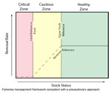 | DFO’s Sustainable Fisheries Plan (Click on image to enlarge)  Fisheries management framework consistent with a precautionary approach. The stock status zones are created by defining the Limit Reference Point (LRP) at the Critical: Cautious zone boundary, and an Upper Stock Reference Point (USR) at the Cautious: Healthy zone boundary and the Removal Reference for each of the three zones. (Source: Department of Fisheries and Oceans Canada)

LESSON 4

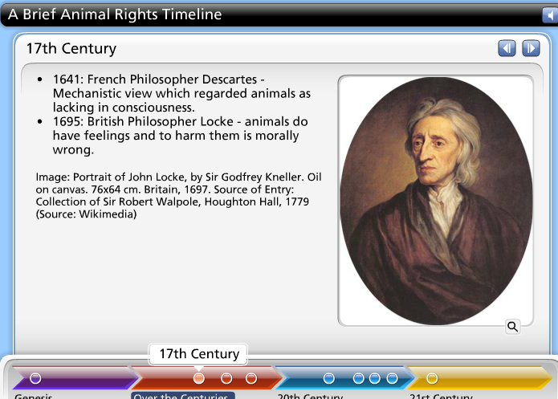
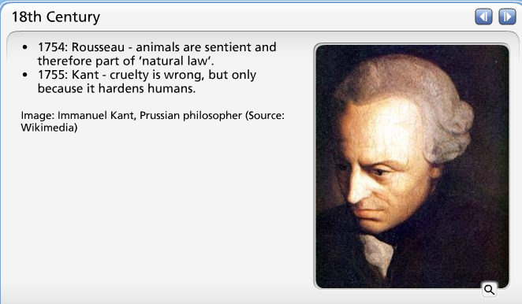
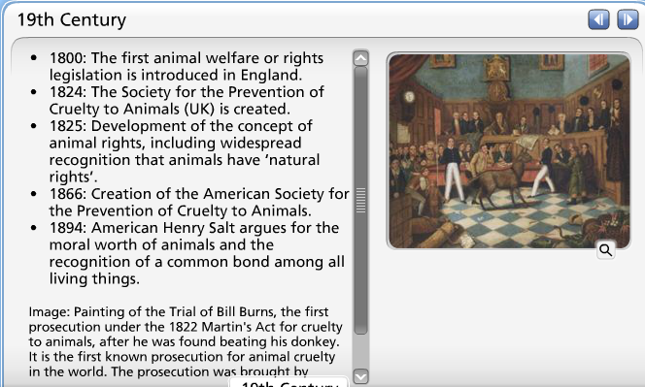
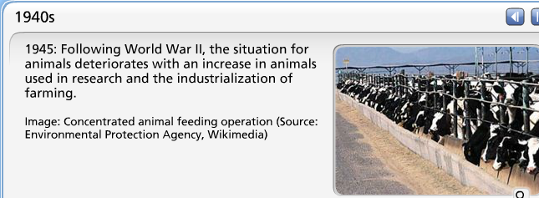
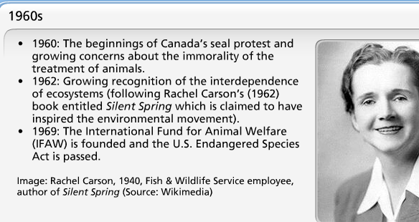
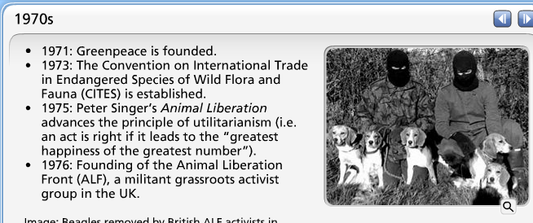
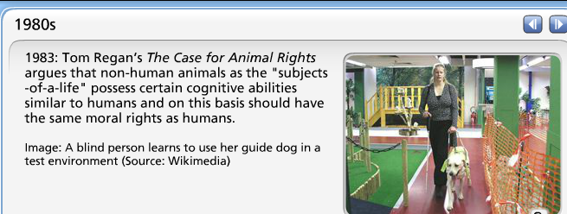
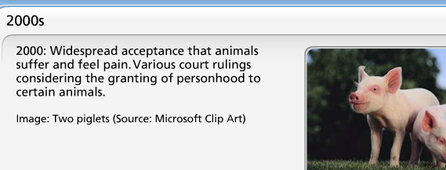
Part 1: The Animal Rights Movement (cont'd)

Philosophical Perspectives
Consider your own personal philosophical position.
Would you align more closely with a utilitarian or rights-based perspective?
 | 
Peter Singer,  professor of Bioethics at Princeton presenting at the College of New Jersey (Source: Wikimedia) | Tom Regan,  professor emeritus of philosophy at North Carolina State University (Source: Wikimedia)
Differences in perspective within the animal rights movement tend to come down to those who hold more traditional animal welfare concerns (utilitarian) versus those with more militant animal rights interests.

Utilitarian Perspective
Peter Singer - Bioethics, Princeton University
- Focus on consequences of an act rather than “natural rights’.
- The interests of animals should be given equal consideration to the similar interests of humans.

Rights-Based Perspective
Tom Regan - Philosophy, North Carolina State University
- Focus on whether acts are inherently right or wrong, regardless of their consequences.
- Animals are “subjects-of-a-life”, they have moral rights which cannot be ignored.
Gary Francione - Law and Philosophy, Rutgers School of Law
- Focus on one animal right: the right not to be treated as property (i.e. owned).

Part 1: The Animal Rights Movement (cont'd)

Contradictions


Above: Model Christy Turlington posing for People for the Ethical Treatment of Animals (PETA). The series of ads triggered criticism from feminist animal rights advocates; Below: A monkey in a restraint tube filmed by PETA inside Covance, Vienna, Virginia, 2004–2005 (Source for both: Wikimedia)
The animal rights movement is associated with numerous contradictions and inconsistencies, including:
- No wild duck, but supermarket chicken is okay.
- Trapping is bad, but the use of animals in labs is acceptable.
- Experimentation on rats, but not on primates.
- Medical research is okay, but not research for cosmetics or weaponry.
- Leather shoes and bags are acceptable, but not fur coats.
- Fish and chicken are okay, but not red meat.

These raise important questions, such as:
- Why is it that these inconsistencies exist?
- Why is it considered more acceptable to experiment on rats than it is on primates, or to use leather but not fur?
Stephen Best, formerly of the International Fund for Animal Welfare (IFAW), offers one possible response to such questions. He argues that practices that utilize animals are okay if there is no waste, and if they are not done in excess. In his words: "It is immoral to kill for fashion, for frivolous things."
Can you think of other contradictions and inconsistencies and account for their possible origin and impact?

Addressing Important Questions
Before taking a closer look at the case of the Atlantic Seal Hunt Protest, what is your response to each of the four questions raised on this slide? Revisit these questions after you have read the case.

With animal rights issues, the controversy is rarely as black and white as whether “to hunt or not to hunt”. Other factors, and hence potential areas of agreement and disagreement, may be involved, such as:
Who  should hunt? | What  should they hunt? | Why  should they hunt? | How  should they hunt?

  Seal hunt protester (Source: Flickr) | There are no clear right or wrong answers to these sorts of questions which is why addressing them often produces inconsistencies even within the animal rights movement itself.  However, by addressing these more specific questions and concerns, we begin to unpack the larger question and gain a better understanding of our own position and priorities as well as that of others. This should facilitate more constructive engagement on these important but often emotionally charged issues.  This lesson focuses on what is perhaps the best known and most controversial of animal rights issues today: the decades long protest of Canada’s Atlantic seal hunt.

Introduction to the Hunt
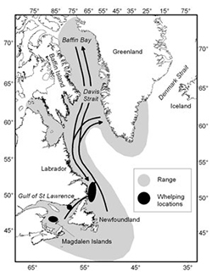
Harp seal migration pattern
(Source: Department of Fisheries and Oceans, Canada)
Harp seals (Pagophilus groenlandicus)
Northwest Atlantic seals:  - 1970s: 2 million harp seals  - 2015: 7.4 million harp seals  Commercial seal hunt:  - Since 1994: Total Allowable Catch (TAC) 186,000-350,000 | Where:  - St. Lawrence Gulf region, ‘gulf’ (30% TAC)  - East coast of Newfoundland ,‘front’ (70% TAC)  When:  - March/April/May  How:  - Shot or clubbed with a hakapik

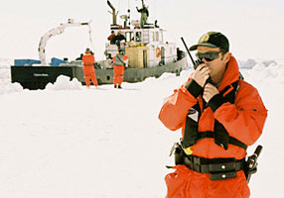 | 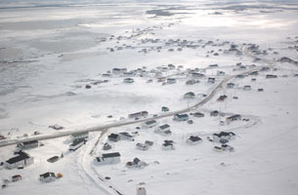

Extent of the Controversy
The seal hunt protest is the longest running and arguably the most successful campaign of any environmental movement in history. Approximately 186,000 seals were being killed each year in Newfoundland before the European Economic Community (EEC) ban, yet the same number of cows, pigs and sheep die each hour in the United States.

Nature of the Controversy
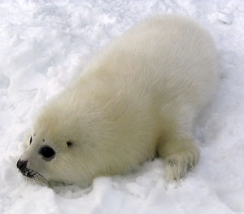
- Strategic language: Hunt or slaughter OR Sea mammals or baby seals
- Powerful images
- Celebrity culture
- Clashing worldviews
- Limited science

Key Events in the History of the Seal Protest
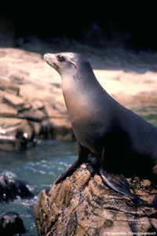
Adult seal
(Source: Microsoft Clip Art)
1969 | - International Fund for Animal Welfare (IFAW) founded
1983 | - European Economic Community (EEC) ban on the import of whitecoat pelts
1987 | - Fisheries and Oceans Canada (DFO) ban on commercial whitecoat hunt
1987-1996 | - Limited seal hunt
1994 | - Revival of the seal hunt in the wake of the collapse of the cod fishery
2006 | - Total Allowable Catch (TAC) peaks at 325,000 seals
2009 | - European Union (EU) ban on seal products

Images of the Protest
These images reflect the diversity of promotional material and protest activities that have been carried out by animal rights activists over the years.
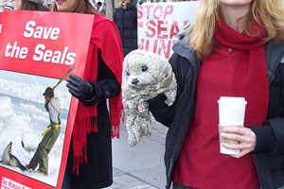 | 
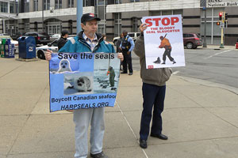 | 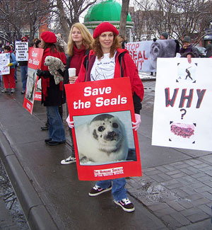
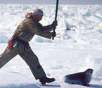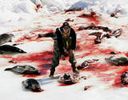

Lesson 4: Animal Rights
Part 2: The Atlantic Seal Hunt Protest (cont'd)
North West Atlantic Harp Seals
Year | TAC  (Total Allowable Catch) | Actual Catch
1994 | 186,000 | 53,000
1995 | 186,000 | 65,000
1996 | 250,000 | 242,000
1997 | 275,000 | 264,000
1998 | 275,000 | 282,000
1999 | 275,000 | 245,000
2000 | 275,000 | 92,000
2001 | 275,000 | 226,000
2002 | 275,000 | 312,000
2003 | 350,000 | 290,000
2004 | 350,000 | 366,000
2005 | 325,000 | 330,000
2006 | 325,000 | 355,000
2007 | 270,000 | 225,000
2008 | 275,000 | 218,000
2009 | 280,000 | 75,000
2010 | 330,000 | 67,000
2011 | 400,000 | 38,000
2012 | 400,000 | 71,000
2013 | 400,000 | 98,000
2014 | 400,000 | 60,000

Sustainability of the Hunt: DFO Perspective

- Sustainable harvest is possible and even preferable to no harvest because beyond a certain threshold, biological productivity is inversely related to population size.  - The DFO management objective: to maintain the herd above 4.1 million animals (N70 on the graph right).  - For more information on DFO's response to ‘myths’, refer to the suggested reading: “Canadian Seal Harvest: Myths and Realities.”  Image: DFO Harp Seal Management Goals  (Source: Fisheries and Oceans Canada) | 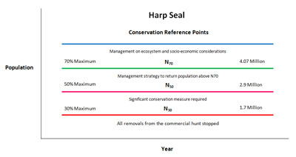

Ecological Arguments For/Against the Hunt

Conflicting ecological claims in relation to the hunt have been put forward:

DFO claims:
- The TAC is based on sound conservation principles.
- The current population level can support a sustainable hunt.
- Seals eat cod and are impeding the recovery of cod stocks in some areas.
- For more information from DFO, check out their website:
Canadian Seal Harvest – Myths and Realities
- Frequently asked questions about the seal harvest

Counter claims:
- Seals eat cod, but seals also eat other fish that prey on cod (see food web for Northwest Atlantic); ocean ecosystems are more complex than DFO suggests.
- For more information from IFAW, check out:
Animal Fact Sheets: Harp Seals

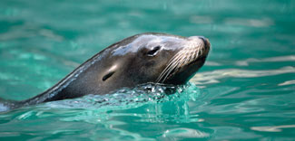

Socioeconomic Arguments For/Against the Hunt
Conflicting claims with respect to the socioeconomic implications of the hunt are also put forward.
DFO Perspective |  | Animal Rights Perspective
- A "significant" source of income in the context of a jobless rate of 15%.  - Provides up to one-third of annual income for some sealers.  - A minor industry in terms of its contribution to Canada's GDP, but locally important. |  | - Minor contribution of 0.06% to Newfoundland's Gross Domestic Product.  - Associated with "frivolous fashion" (furs), artificially created and subsidized markets (seal oil) and black markets (seal penis).  - Only 5,000 to 6,000 sealers (1% of the provincial population).
  
  Suggested Viewing:
  Sealer testimonial
  Canadian Seal Hunt 2009
  Length: 01:10 (Fisheries and Oceans Canada (DFO), Communications Branch)
  Transcript: "If there wasn't a hunt, I guess there would have to be some difficult decisions made and I guess it would mean that I would have to make a decision and probably sealers like myself would have to make a decision on whether or not we could stay in this community. If we lost the seal hunt, I doubt very much if we could survive in a community like this and you know, you put it to your own self, if you have lost 25% to 40% of your own income, and just think about it, what would I do? And basically that is what it means. I would say that we are just ordinary folks who try to make a living from the sea, you know."
  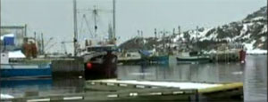

Why Protest? Fund-Raising
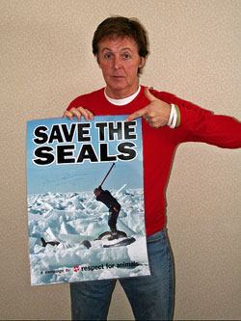
Another perspective related to economic arguments focuses on the motivation of animal rights groups and their long-standing commitment to this particular issue. In the context of the seal population not being endangered or threatened, the point has been made that animal rights groups make more money on an annual basis from their involvement in the seal protest than the sealers themselves earn, leading critics to claim that fund-raising, not protection of species, may be the prime motivation for animal rights groups.
- Supporters of the seal hunt highlight the status of the Canadian harp seal which is listed as "least concerned“, with a healthy and abundant population.
- Some claim that the attention given by animal rights groups to this issue is unwarranted given the healthy status of seals and that the motivation for the protest is the significant revenue it generates for these groups:
  - IFAW: $86 million USD (2009) (Source: IFAW Annual Reports
  - Greenpeace: €195.8 million (2009) (Source: Greenpeace International)
  - PETA: 35 million USD (2010) (Source: Financial Reports)

What is Hunted? Baby Seals!

Marine Mammal Regulations (1993):
- Prohibits commercial hunting of infant harp seals (whitecoats) and infant hooded seals (bluebacks).
Listen to Rebecca Aldworth express her views on what exactly is being hunted.
(Video Length 00:45)
Click on Play to view the video.
- Seals may only be killed once they have started molting (from 12 to 15 days of age) as this coincides with the time when they are abandoned by their mothers.
- Requires that every person "who fishes for seals for personal or commercial use shall land the pelt or the carcass of the seal.“
- Establishes regulations concerning the use of rifles and hakapiks.
Suggested viewing:
DFO Perspective:
- The Harvesting of Harp Seal Pups . The harvesting of seal pups known as white coats, or blue backs (the hooded seal pups), is illegal in Canada and has been since 1987 (Source: Department of Fisheries and Oceans, Canada, YouTube, 00:20)
Humane Society Perspective:
- The Life of a Baby Harp Seal . Watch how the first few weeks of a baby seal's life unfold (Source: YouTube, 00:52)

How the Seal Hunt is Conducted
The conflict and confusion concerning whether Canada's commercial seal hunt is "acceptably humane" revolve around two reports, both based on observations of the 2001 seal hunt and on IFAW video footage of sealing activities.
Listen to Rebecca Aldworth describe her first-hand experience of the seal hunt and share her views on how the seal hunt is conducted. (Warning: video has graphic descriptions of the seal hunt.)
(Video Length 08:21)
Click on Play to view the video.
- The Burdon et al. (2001) report by an international panel of veterinary scientists finds that up to 42% of seal carcasses were likely conscious when skinned and concludes that the hunt is unacceptably inhumane.
- The Daoust et al. (2002) report from a group of Canadian veterinarians claims that 98% of the seals "are killed in an acceptably humane manner".
The contradictory claims of these experts can be explained, according to Lavigne (2005: 1), by: "the different approaches and criteria used in two studies to determine whether animals were killed humanely or not". For example, Burdon et al. (2001) is based on post-mortem analysis of skulls while Daoust et al.(2002) focuses only on seals that were brought aboard sealing vessels. A Royal Commission report (1987) also confirms the humaneness of the clubbing method. The extent to which regulations are enforced has been a concern, however.

Recent Developments

Listen to Rebecca Aldworth discuss these recent developments and her hopes about the future of the seal hunt protest.  (Video Length 08:25)  Click on Play to view the video. | The momentum builds.  - May 2009: EU proposes a ban on trade of seal products.  - February 2011: Canada and Norway launch a formal challenge to the EU ban at the World Trade Organization (WTO).  - September 2015: European Parliament votes in favour of WTO-compliant seal product trade regulation changes.  - October 2015: EU regulation to ban trade in commercial seal products enters into force (with an exemption for Inuit or other indigenous communities).

Part 3: Wrap-up
Listen to the wrap-up for this lesson.
(Video Length 03:10)
Click on Play to view the video.

Roles, Responsibilities and Science
Issues that are tied to ethical and moral considerations are inherently difficult to resolve. However, there are some measures that could be taken to improve scientific inputs to issues such as animal rights, but also a broader range of environmental and natural resource management situations.
What are the roles and responsibilities of scientists, ENGOs, government and the media?
Science inputs can be improved using measures, such as:
  - Encourage independently funded research
  - Ensure adequate funding
  - Standardized research designs and procedures
  - Preference for long-term, on-going research timeframes
  - Development of researcher profiles to make biases apparent
  - Interdisciplinary teams to ensure holistic view
  - International networks - transfer of knowledge

LESSON 5

Part 1: An Overview of Climate Change
Click on Play to listen to the MP3.

The Global Energy Balance and the Greenhouse Effect.
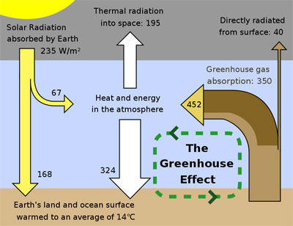
This figure is a simplified, schematic representation of the flows of energy between space, the atmosphere, and the Earth's surface, and shows how these flows combine to trap heat near the surface and create the greenhouse effect (Source: R. A. Rohde, Wikimedia)

What is the Greenhouse Effect?
- A natural and essential phenomenon,
- Solar radiation trapped in the atmosphere by "greenhouse gases" (GHGs) results from:
  - Water vapour (H₂O) in the form of clouds.
  - Carbon dioxide (CO₂) from the burning of fossil fuels.
  - Methane (CH₄) from animal waste, decaying material.
  - Chlorofluorocarbons (CFCs), manufactured gases like aerosols.
- Keeps Earth at a habitable global average temperature: between 14 and 15°C.
- Without the greenhouse effect, Earth would be around -18°C.
- The greenhouse effect, in its natural state, is crucial to life on Earth.
- Too many GHGs, however, means higher temperatures within the atmosphere.
This Enhanced Greenhouse Effect is responsible for global warming

How Does the Greenhouse Effect Happen?
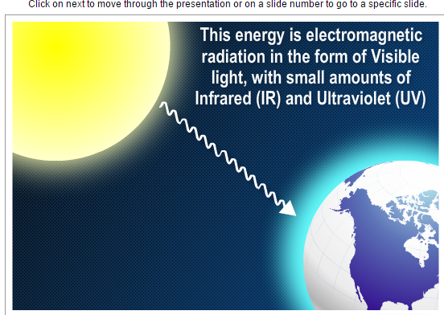
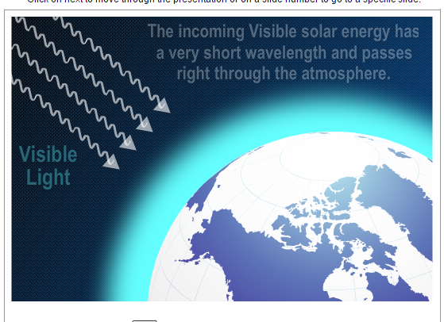
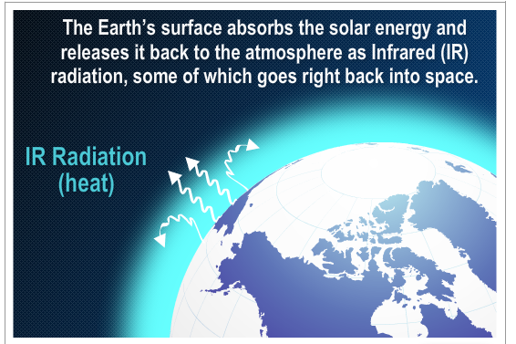
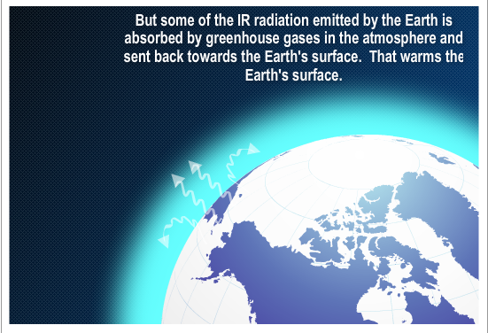
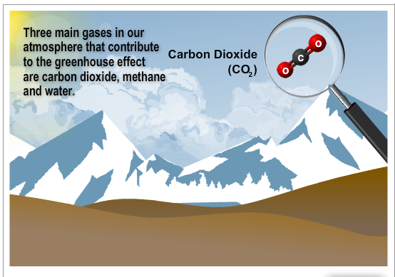
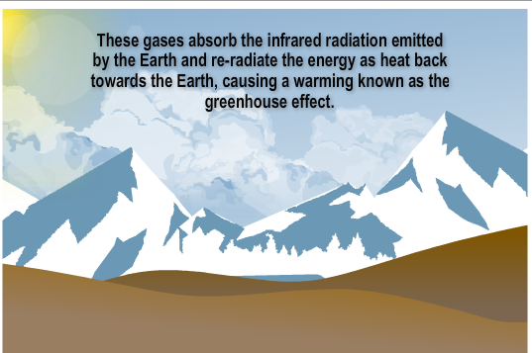
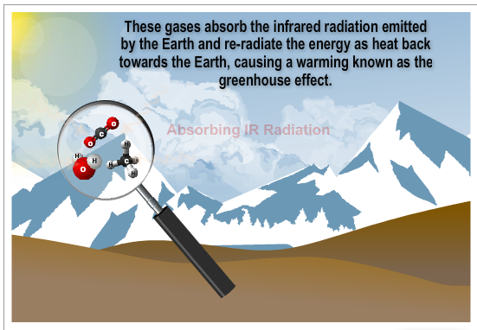
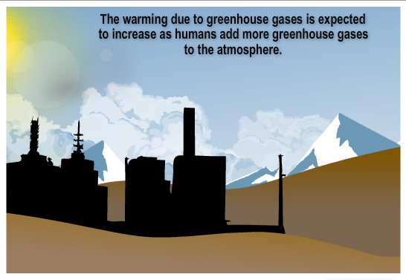

Natural and Human Causes
According to the Intergovernmental Panel on Climate Change (2007), variations in the Earth’s climate over time are caused by two main factors. These include: natural internal processes, such as El Niño and the Arctic Oscillation and changes in external influences either of natural origin (like volcanic activity and variations in solar output) or caused by human activity (like greenhouse gas emissions, human-sourced aerosols, ozone depletion and land use change).
Main causes of  increases in GHGs in our atmosphere: | - Natural internal processes (El Niño)  - Natural external processes (volcanic activity, variations in solar output)  - Human-induced external processes (GHG emissions, ozone depletion, land-use change) | Alone or together, these can all contribute to global warming and climate change

Greenhouse Gas Emissions and Land Use
These two maps demonstrate the impact that land-use change has on a country’s per capita greenhouse gas emissions. See, for example, the difference in Brazil and parts of Indonesia. (Click on maps to enlarge.)

Greenhouse gas emissions per capita in 2000 with land-use change
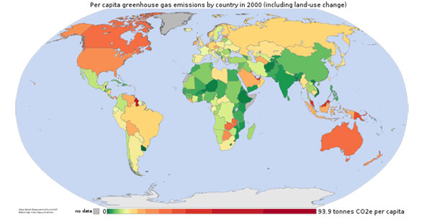

Greenhouse gas emissions per capita in 2000 without land-use change
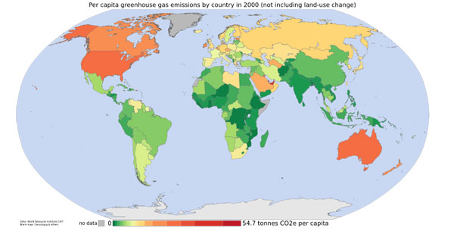

Dilemma of Uncertainty
Projections into the future are always uncertain.
In the case of climate change, uncertainties can be grouped under two headings:
1) Scientific uncertainties:
- Long time scale of the GHE phenomenon has implications for our ability to conduct research and present evidence.
- The signal of climate change is masked by the noise of natural climate variability.
- Lack of understanding of some fundamentals of the Earth’s climatic system.
- Limited understanding of the role of feedback mechanisms.
- Limitations of Global Climate Models in terms of: a) enormous cost; b) coarseness of the areal coverage (very broad regional coverage only); and c) unreliable with respect to key variables such as precipitation.
2) Uncertain role of human activities: | Despite these uncertainties, the Intergovernmental Panel on Climate Change (IPCC), comprised of more than 1,000 scientists, issues a report every six years on the scientific consensus regarding climate change, including projections for future change.  - The most recent report was the IPCC Fifth Assessment Report (2014).
- Uncertainties with GHG emissions.
- Uncertainties with present GHG emissions.
- Uncertainties with future GHG emissions.
Part 1: An Overview of Climate Change (cont'd)

Scientific Consensus on Climate Change
The scientific consensus on climate change relates to three different aspects. First, there is an agreement that the average global temperature has increased by 0.6°C, +/- 0.2°C since the 19th century. The graphs below demonstrate the extent of temperature changes that have occurred, both by continent and globally. Second, the increase in the average temperature for the northern hemisphere was greater for the last century than at any time during the past 1,000 years. Third, increased greenhouse gases in the atmosphere, a reduction in permafrost and snow cover, and the loss of glacier mass are all consistent with increases in global temperatures.
Despite some uncertainties, consensus has been reached on many certainties:
Conclusions of the IPCC (2007):
- Climate change and global warming are a reality, and human activity is largely to blame.

  - That the average global temperature has increased significantly over the last century.
  - That unprecedented temperature increases occurred in the northern hemisphere.
  - That there is growing evidence of changes:
    - Increased atmospheric GHG concentrations
    - Melting glaciers/permafrost/snow cover

Temperature Changes for 1901-2000  (Click on image to enlarge) |  | The melting Cavell Glacier (Jasper National Park, Alberta)  dipped in its own meltwater.
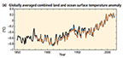 | 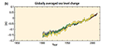 | 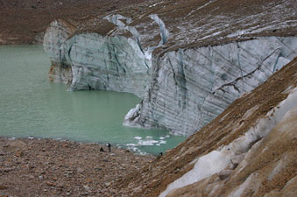
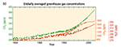 | 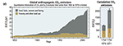

Cause for Concern

Climate Change and Biodiversity
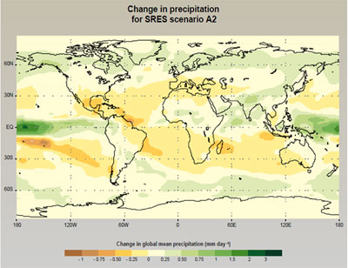
Source: Intergovernmental Panel on Climate Change, "Climate Change and Biodiversity," IPCC Technical Paper V, April 2002, p. 9, http://www.ipcc.ch.
According to the IPCC model projections for climate change, if nothing is done to address the situation we will see potentially catastrophic phenomena, including:
- A rise in average global air temperature of 2 to 4.5°C by 2100; a rise in sea level of 15 to 59 cm by 2100.
- A general increase in precipitation levels and changes in precipitation patterns globally.
- An increase in the frequency and magnitude of droughts, floods and other such hazards.

Is climate change more than global warming?
Potential impacts of climate change extend beyond changes in temperature to include:
- Food security issues
- Sea-level rise
- Ecological disruption
- Social and political impacts
It is important to note that:
- The current rate of change is unprecedented.
- A realized warming of 1°C would almost inevitably imply a continuing rise to around 3°C by the end of the 21st century.
- Impacts will vary geographically - the map on the right illustrates how certain areas will experience a marked decrease in precipitation, exacerbating already dry conditions.

Human Response to Climate Change
Earth’s atmosphere is the ultimate example of a “global commons” (i.e. a commonly-held resource).
  Child wearing a gas mask holding a globe of the Earth (Source: Microsoft Clip Art) | Climate change (global warming) is a classic example of the “tragedy of the commons” because:  - The activities of every human being contribute in some way to the problem.  - Some individuals contribute more negative inputs than others.  - In this respect, More Developed Countries (MDCs) contribute five times the GHG emissions of Less Developed Countries (LDCs), but the population growth of LDCs populations combined with their aspirations to industrialize means that LDC contributions will rise.  - All individuals reap the benefits from the services performed by the atmosphere.  - All are subject to the problems (to a greater or lesser extent) resulting from global climate change.  Challenges to designing appropriate response strategies:  - Uncertainty of exact causes, possible consequences and hence the most appropriate actions.  - No “easy” solution; response will involve major economic and social costs.  - Who will bear the cost? Conflicting interests and perspectives on this.  - Ultimate example of the global commons and the challenges of managing the commons effectively.

Current Responses to Climate Change
Human Development Report, 2008  Two possible responses to climate change:  - Mitigation: Avoid/stop climate change before it happens  - Adaptation: Adapt to the changes/challenges associated with climate change | Arenas for mitigation/adaptation  - Political  - Economic/technological  - Social

Mitigation strategy: Fuel-efficient vehicles | Adaptation strategy: Stilt house in southern Laos
  E85 sticker in the back of the fuel filler door (top left) + E85 bright yellow gas cap (bottom left) + Three typical U.S. commercial E85 flexible-fuel badges from Chrysler (top right), Ford (middle right) and GM (bottom right) (Source: Mariordo Ortiz, Wikimedia) | 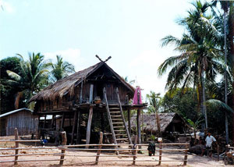  A stilt house in Attapu Province, southern Laos. Stilt houses or pile dwellings or palafitte are houses raised on piles over the surface of the soil or a body of water (Source: Doron, Wikimedia)

Political Solutions
Over the last two decades, there have been several attempts at developing international agreements with regards to climate change. These include:
- The Toronto Convention (1988) | - The “Framework” Convention on Climate Change in Rio (1992) | - The Kyoto Protocol (1997) | - The Copenhagen Summit (2009)
- The Cancun Agreements (2010) | - The Durban Platform For Enhanced Action (2011) | - The Doha Amendment to the Kyoto Protocol (2012) | - Lima Climate Change Conference (COP20 UN) (2014)
- Paris Climate Change Conference (COP21 UN) (2015)

 | 2015 Paris Climate Change Conference  The objective of this conference is to achieve, for the first time in over 20 years of UN negotiations, a binding and universal agreement on climate, from all the nations of the world.  In May 2015, Pope Francis published an encyclical called Laudato si' intended, in part, to influence the conference. The encyclical calls for action against human-caused climate change. The International Trade Union Confederation has called for the goal to be "zero carbon, zero poverty", while the general secretary Sharan Burrow has stated that there are "no jobs on a dead planet".

Economic and Technical Solutions
- Economic and technical mitigation strategies include technological initiatives (such as fuel-efficient appliances or vehicles) and clean development mechanisms.
- Clean development mechanisms provide incentives to companies to adopt "greener" operations, including: carbon taxes, credits on emissions, tradable emission permits and subsidies on non-polluting technologies.
- Clean development mechanisms also include life-cycle accounting, whereby an inventory is taken of relevant energy and material inputs and environmental releases of a product. In addition, an evaluation of the potential impacts associated with these inputs and releases is made. These two steps allow for a clearer picture of what the broader social and environmental impacts a given product has and may allow for more informed decision making on the part of the consumer.
- International standards and corporate responsibility are also important, and to that end many companies are focusing on maximizing efficiency and conservation, both to save resources and to play to the public’s increasing desire to "go green".
 | 

Social Solutions

Thinking globally, acting locally
- National initiatives: 20% club
- Provincial
- Local initiatives: Cities for Climate Protection Program:http://www.icleicanada.org/programs/mitigation/pcp
- Concordia University's contribution:
  - Sustainable Concordia:http://sustainable.concordia.ca
  - R4: Rethink, Reduce/Reuse, Recycle:http://sustainable.concordia.ca/working-groups/r4-rethink-reduce-reuse-recycle/
  - SAF: Sustainability Action Fund:http://www.safconcordia.ca/
- Our individual responsibility
(The web links on this page are also available on the Lesson Links page for this lesson)
Part 1: An Overview of Climate Change (cont'd)

Montreal Protocol
According to Ban Ki-Moon, the United Nations Secretary General:
“A quarter-century ago, one of the greatest challenges facing humanity – the thinning of the ozone layer that protects life on Earth from the harmful ultraviolet rays of the sun – led to what is arguably the best example yet of global cooperation on an environmental issue. The Montreal Protocol on Substances that Deplete the Ozone Layer is not merely a success in meeting its immediate objectives, it offers substantive lessons and inspiration in addressing other global challenges and turning them into opportunities for common progress.”
– Press release: 10 September, 2012
Also, in 2003, political recognition of the Protocol came in the statement of then United Nations Secretary General, Kofi Annan, who termed the Montreal Protocol as “perhaps the single most successful international environmental agreement to date”. (Source: Key Achievements of the Montreal Protocol to Date)

The Montreal Protocol
In 1981, UNEP (United Nations Environment Program), the voice for the environment in the United Nations, proceeded with a proposal to develop a global convention on the ozone layer. Eventually, the proposal resulted in the 1985 Vienna Convention on theProtection of the Ozone Layer, a multilateral environmental agreement. Two years later, in September 1987, the Montreal Protocol on Substances that Deplete the Ozone Layer was negotiated and ratified by Canada along with 23 other countries. (Source:Environment Canada)

Main objective
The core objective of the Montreal Protocol was to gradually phase out all ozone-depleting substances (ODSs) across the globe. In order to accomplish this goal, signatory parties were provided with timelines and assistance to eliminate the consumption and production of ODSs in their countries. (Source: Environment Canada)

Outcomes
- In 2009, the Montreal Protocol became the first UN agreement to achieve universal ratification, affirming the world’s commitment to resolve the ozone crisis and protect our environment. (Source: Key Achievements of the Montreal Protocol to Date)
- By 2010, the phase-out milestone was achieved; all parties had eliminated the consumption and production of ODSs.
- Global observations have confirmed that major ODSs levels in the atmosphere are declining, and it is expected that with the fulfillment of the Protocol’s provisions, the ozone layer will be restored to its pre-1980 levels by the middle of this century.
- The recovery of the ozone layer has circumvented millions of fatal, and non-fatal skin diseases. Additionally, these improvements have delivered substantial climate benefits (ibid).

Ozone Depletion comparison in North America from 1984-1997
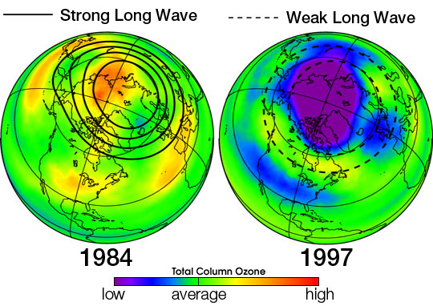

The Great Bear
Arctos is the Greek word for "bear" and the Arctic region derives its name from the stellar constellation of Ursa major, the Great Bear.

How do we define the Arctic?
Various definitions (see map) include:
- The area that lies between 60⁰N and the Arctic Circle.
- The area defined by the10°C July isotherm.
- The area characterised by continuous permafrost.
- The area associated with the Aurora Borealis (northern lights) and magnetic storms.
- The area above the treeline.
Varying perspectives on the Arctic:
- An empty wasteland
- An economic hinterland
- A sovereignty issue
- A pristine environment
- A fragile environment
- A resilient environment
However, as this case study will demonstrate, the Arctic is far more complex than we may think, especially in the face of climate change.

Climate Change in the Arctic

IPCC AR-5 report, 2014
According to the IPCC, the Arctic has undergone drastic changes in recent decades:
- There has been a significant increase in surface temperature over the past 50 years.
- It is 90% certain that the area covered by sea ice shrank 3.5-4.1% per decade since the late 1970s.
- Summer sea ice has retreated at a rate of 9.4-13.6% during this same period.
- It is very likely that the mean rate of global average sea level rise was 3.2 (2.8 to 3.6) mm yr-1 between 1993 and 2010.
The reality of what is happening on the ground has exceeded expectations: Arctic amplification and Arctic Oscillation.

Responses: The Arctic Climate Impact Assessment
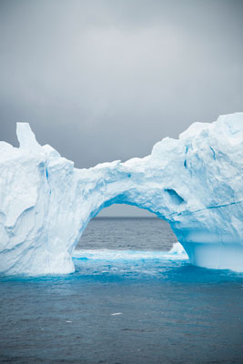
Melting iceberg (Source: Microsoft Clip Art)
The urgency of the Arctic’s situation has resulted in several comprehensive studies, including the Arctic Climate Impact Assessment (ACIA), which speak to the effects of climate change there.
The Arctic Climate Impact Assessment (ACIA):
- Commissioned by the Arctic Council and completed in 2004.
- Involved the collaboration of researchers and communities in several Arctic countries.
- The aim was to evaluate climate change in the Arctic and highlight the impacts it would have on the inhabitants of the region as well as broader implications for the world.
The following is an excerpt from the preface of the ACIA’s Executive Summary document:
“The Arctic is of special importance to the world and it is changing rapidly. It is thus essential that decision makers have the latest and best information available regarding ongoing changes in the Arctic. This…evaluation…has involved an international effort by hundreds of scientists over four years, and also includes the special knowledge of indigenous people” (Source: http://www.acia.uaf.edu).
Key findings focus on 10 themes including:
- Arctic climate change; global implications; vegetation changes; animal species shifts; coastal impacts; marine transportation; thawing ground; indigenous communities; ultraviolet radiation; and multiple stresses.
The next slide addresses each of these themes, highlighting the key findings for each one.

The Arctic Report Card 2014 (Source: http://www.arctic.noaa.gov/reportcard/)

What Is New in 2014?
Rising air and sea temperatures continue to trigger changes in the Arctic. The Arctic is warming at twice the rate of anywhere else on Earth.
However, natural variation remains, such as the slight increase in March 2014 sea ice thickness and only a slight decrease in total mass of the Greenland ice sheet in summer 2014.

Highlights
The warming Arctic atmosphere was strongly connected to lower latitudes in early 2014 causing cold air outbreaks into the eastern USA and warm air intrusions into Alaska and northern Europe. | Polar bears numbers in western Hudson Bay and the southern Beaufort Sea are decreasing in connection with a decrease in the availability of sea ice. | Sea surface temperatures andprimary production are increasing as the sea ice retreats throughout the Arctic Ocean.
Snow cover extent in April 2014 in Eurasia was the lowest since 1967 and sea ice extent in September was the 6th lowest since 1979. | The tundra is "browning" as the length of the growing season is decreasing in Eurasia, but maximum tundra greenness and biomass are increasing across the Arctic. | On the Greenland ice sheetnearly 40% of the surface experienced melting conditions in summer 2014 and the albedo (reflectivity) reached a new record low value in August.

The Vulnerability of Indigenous Communities
Listen to Dr. James Ford explain why Arctic indigenous communities are vulnerable to climate change and how they are adapting, and outline some of the challenges and opportunities they face. (Refer to Key ACIA Finding 8: Indigenous Communities).
(Video Length 14:21)
Click on Play to view the video.
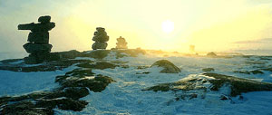Will indigenous culture fade into the past?
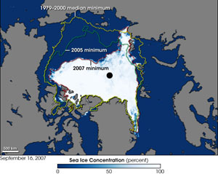
Click on map to enlarge
Map of very substantial decrease in Arctic Sea ice in 2007 from 2005 and also from 1979-2000 (Source: NASA, National Snow and Ice Data (NSIDC), Wikimedia); Above: Inukshuks were stone cairns erected by the Inuit to serve as landmarks or to fool the caribou in hunting (Source: Corel Professional Photos, The Canadian Encyclopedia)

How the Inuit have Experienced Climate Change
Listen to Sheila Watts-Cloutier, an Inuit activist, talk about the Inuit experience of climate change, highlighting how climate change is a human rights issue. In effect, Inuit communities are trying to defend their fundamental 'right to be cold'. (Refer to Key ACIA Findings 7 and 8: Indigenous Communities).
(Video Length 15:21)
Click on Play to view the video.

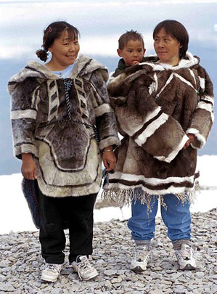
Traditional clothing: left: seal; right: caribou (Iglulik), July 1999. Note the running shoes (Source: Ansgar Walk, Wikimedia)

Addressing Arctic Climate Change
- Increased level of monitoring needed
- Recognition of validity and value of local indigenous knowledge
- Encouragement of collaboration and knowledge sharing
- Enhancing the resilience of those most vulnerable
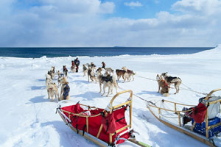

The Future – Adapting to Arctic Climate Change
Watch this video of Dr. James Ford to learn more about the need for increased support for climate change adaptation research and policy in Canada.
(Video Length 04:06)
Click on Play to view the video.
As mentioned earlier, adaptation has begun to gain momentum as a priority for climate change policies – the emphasis on adaptation at the Copenhagen Summit is evidence of this.
Within Canada, there is also a recognition of the importance of adaptation, and the work of researchers like Dr. James Ford highlights some interesting forms of adaptation among Inuit populations in the Arctic.
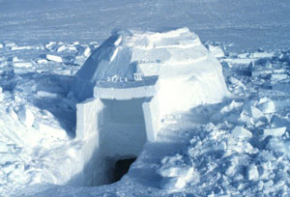
A nearly complete, medium-sized igloo. Note the excavation under the door and the unfinished exterior (Source: National Oceanic and Atmospheric Administration, Wikimedia)

