Week 1
Three marketing “strategies”
- Product orientation
- Selling orientation
- Marketing orientation
Product orientation: consumers will buy the product if they believe it is the best
Selling orientation: the product is fine as-is Advertising=sales >advertising>sales
Marketing orientation: focus is on consumer: lifestyle, needs, wants, demands
Goal: to develop a target market

Some cautionary words: very few products survive without a marketing orientation geared to a target market. The goal is to create a sustainable competitive advantage.

Definition of Marketing (from the textbook)
- Marketing is a set of business practices designed to plan for and present an organization’s products or services in ways that build effective customer relationships.
Value: The fundamental purpose of marketing is to create value for both the firm and customer. Value is in essence what you get for what you give up.

Marketing’s six core aspects
- Marketing helps create value
- Marketing is about satisfying customer needs and wants
- Marketing entails an exchange
- Marketing requires product, price, place, and promotion decisions
- Marketing can be performed by both individuals and organizations
- Marketing occurs in many settings
Core aspect one: satisfying customer needs and wants
- Begins with understanding their needs and wants
- Developing products and services
Core aspect two: marketing entails exchange
- The exchange can occur between any two parties
- Not simply a buyer and seller exchanging money for a good or service
- Can be an exchange of information for convenience
Core aspect three: marketing requires product, price, place, and promotion decisions
- Product (creating value): Product/service, brand, size, quality, features, packaging, warranty
- Price (transacting value): List price, discounts, allowances, costs, payment period, credit terms
- Promotion (communicating value): advertising, sales promotion, personal selling, public relations, direct marketing, electronic media
- Place (delivering value): marketing channels, distribution intensity, location, retailers, online, supply chain, logistics
Products are goods, services, and ideas.
Price is everything the buyer gives up in exchange for the product. (time, money, energy)
Place
- All activities necessary to get the product to the right customer when that customer wants it.
- Supply chain management is the field that examines these activities
- Where would find this product in the store?
Place: marketing channels distribution(分配) strategy
Promotion
- The communication activities of marketing
- Used to inform, persuade and remind potential buyers
- Used to influence their opinions or elicit(引出) a response
Core aspect four: marketing can be performed by both individuals and organizations
- Wholesaling is often only business to business
- All retailing is business to consumer selling
- Swap meets, ebay, year sales…
Core aspect five: marketing occurs in many settings
- Both profit and non-profit entities
- Developing economies
- Entire industries
Core aspect six: marketing helps create value
- Production- oriented era
- Marketing- oriented era
- Sales- oriented era
- Value-based marketing era
Value- based marketing: firms must offer customers something in excess that being offered by the competitors
Firms must understand how each aspect of the product/service creates value for customers
The goal is to find the most desirable balance between providing benefits to customers and minimizing costs
How firms compete on the basis of value?
- Constantly changing consumer perceptions
- Firms must constantly monitor the marketplace in order to create value
- Sharing information
- Becoming value driven: balancing benefits and cost
Understand key benefits
Focus on key benefits
Eliminate cost of less strategic benefits
- Becoming value driven: building relationships with customers
Take a long-term view of customer relationships
Use data to assist in maintaining the relationship

Chapter 2
The strategic Marketing Planning Process
- Define the mission and objectives
- A board description of a firm’s objectives and the scope of activities it plans to undertake
- What types of business are we in?
- What do we need to do to accomplish our goals objectives?
- Conduct a situation analysis
- Using SWOT
 | Positive | Negative
Internal | Strengths  - Strong base of loyal customers  - Excellent geographic location  - Wide distribution networks | Weaknesses  - Little or no brand recognition  - Lack of financial resources  - Poor location
External | Opportunities  - When existing firms exit the market because of financial or other difficulties  - When a firm acquires another firm, the acquiring firm gets market access, new customers, new tech and expertise, and financial resources | Threats  - New entrants into the industry or market  - Natural or man-made disasters  - Political or regulatory changes
- Identifying and evaluating opportunities using STP
- Segmentation: the process of dividing the market into distinct groups of customers, each group having similar needs, wants, or characteristics, who might appreciate products or services geared especially for them in similar ways. (Location season culture)

- Targeting: evaluating the attractiveness of various segments and then deciding which to purse as market

- Positioning: how a firm wants to be positioned in those segments it has decided to purse. This involves defining the marketing mix variables (product, price, place, promotion)

- Implement marketing and allocate resources
- Promotion strategy
- Place strategy
- Product & Service strategy
- Price strategy
a) Price and value for money
Price should be based on the value the customer perceives
b) Place and value delivery
-Product must be readily accessible –how?
-Direct vs. indirect
-Manufacturer ->customers
-Manufacturer ->retailer customer
-Manufacturer-> wholesale->retailer ->customer
-Intensity:
Intensive (Kraft, Pepsi)
Exclusive (Rolex)
Selective (Seiko)
c) Promotion and value communication
- Television
- Radio
- Magazine
- New media
5. Evaluate performance and make adjustments
- Growth strategies
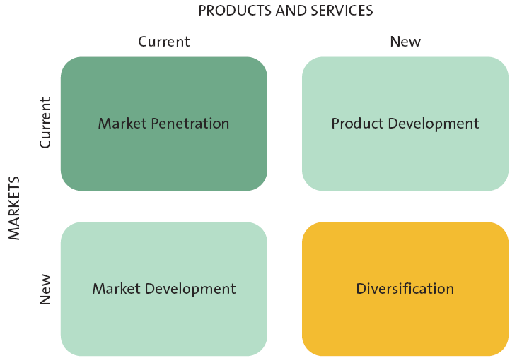
- Market penetration 行销渗透
- Uses the existing marketing mix (the 4ps) and focuses on existing customers
- Encourage current customers to patronize the firm
- Attract new customers from within the firm’s existing target market
- Market development strategy
- Employs the existing marketing offering to reach new market segments
- Product development
- Offers a new product or service to the current target market
- Diversification
- Introduces a new product or service to a new market segment

Sustainable competitive advantage
- A long-term competitive advantage that is not easily duplicable or easily surpassed by the competition
- What distinguishes you from the competition in the minds of your customers
- A very secure advantage that a product or service provider has held over its competitors for a long period of time and that is not easy to surpass
- An advantage that allows a business to be more successful that its competitors over a long period of time
Sustainable competitive advantage attributes
- Exclusivity
- Immediate recognition
- Loyal customers
- Strong brand
Customer excellence
- Retaining loyal customers
- Customer services
Operational excellence
Efficient operations <->excellent supply chain management
Product excellence
- A strong brand
- Unique positioning in the marketplace
- High perceived value
Location excellence
- The three most important things in retailing are location, location, and location

Chapter 3 & 4
Analyzing the marketing environment
- At the heart of the marketing environment is the customer
- Consumers are influenced by many things:
Actions of the company
- Pricing
- Advertising
- Ethics
- Social responsibility
Actions of the company’s competition
- Pricing
- Advertising
- Ethics
Actions of corporate partners in the supply chain
- Quality
- Timelines
- Ethics
- Social responsibility
Successfully leveraging company capabilities
Core competency 能力 > Existing knowledge, facilities, patents applied to > new markets, new products

The microenvironment: competitors
- Identify and analyze direct and indirect competitors
- Know strengths & weaknesses
Competitive intelligence is used by companies to collect and synthesize information about their position with respect to the rivals.
- Sending an employee to a competitive store to check merchandise, prices, traffic
- Other more sophisticate methods
The microenvironment: corporate partners
- Firms are part of alliances
- Align with competitors, suppliers
- Just in time delivery systems

Macroenvironmental factors
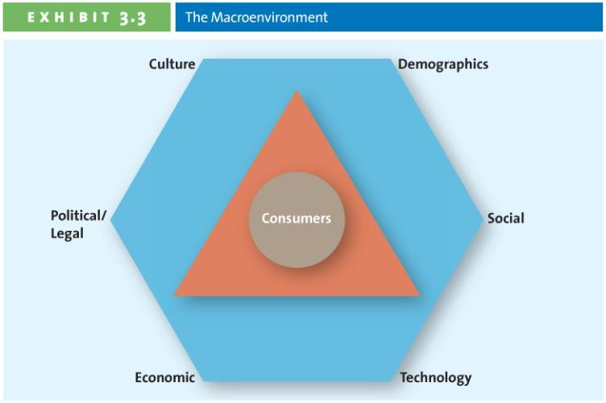
Culture
Culture, country culture, and regional culture

Hofstede: A multiple dimension models of national culture
- Power distance: how a society deals with the fact that people are unequal in a social and status sense
A low rating characterizes societies that stress equality and opportunity
- Uncertainty avoidance: how society copes with uncertainty and deals with risk
A low rating characterizes societies that are more accepting f ambiguity, less rule-oriented, take more risks, and more readily accept change
- Individualism- collectivism: the relative closeness of the relationship between one person and others
Collectivism emphasizes a tight social framework in which people expect others in groups of which they are a part to look after them and protect them
- Masculinity- femininity: the sexuality of roles in society and the degree to which society allows overlap between the roles of men and women
A high femininity rating means the culture sees little differentiation between male and female roles and treats women as the equals of men in all respects
- Long-term vs. short-term orientation: a new addition to Hofsteded’s dimensions. In a culture with short-term orientation, people value the here and now; they accept change more readily and don’t see their commitments as impediments to change

Demographics
Provides an easily understood snapshot of the typical consumer in a specific target market.

Age demographics: generational cohorts ppt 20

Income
Purchasing power is tied to income

Education
Education is related to income, which determines spending power

Gender
Male/female roles have been shifting-> marketing has changed to reflect these shifts

Social trends
Greener consumers: customers who appreciate the efforts of companies to supply them with environmentally friendly merchandise
Privacy concerns: loss of privacy, identity theft, do not call
Time-poor society: in the majority of families, most parents work; consumers have many more choices regarding leisure time; many consumer multitask

Technological advances
Tech has impacted every aspect of marketing
- New products
- New forms of communication
- New retail channels

Economic situation
Foreign currency fluctuations combined with inflation and interest rates affect a firm’s ability to market goods and services

Political/ regulatory environment
- Competition act
- Consumer packaging and labeling act
- Food and drugs act
Marketing research
Consists of a set of techs and principles for systematically collecting, recoding, analyzing and interpreting data that can aid decision makers involved in marketing goods, services or ideas

The marketing research process
Define research problem and objective-> design the research project -> collect data ->analyze data ->present action plan
Step 1: define the objectives and research needs
What? What info is needed to answer specific research questions?
How? How should that info be obtained?

Step 2: designing the research project
Type of data type of research
Advantages and disadvantages of secondary and primary data ppt 35
Collecting primary data: research study must be reliable and valid
Reliability is the extent you will get the same result if the study is repeated under identical situations
Validity is the extent to which the study actually measures what it is supposed to measure

Step 3: data collecting methods ppt 37
Exploratory research methods
Some examples: observation, in-depth interview, and focus group
Conclusive research methods can be either descriptive experimental
Survey research
Web surveying
- Response rates are relatively high
- Respondents may lie less
- It is inexpensive
- Results are processed and received quickly
Experimental research
Scanner research
Panel research

Step 4: analyzing data
Converting data into info o explain, predict and/or evaluate a particular situation

Step 5: presenting results
- Executive summary
- Body
- Conclusions
- Supplements
- Tables
- Figures
- Appendixes
The ethics of using customer info
Bottom line: marketing research should be used only to produce unbiased, factual info.

Chapter 5
The consumer decision process
Need recognition -> information search -> alternative evaluation -> purchase ->post-purchase evaluation
Need recognition: functional needs psychological needs
Info search: internal and external search for info
Internal search for info: a buyer’s own memory and knowledge about the product
External search for info: information outside the buyer’s personal knowledge base: friends, family; commercial media; magazines; Internet

Factors affecting consumer’s search process
Perceived benefits= perceived costs

Actual vs. perceived risk
Performance risk
Financial risk
Social risk
Physiological risk
Psychological risk

Alternative evaluation: evaluative criteria and determinant attributes
Evaluative criteria: how do consumers begin to evaluate different alternatives, and what important attributes and criteria do they use?
Decision Heuristics: price, brand, product presentation

Post purchase: dissonance
- Firm’s attempt to reduce dissonance by reinforcing the decision
- Thank you letters, congratulations letters, quality ratings

Factors influencing he consumer decision process 17
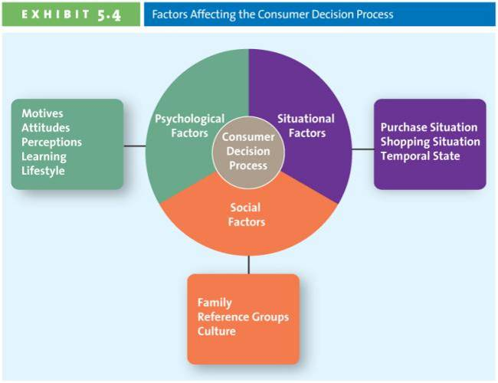

Psychological factors: motives 18
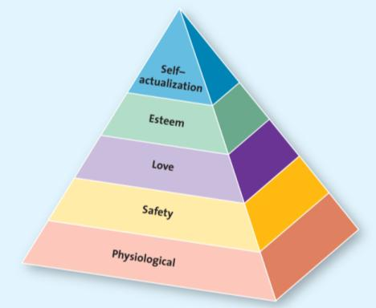

Psychological factors: attitude
The actions we undertake with regard to the issue at hand ->behavioral
What we believe to be true -> cognitive
What we feel about the issue at hand ->affective
Attitude

Psychological factors: learning
Affective both attitude and perceptions
Affected by social experience
Psychological factors: perception
- The processes by which we select, organize, and interpret info to form a meaningful pic of the world

Social factors: family
Social factors: reference groups
Groups
- Family
- Friends
- Coworkers
- Famous people
Provide
- Info
- Rewards
- Self-image
Social factors: culture

Situational factors
Purchase situation-> customers predisposed to purchase certain products or services because of some underlying psychological trait or social factor

Shopping-> store atmosphere, salesperson, crowding, promotions

Temporal state -> out state of mind at any particular time can alter out preconceived notions of what we are going to purchase

Chapter 7
Segmentation Targeting Positioning Process
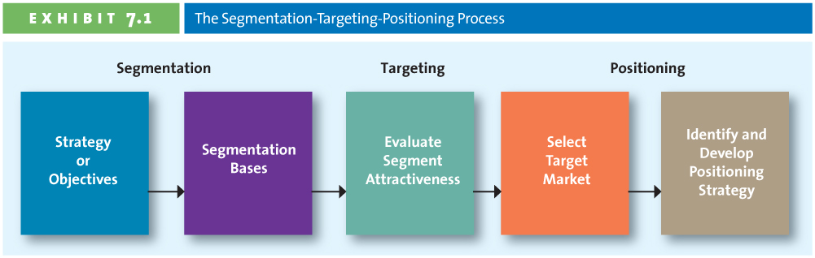

Step 1: establish overall strategy or objective
- Consistent with mission statement
- Derived from mission and current state

Step 2: profile segments
Segmentation base | Sample segments
Geographic | Country, province, city, rural, climate continent
Demographic | Age, gender, income, education, occupation, ethic background, religion, family life cycle
Psychographic | Lifestyles, values, personality, self concept
Behavioral | Benefits sought, usage rates, user status, loyalty

Step 3: evaluate segment attractiveness
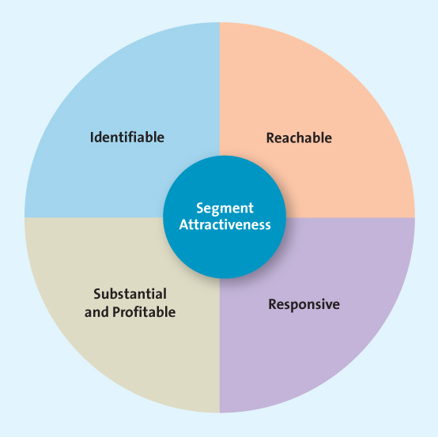

Identifiable
- Who is in their market?
- Are the segments unique?
- Does each segment require a unique marketing mix
Reachable
- Know the product exists > Understand what it can do > Recognize how to buy
Responsive
Customers must:
- React similarly and positively to firm’s offering
- Move towards the firm’s products/ services
- Accept the firm’s value proposition
Substantial and profitable
- Size matters
- Too small and segment is insignificant, not profitable
- Growth potential equally important

Step 4: selecting a target market
The key factor is the marketer’s ability to pursue the target segment
Segmentation strategy
Mass or undifferentiated: everyone is considered a potential user of the product
Differentiated: several market segments with a different offering in each
Concentrated: focus is on a single, primary target market
Micromarketing one-to-one: tailoring a product to suit an individual customer’s wants or needs

Step 5: identify and develop positioning strategy
Positioning methods
- Value
- Product attributes
- Benefits & symbolism
- Competition
- Market leadership
Value
Meet Grandpa Tony now retired:
- He knows the price of everything he has ever bought.
- He clips the newspaper coupons.
- He goes to multiple stores to get the best price.
- He is willing to pay more for quality.
- He trusts brand names.

- The relationship of price to quality
- Different consumers= different value

Product attributes
Meet Selia, first year student.
Reasons for her college choice:
- Close to home.
- Good academic reputation.
- Good financial aid package.
- Did we mention cute guys?
- Focus on the attributes that are most important
- Vary by target market

Benefits and symbolism

Competition
Position against a specific competitor
Position against an entire product classification

Chapter 8
Drivers of innovation

How firms develop new products
- Idea generation> Development of viable new product ideas
- Concept testing> Testing the new product idea among a set of potential customers
- Product development> Develop of prototypes and/or the product
- Market testing> Testing the actual products in a few test markets
- Product launch> Full-scale commercialization of the product
- Evaluation of results> Analysis of the performance of the new product and making appropriate modifications

1. Idea generation

Source
of Ideas
Customer
Input
Internal
R&D
Licensing
Brainstorming
Internal R&D
- Typically by large firms
- High product development costs
- Often the source of technological products
- Often the source of breakthrough products

Licensing
- Firms purchase the rights to technology or ideas from other research-intensive firms
- Biotechnology firms are research intensive but typically lack the resources and expertise to do their own marketing

Brainstorming
- Groups work together
- No idea can be immediately dismissed

Competitors’ products
- Reverse engineering
- Taking a competitor’s product apart, analyzing it and creating a superior product (that does not infringe on patents)

Customer input
- As much as 85% of new business to business products come from customers
- Lead users modify existing products according to their own specific needs

2. Concept testing
- Concept is a brief written description of the product
- Customers’ reactions determine whether or not it goes forward
- Triggers the marketing research process

3. Product development
- Prototype 原型 标准 规范
- Alpha testing 智力测试
- Beta testing

4. Marketing testing

5. Product launch
> The most critical step
- Confirms target market
- Decides on how the product will be positioned
- Finalizes the marketing mix
Mix
Place
Price
Timing

6. Evaluation of results

Why do new product fail?
- Too small target market
- Poor design
- Low product quality
- Incorrect positioning
- Wrong price strategy
- Poor marketing communication
- Competition

Product life cycle
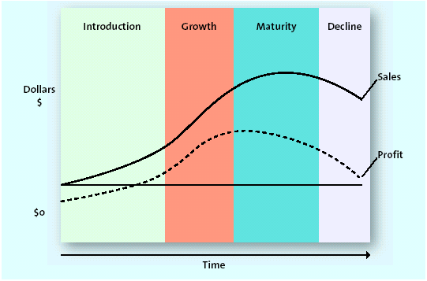

Stages in the product life cycle
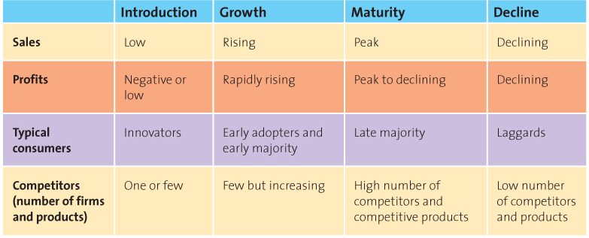

Variations on product life cycle curve

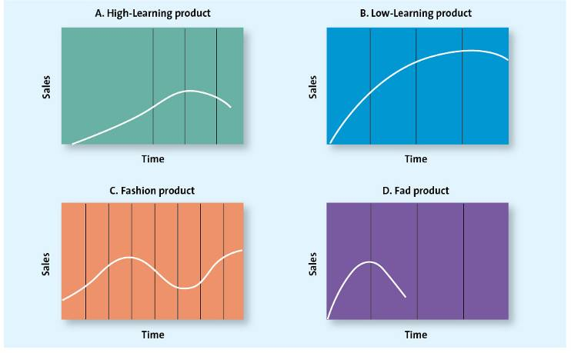

Chapter 9 Product, branding, and packaging decision

Types of product
Specialty (luxury cars): consumers show a strong preference and will spend considerable effort to search for the best suppliers.
Shopping (appliances): consumers will spend a fair amount of time comparing alternatives
Convenience (bread): consumer is not willing to spend any effort to evaluate prior to purchase
Unsought (new-to-the-world products): products that consumers fo not normally think of buying or do not know about

Product mix and product line decisions
Breadth: number of product lines
Depth: number of categories within a product line
Change product mix breadth
- Increase breadth
New product line
- Decrease breadth
Dropping a product line
- Increase depth
Band-Aid now has over 40 products to heal cuts
- Decrease depth
McCormick spices eliminates dozens of products each year

Branding
A brand can use: name, logo symbols, characters, slogans, jingles and even distinctive packages
Value of branding for the customer and the marketer
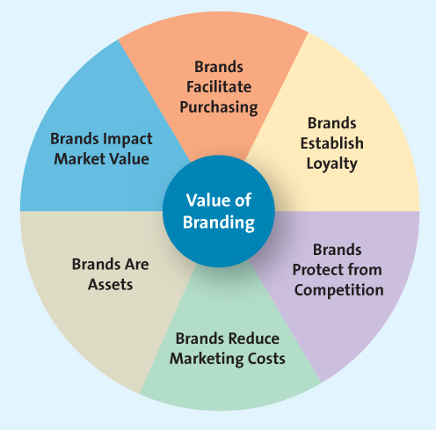
Branding overview
Brand equity: brand awareness, perceived value, brand associations, and brand loyalty
Brand ownership strategies: manufacturer or national brand, store or private label, and generic
Brand name strategies: corporate or family brand, corporate and product line, brand individual

Brand equity: brand loyalty
- Consumers are often less sensitive to price
- Marketing costs are much lower
- Firm insulated from the competition

Choosing a brand name: desirable qualities
- Suggest benefits and qualities
- Easy to pronounce recognize& remember
- Capable of registration & legal protection
- Translated easily

Brand extension
Benefits of brand extension
- Well established name
- Brand known for high quality
- Lower marketing costs
- Synergy among products
- Boost sales of the core brand

Brand dilution
- Evaluate the fit between the product class of the core brand and the extension.
- Evaluate consumer perceptions of the attributes of the core brand and seek out extensions with similar attributes
- Refrain from extending the brand name to too many products
- Is the brand extension distanced enough from the core brand?

What is brand?
Clear idea what they stand for
4 approach to branding
-Corporate
-Individual
-Family
-Personal

What makes up a brand?
- Product
- Service
- Idea
- Designing
- Communication

Chapter 10 Services: The intangible product

Service: any intangible offering that involves a deed performance, or effort that cannot be physically possessed.

Services marketing differ from product marketing 4Is
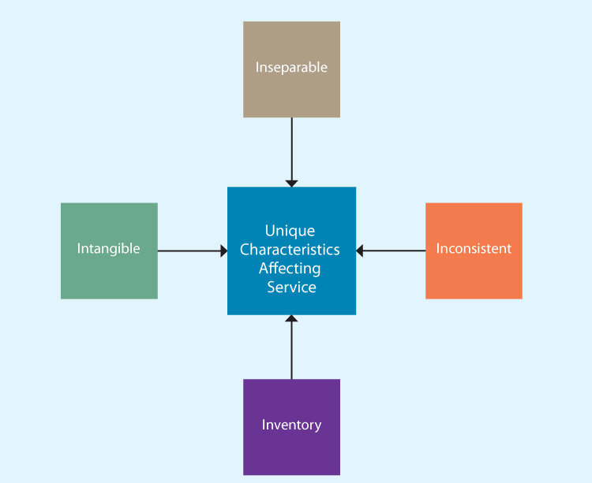

Inseparable production and consumption
- Production and consumption are simultaneous
- Little opportunity to test a service before use
- Delivery service
- Dentist
- Hotel
- University
Inconsistent
- Technology
- Training
- Automation
- Attitude

Providing Great Service: The Gaps Model
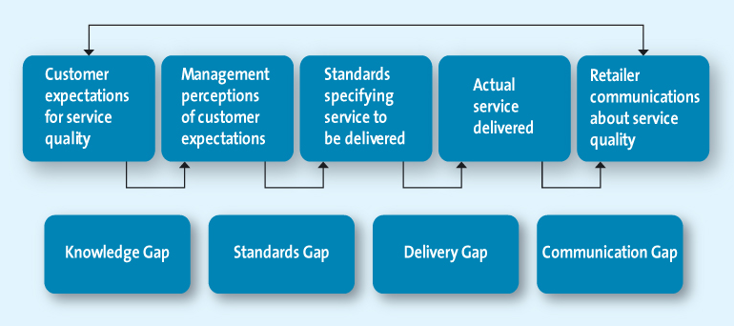

The knowledge Gap: knowing what customers want
Understanding customer expectations

Evaluating service quality
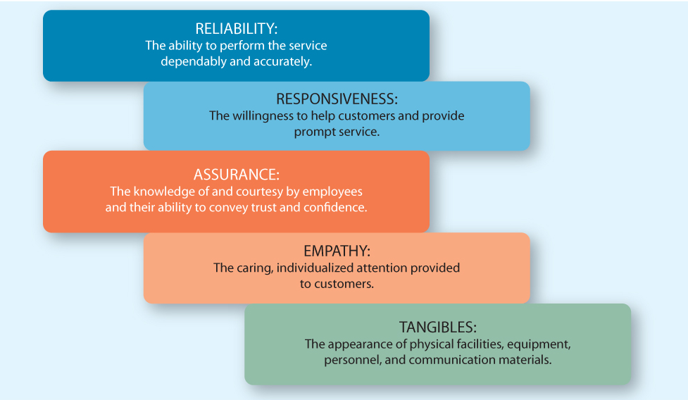

Zone of tolerance
- What is the desired and expected level of service for each of the five dimensions?
- What are the customer’s perceptions of how well the focal service perform vs. how well a competitive service performs? (Ups vs. FedEx)
- What is the importance of each of the five service dimensions?

The standards gap: setting service standards
- Setting standards for quality
- Developing systems to ensure high-quality service

The delivery gap: delivering service quality
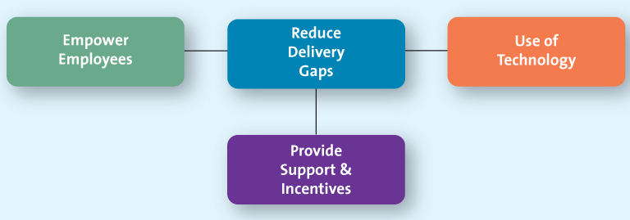

Empowering service providers
Allowing employees to make decisions about how service is provided to customers

Providing support and incentives

Use of technology
- Customers can buy more quickly, more easily, and do so with more information
The communication gap: communicating the service promise
Manage customer expectations > promise only what you can deliver > communicate service expectations

Service recovery
Listen to the customer
Resolve problems quickly >increase service recovery
Provide a fair solution

Listening to the customer
- Customers get emotional over a service failure
- Often customers just want someone to listen

Finding a fair solution
- Distributive fairness (benefits received vs. inconvenience)
- Procedural fairness (perceived fairness of the process used to resolve complaints)

Resolving problems quickly
- The longer it takes to resolve service failure the more irritated the customers
- It is in the firms best interest to solve problems quickly

Chapter 15 Advertising Sales Promotion and Personal Selling

The AIDA Model
Awareness> Interest> Desire> Action
Think > feel > do

Awareness
- Senders first must gain the attention of the consumers
- A multichannel approach increases the likelihood the message will be received
Interest
- After the customer is aware, they must be persuaded
- The customer must want to further investigate the product/ service
Desire
I like it> I want
Action
- Purchase is just one type of action
- What other actions can consumers be asked to take?
Behavior changes (don’t drink and drive)
Attitude changes (this product is high quality)
Physical actions (log on the website volunteer, donate)

Lagged effect
- Advertising does not always have an immediate impact
- Multiple exposures are often necessary
- Difficult to determine which exposure led to purchase

Advertising
- Paid message
- Delivered through media
- Must have identifiable source
- Designed to persuade

Advertising objectives
Inform > persuade > remind
Informative advertising
Early in the product lifecycle, firms use informative advertising to educate consumers about the product/ service.
Persuasive advertising
- Generally occurs in the growth and early maturity stages of the PLC when competition is most intense
- In the later stage of the PLC may be used to reposition an established brand
Reminder advertising
- After the products have gained market acceptance
- Top-of-the-mind-awareness
Focus of advertisements
Institutional advertisements
Product-focused advertisements

Social marketing
- Public service advertising (PSA)
- Under Canadian Radio-television and telecommunications Commission rules broadcasters must devote a specific amount of free airtime to PSAs

Types of consumer sales promotion (need to know these 10)
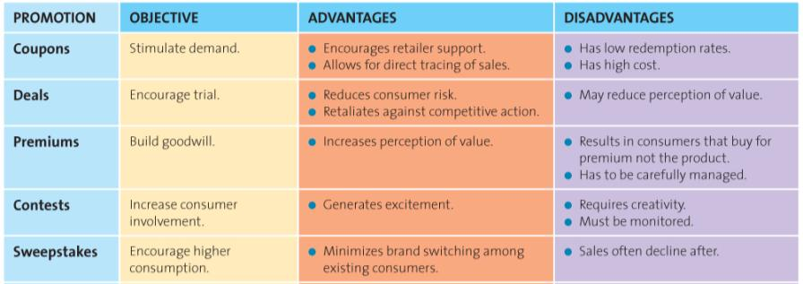
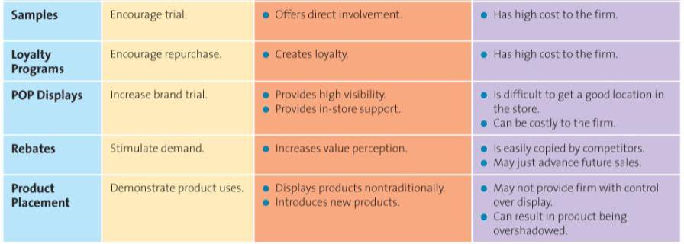

Types of trade sales promotion
- Discounts and allowances
- Co-operative advertising
- Sales force training

Evaluating sales promotions using marketing metrics

Personal selling
The scope and nature of personal selling
- Internet
- Telephone
- Face-to-face
- Teleconference

The value added by personal selling
- Salespeople educate and provide advice
- Salespeople save time and simplify buying
The personal selling process
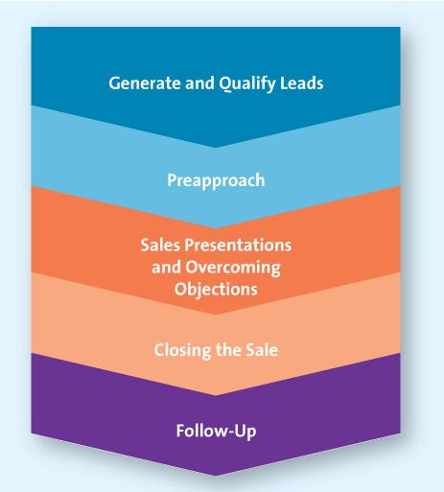
Step 1: generate and qualify leads
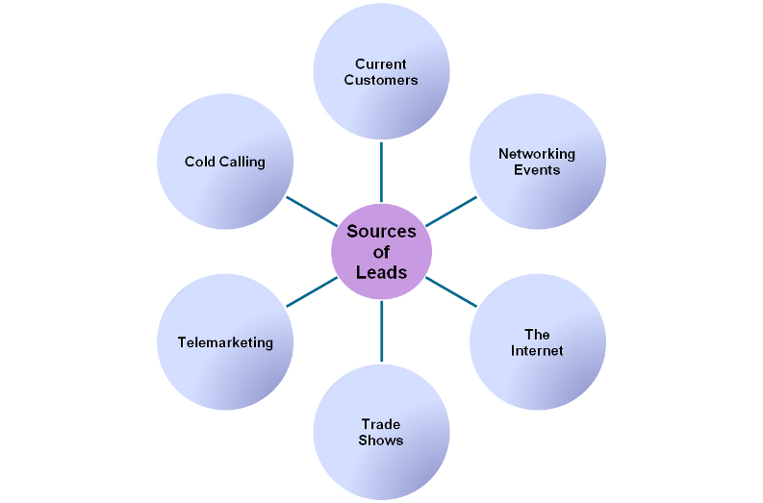Step two: preapproach
- Extends the qualification procedure
- Set goals for what is to be accomplished

Step three: sales presentation and overcoming objections
- The presentation
- Handing objections
Step four: closing the sale
- Getting the order
- Often most stressful part of sales process
- A “NO” one day may be the foundation for a “yes” another
Step five: follow-up
Five service quality dimensions:
- Reliability
- Responsiveness
- Assurance
- Empathy
- Tangibles

Chapter 11 Pricing concepts and strategies for establishing value

Role in price in the Marketing mix
- Price is usually ranked as one of the most important factors in the purchase decisions
- Price is the only element in the marketing mix that generate revenue

The 5Cs of pricing (know the differences)
Competition
Costs
Company objectives
Customers
Channel members
1st C: Company Objectives
- Profit orientation
Maximize profits
Target return pricing
Target profit pricing
- Sales orientation
- Competitor orientation
- Customer orientation

Company objectives—profit
Orientation: Maximize profits
- Mathematical determination of the price at which profits are maximized
- Based on all the factors required to explain sales and profits
- Based on economic theory
Orientation: Target return pricing
- Focus is one the rate at which profits are generated relative to their investments
- Designed to produce a specific return on investment (expressed as a percentage of sales)
Orientation: Target profit pricing
- Focus is on a predetermined profit goal
- Price is used to stimulate a certain level of sales at a certain profit per unit

Company objectives—sales orientation
- Focus on increasing sales
- More concerned with overall market share
- Does not always imply low setting prices
- Why would firms adopt this orientation?
- Many first adopt this orientation to establish a position in the market by getting the most price sensitive consumers to change brands

Company objectives—competitor orientation
- The firm measures itself against its competition
- Value is not part of this pricing strategy
- This strategy is particularly common among smaller firms that lack knowledge or experience in setting prices
- Non-market leader firms also use it to signal they are similar to the market leader
- In many instances new brands will set price equal to the competitors they wish to be compared with knowing that consumers use reference prices to indicate quality

Company objectives—customer orientation
- Focus on customer expectations by matching prices to customer expectations
- A diamond ring from Costco vs. Birks or Jubilee Jewelers

2nd C: Customers
Understanding customers’ reactions to different prices
Price elasticity of demand
- Elastic (price sensitive)
- Inelastic (price insensitive)
- Consumers less sensitive to price increase for necessities
Pe= %change in quantity demanded/ %change in price
Elasticity
Affected by
- Cross-price elasticity
- Substitution effect
- Income effect

3rd C: Costs
- Variable costs
Vary with production volume
- Fixed costs
Unaffected by production volume
- Total cost
Sum of variable and fixed costs

Break-even analysis
Total variable cost= variable cost per unit X quantity
Total cost= fixed cost+ total variable cost
Total revenue= price X quantity
Break-even points (units)= fixed costs/ contribution per unit

4th C: Competition
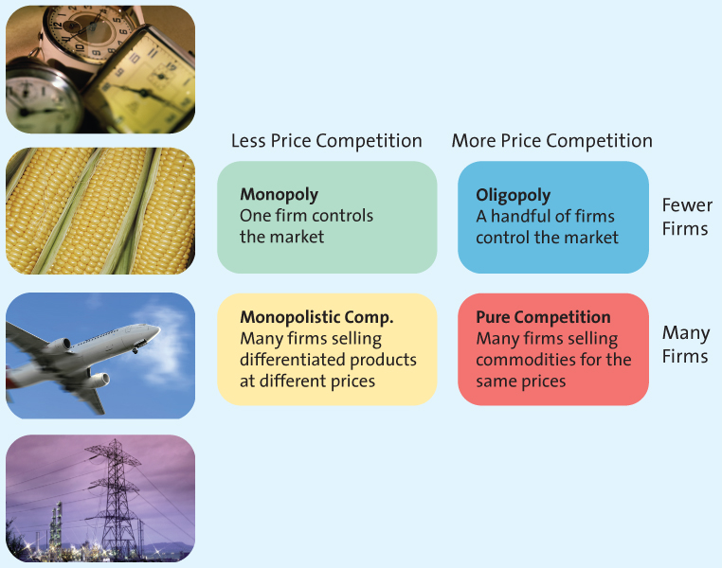

5th C: Channel Members
- Manufactures, wholesalers and retailers can have different perspectives on pricing strategies
- Manufactures must protect against grey market transactions

Other influence on pricing
The Internet
- Increased price sensitivity
- Growth of online auctions

Economic factors
Increasing disposable income
Increasing status consciousness
Cross-shopping
Increasing globalization
Local economic conditions

Pricing strategy
Cost-based
Competitor-based
Value-based
- Cost-based methods
- Cost-base pricing methods start with cost
- All costs calculated on a per unit basis
- Assumes costs don’t vary for different levels of production
- Competitor-based methods
- Set prices to signal information of how product compares with competitors
- Premium pricing
- Value-based methods
- Setting prices that focus on the overall value of the product

New product pricing strategies
- Marketing penetration pricing
- Pricing skimming

Psychological factors affecting pricing strategies
- Reference pricing
- Everyday low pricing
- Odd price
- Price-quantity relationship
Reference prices
- Internal reference price
- External reference price

Everyday low pricing
- Value is created in different ways
- EDLP saves search costs of finding lowest overall prices
- High/low provides the thrill of the chase for the lowest price

Odd prices
- Odd prices may be so traditional that sellers are afraid to round them off
- May suggest a good deal
- May suggest low quality

Pricing tactics
Pricing strategy long term vs. pricing tactics short term

Business to business pricing tactics and discounts
Seasonal discounts: designed to spur buyers into purchasing merchandise early
Cash discounts
- Reduced invoice cost if buyer pays prior to the end of the discount period
- Encourages buyers to pay before the discount period ends
Allowances
- Lowers the final cost in return for specific behavior
- Advertising allowance
- Listing allowance
Quantity discounts
- Cumulative quantity discount
- Noncumulative quantity discount
Uniform delivered vs. geographic pricing: addresses the impact of shipping, which is often a major cost for manufactures

Consumer pricing tactics
Price lining
- Marketers establish a price floor and a price ceiling and set prices in between
- Allows for easy comparison
Price bundling
- Encourage sales of slow moving items
- Encourage stock up
- Encourage trial of new brand
- Incentive to purchase
Leader pricing
- Enticing consumers into the store with the popular aggressively priced item and hoping they will pick up other items while shopping

Consumer price reductions
Markdowns
- An integral component of high/ low pricing strategy
- Enable retailers to get rid of slow moving or obsolete merchandise
- Used to generate store traffic
Coupons and rebates
- Coupons
Retailer handles
- Rebate
Manufacturer issues
Quantity discounts for consumers
- Size discount
- The more you buy the cheaper the unit cost
Seasonal discounts
- Encourage consumers to use services or purchase products year round

Chapter 12 Marketing channels: Distribution Strategy

Distribution Components
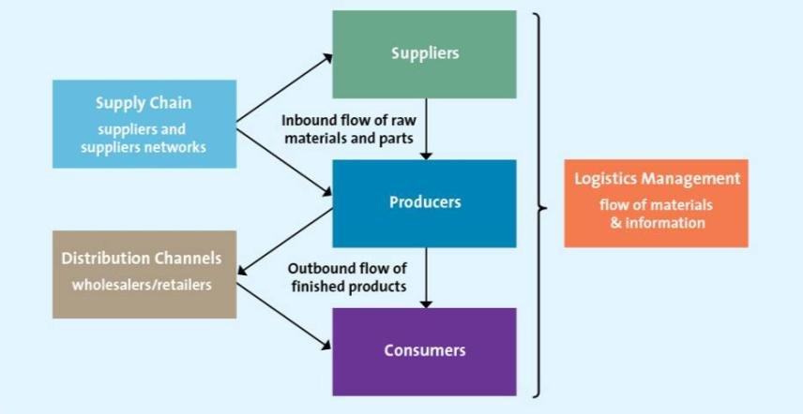

Functions performed by intermediaries
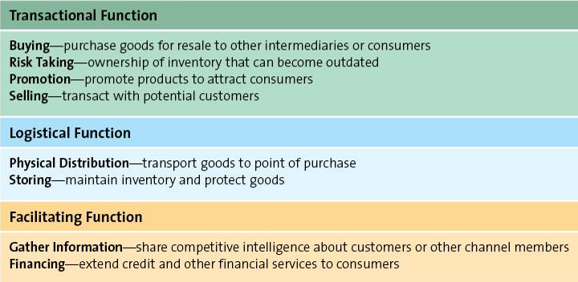

Designing distribution channels
Channel structure
- Direct distribution
- Indirect distribution
- Multichannel distribution
- Or some combination of these forms

Distribution channel structure: Direct& indirect
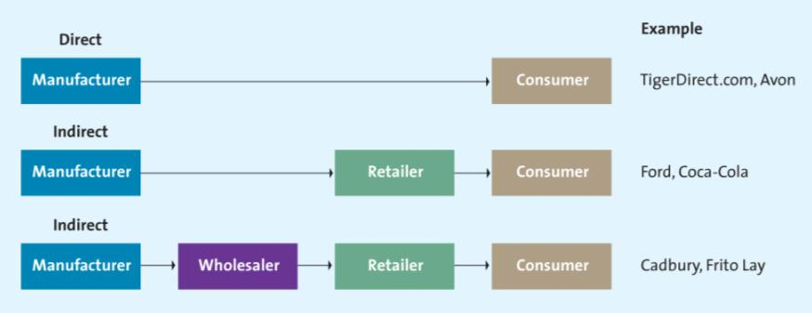

Distribution channel structure” Multichannel
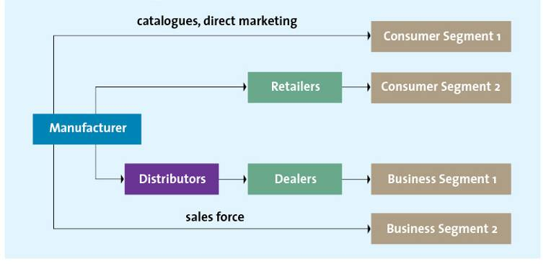

Distribution channel management: Strategic and key!
- Importance of channel management
- Continuous search for sustainable competitive advantage (CSA) more reliably found in channel management
- CSA now more difficult to attain through the usual ways (product, price, promotion)—Why?
The enabling effect of technology “enables” competitors to quickly produce products similar in every respect (so the traditional product strategy approach for SCA is no longer reliable by itself)
Globalization enables competitors to seek out lower input costs to match prices (so SCA based on price alone will not sustain)
Promotional campaigns are very expensive, less effective due to information overload, and are short-lived (so SCA based on promotion will not sustain)
- The power of retailers in marketing channels is increasing, requiring strategic consideration of product and service distribution
Larger retailers have enormous power in the distribution channel
Becoming buying agents for customers, instead of their traditional role as selling agents for suppliers
Most operate on the low price/ low margin model
- A strategic necessity is to continuously reduce distribution costs
The costs of distribution goods are a significant percentage of the final price of product
- Technology’s increasing role and power
Can be harnessed to produce greater efficiency and effectiveness
- Growth requires:
Expansion
New markets
Increased market share and the channel members can help this happen

When channel strategy is particularly important
- Distribution is the most relevant variable for satisfying customer needs and wants
- Parity exists among the competition in price, promotion, and product

Developing channel strategies and structures
Considerations:
- When customers buy
- Where they buy
- How do they buy
- Who actually buys
Purchaser
End user of the product
Who is involved in the buying decision?

Influences on distribution channel structure
- Customer expectations
- Channel member characteristics

Distribution intensity
Mass-produced goods: manufacturers want to get products to as many outlets as possible-the more exposure, the more the sales
Neither mass-produced nor luxury goods: manufactures use a few selected companies in a territory
Luxury goods: manufactures grant exclusive geographic territories to one or a few retailers

Managing distribution channels: Vertical integration
Independent or conventional supply chain (what’s the difference between independent or vertical marketing channel? Multiple choices)

Types of vertical marketing systems
- Administered vertical marketing system
- No common ownership, no contractual relationships
- One member of the distribution channel wields enough power to effectively control the activities of the other members of the distribution channel
- Massive retail chain stores, such Wal-Mart, often preside over administered vertical marketing systems
- Dominant channel member could dictate what is to be produced, when it should be delivered
- Contractual vertical marketing system
-Independent firms at different levels of the supply chain join together through contracts to obtain economies of scale and coordination to reduce conflict
> Contracts could dictate minimum purchasing amount, price, and penalties
- Franchising is the classical example
3. Corporate vertical marketing system
> Typically exemplified when a parent company has complete control and can dictate the priorities and objectives of the supply chain
- It may own facilities including manufacturing plants, warehouse facilities, retail outlets—in other words, it owns the channel

Supply chains streamline distribution
- Reduce number of transactions
- Increase value for consumers
- More efficient and effective

Some common issues in supply chain management
- Order processing time
- Delivery time
- Order size constraints
- Invoice formats
- Physical condition of goods
- Claims process
- Order cycle time
- Product availability
- Rush service
- Accuracy in filling orders
- Protective packaging

Supply chain management affects marketing
- Fulfilling delivery promises
- Meeting customer expectations
- Reliant on an efficient supply chain

Effective supply chain management
All about strategic alliances to ensure:
- Join efforts
- Channel-wide cost effectiveness
- Shared risks and reward

Chapter 13 Retailing
- The set of business activities that add value to products and services sold to consumers for their personal use
- Vertically every penny you personally spend go to retailers
- Any company that sells to consumers for their personal use is defined as a retailer even if they claim to sell at “wholesale” price

Factors for establishing a relationship with retailers

General merchandise retailers
Department stores: brand variety and deep assortment
Full-time discount: broad variety at low prices
Specialty: limited merchandise with service in small store
Drugstores: specialty for pharmaceutical and health
Category specialist: discount with narrow but deep assortment
Extreme value: full line, limited, and very low prices
Off-price: inconsistent assortment of brand name at low prices

Creating a retail strategy using the 4Ps
Product: providing the right mix of merchandise and services
Price: price defines the value of both the merchandise and the service provided
Promotion: retailers use a wide variety of promotions, both within their retail environment and through mass media
Place: convenience is a key ingredient to success

Channels for selling to consumers

Benefits of stores for consumers
- Browsing
- Touching and feeling
- Personal service
- Cash and credit
- Entertainment and social interaction
- Instant gratification
- Risk reduction

Benefits of the Internet and multichannel retailing
- Deeper and broader selection
- Personalization
- Gain insights into consumer shopping behavior
- Increase customer satisfaction and loyalty
- Expand market presence

