Nine Course Objectives
1. Develop a solid understanding of the research or inquiry process
2. Learn how to identify and articulate a complex question that will drive your inquiry.
3. Learn about the variety of information sources available for research and accessible through the Concordia Libraries or the Internet.
4. Learn to design and apply effective search strategies for each of the different retrieval tools geared to scholarly research.
5. Learn how to be a critical consumer of information by evaluating the quality and suitability of sources for a specific topic using established criteria.
6. Learn how to organize your sources into a logical and effective manner through the construction of a working bibliography listing all of the potentially relevant sources you found in your research.
7. Learn how to take comprehensive notes from relevant and credible sources that will support your synthesis of the material.
8. Learn how to use of this wealth of information that has been gathered and analyzed inorfer to form strong arguments (presented in the form of an Outline) that will defend your final thesis or claim about the original inquiry.
9. Learn how to properly document the sources to be used in the research paper using a specific punctuation style.

The American Library Association defines Information Literacy:
As that set of abilities requiring individuals to “recognize when information is needed and have the ability to locate, evaluate, and use effectively the needed information.”
According to the Conference Board of Canada:
Information literacy is considered an essential lifelong learning skill. It is one of a collection of “The skills you need to enter, stay in, and progress in the world of work – whether you work on your own or as part of a team.

SCONUL (The Society of College, National and University Libraries): Recognize or identify a need for information 7 pillars
Identify scope plan gather evaluate manage present

Flowchart of Research process
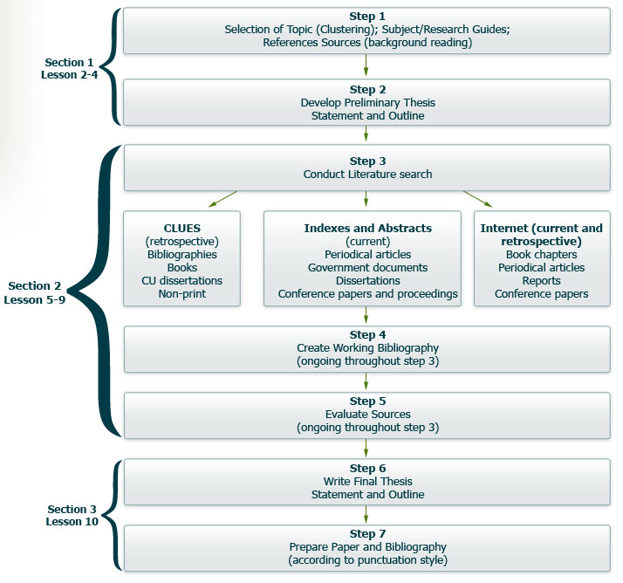
Use ref works for citing and bibliography

Publication Cycles
1. Time time it takes for info to be published in a specific form. (ex: up to 2 years in a scholarly journal, but 4 years in a textbook)
2. Knowledge stage of the original research from an idea being researched to being offered for review by one’s peers, to a final publication in a textbook.
3. Publication format in which the info appears general from the informal publication (research diary) to formal publication (scholarly article, encyclopedia)
4. Access methods we use to access the published info
REVIEW
This lesson began with a discussion of the objectives of the course (so that you now know what you will achieve through your efforts) and provides the foundational information necessary to ground the course.
Information literacy was then identified as a component of the employability skills of the Conference Board of Canada and then defined by the American Library Association and further elaborated by the Society of College, National and University Libraries.
The flowchart of the research process was presented as the template for the course and included the various steps involved from selecting a research topic to the gathering of information necessary for the production of a final product.
Finally, the Publication Cycle was introduced in order to situate throughout the course the various publication types encountered.
Topics covered in this lesson include:
- Course Objectives 1-9  - Information Literacy  - Conference Board of Canada Employability Skills  - Communicate  - Manage Information  - Locate, gather and organize information using appropriate technology and information systems  - Access, analyze and apply knowledge and skills from various disciplines  - Use Numbers  - Think & Solve Problems  - American Library Association  - Recognize when information is needed  - Have the ability to locate, evaluate, and use effectively the needed information  - SCONUL Seven Pillars Model for Information Literacy  - Identify: an information need  - Scope: Distinguish ways of addressing the information gap  - Plan: Develop strategies for locating information  - Gather: Locate and access information  - Evaluate: Apply criteria to assess the information  - Manage: Store and organize the retrieved information  - Present: Synthesize information and create final product | - Flowchart of the Research Process  - Step 1: Selecting the Research Topic  - Step 2: Developing the Preliminary thesis and outline  - Step 3: Conducting the Literature search  - Step 4: Creating the Working bibliography  - Step 5: Evaluating sources  - Step 6: Writing the final thesis statement and the final outline  - Step 7: Preparing the final product and the final bibliography  - Publication Cycle  - The Time Cycle indicating the length of time to publish for each type of material  - The Knowledge Cycle indicating how the information goes from informal to formal  - The Publication cycle indicating the type of material format in which the publication appears  - The Access Cycle indicating the method in which to access the published information

3 investigative conventions
- Analysis
- Evidence
- Discussion
Understanding the terminology
Evaluation select judgement criteria
Interpretation what does it mean
Definition provide definition to show that subject fits into the category (include subject, class, and differences)
Proposal a call for action/ specific considerations
Causal argument a condition exists because of specific circumstances
Comparison (including analogy) useful but should not be main focus of your paper
Precedence conventions or customes, usually well established
Implications explain your findings and come to conclusions.

