For the final read book well – 100% multiple choices Connaitre toute les end of chapters correlations.
Chapter 9 – OB – Personality, Cultural values, and Ability.
Personality: The structures and propensities inside a person that explain his or her characteristic patterns of thought, emotion and behaviour. Personality reflects what people are like and creates their social reputation.
Traits: Recurring trends in people’s responses to their environment.
Cultural values: Shared beliefs about desirable end states or modes of conduct in a given culture that influence the expression of traits.
Ability: Relatively stable capabilities of people for performing a particular range of related activities.
The big five taxonomy: The five major dimensions of personality: conscientiousness, agreeableness, neuroticism, openness to experience and extraversion.
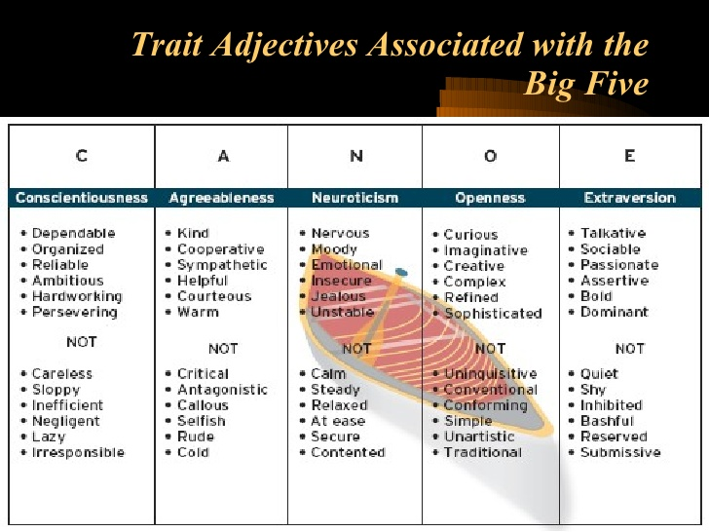
- Conscientiousness: Dimension of personality-reflecting traits like being dependable, organized, reliable, ambitious, hard-working, and persevering.
Accomplishment striving: A strong desire to accomplish task-related goals as a means of expressing one’s personality.

- Agreeableness: Dimension of personality-reflecting traits like being kind, cooperative, sympathetic, helpful, courteous, and warm.
Communion striving: A strong desire to obtain acceptance in personal relationships as a means of expressing one’s personality.

- Neuroticism: Dimension of personality-reflecting traits like being nervous, moody, emotional, insecure, jealous, and unstable.

Negative affectivity: A dispositional tendency to experience unpleasant moods such as hostility, nervousness, and annoyance.
Locus of control: One’s tendency to view the cause of events and personal outcomes as internally or externally controlled.
Ex :
External – Belief unhappy things in people’s life are due to bad luck…
Internal – Belief that unhappy things in people’s life are the results of their own mistakes.

- Openness to experience: Dimension of personality-reflecting traits like being curious, imaginative, creative, complex, refined, and sophisticated. (People who are open to new experiences tend to do well in situations that offer frequent opportunities to learn new things, such as teaching.
Cognitive ability + Openness to experience = Creative thought => Creative performance

- Extraversion: Dimension of personality-reflecting traits like being talkative, sociable, passionate, assertive, bold, and dominant.

Zero acquaintance situations: Situations in which two people have just met.
Status striving: A strong desire to obtain power and influence within a social structure as a means of expressing one’s personality.
Positive affectivity: A dispositional tendency to experience pleasant, engaging moods such as enthusiasms, excitement, and elation.

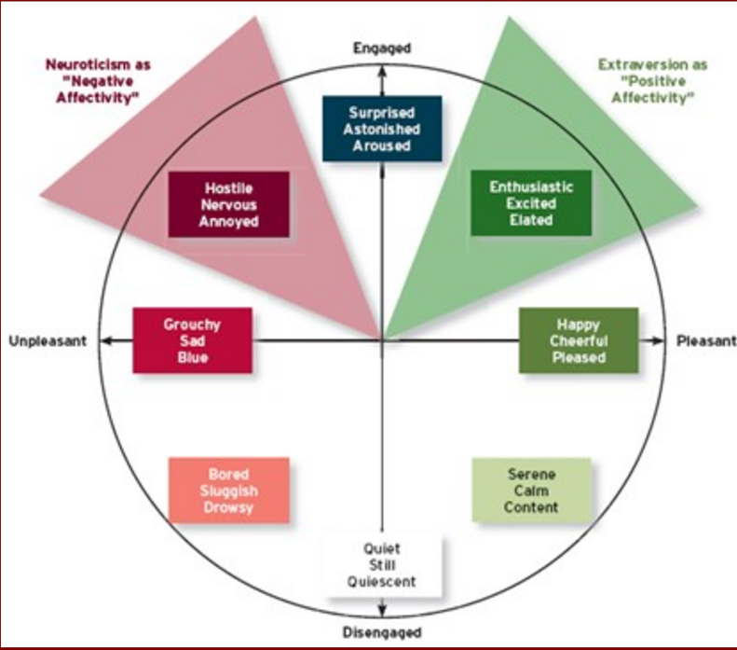

Cultural values

Culture – The shared values, beliefs, motives, identities, and interpretations that results from common experiences of members of a society and are transmitted across generations.

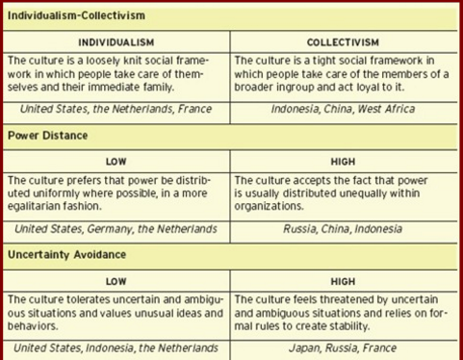
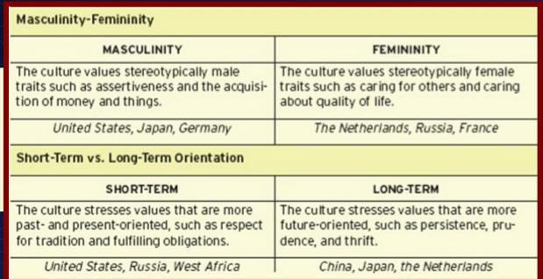

Ethnocentrism: One who views his or her cultural values as ‘’right’’ and values of other cultures as ‘’wrong’’

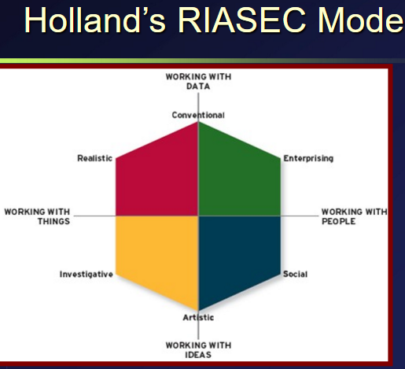
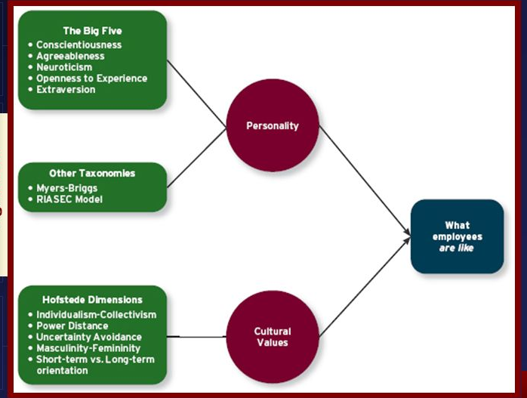
Cognitive ability:

- Capabilities related to the use of knowledge to make decisions and solve problems.
Verbal ability: Various capabilities associated with understanding and expressing oral and written communications.
Quantitative ability: Capabilities associated with doing basic mathematical operations and selecting and applying formulas to solve mathematical problems.
Reasoning ability: A diverse set of abilities associated with sensing and solving problems using insight, rules, and logic.
Spatial ability: Capabilities associated with visual and mental representation and manipulation of objects in space.
Perceptual ability: The capacity to perceive, understand, and recall patterns of information.
General cognitive ability: The general level of cognitive ability that plays and important role in determination the more narrow cognitive abilities. The ‘’g’’ factor.
Emotional ability
Emotional intelligence: A set of abilities related to the understanding and use of emotions that affect social functioning.
Self-awareness: The ability to recognize and understand the emotions in oneself.
Other awareness: The ability to recognize and understand the emotions that other people are feeling.
Emotional regulation: The ability to recover quickly from emotional experiences.
Use of emotions: The degree to which people can harness emotions and employ them to improve their chances of being successful in whatever they are seeking to do.

Physical ability
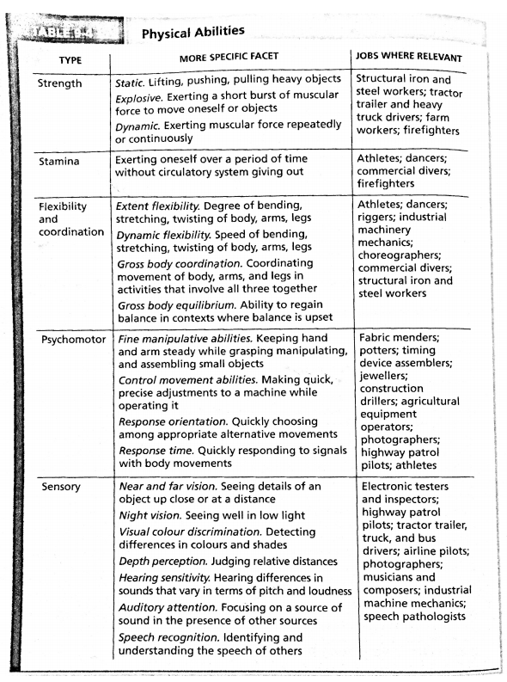

‘’Cognitive ability + Emotional ability + Physical ability = Overall ability’’
Typical performance: Performance in the routine conditions that surround daily job tasks.
Maximal performance: Performance in brief, special circumstances that demand a person’s best efforts.
Situational strengths: The degree to which situations have clear behavioral expectations, incentives, or instructions that make differences between individuals less important.
Trait activation: The degree to which situations provide cues that trigger the expression of a given personality trait.
Wonderlic Personel test: 12 mins test of general cognitive ability used to hire job applicants.

Teams, Diversity, and communication.
http://slideplayer.com/slide/4715062/
Team: Two or more people who work independently over some time period to accomplish common goals related to some task-oriented purpose.
Types of teams
Work team: A relatively permanent team in which members work together to produce goods and/or provide services.
Management team: A relatively permanent team that participates in managerial-level tasks that affect the entire organization.
Parallel team: A team composed of members from various jobs within the organization that meets to provide recommendations about important issues.
Project team: A team formed to take on one-time tasks, most of which tend to be complex and require input from members from different functional areas.
Action team: A team of limited duration that performs complex tasks in contexts that tend to be highly visible and challenging.
Virtual team: A team in which the members are geographically dispersed, and interdependent activity occurs through email, Web conferencing, and instant messaging.
Two types of team development.
- Forming
- Storming
- Norming
- Performing
- Adjourning
Second one has a punctuated equilibrium that results into inertia.
Task independence: The degree of which team members interact with and rely on other team members for information, materials, and resources needed to accomplish work for the team.
Goal orientation: The degree to which a team have a shared goal and align their individual goals with that vision.
Outcome interdependence: The degree to which team members share equally in the feedback and rewards that result from the team achieving its goals.

Team composition – The mix of the various characteristics that describe the individuals who work in the team. Five aspects of team composition.
- Member role: The behaviour a person is generally expected to display in a given context. The withdrawal or addition of a role usually has consequences over an organization. Leader – Staff / Team task / Team building role
- Member ability: A team can only perform at the speed or level of their slowest member. Member’s individual ability but also the ability to combine their abilities in such a way to be beneficial.
- Member personality: Agreeableness of the team members. Agreeable people then to be more cooperative and trusting therefore more effective.
- Team diversity: The degree of which team members are different from one another.
Value in diversity problem solving approach: A theory that supports team diversity because it provides a larger pool of knowledge and perspectives.
Similarity-attraction approach: A theory explaining that team diversity can be counterproductive because people tend to avoid interacting with others who are unlike them.
Surface-level diversity: Diversity of observable attributes such as race, gender, ethnicity, and age.
Deep-level diversity: Diversity of attributes that are inferred through observation or experience, such as one’s values or personality.
- Team size: Not too much but just enough.
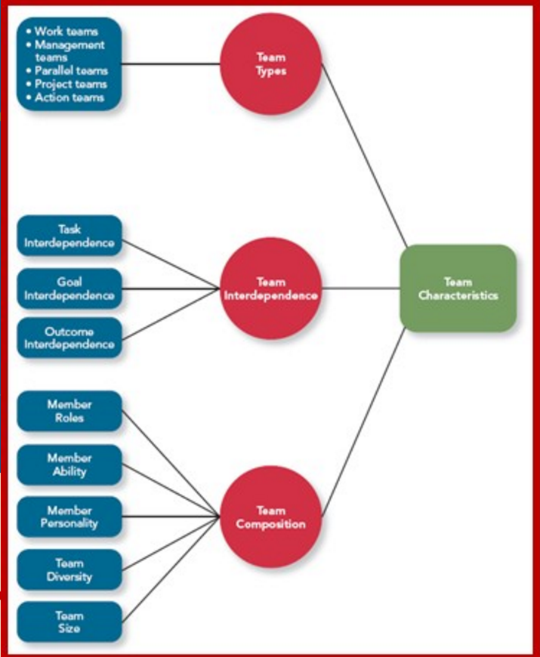
Process gain: When team outcomes are greater than expected based on the capabilities of the individual members.
Process loss: Loss is considered to have occurred when team outcomes are less than expected in view of the capabilities of the individual members.
Task work processes: The activities of team members that relate directly to the accomplishment of team tasks.
- Creative behavior: Focused on generating novel and useful ideas and solutions.
- Decision making: Chapter 8, but using information/intuition towards making specific decisions.
- Boundary spanning: Three types of individuals in groups, Ambassador activities, Task coordinator, scout activities.
Teamwork processes: The interpersonal activities that promote the accomplishment of team tasks but do not involve task accomplishment itself.
- Transition processes: Teamwork processes, such as mission analysis and planning, that focus on preparation for future work in the team.
- Action processes: Teamwork processes, such as helping and coordination, that aid in the accomplishment of teamwork as the work is actually taking place.
- Interpersonal processes: Teamwork processes, such as motivating and confidence building, that focus on the management of relationships among team members.
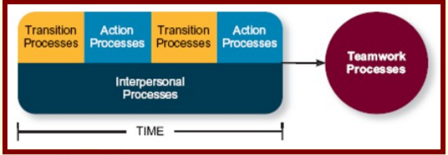
Communication
Communication: The process by which information and meaning is transferred from a sender to a receiver.
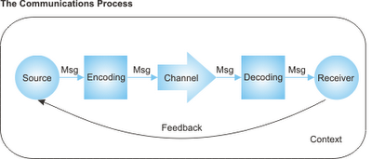
Communication competence: Competence to encode and interpret messages.
Gender differences: Men and woman have different communication styles. Men tend to maintain power and status. Woman tend to build and strengthens their relationships.
Noise: Message can take several forms. And there’s noise that interferes with the message being sent out.
Information richness: Amount and depth of the message.
Network structure: The more communication (between levels) have better effectiveness in complex tasks. But less in effectiveness in simple tasks.

Team states
Cohesion: A team state that occurs when members of the team develop strong emotional bonds to other members of the team and to the team itself.
- Group think: Behaviours that supports conformity and team harmony at the expense of other team priorities,
Potency: A team state reflecting the degree of confidence among team members that the team can be effective across situations and tasks.
Mental models: The degree to which team members have shared understanding of important aspects of the team and its task.
Transactive memory: The degree to which team member’s specialized knowledge is integrated into an effective system of memory for the team.

Taskwork processes + Teamwork processes + Communication + Team states = Progress loss/gain.

Chapter 11 – Power, Influence and negotiation
Power: The ability to influence the behaviour of others and resist unwanted influence in return.
Organizational power
Legitimate power: A form of organizational power based on authority or position. Ex: Make polite clear requests / explain the reason for the requests.
Reward power: A form of organizational power based on the control of resources or benefits. Ex: Offer the types of rewards people desire / Offer rewards that are fair and ethical.
Coercive power: A form of organizational power based on the ability to hand out punishment. Ex: Explain the rules and requirements and ensure people understand the serious consequences of violations.

Personal power
Expert power: A form of organizational power based on expertise or knowledge. Ex: Explain the reasons for a requests and why it’s successful.
Referent power: A form of organizational power based on the attractiveness and charisma of the leader. Ex: Show acceptance and positive regard.
Personal powers + Organizational power = Ability to influence people.
Contingency factors
Substitutability: The degree of which people have alternatives in accessing the resources that a leader controls. Ex: There are no substitutes for the rewards or resources the individual controls.
Discretion: The degree to which managers have the right to make decisions on their own. Ex: The individual’s role is important and interdependent with others in the organization.
Centrality: How important a person’s job is and how many people depend on that person to accomplish their tasks. Ex: The individual has the freedom to make his or her own decisions without being restrained by organizational rules.
Visibility: How aware others are of a leader and the resources that a leader can provide. Ex: Others know about this individual and the resources he or she can provide.
Influence: The use of behaviours to cause behavioural or attitudinal changes in others.
Influential tactics
Rational information: The use of logical arguments and hard facts to show that a request is worthwhile.
Consultation: An influence tactic whereby the target is allowed to participate in deciding how to carry out or implement a request.
Inspirational appeal: An influential tactic designed to appeal to one’s values and ideas, thereby creating an emotional or attitudinal reaction.
Collaboration: An influence tactic whereby the leader makes it easier for the target to complete a request by offering to work with and help the target.
Ingratiation: The use of favours, compliments, or friendly behaviour to make the target feel better about the influencer.
Personal appeals: An influence tactic in which the requestor asks for something based on personal friendship or loyalty.
Exchange tactics: An influence tactic in which the requestor offers a reward in return for performing a request.
Apprising: An influence tactic in which the requestor offers a reward in return for performing a request.
Pressure: An influence tactic in which the requestor attempts to use coercive power through threats and demands.
Coalition: An influence tactic in which the influencer enlists other people to help influence the target.

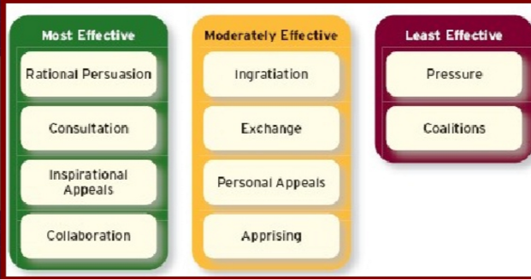
Reponses to influence tactics
Internalization: (most effective) A response to influence tactics where the target agrees with and becomes committed to the request.
Compliance: When target of influence are willing to do what the leader asks but do it with a degree of ambivalence.
Resistance: (least effective) When a target refuses to perform a request and puts forth an effort to avoid having to do it.
Power and influence in action.
Organizational politics: Individual actions directed toward the goal of furthering a person’s self-interest.
Political skills: The ability to understand others and the use of that knowledge to influence them to further personal or organizational objectives.
Conflict resolution
Styles of conflict resolutions:
- Avoiding: A conflict resolution style by which one party wants to remain neutral, stay away from conflict, or postpone the conflict to gather information or let things cool down.
- Accommodating: A conflict resolution style by which one party gives in to the others and acts in a completely unselfish way.
- Collaboration: A conflict resolution style whereby both parties work together to maximise outcomes.
- Compromise: A conflict resolution style by which conflict is resolved through give-and-take concessions.
- Competing: A conflict resolution style by which one party attempts to get his or her own goals met without concerns for the other party’s results.

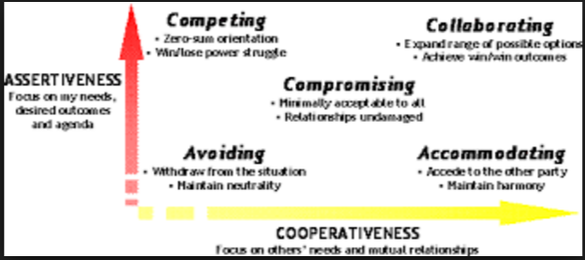
Negotiation: A process in which two or more interdependent individuals discuss and attempt to reach agreement about their differences.
Negotiation strategies:
Distribution bargaining: A negotiation strategy in which one person gains and the other person loses.
Integrative bargaining: A negotiation strategy that achieves an outcome that is satisfying for both parties.
Negotiation stages:
Preparation – Exchanging information – Bargaining – Closing argument.
BATNA: A negotiator’s best alternative to a negotiated agreement.
Application
Alternative dispute resolution: A process by which two parties resolve conflicts through the use of a specially trained, neutral third party.
Meditation: A process by which a third party facilitates a dispute resolution process but with no formal authority to dictate a solution.
Arbitration: A process by which a third party determines a binding settlement to a dispute between two parties.

Chapter 12- Leadership styles and behaviours.
Leadership: The use of power and influence to direct the activities of followers toward goal achievement.
Leader-member exchange theory: A theory describing how leader-member relationships develop over time on a dyadic basis.
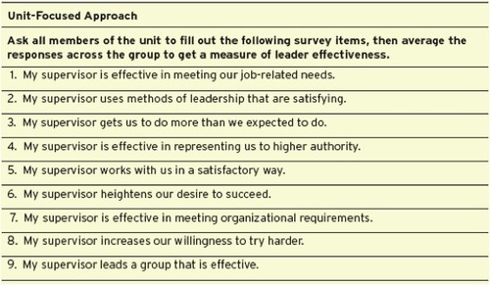
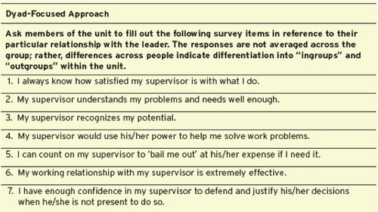
Role taking: Phase in a leader-follower relationship when a leader provides an employee with job expectations and the follower tries to meet those expectations.
Role making: Phase in a leader-follower relationship when a follower voices his own expectations for the relationship, resulting in a free-flowing exchange of opportunities and resources for activities and effort.
In-groups/Outgroups: Ingroups have a greater communication/mutual trust/respect/obligation with the leader compared to outgroup.
Leader effectiveness: The degree to which the leader’s actions results in the achievement of the unit’s goals, the continued commitment of the unit’s employees, and the development of mutual trust, respect, and obligation in leader-member dyads.
Leader emergence: The process of becoming a leader in the first place.
Leader decision making styles
Autocratic style: (highest Leader control) A leadership style where the leader makes the decision alone without asking for opinions or suggestions of the employees in the work unit.
Consultative style: A leadership style in which the leader presents the problem to employees asking for their opinions and suggestions before ultimately making the decision himself.
Facilitative style: A leadership style in which the leader presents the problem to a focus group of employees and seeks consensus on a solution, making sure his or her own opinion receives no more weight than anyone else’s.
Delegative style: (highest follower control) A leadership style where the leader gives the employee the responsibility for making decisions within some set of specified boundary conditions.
Time –driven model of leadership: A model that suggests that seven factors, including the importance of the decision, the expertise of the leader, and the competence of the follower, combine to make some decision making styles more effective than others in a given situation.
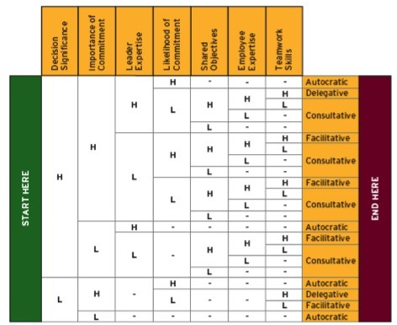
Day-to-day leadership behaviour

Initiating Structure: Reflects the extent to which the leader defines and structures the roles of employees in pursuit of goal attainment. Leaders who are high on initiating structure play a more active role in directing group activities and prioritize planning, scheduling and trying out new ideas.

Consideration: Reflects the extent to which leaders create jobs relationships characterized by mutual trust, respect of employee ideas, and consideration of employee feelings. Leaders who are high on consideration create a climate of good rapport and strong, two-way communication and exhibit a deep concern for the welfare of employees.

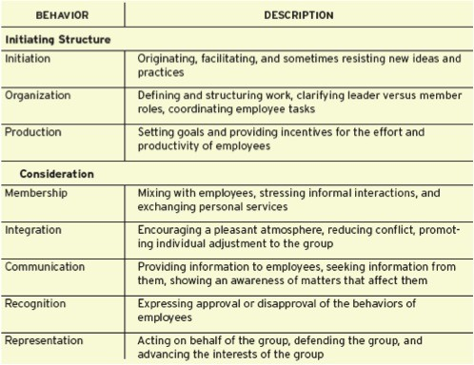

Life cycle theory of leadership: Optimal combination of initiating structure and consideration depends on the readiness of the employees in the work unit.
- Readiness: Is broadly defined as the degree to which employees have the ability and the willingness to accomplish their specific tasks.
- Telling: When the leader provides specific instructions and closely supervises performance.
- Selling: When the leader explains key issues and provides opportunities for clarifications.
- Participating: Leader behaviour in which the leader shares ideas and tries to help the group conduct its affairs.
- Delegating: Leader behavior in which the responsibility for key behaviours over to employees.

Transformational leadership behaviours

Transformational leadership: Involves inspiring followers to commit to a shared vision that provides meaning to their work while also serving as a role model who helps followers develop their own potential and view problems from new perspectives.

Laissez-faire leadership: Is the avoidance of leadership altogether.

Transactional leadership: Occurs when the leader rewards or disciplines the follower depending on the adequacy of the follower's performance.

- Passive management-by-expectation: The leader waits around for mistakes and errors, then takes corrective action as necessary.

- Active management-by-exception: The leader arranges to monitor mistakes and errors, actively and again takes corrective actions when required.

- Contingent reward: Happens when the leader attains follower agreement on what needs to be done using promised or actual rewards in exchange for adequate performance.

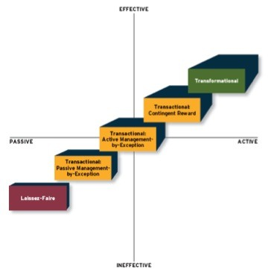
Idealized influence: The power held by a leader who behaves in was that earn the admiration, trust, and respect of followers, causing followers to want to identify with and emulate the leader.
Inspirational motivation: A type of influence in which the leader behaves in ways that foster an enthusiasm for and commitment to a shared vision of the future.
Intellectual stimulation: A type of influence in which the leader behaves in ways that challenges followers to be innovative and creative by questioning assumptions and reframing old situations in new ways.
Individualised consideration: A type of influence in which the leader behaves in ways that helps followers achieve their potential through coaching, development, and mentoring.
How important is leadership?
Substitutes: Situational characteristics that reduces the importance of the leader while simultaneously providing benefit to employee performance.
Neutralizers: Situational characteristics reducing import. Leader, no effect on employee perf.
Chapter 13 – Organizational structure.
Organizational structure: Formally dictates how jobs and tasks are divided and coordinated between individuals and groups within the company.
Organizational charts:
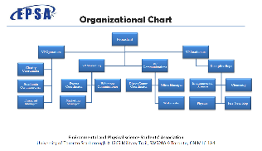
Elements of organizational structure.
Work specialization: The degree to which tasks in an organization are divided into separate jobs.
Chain of command: Answers the question of ‘’who reports to whom’’? and signifies formal authority relationships.
Span of control: Represents how many employees each manager in the organization has responsibility for.
Centralization: Refers to where decisions are formally made in organizations.
Formalization: The degree to which rules and procedures are used to standardize behaviours and decisions in an organizations.
Elements in combinations:
- Mechanistic organizations: Efficient, rigid, predictable, and standardized organizations that thrives in stable environments.
- Organic organizations: Flexible, adaptive, outward-focused organizations that thrive in dynamic environments.
Organizational design.
Organizational design: The process of creating, selecting, or changing the structure of an organization.
Business environment: The outside environment, including customers, competitors, suppliers, and distributors, which all have an impact on organizational design.
Company strategy: An organization’s objectives and goals and how it tries to capitalize on its assets to make money.
Technology: The method by which an organization transforms inputs to outputs.
Company size: The number of employees in a company.

Common organizational forms
Simple structure: An organizational form that features one person as the central decision-making figure.
Bureaucratic structure: An organizational form that exhibits many of the facets of a mechanistic organization.
- Functional structures: An organizational form in which employees are grouped by the functions they perform for the organization.
Multidivisional structures: An organizational form in which employees are grouped by product, client, or geography.
- A) Product structures: An organizational form where employees are grouped around different products that the company produces.
- B) Geographic structures: An OF which employees are grouped around the different locations where the company does business.
- C) Client-Based structure: An OF in which employees are organized around serving customers.
- Matrix structure: A complex form of organizational structure that combines a functional and multidivisional grouping.
How important is structure?
Restructuring: The process of changing an organization’s structure.
Restructuring has negative effect on JP (weak correlation)
Restructuring has a negative effect on OC (moderate correlation)

Chapter 14 – Organizational culture and change.
Organizational culture: The shared knowledge within an organization regarding the rules, norms, and values that shape the attitudes and behaviours of its employees.
Culture components
Observable artifacts: Aspect of an organization’s culture that employees and outsiders can easily see or talk about.
- Symbols/Physical structures/Language/Stories/Rituals/Ceremonies
Basic underlying assumptions: The ingrained beliefs and philosophies of employees.
General culture types
Fragmented culture: An OC type in which employees are distant and disconnected from one another.
Mercenary culture: An OC type in which employees think alike but are not friendly to one another.
Networked culture: An OC type in which employees are friendly to one another, but everyone thinks differently and does his or her own thing.
Communal culture: An OC type in which employees are friendly to one another and all think alike.
 | Low solidarity | High solidarity
High sociability | Networked | Communal
Low sociability | Fragmented | Mercenary

Specific culture types
Customer service culture: A SC type focused on service quality.
Safety culture: A SC type focused on the safety of employees.
Diversity culture: A SC type focused on fostering or taking advantage of a diverse group of employees.
Creativity culture: A SC type focused on fostering a creative atmosphere.

Culture strength
Culture strength: The degree to which employees agree about how things should happened within the organization and behave accordingly.
Subculture: A culture created within a small subset of the organization’s employees.
Counterculture: A subculture whose values do not match those of the organization.
Pros and cons of a strong culture.
- Pros – Differentiates the organization from others/ Allows employees to identify themselves within the organization.
- Cons – Makes merging with another org. difficult./Attracts and retains similar kinds of employees, thereby limiting diversity of thought.
Maintaining an organizational culture
Attraction-selection-Attrition (ASA framework): A theory that states that employees will be drawn to organizations with cultures that match their personality, organizations will select employees that match, and employees will leave or be forced out when they are not a good fit.
Socialization: The primary process by which employees learn the social knowledge that enables them to understand and adapt to the organization’s culture.
- Anticipatory stage: A stage of socialization that begins as soon as a potential employee develops an image of what it would be like to work for a company.
- Encounter stage: A stage of socialization beginning the day an employee starts work, during which the employee compares the information learned as an insider.
- Reality shock: A mismatch of information that occurs when an employee finds that aspect of working at a company are not what the employee expected it to be.
- Understanding and adaptation: The final stage of socialization, during which newcomers come to learn the content areas of socialization and internalize the norms and expected behaviours of the organization.
Changing an organizational culture.

The change progress – Three steps – Unfreezing, change initiative, and refreezing.

Changes in leadership – New organizational culture that was less about inventing things and more about listening to consumers and designing exciting new consumer products.

Mergers and acquisitions – Putting two distinct culture together.
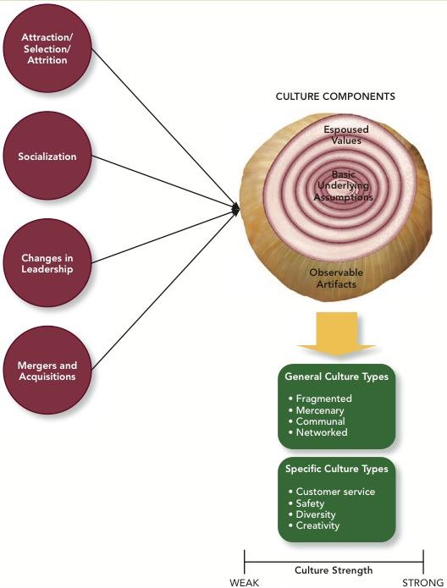
Person-organization fit- The degree to which a person’s values and personality match the culture of the organization.
Realistic job previews – Process of ensuring that a prospective employee understands both the positive and negative aspects of the job.
Strong correlation- Person-organization fit -----Organization commitment
Weak correlation – Person-organization fit ----- Job performance

