6 | Companies’ Vision | - Dyer, chapter 4: “Underlying assumptions”  - 8- Collins & Porras: “Building your company’s vision”, HBR, Sep-Oct 1996  - 9- Jordan, “Dance for your dinner”, Canadian Business, Nov. 22, 2010  - 10- Additional reading: Zaleznik, “Managers and leaders. Are they different?” HBR
7 | The Manager’s job, Social power | - Dyer, chapter 5: “Causal claims”  - 11- Mintzberg, “Manager’s job: Folklore and fact”, HBR Mar-Apr 1990  - 12- French & Raven: “The bases of social power”, Institute of social research, 1959  - 13- Austin, The Megabus effect, Business Week, April 7, 2011
8 | Strategy, resources and capabilities | - Dyer, chapter 6: “Techniques of persuasion”  - 14- Barney, “Looking inside for competitive advantage”, Academy of management, Nov 1994  - 15- Van Praet, Land-grabber or farming’s structure? Quebec’s Pangea says bigger is better, Financial Post, May 12, 2014
9 | Performance, measurement and evaluation | Dyer, chapter 7: “Writing a persuasive essay”  - 16- Kaplan & Norton, “The balanced scorecard”  - 17- Cassivi, ‘’The Circus’ Tarnished Brand’’, La Presse, Jan 17, 2013
10 | Managing change | 18- Handy, “The Sigmoid curve”  - 19- Chu & Weiss, ‘’The Cobbler’s Conundrum’’, Fast Company, July/August 2013
11 | Motivation | - 20- Herzberg: “One more time: How do you motivate employees?”, HBR, Sep-Oct. 1987  21- Beer, “The sweat smell of success”, Canadian Business, July 2012

THEORIES

COLLINS & PORRAS:
Vision: provides guidance about what core to preserve and what future to stimulate progress towards.
Core ideology (core values and core purpose): enduring character of an organization and is the source of guidance inspiration. It is the glue that holds an organization together as it grows, diversifies, expands loyalty. It is the consistent identity of the organization that transcends product or marker life cycles.
Core values: beliefs about what is important. Small set of timeless guiding principles, company should not change core values in response to marker change.
Core purpose (reason for existing): the organizations reason for being, people’s idealistic motivations for working at the company
Not a goal or business strategy
- Core purpose should inspire change since a company can never fully achieve its purpose (guiding light)
- Core purpose is to guide and inspire

Discovering core ideology:
* You do not create or set core ideology, you discover it!
- Ideology has to be authentic
- Role of core ideology is to guide and inspire not to differentiate
- Core ideology needs to be meaningful and inspirational only to people inside organization because they need to commit to the ideology over the long term
- A clear and well-articulated ideology attracts to the company people whose persona values are compatible with the company’s core values
- Core values and core purpose attract and retain those people who are compatible
- Core ideology $≠$ core competence

Envisioned Future:
- BHAG (big, hairy, audacious, goal) 10-30 years to complete
- Vivid description (what it will be like to achieve goal)

BHAG: engages people – it reaches out and grabs them it is tangible, energizing, highly focused
Vision level BHAG
- Applies to the entire organization and requires 10-30 years of effort to complete
- Setting BHAG that far into the future requires thinking beyond the current capabilities of the organization and the current environment.
BHAG should not be a sure bet (50-70% success rate). Organization must believe that it can reach the goal

Vivid description: vibrant, engaging and specific description of what it will be like to achieve the BHAG.
- Translate the vision from words into pictures that people can carry around in their heads
- Passion, emotion and conviction are essential parts of the vivid description.

ZALEZNIK:
Main Claim: Managers embrace process, seek stability and control, and instinctively try to resolve problems quickly – sometimes before they truly understand the problem’s significance. Leaders, in contrast, tolerate chaos and lack of structure and are willing to delay closure in order to understand the issue more fully.

Business leaders have much more in common with artists, scientists and other creative thinkers than they do with managers
Organizations require both managers and leaders in order to succeed; but developing both requires a reduced focus on logic and strategic exercises in favour of an environment where creativity and imagination are permitted

Attitudes towards goals:
Manager:
- Takes an impersonal, passive outlook
- Goals arise out of necessities, not desires
Leaders:
- Take a personal, active outlook. Shape rather than respond to ideas
- Change how people think about what is desirable and possible
- Set company direction

Conceptions of work:
Managers:
- Negotiate and coerce. Balance opposing views
- Design compromises. Limit choices
- Avoid risk
Leaders:
- Develop fresh approaches to problems
- Increase options. Turn ideas into exciting images
- Seek risk when opportunities seem promising

Relations with others:
Managers:
- Prefer working with people, but maintain minimal emotional involvement; lack empathy
- Focus on process; how decisions are made rather than what decisions to make
- Communicate by sending ambiguous signals; subordinates perceive them as detached and manipulative
- Organization accumulates bureaucracy and political intrigue
Leaders:
- Attracted to ideas; relate to others directly and intuitively
- Focus on substance of events and decisions, including their meaning for participants
- Subordinates describe them with emotionally rich adjectives
- Relations appear turbulent, intense, disorganized; yet motivation intensifies and unanticipated outcomes occur

Sense of self:
Managers:
- Comes from perpetuating and strengthening existing institutions
- Feel part of the organization
Leaders:
- Comes from struggles to profoundly alter human and economic relationships
- Feel separate from the organization

HENRY MITZBERG:
Talks about the importance of the manager’s role and the need to understand it properly and thoroughly before attempting to train and develop more managers.

The nature of managerial work (6 characteristics)
- The managers job is a mixture of regular programmed jobs and unprogrammed jobs/tasks.
- A manager is both a generalist and a specialist
- A managers rely on information from all sources but show a preference for that which is orally transmitted
- Managerial work is made up of activities that are characterized by brevity, variety and fragmentation.
- Managerial work is more an art than a science and is reliant on intuitive process and a feel for what is right
- Management work is becoming more complex

According to Mintzberg, the roles of the manager or the expectations for a manager’s behaviour, fall into 3 categories:
- Informational: managing by information
a. monitor: collecting all type of information that are relevant and useful for the organization
b. dissemination: transmits some privileged information directly to subordinates, who would otherwise have no access to it
c. spokesperson: transmits information from within the organization to outsiders.
- Interpersonal: managing through people
a. figurehead: head of an organization and must perform some ceremonial duties and role may sometimes be routine, involving little serious communication
b. leader: establish the atmosphere and motivate the subordinates and are responsible for the work of its people
c. liaison: developing and maintain webs of contacts outside the organization
- Decisional: managing through action
a. entrepreneur: seeks to improve organization and to adopt it to changing conditions in the environment
b. disturbance handler: deals with disputes or problems and takes corrective action
c. resource allocator: decides on the use of organizations resources
d. negotiator: negotiating with individuals and dealing with the organizations and defends the business’s interests

Becoming a more effective manager:
- Be aware of the roles you prefer. Stretch beyond those you are most comfortable in, depending on what the situation demands
- Reduce workload by giving subordinates the information they need to be more self-sufficient
- Avoid superficial decision making by taking advantage of expert analysts
- Force yourself to do things you believe are important

FRENCH & RAVEN:
The base of social power of French and Raven is a theory that identifies 5 bases or sources of social organizational power.

- Reward Power: Is the ability to compensate another for their compliance and work
- Coercive Power: Is the understanding that one has the ability to punish others for not complying
- Legitimate Power: Based on the perception that people have the formal right to make demands and to expect compliance and obedience from others
- Referent Power: Is the influence one has on others from being well liked or respected by others
- Expert Power: Is the ability to influence others based solely on one’s in depth knowledge, superior skills and experience

JAY BARNEY:
- A firm will give a sustained competitive advantage if its resources and capabilities are valuable, rare, and inimitable and organized in a way that allows to exploit potential opportunities.
- A firm will be successful if it has resources with the right attributes and characteristics
- A firm’s resources and capabilities include all of the financial, physical, human and organizational assets used by a firm to develop, manufacture, and deliver products or services to its customers
- Financial: debt, equity, retained earnings
- Physical: machines, manufacturing, facilities
- Human: experience, knowledge, judgment, wisdom
- Organizational: History, relationships, trust, culture, formal reporting structure, patents
- A complete understanding of sources of competitive advantage requires the analysis of a firm’s internal strengths and weaknesses as well.

Four important questions about resources capabilities
- The question of value: Does a firm’s resources and capabilities enable it to exploit an opportunity, and/or neutralize it?
- The question of rareness: How many competing firms already possess these valuable resources and capabilities?
- The question of imitability: Do firms without a resource or capability face a cost disadvantage in obtaining it compared to firms that already possess it?
Barney has identified 3 reasons why resources can be hard to imitate.
a. Historical conditions: valuable and rare resources acquired or developed through unique historical circumstances can be costly to imitate and thus a source of sustained competitive advantage.
b. Importance of numerous small decisions: a firm’s competitive advantage seems to depend on numerous small decisions through which a firm’s resource and capabilities are developed and exploited in developing, nurturing and exploiting resources
c. the importance of social complex resources: the resources and capabilities that are based on company’s culture or interpersonal relationships (reputation, trust, friendship, teamwork, and culture) (while not patentable are much more difficult to imitate)
- The question of organization: Is a firm organized to exploit the full competitive potential of its resources and capabilities?

KAPLAN & NORTON:
- The balances scorecard is a strategic planning and management system that is used extensively in business to align business activities to the vision and strategy of the organization, improve internal and external communications, and monitor organization performance against strategic goals.

Four perspectives for a balanced scorecard:
- The customer perspective: the importance of customer focus and customer satisfaction in any business. If customers are not satisfied, they will eventually find other suppliers that will meet their needs.
- The internal business perspective: refers to the internal business process. Metrics based on this perspective allow the managers to know how well their business are running, and whether its products and services conform to customer requirements. Metrics must be developed and designed by people within the company that know these processes well.
- Innovation & learning perspective: refers to the importance of individual and corporate self-improvement. In a knowledge-worker organization, people are the main resources, and with the rapid technological workers to be in a continuous learning mode. Certain metrics can be put into place to help guide managers in allocating resources where they can help the most.
learning & growth constitute the essential foundation for success of any knowledge-worker organization.
- The financial perspective: timely and accurate funding data will always be a priority; they must ensure profitability for shareholders. These measures indicate whether or not the company’s strategy, implementation and execution are contributing to the bottom line.

HANDY:
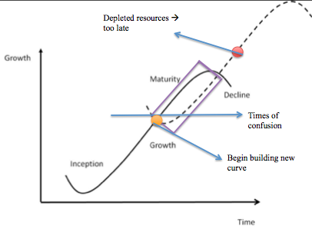
*when a company is left at point B, only new people will be able to lift the organization to the second curve
- Sigmoid curve: sums up the story of life itself
the secret to constant growth is to start a new sigmoid curve before the first one begins to diminish
The second curve
- The discipline of the second curve requires that you always assume that you are near the peak of the first curve, at point “Begin building new curve” and should therefore be starting to prepare for the second curve
- It assumptions turns out to be wrong, nothing has been lost. Only the exploratory phase of the second phase has been done
no major commitments will have been done until curve 2 overtakes curve 1; which will not happen if curve 1 is on the rise
- Keeping the two curves going will become a habit
- While making second curve, it is common to challenge the assumptions underling the first curve
- The discipline of the second keeps one sceptical, curious, and inventive – attitudes that are essential in a time of change
- The second curve follows the traditional four-stage style cycle of discovery
- questions start it off! ideas possibilities hypotheses
- In the second curve it is important to not re-invent the same life because that would perpetuate the first curve
- Essential: let go of the past
- Second curve is always different, although it builds on and grows out of the first curve

Paradox of time
*By the time you know where you need to go, it is already too late
“if one is too emotionally attached to what has gone before, it is difficult to be different in any way”

Curvilinear Logic
- Paradox of success
- What got you where you are won’t keep you where you are
- Curvilinear logic means starting life over again, something that gets harder as one gets older
- *Entrust the curvilinear thinking to the next generation
- Can see more clearly where the first curve is heading and what the next curve might look like
- *The elders of the organization must allow change, give permission to be different, and then when the next curve is established, they must exit/get out of the way
- For that to happen, there has to be a new curve for them outside

HERZBERG:
Two Factor Theory:
- Hygiene Factors: Needed to ensure an employee does not become dissatisfied. They do not lead to motivation, but without them, there are possibilities of dissatisfaction. (Examples: working conditions, quality of supervision, status, security, salary, company policies, interpersonal relations)
- Motivation Factors: Needed to motivate an employee into higher performance motivators is the primary source of satisfaction. (Examples: achievement, responsibility, growth, interest in the job, recognition for achievement, advancement for higher level task)

Combining Hygiene & Motivation Factors
- High hygiene & high motivation ideal situation where employees are highly motivated l and have few complaints
- High hygiene & low motivation employees have few complaints but are not motivated (job seen as a pay check)
- Low hygiene & high motivation employees are motivated but have lots of complaints. A situation where job is exciting and challenging but salaries and work conditions are poor.
- Low hygiene & low motivation unmotivated employees with many complaints. (Worse situation)

Job Enrichment: (Vertical Job Enlargement)
- Provides employee with more task to do as part of the job and gives them the responsibility and authority needed to complete the task
- Give people responsibility for the complete process of the task
- Make information directly available to employees. Rather than sending it through their managers
- Enable people to take on new, more difficult tasks they have not handled before
*Employees gain an enhances sense of responsibility and achievement; along with new opportunities to learn and grow

Job Loading:
- Horizontal job loading:
- Adding tasks to a job but not responsibilities
- The “meaningness” of the job is simply increased
- Vertical job loading:
- Adding meaningful tasks that will lead to growth
- Additional tasks that permit growth and provide motivating factors
Job Enlargement (Horizontal Job Enlargement): Widening the range of jobs at the same level in the organization and adding them to the existing job. (Herzberg says there is little motivation value to this approach)

Job Rotation: Planned rotation of staff between jobs to alleviate monotony (lack of interest and variety) and provide a fresh job challenge. (Herzberg says it is likely to improve job satisfaction but unlikely to create positive motivation)

CLASS 6:
CHAPTER 4:
Dyer, chapter 4: “Underlying Assumption”
- What are the author’s underlying assumptions?
- What are the suppositions upon which the argument is based?
- What must we believe if we are to see the evidence as relevant to the claim?
- Subjecting underlying assumptions to careful scrutiny is an important step in the critique of a text.

Why are they “underlying”?
- Underlying assumptions are usually found in the gap that separates claims and evidence.
- Once a person’s assumptions about a certain topic are formed, they are the foundation of everything she thinks, says, and does on that topic.
- Deeply ingrained and taken for granted.
- Uncovering assumptions and making them explicit is an important step in evaluating an argument

How to find underlying assumptions
- In essence, we find underlying assumptions by looking at what people write, then making guesses about what they must believe in order to have written that
- We look for the gap between the evidence and the claim by asking:
- What must be true if the claim is to follow from this evidence?
- What general principle might link this particular claim to this particular evidence?
- What beliefs might I expect from this type of person?

Reality assumptions
- 2 major types of assumptions:
1) Reality
2) Value
- Reality assumptions are our beliefs about what events have taken place, what exists, or how things work in the world; beliefs about reality.

Challenging reality assumptions
- Evaluate accuracy
- This consists of critiquing the quality of the assumptions

Value assumptions
- Values are our set of ideals, our standards of right and wrong, and the way things ought to be.
- Recognize through: ought, should, desirable
- Value conflicts are quite common

Challenging value assumptions
- Value conflicts and differential value rankings are reasons for disagreements about the relevance of the evidence presented for a claim.
- Values are often developed in early life and are resilient to change

Effective writing
- Critical thinking about underlying assumptions can help you to improve your own writing.
- A large quantity of evidence for your claims and ensuring that the evidence is of good quality are both necessary but not good enough to be convincing.
- It is important to make sure each piece of evidence is relevant.
- Ask yourself: is this assumption always true?

CLASS NOTES:
Explore underlying assumptions
- Underlying assumptions = logical link that fills the gap between the evidence and the claim
  - Implicit or explicit principles that form the bases of our beliefs & reasoning
  - Tells us whether evidence provided for a claim is relevant

Exploring and finding underlying assumptions
- What must be true if the claim is to follow from this evidence?
- What general principal might link this particular claim to this particular evidence?
- What beliefs might I expect from this type of person?
- Could someone believe this evidence and still disagree with the claim? Why?

Underlying assumptions
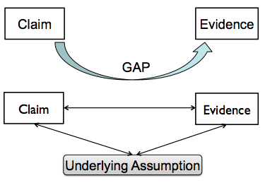

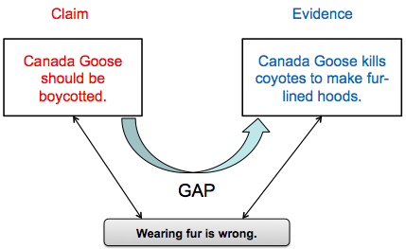
Explore underlying assumptions
- Reality assumptions: our beliefs about reality; about the way things are
- Value assumptions: our ideals, our standards of right and wrong, the way things ought to be
- Challenging underlying assumptions

Collins & Porras: Vision
“Vision provides guidance about what core to preserve, and what future to stimulate progress toward.” 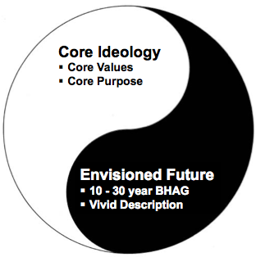
Collins & Porras
- Core ideology:
  - You do not create a core ideology – you discover it
  - Enduring character of an organization – a consistent identity that transcends product or market life cycles, technological breakthroughs, management fads, and individual leaders
  - Glue that holds the organization together
- Consists of:
  - Core values and
  - Core purpose

Collins & Porras: Core Idealogy
- Core values: Essential and enduring tenets; small set of timeless guiding principles; beliefs about what is important
  - The “Code of Ethics” or “How we do business”
  - Seldom change – if ever, even in times of uncertainty
- Core purpose: The organization’s reason for being; the idealistic motivations for doing the company’s work; capture the soul of the organization
  - Why do we exist?
  - Forever pursued but never reached
  - Does not change but should inspire change
- “Discovering” Core Ideology
  - You do not create or set core ideology
  - Description of what actually exists, not just what we wish existed
  - Needs to be meaningful and inspirational only to people inside the organization
  - Find people who are predisposed to share the organization’s core values and purpose
  - More than creating a perfect statement!

Collins & Porras: Envisioned Future
- Envisioned future is a “Creative Process”
  - BHAGs: “Big, Hairy, Audacious Goals”
    - 10-30 year timeframe
    - Powerful way to stimulate progress
    - Clearly articulated & compelling; serves as unifying focal point of effort; acts as a catalyst for team spirit
    - Takes little or no explanation
    - Not a sure bet….!
  - Vivid description is important: passion, emotion and conviction
**Be aware of the “we’ve arrived syndrome”**
- When you attain your BHAG, do not give up but create another BHAG

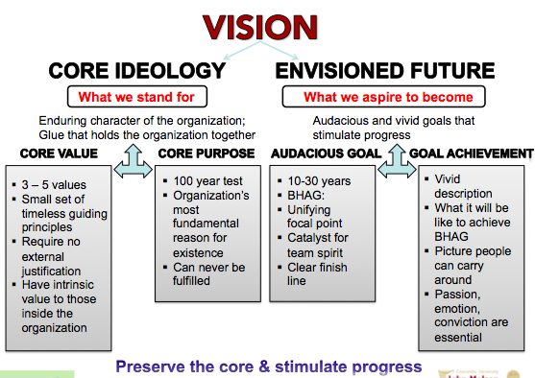

CLASS 7:
CHAPTER 5:
Dyer, chapter 5: “Causal Claims”
- Certain events or factors (causes) are responsible for bringing about other events or situations (effects)

Causal reasoning is natural – and useful
- Without causal links between situations, nothing would make sense
- The identification of causal relationships gives meaning to the world that surrounds us
- Cause-and-effect relationships are also the basis for decision making and reasoned action

Causal reasoning can be very difficult
- In the complex situations we encounter in the world of business, it is sometimes difficult to find reasonable and likely causes for certain outcomes
- The difficulty in determining cause-and-effect links rise from the fact that outcomes may have multiple causes
- As critical thinkers we must examine carefully the causal claims of authors
- Rival causes: 3 types
1) related to differences between groups
2) correlation between characteristics
3) the post hoc ergo propter hoc fallacy

Differences between groups
- Think: are there any differences between the groups that could cause the effect?
- Unless in a controlled experiment, there is usually differences between groups (unrelated factors that cause the effect)

Correlation between characteristics
- Taking a correlation between two factors and claiming a causal link.
- Think: “When ice cream sales increase, rape increases” (example from psychology) ice cream does not cause the incidence of rape to occur but in the summer, when ice cream sales increase, people are outside more and this causes rape incidences to increase

The post hoc ergo propter hoc fallacy
- Loosely translates to: after this therefore because of this
- Can be classified as superstitious behaviour
- Just because an event was followed by another event does not necessarily mean that the first event caused the second one

Can we ever be sure?
- Multiples causes and rival causes (the three of them) make it hard to come to a conclusion sometimes
- In the applied, practical world of business, we have to be confident about causal relationships if we are to avoid wasting money and human effort

Experimental research
- Testing causal claims is the raison-d’être of experimental designs in business research
- The primal aim of an experiment is to rule out rival causal explanations
- In experimental research:
- Ensure no differences between groups
- Keep all variables between the two groups constant (room temp, time of day, etc.)
- Use random assignment (to avoid bias)
- Formal experimentation can be very costly
CLASS NOTES:
Mintzberg’s manager’s roles
- Myth:
  - Managers plan, organize, coordinate & control
- Realities:
  - Interpersonal roles
    - Figurehead, Leader, Liaison
  - Informational roles
    - Monitor, Disseminator, Spokesperson
  - Decisional roles
    - Entrepreneur, Disturbance-handler, Resource-allocator, Negotiator

Managerial roles
- Figurehead
- Leader
- Liaison
- Monitor
- Disseminator
- Spokesperson
- Entrepreneur
- Disturbance-handler
- Resource-allocator
- Negotiator

Mintzberg interview
An interview with Henry Mintzberg
http://www.theglobeandmail.com/video/pure-managing/article1288545/
https://www.youtube.com/watch?v=TVBPhCJh-dw

The concept of “power”
- Does the notion of “power” appeal to you? Why or why not?
- Why do we need to consider it in a management context?
- How can we tell if someone has power?
- How does an individual gain power?
- Is there a one type of power or several types?

Types of Power: French & Raven “who holds it over whom”
- Reward Power, based on one’s perception that the other has the ability to mediate rewards for him
- Coercive Power, based on one’s perception that the other has the ability to mediate punishments on him (do it or you’re fired)
- Legitimate Power, based on one’s perception that the other has a legitimate right to prescribe behaviour for him
- Referent Power, based on one’s identification with the other (parents you want to make them happy)
- Expert Power, based on one’s perception that the other has some special knowledge or expertise (
Types of Power: French & Raven
REWARD - COERCIVE - LEGITIMATE - REFERENT – EXPERT
1. Share my experience & special skills
2. Tell them that they have commitments to meet
3. Give them tough, undesirable jobs to do
4. Make them feel like I approve of them
5. Make them feel important
6. Give them a good peer evaluation
7. Provide good technical suggestions
8. Make them recognize they have tasks to accomplish
9. Provide them with special benefits
10. Make things unpleasant for them
11. Influence their getting a pay increase
12. Make them feel they have commitments to meet
13. Make the work difficult for them
14. Provide them with good task-related advice
15. Make them feel personally accepted

Forms of managerial influence
Role
- Figurehead
- Leader
- Liaison
- Monitor
- Disseminator
- Spokesperson
- Entrepreneur
- Disturbance-handler
- Resource-allocator
- Negotiator

Social Power
- Reward power
- Coercive power
- Legitimate power
- Referent power
- Expert power

Causal Claims
“Reality is a marble cake”
This is Henry Mintzberg’s way of saying that cause and effect relationships are multiple, and therefore difficult to identify.

- Causal explanation = Author’s interpretation of cause & effect relationships
- Rival causes: The same evidence can be consistent with different interpretations
- 3 types of Rival causes related to:
  - Differences between groups
  - Association of characteristics
    - Reverse causation?
    - Effect of 3rd variable?
  - The post hoc, ergo propter hoc fallacy
<After this> <Therefore> <Because of this>

CLASS 8:
CHAPTER 6:
Dyer, chapter 6: “Techniques of Persuasion”
- What makes an argument persuasive?
- Quality of the evidence of the claims (A,P,S,R,A,C)
- Evaluate the evidence that is presented but think of the evidence that was omitted
- Soundness of the causal argument
- Do we agree with the underlying assumptions?
A “how-to” approach
- The approach taken in this chapter is to describe how to build a persuasive argument; we shall then use this information to understand why certain authors are convincing, while others are not.

Anticipate and counter readers’ objections
- What objections could be made to your argument?
- Bring them up in your writing and how why they are wrong
- Some common types of objections:
- Readers are aware of the of negative evidence that refutes you claim
- Readers can come up with alternative causal explanations that are consistent with your evidence
- Readers disagree with your value preferences or reality assumptions

Negative Evidence
- If you are aware of negative evidence, the sensible response is to present such evidence in order to show that you have given it due consideration

Rival Causes
- Rival causes: 3 types
1) related to differences between groups
2) correlation between characteristics
3) the post hoc ergo propter hoc fallacy
- If you can think of a rival cause, bring it up so readers cannot find a hole in your argument
Debateable assumptions
- Show that the debatable assumption is incorrect with explicit data
Limit your claims when you have no rebuttal
- Limits to your generalization (mention further research needs to be done in order to come to a definitive conclusion)
- An assessment that the level of probability of your claim is less than 100% (evidence for conclusion is mixed but it is still probable because of evidence xx)
- A refinement or redefining of your terms

Rhetoric
- How language affects the credibility and persuasiveness of your argument
- Language is the primary tool to communicate thinking
- Be complete: present reasoning in full and clear detail
- Use an appropriate tone: create a relationship between you and your audience
- Be vivid: brings your evidence to life, attracting attention to your points and making them memorable for your readers

Effective reading
- First task: expose and criticize the bare bones of the argument (claims, evidence, assumptions)
- Second task: consider alternate arguments

CLASS NOTES:
Jay Barney
- Jay Barney is one of the most influential contributors within the field of strategy today. He is also a professor at Fisher College of Business at Ohio State University.

The SWOT framework
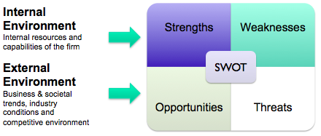
- SWOT Analysis is the traditional tool for strategic analysis. It is not Barney’s theory
- SWOT framework has two components: Internal and External Environment analysis

Barney’s article
(Looking Inside for Competitive Advantage) provides a tool to assess the organization’s internal resources and capabilities.

THE CLAIM: A firm will have a sustained competitive advantage if its resources and capabilities are valuable, rare, inimitable and organized in a way that allows it to exploit potential opportunities.

Barney’s secondary claims
- The most careful and complete analysis of firms’ competitive environments cannot, by itself, explain their success.
- Strategists also need to analyze the competitive implications of firms’ internal strengths and weaknesses

The Firm’s Resources and Capabilities
- Financial, physical, human, organizational assets used by the firm to develop, manufacture and deliver products and services to its customers.
- Financial: debt, equity, retained earnings, etc…
- Physical: machines, manufacturing facilities, buildings.
- Human: experience, knowledge, judgment, propensity for risk, wisdom, etc…
- Organizational: history, relationships, trust, culture, formal reporting structure, control systems, patents, etc….

Four important questions about resources and capabilities
- The Question of Value: Does a firm’s resources and capabilities enable it to exploit an opportunity, and/or neutralize a threat?
- The Question of Rareness: How many competing firms already possess these valuables resources and capabilities?
- The Question of Imitability: Do firms without a resource or capability face a cost disadvantage in obtaining it compared to firms that already possess it?
- The Question of Organization: Is a firm organized to exploit the full competitive potential of its resources and capabilities?

The question of Value
- Resources and capabilities may become less valuable over time
  - Changes in customers’ tastes
  - Changes in the industry and structure
  - Changes in technology
- Changes in the environment can make some resources and capabilities less valuable, may have no effect on others, and may even make some more valuable than they were before
- The key for managers is to evaluate whether or not their resources and capabilities continue to add value
- Companies must find new ways to apply their traditional strengths to exploit opportunities and/or neutralize threats

The question of Rareness
- How many competing firms already possess these valuable resources and capabilities?
- If a particular resource or capability is controlled by numerous competing firms, it is not a competitive advantage for any one of those firms
- This does not mean that common, but valuable, resources are not important
  - These resources may still be essential for survival
  - If resources and valuable and rare, it usually means that the firm can gain at least a temporary competitive advantage

The question of Imitability
- Imitation can occur in at least two ways:
  - Duplication and Substitution
  - Three reasons why it can be costly to imitate:
  - The importance of history: Valuable and rare resources acquired or developed through unique historical circumstances can be a source of sustained competitive advantage (Caterpillar; Komatsu’s strategic substitute)
  - The importance of numerous small decisions: A firm’s competitive advantage seems to depend on numerous “small decisions” (rather than big ones) through which a firm’s resources and capabilities are developed and exploited (The Mailbox Inc.)
  - The importance of socially complex resources: Reputation, trust, friendship teamwork and culture, while not patentable, are difficult to imitate (HP and the HP way)

The question of Organization
- A firm’s Organization is based on its:
  - Formal reporting structure
  - Explicit management control systems
  - Compensation policies
- Referred to as Complimentary Resources
  - They must be combined with other capabilities and resources for a firm to realize its full competitive advantage
  - The firm must be ready (organized) to exploit the full competitive potential of its resources and capabilities

Applying the VRIO Framework Value and Rarity
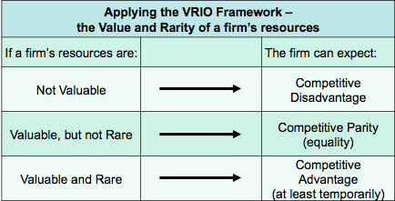
Applying the VRIO Framework Value, Rarity and Inimitable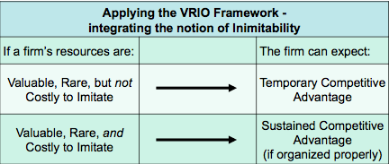

Applying the VRIO Framework Value, Rarity, Inimitable, Organized Properly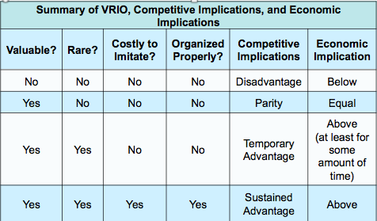

Techniques of Persuasion
  - Anticipate readers’ objections based on
    - Negative evidence
    - Alternative or rival causes
    - Debatable or conflicting assumptions
      - Reality assumptions
      - Value assumptions
  - The whole strategy is to:
    - Counter-argue objections
- Limit claims you cannot rebut
  - Acknowledging limitations makes your writing MORE persuasive
    - Limits to your generalizations
    - Level of probability less than 100%
    - Re-defining terms
- Rhetoric – use of language to convince
  - Completeness or Detail (evidence and assumptions)
  - Tone (scholarly vs. narrative)
  - Vividness (being concrete draws attention)

CLASS 9:
CHAPTER 7:
Dyer, chapter 7: “Writing a Persuasive Essay”
- Need to be aware of your audience and their beliefs and values, and to build this awareness into the way you present your ideas
- By writing, by confronting your ideas outside your own head, you uncover, develop, and clarify your thoughts

First steps
- What is the issue to be discussed and what is your position on this issue
- Sometimes you know the claim immediately and sometimes the claim comes later in the writing
- Make an outline

Secondary sources
- Use reputable sources: peer-reviewed, scholarly, sponsors of the website
- Citing reputable sources increases authority
- Critically read the secondary sources: asses the quality of the evidence presented by the author (SPAARC)
- Review the authors underlying assumptions: reality or value assumptions
- Quotations may enhance the precision and vividness of the argument

Interviews
- Interview with respect and report accurately what you are told
- Explain the purpose of your study (ethical)
- No negative consequences to interviewee and confidentiality
- Prepare the questions in advance and ensure they are more than just yes/no answers
- Respect the agreed upon duration

Organizing your ideas
- Read through your notes and decide on the order of the presentation
- Ensure each piece of evidence is relevant
- Address underlying assumptions

Writing the first draft
- Put the major claim at the beginning of the text and an enticing introductory statement
- Put all points in the body paragraphs
- Come full circle in the conclusion
- Usually APA style

Revising
- Reread the entire document
- Make sure the introduction is arousing
- The conclusion must: summarize the arguments presented, remind the readers what they have learned, and evidence supports claims well
- Check for spelling and grammar mistakes

Images enhance the clarity of your essay
- Visual aids, diagrams, tables charts then explain their significance
- Clear title for the essay

“Writing to change the world”
- Write to leave an impact on the world
- Do not create propaganda
- Write to make the reader care about your issue too

CLASS NOTES:
Kaplan & Norton’s balanced scorecard
“What you measure is what you get.”
or
“If you don’t know where you are going, you are never going to get there.”

- The traditional financial performance measures worked well for the industrial era
- Today, the “bottom line” is not enough
- Managers want a balanced presentation of both financial and operational measures
- The Balanced Scorecard is a Performance Measurement System / Tool
Giving managers complex information at a glance
- Four perspectives for a balanced scorecard
  - Customer perspective
    - How do customers see us?
    - What matters most to customers?
  - Internal business perspective
    - What must we excel at?
    - How can we meet customer expectations?
  - Innovation & learning perspective
    - How can we make continual improvements and create value?
  - Financial perspective
    - How do we look to shareholders?
    - How can we ensure profitability and financial health?
- Is there still a need for financial perspective?
  - Take care of innovation, learning, operations and customers and the financial results will follow…
  - Not necessarily!
    - Companies don’t always follow up their operational improvements with another round of actions
    - Example: reduced cycle / setup time does not necessarily lead to increased profits
  - Financial results remind executives that operational improvements should lead to:
    - Increased sales or market share
    - Reduced operating expenses
    - Higher asset turnover

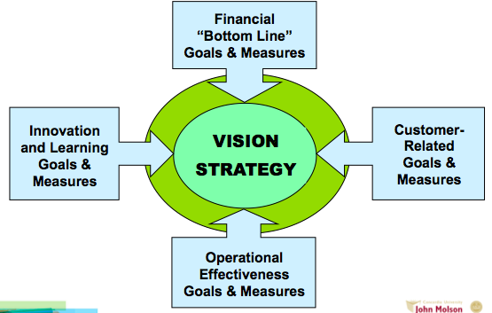
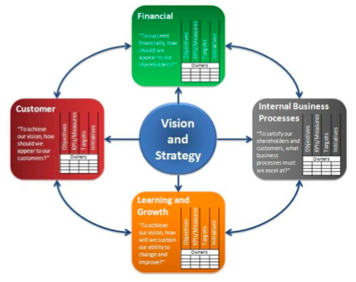

Balanced Scorecard: Template for Financial Perspective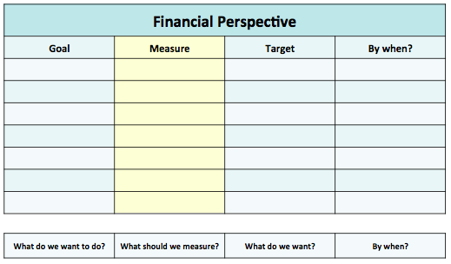

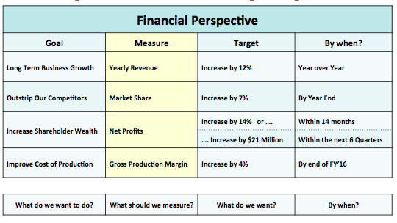

Writing a persuasive essay:
- Outline your (contestable) claim and sub-claims
  - Ask yourself: “Why do I think this claim is true?” List reasons
  - Logic of your argument must be crystal clear
- Arrange your evidence
  - 2-3 pieces of evidence for each sub-claim (sufficient; accurate)
    - Views of experts; Quotes from interviews (authoritative; precise)
    - Statistics (precise)
    - Examples from your own experience, diverse, variety of others (representative)
    - Detailed descriptions / background information (precise)
  - Give each section of your essay a meaningful subtitle (clear)
  - Any negative evidence? Do you anticipate readers’ objections? Do you need more evidence?
- Write your first draft
  - Don’t try for perfection the first time
  - Be careful not to plagiarize!!!
- Revise your work
  - Team contributions have to be integrated – similar style
  - Write your introductory sentences – engage the reader’s interest and attention
  - Write your concluding sentences – a strong ending tells people what they have learned
  - Add visual aids (charts, photos, clipart, concept maps)
- Full list of references

CLASS 10:
CLASS NOTES:
Sigmoid curve: Key to effective growth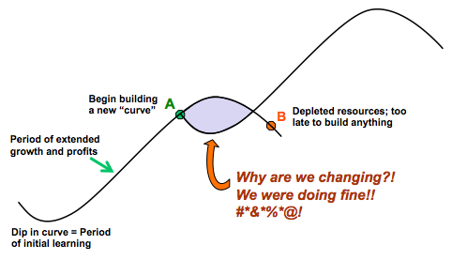

Sigmoid curve: Key to effective growth
- The Paradox of Time:
  - If you keep on going the way you are, you will miss the road to the future
- The Paradox of Success:
  - The things and the ways which got you where you are seldom those that keep you there
- The Paradox of Evolution:
  - The accelerating pace of change shrinks every sigmoid curve, especially in business
- The Pathway Through Paradox:
  - Build a new future while maintaining the present

- The discipline of the second curve:
  - How do we know where we are on the first curve?
  - Always assume you are near the peak (point “A”) and should be preparing for the second curve
  - Keeping the 2 curves going should be a habit
    - Benefits of the discipline of devising the second curve
    - The traditional four-stage cycle of discovery: Questions Ideas Test Review
  - It is essential to let go of your past

- Curvilinear logic:
    - Everything in life has its ups and downs and nothing lasts forever or was there forever
    - It means starting life (or relationships, business, operations…) again, and it is harder as you become older
  - Example: Japanese “Kaizen” – continuous improvement
    - Do not abandon the first curve too early:
      - First curve provides resources and time that the second curve needs in order to develop

- Fertilizing the second curve:
  - Seniors: give permission and encouragement
  - Next generation: accept responsibility
  - It is crucial that the next generation realize that they have the responsibility to help shape the future
    - If not them, who??
  - To manage paradox, you need to live with it as well as analyze it
    - It is not just a job for the consultants

- Very hard for leadership to do this:
  - You have to interrupt success while it is still successful
  - It is much easier to lead people out of a crisis
  - You have to create an image of a more compelling future on the other side of the next “curve”
  - You may have to step aside as leader

Capitalism
- “Capitalism, newly triumphant, probably has to re-invent itself” (Handy, p. 55)

CLASS 10:
CLASS NOTES:
Herzberg’s concepts:
How do you motivate employees?
- Hygiene factors: How you are treated at work (salary, working conditions) LEAD TO JOB DISSATISFACTION
- Motivators: Money as a motivator? Motivators are something that pushes people to better themselves, something that is rewarding (achievement, responsibility). LEAD TO JOB SATISFACTION
**FACTORS THAT LEAD TO SATISFACTION ARE **DISTINCT** FROM THOSE THAT LEAD TO DISSATISFACTION**
- Job Dissatisfaction: Unhappiness with a job based on several factors (underpaid, poor management/communication, job insecurity, limited growth, lack of interest (boredom))
- Job Satisfaction: Happiness with a job based on several factors. (Sense of accomplishment, being told you do well, improvement)
- Job enrichment / Vertical job loading: Employees are granted the opportunity to perform more and NEW tasks (opportunity to motivate).
- Job enlargement / Horizontal job loading: more of the same tasks that employees will continue to do (no opportunity to motivate).
- Negative KITA: A physical or psychological threat that makes you work harder (negative) (Example: a teacher says you cannot do well in the class and you end up acing the test).
- Positive KITA: To create movement through physiological motivation (positive). Sense of accomplishment. (Example: If you perform this task then you will receive some kind of benefit)

Herzberg’s Hygiene Factors & Motivators
Hygiene Factors (Not necessarily satisfaction but will keep dissatisfaction at bay not motivators) | Motivators (These get you to “jump out of bed” in the morning, “love your job”)
- Salary and benefits  - Company policies and administration  - Supervision  - Relationship with peers  - Work conditions / Physical environment  - Status  - Job Security | - Achievement  - Recognition  - The work itself  - Responsibility  - Advancement / Promotion  - Growth

Herzberg’s Hygiene Factors & Motivators
Hygiene Factors (job environment)
- They will never give you job satisfaction
- They will only give you no job dissatisfaction
Motivators (job content)
- Are the only long-term way to ensure job satisfaction

Principles of vertical job loading
- Remove some controls while retaining accountability
- Increase accountability of individuals for own work
- Give person a complete natural unit of work
- Grant additional authority; job freedom
- Make periodic reports directly available to workers themselves rather than supervisors
- Introduce new, more difficult tasks
- Assign workers to specialized tasks, enabling them to become experts
Two factor theory - Herzberg
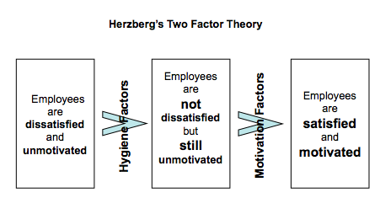

Some steps for job enrichment
- Select jobs, approaching them with the conviction that they can be changed
- Brainstorm possible changes
- Screen to remove hygiene suggestions & horizontal loading
- Avoid direct participation by the employees whose jobs are to be enriched
- Be prepared for an initial drop in performance
- Expect first-line supervisors to experience some anxiety

