Class | Topic | Read and Prepare for class discussions
1  Done | Introduction to the course | - COURSE OUTLINE posted on Moodle  - Dyer, chapter 1: “Introduction to critical thinking”
2  Done | The Marshmallow Challenge | - Dyer, chapter 2: “Claims” and Appendix 1 “Business terms and popular expressions,” pages 92-101
3  Done | Building successful organizations | - Chandler, “The enduring logic of industrial success”, HBR, Mar-Apr 1990  - Samsung: The next big bet, The Economist, Oct. 1st , 2011
4  Done | Structure, function and growth of firms | - Dyer, chapter 3: “Evidence”  - Greiner, “Evolution & revolution as organizations grow”, HBR, May-Jun 1994  - Reguly, “Caffeinated strategy, unadulterated brew”, Globe and Mail, 25 January 2013
5 | Leadership Progress report 1 due | - Tannenbaum and Schmidt, ‘’How to choose a leadership pattern’’ HBR, May-June1973  - Deutschman, “The fabric of creativity,” Fast Company, December 2004  - Macdonald: “Open wide,” Maclean’s, Jan. 19, 2009
FUNDAMENTAL BUSINESS THEORIES (ON MIDTERM 20%) |  | - Chandler on business success  - Greiner on evolution/growth of organizations  - Tannenbaum & Schmidt on leadership

NOTES FROM THEORIES:

CHANDLER:
- Major claim: successful firms capitalize on economies of scale and scope; they have functional management structure and invest in research and development and grow from related diversification; this will allow them to stay ahead of competition.
- Economies of scale: doing things on a bigger scale reduces costs.
- Economies of scope: using the same raw materials to produce various products.
- Managerial enterprise: making necessary investments in management, production and distribution in order to capitalize in economies of scale and scope.
- Research and development: new technologies, improving quality innovation
* hiring managers with experience and skills to understand the company’s products and processes.
- Management hierarchy: separation of upper and lower level management.

GREINER:
- Major claim: organizational growth is done in 5 phases and by implementing the right strategies and managerial structures, they can resolve the crisis and move on.
- Each phase begins with a period of evolution and has its moments of stability and growth but eventually ends with a revolutionary period.
- Management practices that work well in one phase brings crisis and chaos in another.
1. AGE: lifespan of organization: management problems and principles are rooted in time.
2. SIZE: company’s problems and solutions change as number of employees and sales volume increase.
3. Stages of evolution: prolonged growth
4. Stages of revolution: time of crisis between periods of evolution
5. Growth rate of the industry: speed at which industry goes through the stages is related to the market environment of the industry.
- Evolutions/Revolutions:
Evolutions | Revolutions
Creativity: emphasis on creating a product | Leadership: unwanted management responsibilities (solution find strong manager with knowledge and skills to lead)
Direction: period of sustainable growth | Autonomy: employees dislike hierarchy: torn between following procedures and taking initiative (top managers dislike giving up responsibilities to lower management) (solution work towards delegation)
Delegation: separation between top and lower management | Control: top level managers seek to regain control (solution special coordination techniques)
Coordination: use of formal systems to achieve greater coordination | Red tape: organization too large to be managed through rigid systems (solution collaboration)
Collaboration: more flexible approach to management and no more formal system | ??:
- Secondary claim: organizations should not try to skip phases
- Top managers whose style is no longer appropriate should remove themselves
- Growth is not inevitable

TANNENBAUM & SCHMIDT
- Continuum leadership model shows the relationship between the level of freedom that a manager chooses to give to a team and the level of authority used by the manager.
- Teams freedom increases and leads to managers authority decreasing

3 forces that impact the choice of managerial style:
- Force in the manager:
a. Their value system (how they feel about individuals making decisions)
b. Their confidence is subordinates (does he trust them?)
c. Their leadership inclination (how they feel about giving orders)
d. Their feelings of security in an uncertain situation
- Forces in the subordinate:
a. high need for independence
b. readiness to assume responsibility to decision making
c. like receiving order vs. more freedom
d. importance they put via company problems (their interest)
e. have necessary knowledge and experience to deal with problem
f. expectations in decision making
- Forces in situation:
a. types of organization (value and traditions)
b. group effectiveness
c. the problem itself (determine how much authority to give)
d. pressure of time
e. long-run strategy (shift thinking from tactics to large-scale strategy)
f. objectives to be attained

Continuum levels:
- Manager decides and announces decision: subordinates have no say in the decision making process (manager reviews options and comes to a decision)
- Managers decides and explains his reasoning: manager makes the decision and explains why it’s good and he lists the benefits the team will enjoy
- Manager decides and allows subordinates to discuss: manager makes the decision and explains the process that led to it. The subordinated are allowed to question the decision in order to get a better understanding. (more motivational higher team involvement)
- Manager suggests a decision and invites subordinates to contribute their input: manager takes the views of the subordinates into consideration. The subordinates have an influence in the making of the decision.
- Manager presents problem, gets suggestions, then decides: subordinates are active in decision making; manager presents the problem and subordinates are expected to have some suggestions to solve the problem and the manager will choose the best option. This is a decision making process done when a team has more experience and knowledge than the manager.
- Manager explains the problem, describes the parameters and expects the subordinates to come up with a decision: manager has given the subordinates the power to decide; although it has to be within the limitations set by the manager. The manager may or may not be part of the team that decides. This decision making process can only happen when the subordinates have the required knowledge and skills in order to deal with the problem in an efficient manner.
- Manager lets the subordinates identify the problem, develop solutions, while deciding the course of action and parameters: manager states that he will support the decision. Therefore the manager has the same amount of authority as subordinates in the decision making process.

CLASS 1:
CHAPTER 1:
Dyer, chapter 1: “Introduction to critical thinking”
- Critical thinking is an approach to reading, thinking, and learning that involves asking questions, examining our assumptions, and weighing the validity of arguments.
- Critical thinkers are: self-aware (work on knowing their own biases), curious (pose questions, challenge ideas), independent (listen to the ideas of others and use that learning to develop their own opinions)

“You’re so critical”:
- Critical in our ordinary conversations often mean negative or judgemental
- Greek word from Kritikos: to analyse, question or make sense of something

Critical thinking about business:
- Business books have had a huge increase in sales since the 80s but the popularity may stem from the differing ideas in the book the ability to critically analyse the information presented is the main idea

Buyer beware:
- The books are not necessarily reliable, valid, or scientifically sound.
- They are so likely to influence the naïve since they are well-written
- Critically thinkers will not passively accept the ideas of others
- Business plays an important role in all aspects of our lives (even medical)

The Sponge:
- Readers that soak up all the information passive activity (must go beyond this to become a critical thinker)
- The next step after being a sponge = evaluate and judge critically

Dimensions of critical thinking (5 PARTS):
- Central claims: thinking is directed at a significant and useful idea point of text
- Quality of evidence: sufficient ideas? Information accurate?
- Underlying assumptions and Values: identify the points of view that underlie the stated beliefs and evaluate their strengths and weaknesses?
- Causal claims: pay attention to inferences about cause and effect (judge validity)
- Techniques of persuasion: pay attention to how ideas are presented in order to persuade readers and listeners

Critical thinking and effective communication:
- Critical thinking improves your arguments when you write or speak
- Helps to state views clearly and provide appropriate justification
- Avoid fallacies (myths/misconceptions) in reasoning
- Explore underlying assumptions
- Careful attention to words makes writer clearer and more persuasive
CLASS 2:
CHAPTER 2:
Dyer, chapter 2: “Claims”
- The first thing to do when reading a text is to identify the claim: the major conclusion of the piece of writing.
- Central claims usually appear in the very beginning and are restated at the end of the piece.
- Cue words (when the author is about to identify the claim): therefore, thus, in summary, clearly, in short, etc.
- Evidence will either support or try and disprove the claim

Uncontested claims:
- We usually do not contest claims that are consistent with our own experiences and observations (traffic during rush hour)
- Claims that are subjective (golf is my favourite sport)
- Claims that appear to be facts that are independent of interpretation (Quebec is larger than Nova Scotia) or news articles (train accident)
- Areas in which there is agreement among experts, common sense (cannot be in two places at once)
- Technical or mathematical claims (debits = credits in accounting)

Contestable claims:
- Political commentaries and editorials are full of contestable claims much more interesting that uncontested claims
- Often new claims that spike curiosity
- May be labelled as fact but it is not and is contestable
- Must provide evidence to support the claim

Presenting claims:
- For shorter texts: a single sentence of the claim
- For longer texts: a list of important concepts / concept map summarize concisely large amounts of information

Claims and concept maps:
- What are Concept Maps?
  - “Concept maps are a compact way of summarizing complex material.”
  - “A picture, the saying goes, is worth a thousand words.”
  - Concept maps may be simple boxes-and-arrows figures that highlight the main issues and show relationships. They may look like tree diagrams, geographical maps, or other creative images that summarize the author’s main point.”

Writing effectively:
- Claims must be identified with clarity and emphasis
- Claims must be near the beginning or end of the text with cue words
- Title should clearly present the idea
- Longer reports could include concept maps

APPENDIX 1:
- Board of Directors: A group of people who have the legal responsibility to guide the affairs of a corporation or firm.
- Corporate governance: refers to the rights and responsibilities of the board of directors, managers, and owners of a company
- Bottom Line: (=net income) A summary number that expresses how successful a company has been from a financial point of view.
Triple bottom line: financial, social and environmental bottom line
- CEO: Appointed by the board of directors to head the firm’s activities; sets company policies and a strategic direction.
- Emotional Intelligence: The ability to understand and manage your own emotions, accurately perceive and understand the emotions of others, and use emotions competently to sustain good relationships.
- Globalization: The steady increase in the extent to which markets, labour, knowledge and technology, as well as commercial, social, and political activities in countries around the world are integrated.
- Knowledge Workers: Employees who work primarily with their intellect and knowledge, and who create value for a firm by processing and creating information.
- Intellectual capital: is a broader term that refers to the set of intangible assets that a company owns or controls.
- Outsourcing: Delegate some of the organization’s activities to an outside manufacturer or service supplier.
- R&D: The activities in a firm that combine scientific and technological research and development to produce innovations in products or services.
- Shareholders: Part owners of the corporation; invested in a company and have been issued shares in proportion to their investment.
- Vision: An image of the future held by leaders of the organization

CLASS 3:
Chandler:
“The Enduring Logic of Industrial Success” is based on Chandler`s theory of Managerial Enterprise:
The dynamic logic of growth and competition that drives modern industrial capitalism
- Definition: Large industrial concerns in which operating and investment decisions are made by a hierarchy of salaried managers governed by a board of directors

Chandler’s Major Claims; Two key concepts
- Economies of scale:
Large plants can produce products at a much lower cost than small ones because the cost per unit drops as the volume of output rises
- Economies of scope:
Large plants can use many of the same raw and semi-finished materials and intermediate production processes to make a variety of different products
To obtain these economies, firms must invest heavily in Research & Development and Production

As well, for firms to benefit from these economies of scale and scope (i.e. capitalize on their manufacturing investments):
  - Flow of materials must be kept constant in order to assure capacity utilization
  - National (and international) marketing and distribution functions must be created
  - Teams of managers need to be recruited:
    - Lower and middle class managers to coordinate the flow of products through production and distribution
    - Top managers to coordinate and monitor current operations and to plan and allocate resources for future activities

Chandler’s Secondary Claims
- Once a firm loses the opportunity to be a first mover, it is difficult to regain competitive advantage
- Entrepreneurial companies that do not make investments to create organizational capabilities cannot achieve long-term success
- Unrelated diversification: when managers acquire businesses in which they have few if any organizational capabilities to give them a competitive edge (ignore logic of managerial enterprise) good, its easy (diversifying products but using the same raw materials (RELATED much harder)
- This leads to...
- Separation of top vs middle managers:
- Top managers have little knowledge of or experience with the technological processes and markets of the new acquisitions
- Overload in decision making at the corporate office
- Stock market pressures: lose profits and market share if:
- Entrepreneurial enterprises fail to become managerial enterprises
- Managerial enterprises fail to maintain their competitive capabilities
- Short-term thinking: making a quick buck and trying to gain competitive edge through unrelated diversification
- Business ownership patterns have diminished the likelihood of many firms’ long-term success
- In competitive battles, Innovation and Strategy are more powerful weapons than price
**Understand how to interpret/make concept maps**

CHANDELER’S CONCEPT LIST
- Managerial Enterprise
- Economies of scale
- Economies of scope
- Functional divisions, management hierarchy and geographical expansion
- Efficient flow
- Marketing and Distribution channels
- Hierarchy or management
- First mover 1. Spend a lot of money on production and plants 2. Research and Development
- Related and Unrelated (separation of top and middle managers) diversification
- Entrepreneurial enterprise (staying small)
- Stock market pressure (due to ownership pattern)
- Short-term thinking (due to market pressure)

CLASS 4:
CHAPTER 3:
Dyer, chapter 3: “Evidence”
- Evidence is any statement that is a response to the question
- In the absence of evidence, a claim is merely an unsubstantiated opinion; the more contestable or controversial the claim, the more important that it be bolstered by solid evidence.
- Claim: central idea that the author is trying to persuade you to accept
- Evidence: any statement that is a response to the question “Why is this true?”
- Claim + Evidence = Argument
- Several arguments can be present in a longer piece of writing

Finding the Evidence:
- Evidence helps us to form judgments about claims
- An argument is the combination of a claim and the evidence for it
- Can consist of:
- Statistics, Details of past events,
- Anecdotes, Quotes, Previously established claims, etc…
- Cue words: because, as a result, in the first place, etc.
- Each piece of evidence has to be explained

Quality of evidence: (6 qualities of good evidence)
- Accuracy use proxies or other cues to decide whether the information is accurate/ check for obvious errors (spelling, grammar)
- Difficult to judge without an independent source of information
- 2 ways to proceed:
- Do our own research to verify accuracy
- Use proxies to evaluate accuracy: errors such as grammar, spelling mistakes, inaccurate quotes, or lack of precision
- Precision quality statistics (…9% rather than almost 10%)/ do not use words like: a great deal, many, often, few, etc./ use numbers and direct quotations/ precision is often used as a proxy for accuracy/ over-precision (an accountant working for 17 hours, 9 minutes, 34.6 seconds) vs. under-precision
- Sufficiency sufficient support (one is not enough)/ large sample size (n=30)
- Beware the “fallacy of hasty generalization”
- Representativeness variety in the sources of evidence should match the variety in the population relevant to the claim
- Beware the “fallacy of hasty generalization” (again)
- Authority business scholars, MDs, PhDs, etc.,
- Training, credentials, experience of others
- Classic sources are typically authorative
- Current writing is usually more authorative
- Authority is context-dependent:
- Beware the “fallacy of false appeal to authority”
- Also, the “fallacy of argumentation ad populum” (bandwagon effect)
- Clarity of expression
- If you present a table or a figure and direct quotations, explain the results and how they are relevant.
- Once the evidence is expressed with clarity it takes on meaning.

Other objections:
- Personal underlying assumptions can affect what you see as accurate/precise/relevant evidence.

Effective writing:
- Present claim supporting evidence supporting evidence etc. conclusion
- Citing sources allows others to judge authority (the selection of authority to cite must be representative)
- Clarity and precision

Larry Greiner:
Major Claims:
- Organizations grow through a series of evolutionary and revolutionary phases that are a function of the age and the size of the organization
- Managerial problems and practices are rooted in time – they do not last throughout the life of an organization
- Management practices that work well in one phase bring on a crisis in the next

Greiner’s primary concepts:
Five dimensions to analyze Organizational Development
- Age of the organization
- Size of the organization
- Stages of evolution
- Stages of revolution
- Growth rate of industry

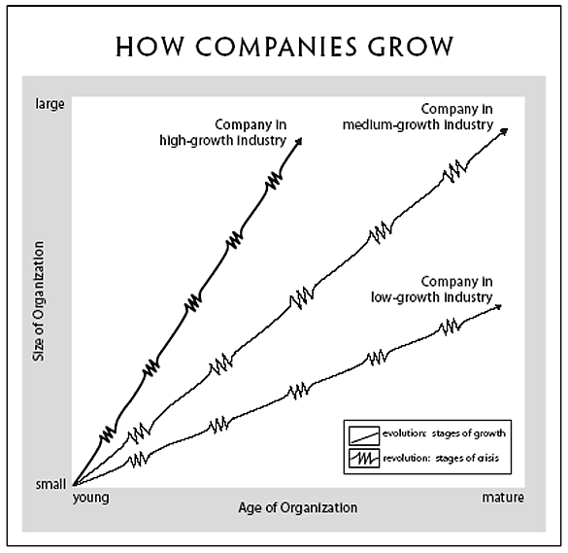

The five phases of growth (Evolution in black and revolution in red)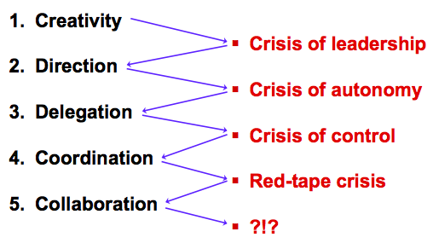

Concept Map:
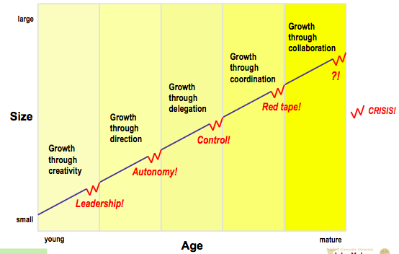

Organizational practices in the Five Phases of Growth **MEMORIZE**
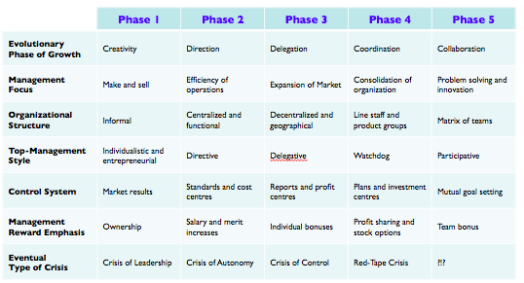

Greiner’s concept map:
- For each evolutionary phase, the student should know:
  - The exact name of the evolutionary phase
  - The characteristics of the evolution phase (what is happening)
  - The issues that lead to a crisis
  - The exact name of the crisis
  - The required solution for the crisis

Greiner’s secondary claims:
- Top managers should try to recognize where they are and anticipate where they need to go in the developmental sequence
- Organizations should not try to skip phases nor should they try to avoid revolutions
- Top managers whose style is no longer appropriate should consider removing themselves
- Top managers should realize that solutions breed new problems
- Growth is not inevitable

Advantages of large, bureaucratic organizations
- Hierarchical authority promises control and
responsibility
- Specialization of sub-units promises accountability, control and expertise
- Management by rules promises control and consistency
- Being impersonal promises objectivity, consistency and equality

Employees’ examples of red tape
- Each department has its own agenda, and departments don’t cooperate to help other departments get the job done
- Top managers are dangerously ill-informed and insulated from what is happening on the front lines or in "the field”
- Quantitative measurements are favoured over qualitative measurements, so the concentration is on quantities of output, with less and less concern for quality of output
- Both employees and customers are treated more as numbers than people

CLASS 5:
Background: Classic ideas about leadership
- Trait leadership theories (pre-1950s; revived in 1990s)
  - Are there “born leaders?”
  - What traits are important?
- Behaviour leadership theories (1950s - 1960s)
  - Do successful leaders behave in certain ways?
  - Can these behaviours be learned?
- Contingency/Situational leadership theories (1960s - 1970s)
  - What does successful leadership depend on?

Answering the Need
- Old Problem: How to lead followers?
- New Problem: When should a decision be made by the leader? When should employees be consulted? And to which extent? (i.e. when should a leader make a decision and when should they offer their opinion)
“... The purpose of this article is suggest a framework which managers may find useful in grappling with this dilemma....” R. Tannenbaum and W.H. Schmidt; HBR: May-June 1973; page 163
Tannenbaum & Schmidt: How to choose a leadership pattern -- concept map
The concept map (from left to right) boss centred to subordinate centred (therefore it begins at the boss makes a decision to subordinates make a decision and checks with boss)

Key Questions
- If the subordinates make the decision, is the manager responsible? The manager (even if he doesn’t make the decisions) is responsible for the whole team. It is their decision to pass the responsibility in the first place.
- What role should managers play?
  - Member or authority figure depends on situation
- Should subordinates be able to tell what style manager is using? Yes
- How do you measure a manager’s “democracy”? What makes for a good, democratic manager let others make big decisions not just small ones all the time

The notion of Contingency
- Q.1: Is there a universal type of leadership?
- Q. 2: What types of leadership are practical and desirable?
- A. 1: no
- A. 2: It depends on the manager, the subordinate and the situation.

How to Lead: Impact of 3 Forces
- Forces in the Manager (1)
- Forces in the Subordinate (2)
- Forces in the Situation (3)

How to Lead: Forces in the Manager (1)
- Value system
- Confidence in subordinates
- Own Leadership inclinations
- Feelings of security

How to Lead: Forces in the Subordinate (2)
More Democratic: *Remember they are human beings like you
- High need for independence
- Readiness to assume responsibility
- High tolerance for ambiguity
- Identify with the organization’s problems and goals
- Have knowledge and experience
- Learned to be part of decision making

How to Lead: Forces in the Situation (3)
- Type of organization
- Group effectiveness
- Nature of the problem
- Time pressures
- Long-run strategy
- Objectives to be attained

Tannenbaum & Schmidt: Revised Model New Concept Map
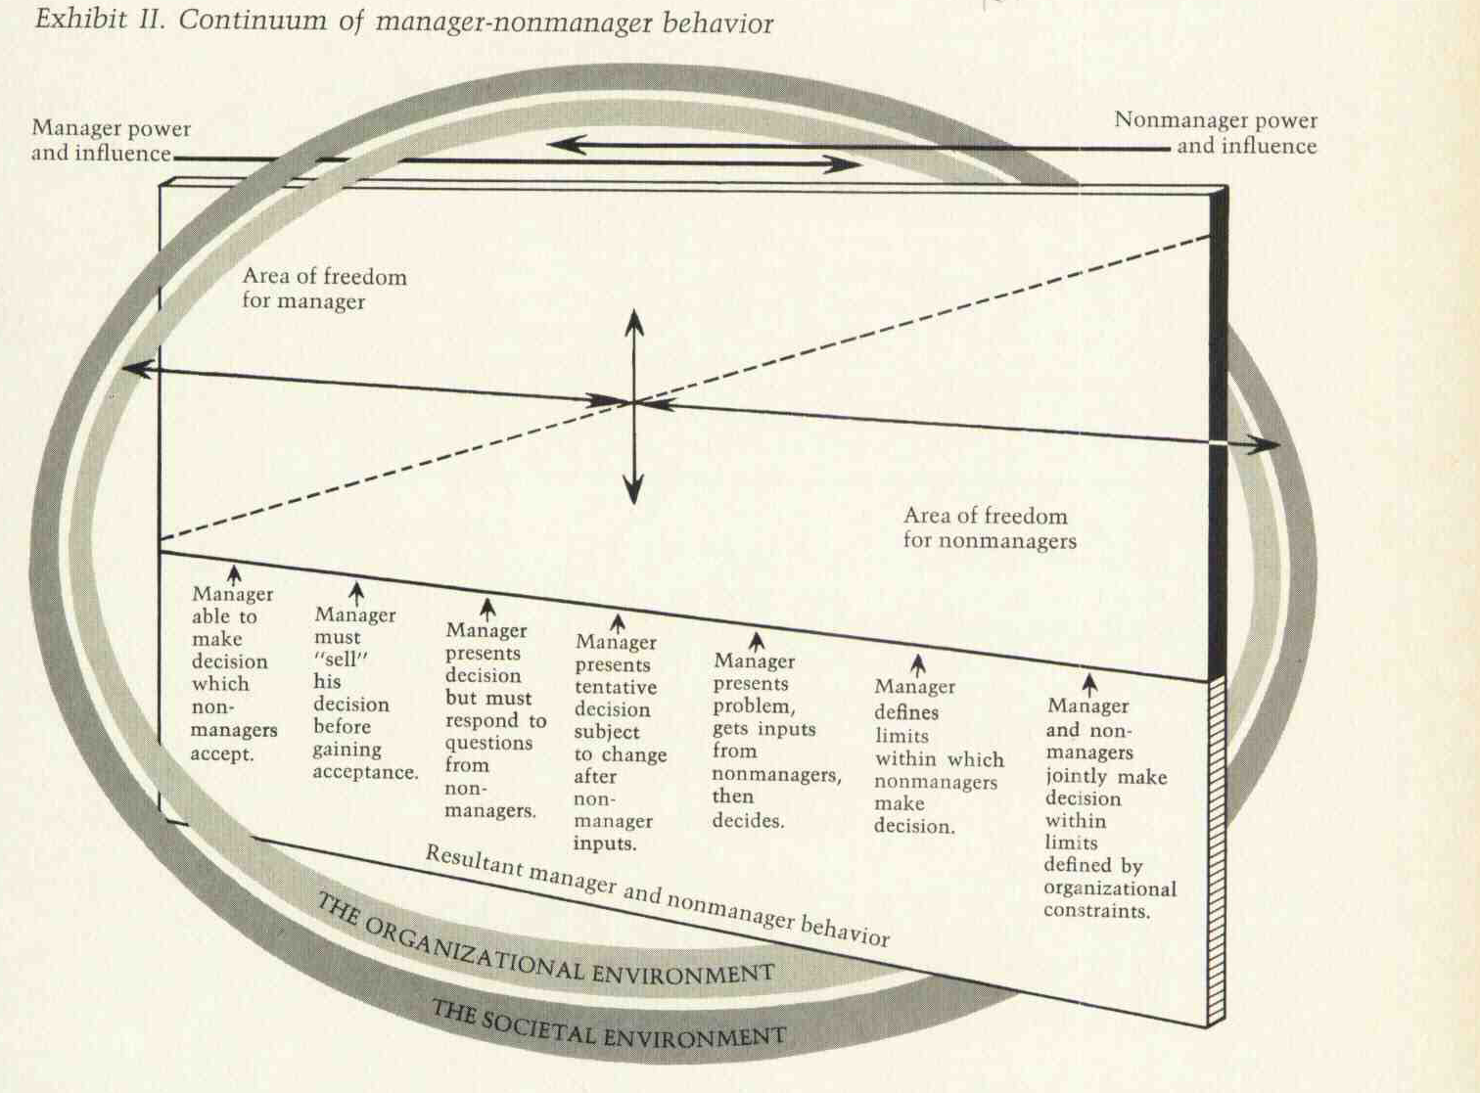

Zaleznik: Managers and Leaders Are They Different?
Zaleznik’s main claim:
- “Managers embrace process, seek stability and control, and instinctively try to resolve problems quickly…..
- Leaders in, contrast, tolerate chaos and lack of structure and are willing to delay closure in order to understand the issue more fully” (p.74)
- Vision versus Execution and results
Zaleznik’s sub-claims
- “Organizations need both managers and leaders to succeed” (p.74)
- “Business leaders have much more in common with artists, scientists, and other creative thinkers than they do with managers” (p.74)
- Do you recall the Forbes excerpt from class 1?
- “Leaders work from high risk positions” (p.77)
- “Where managers act to limit choices, leaders develop fresh approaches to long-standing problems and open issued to new options” (p.77)
- “Managerial personalities form moderate and widely distributed attachments. Leaders, on the other hand, establish, and also break off, intensive one-to-one relationships.” (p.79)

MIDTERM PREPARATION
- Re-read all theories covered so far
- Review all relevant chapters in textbook
- Do questions at end of chapter (some are answered in the back of the book)
- Review and enhance your own concept maps
- Practice application using articles found in business magazines and newspapers

REVIEW
Review: Chandler’s concepts
- Economies of scale & economies of scope
- Functional divisions, management hierarchy & geographical expansion
- First movers & challengers
- Research & development (innovation)
- Related & unrelated diversification
- Separation of top and middle managers (in the case of unrelated diversification)
- Entrepreneurial enterprise (staying small)
- Stock market pressure (due to ownership pattern)
- Short-term thinking (due to market pressure)
Review: Chandler’s claims
- Successful firms capitalize on economies of scale & scope, create management structures and invest in research & development
  - Once a firm loses the opportunity to be a first mover, it is difficult to regain competitive advantage
  - Growth through unrelated diversification is a poor corporate strategy
  - Business ownership patterns have diminished the likelihood of long-term success

Review: Greiner – key concepts
- Age of the organization
- Size of the organization
- Stages of evolution
- Stages of revolution
- Growth rate of industry
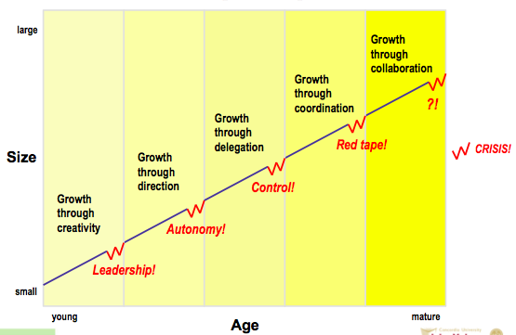
Greiner’s major claims
- Organizations grow through a series of developmental (evolutionary and revolutionary) phases that are a function of the age and the size of the organization
- Managerial problems and practices are rooted in time – they do not last throughout the life of an organization
- Management practices that work well in one phase bring on a crisis in the next

Review: Tannenbaum & Schmidt
How to Lead: 3 Forces impact
- Forces in the Manager
- Forces in the Subordinate
- Forces in the Situation

Review: Critical thinking skills
- Claims
  - The major conclusion of a piece of writing that the author is trying to persuade you to accept
  - Explicitly or implicitly stated
  - Uncontestable or contestable
- Good Evidence
  - Accuracy
  - Precision
  - Sufficiency
  - Representativeness
  - Authority
  - Clarity of expression

Business terms & popular expressions
- Board of Directors
- Bottom Line
- Chief Executive Officer
- Emotional Intelligence
- Globalization
- Knowledge Workers
- Outsourcing
- R&D
- Shareholders
- Vision

