Educ 240 Final Exam
Lesson 2
Human Resource Management
- Strategic approach to the management of an organization’s employees
- Objective is to recruit, motivate, develop and retain employees whose performance is necessary for the attainment of the organization’s goals.
Performance Management
- The process of establishing performance expectations with employees
- Design of interventions and programs to improve performance
- Monitoring the success of the interventions and programs
Training
- Acquisition of knowledge, skills and abilities to improve performance on one’s current job
- Planned effort undertaken by a company to facilitate their employees’ learning f job-related competencies
- Immediate impact
Development
- Acquisition of knowledge, skills and abilities required to perform future job responsibilities and the long-term achievement of individual career goals and organizational objectives
- Future impact
Benefits of Training and Development
Employee Benefits
- Intrinsic
- Greater knowledge and skills
- High self-efficacy
- Feel more useful
- More positive attitudes toward their job and organization
- Extrinsic
- Higher earnings
- More marketable
- Grater job security
- Enhanced promotion prospects
Organizational Benefits
- Organizational Strategy
- Help organizations achieve their short and long-term goals
- Increase Organizational effectiveness
- Better productivity, fewer errors, fewer accidents, less supervision needed
- Return on investment
- Employee recruitment and selection
- A company’s training and development program can help recruit new employees, and retain the ones they have
Societal Benefits
- Educated Population
- Helps create an educated and skilled workplace
- Provides skills that also serve employees outside of the work environment
- Better Standard of Living
- A better-trained workforce is more productive, thereby improving the economy and the standard of living
Training in Canada
- Demographics
- Aging workforce as baby boomers retire (employee turnover)
- Greater rate of workers leaving than ability of new employees to fill void
- Likely have to rely on immigration
- Loss of expertise and knowledge
- Greater need for knowledge management initiatives
- Unemployment Rate
- Depend on availability of work, and people capable of working
- Shortage of available work, training need to provide opportunities for unemployed to get another job
- Labor force, decrease due to retirement, gab filled by new workers, training needed to fit the void
- Evolution of Information Technologies
- New products
- New ways of gathering information
- New ways of communicating
- New ways to efficiently carry out the tasks of one’s job
Quebec 1% Law
- Bill 90 (1995)
- Requires investment of a minimum of 1% of company’s total payroll on the training of its employees
- Cases only where payroll exceeds 1 million $$
- Failure to comply would result in a tax equivalent to the unspent amount
- Collected monies pooled to finance workplace training initiatives throughout province
- Results
- 6 year span starting in 1997, workplace training enjoyed fastest growth ate in Canada in workplace training
- Increased by 57%
- Despite significantly narrowing the gap, province still below the national average
- Training participation among companies was not evenly distributed
High Performance Work System
- An interrelated system of HR practices and policies which typically includes:
- Rigorous recruitment and selection procedures
- Performance-contingent incentive compensation
- Performance management
- Extensive training and development programs
- Workplace training not an independent activity
- Influenced by a broader organizational and environmental context, and a human resource system
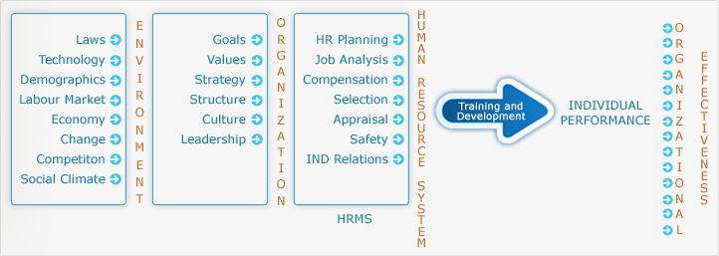

- Environmental Factors
- Laws
- Ex. Quebec’s 1% law
- Technology
- Employees must be trained in using new technologies if they are to be adopted
- Demographics
- Ageing workforce means a brain drain, challenge to transfer know-how to new workers
- Labor Market
- Changes in demographics of workplace with require adaptations in the amount and type of training required
- Economy
- Economic downturn of 2009-10 caused higher unemployment and a return to school for many
- Change
- Trends, new laws, economic changes etc.
- Competition
- International competitors, customers, suppliers, employees require cross-cultural awareness training
- Social Climate
- Specialized training programs that deal with diversity, security, and stress management etc.

- Organizational Factors
- Strategy
- One of most influential factors of T & D
- Strategic Human Resources Management (SHRM): Alignment of human resources practices with an organization’s business strategy
- Strategic Training and Development (ST&D): the alignment of an organizations training needs and programs with an organization’s strategy and objectives
- Training becomes strategic when it is related to the business strategy
- Structure
- Changes in employee tasks and responsibilities due to structural change within organization
- Emphasis on teamwork may require additional training in communication, supervision and cross-training
- Culture
- Shared beliefs, values and assumptions in organization
- Human Resources Management system
- All functional areas of HR work together to create an HR system
- Driven by organizational strategy and SHRM
- What constitutes a High Performance Work System
- Leads to a Strategic Model of Training and Development
Instructional Systems Design Model (ISD)
- A rational and scientific model of training and development process that consists of a needs analysis, training design and delivery, and training evaluation
- 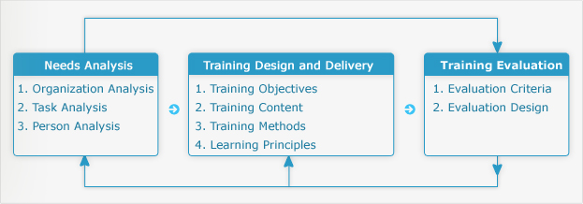

Lesson 3
Organizational Learning
- Process of creating, sharing, diffusing, and applying knowledge in organizations
- It is not simply a focus on current need or deficiencies, but also on continuous learning
- A main characteristic of an adaptive or agile organization; one that is able to identify the need to alter its practices based on shifts in its environment
Four Key Dimensions of a Learning Organization
- Vision: requires clear vision of organization’s strategy and goals
- Culture: Fosters information sharing and continuous learning
- Learning Systems/Dynamics: Seek solutions to problems through a systemic view of the organization and its environment
- Knowledge Management/Infrastructure: Technology, systems and processes to support the capture, dissemination and evaluation of knowledge. Ensure that the right person has the right knowledge and the right time
Knowledge
- Sum of What is known: a body of truths, information, and principles
- Found in the minds of employees
- Transferred and stored in information systems in the organization
- Embedded in tools and standard operating procedures and processes
Knowledge can be grouped in Two Ways
- Explicit: things you can buy and trades, such as patents or copyrights and other forms of intellectual property
- Knowledge that has been codified and documented
- Can be written into procedures or stored in databases
- Small proportion of corporate knowledge
- Tacit: known only by the individual and is not necessarily known by the organization
- Valuable wisdom learned from experience
- Difficult to Transfer
- Difficult to Articulate
Intellectual Capital
- An organizations knowledge, experience, relationships, process discoveries, innovation, market presence, and community influence
- Source of innovation and wealth production
- Has to be formalized, captured, and leveraged to produce a more highly valued asset
- Types of Intellectual Capital
- Human: knowledge, skills, and abilities of employees
- Renewal: Intellectual property such as patents, licenses, copyrights, and marketable innovations
- Structural: systems and relationships that allow employees to communicate, solve problems, and make decisions
- Relationship: Organization’s relationships with suppliers, customers, and competitors that influence how thy do business
Knowledge Management
- The creation, collection, storage, distribution, and application of compiled know-what and know-how or, seeks to identify and connect individuals based on their expertise and areas of activity
Informal Learning
- Learning that occurs naturally as part of work and is not planned or designed by the organization
Formal Learning
- Learning that is structured and planned by the organization
Multilevel Systems Model of Organizational Learning
- Organizational Level Learning <-> Group Level Learning <-> Individual Level Learning
- Organizational Level Learning
- Organizations leadership, culture, vision, strategy, and structure
- Must develop and implement strategies for knowledge management and learning
- Necessary to acquire and share information and to distribute it
- Will influence the extent to which teams and individuals seek out new information and learning opportunities
- Group Level Learning
- Climate, culture, norms, dynamics, and processes as well as the nature of the group task in terms of complexity and task interdependence
- Learning will be influenced by these factors
- Influence the extent to which learning occurs at the group level
- Individual Learning
- Must have formal and informal opportunities to learn
- Organization needs to provide structured and formal training & development programs in order for employees to acquire new knowledge and skills.
- Employees must also be rewarded for learning and applying what they learn on the job
Lesson 4
Learning
- The process of acquiring knowledge and skills, and a change in individual behavior as a result of some experience
- Interaction between the individual and the environment that results in a relatively permanent change in behavior
- Persisting change in human performance as a result of experience
Gagne’s Five Learning Outcomes
- Verbal Information
- Facts, knowledge, principles, information (declarative knowledge)
- Verbs: state, recite, tell, declare, define
- Ex. Define the term learning
- Intellectual Skills
- Concepts, rules, and procedures (procedural knowledge)
- Categories: discrimination, concrete concept, define concept, rule, high-order rule etc.
- Verbs: distinguish, identify, classify, solve, label, specify
- Cognitive Strategies
- Application of information and techniques
- Understanding how and when to use the information
- Verbs: adopt, create, originate, invent
- Motor Skills
- Coordination and execution of physical movements
- Verbs: execute, perform, demonstrate
- Attitudes
- Preferences and internal states associated with beliefs and feelings
- Verbs: elect, favor, prefer, choose
Stages of Learning
- Declarative Knowledge: learning knowledge facts, and information
- Knowledge Compilation: integrating tasks into sequences to simplify and streamline the task
- Procedural Knowledge: learner has mastered the task & performance is automatic and habitual
Kolb’s Learning Style
- The way in which an individual gathers information and processes and evaluates it during the learning process
- Four ways in which individuals gain experience
- Concrete Experience (CE)
- Abstract Conceptualization (AC)
- Reflective Observation (RO)
- Active Experimentation (AE)
- Converger (AC + AE) = Thinking and Doing
- Diverger (CE + RO) = Feeling and Watching
- Assimilator (AC + RO) = Thinking and Watching
- Accommodator (CE + AE) = Feeling and Doing
Learning Theory
- A set of propositions and constructs tat attempt to explain how change in behavior is achieved
Conditioning Theory
- Learning is a result of reward and punishment contingencies that follow a response to a stimulus
- A stimulus or cue would be followed by a response, which is then reinforced
- Strengthens the likelihood that response will occur again and that learning will result
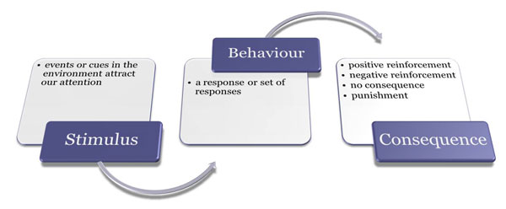
- Shaping: reinforcement of each step in a process until is mastered
- Chaining: reinforcement of entire sequence of a task
- Generalization: Conditioned response occurs in circumstances different from those during learning
- Implications For Training: suggests that trainees should be encouraged and reinforced throughout the training process
Situated Cognition
- Theory builds on cognitive approaches to understanding learning
- Focuses on the structures that are created in the mind, though experience, and that future mediate our interpretation of experience
- Structures are call mental models or Schema
- Schema evolve through different process in which they are tweaked to deal with new experiences, or undergo radical restructuring
- Schema serve as filters that focus our attention in different ways
- Learning seen as process in which schema are further elaborated to contend with new experiences
- Based on an information processing model of the mind
- Key elements in the basic model: short-tem, working, and long-term memory
Social Learning Theory
- Three Key Elements
- Observation: learning by observing
- Four critical elements: attention, retention, reproduction, reinforcement
- Self-Efficacy: judgments people have about their ability to successfully perform a specific task
- Influenced by four sources of information in order of importance
- Task Performance outcomes, observation, Verbal persuasion, Physiological state
- Self-Management: Managing ones’ behavior through a series of internal processes
- Observe personal behavior
- Setting Performance Goals
- Assessing Personal Progress
- Rewarding Oneself for Goal Achievement
- Concepts: self-regulation, metacognition
- Implications for Training: learning can be improved by providing trainees with models who demonstrate how to perform a training task; by strengthening trainee self-efficacy, by teaching trainees how to regulate their behavior and performance
- Self-Regulation Prompts: asking trainees questions about their learning, goals, and goal progress to encourage self-regulation during training
Adult Learning Theory
- Andragogy: an adult-oriented approach to learning that takes into account the differences between adult and child learners
- Pedagogy: the traditional approach to learning used to educate children and youth
- Implications for Training: the design and instruction of training programs should be the joint responsibility of the trainer and trainees based on adult self-assessment needs. Adults should have some input about the training they will receive as well as how it will be designed and delivered
Motivation
- Degree of persistent effort that one directs toward a goal
- Extrinsic Motivation: stems from factors in external environment
- Intrinsic Motivation: stems from a direct relationship between work and task
Theories of Motivation
Need Theories
- Needs refer to physiological and psychological desires
- Needs are motivational because people are motivated to obtain the things that will satisfy their needs
- Maslow’s Hierarchy of Needs
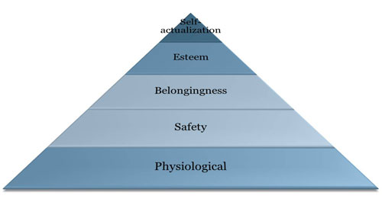
- Physiological: needs people must satisfy to survive (food, shelter, water)
- Safety: security, stability, freedom from anxiety
- Belongingness: social interaction, companionship, friendship
- Esteem: competence and appreciation by others
- Self-actualization: developing ones true potential as an individual and experience personal fulfillment
- Alderfer’s ERG Theory
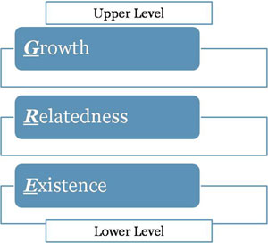
- Implications for Training: highlight the fact that employees needs must be considered in the design of a training program
Process Theories
- Expectancy Theory
- Energy or force that a person directs toward an activity is a direct result of three factors
- Expectancy: individuals subjective probability that they can achieve a particular level of performance on a task
- Instrumentality: subjective likelihood that attainment of a first-level outcome such as an A or B in this course will lead to attractive consequences that are known as second-level outcomes
- Valence: refers to the attractiveness of first and second-level outcomes
- Effort: Expectancy x (Instrumentality x Valence)
- Goal Setting Theory
- Peoples intentions are a good predictor of their behavior
- Goals are motivational because they direct people’s efforts and energies and lead to development of strategies to help them reach their goals
- Characteristics for goals to be motivational are:
- Specific in terms of their level and time frame
- Challenging
- Must be accompanied by feedback
- People must accept them and be committed to them
- Goal Orientation
- Mastery/Learning Goals: Process-oriented goals that focus on learning process
- Performance Goals: outcome-oriented goals that focus attention on achievement of specific performance outcomes
Training motivation
- The direction, intensity, and persistence of learning-direct behavior in training contexts
- Personality Variables that predict training motivation
- Locus of control
- Achievement motivation
- Anxiety
- Conscientiousness
- Self-efficacy
Model of Training Effectiveness
- Training motivation also strong predictor of learning and training outcomes
- Self-efficacy, cognitive ability, and personality characteristics also have an effect on learning
- Attitudes (job involvement, job satisfaction, and organizational commitment)
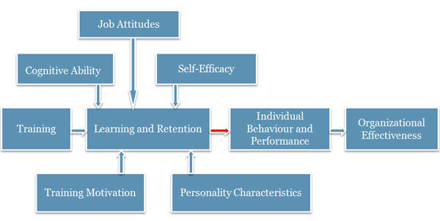
- Key issue for training is ensuring that what is learned is applied in workplace
- Degree of transfer attain in training often limited

Lesson 5
Transfer of Training
- Generalization of knowledge and skills learned in training on the job and maintenance of acquired knowledge and skills over time
- Positive: Trainees effectively apply new learning on job
- Zero: Trainees do not apply new leaning on job
- Negative: Trainees perform worse on job after training
Types of Transfer of Training
- Near: applying new learning situations that are very similar to those in which training occurred
- Far: applying new learning to situations that are different from those in which training occurred
- Horizontal: Transfer across different setting at the same level
- Vertical: Transfer from trainee level to organization level
Barriers to the Transfer of Training
- Immediate manager does not support the training
- The culture in the work group does not support the training
- No opportunity exists to use the skills
- No time is provided to use the skills
- Skills could not be applied to the job
- The systems and processes did not support the skills
- The resources are not available to use the skills
- Skills no longer apply because of changed job responsibilities
- Skills are not appropriate in our work unit
- Did not see a need to apply what was learned
- Old habits could not be changed
- Reward systems don’t support new skills
Baldwin & Fords’ Model of Transfer Training
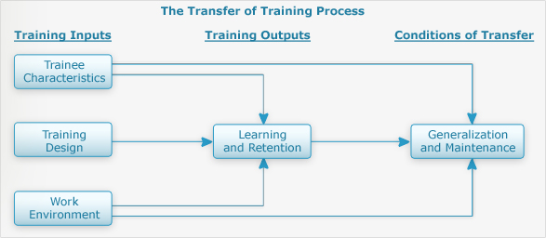

Transfer of Training Activities Before Training
- Management
- Decide who should attend
- Readiness to learn/trainability
- Trainability tests
- Increase motivation to learn
- Meet with employees to discuss training needs
- WIIFM (What In It For ME?)
- Trainer
- Ensure application of ISD Model
- Ensure both trainees supervisor and trainees are prepared in terms of knowing objectives and benefits
- Find out supervisor and trainee needs and expectations
- Ensure that trainees are prepared for training in terms of prerequisite courses/readings etc.
- Trainees
- Find out about training objectives prior to attendance
- Meet with supervisor to discuss training program and develop action plan for learning and transfer
- Prepare for training program

Transfer of Training Activities During Training
- Management
- Participate in training programs
- Speak about importance of training programs
- Attend training programs before trainees
- Reassign employees work while they are attending training
- Trainer
- Incorporate conditions of practice, adult learning principles, and other learning principles in design
- Include content and example that are relevant
- Include instruction on transfer of training
- Have trainees prepare a performance contract
- Trainees
- Enter training program with positive attitude and motivation
- Engage themselves by actively participating
- Develop an action plan for application of training on the job
Transfer of Training Activities After Training
- Management
- Ensure trainees have immediate and frequent opportunities to practice and apply what they learned
- Encourage and reinforce trainees’ application of new skills
- Develop action plan with trainees, reduce job pressures and workload, arrange practice sessions, give promotional preference to employees who have received training, and transfer and evaluate employees’ use of trained skills on job
- Trainer
- Conduct field tests
- Offer booster sessions (face-to-face)
- Trainees
- Begin using new knowledge on the job ASAP
- Meet with supervisor to discuss opportunities for transfer
- Form a Buddy System
- Consider high-risk situations that might cause a relapse and develop strategies for overcoming them and avoiding a relapse
Identical Elements
- Providing trainees with training experiences and conditions that closely resemble those in the actual work environment
General Principles
- Teaching trainees the general rules and theoretical principles that underlie the use and application of particular skills
Stimulus Variety
- Providing trainees with a variety of training stimuli and experiences, such as multiple examples of a concept, or practice experiences in a variety of situations
Transfer of Training Interventions
- Interventions provided at the end of a training program to facilitate the transfer of training
Relapse Prevention
- Intervention that instructs trainees to anticipate transfer obstacles and high-risk situations in the work environment and to develop coping skills and strategies to overcome them
Self-Management
- A post-training transfer intervention that teaches trainees to manage their transfer behavior
Goal-Setting Intervention
- Instructs trainees about the goal-setting process and how to se specific goals for the use of trained skills on the job
Transfer System
- All factors in the person, training, and organization that influence transfer of learning to job performance
Transfer System Factors

