PSY 1102: 1st Midterm Study Notes

Chapter 4: Nature, Nurture, and Human Diversity

Genes
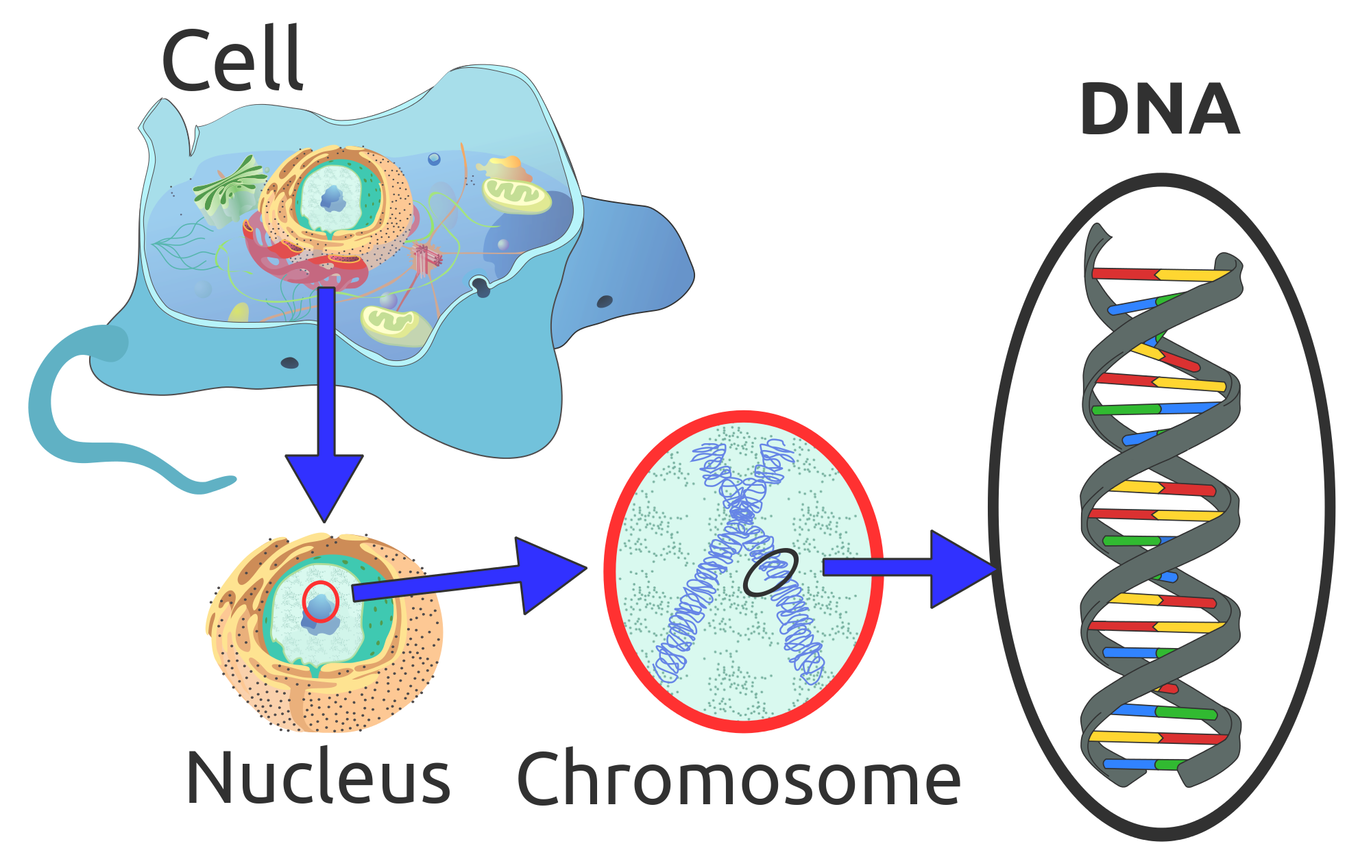
- Heredity interacts with our experience to create individual differences and universal human nature
- The plan for your book of life consists of 46 chapters – 23 are donated by mothers egg, 23 are donated by fathers sperm
- These chapters are called a Chromosome and is composed of a coiled chain of the molecule called DNA (deoxyribonucleic acid)
- Genes small segments of the the ginat DNA molecule form the words of the chapters- you have 20,000 to 25,000 gene words
- Genes can be either active (expressed) or inactive and can be turned on due to environmental factors
- When turned on genes provide the code for protein molecules, our bodys building blocks

- Genetically speaking every human is your twin – human Genome researchers have discovered the common sequence within human DNA- it is this shared profile that makes us human rather than chimpanzees
- We aren’t that different from our chimpanzee cousins – we share about 96% of our DNA sequence with them, our DNA is 99.4% similar to theirs- yet the difference matters because we can do things they cannot
- Geneticist and psychologist are interested in in slight person to person differences in our DNA – these differences give clues to things like why some people are more prone to disease or tall than others
- Every part of us is due to different genes interacting with their environment, thus our genetic predispositions, our genetically influences traits, help to explain both our shared human nature and our human diversity.

Chromosome: Threadlike structures made of DNA molecules that contain the genes
DNA: a complex molecule containing the genetic information that makes up the chromosomes
Genes: the biochemical unites of heredity that make up the chromosomes; a segment of DNA capable of synthesizing a protein
Genome: the complete instructions for making an organism, consisting of all the genetic material in that organism chromosome

Twin and Adoption Studies
- Used by behavior geneticists tease apart the influence of environment and heredity, they do this by controlling the home environment while varying heredity and controlling heredity while varying home environments

Behavior genetics: the study of the relative power and limits of genetic and environmental influences on behavior
Environment: every non-genetic influence, from parental nutrition to the people and things around us

Identical Vs. Fraternal Twins
- Identical Twins develop from a single (monozygotic) fertilized egg that splits in two- thus they are genetically identical
  - Although they have the same genes they don’t always have the same number of copies of those genes- this helps explain why one twin might be more at risk for a certain illness
  - Most identical twins share one placenta, but one in every 3 identical twins have separate placenta – one placenta may provide slightly better nourishment which contributes to differences
- Fraternal Twins develop from a separate (dizygotic) fertilized egg- they share one womb but they are only as similar as brothers and sisters

- Shared genes can translate into shared experiences if one identical twin has Alzheimer’s the other twin has a 60% chance of getting it, if the twin is fraternal they only have a 30%risk
- Studies found that identical twins are much more similar than fraternal twins in extraversion and neuroticism – if genes influence these traits might they influence the social effects of these traits
- To find out a study was done of 1500 same sex middle ages twin pairs- If you have a fraternal twin who divorced you have a 1.6 times greater chance of getting divorced, identical twins have 5.5 times greater odds
- From this they found peoples divorce risks are about 50% attributable to genetic factors
- Studies have also shown that identical twins who were treated less similarly by parents are not psychologically less alike then twins who parents treated them the same
- In explaining individual difference genes matter!

Separated Twins
- In Sweden 99 separated identical twins were identified as well as 200 seperated fraternal twins
- Compared with the identical twins reared together the separated identical twins had somewhat less similar personalities
- Still separated twins were more alike if genetically identical than fraternal – and separation shortly after birth (rather than, say, at age 8) did not amplify their personalities
- We know that this isn’t due to hours of comparison trying to find similarities because Bouchard found that separated fraternal twins did not exhibit similarities comparable to those of separated identical twins

Biological Vs. Adoptive Relatives
- Adoption creates 2 groups, Genetic relatives (biological parents are siblings) and environmental relatives (adoption parents and siblings)
- We can therefore ask whether adopted kids are more like genetic or adoptive parents and siblings – what is more important environment and genetics? D
- The findings are that people who grow up together, whether biologically related or not, do not often resemble each other in personality
- In traits such as extraversion or agreeableness, adoptees are more similar to their biological parents than to their caregiving parents – the environment shared by a family’s children has virtually no discernible impact on their personalities
- This is also true in tests done on monkeys raised by adoptive mothers
- Questions as to why people raised in the same environment are so different interest behavior geneticist curiosity
- Parenting still matters- a pair of adopted children or identical twins will, especially during adolescents have similar religious beliefs if reared together
- Studies indicate that adoptive homes are actually better for kids because parents are carefully screened, unlike biological parents

Temperament and Heredity
- Heredity predisposes one quickly apparent aspect of personality – Temperament or emotional excitability
- From the first week of life some babies are difficult and others are easy or relaxed. Slow to warm up babies do not take well to new people
  - Emotionally reactive newborns tend to be most reactive 9 month olds
  - Inhibited and fearful 2 years olds often are still shy at 8 years old and about half will become introverted adolescents
  - Emotionally intense preschoolers tend to be relatively intense young adults – a New Zeeland study of more than 900 people found that emotionally reactive and impulsive 3 year olds developed into somewhat more impulsive aggressive and conflict prone 21 year olds
- Anxious infants have high heart rates and reactive nervous systems when facing new situations
- One form of gene that regulates the neurotransmitter serotonin predisposes a fearful temperament and in combination with unsupportive caregiving, and inhabited child – such evidence proves the theory that our biologically rooted temperament helps form our identity

Molecular Genetics
- Based around the common question of behavior geneticists of do genes influence behavior?
- Molecular genetics seeks to identify the specific genes influencing behavior
- Adoption studies tell us that heredity influences body weight but there is not obesity gene – more likely genes influence how quickly our body tells us “I’m full”, or how quickly we burn of calories
- Because traits cannot be attributed to one gene a goal of molecular behavior genetics is to find some of the many genes that that together orchestrate traits such as body weight, sexual orientation, and extraversion

- Genetic tests can now reveal at risk populations for dozens of diseases – they can pinpoint genes that put people at risk for learning disabilities, depression, bi polar disorder etc.
- To find this out geneticists find families that have had the disorder across several generations
- They take blood samples and cheek swabs of those in the family that are affected and unaffected – then they examine the DNA looking for differences –
- If they can identify predict risks these people can take steps to solve the problem
- Using DNA scanning techniques medical personal are able to tell expecting parents hoe their fetuses genetics differ from normal patterns and what this might mean
- This process has ethical dilemmas because it may lead parents to abort their children in order to have perfect babies – by doing this we may deprive ourselves of future world leaders

Molecular Genetics: the subfield of biology that studies the molecular structure and function of genes

**Heritability
- Using twin and adoption studies, behavior geneticists can mathematically estimate the heritability of a trait – the extent to which variation among individuals can be attributed to their different genes
- Genetic influence explains that 50% of the observed variation among people are attributed to genes
- We can never say what percentage of an individuals personality or intelligence is inherited – it makes no sense to say that your personality is due is due x % to your heredity and y % to your environment – it refers to the extent to which differences among people are attributed to genes
- 12 boys raised in a barrel same equal environment but their difference in test scores is due to heritability

- As environment become more similar heritability becomes more important –as environments become different and some people have more advantages heritability becomes more important

- Putting people in a new social context can change their aggressiveness – todays peaceful Scandinavians carry many genes inherited from their Viking warrior ancestors
- Those studying the heritability if a trait try to determine how much of our individual variation in that trait is due to our genes

Heritability: the proportion of variation among individuals that we can attribute to genes. The heritability of a trait may vary, depending on the range of populations and environments studied

Gene- Environment Interaction
- Among our similarities, the most important is our enormous adaptive capacity.
- Some human traits such as having two eyes develop are the same in virtually every environment – but other traits are expressed only in particular environments such as callused feet from going barefoot a biological adaption to friction
- Our shared biology enabled our develop diversity
- Genes and environment, nature and nurture, work together like two hand clapping-Genes are self regulating- rather than acting as blueprints that lead to the same result no matter what the context, genes react
- Two people with identical genes but different experience will have similar but not identical minds
- Asking whether our personality is more a product of our genes or our environment is like asking whether the area of a field is more the result of its length or its width. We could however ask whether the differing areas of various fields are more the result of differences in their length or their width, and also whether person to person personality differences are influenced by nature or nurture

- Genes and experience are both important and they interact with each other
- If a there are 2 babies and one is more genetically predisposed to being likeable and sociable then they are going to get more attention and care turning out a better person- the result is neither do only to nature or nurture they both interact
- Identical twins remember their parents behavior the same whereas fraternal twins have very different experiences- children experience different parents depending on their own qualities – as we grow older we select environments that well suited to our nature

- Genes are their active or inactive and are triggered due to environment
- The field of epigenetics is studying the molecular mechanism by which environment trigger genetic expression
- One such trigger or epigenetic mark is an organic methyl molecule attached to part of a DNA strand – it instructs the cell to ignore any gene present in the DNA stretch, thereby preventing the DNA from producing the proteins coded by that gene
- Environmental factors such as drugs, diet and stress can affect this causing harm by regulating gene expression **see figure 4.3 pg 138

Interaction: the interplay that occurs when the effect if one factor (such as environment) depends on another factor (such as heredity)
Epigenetics: the study of influences on gene expression that occur without a DNA change

