- Teams and Informal Groups
  - Eight types of formal teams (Exhibit 8.1)
    - Departmental teams
      - consist of employees - similar or complementary skills
      - located in the same unit of a functional structure, minimal task interdependence because each person works with clients in other departments
    - Productions/service/leadership Teams
      - multi-skilled employees – diverse competencies
      - Team members collectively produce common product
    - Self-directed teams
      - organized around work processes that complete an entire piece of work requiring several interdependence tasks
      - substantial autonomy over execution of tasks
    - Advisory teams
      - provide recommendations to decision makers
      - committees, advisory councils etc...
    - Task force (project teams)
      - multi-skilled, temporary teams who solves problems, realizes an opportunity or designs a product/service
    - Skunkworks
      - multi-skilled teams away from organization
      - relatively free from hierarchy
      - initiated by entrepreneurial leader who borrows people/resources to design product/service
    - Virtual teams
      - members operate across space, time and organizational boundaries and are linked through information technologies to achieve organization tasks
      - May temporarily task force of permanent service team
    - Communities of practice
      - Teams (often informal) bound together by shared expertise
      - Often rely on info technologies
  - Informal groups
    - System of behavioral rules/norms that emerge in a group
  - Advantages and disadvantages of teams
    - Advantages
      - quickly share information/coordinate tasks
      - Provide superior expertise to customers
      - More motivated when working in teams because employees have the drive to bond. Also because they are accountable to fellow team members who monitor performance more than a traditional supervisor.
    - Three common challenges
      - Process losses
        - resources (time/energy) expended toward team development and maintenance rather than the task
        - More efficient for an individual to work out an issue alone than to resolve differences with other people
      - Adding people to a team
        - Brooks law – adding more people to a late software project will only make it later.
      - Risk of Productivity Loss
        - Social Loafing – problem that occurs when people exert less effort when working in teams than when working alone.
- The Model of Team Effectiveness (4 Major Parts)
  - 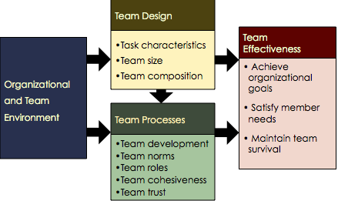
  - Organizational & Team Environment (5 elements)
    - represents all conditions beyond the teams boundaries that influences its effectiveness
    - rewards – for team performance
    - communication systems influence team effectiveness
    - org structure – flourish when work organized around work processes
    - org leadership- providing support and strategic direction
    - physical space- design
  - Team Design (3 elements)
    - Task characteristics
      - Task interdependence – extent to which team members must share materials, info, expertise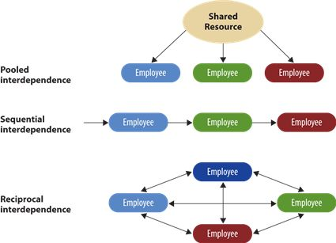
    - Team size
      - Should be large enough to provide necessary competencies and perspectives to perform work, yet small enough to maintain efficiency coordination and meaningful involvement of each member.
    - Team composition & diversity
      - MOST CHARACTERISTICS ARE DEPICTED IN THE 5 C’S
      - 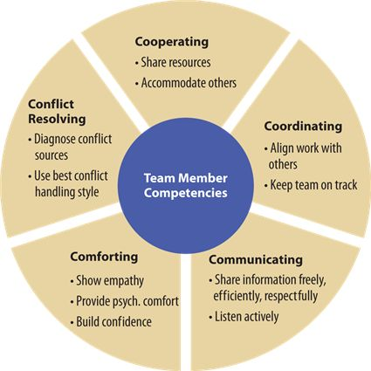
  - Team Processes (4 elements)
    - Team development (4 stages)
      - 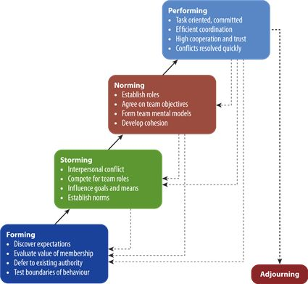
    - Adjourning: occurs when teams about to disband, members shift attention away from task orientation to relationship focus
  - Team Development as Membership & Competence
    - Two central processes in team development
      - Team Membership Formation (developing team identity)
        - Transition from “them” to “us:
        - Related to team as social identity
      - Team Competence Development (Developing team comp)
        - Forming routines with others
        - Forming shred mental models, converging views to form together
  - Team norms
    - Informal rules/shared expectations that groups establish to regulate the behavior of their members.
    - Apply only to behavior
    - Norms Develop through:
      - Initial team experiences
      - Critical events in team’s history
      - Experience/values members bring to the team
  - Team Building
    - Any formal intervention directed toward improving the development and functioning of work team
    - Types of Team Building
      - Clarify team’s performance goals (task focuses, increase motivation, feedback mechanism)
      - Improve team’s problem solving skills
      - Improve role definitions (clarify, reconstruct, expectations of you and others helps develop shared mental modes)
      - Improve relationships (most common, learn about each other, build trust, eg obstacle course challenges)
  - Team cohesion
    - Refers to degree of attraction people feel toward the team and their motivation to remain members.
    - 6 influencing factors
      - Member similarity – people with similar backgrounds and values are more comfortable with and attracted to each other (similar – attraction effect) (some forms of diversity have less effect)
      - Team Size – Smaller teams tend to have more cohesion than larger teams. Easier for a few people to agree on goals and coordinate work activities.
      - Member interaction – regular interaction increases cohesion. Calls for tasks with high interdependence
      - Somewhat difficult entry – team eliteness increases cohesions. But lower cohesion with severe initiation.
      - Team Success – Cohesion both emotional/instrumental when successful teams fulfill member needs/goals. Success increases social identity with team
      - External competition – cohesion increases when members face external competition/valued objective (challenges increase cohesion when not overwhelming)
  - Team trust (3 levels)
    - “a physiological state comprising the intention to accept vulnerability based upon positive expectations of the intent or behaviour of another person”
    - The positive expectations one has toward another person/group in situations involving risks
    - Calculus- based Trust:
      - team members will act appropriately bc they face sanctions if actions violate reasonable expectation
      - Lowest potential trust
      - Easily broken by violation
      - Cannot sustain team relationships alone
    - Knowledge-based Trust:
      - Based on P&C of group members (below)
      - Consistency of actions generates trust
      - Higher potential level of trust
      - Stable as it develops over time
    - Identification-based Trust:
      - Common understanding of models (below)
      - Emotional bond with members
      - High-performance teams
      - Highest potential

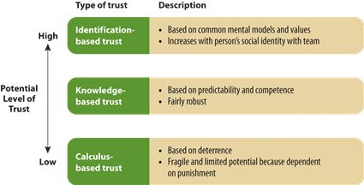
- Self-Directed Teams (SDTs)
- Virtual Teams
  - Teams whose members operate across space, time and organizational boundaries and are linked through information technologies to achieve organizational tasks
  - Success factors for virtual teams (4)
    - Must have good communication technology skills, strong self-leadership skills and higher emotional intelligences so that they can decipher the feelings of other team members from email
    - Should have a toolkit of communication channels (email) and the freedom to choose the channels that work best for the,.
    - Plenty of structure
    - Meet face-to-face fairly early in the team development process.
- Team Decision Making
  - Constraints on team decision making (4 common problems)
    - Time Constraints – Teams take longer than individuals to make decisions. Extra time needed to organize, coordinate, maintain relationships
    - Evaluation Apprehension – decision making problem occurs when individuals are reluctant to mention ideas that seem silly because they believe that other team members are silently evaluating them. Based on desire to create favorable self-presentation and protect self esteem. Most common in meetings with different status levels or expertise
    - Pressure to conform – cohesion leads employees to conform to team norms – keeps groups organized around common goals but may cause members to suppress their opposing opinions
    - Groupthink – tendency of highly cohesive groups to value consensus at the price of decision quality. Attempts to maintain harmony. Harmony as group norm most apparent when strong social identity with group is present.
  - Team structures that improve decision making (4)
    - Constructive conflict
      - Conflict where people focus their discussion on the issue while maintaining respect for people having other points of view
      - Encourages people to present their divergent viewpoints so ideas and recommendations can be clarified, redesigned and tested for logical soundness
      - Main problem: defensive when ideas are questioned/critiqued
    - Brainstorming
      - Free-wheeling, face to face meeting where team members aren’t allowed to criticize but are encouraged to speak freely, generate as many ideas as possible and build on the ideas of others.
      - Spreads enthusiasm and increases team cohesion
      - Four rules:
        - Speak freely – describe even craziest ideas
        - Don’t criticize – others or their ideas
        - Provide as many ideas as possible – the quality of increases increased with the quantity of ideas
        - Build on other ideas
    - Electronic brainstorming
      - Relies on networked computers for submitting and sharing creative ideas
      - After receiving a question/issue participants ideas are distributed anonymously to others and people are encouraged to piggy back ideas.
      - Members eventually cote electronically on ides, followed by face to face discussion
      - Allows for generating ideas with little production blocking, evaluation apprehension or conformity problems.
      - Seems too structured and technology bound for some
    - Nominal group technique
      - tries to combine the benefits of team decision making without the problems mentioned earlier
      - Three stages:
        - Silently & independently document their ideas
        - Together describe ideas to team with no criticism but encouraged to ask for clarification
        - Members silently & independently vote on proposed ideas
      - Generates increased number/quality of ideas
      - High task orientation and low conflict potential
      - But blocking and evaluation apprehension still occur

- Power Defined
  - Power is the capacity of a person, team or organization to influence others – not the act of changing someone’s attitudes or behaviors
  - Model of Power in Organizations

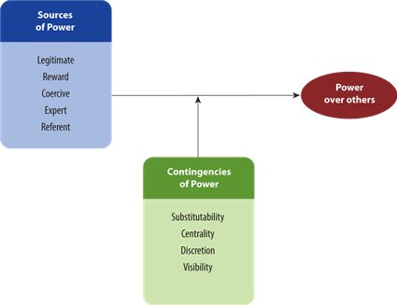
- Sources of Power in Organizations
  - 1) Legitimate Power
    - Agreement among organizational members that people in certain roles can request certain behaviors of others.
    - Perceived obligation from formal job description and informal rules of conduct
    - Power depends on more than just job description it also depends on mutual agreement from those expected to abide by authority (ie boss physically cannot make you stay late)
    - Legit power operated within “zone of indifference”- range within which people are willing to accept someone else’s authority. Zone increases with trust and perceived fair decisions.
    - Some people are more obedient than others (value conformity and tradition)
    - Organizational culture is a factor
      - ex. managers right to tell employees what tasks to perform, who to work with, what office resources they can use etc..
  - 2) Reward Power
    - Derived from persons ability to control allocation of rewards valued by others and to remove negative sanctions
    - Managers have formal authority that gives them power over the distribution of organizational rewards like pay, promotions, time off, vacation schedules and work assignments.
    - Employees have reward power over bossed via 360 feedback which effects boss’s promotion and other reward
  - 3) Coercive Power
    - Ability to apply punishment
    - Employees coercive power includes being sarcastic toward co-workers or threatening to ostracize them if they fail to conform to team norms. Controls team behaviour
  - 4) Expert Power
    - Originates from within the PERSON (unlike first three which is through position).
    - Individuals capacity to influence others by possessing knowledge or skills valued by others
      - Prevention – most effective strategy to prevent environmental changes from occurring
      - Forecasting – Predict environmental changes from occurring
      - Absorption – absorbing or neutralizing the impact of environmental shifts as they occur.
  - 5) Referent Power
    - Capacity to influence others on the basis of an identification with and respect for the power-holder
    - Originates with power holder, largely a function of their interpersonal skills & tends to develop slowly.
    - Associated with charismatic leadership
    - Charisma produces a high degree of trust, respect, and devotion towards the charismatic individual
- Contingencies of Power (Contingencies are situational factos/conditions)
  - 1) Substitutability
    - Refers to availability of alternatives. Power is strongest when one has monopoly over a valued resource.
    - Power decreases as the number of alternative sources of the critical resources increase
    - Refers to not only other sources that offer the resource but also to substitutes of the resource itself (ie technology)
    - Nonsubstitutability is strengthened by controlling access to resource. (knowledge and tasks)
  - 2) Centrality
    - Refers to power holders importance based on the degree and nature of interdependence between the power-holder and others.
    - High centrality is when most people in org would be adversely affected by your absence and would be affected quickly
  - 3) Discretion
    - Freedom to exercise judgment, make decisions without referring to a specific rule or receiving permission from someone else
    - Lack od discretion = less power
    - Managers with an internal locus of control are viewed as more powerful because they behave as though they have discretion in job (even if they don’t)
  - 4) Visibility
    - Power doesn’t flow to unknown people in the organization. Those who control valued resources/knowledge will yield power only when others are aware of these sources of power
    - To increase visibility- take people-oriented jobs and work on projects that require frequent interaction with senior managers.
    - Strategic location of office to LITERALLY by more visible
- The Power of Social Networks
  - Cultivating social relationships with others to accomplish ones goals
  - Increases Power through:
    - Social capital- durable network connecting people to others with valuable resources
    - Referent Power – ppl tend to identify more with partners within their own networks
    - Visibility & centrality contingencies
  - Social capital – knowledge/resources available to people or social units (teams) from a durable network that connects them to others
    - Gaining power from social networks through social capital
    - Trust support, sympathy, motivation
    - Improves expert power, enhances visibility and referent power
      - Increase in network ties
      - More people connected to you = the more resources (info, favors) you have access to.
      - Social networks are elements of the informal org but can create barrier to those not connect (ie women left out because they do not participate in golf games)
  - Consequences of power
    - When people feel empowered they believe they have power over themselves and freedom from being influenced by others – tends to increase motivation etc – this feeling of personal power increases automatic rather than mindful thinking. More likely relies on stereotypes, have difficulty empathizing and generally less accurate perceptions.
    - When an individual has power over others is accompanied by a sense of responsibility for the people they have power over and tend to be more mindful of their actions and engage in less stereotyping.
- Influencing Others (8 Types of Tactics)
- Influence: any behaviour that attempts to alter someone’s attitudes or behaviour
  - Applies one or more power bases, process through which people achieve organizational objectives, Operates up down and across the org hierarchy
  - First 5 = ‘hard’ behaviour change through position of power
  - Last 3 = ‘soft’ rely on personal sources of power & appeal to persons attitudes and needs
    - Silent authority
      - influencing behavior through legitimate power & role modeling
      - following requests without overt influence
      - common in high power distance cultures
    - Assertiveness
      - Actively applying legitimate/coercive power to influence through pressure/threats (“vocal authority”)
      - Reminding, confronting, checking, threatening
    - Information control
      - Manipulating other’s access to info to change attitudes/behavior
      - Withholding, filtering, re-arranging info
    - Coalition formation
      - Group forms to gain more power than individuals alone
        - Pools resources/power
        - Legitimizes the issue
        - Power through social identity
    - Upward appeal
      - Gaining support from people with higher authority (appealing to them)
      - Includes appealing to firm’s goals
      - Alliance or perceived alliance with higher status person
    - Persuasion
      - Using logical arguments, factual evidence, emotional appeals to convince people of the value of a request
      - Depends on persuader, message content, message medium, audience
    - Ingratiation/Impression Management
      - Attempting to increase liking by, or perceived similarity, to some targeted person
      - Ingratiation – seeking to please
      - Impression mgmt. – actively shaping our public image to satisfy basic norms of social behaviour
    - Exchange
      - Promising or reminding of past benefits/resource in exchange for target persons compliance.
      - Includes negotiation and networking
  - Consequences of influence tactics
    - 1) resistance - occurs when people/work units oppose the behavior desired by the influencer by refusing, arguing or delaying engagement in the behavior
    - 2) compliance - people are motivated to implement the influencers request at a minimal level of effort purely for instrumental reasons (motivated by external sources, rewards, to implement request)
    - 3) commitment – people identify with the influencers request and highly motivated to implement it even when extrinsic sources of motivation are no longer present
    - 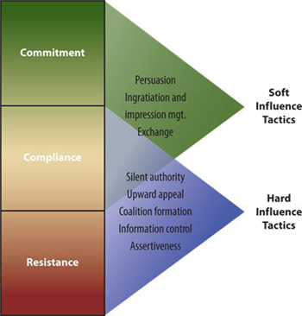
  - Contingencies of influence tactics
    - “Soft” tactics generally more acceptable than “hard” tactics
    - Appropriate influence tactic depends on:
      - Influencer’s power base
      - Organizational position
      - Cultural values and expectations
- Influence and Organizational Politics
  - Conditions supporting organizational politics (4)
    - Scarce resources
    - Complex & ambiguous decisions
    - Organizational change
    - Tolerance of politics
  - Personal characteristics
    - strong need for personal as opposed to socialized power
    - People who need personal power seek power for its own sake and try to acquire more power
  - Minimizing organizational politics and its consequences
    - Introduce clear rules/regulations that specify use of scarce resources
    - Leaders must actively manage group norms to curtail self-serving influence activities – support organizational values that oppose political tactics
    - Limit adverse effects of political perceptions by giving employees more control over their work and keeping them informed

- Two Types of Conflict
  - Emerging view (constructive & relationship conflict)
    - Constructive conflict
      - people focus their discussion on the issue while maintaining respect for people and don’t focus on parties
      - Different positions are encouraged so ideas and recommendations can be clarified, redesigned and tested for logical soundness.
    - Relationship conflict
      - Focuses on the characteristics of other individuals, rather than on the task or issue as the source of conflict.
      - Introduces perceptual biases
      - Distorts info processing
- Minimize relationship conflict (RC)
  - Emotional intelligence
    - RC minimized when team members have high levels of emotional intelligence
  - Cohesive team
    - RC suppressed when conflict occurs within a highly cohesive team. The longer people know each other and their relationships grow, the more latitude they give to each other to show emotions without being personally offended.
  - Supportive Team Norms
    - Can hold RC at bay during constructive debate
    - Team norms encourage openness, team members learn to appreciate honest dialogue without personally reacting to any emotional display during the disagreements.
- The Conflict Process Model
  - 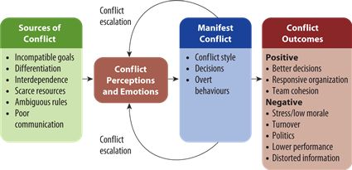
- Structural sources of conflict
  - Incompatible goals
    - occurs when the goals of one person/department interfere with another persons’/department’s goals
  - Differentiation
    - Differences among people regarding training, values, beliefs and experiences.(common goals diff beliefs in how to achieve)
  - Interdependence
    - refers to extent employees share materials, info, or expertise to perform their jobs. Conflict increases the more sharing (increase of interdependence). It increases the conflict because there is a greater chance that each side will disrupt or interfere with the other side’s goals
  - Scarce resources
    - Generates conflict because each person/unit requiring the same resource necessarily undermines others who also need that resource to fulfill their goals
  - Ambiguous rules
    - uncertainty increases the risk that one party intends to interfere with the other party’s goals.
    - Ambiguity encourages political tactics, employees enter a free-for-all battle to win decisions in their favor
  - Communication problems
    - lack of opportunity, ability, or motivation to communicate effectively
    - When parties lack comm. opportunities -tend to rely on stereotypes to understand each other
    - Some people lack the necessary skills to communicate in a diplomatic, non confrontational manner
    - Perception of conflict reduces motivation to communicate. Uncomfortable, so people interacting with others in a conflicting relationship
- Interpersonal Conflict Management/ Handling Styles (5)
- 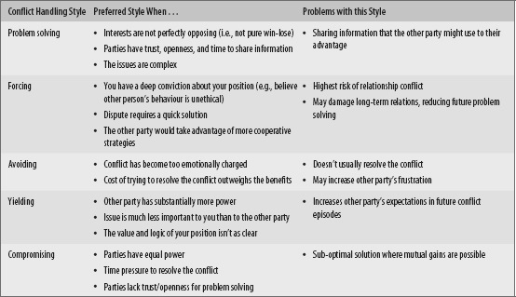
  - Problem Solving: find a mutually beneficial solution for both parties.
    - Win-win orientation
    - Info sharing is important feature
  - Forcing: tries to win conflict at the others expense
    - Win-lose orientation (fixed amount)
    - Rely on “hard” tactics
  - Avoiding: trying to avoid conflict all together
    - Low concern for self and other party
  - Yielding: giving in completely to other sides wishes or cooperating with little attention to self interest
    - Making unconditional promises
    - Offering help with no expectation for reciprocal help
  - Compromising: looking for a position in which losses = valued gains
    - Matching other party’s concerns
    - Making conditional promises or threats
    - Actively searching for middle ground
- Structural Approaches to Conflict Management (6 recommendations)
  - Emphasizing Subordinate Goals
    - Subordinate goal: any goal that both conflicting parties value and whose attainment is beyond the resources and effort of either party alone.
    - Emphasize common objective rather than conflicting sub-goals.
    - Reduces goal incompatibility and differentiation
  - Reducing Differentiation
    - Remove sources of different values & beliefs that create conflict
    - Increase willingness to coordinate by creating common experience. (Can do this by rotating employees around to different jobs)
  - Improving Communication and Understanding
    - Employees understand and appreciate each other’s views through communication
    - Relates to contact hypothesis: the more meaningful interactions we have with someone, the less we rely on stereotypes to understand that person
    - Two warnings:
    - Must do it AFTER differentiation has reduced or else dialogue will escalate
    - A western strategy may conflict with values/traditions in other cultures
  - Reducing Interdependence
    - Dividing shared resources
    - Combine tasks
    - Use buffers
  - Increasing Resources
    - Increase the amount of available resources.
    - Compare costs to cost of dysfunctional conflict that would arise to see if it is worth it
  - Clarifying rules and procedures
    - Clarify resource distribution
    - Establish rules and procedures
    - Redefine terms of interdependence
- Resolving Conflict through Negotiation
  - Negotiation: attempting to resolve divergent goals by redefining terms of interdependence
  - Which conflict handling style is best in negotiation
    - Begin cautiously with problem solving style
    - Shift to a win-lose style when:
      - Mutual gains situation isn’t apparent
      - Other party wont reciprocate info sharing
  - The bargaining zone model (3 critical points)
  - 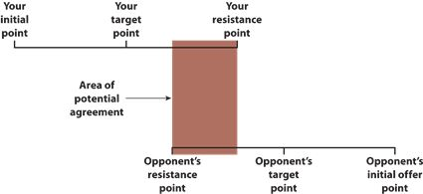
  - Strategies for claiming value (4)
    - Prepare/Set Goals
    - Know your BATNA
      - Best alternative to a negotiated agreement
    - Manage Time
    - Manage First Offers and Concessions
  - Strategies for creating value (3)
    - Gather Info
    - Discover priorities through offer and concessions
    - Build the relationship
  - Situational influences on negotiations (3)
    - Location – easier on home turf, face to face
    - Physical setting – seating, formality, face to face, distance
    - Time passage and deadlines – increased time in negotiating= increased commitment to reach agreement but also increases escalation of commitment problem
    - Audience characteristics – audience present = more competitive
  - Effective Negotiation Behaviour
    - Preparation and Goal Setting
    - Gathering Info
    - Communicating effectively
    - Making allowances

- Leadership- the ability to influence, motivate, and enable others to contribute toward the effectiveness of organizations of which they are members
- Competency (Trait) Perspective of Leadership
- Competencies- Personal characteristics that lead to superior performance in a leadership role (skills, knowledge, values)
  - 8 Competencies/Traits
    - Personality
      - Leaders have higher levels of extroversion (are comfortable having an influential role in social settings- talkative, outgoing) and conscientiousness (set higher personal goals for themselves, more motivated and higher performance expectations – dependable, self-disciplined)
    - Self-Concept
      - Successful leaders have positive self evaluation, high self-esteem and self-efficiency, and internal locus control. Have complex, internally consistent, and clear self-concept
    - Drive
      - Leaders have inner motivation to pursue goals that relates to a high need for achievement. Drive inspires curiosity, and action orientation.
    - Integrity
      - Refers to truthfulness, and consistency in words and actions (honesty and ethics). Have high moral capacity to judge dilemmas bc of values.
    - Leadership motivation
      - Leaders need for socialized power to accomplish team or organizational goals.
    - Knowledge of the business
      - Leaders have tacit/explicit knowledge about companies environment, enabling the leader to make more intuitive decisions
    - Cognitive/Practical intelligence
      - Leaders have above-average cognitive ability to process large amounts of info and have ability to solve real-world problems by adapting to, shaping or selecting appropriate environments
    - Emotional intelligence
      - Leader’s ability to monitor own and others emotions to guide their thoughts/actions (able to perceive, express, assimilate, understand, and regulate emotions)
  - Limitations and practical implications
    - Assumes all effective leaders have the same personal characteristics
    - Alternative combo’s of competencies may be equally successful
    - Competency perspective views leadership as something within a person, yet experts emphasize that leadership is relational
- Behavioral Perspective of Leadership
- People- oriented behaviours (supportive)
  - Showing mutual trust and respect
  - Concern for employee needs
  - Looks out for employee well-being
- Task-oriented behaviours (directive)
  - Assign specific tasks
  - Ensure employees follow rules, clarify roles, monitor performance
  - Set “Stretch goals” to achieve performance capacity
- Choosing between directive vs. supportive

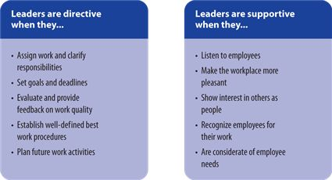
  - Directive L = leads to higher job performance
  - Supportive L = reduces absenteeism, grievances, turn over, job dissatisfaction and stress
- Choosing between Task and People Leadership
  - two categories are broad generalizations, that mask specific behaviour within each category
  - Assumes high levels of both styles are best in all sit. BUT REALITY the best style depends on the situation
- Contingency Perspective of Leadership
  - Path-goal theory of leadership
    - 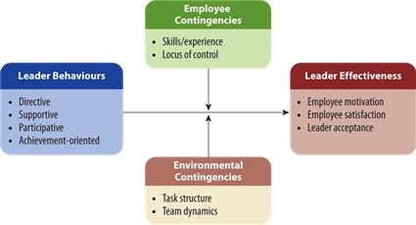
    - Leadership styles (4)
      - Directive
        - clarifying behaviors that provide a psychological structure for employees
      - Supportive
        - Provide psychological support for employees
      - Participative
        - encourage/facilitate subordinate involvement in decisions beyond their normal work activities
      - Achievement-orientated
        - encourage employees to reach peek performance
    - Contingencies of path-goal theory (4)
      - Skill and experience
        - combo of directive and supportive
      - Locus of control
        - Believe they have control over their work environment
      - Task structure
        - non-routine tasks – occurs in complex work situations
      - Team dynamics
        - cohesive teams with performance-oriented norms
  - Other contingency theories
    - Situational leadership theory
      - effective leaders vary their style with the ability and motivation of followers
      - Four leadership styles
        - telling
        - selling
        - participating
        - delegating
    - Fiedler's contingency model
      - earliest contingency theory of leadership
      - leader effectiveness depends on whether the person’s natural leadership style is appropriately matched to the situation
  - Leadership substitutes
    - identifies conditions that either limit a leaders ability to influence employees or make a particular leadership style unecessary
- Contingency perspective is based on the idea that most appropriate leadership style depend on the situation. Insightful and flexible leaders must be able to adapt behaviours and styles to immediate situation, must have high emotional intelligence to diagnose circumstances
- Path-Goal Leadership
  - Theory of leadership based on the expectancy theory of motivation that relates several leadership styles to specific employee situational contingencies. They create:
    - Paths= employee expectancies
    - Goals= Employee performance
  - States that effective leaders ensure that employees who perform their jobs will receive more valued rewards than those who perform poorly
- Path-Goal Leadership Styles
  - Directive: are clarifying behaviours that provide structure, clarifies and means to meet goals, use rewards and disciplinary actions
  - Supportive: leader is friendly and approachable, makes work more pleasant, treats employees with equal respect, shows concern for status, needs, and well-being
  - Participative: encourage subordinate involvement in decisions, leaders consult, ask for suggestions, and takes ideas into consideration
  - Achievement-oriented: encourages employees to reach peak performance, sets challenging goals, always seeking improvement from emp. And has a high degree of confidence that empl. Will assume responsibility and achieve challenging goals

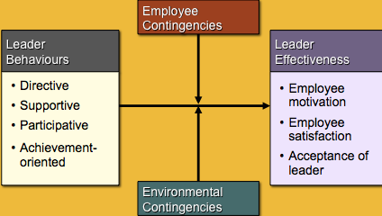
- Contingencies of Path-Goal Theory
- Employee Contingencies
  - Skills and experience: combinations of directive and supportive leadership is best for employees who are/perceived as inexperienced or unskilled
  - Locus of Control: people with internal- they have control over enviro and prefer participative and achievement oriented not directive. People with external- performance is due more to luck prefer directive and supportive leadership
- Environmental contingencies
  - Task structure: non-routine task: directive style to minimize ambiguity not good in routine bc seen as unnecessary close control. Participative also preferred bc the lack of rules gives them more discretion to achieve goals- not good with routine bc they lack the discretion. Routine task: supportive style to help cope with tedious nature of work
  - Team Dynamics: cohesive teams substitute supportive leadership with low cohesion need supportive. Performance-oriented teams substitute for directive and possible achievement-oriented leaders.
- Situational Leadership Theory:
- - a commercially popular theory but poorly supported leadership model, stating that effective leaders vary their style (telling, selling, participating, delegating) with the “readiness” of followers.
  - Readiness refers to employees ability ad willingness to do task
    - Ability refers to the skills and knowledge that they poses to do task without guidance
    - Willingness refers to their motivation and commitment to do task
  - Telling is the only model that works- has high task behaviour & low supportive behaviour (directive style)
- Transformational Perspective of Leadership
  - Transformational leadership
    - Perspective that explains how leaders change teams or orgs by creating, communicating and modeling a vision for organization or work unit, and inspiring employees to strive for that vision
    - Is about “leading”- changing the orgs strategies and culture so that they have a better fit with surrounding enviro
    - are agents of change in the organization who energize and direct employees to new set of corp values and behaviours
    - steer company into better course of action, important in orgs that requires alignment with external enviro
  - Transactional Leadership
    - Leadership that helps orgs achieve their current objectives more efficiently such as linking job performance to valued rewards and ensuring that employees have resources needed to get the job done.
    - “managing” or “doing the right thing” bc focus is on improving employee performance and well-being
    - Improves org efficiency
    - Relates to contingency leadership theories (eg. Path-goal)
  - Transformational vs. charismatic leadership
    - Some say the two are interchangeable but there is a distinction
    - Charisma is a personal trait/relational quality that provides referent power over followers
    - Transformation leadership is a set of behaviours that people use to lead the change.
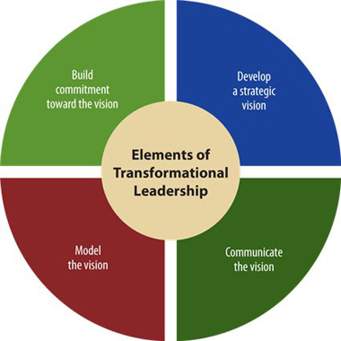
- Elements of transformational leadership (4 elements)

  - Develop a strategic vision:
    - represents substance of transformational leadership.
    - Creates a “high purpose” or superordinate goal that energizes and unifies employees.
    - Might originate from leader but likely employees.
    - Pays an important role in org effectiveness.
    - Visions offers motivational benefits of goals setting.
    - Visions distinguish from current situation, and makes goals appealing and achievable
  - Communicate the vision:
    - Transformational leaders communicate meaning and elevate importance of the visionary goal to employees, frame message round grand purpose with emotional appeal.
    - Bring vision to life through symbols, metaphors, stories and other vehicles
  - Model the Vision:
    - Don’t just talk, they indorse it “walk the talk”
    - Persistent in actions to legitimize vision
    - Walk the talk through events like visiting customers, moving their office closer to employees, holding ceremonies to detroy outdated policy manuals. It also builds trust
    - Greater consistency in leaders actions = the more employees will believe and follow leader.
  - Build Commitment toward the Vision”
    - Words, symbols, and stories build a contagious enthusiasm that energizes people to adopt the vision on their own.
    - Leaders how “can do” attitude by enacting their vision.
    - Build commitment by involving employees in the process of shaping the organization’s vision
- Implicit Leadership Perspective
  - Prototype of effective leaders
    - preconceived beliefs about the features/behaviors of effective leaders
    - Develop through socialization shape the followers expectations/acceptance of others as leaders and affects the willingness to remain as a follower
    - * Preconceived image of effective leader, used to evaluate leader effectiveness
  - Romance of leadership
    - Followers distort their perception of the influence that leaders have on the environment
    - People want to believe that leaders make a difference
    - *amplify effect of leaders on org results, fundamental attribution error, need for situational control

- Organizational Structure
  - Division of labor and the patterns of coordination, communication, workflow and formal power that direct organizational activities
  - Formally dictates what activities receive the most attention and financial, power, and information resources
  - Related to many OB topics (job design, teams, power, org culture, org change)
- Division of Labor and Coordination
  - Division of Labor
    - Subdivision of work into separate jobs assigned to different people
    - Leads to job specialization, each job includes narrow subset of the tasks necessary to complete the product/service
    - Is limited by ability to coordinate work
    - Potentially increases work efficiency
    - Necessary as company grows and work becomes more complex
  - Coordinating Work activities Through: (3 ways)
    - Informal communication
      - Sharing info on mutual tasks
      - Forming common mental models to synchronize work activities
      - Allows flexibility
      - Vital in nonroutine and ambiguous situations
      - Easiest in small firms
      - Applied in team-based structures
      - Large companies encourage coordination through informal communication by creating integrator roles (responsible for coordinating work process by encouraging employees I each work unit to share info & informally coordinate work activities)
        - Sub types: Direct communication, liaison roles, integrator roles, temporary teams
    - Formal hierarchy
      - Informal communication is time consuming therefore second coordinating mechanism is created (Form hier)
      - It assigns legitimate power to individuals, who then use this power to direct work processes and allocate resources
      - Work is coordinated through direct supervision
      - Coordination strategy for departmentalization
    - Standardization (3 forms)
      - Creating routine patterns of behavior or output
        - Standardized processes – quality/consistency of a product/service can be improved through job descriptions and procedures. (best when work is routine or simple less effective in nonroutine and complex work)
        - Standardized outputs – ensuring that individual and work units have clearly defined goals and output measures(ie assigning sales targets)
        - Standardized skills – coordinate work effort by extensively training employees or hiring people who have learned precise role behaviors from educational programs. Ie training (used in used in hospital operating rooms)
- Elements of Organizational Structure (4 elements)
  - Span of control
    - Number of people directly reporting to the next level in the hierarchy
    - Assumes coordination through direct supervision
    - Narrow span when very few people report directly to manager
    - Wide span when a manager has many direct reports
    - Wider span of control possible when:
      - Using other coordinating mechanisms (informal communication and specialized knowledge)
      - Employees preform routine tasks, less need for direction
      - There is low employee interdependence (do not need to depend o others)
  - Tall vs Flat Structures
    - Span of control is interconnected with org size and number of layers in the org hierarchy
    - As companies grow they:
      - Build taller hierarchy
      - Widen span, or BOTH
    - Problems with tall hierarchies:
      - Higher overhead costs bc layers mostly consist of mgrs.
      - Bad upward information- managers receive low quality and less timely info from external enviro bc info from front-line employees is transmitted slowly/ filtering
      - Undermine employee empowerment and engagement because they focus power around managers not staff
    - Trend toward Flatter structures
      - Firms are moving toward flatter structures (delayering)
        - Reduces costs and minimized problems from tall
      - Problem: risk of cutting too much middle mgmt.
        - Could cause long term problems- need managers to help coordinate, make decisions, resolve conflict
  - Centralization
    - Degree to which formal decision making authority is held by a small group of people typically those of top organizational hierarchy.
    - Most begin with this structure as the founder makes most decisions and tries to direct org toward their vision.
    - As org grows, cant make all decisions so consequently larger orgs decentralize
  - Decentralization
    - Disperse decision authority/power throughout the organization
    - Different degrees of decentralization can occur simultaneously in different parts of org.
  - Formalization
    - Degree to which organizations standardize behavior through rules, procedures, formal training and related mechanisms (increasing efficiency and compliance)
    - Formalization increases as firms get older, larger and more regulated
    - Problem: Formalization tends to
      - Reduce organizational flexibility
      - Discourage org learning/creativity
      - Reduce work efficiency
      - Increase job dissatisfaction and work stress
  - Mechanistic versus organic structures
    - Mechanistic – characterized by a narrow span of control and high degree of formalization and centralization
    - Organic – Operate with wide span of control, little formalization and decentralized decision making
- Forms of Departmentalization (the fourth element)
  - Departmentalization: specifies how employees and their activities are groups together. Fundamental strategy for coordinating org activities bc it influences or behaviour is 3 ways: (functions)
    - Established the chain of command – establishes interdependencies among employees and subunits
    - Focuses people around common mental models or ways of thinking, like serving clients, supporting specific skills set. Measures performance
    - Encourages coordination through informal communication among people and subunits.
  - Simple Structure
    - Begin with this. Employ few people, offer one distinct product/service
    - Minimal hierarchy
    - Employees perform broadly defined roles
  - Functional
    - Organizes employees around specific knowledge or other resources
    - Creates special pools of talent that typically serve everyone in org. providing more economies of scale
    - Increases employee identity with the specialization. Direct supervision is easier here
    - Limitations:
      - Grouping empl around skills tend to focus attention on those skills and related needs rather than on the company’s product or client needs
      - Unless transferred, may never develop a broader understanding of the business.
      - Compared to others it produces higher dysfunctional conflict and poorer coordination in serving clients or developing products.
    - Example: 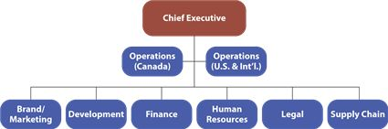
  - Divisional (3)
    - Organizes employees around geographic areas, products or services, or clients.
    - Geographic structure organizes employees around distinct regions of the country. Moving away from this structure bc:
      - Clients can purchase online and communicate with businesses from almost anywhere
      - Reduced geographical variation (preferences for many products are becoming similar around the world.
      - Large comp increasingly have global business customers who demand one global point of purchase not in every country
    - Product/Service structure organized work around distinct outputs
    - Client structure organizes employees around specific customer groups.
    - Which to adopt depends on the primary source of environmental diversity or uncertainty.
    - Ie Mcdicks uses geographic regions to better serve – hongkong more fish products, India more vegetarian.
  - Evaluating Divisional Structure:
    - Divisional form is building block for structure
    - It accommodates growth relatively easily and focuses employee attention on products/ customers rather than tasks
    - Different products/services/clients can be accommodated with new divisions
    - Limitations: tends to duplicate resources (eqiup, IT expertise)
    - Unless division large, resources aren’t used as effectively
    - Creates silos of knowledge
    - Deciding on a structure is hard bc global orgs have diversity and uncertainties in many ways and decision affects political dynamics (switching could result in people getting demoted)
  - Example: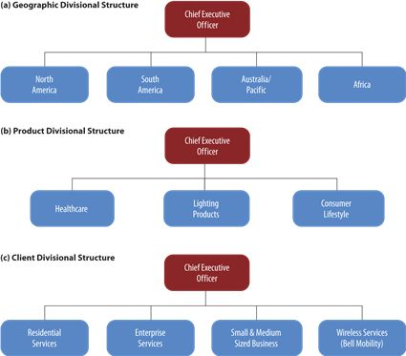
  - Team-based
    - built around self-directed teams that complete an entire piece of work, such as manufacturing a product.
    - Usually organic. Wide span of control. Highly decentralized
  - Matrix
    - Organic structure that overlays two structures in order to leverage the benefits of both
    - Example: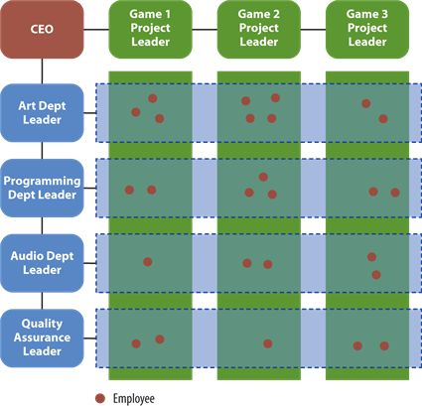
  - Network
    - An alliance of several organizations for the purpose of creating a product or serving a client
    - Example: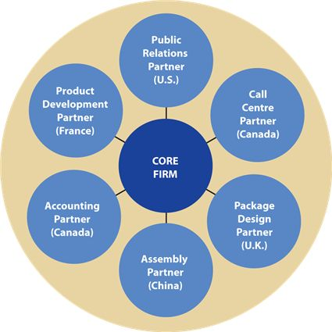
- Contingencies of Organizational Design (4)
  - External environment (4 characteristics)
    - The best structure for an organization depends on its external enviro. External enviro is anything outside the organization including stakeholders, resources, and competitors
      - Dynamic vs. Stable Environments
        - Dynamic have high rate of change, leads to novel situations and lack of identifiable patterns. If employees are experienced and coordinate well in teamwork an Organic structure is best suited for this enviro
        - Stable enviro’s have regular cycles of activity, steady conditions and predictable changes. Best to use mechanistic structure
      - Complex vs. Simple Environments
        - Complex have many elements, whereas simple environments have few things to monitor. Complex environments require decentralized org – decisions are pushed down to the people with the proper info to make informed decisions. Less need for decentralization in simple enviro
      - Diverse vs. Integrated Environments
        - Organizations located in diverse environments have a greater variety of products or services, clients and regions. Integrated enviro has only one client/product/geographical area. The more diversified the enviro the more essential it is to use a divisional structure aligned with the diversity. When integrated- used functional structure or geographic if global
      - Hostile vs. Munificent Environments
        - Firms in hostile environments face resource scarcity and more competition in the marketplace, dynamic because they reduce the predictability of access to resources and demand for outputs. Organic structure is best- unless enviro is extremely hostile (server shortages of supplies or lower market share) orgs tend to temp. centralize to make decisions faster – may result in lower-quality decisions during crisis bc top mgmt. have less info. Munificent enviros have plenty of resources and product demands. Less need for organic structure
  - Organizational size
    - As orgs grow they have:
    - More division of labour (job specialization)
    - Greater use of standardization
    - More hierarchy and formalization
    - More decentralization
  - Technology
    - Refers to mechanisms or processes by which an org turns out its product or service
    - Two contingencies:
      - Variability: the number of exceptions to standard procedure that tend to occur
      - Analyzability: the predictability of difficulty of the required work.
  - Organizational strategy
    - The way the organization positions itself in its setting in relation to its stakeholders, given the organizations resources, capabilities, and mission.
    - Structure follows strategy
      - Strategy points to the envoi in which the org will operate
      - Leaders decide which structure to apply (how large to grow/ tech to use)
    - Differentiation strategy
      - Providing unique products or attracting clients who want customization
    - Cost leadership strategy
      - Maximize productivity in order to offer competitive pricing

- Organizational Culture Defined
  - consists of the values and assumptions shared within an organization
  - Directs everyone in the organization toward the “right way” of doing things
  - The basic patter of shared values and assumptions governing the way employees within an org think about and act on problems and opportunities
  - Personality of the org
- Elements of Organizational Culture
  - Values = stable, evaluative beliefs that guide our preferences for outcomes or courses of action in a variety of situations
    - Values exist as a component of or culture in the form of shared values
  - Shared values and assumptions
    - Shared values are values that people within the organization have in common and place near the top of their hierarchy of values
    - Shared assumptions are a deeper element that some experts believe is the essence of corporate culture
      - unconscious, taken-for-granted perceptions of behavior that are considered the correct way to think and act toward problems and opportunities
      - So deeply ingrained often you probs wouldn’t discover them by surveying employees- only by observing, analyzing decision and debriefing would assumptions rise to the surface
  - Some orgs will publicly state their shared values. These value proclamations represent espoused values- the values leaders say they & staff rely on to guide decisions. People construct a get good public image by claiming values believed to be socially desirable. These statements are espoused also bc leaders may abide by them but lower level empl may not share the values.
  - In contrast, org culture consists of shared enacted values- the values that leaders and empl truly rely on to guide their decisions and actions

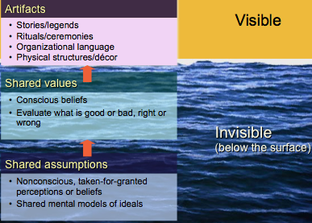
- Content of Organizational Culture
  - Orgs differ in their cultural content – the relative ordering of values
    - A few dominant values (ie dell puts efficiency and competitiveness way above innovation and style)
  - Problems with measuring org culture:
    - Oversimplifies diversity of possible values
    - Ignores shared assumptions
    - Adopts an “integration” perspective- assume that most orgs have fairly clear, unified culture that is easily decipherable. Assumes that when an org’s culture changes, it shifts from one unified condition to a new unified condition with only temporary ambiguity or weakness during the transition
  - An orgs culture is blurry
    - Consist of diverse subcultures
    - Values exist within individuals not work units
- *some degree of shared values & assumptions do exist
  - Talking bout org culture we r referring to the dominant culture
    - The values and assumptions shared most consistently and widely with members
    - Orgs are composed of subcultures
  - Subcultures
    - Located throughout various divisions, geographic regions, and occupational groups
    - Some enhance dominant culture by espousing parallel assumptions and values; others differ from but do not oppose dom culture
    - Others are called countercultures bc they embrace values or assumptions that directly oppose dom culture
      - Can potentially create conflict
    - Two important functions:
      - Maintain the orgs standards of performance and ethical behaviour.
      - Are spawning ground for emerging values that keep the firm aligned with the needs of customers, suppliers, society and their stakeholders.
- Organizational Culture Profile
- 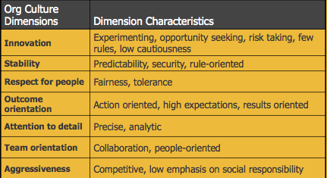
- Deciphering Culture through Artifacts (the visible/observable symbols and signs of and orgs culture)
  - Decipher org culture indirectly though artifacts (ie the way visitors are greeted)
  - Artifacts reinforce and potentially support changes to an orgs culture. (observe behaviour, note physical structure, interview staff – need tp sample info from a range of or artifacts to understand org culture)
  - Org Stories and Legends
    - Stories spread strong org culture
    - Stories serve as powerful prescriptions for the way things should and shouldn’t be done
    - Produce emotions = helps improve memory of the lesson
    - Greatest effect when they describe real people, assumed true, known by all
  - Rituals and ceremonies
    - Rituals are programmed routines of a daily organizational life that dramatize the orgs culture. (ie how visitors are greeted, how often sr execs visit subordinates, how people communicate)
    - Ceremonies are more formal artifacts than rituals. Are planned displays of org culture, conducted specifically for the benefit of the audience (ie publicly rewarding/punishing, or celebrating a launch)
  - Organizational language
    - How employees talk to each other, describe customers, express anger and greet stakeholders – all verbal symbols of cultural values
  - Physical Structures and Symbols
    - Shape, size, location and age of building reflect and influence the orgs culture
    - Can suggest the company’s emphasis on teamwork, enviro friendliness, flexibility
    - Desk, chairs, wall hangings convey cultural meaning
- Functions of a Strong Org Culture
  - Corp cultural strength refers to how widely and deeply employees hold the company’s dominant values and assumptions
    - Most employees across all subunits understand and embrace dom values
    - Values and assumptions are institutionalized through well-established artifacts- making it difficult to change culture
    - Strong cultures are long lasting
  - A strong corp culture potentially increases the company’s success by serving three important functions:
    - Control system
      - Organizational culture is a deeply embedded form of social control that influences employee decisions and behavior
      - persuasive and operates non-consciously
    - Social glue
      - organizational culture is “social glue” that bonds people together and makes them feel part of the organizational experience
      - employees are motivated to internalize the dom culture bc it fulfills need for social identity
      - Way to attract new staff and retain top performers
    - Sense making
      - Organizational culture assists the sense-making process. Helps employees understand what goes on and why
      - Easier to know what is expected and to interact with others who know/believe in culture
  - Contingencies of organizational culture and effectiveness
    - Alignment with environment
      - Organizations culture content (dominant values and assumptions) fits the external environment.
    - Avoiding a corporate cult
      - Degree of cultural strength.
      - Companies with strong cultures (corp “cults”) may be less effective than companies with moderately strong culture. Reasons Cults undermine effectiveness:
      - Strong culture locks decision makers into mental models that blind them to new opportunities and unique problems
      - They suppress dissenting subculture values- which can help in some cases by improving creative thinking and offering levels of ethical awareness over the dominant culture
    - Adaptive culture
      - A culture in which employees focus on the changing needs of customers and other stakeholders and support initiatives to keep pace with those changes
      - Have external focus, employees hold a common mental model that org success depends on continuous change
      - Employees in adaptive culture pay as much attention to org processes as they do to the goals. Engage in continuous improvement of internal processes (production, customer service)to serve external stakeholders
      - Employees have strong sense of ownership. Assume responsibility for org performance
      - Adaptive cultures are adaptive and quick, employees seek opportunities rather than wait for them to arrive.

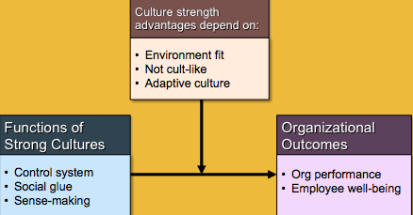
- Merging Organizational Cultures
  - Most Mergers fail partly because corporate leaders are so focuses on financial or marketing logistics of merger they fail to conduct due-diligence audits on their respective corp cultures.
  - Typically mergers suffer when orgs with significantly divergent corp cultures merge into one.
  - Bicultural audits
    - Process of diagnosing cultural relations between the companies and determining the extent to which cultural clashes will likely occur.
    - Doing a bicultural audit can minimize cultural collisions and fulfill their duty of due diligence
    - First: identifies cultural differences between merging companies
    - Second: bicultural audit data are analyzed to determine which differences will result in conflict and which cultural values provide common ground to build a cultural foundation
    - Third: Identifies strategies and preparing action plans to bridge the two organizations cultures
  - Strategies for merging cultures (4)
    - Assimilation
      - Occurs when employees at acquired company willingly embraces acquiring firms cultural values
      - Works best when the acquired firm has a weak dysfunctional culture and the acquiring company’s culture is strong ad aligned with external enviro
      - Clash is rare bc weak culture employees r looking for better cultural alternatives
      - Is rare though, often employees resist org change particularly when they are asked to throw away personal values
    - Deculturation
      - Acquiring firm imposes its culture on unwilling acquired firm
      - Acquiring firm strips away artifacts and reward systems that support old culture. Those who don’t adapt are fired
      - Necessary when acquired corp culture clashes but employees don’t see it
        - This strategy is difficult to apply effectively bc the acquired firms employees resist cultural intrusion which delays or undermines merger process
    - Integration
      - Merging companies combine the two or more cultures into a new composite culture – preserving the best features from each
      - Integration is slow & potentially risky bc many forces preserving existing cultures.
      - Should be considered then both have weak cultures or when cultures include multiple overlapping values
      - Works best when people realize that their existing cultures were ineffective- motivating them to adopt new dom values
    - Separation
      - Occurs when merging companies agree to remain distinct entities with minimal exchange of culture or organizational practices
      - Works best when the 2 firms are in unrelated industries or operate in diff countries bc the most appropriate cultural values tend to differ by industry and national culture.
      - Acquiring firm finds it difficult to keep hands off acquired firm
- Changing and Strengthening Organizational Culture (4 Strategies)
  - Changing culture is difficult, slow and can often cange/replace leaders
  - Actions of founders and leaders
    - Org culture begins with founders. Culture can reflect founders personality and can remain for decades
    - Founders often are visionaries who provide powerful role modeling for others to follow.
    - Founders can reshape culture by applying transformational leadership and organizational change practices
  - Aligning artifacts
    - More than just visible indicator of culture, also mechanisms that keep culture in place.
    - By altering artifacts or creating new ones, leaders can potentially adjust the culture
    - Eg. Moving company to knew offices that better reflect a diff culture
    - Culture can be altered or strengthened through the artifacts of stories & behaviours.
    - Leaders play a role by creating memorable events that symbolize the cultural values they want to develop/maintain
  - Culturally consistent rewards
    - Reward systems are artifacts that often have a powerful effect on strengthening or reshaping an orgs culture
  - Attracting, selecting and attrition (ASA theory)
    - ASA Theory
      - States that organizations have a natural tendency to attract, select and retain people with values and personality characteristics that are consistent with the organizations character, resulting in a more homogenous organization and a stronger culture
      - Culture is strengthened by hiring people who already embrace cultural values
    - Attraction – job applicants engage in self-selection by avoiding employment in companies whose values are incompatible with their own. Companies encourage this by actively describing culture
    - Selection – ‘best fit’ is considered in hiring. Companies with strong cultures put applicants through multiple interviews and other selection tests to gauge their values and level of congruency.
    - Attrition – people are motivated to seek out enviros that are greatly congruent with personal values and to leave enviros with a poor fit. This occurs bc person-organization values congruence supports their social identity and minimizes. Likely to quit if incompatibility is high.

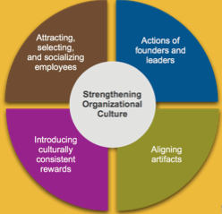
- Organizational Socialization
  - Process by which individuals learn the values, expected behaviors and social knowledge necessary to assume their roles in the organization
  - Psychological contracts (2 types)
    - individuals beliefs about the terms and conditions of a reciprocal exchange agreement between that person and another party
    - Transactional contracts
      - primarily short-term economic exchanges
      - responsibilities well defined around narrow set of obligations
    - Relational contracts
      - long-term attachments
      - Encompass a broad array of subjective mutual obligations
  - Stages of socialization
    - Stage 1: Pre employment socialization
      - Learn about the organization and job
      - Form employment relationship expectations
    - Stage 2: Encounter
      - Test expectations against perceived realities
      - Reality shock: stress that results when employees perceive discrepancies between their pre-employment expectations and on-the-job reality
    - Stage 3: Role Management
      - Strengthen work relationships
      - Practice new role behaviors
      - Resolve work – network conflicts
  - Improving the socialization process
    - Realistic job preview
      - provides applicants with a balance of positive/negative info about the job/work context

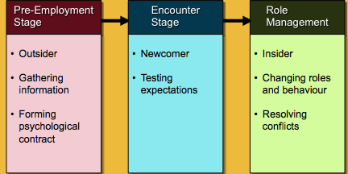

- Lewin's Force Field Analysis Model
  - Kurt Lewin’s model of system-wide change that helps change agents diagnose the forces that drive/restrain proposed organizational change
  - Driving Forces: push organizations toward a new state of affairs. Might include new competitors or technologies, evolving workforce expectations, or host of other environmental changes (external forces).
    - Corporate leaders (leaders visions) also produce these driving forces when external forces for change aren’t apparent enough.
  - Restraining Forces: maintain status quo. Commonly called ‘resistance to change’ bc they appear as: employee behaviours that block the change process
  - Stability occurs when the driving and restraining forces are roughly equal.
  - Model emphasizes that effective change occur by unfreezing the current situation, moving to desired condition, then refreezing the system so it stays at desired state
    - Unfreezing: first part of the change process whereby the change agent produces a disequilibrium between the 2 forces
    - Refreezing: later part of change process where systems and conditions are introduced that reinforce and maintain the desired behaviours

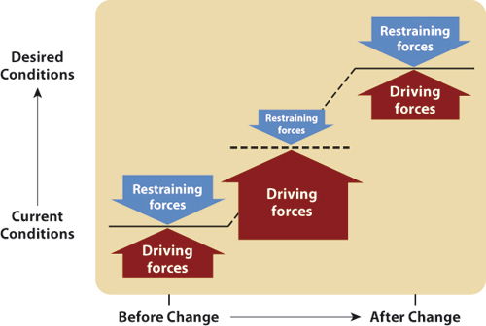
- Restraining Forces
  - Resisting to change comes in many forms (overt work shortages, subtle attempts to continue the “old ways”)
    - Eg. Complaints, absenteeism, passive noncompliance
  - Subtle resistance more common than overt but subtle creates greatest obstacle bc that re not visible
  - Resistance to change is normal human response
  - Need to see resistance to change as a resource
    - Resistance incidents are symptoms of deeper problems in the change process. They’re signals showing that change agent isn’t properly addressing underlying conditions that support effective change.
      - Employees may worry about consequences of change (power and status)
      - Employees are concerned about the process of change itself (effort needed to break old habits)
    - Should be recognized as a form of constructive conflict. This can improve decision making – better identifying ways to increase org success. Can also allow change agents the ability to improve the change strategy/process
      - Constructive conflict can be accompanied with dysfunctional relationship conflict- happens when they see change as impediment not resource.
    - Should be viewed in the context of justice and motivation. Resistance is a form of voice- so it potentially improves procedural justice
      - By redirecting initial forms of resistance into constructive convos, change agents can increase employee feelings of awareness.
      - Resistance is motivational, change agents can harness motivation to strengthen commitment to the change initiative
- Sources to Resistance
  - Reasons relate to lack of motivation – estimate negative consequences outweigh benefits
  - Inability to change due to lack of inadequate skills and knowledge
  - Lack a sufficiently clear understanding about what is expected
- Why employees resist change (6 reasons)
  - Direct Costs
    - Lack commitment to a change when personal cost-benefit calculation is negative
    - Losing something of value due to change
  - Saving Face
    - Resist change as a political strategy to “prove” decision is wrong or person enforcing change is incompetent.
    - Not-Invented-Here syndrome
  - Fear of the Unknown
    - Resist bc they worry they cannot adjust to the new requirements. Fear of unknown increased the risk of personal loss
  - Breaking Routines
    - Forcing someone out of their comfort zones and requiring them to invest time/energy in learning new role patterns
    - People like to keep things the way they are / find change to be too complicated or time wasting
  - Incongruent team dynamics
    - Conformity to existing team norms may discourage employees from accepting organizational change
    - Team norms hat are contrary to desired change need to be alteres
  - Incongruent Organizational Systems
    - Rewards, info systems, patterns of authority etc. when properly aligned they reinforce desired behaviors however when misaligned they pull people back into their old attitudes.
- Unfreezing, Changing, and Refreezing
  - Effective change occurs by unfreezing current situation, moving ot desired condition, and the refreezing the system so it remains at desired state
  - Unfreezing occurs when the driving forces are stronger than the restraining forces – happens by making the driving forces stronger and weakening or removing the restraining forces
  - Driving forces must increase enough to motivate change but cant only increase driving forces need to decrease change
- Creating an urgency for change
  - Exposing employees to external forces so they understand the reason for change
    - Environmental changes represent the driving forces that motivate people to face the risks that cage creates
  - Urgency doesn’t need to originate from problems or threats, can come from informing employees about competitors, changing consumer trends, impending gov regulations
  - Put employers in direct contact with customers bc they provide a human element that further energizes employees to change behaviour
- Creating urgency without External Factors
  - By creating a future vision of a better organization, leaders effectively make the current situation less appealing
  - Requires persuasive influence to helps employees visualize future competitive threats and environmental shifts
- Minimizing Resistance to Change
  - Communication
    - Highest priority and first strategy to change
    - Generates urgency to change
    - Reduces uncertainty (fear of unknown)
    - Problem: time consuming and costly
  - Learning
    - Provides new knowledge & skills
    - Includes coaching and other forms of learning – time consuming but
    - Helps break old routines and adopt new ones
    - Can be costly
  - Employee Involvement
    - Essential unless change must occur quickly or employee interest are highly incompatible with the orgs needs
    - Employees feel personally responsible for the success of change effort not agents of someone else’s decision
    - Helps saving face and reducing fear of unknown
    - Includes future search- system-wide groups sessions usually lasting a few days in which participants identify trends and way to adapt to those changes
    - Includes task forces
    - Problems: time consuming, can lead to conflict if too many are involved and there is limited opportunity to contribute
  - Stress MGMT
    - Org change is stressful because is threatens self-esteem and creates uncertainty of future
    - Communicating, learning and involvement are not enough to minimize stress
    - Introduce stress mgmt. practices to help cope
    - Potential benefits:
      - More motivation to change
      - Less fear of unknown
      - Fewer direct costs
    - Problems: time-consuming, expenses, doesn’t help everyone
  - Negotiation
    - If resistance to change present need influence tactics
    - Negotiation is form of influence that involves promising benefits or resources in exchange for compliance to change
    - Necessary when people may lose out from the change
    - Problems: expensive, gains compliance not commitment
  - Coercion
    - Used when all else fails
    - Includes persistently reminding people of obligations, frequently monitoring behaviour to ensure compliance, confronting those who do not change, using threats to force compliance
    - Replacing resistant staff is an extreme step
    - Replacing staff is a radical form of org “unlearning” bc you are removing knowledge
    - Problems:
      - Reduces trust
      - May create more subtle resistance
      - Encourage politics to protect job
- 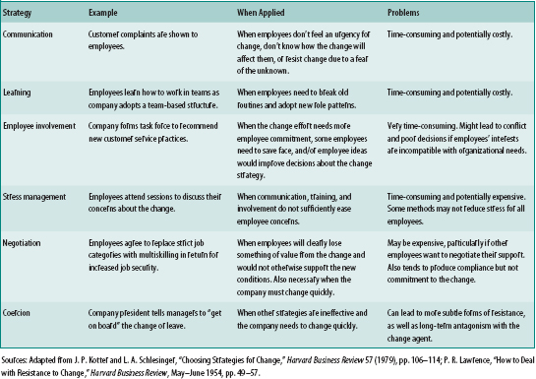
- Change Agents, Strategic Visions, and Diffusing Change
  - Change agents
    - Come in different forms and more than one person is often required to fulfill these different roles
    - Transformational leaders are the primary agents of change
      - They develop an appealing vision of the desired future state, communicate that vision in ways that are meaningful to others, make decisions and act in ways that are consistent with that vision and build commitment to that vision
    - Strategic vision – key element of change
      - provides sense of direction, establishes the critical success factors against which the real changes are evaluated
      - Provides an emotional foundation to the change because it links the individuals values and self-concept to the desired change
  - Diffusion of change
    - Motivation
      - Widely communicate celebrate the pilot project’s success
      - Reward/recognize pilot project employees as well as those who work at transferring that change to other parts of the organization
      - Ensure that managers support and reinforce the desired behaviors related to the pilots projects success
      - Identify and address potential sources of resistance to change
    - Ability
      - Give employees the opportunity to interact with and learn from those in the pilot project
      - Reassign or temporarily second some pilot project employees to other work units, where they can coach and serve as role models
      - Give employees technical training to implement practices identified in the pilot project
    - Role Perceptions
      - Communicate and support employees to discover how the pilot project practices are relevant for their own functional areas
      - Ensure that the pilot project is described in a way that is neither too specific nor too general
    - Situational Factors
      - Give staff sufficient and resources to learn and implement the pilot project practices in their work units
- Four Approaches to Organizational Change
  - Action research approach (3 steps)
    - Problem-focused change process that combines action orientation (changing attitudes and behavior) and research orientation (testing theory through data collection and analysis)
    - 1) Form client-consultant relationship
      - Consultants need to determine the clients readiness for change, including whether people are motivated to participate in the process, are open to meaningful change, and possess the abilities to complete the process
    - 2) Diagnose need for change
      - Gather data
      - Analyze data
      - Decide objectives
    - 3) Introduce intervention
      - Implement the desired incremental or quantum change
    - 4) Evaluate and stabilize change
      - Determine change effectiveness
      - Refreeze new conditions

