BCH2333 Lab

Section 14 (Thursday Afternoon Week 2)

Lab 5: Nucleic Acids

TA: Nafisa Tasnim

April 5, 2016

Team 2

Meredy Minasvand
7774955

Purpose
The purpose of this experiment is to extract the DNA from E.Coli and analyze the transformation of double stranded DNA to single stranded DNA in a stock solution of E.Coli using melting curves. A melting technique is used to obtain data for melting curves that are plotted to reflect the effects of salt at low and high concentrations on the stability of the stock commercial E.Coli. This same melting technique is used to compare the quality and homogeneity of E.Coli prepared in the lab in comparison to a commercial source of E.Coli.

R1
Ultraviolet (UV) spectrophotometry was used in the lab to asses the amount of DNA present in the samples and the degree of purity. The DNA was sample was prepared using 60mg of Escherichia coli, strain B suspended in 4mL of Standard saline-EDTA (0.15 M NaCl in 0.1M ethylene-diamine tetra-acetate EDTA, pH 8) in a 50 mL falcon tube. This was then mixed with 375µl of 25% sodium dodecyl sulfate (SDS), and intubated in a 60$℃$ water nah for 10 minutes. After it was cooled 0.725 mL of 6.0 M NaClO₄ was added and mixed before adding 5.0 mL of chloroform:isoamyl alcohol (24:1). Following gently mixing and centrifugation at 12,000 xg for 5 minutes the upper aqueous phase was removed and 10 mL of 70% ethanol was added to it in a falcon tube. 50 mL of the DNA solution is mixed with 950 mL of 15mm citrate buffer in a cuvette and this is measured at 233nm, 260nm, and 280nm. Since there is aromaticity in the purine and pyrimidine bases we expect a maximum absorbance at 260nm. Proteins absorb UV light with maximum absorbance at 280nm. The A260/A280 ratio is a function of the relative amounts of the different nucleotides in a specific DNA and is usually between 1.8 and 1.9 and a higher ratio is evidence of RNA contamination. On the other hand, Nucleic acids have an absorbance minimum at 234 nm but protein causes an increase of the absorbance at this wavelength. A A234/A260 ratio higher than 0.50 shows protein contamination. The results from these ratios help for assessing purity of DNA.

Sample Calculations (R1)

A₂₆₀/A₂₈₀ Ratio Calculations for RNA Contamination

Absorbance at 260nm = 0.340nm
Absorbance at 280nm = 0.242nm

A₂₆₀/A₂₈₀ = 0.340nm/0.242nm = 1.40

A₂₃₄/A₂₆₀ Ratio Calculations for Protein Contamination

Absorbance at 234nm = 0.308nm
Absorbance at 260nm = 0.340nm

A₂₃₄/A₂₆₀ = 0.308nm/0.340nm = 0.91

Purity of a DNA sample is dependent upon the amount of contamination present in the sample. To determine if there was contamination to the DNA products we use the calculated ratios above to determine if they fall within the ranges necessary. For the A₂₆₀/A₂₈₀ calculation the value obtained was 1.40 for the ratio. It is known that a majority of pure double-stranded DNA show a A₂₆₀/A₂₈₀ ratio and and that anything higher means that there was RNA contamination. Since the ratio calculated was less than the expected ratio it is evident that a A₂₃₄/A₂₆₀ calculation is necessary to determine if the love value for the A₂₆₀/A₂₈₀ ratio is caused by protein contamination. After the A₂₃₄/A₂₆₀ ratio calculation is completed it is evident that there was protein contamination in the DNA sample since the expected ratio is 0.50 and the calculated ratio was 0.91. Any ratio higher than 0.50 is indicative of protein contamination so we can assume contamination was present and the sample is not pure.

R2

Figure 1. Melting curve of commercial E.coli DNA with no additives present. The graph below is a melting curve with the absorbance of the DNA solution (solution A) and the derivative plotted relative to the increasing temperature. The absorbance at 260nm represents the hyperchromic shift that occurs when a double stranded DNA helix dissociates and the inflection point for the plotted derivative points helps us to gain more precise data on the exact temperature where the DNA dissociates. This temperature is referred to as the melting temperature (T_{m}). Solution A was prepared using 50µl of stock commercial E.Coli DNA and mixing it with 950µl of 15mM citrate buffer at pH 7 creating 1mL of a 1:20 dilution. This solution was then loaded into the Cary 100Bio spectrophotometer to obtain the values plotted below. Data presented came from team 2.
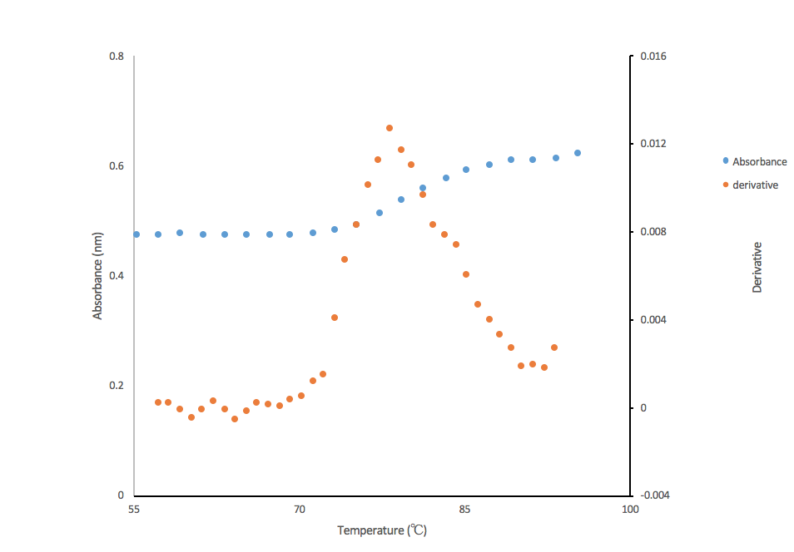

Figure 2. Melting curve of commercial E.Coli DNA with 0.03M NaClO₄ present. The graph below is a melting curve with the absorbance of the DNA solution (solution A) and the derivative plotted relative to the increasing temperature. The absorbance at 260nm represents the hyperchromic shift that occurs when a double stranded DNA helix dissociates and the inflection point for the plotted derivative points helps us to gain more precise data on the exact temperature where the DNA dissociates. This temperature is referred to as the melting temperature (T_{m}). Solution B was prepared using 50µl of stock commercial E.Coli DNA and mixing it with 950µl of 15mM citrate buffer at pH 7, and 0.03M NaClO₄ creating 1mL of a 1:20 dilution. This solution was then loaded into the Cary 100Bio spectrophotometer to obtain the values plotted below. Data presented came from team 10.

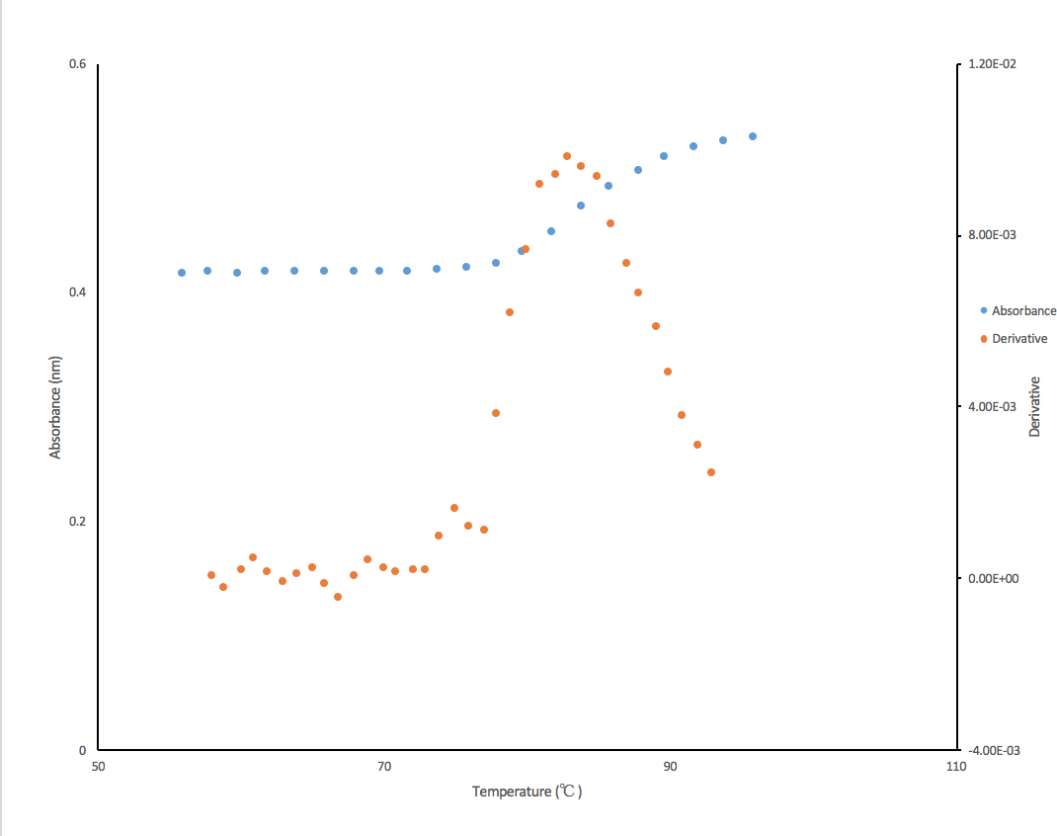

Figure 3. Melting curve of DNA with 4.75M NaClO₄ present. The graph below is a melting curve with the absorbance of the DNA solution (solution A) and the derivative plotted relative to the increasing temperature. The absorbance at 260nm represents the hyperchromic shift that occurs when a double stranded DNA helix dissociates and the inflection point for the plotted derivative points helps us to gain more precise data on the exact temperature where the DNA dissociates. This temperature is referred to as the melting temperature (T_{m}). Solution B was prepared using 50µl of stock commercial E.Coli DNA and mixing it with 950µl of 15mM citrate buffer at pH 7, and 4.75M NaClO₄ creating 1mL of a 1:20 dilution. This solution was then loaded into the Cary 100Bio spectrophotometer to obtain the values plotted below. Data presented came from team 7.

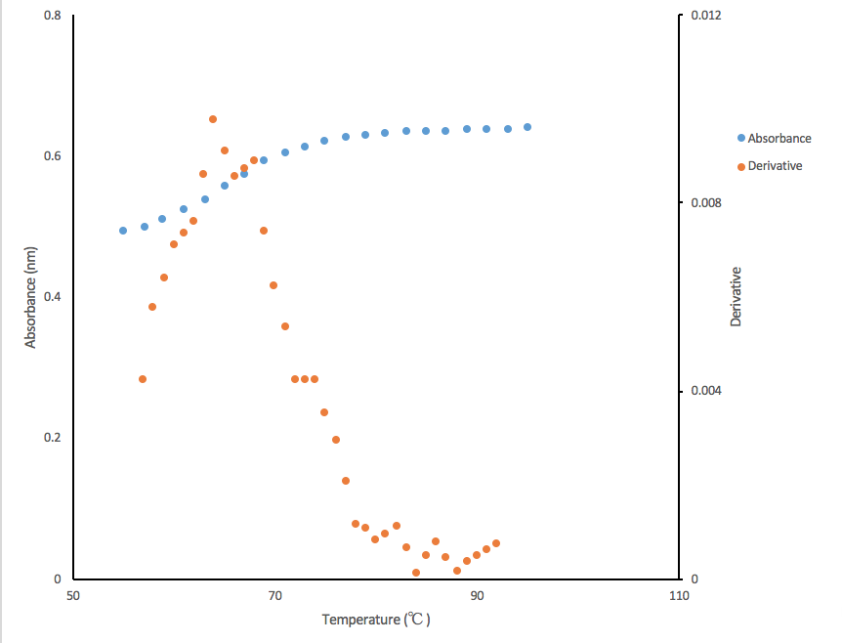

Figure 4.
The graph below is a melting curve with the absorbance of the DNA solution (solution A) and the derivative plotted relative to the increasing temperature. The absorbance at 260nm represents the hyperchromic shift that occurs when a double stranded DNA helix dissociates and the inflection point for the plotted derivative points helps us to gain more precise data on the exact temperature where the DNA dissociates. This temperature is referred to as the melting temperature (T_{m}). . The DNA was sample was prepared using 60mg of Escherichia coli, strain B suspended in 4mL of Standard saline-EDTA (0.15 M NaCl in 0.1M ethylene-diamine tetra-acetate EDTA, pH 8) in a 50 mL falcon tube. This was then mixed with 375µl of 25% sodium dodecyl sulfate (SDS), and intubated in a 60$℃$ water nah for 10 minutes. After it was cooled 0.725 mL of 6.0 M NaClO₄ was added and mixed before adding 5.0 mL of chloroform:isoamyl alcohol (24:1). Following gently mixing and centrifugation at 12,000 xg for 5 minutes the upper aqueous phase was removed and 10 mL of 70% ethanol was added to it in a falcon tube. 50 mL of the DNA solution is mixed with 950 mL of 15mm citrate buffer in a cuvette

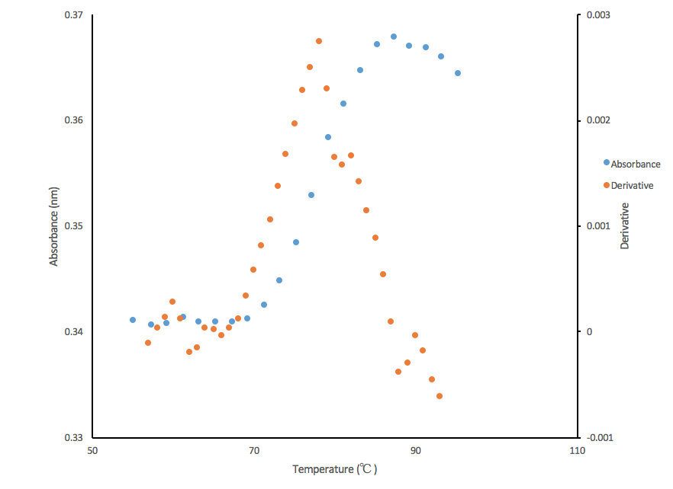

Table 1. DNA melting curve results for commercial and extracted DNA with and without NaClO₄ additives.

DNA sample | T_{m} ($℃$) | $∆$T ($℃$) | h (%) | h/$∆$T($℃$⁻¹)
a) Commercial | 78.22 | 9.95 | 16.9 | 1.70
b) Commercial + 0.03M NaclO₄ | 82.87 | 11.94 | 22.4 | 1.87
c) Commercial + 4.75M NaClO₄ | 64.02 | 10.05 | 15.6 | 1.55
d) Extracted DNA (Step 15) | 78.02 | 16 | 6.6 | 0.41

Sample Calculations

Melting Temperature Calculation

T_{m} is the temperature at which the DNA helix dissociates and there is 50% of molecules that are double stranded and 50% of molecules that are single stranded. The T_{m} is the melting temperature and is represented by the highest point on the graph. To get the values for this the max point (the largest derivative value) was used.

Temperature Change Calculation

$∆$T = T_{f} – T_{i}
T_{f} = Temperature where DNA stops denaturing

T_{i} = Temperature where DNA starts denaturing
$∆$T (solution A) = T_{f} – T_{i} = 87.22$℃$ – 77.27$℃$ = 9.95$℃$

$∆$T (solution B) = T_{f} – T_{i} = 89.66$℃$ -77.72$℃$ = 11.94$℃$

$∆$T (solution C) = T_{f} – T_{i} = 71.07$℃$ - 61.02$℃$ = 10.05$℃$

$∆$T (solution D) = T_{f} – T_{i} = 89.27$℃$ -73.27$℃$ = 16$℃$

Hyperchromicity (h%)

Solution A used as example

h% = 100 (A_{s} – A_{d})/ A_{d} = 100 ($∆$A/A_{d})
A_{d} = Absorbance of double strand
A_{s} = Absorbance of single strand

h% = 100 (0.599607825 - 0.512822509)/ 0.512822509

h% = 16.9 %

h /∆T ratio calculation
Solution A used as example
h = Hyperchromocity (h%)
$∆$T = Temperature Change

*both calculated above

h /∆T = 16.9%/ 9.95

h /∆T ratio = 1.70 $℃$⁻¹

R3
The melting temperature T_{m} for the commercial DNA containing the highest molarity (4.75M) of NaClO₄ is the lowest at 64.02$℃$ and highest for the DNA containing the lower molarity of NaClO₄ (0.03M). It is evident with these results that when the strength of Na⁺ present is greater than 0.03M the melting temperature is reduced, and this occurs because the higher salt concentration will shield the negative phosphates on the DNA molecule and this eliminates the repulsion forces between the two antiparallel strands decreasing stability. T_{m} is midpoint of the melting curve when there is 50% single and 50% double strands left. The reduction in stability allows the molecule to go through the denaturation/renaturation process faster, therefore at a lower temperature decreasing T_{m}.

R4
The h /∆T ratio represents pure and intact DNA and it usually means that the graph displays a steep melting curve. All of the ratios are above 1, almost at around 2 except for solution d which is the extracted DNA which is 0.41. This means that the DNA is not as pure for the extracted DNA since above we calculated that there was protein contamination making it less pure. It is also evident that al the DNA is impure slightly because the hypechromicity is less than 40% but the lowest is the extracted DNA (solution d).

R5
Figure 5. Agarose gel electrophoresis of DNA. A 100mL of a 1% (w/v) agarose solution in TAE (40mM tris-acetate, 1.0mM EDTA) buffer was heated in the microwave. It is then cooled to 50-55$℃$ and 10µl of SyBr Safe DNA stain before being poured into the try. The MassRuler Express Forward DNA ladder is constituted of 12 DNA fragment varying in size from 100 base pairs (bp) to 10,000 bp

EcoRi
300
200
500
700
1500
1000
2000
5000
3000
10 000
Team 2
control
10 000

Table 2. Mobility and weight of molecular markers on agarose gel. The mobility was obtained from measuring the distance from the base of the gel to each DNA marker.
Mobility (cm) | Log(bp)
3.1 | 4
3.4 | 3.845
3.9 | 3.700
4.8 | 3.477
5.6 | 3.301
6.3 | 3.176
7.3 | 3
8.1 | 2.845
8.8 | 2.700
9.8 | 2.477
10.4 | 2.301
2

Figure 6. Log molecular weight (bp) plotted against migration distance for all bands from gel electrophoresis.


