Lab 3: Muscle Physiology and Electromyogram (EMG) Activity

Danny Aboujamra
March 6th, 2016
L20
Dr. Graham Scott
Abstract
The integral of the EMG values recorded from motor units during forearm muscle contraction are directly proportional to the integral of the force values with slight discrepancies, due to the fatigue effect. The dominant and non-dominant forearms differ in strength and force potential due to the circumference values of the circumference values also have a positive correlation with the maximum force. The time it takes to 50% of the maximum value, fatigue, is directly proportional to the circumference of the forearms. The circumference of the forearm influences the diameter of each muscle fibre physiologically associated with them. The antagonistic muscles, biceps and triceps, contracted show counteractive EMG activity, related to tension.

Introduction
Motor neurons and muscle fibres make up the corresponding motor units that counterpart to contract muscles in the body. The muscles of interest are the forearm in the dominant and non-dominant arm as well as the bicep and tricep in the left arm. The force of muscle contraction is dependant on the amount of active motor units in the muscles of interest. Physiologically, the size of the muscles is directly proportional to the amount of active motor units that can be present in the muscles. An electromyography (EMG) is a procedure that assesses the synaptic transmissions from the motor neurons by recording spike-like signals on a graph. The electrical activity in the muscle is caused by the changes in membrane potential. The duration of the spike-like signals found on the EMG graph are equivalent to the duration of the corresponding muscle contractions. Prolonged EMG signals determine the rate of fatigue, half of the maximum force, for the muscles of interest in the dominant and non-dominant arm.
Methods
Please refer to the Biology 2A03 laboratory manual for detailed methods and materials (Muscle Physiology and Electromyogram (EMG) Activity, 2016).
Results
The integral, absolute area under the recorded spikes, of the EMG values were plotted against the integral of the force values for the four increasing clenches with an overall positive correlation for both the dominant and non-dominant forearms (Fig. 1). The slope for the dominant forearm trend line, 0.0258, was relatively greater than the slope for the non-dominant forearm trend line, 0.0105. The integral of the force values increased 28.4 fold between the integral of the EMG values, 2.739 and 11.184. Discrepancies were shown with regards to the overall positive correlation, at the third plotted value (8.349, 0.029) for the dominant arm (R²=0.63706) and at the second plotted value (6.238, 0.014) for the non-dominant arm (R²=0.87321).
Figure 1: The integral of EMG values versus the integral of force values for the recorded four increasing dominant and non-dominant forearm clenches.
The maximum force values were plotted against the dominant and non-dominant forearm circumference values in the lab section (Fig. 2). A positive correlation between the dominant and non-dominant maximum force values and circumference values were shown in Figure 2. The slope of the dominant forearm trend line, 3.0545, was relatively greater than the slope of the non-dominant forearm trend line, 2.5983. The R² value for the dominant and non-dominant forearm, respectively, was 0.34211 and 0.25842. The greatest value for the dominant forearm circumference, 31 cm, corresponded to the greatest value for the maximum force, 60 kg. The greatest value of the maximum force for the non-dominant forearm, with a circumference of 29.5 cm, was 46.725 kg.
In the lab section, the dominant and non-dominant forearm circumference values were plotted against the values for the time until fatigue (Fig. 3). A positive correlation between the values of forearm circumference and time to fatigue were shown. The slope of the dominant forearm trend line, 2.4464, was relatively greater than the slope of the non-dominant forearm trend line, 1.9811. The R² value for the dominant forearm and non-dominant forearm were, respectively, 0.04991 and 0.1192.
Figure 3: Dominant and non-dominant circumference values versus the time to fatigue, 50% maximum force, clenched by all subjects in the lab section.
Figure 2: Dominant and non-dominant forearm circumference values versus the maximum force clenched by all subjects in the lab section.
The non-dominant forearm for an individual subject had a relatively longer time to fatigue and a greater value for maximum force than the dominant forearm (Table 1). The time to fatigue recorded for the dominant and non-dominant forearm were, respectively, 92 seconds and 30.74 seconds. The maximum force shown for the non-dominant forearm was 36.91 kg and 32.5 kg for the dominant forearm. The circumferences for the non-dominant and dominant forearms were almost equal, 26.67 and 26.5 cm, respectively.
Table 1: Individual subject’s dominant and non-dominant forearm values for: time to fatigue, forearm circumference and maximum force.

The EMG anterior values ranged from -5 to 4 mV and from -1.4 to 1.9 mV for the EMG posterior values (Fig. 4). The interval of the five arm bends with a weight was between the time values 7 seconds and 11 seconds. The maximum EMG anterior value, 4mV, occurred at t=10 seconds, where the EMG posterior value was 0.8 mV. The maximum EMG posterior value, 1.9 mV, occurred at t=11 seconds, where the EMG anterior value was 2 mV.

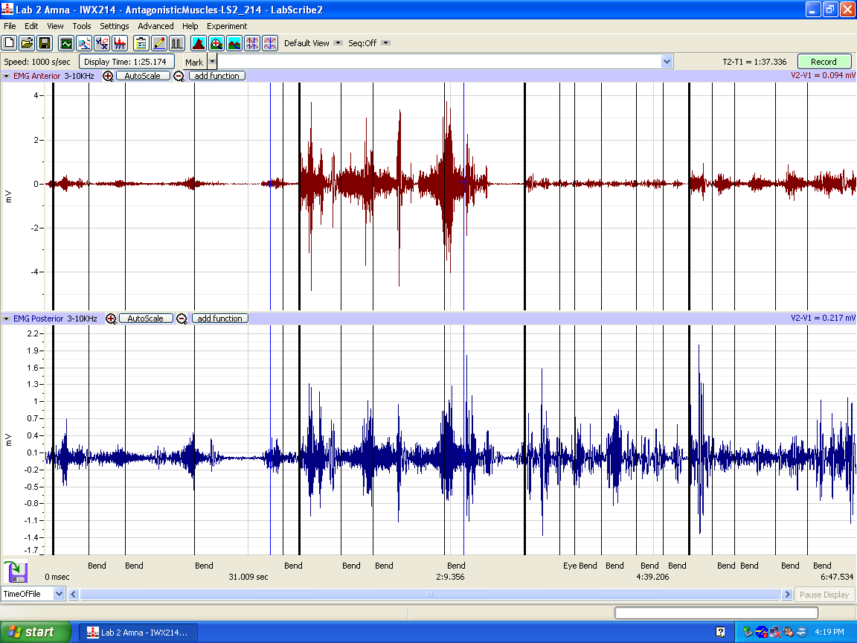
Discussion
Figure 4: EMG activity (mV) in antagonistic muscles, anterior and posterior, during five arm bends with a weight.
There is an overall positive correlation between the area under the EMG trace for each clench and the force of the clench, however, not a perfectly linear relationship. For example, there is an uncorrelated drop in force integral values between 0.133 and 0.029 for the dominant forearm in Figure 1. Along with the dominant forearm, the non-dominant forearm also has a positive correlation with a linear discrepancy between the force integral values 0.03 and 0.014 (Fig. 1).
The discrepancy may be related to the inconsistency of unilateral fatiguing effects in motor neurons, leading to a reduction in force. As fatigue progresses, the rate of motor neurons reduce, which in turn reduces the number of available action potentials for the forearm muscles, leading to a reduction in force output. Conversely, muscles may often also continue generating action potentials due to neural drive; however, the muscle is unable to contract due to molecular fatigue events in the muscle fibres, which also leads to a reduction in force output.
The dominant forearm has a relatively greater ratio of grip strength to EMG signal than the non-dominant forearm. The difference in forearm strength is due to the positive correlation between the forearm circumference and maximum force. As the dominant forearm has a slightly greater circumference, 26.67 cm, relative to the non-dominant forearm, 26.5 cm (Table 1). The difference in circumference between the dominant and non-dominant forearm is likely caused by the diameter of each muscle fibre rather than the total number of muscle fibres in the forearm. The total number of muscle fibres in the right forearm is equivalent to that of the left.
The number of motor units recruited and the number of times each unit is stimulated is directly proportional to the amplitude and duration of the EMG signal and of muscle contraction. Starting with the smallest motor units, progressively larger units are recruited with increasing strength of muscle contraction. The result is an orderly addition of sequentially larger and stronger motor units resulting in a smooth increase in muscle strength. This orderly recruitment of sequentially larger motor units is referred to as the "Henneman size principle", or simply "size principle."² Recording from the ventral rootlets in cats and measuring the amplitudes of motor axon spikes, Henneman et al concluded that motor axon diameter, conduction velocity and, by further inference, motor neuron cell size all increase with functional threshold.²
The myoelectric signals that are emitted from an active muscle contain information about the muscle fibre types that generated the signal. When a muscle is active, the faster fibres generate higher frequencies within the myoelectric spectra than slow fibres and distinct high- and low-frequency bands have recently been identified that characterize activity from faster and slower fibres, respectively, in the rainbow trout, cat, rat and in man⁵.
During the bicep curl, the anterior EMG value is increasing when the arm is raised while the corresponding posterior EMG value is decreasing. This inverse relation is evident with the values of the graph in Figure 4. These nerves carry impulses to and from the brain and control conscious movement; when moving a muscle in an arm, leg or other part of the body the nerve impulses for movement are carried to both the primary muscles involved in the movement and the antagonistic muscles that counter them. Nerve synapses decide the number of muscle fibres that contract and to the degree they contract, restricting motion.
The EMG activity of voluntary muscle contractions is related to tension. This tension is the reason why the EMG signal might change if the load being lifted is constant. The unit of the muscle contraction is a motor unit, which is comprised of a single alpha motor neuron and all the fibres it enervates. This muscle fibre contracts when the action potentials (impulse) of the motor nerve which supplies it reaches a depolarization threshold.

Work Cited

Gordon T, Thomas CK, Munson JB, Stein RB. (2004) The resilience of the size principle in the organization of motor unit properties in normal and reinnervated adult skeletal muscles. Canadian Journal of Physiology and Pharmacology 82(8- 9):645-61.¹

Henneman E, Somjen G, Carpenter D. O. (1965). Functional Significance of cell size in spinal motoneurons. Journal of Neurophysiology 28:560-80.²

Hodson-Tole EF, Wakeling JM. (2009). Motor unit recruitment for dynamic tasks: current understanding and future directions. Journal of Comparative Physiology B. Jan. 179(1):57-66.³

Kawamoto, J., Aboodarda, S. J., Behm, D.G., et al. (2014). Effect of differing intensities of fatiguing dynamic contractions on contralateral homologous muscle performance. Journal of Sports Science & Medicine. 13(4): 836–845.⁴

Wakeling J.M (2004) Motor units are recruited in a task dependent fashion during locomotion. Journal of Experimental Biology. 207, 3883–3890.⁵

