Optional Assignment: Dietary analysis

NAME: Danny Aboujamra
DATE: April 1st, 2016 (Day 1)
TIME/MEAL | ITEM | AMOUNT | FOOD GUIDE SERVING | NUTRIENT INFORMATION
8 am  (Meal 1) | Honey  Nut Cheerios  (Whole Grain Oats) | 1 cup (28 g) | 1 Grain Product | - Total fat 1.9 g (17.1 kcal)  - Saturated fat 0.4 g  - Polyunsaturated fat 0.7 g  - Monounsaturated fat 0.7 g  - Sodium 161.3 mg  - Potassium 179.5 mg  - Carb 21 g (84 kcal)  - Fibre 2.6 g  - Sugar 1.2 g  - Protein 3.4 g (13.6 kcal)  - Thiamin 0.375 mg  - Folate 200 µg  - Vitamin B12 1.5 µg  - Vitamin D 40 IU  - Calcium 100 mg  - Iron 8.1 mg
8 am  (Meal 1) | 2% Whole Milk | 125 ml | 1 Milk & Alternatives | - Total fat 2.54 g (22.86 kcal)  - Saturated fat 1.62 g  - Polyunsaturated fat 0.094 g  - Monounsaturated fat 0.722 g  - Cholesterol 10 mg  - Sodium 53 mg  - Potassium 193 mg  - Carb 6.03 g (24.12 kcal)  - Sugar 6.52 g  - Protein 4.25 g (17 kcal)  - Thiamin 0.12 mg  - Folate 12 µg  - Vitamin B12 2.8 µg  - Vitamin D 210 IU  - Calcium 285 mg  - Iron 0.162 mg
10 am | Water | 2 cups (470 ml) | N/A | N/A
1:30 pm  (Meal 2) | Swiss Chalet: Quarter Chicken (white meat w/ skin) | 156 g | 1 Meat  & Alternatives | - Total fat 11 g (99 kcal)  - Saturated fat 3.5 g  - Trans fat 0.1 g  - Cholesterol 140 mg  - Sodium 330 mg  - Fibre 1 g  - Protein 48 g (192 kcal)
1:30 pm  (Meal 2) | Tropicana: Orange Juice | 10 oz (284 g) | 1 Vegetables & Fruit | - Potassium 533.92 mg  - Carb 30.7 g (122.8 kcal)  - Sugar 26.1 g  - Protein 2.3 g (9.2 kcal)
3:30 pm | Water | 1 cup (235 ml) | N/A | N/A
6:00 pm | Water | 1 cup (235 ml) | N/A | N/A
7:00 pm  (Meal 3) | Spaghetti & Tomato Sauce (1 tbsp. olive oil, 2 garlic cloves, tomatoes, 1 tbsp. tomato paste, 1/3 cup parsley, ½ tbsp. sugar, 1 cup spaghetti) | 1 cup (200 g) | -1 Grain Product  -4 Vegetables & Fruit | - Total fat 3.99 g (35.91 kcal)  - Saturated fat 0.61 g  - Polyunsaturated fat 1.527 g  - Monounsaturated fat 1.064 g  - Sodium 563 mg  - Potassium 498 mg  - Carb 53.62 g (214.48 kcal)  - Fibre 2.7 g  - Sugar 11.14 g  - Protein 9.87 g (39.48 kcal)
7:00 pm  (Meal 3) | Canada Dry: Ginger Ale | 355 ml | N/A | - Sodium 50 mg  - Carb 32 g (128 kcal)  - Sugar 32 g
9:00 pm | Water | 1 cup (235 ml) | N/A | N/A
11:30 pm | Water | 1 cup (235 ml) | N/A | N/A

NAME: Danny Aboujamra
DATE: April 2nd, 2016 (Day 2)
TIME/MEAL | ITEM | AMOUNT | FOOD GUIDE SERVING | NUTRIENT INFORMATION
10 am  (Meal 1) | Bacon & Egg Sandwich (2 pieces of bacon, 2 eggs, 2 pieces of toast) | 224 g | -1 Grain Products  -2 Meat & Alternatives | - Total fat 35.5 g (319 kcal)  - Saturated fat 7.6 g  - Sodium 983 mg  - Carb 34.4 g (137.6 kcal)  - Fibre 5.8 g  - Sugar 1.3 g  - Protein 27 g (108 kcal)
10 am  (Meal 1) | Tropicana: Orange Juice | 10 oz (284 g) | 1 Vegetables & Fruit | - Potassium 533.92 mg  - Carb 30.7 g (122.8 kcal)  - Sugar 26.1 g  - Protein 2.3 g (9.2 kcal)
10 am  (Meal 1) | Whole Avocado (Medium) | 145 g | 1 Vegetables and Fruit | - Total fat 8 g (72 kcal)  - Saturated 2g  - Polyunsaturated 3 g  - Monounsaturated 2 g  - Cholesterol 10 mg  - Sodium 870 mg  - Potassium 65 mg  - Carb 9 g (36 kcal)  - Sugar 1 g  - Protein 2g (8 kcal)
11 am | Water | 1 cup (235 ml) | N/A | N/A
2 pm  (Meal 2) | McDonalds: Big Mac Meal (Medium) | 363 g | -3 Vegetable & Fruit  -1 Meat & Alternatives  -1 Grain Product | - Total fat 40 g (360 kcal)  - Saturated fat 10 g  - Sodium 2600 mg  - Carb 123 g (492 kcal)  - Fibre 10 g  - Sugar 51 g  - Protein 33 g (132 kcal)
4 pm | Water | 2 cup (470 ml) | N/A | N/A
6 pm | Water | 1 cup (235 ml) | N/A | N/A
8 pm  (Meal 3) | Stir fry (2 tbsp. vegetable oil, 1 clove garlic, 1 red chilli, 3 spring onion, 3 mushrooms, 1 green cabbage, sea salt, 2 tbsp. soy sauce, sesame seeds, ground black pepper, noodles) | 1 cup (240 ml) | -5 Vegetable and Fruit  -1 Grain Product | - Total fat 8 g (72 kcal)  - Saturated fat 5 g  - Monounsaturated fat 1 g  - Sodium 50 mg  - Carb 2 g (8 kcal)  - Sugar 3 g  - Protein 4 g (16 kcal)
8 pm | Water | 2 cups (470 ml) | N/A | N/A
11 pm | Water | 1 cup (235 ml) | N/A | N/A

NAME: Danny Aboujamra
DATE: April 3rd, 2016 (Day 3)
TIME/MEAL | ITEM | AMOUNT | FOOD GUIDE SERVING | NUTRIENT INFORMATION
9:30 am  (Meal 1) | Pita Bread & Cheddar Cheese | 155 g | -1 Grain Product  -1 Milk & Alternatives | - Total fat 23 g (207 kcal)  - Carb 88 g (352 kcal)  - Fibre 5 g  - Sugar 28 g  - Protein 11 g (44 kcal)
9:30 am  (Meal 1) | Earl Grey’s Tea w/ 1 tbsp. sugar | 1 cup (235 ml) | N/A | - Total fat 5 g (45 kcal)  - Polyunsaturated fat 1 g  - Monounsaturated fat 1 g  - Cholesterol 188 mg  - Sodium 3591 mg  - Potassium 3464 mg  - Carb 167 g (668 kcal)  - Fibre 45 g  - Sugar 19 g  - Protein 120 g (480 kcal)
2:30 pm  (Meal 2) | Bourbon St. Grill: Noodles | 10 oz. | 1 Grain Product | - Total fat 1 g (9 kcal)  - Sodium 61 mg  - Potassium 808 mg  - Carb 19 g (76 kcal)  - Fibre 8 g  - Sugar 3 g  - Protein 7 g (28 kcal)
2:30 pm  (Meal 2) | Bourbon St. Grill: Mixed Vegetables | 6 oz | 1 Vegetables & Fruit | - Total fat 5 g (45 kcal)  - Sodium 97 mg  - Potassium 174 mg  - Carb 15 g (60 kcal)  - Sugar 15 g
2:30 pm  (Meal 2) | Bourbon St. Grill: Bourbon Chicken | 6 oz | 1 Meat & Alternatives | - Total fat 2 g (18 kcal)  - Saturated 1 g  - Polyunsaturated 1 g  - Monounsaturated 1 g  - Sodium 23 mg  - Carb 4 g (16 kcal)  - Sugar 4 g
2:30 pm  (Meal 2) | Nestea: Iced Tea Lemon | 8 fl oz | N/A | - Total fat 12 g (108 kcal)  - Saturated 4 g  - Cholesterol 60 mg  - Sodium 885 mg  - Potassium 157 mg  - Carb 1 g (4 kcal)  - Protein 19 g (76 kcal)
4 pm | Water | 1 cup (235 ml) | N/A | N/A
6 pm | Water | 1 cup (235 ml) | N/A | N/A
9 pm  (Meal 3) | 2 Stuffed Zucchini- Beef (2 large zucchinis, 1 ½ pounds beef, 10.75 ounce can condensed tomato soup, 10.75 ounces can water, 1 small yellow bell pepper, 1 egg, 1 tbsp. Italian seasoning, ½ tbsp. garlic powder, 1 cup Italian cheese) | 205 g | -3 Vegetables and Fruit  -2 Meat & Alternatives  -1 Milk & Alternatives | - Total fat 374 g (3366 kcal)  - Saturated fat 246 g  - Cholesterol 1844 mg  - Sodium 3802 mg  - Potassium 635 mg  - Carb 397 g (1588 kcal)  - Sugar 375 g  - Protein 91 g (364 kcal)
9 pm  (Meal 3) | Diet Coke | 12 fl oz | N/A | - Sodium 40 mg

Danny Aboujamra
Personal DRI Goal Values
Name: Danny Aboujamra
Student Number: 1419302
I am (male/female): Male
My age is: 19
The following values should be collected from the DRI tables inside the cover of the Understanding Nutrition (First Canadian Edition) textbook, reflecting your gender and age as indicated above.
DRI group | DRI type | Personal Goal Value
Macronutrients | EER (kcal/day) | 3000
 | Carbohydrate RDA (g/day) | 300
 | Total fibre AI (g/day) | 24
 | Total fat (g/day)* | 91.7
 | Protein RDA (g/day) | 55
 | Water AI (L/day) | 3.7
Micronutrients | Thiamin RDA (mg/day) (B1) | 1.2
 | Folate RDA (μg/day) | 400
 | Vitamin B12 RDA (μg/day) | 2.4
 | Vitamin D RDA (μg/day) | 15
 | Sodium AI (mg/day) | 1500
 | Calcium RDA (mg/day) | 1000
 | Iron RDA (mg/day) | 16.3
 | Potassium AI (mg/day) | 3800
* Health Canada suggests a diet that is low in saturated fat, trans fat, and cholesterol and provides 20-35% of the daily energy intake from fat (see page 150 in the textbook for more details). Your total fat goal in g/day is calculated from your desired % energy from fat (choose between 20 to 35%):
27.5% fat ÷ 100 x 3000 kcal EER (from above) ÷ 9 kcal/g of fat = 91.7 g/day total fat.

Critique

There are a total of 5 servings of vegetables and fruit on day 1, 10 servings on day 2 and 4 servings on day 3. The target for vegetables and fruit for “My Food Guide” is 10 servings. There is a deficit in the recommended vegetables and fruit servings on day 1 and day 2. There are a total of 2 servings of grain products on day 1, 3 servings on day 2 and 2 servings on day 3. The target for grain products for “My Food Guide” is 8 servings. There is a large deficit in the recommended grain product servings on all three days. There are a total of 2 servings of milk and alternatives on day 1, 0 servings on day 2 and 2 servings on day 3. The target for milk and alternatives for “My Food Guide” is 2 servings. There is a deficit in the recommended milk and alternatives servings on day 2, due to no intake of dairy products. There is a total of 1 serving of meat and alternatives on day 1, 1 serving on day 2 and 3 servings on day 3. There is a deficit in the recommended meat and alternatives servings on day 1 and day 2. To be closer to a healthier diet, an increase amount for each food guide serving is required, specifically grain products (e.x. cracker snacks, cake, popcorn).

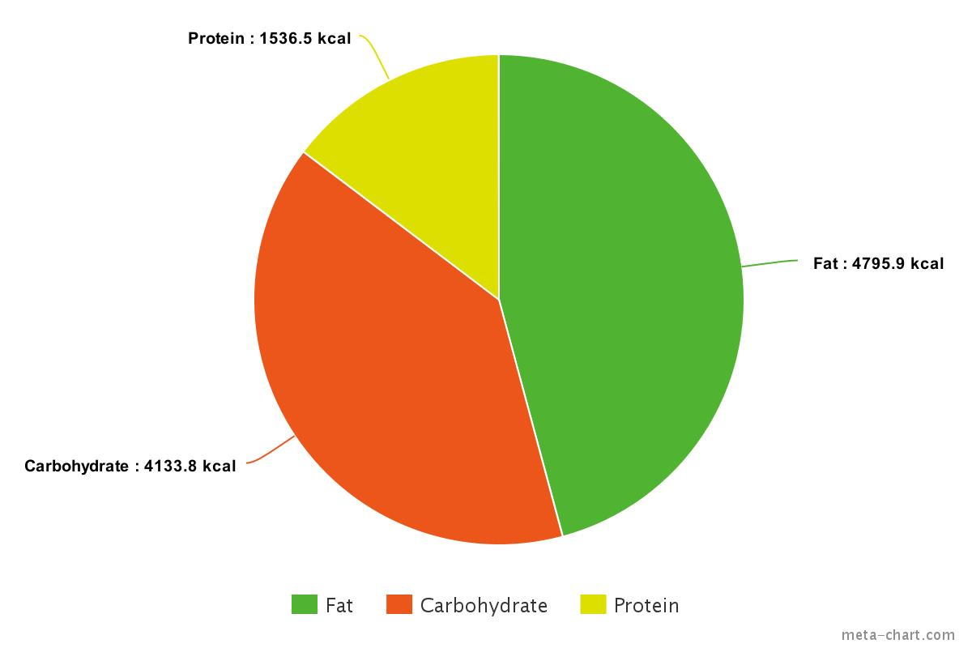
The macronutrient and micronutrient content are accessible through the nutritional facts information found on the product or online and the values for each food item are shown on the 3-day record chart, in the nutritional information column. Most of the micronutrient content, those shown in the table of Personal DRI Goal Values, is presented as a daily value percentage that is calculated by dividing the amount of the nutrient in a serving size by its daily value then multiplying that by 100. Thus, multiplying the daily value percentage, divided by 100, by the daily value for the micronutrient, calculates the content in mass. For example, in Honey Nut Cheerios, the daily value percentage for thiamin, 0.25, is multiplied by the daily value of thiamin, 1.5 mg, resulting in 0.375 mg. The total energy consumed, for macronutrients, is 1019.5 kcal (230.6 g) on day 1, 1892.6 kcal (358.9 g) on day 2 and 7554 kcal (1361 g) on day 3. The average food intake data over the three days, for macronutrients, is 1950.5 g (3488.7 kcal). The recommended AMDR is consistent with the protein energy (15%) but not with the fat (46%) or carbohydrate (39%) energy. The fat energy is too high, whereas the carbohydrate energy is too low, when compared to the AMDR. Thus, dietary changes such as adjusting intake for lower fat and higher carbohydrate foods will result in a healthier diet.

The first form of diet analysis followed a food guide serving criteria, based on the 4 different food categories. Whereas, the second form of diet analysis followed a nutrient content criteria, based on energy and mass of foods. There was a discrepancy regarding energy densities in different foods. For example, the McDonalds Big Mac has a small amount of food servings relative to the stir-fry and Swiss Chalet together but still has a higher value of fat energy. Canada’s Food Guide recommendations are helpful to guide one to a generally healthier diet; however, it is not completely sufficient in ensuring a diet with no nutrient deficiencies. This is because Canada’s Food Guide bases its recommendations on the amount of food guide servings and not the energy densities for nutrients accommodated with varying foods.

