1. (10 marks) Consider both aspects of control (negative and positive) of the lac operon.
Note: IPTG (isopropyl β-D-1-thiogalactopyranoside) is a fortuitous inducer that does not require the LacY the lactose permease to enter the cell.
Also, assume transcription of the lac operon by RNA polymerase is highly dependent upon the catabolite activator protein and that the binding site for CAP-cAMP (the lac operon’s transcription activator binding site) is designated “Ac”. By convention only mutated activator (Ac), operator (O) and promoter (P) elements, and genes (cap, lacZ or lacY) elements of genes are indicated.

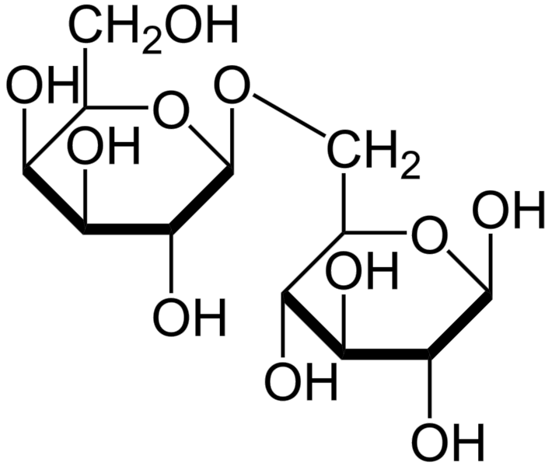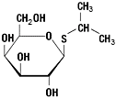

IPTG Allolactose

How much ß-galactosidase would you expect (please give estimates) each of the following strains to express in minimal medium with the carbon sources and IPTG as indicated in the four columns? The amount of ß-galactosidase activity is is give in units of activity per ml of cells from a growing culture with 5 X 108 cells per ml. Note: for cases where the cells are unable to grow or would grow very poorly inset "NG" for no growth into the table.

Strain genotype | glycerol | glucose | lactose | glycerol and IPTG
Wild type | 0.7 units | 0.35 units | 1200 units | 1200 units
I- | 1200 | > 0.35 to 2 | 1200 | 1200
Oc | 1200 | > 0.35 to 2 | 1200 | 1200
P- (promoter mutation reducing similarity to the E. coli promoter consensus sequence | < 0.7 | < 0.35 | 0 to 100 (poor or no growth) | 0 to 100
Is | 0.7 | 0.35 | NG | 0.7

Is Oc | 1200 | > 0.35 to 2 | 1200 | 1200
Cap- | 0.35 | 0.35 | NG | 0.35 to 25
Ac- | 0.35 | 0.35 | NG | 0.35 to 25
Pu (promoter mutated to match the E. coli promoter consensus sequence) | >0.7 | 0.7 | 1200 | 1200
Cap- Pu | 0.7 | > 0.7 to 2 | 1200 | 1200
I+/ I-d (merodiploid with two copies  of the lac operon one copy has a wild type, I+ lac repressor gene the other  an I-d repressor gene | 1200 | 0.7 | 1200 | 1200
I+ / Is (merodiploid with two copies of the lac operon) | 0.7 | 0.35 | NG | 0.7
Oc Z-/ Is (merodiploid with two copies of the lac operon) | 0.7 | 0.35 | NG | 0.7
Z- / Y- (merodiploid with two copies of the lac operon) | 0.7 | 0.35 | 1200 | 1200
Z- / Is Ac- Oc Y- (merodiploid with two copies of the lac operon) | 0.7 | > 0.35 to 2 | > 0.35 to 2 poor growth or no growth | > 0.35 to 2

2. (10 marks) The tryptophan operon of a recently discovered strain of Escherichia coli is subject to regulation by attenuation (20-fold) and transcriptional control (50-fold). The chloramphenicol acetyl transferase (cat) reporter gene shown in the figure below was cloned into a plasmid vector and the plasmid transformed into the recently discovered E. coli strain. The transformed strain expresses about 500 units of chloramphenicol acetyl transferase during
growth in medium without tryptophan.

Figure of reporter gene:

trp promoter operator

cat reporter gene

trp leader region

How much cat activity will the combinations of E. coli strains and mutated reporter genes express under the growth conditions indicated?
Note: The trpR- mutation behaves as if no tryptophan aporepressor protein is produced and the trpRS mutation is an active repressor even in the absence of tryptophan.

Genotype of E. coli strain | trp-cat reporter gene plasmid | Relative levels of chloramphenicol acetyl transferase activity
Genotype of E. coli strain | trp-cat reporter gene plasmid | Minimal medium with no tryptophan | Minimal medium with tryptophan
Wild type | plasmid as shown above | 3000 | 3
Wild type | plasmid with the entire leader region deleted | 3000 | 60
Wild type | plasmid with region 1 deleted | 3000 | 60
Wild type | plasmid with glycine codons replacing the two tryptophan codons of the leader peptide | 3000 | 60
trpR- | plasmid as shown above | 3000 | 150
Wild type | plasmid with a trp Oc mutation | 3000 | 150
trpR- | plasmid with a trp Oc mutation | 3000 | 150
Wild type | Plasmid with leader region 3 deleted | 3000 | 60
trpRs | plasmid as shown above | 60 | 3
Wild type | plasmid with 4 tryptophan codons in place of the two tryptophan codons (assume that the ability of the leader region to form 1-2, 2-3 and 3-4 stem loops is not  affected) | > 3000 to 6000 | 3 to 6

Wild type | plasmid with the region of the leader region just downstream of region 4 (containing the series of template A residues) deleted | 3000 | 60

3. (10 marks) For the following three growth conditions. Draw the regulatory region of the lac operon including the activator (Ac) site , the promoter (P) and the operator (O) and the proteins that would be able to bind including RNA polymerase, the transcription activator protein (Cap- cAMP) and the lac represssor protein (I). Note: If RNA polymerase is recruited to the promoter assume it is present at the closed promoter complex step in its promoter binding cycle.

i) media with glucose as the carbon source

I

Ac P O

ii) media with glycerol as the carbon source
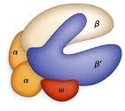Note: the the dot represents cAMP bound to Cap which is bound to the Ac site. RNA polymerase with sigma (not shown) can therefore with the help of Cap-cAMP bind to the promoter -10 -35 elements; however, transcription by RNA pol is blocked by lac repressor bound to the operator site.

I

Ac P O

iii) media glycerol as the carbon source and IPTG.
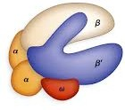Note: the the dot represents cAMP bound to Cap which can in this form bind to the Ac site. RNA polymerase with sigma (not shown) can therefore with the help of Cap-cAMP bind to the promoter -10 -35 elements.

4

Ac P O

