PSYC 3495 : Neuroscience of Aging and Cognitive Health Lecture 4, January 28, 2016
Attention & Memory (Part I)
Neurocognitive Aging: A quick Review

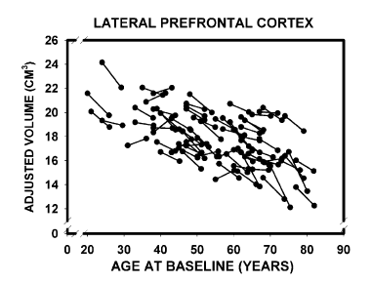 | 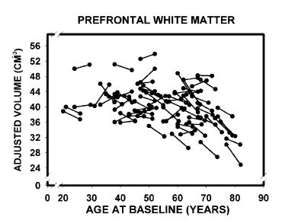

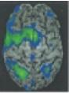 | 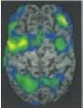
Young | Old

The Meaning of this Chart
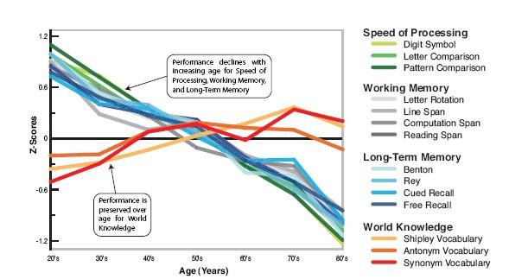

Neurocognitive aging: a quick Review
REVIEW: Human cognitive aging: Corriger la fortune? By: Ulman Lindenberger
(Science 31 Oct 2014: Vol. 346, Issue 6209, pp. 572-578 DOI: 10.1126/science.1254403)

What does this picture mean?

- This very important Image!
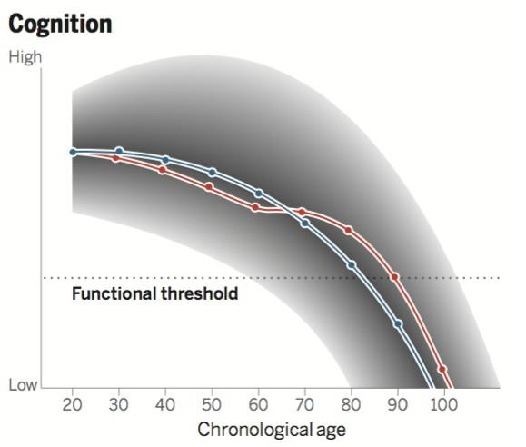
- Grey area is variability
- What is the feature of that Grey area?
  - there is more variability early in life
- The probability map of trajectory: (The lines on the grey area)
  - The Blue lines represent: The most likely path of cognitive aging
  - The Red line represents: The hope that you can improve your cognitive aging
    - There are things you can do to modify yourself to go to the better path of cognitive aging, For example:
      - Exercise
      - Social interactions
      - Meditation
      - Controlling your tension
      - Stress deduction
      - Diet (The impact of diet)
      - Reduce salt intake, avoid obesity, or high blood pressure
  - The “Functional Threshold” in the chart is where you become functionally impaired
  - At 60 years, the red line crosses over, why?
    - These people are falling below the most likely (or positive) path.
      - The idea is that these people may have made bad choices, (bad modifiers)
        - When these people realize they are on a bad pathway, they may realize to start changing their routine in order to get themselves on the more positive path.
          - Meaning you are pushing beyond what might be your typical pathway (thinking: ok now I have to diet, or reduce my stress through meditation). These people are trying to change their life with positive modifiers. No one wants to be functionally dependant, so they undergo modifying behaviour.
        - This gap between the red and blue lines may be explained by health care, family care, etc
    - This image is from a paper which is on MIDTERM
      - In this paper they compared the results from two separate methods of doing their study (Measuring cognitive aging):
        - Method 1: Cross- sectional study:
          - Young participants vs Older participants
        - Method 2: Longitudinal Study:
          - You measure one participant when they are younge then again when they get a little older, then again as they age a bit more, etc
        - Result: The changes are greater when using the cross sectional method of measuring cognitive aging than if you were to employ the longitudinal method of measuring cognitive aging.
        - In cross sectional research the differences is bigger than in longitudinal study.
          - WHY?
            - Because, 20 years ago was very different from now.
            - When you are measuring cross sectionally, you are not measuring the same people (as you would in longitudinal studies).

Chapter 4: Attention

Attentional Theories of Aging
- There are several theories on how attention changes as you get older (the 4 points on this slide)
- These four theories below explain: How much you are able to attend to at any given moment.
- Attentional control: the more you are able to bring your attention back at hand (from being distracted) the better your control; or the better you are from getting distracted the better your control.
- Reduced Attentional Capacity or Control
  - From lecture: This theory describes: How you are able to map that attentional control on your goals
  - Quantity of processing resources declines with age
  - Example: Useful field of view (UFOV)
- Inhibitory Deficit
  - Decreased ability with increasing age to ignore irrelevant stimuli and focus on relevant ones
- Frontal System Deficit
  - Frontally mediated systems are susceptible to effects of aging
- Neuromodulation hypothesis
  - Integrating inhibition and frontal systems hypotheses (Gazzaley et al., 2005)
GOING BACK TO UFOV DISCUSSION FROM THEORY #1.
- The UFOV test is now being used to assess driving capacity
  - The problem is that you are not able to suppress the other things present in your environment. Therefore, you have to go back and bring your attention back (to the road, instead of the cute person on the sidewalk).
- As you age, the frontal lobe changes, with those changes, you have a loss on frontal resources or capacity, this leads to reduced attention abilities.
- Neuromodulator: we modulate what we take in

Age-related differences in attention
From Lecture:
- Vigilance: in older adults, sustained attention seems to be preserved
- Divided: As you get older, there may be a reduction to split your attention between two things at once. Cannot multi-task.
- Selective: Are you able to move attention around, but are you still able to pay attention to things that are important and ignore what is not.
From Slides
- Vigilance (Sustained Attention) tasks
  - Age-related differences only when tasks are complex or strictly timed
- Divided attention tasks *
  - Age-related differences when demands of the tasks exceed older adults’ attentional resources/capacity
- Selective attention tasks *
  - Age-related differences when the situation makes it difficult to ignore distracting stimuli

Sensory and Attentional Functions in Aging
- Useful Field of View
  - Periphery: are you able to see this vehicle in front of you, BUT while you are looking at vehicle #1, can you also see another vehicle (#2) way over to the left, WHILE you are still looking at vehicle #1 (which is located directly in front of you). (looking at both vehicles simultaneously)
Useful Field of View (UFOV)
- Aging = poor discrimination / localization of peripheral visual information in noisy / cluttered visual environments
- Computerized task predicts driving safety.
- Multiple subtests:
  - Identify vehicle in central fixation (Processing Speed)
  - Identify vehicle in central fixation and periphery (Divided Attention)
  - Discrimination task at fixation with distractors in periphery (Selective Attention)

UFOV Test 1: Processing Speed
-Processing speed (picture of a car was flashed, what was the object

- Fixation box
- Car or Truck in central box
- Noise Mask
- Response: Identification of Car or Truck

UFOV Test 2: Divided Attention
- Fixation box
- Car or Truck in central box AND Car/Truck at a peripheral location
- Noise Mask
- Response 1: Identification of central Car or Truck
- Response 2: Location of peripheral Car/Truck

UFOV Test 3: Selective Attention
Have to suppress all the triangles and look to see if the object in the centre is a car or truck, and also find the location of the second object and identify if the second object is a car or truck. This screen was flashed at class for only 1 second.

- Fixation box
- Car or Truck in central box AND Car/Truck at a peripheral location AND distracting peripheral triangles
- Noise Mask
- Response 1: Identification of central Car or Truck
- Response 2: Location of peripheral Car/Truck

Sensory and Attentional Functions in Aging
Useful Field of View (UFOV)
- Age-related decrements hypothesized to be related to constriction in attentional breadth or scope (i.e. UFOV) … reducing the area that can be processed in a single glance.
- In other words, aging = reduced attentional capacity.
- BUT emerging work suggests that UFOV decrements = age-related loss of attentional control not capacity

UFOV
- Capacity in the window vs control
- Used flanker-task and spatial cueing tasks to assess attentional capacity versus control hypotheses of UFOV decrements in aging.
- When they did the flanker task: standard measure of attentional capability.
  - Their performance was not impacted by spatial spread
  - NOT correlated with attention capacity
    - BUT, UFOV measures capacity
Sensory and Attentional Functions in Aging
Useful Field of View (UFOV)
- Cosman et al., 2011
- Used flanker-task and spatial cueing tasks to assess attentional capacity versus control hypotheses of UFOV decrements in aging.

Flanker Test

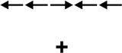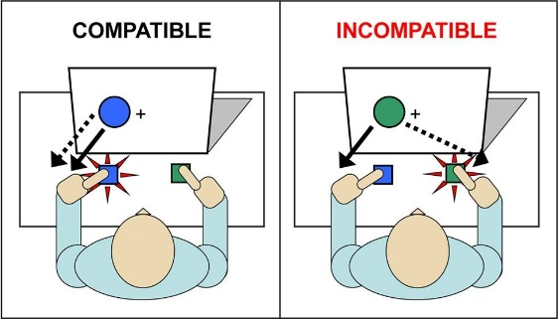

- No relationship between UFOV impairment and impact of flanker eccentricity (spatial spread)
- No evidence for reduced attentional capacity

Sensory and Attentional Functions in Aging
Spatial Cueing Task

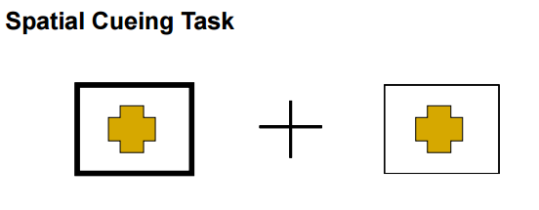
Spatial Cueing Task
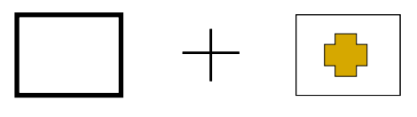

Spatial Cueing Task

- Robust relationship between incongruent RT and UFOV impairment
- Evidence for reduced attentional control (inability to disengage from cued target)
Spatial Cueing Task
- This measures control
- Older adults are poor on this task
- The performance was worse in older adults
- If I’m training for driving: I want to test attentional control

Attentional Functions in Aging
Reduced Neuromodulation
- Top-down suppression deficit underlies working memory impairment in normal aging
Reduced Neuromodulation
- Older adults have problems modulating their response to irrelevant information
  - Inability to suppress those distractions (worries that you have, social media, etc)
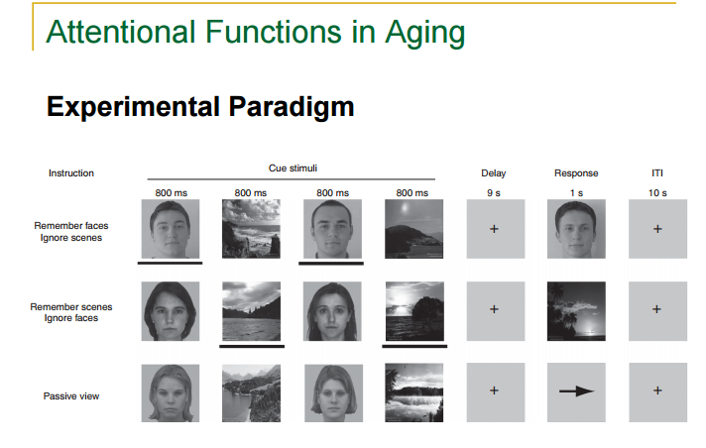
- Experimental Paradigm:
  - There are 3 core conditions:
    - You are remembering faces and ignoring routine
      - Selective attention matter
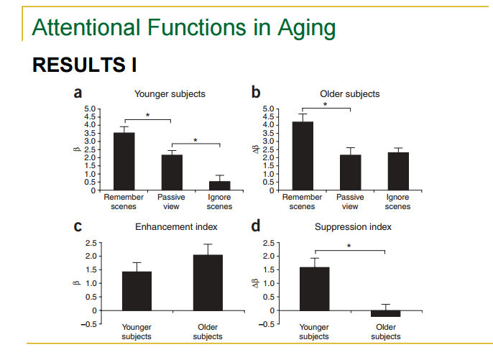

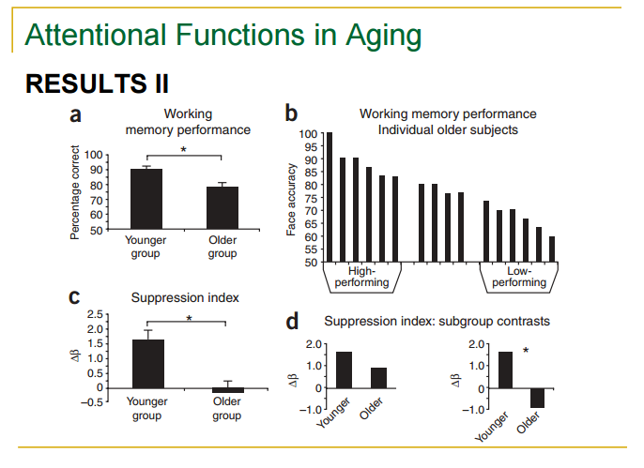

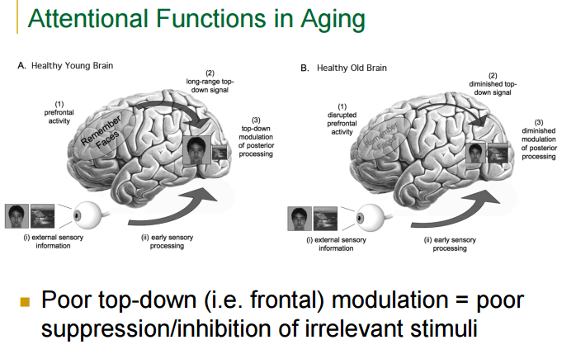

The Parahippocampal face area
- It is selective and active when seeing faces
- In the passive seeing conditions, there are scenes as well as faces.
  - Now you have to remember the scenes and ignore the faces
    - relative from just seeing
      - Neural activity goes up
      - You can modulate activity in the parahippocampal face area
Working Memory task charts
- Younger adults perform better than older adults
- BUT: FOR EXAMPLE: When watching a game: the game is very relevant to that adult. This enhancement is around that stimulus. This enhancement pushed out any distractions. (calling dad for 3 hours while he is watching the game, he will not hear you, he is too focused on the game).
- BUT, in the study conducted (pictures of faces and scenes): these scene are not very interesting to the adults, not very salient. If we used emotional faces or funny faces, then there would be more salience
The 4 charts
- Chart b: Working memory performance individual older subjects
  - High preforming: they are responding better to faces (high preforming working memory.
  - Low preforming: they are attending to what is irrelevant. The people who are not suppressing were able to identify those irrelevant information (irrelevant faces they were told to ignore earlier)
    - Older subjects: showed them pictures and scenes. But told them to ignore the faces. then asked was this face present?
- Chart d: younger vs older high preforming (good suppressor adults) and the second chart (chart b) was younger vs older adults who were low preforming

CHAPTER 5: MEMORY

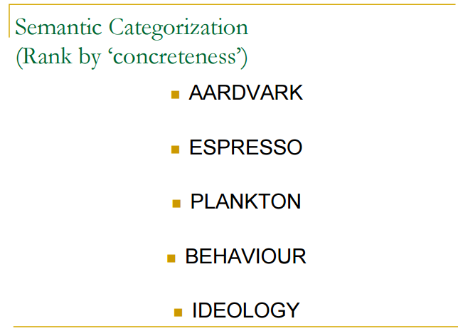

Semantic Categorization
-behaviour and ideology are the least concrete

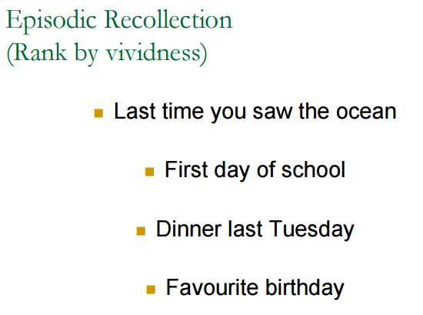

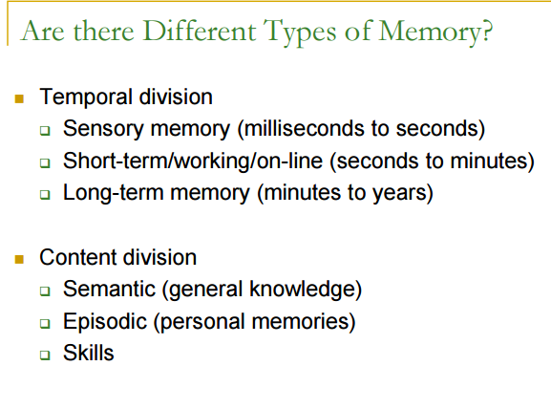
Least to most lowered with age:
1) Skills memory (pretty good in older adult)
2) Sematic
3) episodic memory (gets much worse with age)

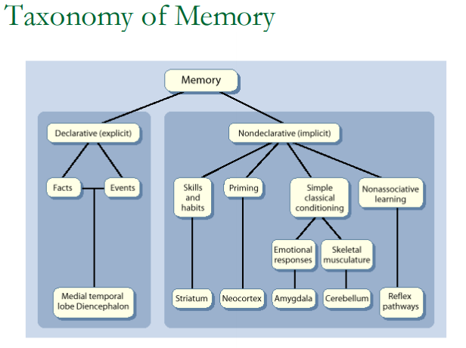

Memory and Aging:
EXPLICIT MEMORY

Explicit Memory
-Declarative side of explicit memory
-Memory is very influenced of the emotional state of the mind and how important it is to you
-Hippocampus: very related to spatial memory and episodic memory.
-Together these all form the circuit for explicit memory
-Hippocampus: is very linear and declines with age.
Types of memory that change with aging
-episodic memory is the medial temporal lobe
-sematic knowledge seems to be associated with lateral temporal region
-semantic because you are trying to remember an event
-medial= recaletic experience
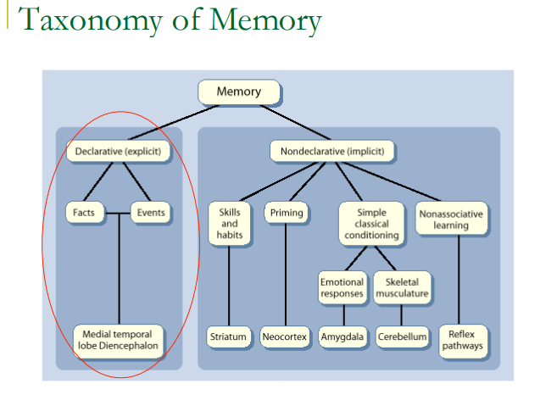

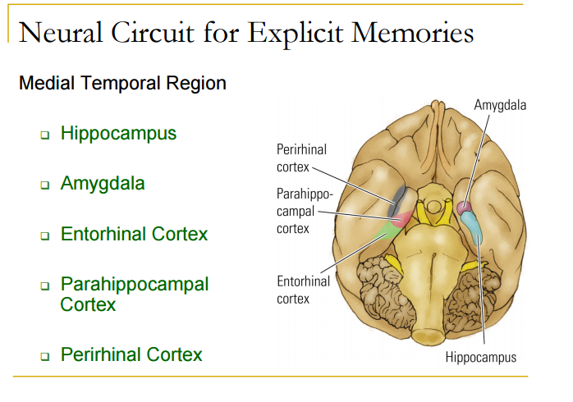

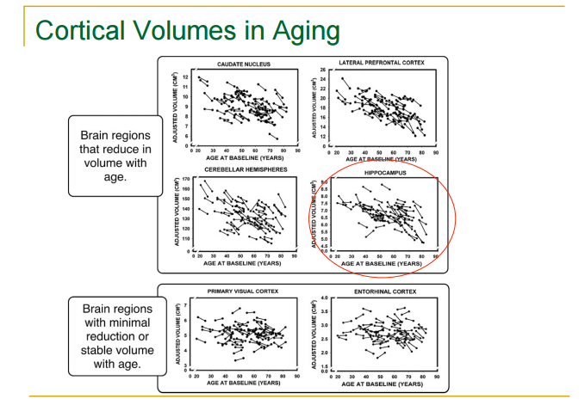

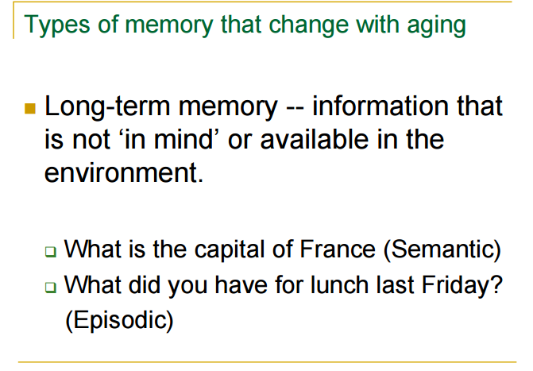

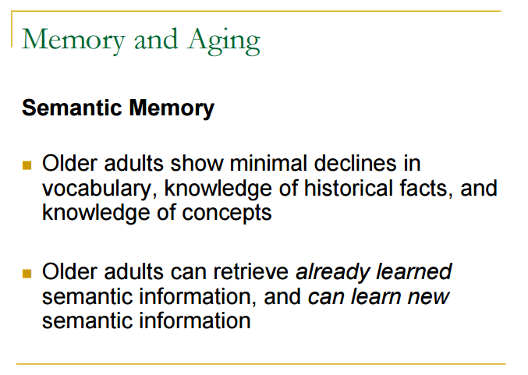

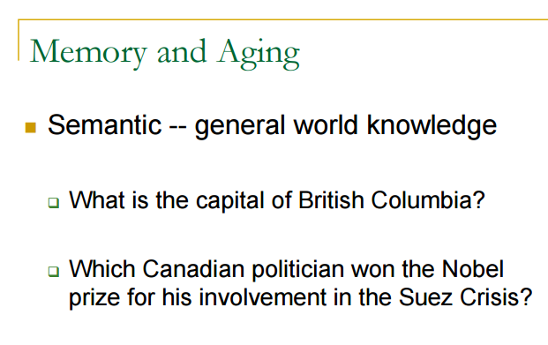

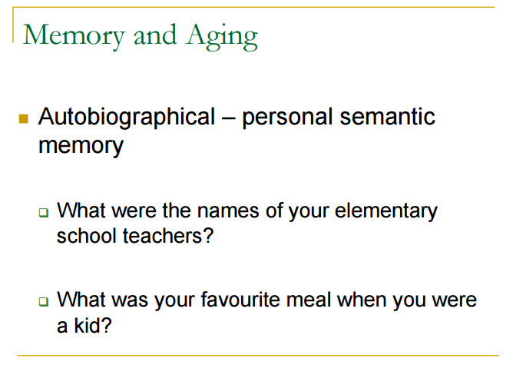

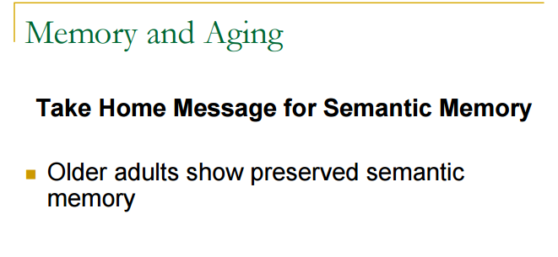

Memory and aging
-episodic memory: detailed memory
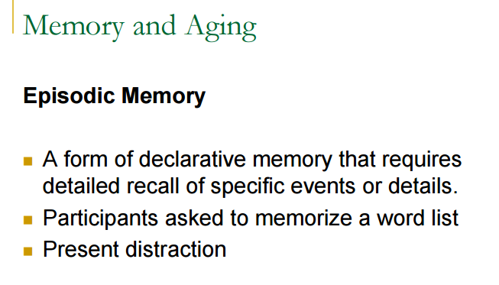

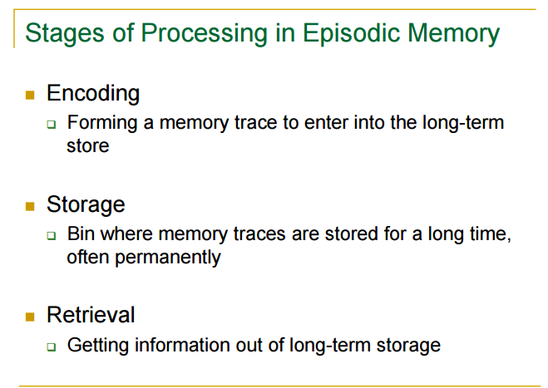

Stages of Processing in episodic memory
-Older memories have been accessed more which is why you have a more stable ability to access these memories
-imagery = association --> strategy for remembering words on the recall the word test
-then give retrieval cue: and people were able to remember more words.
-Bring out episodic recollection using the frontal lobe.
-When just asked to remember words (without retrieval cues), participants remembered less words

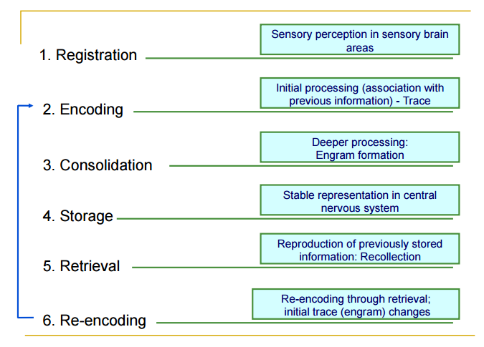

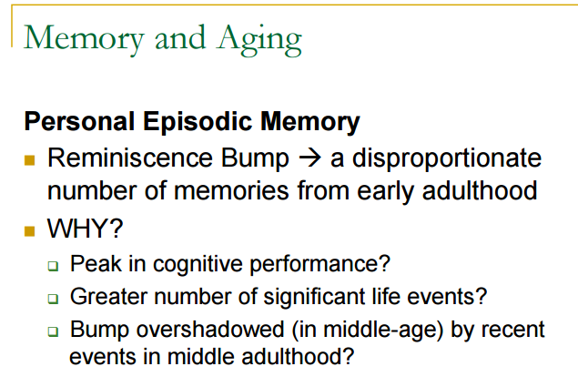

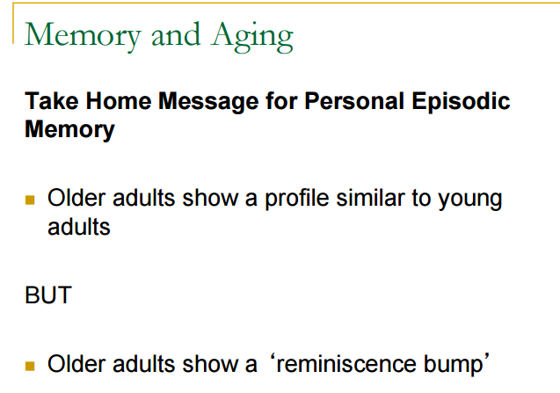

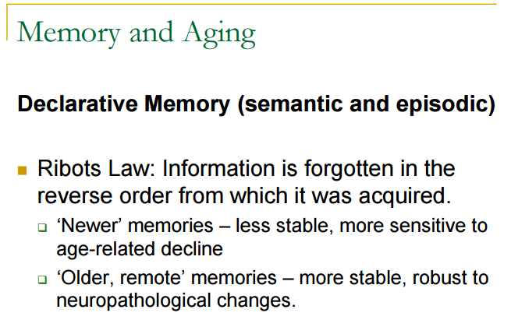

Memory and aging
- Adults are able to remember things when they were younger better. This may be because they were able to control measures better back then or when you are younger, everything is newer, more salient, more interesting, so they were deeply encoded
- Profile means that memories that are more recent are forgotten. The recent memories have been encoded less so they are less likely to be remembered.
  - You tell a story that happened to you 30 years ago about 100 times, But for something that just happened you haven’t told the story that many times (you haven’t encoded and recoded the situation enough), so these recent memories are more prone to be forgotten than the older memories.

Declarative Memory
- We will remember older memories better then newly established memories
- But, if the older more remote memories that have been encoded and re-encoded then that memory will be more established, which describes the general principle of Ribots law

