STUDY CHECKLIST – Midterm Study Guide

Chapter 1: Consumers in the marketplace

Consumer behavior as a process (Fig 1.1)

Consumer behaviour: is the study of the processes involved when individuals or groups select, purchase, use, or dispose of products, services, ideas, or experiences to satisfy needs and desires.

- consumption is a process, in which the exchange is only one aspect of.
- the expanded view of buying behaviour includes the issues that influence consumers before, during and after a purchase.

3 stages of the consumption process:
 | Consumer perspective | Marketer's perspective
Pre-purchase issues | need recognition, information search, evaluating alternatives | how to form and/or change attitudes, what cues do consumers use
Purchase issues | Acquiring the product - stressful or pleasant? what does the purchase say about the consumer | Situational factors affecting purchase decision (time pressure, store display, lighting, music, staff…)
Post-purchase issues | product evaluation, disposal, environmental consequences | What determines satisfaction and repurchase? Will consumers talk to others about the purchase? If so where, how, and what will they say.

Psychographics: differences in consumer’s personalities, attitudes, values and lifestyles.

Relationship marketing: Building bonds with consumers
- assumes a 2 way communication between the company and the consumer
- Involves making an effort to interact with consumers on a regular basis, giving them reasons to maintain a bond with the company over time. (EX: Starbucks, coke and Facebook)
- Illusion of caring

Virtual consumption
- Electronic marketing increases convenience by breaking down many of the barriers caused by times and location. (B2B, B2C and even C2C!)
- Digital native; students that have grown up “wired” in a highly networked, always-on world, where digital technology had always existed
- today the internet is the ‘backbone’ of our society
- Horizontal revolution; the flow of information across people (not just vertically from companies down to consumers) greatly due to social media.
- Social media; online means of communication, conveyance, collaboration, and cultivation among interconnected and interdependent networks of people, communities and organizations enhanced by technological capabilities and mobility!
- Synchronous interaction; occur in real time i.e. (fb chat, or texting back and forth)
- Asynchronous interactions; do not require all participants to respond immediately (i.e. fb msg, or text a friend and only get a respond the next day)
- Consumer generated content

Needs versus wants: do marketers manipulate consumers?

- Do marketers give people what they want, or do they tell people what they should want?
- Needs have not really changed over the years, how they materialize has changed
- Marketers don't create needs, we satisfy existing needs in a multitude of different ways.

Do Marketers Create Artificial Needs?
- A need is a basic biological motive, while a want represents one way society has taught to satisfy that need.
- The need already exists, marketers simply suggest different ways to satisfy them
- A basic objective of advertising is the create awareness that these needs exist, rather than to create new needs.

Are Advertising and Marketing Necessary?
- Products are designed to meet existing needs, and advertising merely helps to communicate the products availability.
- According to the economics-of-information perspective, advertising is an important source of consumer information.

Welcome to Consumer Space → who controls the market - companies or consumers?
- back in the day companies did! they called the shots
- nowadays people feel empowered to choose how, when or if they will interact with corporations as they construct their own consumer space
- people still ‘need’ companies, but in new ways and on their own terms

Public Policy and Consumerism
- Consumer welfare is protected by many laws (at the federal, provincial, and municipal level)
- The main thrust of regulation is to protect consumers from unfair business practices and to protect the broad interests of society.
- To a large degree consumers depend on their governments to regulate and police safety and environmental standards!
- Protecting consumers is more problematic now as the majority of manufacturing has moved offshore.

Examples of federal government legislation intended to enhance consumer welfare include;
- National Trademark and True labeling Act (1949)
- Food and Drugs Act (1953)
- Hazardous Products Act (1969)
- Motor Vehicle Safety Act (1970)
- Consumer Packaging and Labelling Act (1970)
- Textile Labelling Act (1970)
- Weights and Measures Act (1971)
- Precious Metals Marketing Act (1973)
- Competition Act (1986)
- Personal Information Protection and Electronic Documents Act (2000)
- Physical Activity and Sport Act (2003)
- Canada Consumer Product Safety Act (2010)

Consumer Activism and Its Impact on Marketing

Culture jamming aims to disrupt effort by the corporate world to dominate our cultural landscape.
- People are getting tired of always being harassed by advertising
- On a corporate level, firms are becoming increasingly interested in CSR

Corporate Social Responsibility (CSR) companies voluntarily choose to protect or enhance their positive social and environmental impacts as they go about their business.
- Often driven by consumer demand, as companies try to differentiate themselves)

Corporate giving; donating money to a good cause

Cause-related marketing; promise to donate to charity as a purchase incentive.

Green marketing; offering products in ways that are less harmful to the environment

Social marketing; using marketing techniques normally used to sell basic products employed to encourage positive behaviour (ex; MAAA).
- Applies marketing concepts in order to change behaviour for the betterment of the individual and society.
- Often used to counter act addictive and compulsive consumption (ex; anti-smoking adds)
- Frequently use fear appeals as a way to heighten awareness of problem behaviours and encourage behavioural change

Transformational consumer research (TCR) promotes research projects that include the goal of helping people or bringing about social change.

The dark side of consumer behaviour – term used to refer to addictive or compulsive behaviours (such as smoking, excessive alcohol consumption, overeating, drug addiction, or even compulsive shopping.

Addictive consumption:
Consumer addiction; a physiological or psychological dependency on products or services. (Including addiction to alcohol, drugs, and cigarettes)
- Many companies profit from selling addictive products OR selling solutions to addiction
- Examples include; the ‘crackberry’, internet addiction in south korea, online gaming

Compulsive consumption: refers to repetitive shopping, often excessive, done as an antidote to tension, anxiety, depression or boredom.
- born to shop, and shop till you drop, shopaholics, addictive consumption for shoppers…
- Consumers who feel compelled to shop rather than because shopping is a pleasurable or functional task.
- Not to be confused with impulse buying. Compulsive buying has to do with the process of buying, and not the purchases themselves.

3 common elements much negative or destructive consumer behavior is characterized by:
- Behavior is not engaged in by choice
- Gratification derived is short lived
- Person experiences guilt or regret afterwards
examples; gambling, casino, sports, apps, lotto,

Chapter 2: Consumers as individuals

Sensation: is the immediate response of our sensory receptors (those in our eyes, ears, nose and mouth) to such basic stimuli as light, color, and sournd.

Perception: is the process by which sensations are selected, organized, and interpreted.
- Preferences are shaped by our perceptions; how we organize, interpret and form associations about brands!

Model of perceptual process – perception is a 3 stage process translating raw stimuli into meaning.
Attention; the extent to which processing activity is devoted to a particular stimulus.
Interpretation; the meaning people assign to a sensory stimuli.

Exposure; the process by which the consumer comes in contact with the stimulus and has the potential to notice it!
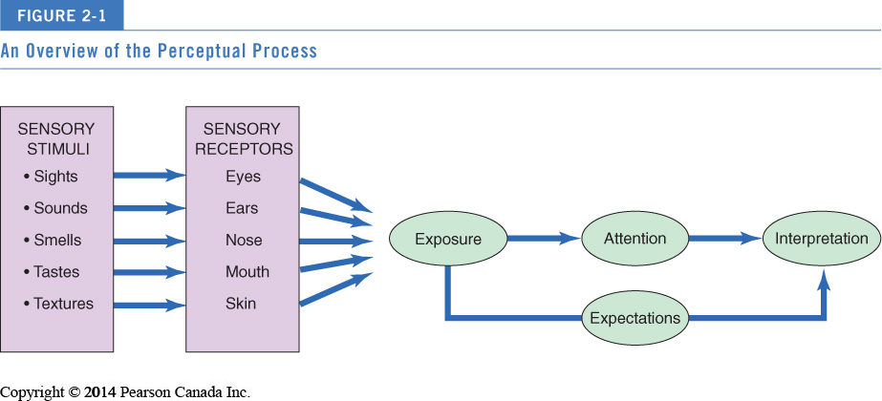

Sensory marketing – Harnessing perception for a competitive advantage!
- Where companies pay extra attention to the impact of sensation on our product experience
- Companies recognize that out senses help us decide which products appeal to us – and which ones stand out
- Marketers can appeal to each of the sensory systems in a variety of ways

1.) Sight
- Marketers rely heavily on visual elements in advertising, store design and packaging.
- Meaning is communicated on the visual channel
- Perception can be colored
  - Colors directly influence our emotions
  - Colors are rich in symbolic values and cultural meaning
  - Some reactions to color come from leaned associations
  - Some reactions to color are due to biological differences (woman light brighter tones, and are sensitive to subtle shading and patterns. Women see color better than men do)
  - Age influents our response to color; as our eyes mature they develop a ‘yellow cast’ (colors look duller thus older people tend to like white and bright tones)
  - Color choice greatly influence consumer’s assumptions about what is inside the package!
  - Trade dress; strongly associated color combinations with companies (EX; tiffany’s, coke)
- Optical illusions cause us to eat and drink more
  - When consuming from large packages or pouring into wider glasses we consume more
- Visual cues in packaging impact consumption

2.) Smell can; stir emotions, create calming feeling, evoke memories, and relive stress!
- Some responses to scents are a result of early associations that call up good or bad feelings
  - Businesses are now exploring connections b/w smell, memory, and mood.
- Consumer’s reactions to odors depend on their cultural background, to some extent. (ex; there is a huge difference from culture to culture on how one would like to smell!)
- We process fragrance cues in the limbic system (the most primitive part of the brain and the place where we experience immediate emotions)
- Smell can also lead to different behavioral reactions to stimuli
  - We may be weird to select compatible mates, (but not those too similar to us to cause inbreeding) based on smell, claimed one study.
- Common example; ‘The Axe effect’
- Sent marketing; marketers aiming to leverage to potential power of smell (ex; Abercrombie, Cinnabon)

3.) Hearing
- Many aspects of sound affect people’s feelings and behaviors
- Certain music can create a certain mood/ambiance
- Sound effects behavior!
  - High tempo = more stimulating (airline line up example)
  - Slower tempo = more relaxing
- Phenoemes; are individual sounds. They might be more or less preferred by customers (an I sound would be lighter that an A sound)

4.) Touch
- Touch is the most basic of the senses; we learn this before vision and smell
- Moods are relaxed or stimulated on the basis of sensations of the skin
- Haptic (touch) senses appear to moderate the relationship b/w product experience and judgment confidence (we are more sure about what we perceive when we can touch it)
- Touching affects the product experience, and touching an item forms a relationship with the product
  - When we touch a product we suddenly have a symbolic attachment with it
- Low autotelics; people who DO NOT normally have a compulsion to touch products
- High autotelics; people who DO have a compulsion to touch items
- Kansei engineering; a Japanese philosophy that translates customers feelings into design elements

5.) Taste
- People tend to have STRONG preferences for certain flavors
- culture in general determines desirable taste
- Changes in our culture also determines test we find desirable – Taste trends? Why? Novelty… (ex; green tea, poutine flavor chips, wasabi)
- Marketers have discovered various ways to influence consumers perceptions of the taste of the product itself – (ex; coloring the product different shades will lead to consumers perceiving a difference in the taste, even if it is flavored exactly the same!)

PERCEPTUAL PROCESS IN DETAIL
STAGE 1: EXPOSURE
Exposure occurs when a stimulus comes within range of someone’s sensory receptors

Sensory thresholds; we do not perceiving all stimuli; our senses are limited thus we have a threshold! Psychophysics; science that focuses on how the physical environment is integrated into our personal, subjective world.
Absolute threshold; the minimum amount of stimulation that can be detected on a sensory channel

Differential threshold; the ability of a sensory system to detect changes in a stimulus or differences b/w two stimuli
- Just noticeable difference (JND); the minimum CHANGE in stimulus that can be detected. (the ability to detect the difference is relative)
Why would we want to know the JND point?
  - So that reduction on product size, increases in prices or changes in packaging can go unnoticed
  - To make sure product improvements are perceived by the public
- Weber’s law; the AMOUT OF CHANGE necessary to be noticed is systematically related to the original intensity of the stimulus.
  - Thus the STRONGER the original stimulus, the GREATER the CHANGE must be for it to be noticed!
  - Apply Webbers law and we realize the main point is the ratio and never the absolute difference.
  - EX; A rule of thumb used by some retailers is markdowns should be at least 20% to make an impact on shoppers

Subliminal perception; the perception of stimuli below the level of customer consciousness. There is no real evidence that subliminal messages are effective.
*IF YOU CAN SEE IT OR HEAR IT ITS NOT SUBLIMINAL

STAGE 2: ATTENTION
Attention; refers to the extent to which the brains processing activity is devoted to a particular stimulus. This allocation can vary depending on the characteristics of both the stimulus and the recipient.
There is a lot of competition for our attention
- Sensory overload; when we are exposed to far more information that we are able or willing to process (generally coming from commercial sources – we are exposed to 3500 adds daily)
- Networks sneak in ads during non-commercial times
- Ads and entertainment are intertwined (product placement, and products becoming part of a story line)

Perceptual selectivity; people only pay attention to a small portion of the stimuli they are exposed to. We pick and choose among stimuli to avoid being overwhelmed.

Personal selection factors: how we choose
- Experience – result of acquiring stimulation
- Perceptual filters – based on past experiences, influence what we decide to process
- Perceptual vigilance – Consumers are more aware of stimuli when it relates to current needs!
- Perceptual defense – people see and hear what they want to see and hear. (EX: anti-smoking ads)
- Adaptation – the degree to which consumers continue to notice a stimulus over time. Factors that can lead to additivity include; intensity, duration, discrimination, exposure and relevance.

Stimulus organization (stimulus selection factors)
- Characteristics of the stimuli play an important role in determining what gets noticed and what gets ignored
- Generally stimuli that DIFFER from others around them are more likely to be noticed contrast
- Contrast can be created by size, color, position and novelty

STAGE 3: INTERPRETATION
Interpretation; the meaning people assign to a sensory stimuli.
- Consumers assign meaning to stimuli based on the schema – set of beliefs, to which the stimulus is assigned.
- A schema provides a cognitive framework that helps organize and interpret information that surrounds a particular stimulus.
- Identifying and evoking the right schema is crucial to many marketing decisions, bc it determines what criteria will be used to evaluate the product, package or message.

Stimulus organization
- We do not perceive in isolation; we tend to view stimulus in terms of relationships with other events, sensations or images.
- Our brains tend to relate incoming sensations to others already in memory
- Gestalt psychology; people derive meaning from the totality of a set of stimuli rather than from an individual stimulus (when you hear the music at the café, you are also smelling the fresh brewing coffee, and hearing the chatter surrounding you)
- Gestalt means whole, pattern or configuration. the gestalt perspective provides several principles relating to the way stimuli are organized;
Principle of closure; implies that consumers tend to perceive an incomplete picture complete. We tend to fill in the blanks on the basis of our prior experience/knowledge.
Principle of similarity; consumers tend to group objects that share similar physical characteristics. They group like items into sets to form an integrated whole. (we often do this with color associations ex: green giants ‘sea of green’)
Figure-ground principle; where one part of the stimuli will dominate (the figure) while other parts fall into the background.

Perceptual positioning…
- A product stimulus is often interpreted in light of what we already know about ta product category and the characteristics of existing brands
- Perceptions of a brand comprise both its functional attributes and its symbolic attributes
- Out evaluation of a product is typically the result of what it means rather than what it does

Chapter 3: Learning and memory

Learning = ongoing responses to external events.
- Learning refers to a relatively permanent change in behavior that is caused by experience.
- The experience does not have to be direct, we learn vicariously through others as well.
- We also unintentionally learn/acquire knowledge; a process known as incidental learning.

Behavioral learning theories – assume that learning takes place as the result of Reponses to external events, as opposed to internal thought processes.
The 2 major approaches to behavioral learning;
- Classical conditioning (Pavlovian or respondent conditioning) – learning process that occurs when a stimulus that elicits a response is paired with another stimulus that initially does not elicit a response on its own.
  - Unconditioned stimulus (UCS) – ex; meet powder = salivation
  - Conditioned stimulus (CS) – ex; sound of bell because of the learned association
  - Conditioned response (CR) – ex; bell = salivation
*when these cues are consistently paired with conditioned stimuli, such as brand names, consumers may learn to feel hungry, thirst, or aroused when later exposed to the brand cues.

Associative Learning-  Classical conditioning is a form of associative learning, where consumers learn associations between stimuli in a simple way (without complex processes such as memory or cognition taking place). | Marketing Applications of Conditioning –  Many marketing strategies focus on the establishment of associations b/w stimuli and responses.
Repetition – repeated exposures increase the strength of stimulus-response associations and prevent decay of these associations in memory. | Repetition is needed to ensure that the consumer is actually exposed to and processes the ad.  Too much results in advertising wearout.
Stimulus generalization – refers to the tendency of stimuli similar to the conditioned stimuli to evoke similar conditioned responses.  EX: we are conditioned to think pink = girl, so anything pink we think is girly) | Central to branding and packaging capitalize on consumer’s positive associations with existing brand or company.  Strategies based on stimulus generalization include; family branding, product line extension, licensing, and look-a-like packaging.
Stimulus discrimination - occurs when a stimulus similar to the conditioned stimulus is NOT followed by a unconditioned stimulus. In this case, reactions are weekend, and will soon disappear.  **Part of the learning process is to respond to some stimuli but not to other similar ones. Companies will often discourage buying the ‘cheap imitations’. | EX: Rickards red label lists the manufacturer as Capilano Brewing co. because marketers want to encourage stimulus discrimination, as they do not want the consumer to have to same conditioned response to Rickards red as they do for Coors Light (the actual maker of the beer).

- Instrumental conditioning (operant conditioning) occurs as the individual learns to perform behaviors that produce positive outcomes, and to avoid behaviors that yield negative outcomes.

Look at 222 notes… did not elaborate on this from the text book

Four types of learning schedules
Ratio schedules reinforce the learner based on the number of responses that have been completed
Interval schedules reinforce the learner after a certain amount of time passes since the appropriate response
- Fixed ratio reinforcement –knows how many responses are required for reinforcement.
ex; seasonal sales/coffee cards
- Variable-ratio reinforcement – does not know how many responses is needed for reinforcement.
ex; secret sales/flash sales
- Fixed-interval reinforcement – after a specific time has passed, the first response that is made brings the reward. ex; frequent flyer programs/point cards/frequency marketing
- Variable-interval reinforcement – time that must pass before reinforcement is delivered is unknown. ex; roll up the rim to win/lotto

*principles of instrumental conditioning are at work when a consumer is rewarded or punished for a purchase decision.

Cognitive learning theory; stresses the importance of internal mental processes. This perspective views people as problem solvers who actively use information from the world around them to master their environment.
- You have to know how people think in order to effectively market to them.

Is learning conscious or Not?
- Whether or when are we aware of our learning process? … Behavioral learning stresses the conditioning aspect, cognitive learning says its still all based on cognitive factors because the formation of expectations for desired response still needs mental activity.
- We do process at least some information in an automatic, passive way mindlessness
- We like to classify new things in existing categories because its easier
- Our reactions are activated by a trigger feature which is some stimulus that that cues us towards a particular pattern. Leads to a change in behavior without being aware of it. (ice coffee or hot coffee lab technician experiment)

Observational learning (or vicarious learning)
- Happens when people watch the actions of others and note the reinforcements they receive for their behaviors.
- Learning occurs as a result of vicarious rather than direct experience.
- The process of imitating the behavior of others is called modeling.
- Ex; role models, celebrities, people we do not want to be like. We can learn what to do through observing positive reinforcement and what not to do from observing negative reinforcement and punishment.

The 4 conditions that must be met for observational learning in the form of modeling to occur;
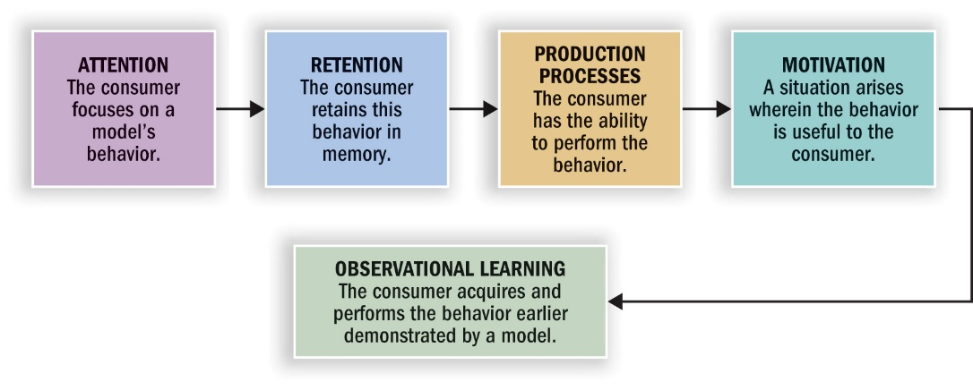
The role of memory in learning
Memory; involves a process of acquiring information and storing it over time so that it will be available when needed.
Memory process –an information-processing approach
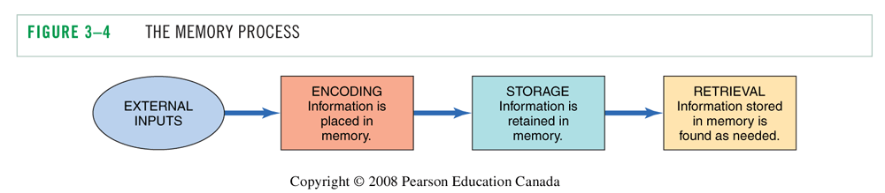
Sensory stimuli… | Encoding stage; information is entered in a way the system will recognize. (we encode information to help us retain it later) | Storage stage; this knowledge is integrated with what is already in the memory and ‘warehoused’ for later/until needed. | During retrieval, the mind accesses the desired information.

Encoding of information for later retrieval;
- The way info is encoded helps to determine how it will be represented in memory
- Encoding involved linking new information to existing knowledge to make the new info more meaningful
- Incoming data that are associated with info already stored in memory has a higher chance of being retained.
- Memory can depend on the involvement of the product as well! Low involvement products benefit from descriptive names!
Types of meaning
- Sensory meaning – colors, shapes
- Semantic meaning – symbolic associations
- Personal relevance – episodic/flashbulb memories. Brands are more likely to be positively evaluated and purchased when they connect to a consumer through a narrative.

Memory systems – 3 distinct memory systems; Sensory memory, short-term memory, and long-term memory
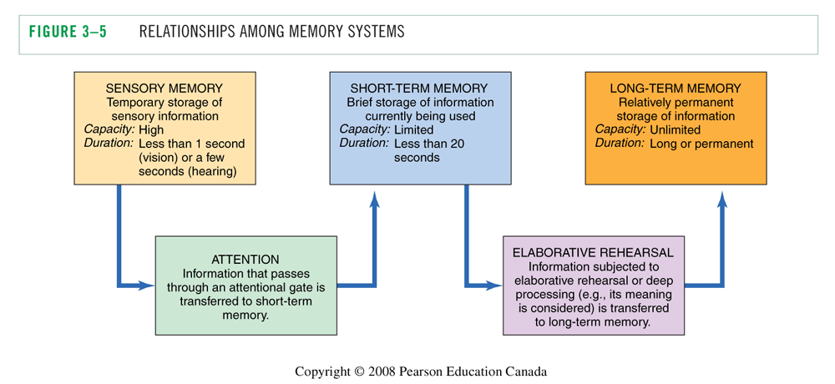
Storing information in memory;
Associative networks
Associative network models; propose that an incoming piece on information is stored in as associative network containing many bits of related information organized according to some set of relationships.
- The consumer has organized systems of concepts relating to brands, stores, manufacturers …
- Knowledge structures of interconnected nodes
- Hierarchical processing model
- Everybody has different associations and those are the ones most interesting to brand managers. By knowing what people associate with things, they can market or advertise better…

Spreading activation – as one node is activated, other nodes associated with it also begin to be triggered. Meaning thus spreads across the network, bringing up concepts including competing brands and relevant attributes that are used to form attitudes towards the brand.
- The way a piece of info is stored in memory depends on the type of meaning associated with it.

Different network levels/ meaning types of associated nodes
- Brand specific
- Ad-specific
- Brand identification
- Product category
- Evaluative reactions

Levels of knowledge
How does knowledge get stored?
- knowledge is coded at different levels of abstraction and complexity
- meaning concepts are individual nodes
- Proposition or a belief is combined meaning concepts into a larger unit. A proposition links 2 nodes together to form a more complex meaning, which can serve as a single chunk of information.
- Schema – a complex network of propositions. A schema is a cognitive framework that is developed through experience.
- Script – a sequence of procedures to perform a task, or that is expected by an individual (ex; technology taking over consumer interactions is changing the script)

Analogical learning – the marketer informs consumers about a new product using an analogy. If the marketer wants to inform or educate the consumer about a new product, the marketer might do so by drawing an analogy (highlighting similarities) between the new product and an existing one.
- Base – the existing product = original source of knowledge
- Target – the new product = what the existing knowledge will be transferred to
Analogical learning can take 2 forms;
- Attributes – which are identifiable features or properties of the product
- Relations – how the product relates to a desired outcome

Retrieving Information for purchase decisions - Long-term memory and retrieval
- Process of accessing information from long-term memory factors.
- Some differences in retrieval ability are physiological (older ppl don’t remember as well), others are situational (relating to the environment the message was delivered).
- Recall is enhanced when consumer pays more attention in the first place
- Pioneering brands and descriptive brand names are better recalled
- The viewing environment can also effect recall - continuous activity in show, ppl will pay more attention the commercial, and people remember the first commercial they see in a sequence than the last one.

Factors influencing retrieval
- Familiarity and recall – prior familiarity with an item enhances its recall
- Salience and recall – the salience of a brand refers to its prominence or level of activation in memory.
Mystery ads (where the brand is not identified until the end of the ad) are more effective at building associations in memory b/w the product category and that brand.
The intensity and type of emotions we experience at the time also affect how we recall the event later.
- Pictorial vs verbal cues – information presented in picture form is more likely to be recognized later

Factors influencing forgetting ….(skiped)

Products are memory markers – possessions call forth memories of the past (autobiographical memories, nostalgic memories..)

Nostalgia and marketing – the marketing power of nostalgia
Nestolgia; has been described as bittersweet emotion, in which the past is viewed with both sadness and longing. (ex; ‘the good old days’ or ‘back in the day’)

Memory biases – problems with memory measures
- Response biases
- Memory lapses – we are prone to unintentionally forgetting info., including omitting facts, averaging or normalizing, and telescoping.
- Memory for facts vs feelings

Chapter 4: Motivation and Affect
- Often people’s choices are influenced by their values – their priorities and beliefs about the world.
- Satisfying needs is useless unless we can figure out what those needs are and why they exist

Motivation; refers to the processes that cause people to behave as they do. An activated need, and tension that drives a person to reduce this tension.

The motivation process:
- A need is aroused because a discrepancy exists between consumers present state and desired state
- Once a need has been activated a state of tension exists that drives the consumer to attempt to reduce or eliminate this tension.
- degree of motivation/drive = The magnitude of tension determines urgency consumers feels to reduce the tension; thus satisfying the need
- Could be utilitarian (a desire to achieve some functional or practical benefit)
- Could be hedonic (an experiential need involving emotional responses or fantasies)
- The desired end state = the consumers goal
- Want = differing manifestations of a need created by personal and cultural factors, the particular form of consumption used to satisfy a need *(on an individual level – our needs could be the same ex hunger, but out wants will differ – cheese burger vs a salad).

Different motivational theories
- Instinct – in early work they described motivation as instinct – innate patterns of behavior universal in a species
- Drive theory – focuses on the biological needs that produce unpleasant states of arousal (ex; Hunger). We are motivated to reduce the tension caused by this arousal and return to a balanced state known as homeostasis (where your present state = your desired state).
- A person’s degree of motivation depends on the distance b/w their present state and the goal.
- Contradictory to drive theory, people often do things that increase a drive state rather than decrease it. (Ex; delay gratification, forgo urges)
- Expectancy theory – behavior is pulled by expectations of achieving desirable outcomes (positive incentives) rather than pushed from within. (Ex; we chose one product over another because we expect it to have more positive consequences)
- focuses on cognitive factors rather than only biological ones
- under expectancy theory positive incentives could be money or social status…

Classification of needs
- biological vs. learned
Biological needs: necessary to maintain life (ex; food, air, water)
Psychogenic needs: culture-related needs or are acquired in the process of becoming a member of a culture (ex; need for status, power, affiliation…)

- utilitarian vs. hedonic
Utilitarian needs: implies that consumers will emphasize the objective, tangible aspect of products (ex; KM/liter of gas in a car, or the amount of fat/calories/salt in a bag of chips)
Hedonic needs: subjective and experiential, leading to consumers to reply on a product because it meets their need for excitement, self-confidence, or fantasy… involving emotional responses or fantasies.
Motivational Conflicts
A goal have valence – it can be positive or negative
Goal Valence
- Positively valued goal = Approach
- Negatively valued goal = Avoid

A purchase decision may involve more than one source of motivation, consumers often find themselves in a situation where different motives conflict with one another. Marketers attempt to satisfy consumer’s needs, they can also help provide possible solutions to these conflicting motive dilemmas.

3 general types of motivational conflict
- Approach – approach conflict (ex; buy a new car, take a vacation)
A person must chose between 2 desirable alternatives
- Approach – avoidance conflict (ex; eat the hamburger, don’t want to gain weight)
when we desire a goal but wish to avoid it at the same time
- Avoidance – avoidance conflict (ex; pay rent, ray tuition)
between a rock and a hard place, must make a decision between 2 things we don’t want to do!

Classifying consumer needs – needs relevant to consumer behavior
- Need for achievement – strongly value personal accomplishment
- Need for affiliation – to be in the company of others, relevant to products that alleviate loneliness and that are consumed among groups
- Need for power – to control ones environment, having a mastery over ones surroundings
- Need for uniqueness – to assert ones individual identity, satisfied by products promising to bring ou a consumers distinctive qualities

Maslow’s Hierarchy of Needs
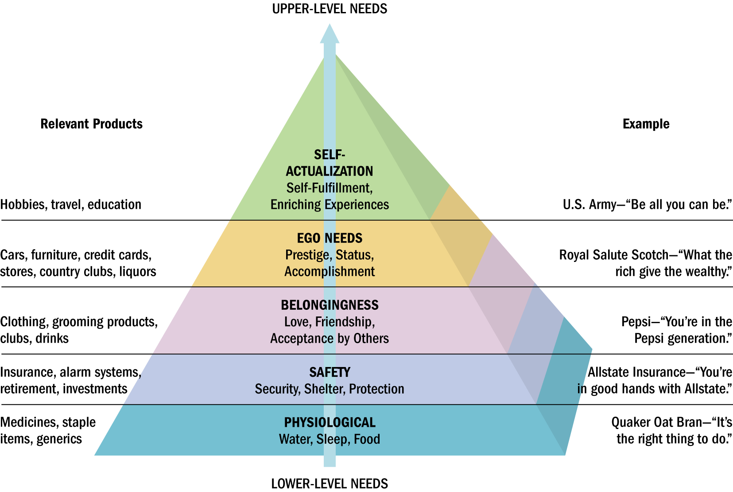
- Most people spend most of their lives trying to fill their ego needs and never move on to the 5th level of self-actualization
- Predicts that higher-order needs become the driving force behind human behavior as the consumers lower-level needs are satisfied
- Satisfaction does not motivate behavior; dissatisfaction does

Criticisms of Maslow’s Hierarchy of needs
- We do not need to satisfy on need totally before the next level of need motivates behavior
- Sometimes certain behaviours satisfy 2 needs at once
- There is not measurement tool for researchers to test the need hierarchy empirically
- Cannot measure precisely how well satisfied one need is before the next becomes operational
- The model is based on western culture, and shouldn’t be taken too literally (some levels may be switched in other cultures)

SMART goal setting – motivation and goal fulfillment
- People often set goals related to consumption (ex; lose weight, consumer less energy, consume more helthy foods, and exercise more…)

Specific | Its easier to attain a clearly specific goal than a general one
Measurable | Needs to have concrete criteria by which goal attainment can be assessed
Attainable | Must be challenging but realistic = attainable
Relevant/ realistic | Must be relevant; something important to the goal setter
Timely | Goal should have a targeted time point for completion

- When you set SMART goals, its statistically proven you are more likely to achieve these goals
- Sometimes consumers decrease effort when they get closer to their goal – consumers who subjectively feel closer to attaining a goal (such as weight loss) are ironically then more likely to change course and pursue an alternative goal (such as enjoyment)…this may lead to actions inconsistent or counter active to the original goal
- Goals can e uncousiosly activated (classical conditioning) sometimes the motive to attain a goal can be activated in consumption contexts without the consumer even being aware or it!

Involvement: a persons perceived relevance of the object/consumption activity based on their inherent needs, values and interests.
- Motivation to process information – there is a perceived link between a consumer’s needs, goals, or values and product knowledge, the consumer will be motivated to pay attention to products information

Involvement is a motivational construct depending on…
- Personal interests in product category
- Risk
- Probability of bad purchase
- Pleasure value of product category
- Sign value of product category (self-concept relevance)

Felt involvement; consumers do not continually experience involvement. It is a psychological state that consumers experience only at certain times and locations.

Levels of involvement
- Type of information processing that will occur depends on consumers LEVEL of involvement, ranging from; simple processing to elaboration.

How involvement affects consumer information processing;
Inertia | Flow state
LOW involvement | HIGH involvement
- Simple processing  - Only basic features of the message are considered  - Decisions are made out of habit, because consumers lack motivation to consider alternatives | - Consumption decisions are well thought out, with passionate intensity reserved for ppl and objects that carry great meaning to the individual.  - Consumers elaborate on info, and consider alternatives.  - Incoming information is linked to preexisting knowledge.

- Degree of involvement is a continuum (ranging from lack of interest to obsession)

3 broad types of involvement:
- Product involvement: consumers level of interest in a particular product
*Arguably the most powerful way to enhance product involvement is to invide customers to play a role in designing or personalizing what the buy mass customization enhances product involvement
- Message-response involvement: consumers interest in processing marketing communication.
EX: TV is low involvement because consumers passively watch and have to power to tune out, Print is higher involvement because the consumer must actively process what they are reading, and can pause for reflection.
- Purchase situation involvement: refers to differences that may occur when buying the same object for different contexts! Wha timage does the purchase portrays? Are you susceptible to social risk?
(EX: buying you sister a birthday gift or your co-worker you hate)

Strategies to increase involvement By being aware of some basic factors that increase or decrease attention we can take steps to increase likelihood of capturing a customer’s interest/attention
- Appeal to customers hedonic needs (ex; ads with sensory appeal generate higher levels of attention)
- Use novel stimuli (ex; unusual cinematography, sudden silences, unexpected movements, surprise appeals)
- Use prominent stimuli (loud music, fast action, large print, colorful pages to quickly grab attention)
- Use relevant celebrities for your target
- Relationship marketing (maintain an ongoing bond with consumers)
- Consumer generated content (ask your customers to co-create)

Affect; the experience of emotionally laded states
3 types of affective responses
- Evaluations: lowest level – involve valenced (positive or negative) reactions to events and objects, that are not accompanied by high levels of arousal.
- Moods: moderate level – involve temporary positive or negative affective states accompanied by moderate levels of arousal.
- Emotions: higher level – not sustainable long term, more intense and often related to a specific trigger

How do marketers use affect?
- Positive moods and emotions are often highlighted as a product benefit (affect as a product benefit)
ex:
- Sometimes highlight the avoidance of negative affect as a product attribute
ex:
- Helping others as a means of resolving one’s own negative moods (negative state relief)
ex: making consumers feel bad and then giving them a way to feel better help the starving children
- Our judgments are often consistent with our existing mood states (mood congruency) make sure consumer comes in contact with the product/message/ad wtv when they are in a good mood!
ex; put adds during funny tv shows, play pleasant music in stores,
How social media taps into our emotions;
Sentiment analysis; (or opinion mining) is a process that scans social media platforms to collect and analyze the words people use when they describe a specific product or company.
- When people feel a particular way, they are likely to chose certain words that tend to relate to that emotion.
- From these words the researcher will create a word-phase dictionary (or library) to code the data.\
- Cool way to gauge consumers opinions without them knowing, giving a truer, honest result.
- Text mining software would collect reactions and combine them with others to pain a picture of how people are talking about the product!

Discrete emotions… (not in study guide) ? p.112

Chapter 5/ Lecture 4

Means-ends chain
- Links consumers knowledge about product attributes with their knowledge about consequences and values.
- People think about product attributes in terms of personal consequences

Characteristics of Means-End Chains
- Not every means end chain lead to a value
- Some means end chain could be incomplete. A level in the chain might be missing.
- Some attributes might lead to different means end chains depending on perceived benefits and risk

Marketing implications of means-end chains
How can we identify means-end chains?
- Personal interviews
  - Identify attributes
Laddering; is an interview technique, aimed to move up in means-end chain until the interviewer hits the true value a consumer sees in a product. It is used to uncover the underlying emotions, consequences, and personal values that drive consumer choice
- Through a series of probing questions, the interviewer takes the respondent up the ladder step-by-step.
- It is critical to get specifics at each level of the ladder, and sometimes respondents challenge the interviewer by jumping around different levels of the ladder.
- The ladder is not useful to the analysis unless each step is completed with a single specific response

The Self
- Conscious of one’s own identity
- Assumes to be idiosyncratic (characteristic, personal, individual, distinctive, particular) the emphasis on the unique nature of the self is much greater in western societies
- **consumer’s feelings about themselves shape their consumption practices!
- Independent interpretation of the self – which emphasized the inherent separateness of each individual (this is a wester view)
- Interdependent selves a person’s identity is largely defined by the relationships he or she has with others. (a non-western view)

The self-concept – beliefs a person holds about their own attributes and how we evaluates these qualities. Can be somewhat stable over time.

Attributes of self-concept can be described along such dimensions;
- Content (ex; facial attractiveness vs mental aptitude)
- Positivity or negativity (ex; self-esteem)
- Intensity
- Stability over time
- Accuracy (ex; degree to which ones self-assessment corresponds to reality)

Self-esteem; to positivity of your attitudes towards yourself/ of a person’s self-concept.
- Degree of positivity towards ones self-evaluation.

Self-esteem advertising – marketing communications can influence a consumer’s level of self esteem
- Exposure to adds can trigger social comparison - a process where people evaluate themselves by comparing themselves with others (such as peers, role models, idealized images in advertising)
- Attempts to change product attitudes by simulating positive feeling about the self.

Real/ actual self – who we think we are! A persons realistic appraisal of the qualities they do and do not possess.
Ideal self – who we want to be! A persons conception of how they would like to be, particularly molded by elements of ones culture.
- We chose some products because we think they are consistent with our real self while we buy others to help us reach an ideal standard!
- Impression management – where we work hard to manage what others think of us (often by things we consume)

Fantasy appeals –marketing communications aimed at people with a large discrepancy between their real and ideal selves! (bridging the gap between the selves) ex; old spice smells like a man, man commercials
Fantasy; a self-induced shift in consciousness

Multiple selves (role identities); different components of the self that become active in different context/ environments. We have as many selves as we have social roles!
- Depending on the situation we act differently, use different products and services!
- A person may require a different set of products to play a number of desired roles.
- Some identities are more central to the self than others, but others may be dominant in specific situations

Virtual identity; another self – a virtual self.
- Researchers are currently investigating how these online selves will influence consumer behavior and how the identities we choose in computer mediated environments (online) relate to our real life identities!

Symbolic interactionism; stresses that relationships with other people play a large part in forming the self.
- Self-fufilling prophecy – the tendency to pattern out behavior on the perceived expectations of others. By acting the way we assume others expect us to act, we often wind up confirming these perceptions.

Looking glass self; the process of imagining the reactions of others towards us.
- We take readings of our own identity by “bouncing” signals off others and trying to project the impression they have of us.
- We see ourselves as we imaging others see us(reflected self, helps shape self-concept)

Self-consciousness; a painful awareness of ones self-magnified by the belief that others are intently watching.
- A heightened concern about the nature of one’s public ‘image’ also results in more concern about the social appropriateness of products and consumption activities.
Public self-consciousness; a heightened concern about the nature of one’s public image.

Self-monitoring; awareness of how one presents oneself in a social environment (actors, put on a show)
The extent to which people regulate and observe how they appear and behave in social settings and relationships. Monitor behavior, expressions… so they project the ‘right’ image of themselves.

Consumption and self-concept - our (purchasing) behavior help others to make judgments about our social identity. We tend to buy products that fit with our personality or our augmented personality.
- Symbolic self-completion theory; predicts that people who have an incomplete self-definition tend to complete this identity by acquiring and displaying symbols associated with it.
  - Using consumption info to define the self when an identity is yet to be completely formed
  - Using products/objects as a ‘social crutch’ during periods of uncertainty
  - One of the first things institutions that want to repress individuality and encourage group identity (like a prison or convents) is to confiscate personal possession.

Self/product congruence; people demonstrate consistency between their values and the things they buy.
- Many consumption decisions relate to self-definition (ex; I am an artist, I own a mac)
- Self-image congruence models; predict that products will be chosen when their attributes match some aspect of the self.

Extended self – are the external objects that we consider a part of us.
- Many material objects, ranging from personal possessions and pets to national monuments or landmarks, help to form a consumer’s identity (ex; IPHONE!)

Consumers define themselves by referring to 4 levels of the extended self
- Individual level; personal possessions (ex; jewelry, cars, clothing, ‘you are what you wear’)
- Household/family level; residence and furnishing (ex; the house is a symbolic body for the family)
- Community level; neighborhood or town on is from (ex; defining oneself based on where they are from… Americans!, city girls, farmer boys…)
- Group level; social groups
Gender roles (and stereotypes)
Sex | Penis/vagina (what we are born with)
Gender | Male/female (how we feel)
Sexuality | Who we are attracted to

- It’s unclear to what extent gender differences are innate vs culturally shaped but they’re certainly evident in many consumption decisions

Gender differences in socialization
- Every society creates a set of expectations regarding behaviors appropriate for men and women and finds ways to communicate them.
- In many societies men are controlled by agentic goals which stress self-assertion and mastery
- Females are taught to value communal goals such as affiliation and then fostering of harmonious relations
- Research indicates that our brains are ‘weird’ to react differently to males and felames (might eplain why men tend to objectify women)
- Gendering

Gender vs sexual identity
- A persons biological gender (sex) does not totally determine whether he or she will exhibit sex type traits; characteristics stereotypically associated with one gender or another.
- Masculinity and femininity are not biological characteristics they are socially constructed behavioral characteristics

Sex-type products – products that take on masculine or feminine attributes, and consumers often associate them with one gender or another.
- The sex-typing is often created by marketers/advertisers
- The pink tax –female pay more for virtually the same products as men…
- When is it ok to segment based on gender? When it is based on biological differences!

(teacher skipped; androgyny, gender-bending products, female roles, male roles, and LGBT consumers)

Body image; refers to a consumers subjective evaluation of their physical self
- A persons physical appearance is a large part of their self-concept
- Some marketing strategies exploit consumer’s tendencies to distort their bod image by preying on insecurities about appearance. They create a gap between the real self and the ideal self, thus the customer then wants to buy the product that will bridge the gap!

Body cathexis; a person’s feelings about their body – a person’s mental and emotional investment about their body.
- Cathexis refers to the emotional significance of some object or idea to a person, and some parts of the body are more central to self-concept than others

Beauty ideals and how they are used in marketing
- Ideals of beauty; a particular model, or exemplar, of appearance
- Only 2% of Canadian women believe physical characteristics define true beauty!
- Periods of history tend to be characterized by a specific “look”, advertisers and other forms of mass media play a significant role in determining which forms of beauty are considered desirable at any point in time!
- Chinese consider appearance so important that they view plastic surgery as a commercial investment
- The wester ideal of beauty’s marketed around the globe, and everyone benefit$!
- Fattism – our society is obsessed with weight, and marketers/advertisers are always stressing the pressure to be slim
- The desire to be slim has a large impact on consumption; eating habits, hobbies, and clothes choices
- Body dysmorphic disorder – an obsession with perceived flaws in appearance
- The importance of breast size to self-concept resulted in a successful marketing strategy undertaken by underwear companies!
- Our culture is also obsessed with self-improvement and its marketed like crazy to our generation, because we are put on this petistule that we have to be better than all those that came before us.

Body positivity….?
- As seen is recent campaigns? Dove… new barbi?

Bodywork (cosmetic surgery, decoration of body)

Decorating the self serves a number of purposes (original purposes…)
- To separate group members from non-members
- To places the individual in the social organization
- To place the person in a gender category
- To enhance gender-role identification
- To provide a sense of security
- To indicate desired social conduct
- To indicate high status or rank

Chapter 6 – Personality, lifestyles, and values

Personality: a person’s unique psychological makeup and how it consistently influences the way he or she responds to the environment.
- Argued that people tend not the behave consistently across different situations thus we don’t seem to exhibit stable personalities (similar to the idea we have many selves… we may also have many personalities)

Freudian Theory of Personality
- Much of human behavior stems from a fundamental conflict between a person’s desire to gratify their physical needs and the necessity to function as a responsible member of society.
- Personality results from a dynamic struggle between inner physiological drives (hunger, sex, aggression) and social pressure to follow lows, rules and moral codes.
Id | - The component of the self entirely oriented towards immediate gratification  - Operates according to the pleasure principle – behavior is guided by the primary desire to maximize pleasure and avoid pain!  - The Id is selfish, illogical and ignores consequence  - Assumes to control the unconscious motives
Superego | - the counterweight to the id a persons conscience  - internalizes societal norms and prevents the Id from seeking selfish gratification
Ego | - the system that mediates between the Id and the Superego  - reality principle; the ego finds ways to gratify the Id that will be acceptable to the outside world (balancing the 2 opposing forces)

Marketing implications based on Freud
- Using products that signify forbidden desires (ex; hummer and domination, sports car and secual gratification)
- Sexualization of non-sexual objects
- Potential importance of unconscious motives underlying purchases implying consumers cannot necessarily identify their true motives for choosing a particular product.
- Hints that the ego relies on the symbolism in products to compromise between the demands of the Id and the prohibitions of the Superego a person will channel their unacceptable desires into acceptable outlets by using products that satisfy these underlying desires.
Motivational Research (and how it is used in marketing)
- Uses Freudian ideas to understand the deeper meanings of products and advertisements
- Motivational research was the first attempt to apply Freudian theories, and largely based on psychoanalytic interpretations, with a heavy emphasis on unconscious motives.
Relying on;
  - In-depth interviews; technique that probes deeply into a few consumers purchase motivations
    - Pioneered by Earnest Ditcher! Who conducted in-depth interview studies on more than 230 different products and associated different motives with these products.
  - Latent motives; underlying motives, deep seated needs which can be targeted
  - Reptilian hot buttons; consumers are driven by unconscious needs and impulses, term pegged from Dr. Rapaaille

Criticism of Motivational research;
- Some feel it does not work at all research lacks precision and validity
- Others find it works too well giving advertisers the power to manipulate consumers

Why is Motivational Research appealing to marketers?
- Cost efficient – motivational research is less expensive than large scale surveys
- Providing insights – findings can possibly shed light on deep seeded needs and provide a more powerful message for marketers to work with
- Intuitive sense – some findings seem intuitively plausible after the fact

Neo Freudian Theories
Karen Horney | Proposed that people can be divided into 3 categories;  1. Compliant - moving toward others (want to be like everyone else, more brand loyal)  2. Detached - moving away from others (don’t want to be like everyone else, drink more tea than coffee)  3. Aggressive - or against others (don’t want to be told what to do, prefer distinctly masculine images)
Karl Jung | - criticized Freud’s emphasis on sex  developed his own method of psychotherapy known as analytical psychology  emphasizes the individual development as a creative person, and their individual and racial history in the formation of personality = We are a product of our past and future (who we were, and what we want forms us)  - people are shaped by cumulative experiences of past generations  Believed we are shaped by collective unconscious; a storehouse of memories inherited from our ancestral past that derive our behavior. These shared memories create archetypes!  Archetypes; universally shared ideas and behavior patterns created by shared memories (ex; mother earth, old wise man, the rebel, the vixen…)

Archetypes and how they are used in branding
- some brands have personalities that are in many ways quite similar to human personalities.
BrandAsset valuator (BVA) group created the BrandAsset Archetypes model – measuring brand personality, and the heath of a brand!
- Use this model to identify if a brand had a sick personality or not.
- A heathy personality is one where the Archetypes overwhelm their corresponding shadows
- A sick personality occurs when the shadow dominates! In this case a company must take action!!

Used in branding because;
- Achetypes are grounded in the human psyche across all cultures and points in time, they are easy to understand making the brand personality easy to communicate
- Measuring the heath of a brand personality can act as early warning signs of a brand in trouble

Trait theory
An approach to personality that focuses on the quantitative measurement of specific personality traits, or identifiable characteristics that define a person.
- Suggests that our personality is made up of many small quantifiable parts – known as traits.
- Collectively these traits define our personality
- Personality characteristics influence people behavior when the situation calls for a particular personality characteristic
- Personality alone will not always predict consumption behavior, personality traits often interact with situational factors to predict how consumers will behave!

Traits specific to consumer behavior;
NOTE: people buy products that are extensions of their personalities.
- Innovativeness (degree to which a person likes to try new things)
- Materialism (amount of emphasis placed on acquiring and owning products)
- Frugality (opposite of materialism, deny short term purchasing whims and resousfully use what one already owns)
- Self-consciousness (degree to which someone deliberately monitors and controls the image of the self that is projected to others)
- Need for cognition (the degree to which a person likes to think about things ex; read all the manuals, google the components of their vitamins, want to know how things work) this effects how much product info a company will disclose
- Extroversion; trait of being socially outgoing
- Introversion; trait of being quiet and reserved

Some research examines consumption differences between individuals who are idiocentrics and those who are allocentrics. The extent to which a person is motivated to consume in order to please others and fit in (outer vs. inner directed)
Idiocentrics - Having an individualistic orientation | Allocentrics - Having a group orientation
Need for uniqueness – degree to which a person is motivated to stand apart from the crowd | Power of conformity – the impact of shaping ones behavior to meet the expectations of a group
Differences between personality types
- More content with current like  - Less likely to avoid unhealthy foods  - Spend less time preparing food  - More likely to work hard and stay late at work  - More interested in traveling to other countries | - Less satisfied with current like  - More likely to avoid unhealthy foods  - Love the kitchen; spend time preparing food  - Less likely to work late  - Visit library, and finish books

Brand personality – the set of traits people attribute to a product as if it were a person!
- The brands personality will either match a person’s personality or complement it.
- Our feelings about a brands personality are an important part of brand equity
- Packaging and other physical cues create a personality for a product
- Marketing activities can also influence inferences about the product or brands personality!
- Animism; the practice found in many cultures where lifeless objects are given qualities that make them somehow alive. Either associated the object directly with a human (such as a celebrity) or giving the object human characteristics (such as treating a doll as your human friend, or the Micheline man)

Common traits people attribute to products include;
- Old fashioned, wholesome, traditional (ex; Levis)
- Surprising, lively (ex; covergirl)
- Serious, intelligent, efficient (ex; IBM)
- Glamorous, romantic, sexy (ex; Victoria secret)
- Rugged, outdoorsy, tough, athletic (ex; Northface, underarmer)
- Creative, innovative, (ex; Mac)

Personality of positioning
- Brans positioning strategy is a statement about what that bran whats to be in the eyes of the consumer – relative to the competition
- A brand personality is also a statement about how the brand is positioned
- Repositioning a product is basicly giving the brand a personality makeover
- But like ppl, its hard to convince someone of a personality change

Lifestyles (and how they are used in marketing) = who we are, and what we do
Lifestyle; refers to a consumption pattern reflecting a person’s choices of how they spent time and money.
- In contrast to personality which describes consumers from an internal perspective, lifestyle is concerned with overt actions and behavior.

Lifestyle marketing – this perspective recognizes that people sort themselves into groups on the basis of the things they like, how they like to spend their leisure time, and how they chose to spend their disposable income.
*these choices about likes, leisure and spending create opportunities for market-segmentation strategies that recognize the strength of a chosen lifestyle in determining both the types of products purchased and the specific brands more likely to appeal to a designated lifestyle segment! (lifestyle segmentation)

- A goal in life-style marketing is to allow consumers to peruse their chosen way of enjoying their lives and expressing their social identities, a key aspect of this strategy is to focus on product usafe in desirable social settings.
- Some companies will market to match a certain lifestyle, others will create an aspirational lifestyle for consumers to buy into

lifestyle is more than the allocation of discretionary income, it’s a statement about who we are in society and who we are not!
lifestyles are not set in store, unlike deep-seeded values, peoples tastes and preferences evolve, so that consumption patterns viewed favorably at one time may be laughed at a few years later (ex; fashion trends)
we often choose a product precisely because we associate it with a certain lifestyle (ex; fitness clothing)

- Product complementary; occurs when symbolic meanings of products are related to each other
- Product constellations (or consumption constellations)l; sets of complementary products used to define communicate and perform social roles
- Co-branding (strategies); strategies that recognize that even unattractive products are more attractive when evaluated with other liked products
  - ex; Dove and bally total fitness, nike and apple, apple and volkswagen

Psychographics & Psychographic Segmentation use of psychological, sociological and anthropological factors for market segmentation
- Categories beyond demographic characteristics
- Demographics allow us to describe who buys one product, psychographics tell us what they do it
- When personality variables are combined with knowledge about lifestyle preferences

Uses of psychographic segmentation
- To define the target market
- To create a new view of the market
- To position the product
- To better communicate product attributes
- To develop overall strategy
- To market social and political issues

Psychographic segmentation typologies
- Segmentation typologies: developed by companies and advertising agencies to identify groups of consumers with common lifestyles (activities, interests, opinions) AIO
- Proprietary systems; information is developed and owned by the company and the company will not release the info to outsiders

AIO examples;
Activities; work, hobbies, social events, vacation, entertainment, club membership, community, shopping, sports
Interests; family, home, job, community, recreation, fashion, food, media, achievements
Opinions; themselves, social issues, politics, business, economics, education, products, future, culture

Value based segmentations (eg: VALS2)
- VALS (Value and lifestyles) = the most well knows and widely used segmentation system
- VALS divides people into 8 groups, according to both psychographic characteristics and resources (wich include; income, education, energy levels, and eagerness to buy)
  - Innovators
  - Thinkers
  - Achievers
  - Experiencers
  - Believers
  - Strivers
  - Makers
  - survivors
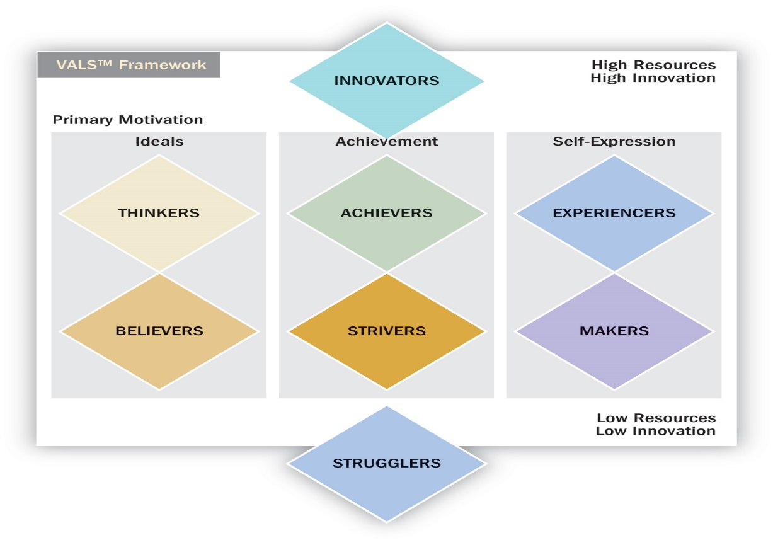

Geodemography analytical techniques that combine data on consumer expenditures and other socioeconomic factors with geographic info about areas in which people live to identify consumers with common consumption patterns.
- The assumption is that people with similar needs tend to live close to eachother
- Identifying pockets of like-minded people

A value is a belief that some condition is preferable to its opposite 2 ppl can believe in the same behavior (ex; vegetarianism) but their underlying beflief system may be quite different (ex; animal activism vs heath concerns)

New core values;
- Conscientious consumerism (the growing green market, attitudes v.s behaviors)
- LOHAS = Lifestyle of health and sustainability (greed is spreading to the mass market, Walmart “live better index”

PRIZM (Potential Rating Index by Zip Market)
- A geodemographic based index
- Makes every Sip code into distinct categories
- Different clusters exhibit different consumption patters, classes, and lifestyles

