Marketing Final Notes

CHAPTER 10 – NEW PRODUCT DEVELOPMENT AND PRODUCT LIFE-CYCLE STRATEGIES

New product development strategy:
- New product development – the development of original products, product improvements, product modifications, and new brands through the firms own product-development efforts
- Why do so many new products fail?
  - Although an idea may be good the company may overestimate market size
  - Product may be poorly designed or incorrectly position, launched at the wrong time, priced too high or poorly advertised

New product development process:
- Idea generation - the systematic search for new product ideas
  - Internal idea sources – the company can find new ideas through formal research and development
  - Companies can also obtain good new-product ideas from external sources i.e. suppliers and distributors
- Idea screening – screening new product ideas to spot good ideas and drop poor ones asap
- Concept development and testing:
  - Product concept – a detailed version of the new product idea stated in meaningful consumer terms
  - Concept testing – testing new product concepts with a group of target consumers to find out if the concepts have strong consumer appeal
- Marketing strategy development – designing an initial marketing strategy for a new product based on the product concept
  - Marketing strategy statement – consists of 3 parts
    - First – describes the target market, the planned value proposition and the sales, market share and profit goals for the first few years
    - Second – outlines the products planned price, distribution, and marketing budget for the first year
    - Third – describes the planned long-run sales, profit goals and marketing mix strategy
- Business Analysis – a review of the sales, costs, and profit projections for a new product to find out whether these factors satisfy the company’s objectives
- Product development – developing the product concept into a physical product to ensure that the product idea can be turned into a workable market offering
- Test marketing – the stage of new product development in which the product and marketing program and tested in realistic market setting
  - Standard test markets - The company finds a small number of representative test cities, conducts a full marketing campaign in those cities and uses store audits, consumer and distributor surveys and other measures to gauge product performance
  - Controlled test markets – usually cost less than standard test markets
- Commercialization – introducing a new product into the market
- Customer-centered new-product development – new-product development that focuses on finding new ways to solve customer problems and create more customer problems and create more customer satisfying experiences
- Team based new product development – an approach to developing new products in which various company departments work closely together, overlapping the steps in the product-development process to save time and increase effectiveness
  - Under the sequential product development approach one company department works individually to complete its stage of the process before passing the new product on to the next department and stage
- Product life cycle – the course of a product’s sales and profits over its lifetime. It involves 5 distinct stages:
  - Product development – begins when the company finds and develops a new-product idea. During this stage sales are zero and the company’s investment costs mount
  - Introduction – a period of slow sales growth as the product is introduced in the market. Profits are nonexistent in this stage because of the heavy expenses of product introduction
  - Growth – is a period of rapid market acceptance and increasing profits
  - Maturity – is a period of slowdown in sales growth because the product has achieved acceptance by most potential buyers. Profits level off or decline because of increased marketing outlays to defend the product against competition
  - Decline – the period when sales fall off and profits drop

- Introduction stage – the product life-cycle stage in which the new product is first distributed and made available for purchase
- Growth stage – the product life-cycle stage in which a product’s sales start climbing quickly
- Maturity stage – the product life-cycle stage in which sales growth slows or levels off
- Decline stage – the product life-cycle stage in which a product’s sales decline

CHAPTER 11 – PRICE

- Price – the amount of money charged for a product or service, or the sum of the values that customers exchange for the benefits of having or using the product or service
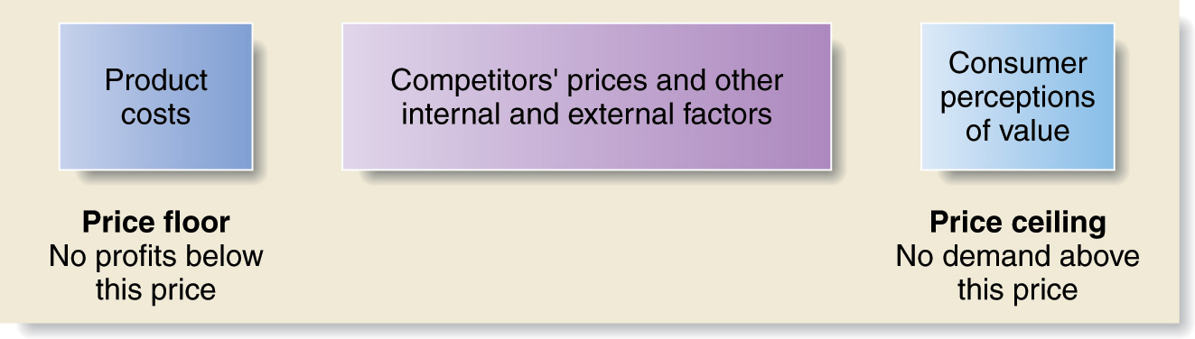
- Value based pricing – setting price based on buyers’ perceptions of value rather than on the seller’s cost
  - Good-value pricing – offering just the right combination of quality and good service at a fair price
  - Value-added pricing – attaching value-added features and services to differentiate a company’s offers and charging higher prices
- Cost-based pricing – setting prices based on the costs for producing, distributing, and selling the product plus a fair rate of return for effort and risk
  - Fixed costs (overhead) – costs that do not vary with production or sales level
  - Variable costs – costs that vary directly with the level of production
  - Total costs – the sum of the fixed and variable costs for any given level of production
- Experience curve (learning curve) – the drop in the average per-unit production cost that comes with accumulated production experience
- Cost-plus pricing – adding a standard markup to the cost of the product

- Break-even pricing (target profit pricing) – setting price to break even on the costs of making and marketing a product, or setting price to make a target profit
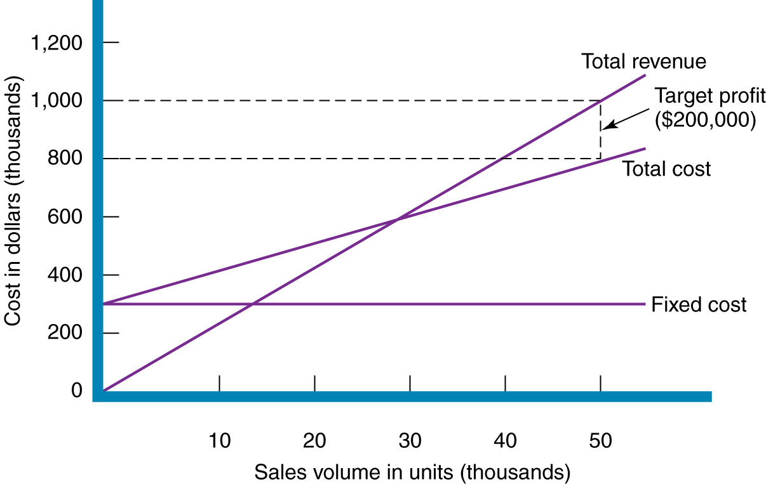

- Target costing – pricing that starts with an ideal selling price, then targets costs that will ensure that the price is met
- The market and demand
  - Under pure competition – market consists of many buyers and sellers trading in a uniform commodity such as wheat, copper, or financial securities. No single buyer or seller has much effect on the going market price. A seller cannot charge more than the going price
  - Under monopolistic competition – the market consists of many buyers and sellers who trade over a range of prices rather than a single market price. A range of prices occurs because the sellers can differentiate their offers to buyers
  - Under oligopolistic competition – the market consists of a few sellers who are highly sensitive to each other’s pricing and marketing strategies. The product can be uniform or no uniform. There are few sellers because it is difficult for new sellers to enter the market
  - Pure monopoly – the market consists of one seller
- Demand curve – a curve that shows the number of units the market will buy in a given time period, at different prices that might be charged
- Price elasticity – a measure of the sensitivity of demand to changes in price
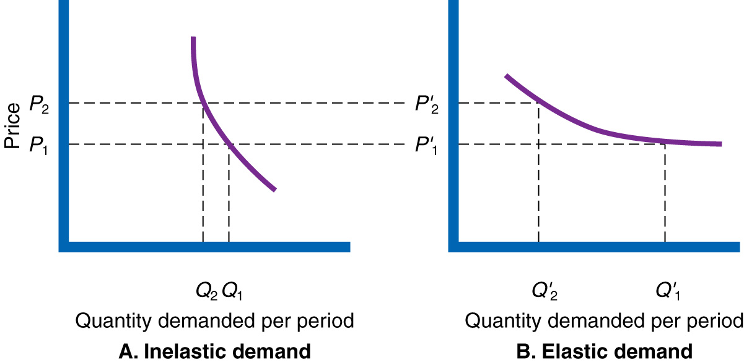

New product pricing strategies:
- Market-skimming pricing – setting a high price for a new product to skim maximum revenues layer by layer from the segments willing to pay the high price; the company makes fewer but more profitable sales
- Market-penetration pricing – setting a low price for a new product to attract a large number of buyers and a large market share

Product mix pricing strategies:
- Product line pricing – setting the price steps between various products in a product line based on cost differences between the products, customer evaluations of different features and competitors prices
- Optional-product pricing – the pricing of optional or accessory products along with a main product
- Captive product pricing – setting a price for products that must be used along with a main product, such as blades for a razor and ink for a printer
- By-product pricing – setting a price for by-products to make the main product’s price more competitive
- Product bundle pricing – combining several products and offering the bundle at a reduced price

Price adjustment strategies:
- Discount – a straight reduction in price on purchases during a stated period of time
- Allowance – promotional money paid by manufacturers to retailers in return for an agreement to feature the manufacturer’s products in some way
- Segmented pricing – selling a product or service at two or more prices, where the difference in prices in not based on differences in costs
- Psychological pricing – a pricing approach that consider the psychology of prices and not simply the economics; the price is used to say something about the product
- Reference prices – prices that buyers carry in their minds and refer to when they look at a given product
- Promotional pricing – temporarily pricing products below the list pricer and sometimes even below cost, to increase short run sales
- Geographical pricing – setting prices for customers located in different parts of the world
  - FOB-origin pricing – a geographical pricing strategy in which goods are placed free on board a carrier; the customer pays the freight from the factory to the destination
  - Uniform-delivery pricing – a geographical pricing strategy in which the company charges the same price plus freight to all customers regardless of their location
  - Zone pricing – a geographical pricing strategy in which the company sets up two or more zones. All customers within a zone pay the same total price; the more distant the one, the higher the price
- Dynamic pricing – adjusting prices continually to meet the characteristics and needs of individual customers and situations

CHAPTER 12 – CUSTOMER VALUE

Supply chains and the value delivery network:
- Value delivery network – the network made up of the company suppliers, distributors, and ultimately customers who “partner” with each other to improve the performance of the entire system in delivering customer value

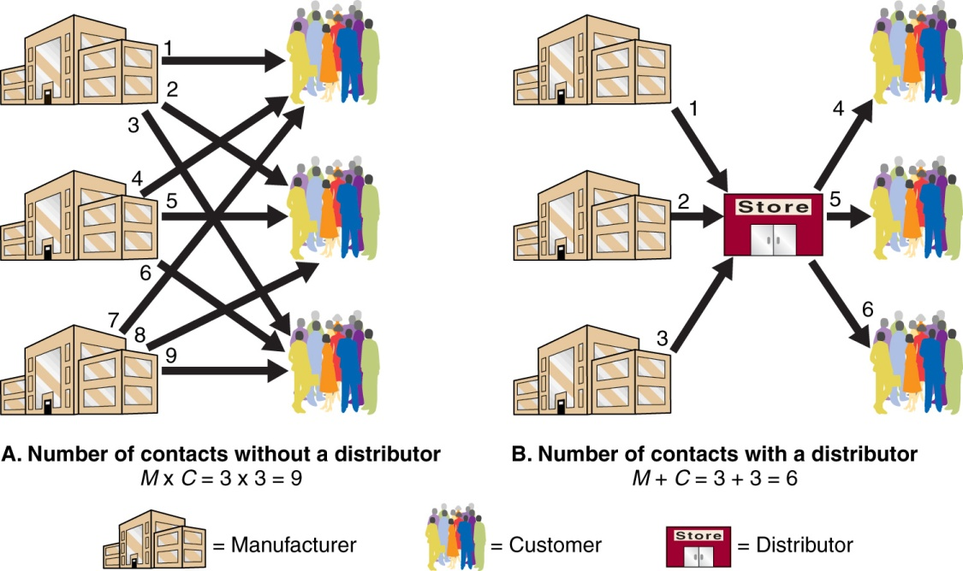

Marketing Channels:
- Marketing channel (distribution channel) – a set of interdependent organizations that help make a product or service available for use or consumption by the consumer or business user
- Channel level – a layer of intermediaries that perform some work in bringing the product and its ownership closer to the final buyer
- Direct marketing channel – a marketing channel that has no intermediary levels
- Indirect marketing channel – a marketing channel containing one or more intermediary levels
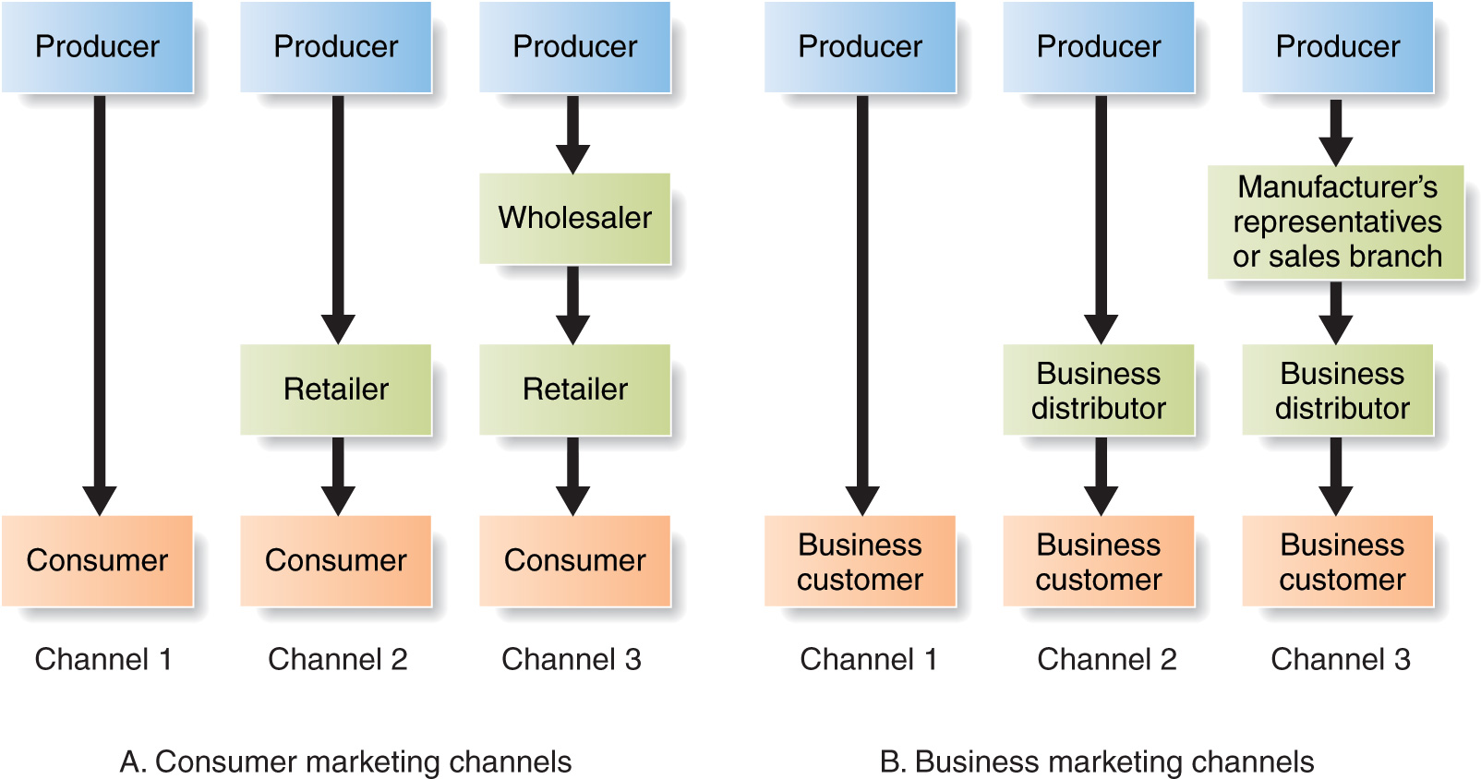

- Channel conflict – disagreements among marketing channel members on goals and roles – who should do what and for what rewards
- Conventional distribution channel – a channel consisting of one or more independent producers, wholesalers and retailers, each a separate business seeking to maximize its own profits, even at the expense of profits for the system as a whole
- Vertical marketing system (VMS) – a distribution channel structure in which producers, wholesalers, and retailers act as a unified system. One channel member owns the others, has contracts with them, or has so much power that they must all cooperate
- Corporate VMS – a vertical marketing system that combines successive stages of production and distribution under single ownership- channel leadership is established through common ownership
- Contractual VMS – a VMS in which independent firms at different levels of production and distribution join together through contracts to obtain more economies or sales impact then they could achieve alone
  - Franchise organization – a contractual vertical marketing system in which a channel member, called a franchisor, links several stages in the production-distribution process
- Administered VMS – a VMS that coordinates successive stages of production and distribution, not through common ownership or contractual ties, but through the size and power of one of the parties
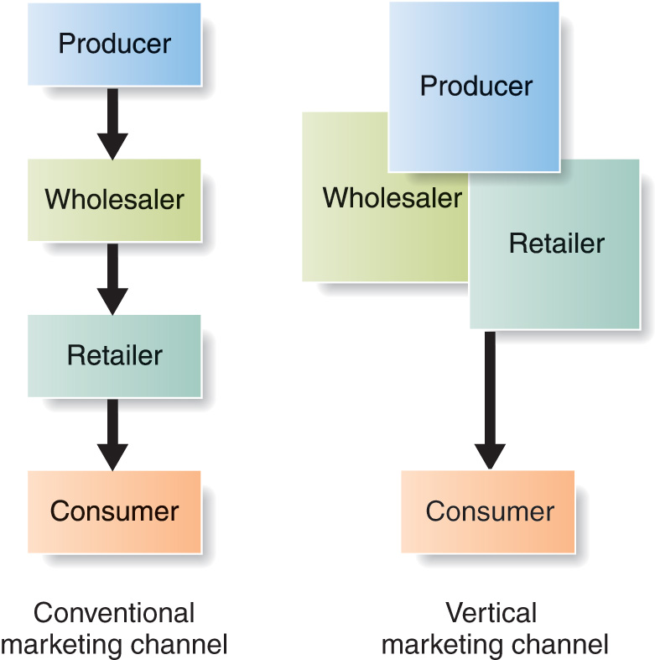

- Horizontal marketing system- a channel arrangement in which two or more companies at one level join together to follow a new marketing opportunity
- Multichannel distribution system – a distribution system in which a single firm sets up two or more marketing channels to reach one or more customer segments
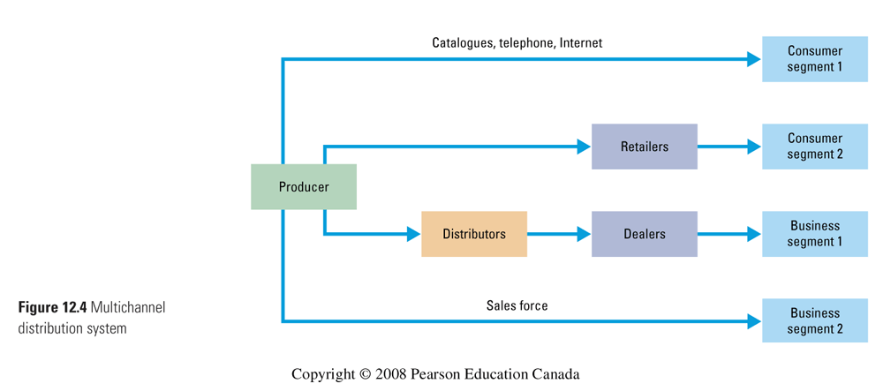
- Disintermediation - the cutting out of marketing channel intermediaries by product or service producers, or the displacement of traditional resellers by radical new types of intermediaries

Marketing channel design decisions:
- Marketing channel design – designing effective marketing channels by analyzing consumer needs, setting channel objectives, identifying major channel alternatives, and evaluating them
- Identifying alternatives involves deciding on the number of marketing intermediaries:
  - Intensive distribution – stocking the product in as many outlets as possible
  - Exclusive distribution – giving a limited number of dealers the exclusive right to distribute the company’s products in their territories
  - Selective distribution – the use of more than one but fewer than all the intermediaries who are willing to carry the company’s products
- Evaluating alternatives involves:
  - Economic criteria – compares the likely sales, costs, and profitability of different channel alternatives
  - Control issues – using intermediaries usually means giving them some control over marketing. Some take more control than others – company generally prefers to keep as much control as possible
  - Adaptive criteria – channels usually involve long term commitments, yet the company wants to keep the channel flexible so that it can adapt to environmental changes

Channel management decisions:
- Marketing channel management – selecting, managing and motivating individual channel members and evaluating their performance over time

Public policy and distribution decisions:
- American marketing association (AMA) code puts into question practices around these issues:
- Exclusive dealing – when the seller allows only certain outlets to carry its products – legal as long as they do not substantially lessen competition or tend to create a monopoly
- Exclusive territories – illegal when a producer tries to keep a dealer from selling outside its territory
- Trying agreements – producer sells to dealer only if dealer will take some or all of the rest of the line – legal but causes channel conflict
- Dealers’ rights – the right of producers to drop dealers is somewhat restricted
- Sources of supply – cheaper oversees labor – ethical issues

Marketing Logistics and supply chain management:
- Marketing logistics (physical distribution) – planning, implementing and controlling the physical flow of materials, final goods, and related information from points of origin to points of consumption to meet customer requirements art a profit
- Supply chain management – managing upstream and downstream value-added flows of materials, final goods and related information among suppliers, the company, resellers and final consumers
- Distribution center – a large, highly automated warehouse designed to receive goods from various plants and suppliers, take orders, fill them efficiently, and deliver goods to customers as quickly as possible
- Intermodal transportation – combining two or more modes of transportation

CHAPTER 14 – COMMUNICATIONS STRATEGY

The promotion mix:
- Promotion mix (marketing communications mix) – the specific blend of promotion tools that the company uses to persuasively communicate customer value and build customer relationships
  - Advertising – any paid form of nonpersonal presentation and promotion of ideas, goods, or services by an identified sponsor
  - Sales promotion – short-term incentives to encourage the purchase of sale of a product or service
  - Personal selling – personal presentation by the firm’s sales force for the purpose of making sales and building customer relationships
  - Public relations – building good relations with the company’s various publics by obtaining favorable publicity. Building up a good corporate image, and handling or heading off unfavorable rumors, stories and events
  - Direct marketing – direct connections with carefully targeted individual consumers to both obtain an immediate response and cultivate lasting customer relationships
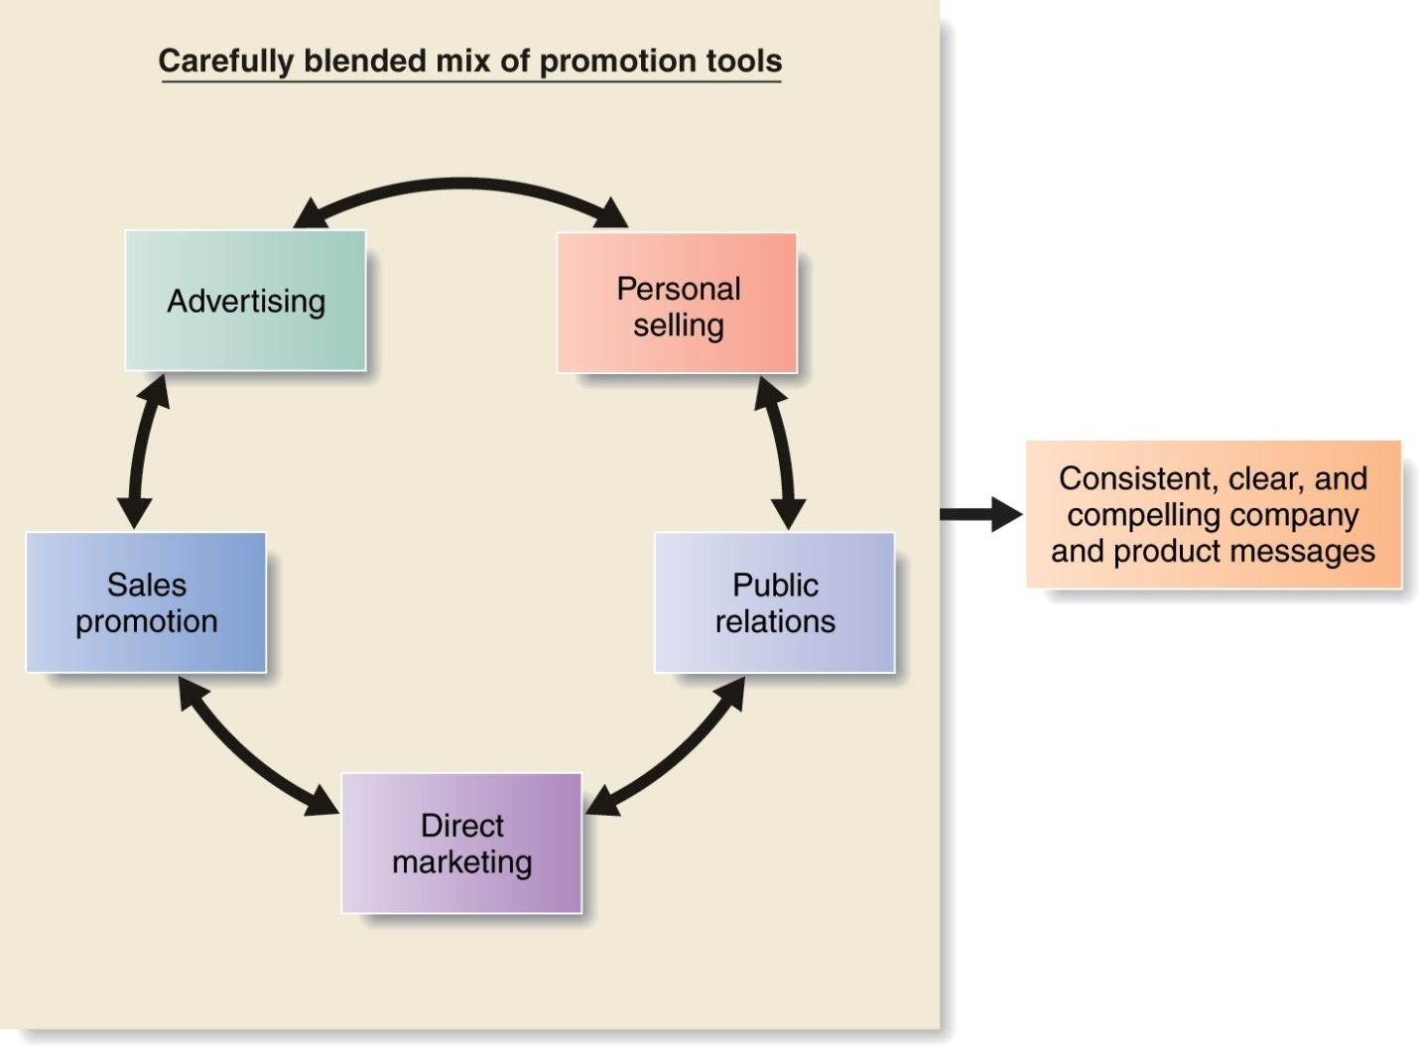

Integrated marketing communications:
- Integrated marketing communications (IMC) – carefully integrating and coordinating the company’s many communications channels to deliver a clear, consistent and compelling message about the organization and its products

Steps in developing effective marketing communications:
- Identify the target audience
- Determining the communication objectives
  - Buyer-readiness stages – stages consumers usually pass through on their way to purchase:
    - Awareness
    - Knowledge
    - Liking
    - Preference
    - Conviction
    - Purchase
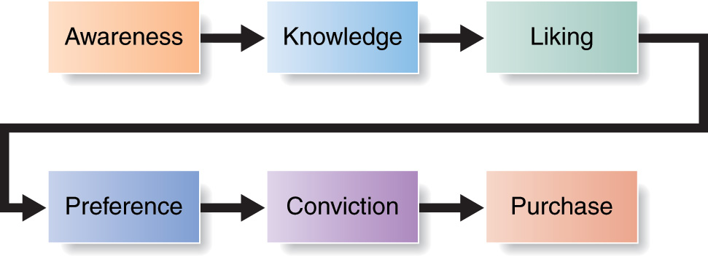

- Design a message
- Choose media
  - Personal communication channels – channels through which two or more people communicate directly with each other, including face to face, on the phone, through mail or email or even through an internet chat
  - Word of mouth influence – personal communication about a product between target buyers and neighbors, friends, family or associates
  - Buzz marketing – cultivating opinion leaders and getting them to spread information about a product or service to others in their communities
  - Nonpersonal communication channels – media that carry messages without personal contact or feedback, including major media atmosphere and events
- Select the message source
- Collect feedback

Setting the total promotion budget and mix:
- Affordable method – setting the promotion budget at the level management thinks the company can afford
- Percentage of sales method – setting the promotion budget at a certain percentage of current or forecasted sales or as a percentage of the unit sales price
- Competitive- parity method – setting the promotion budget to match the competitor’s outlays
- Objective and task method – developing the promotion budget by
  - Defining specific objectives
  - Determining the tasks that must be performed to achieve them
  - Estimating the costs of performing these tasks
  - The sum of these costs is the proposed promotion budget

- Advertising
  - Can reach masses of geographically dispersed buyers at a low ost per exposure
  - For companies who want to reach a mass audience – tv is the place to be
  - Large scale advertising says something positive about seller’s size and success
  - Consumers tend to view advertised products as more legit
  - Helps build long term image
  - Very expensive
  - Impersonal
  - One-way communication

- Personal selling
  - Most effective tool at certina stages of buying process – particularly in building buyer preferences and actions
  - Builds customer relationships
  - Solve customer problems
  - Sales force requires longer term commitment
  - Most expensive promotion tool

- Sales promotion
  - Coupons, contests, deals…
  - Strong incentive to purchase
  - Invite and reward quick response
  - Effects are short lived
  - Not as effective in building long term brand preference or customer relationships

- Public relations
  - Believable – news stories, features, sponsorships, events…
  - Can reach people who avoid sales people and ads

- Direct marketing
  - Direct mail, catalogues, telephone marketing, online marketing …
  - Less public
  - Immediate and customized
  - Interactive

Promotion mix strategies:

- Push strategy – promotion strategy that calls for using the sales force and trade promotion to push the product through channels. The producer promotes the product to channel members who in turn promote it to final customers
- Pull strategy – a promotion strategy that calls for spending a lot on advertising and consumer promotion to induce final consumers to buy the product, creating a demand vacuum that “pulls” the product through the channel
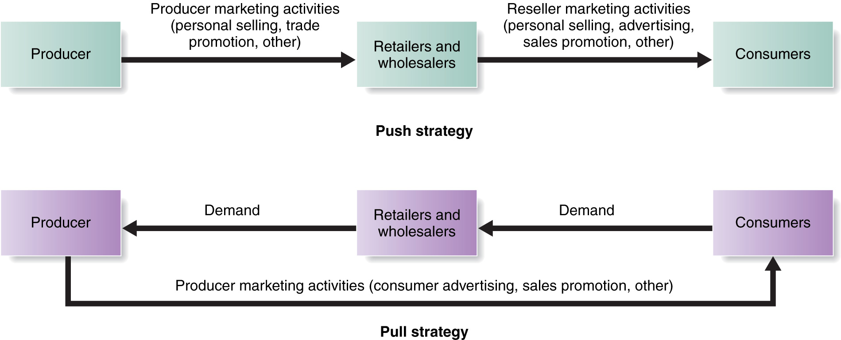

Integrating the promotion mix:
- Start with customers
- Analyze trends- internal and external
- Audit the pockets of communications spending throughout the organization
- Team up in communications planning
- Create compatible themes, tones, and quality across all communications media
- Create performance measures that are shared by all communications elements
- Appoint a director responsible for the company’s persuasive communications efforts

CHAPTER 15 – ADVERTISING AND PUBLIC RELATIONS

Advertising:
- Advertising – any paid form of nonpersonal presentation and promotion of ideas, goods, or services by an identified sponsor
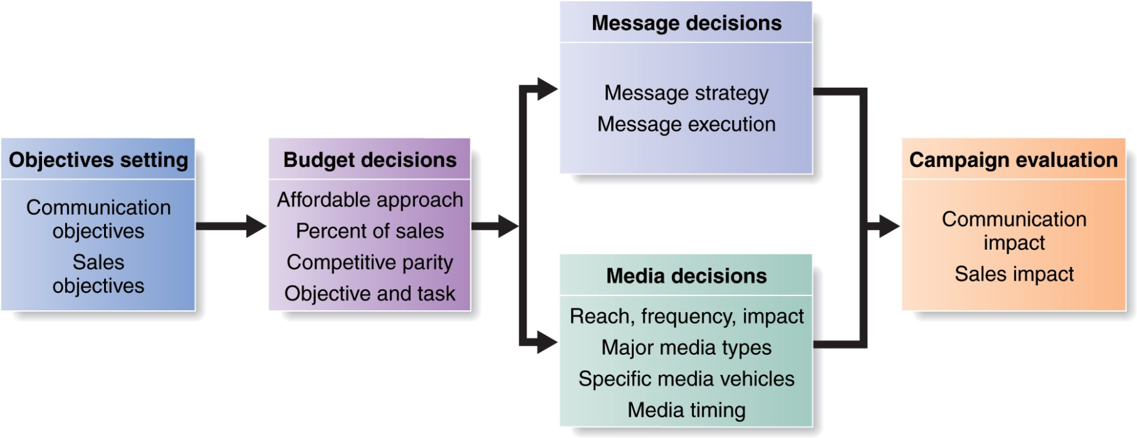
- Advertising objective – a specific communication task to be accomplished with a specific target audience during a specific period of time
  - Informative advertising – used heavily when introducing a new product category
  - Persuasive advertising – becomes more important as competition increases
  - Reminder advertising – important for mature products to help maintain customer relationships and keep customers thinking about the product
- Advertising budget – the dollars and other resources allocated to a product or company advertising program
- Advertising strategy – the strategy by which the company accomplishes its advertising objectives. It consists of two major elements: creating advertising messages and selecting advertising media
- Madison and vine – a term that has come to represent the merging of advertising and entertainment in an effort to break through the clutter and create new avenues for reaching consumers with more engaging messages
- Creative concept – the compelling “big idea” that will bring the advertising message strategy to life in a distinctive and memorable way
- Execution style – the approach, style, tone, words, and format used for executing an advertising message
- Advertising media – the vehicles through which advertising messages are delivered to their intended audiences
- Return on advertising investment – the net return on advertising investment divided by the costs of the advertising investment
- Advertising agency – a marketing services firm that assists companies in planning, preparing, implementing, and evaluating all or portions of their advertising programs

Public relations:
- Public relations - building good relations with the company’s various publics by obtaining favorable publicity, building up a good corporate image and handling or heading off unfavorable rumors, stories, and events

CHAPTER 16 – PERSONAL SELLING AND SALES PROMOTION

Personal Selling:
- Personal selling – personal presentation by the firm’s sales force for the purpose of making sales and building customer relationships
- Sales person – an individual representing a company to customers by performing one or more of the following activities: prospecting, communicating, selling, servicing, information gathering or relationship building

Managing the Sales force:
- Sales force management – the analysis, planning, implementation, and control of sales force activities. It includes designing sales force strategy and structure, and recruiting, selecting, training, supervising, compensating and evaluating the firm’s salespeople
- Territorial sales force structure – a sales force organization that assigns each salesperson to an exclusive geographic territory in which that salesperson sells the company’s full line
- Product sales force structure – a sales force organization under which salespeople specialize in selling only a portion of the company’s products or lines
- Customer sales force structure – a sales force organization under which salespeople specialize in selling only to certain customers or industries
- Outside sales force (field sales force) – outside salespeople who travel to call on customers in the field
- Inside sales force – inside salespeople who conduct business from their offices via telephone, the internet, or visits from prospective buyers
- Team selling – using teams of people from sales, marketing, engineering, finance, tech. support, and even upper management to service large complex accounts

The personal selling process:
- Selling process – the steps that the salesperson follows when selling, which include prospecting and qualifying, pre-approach, approach, presentation and demonstration, handling objections, closing and follow up
- Prospecting – step in which the salesperson or company identifies qualified potential customers
- Pre-approach – step in which the salesperson learns as much as possible about a prospective customer before making a sales call
- Approach- step in which the salesperson meets the customer for the first time
- Presentation – step in which the salesperson tells the “value story” to the buyer, showing how the company’s offer solves the customer’s problems
- Handling objections – step in which the salesperson seeks out, clarifies, and overcomes customer objections to buying
- Closing – step in which the salesperson asks the customer for an order
- Follow up – final step – salesperson follows up after the sale to ensure customer satisfaction and repeat business

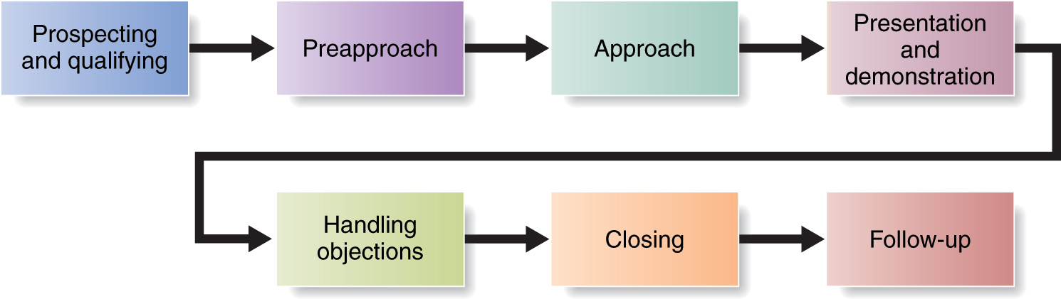
Sales Promotion:
- Sales promotion – short-term incentives to encourage the purchase or sale of a product or service
- Consumer promotions – sales promotion tools used to boost short-term customer buying and involvement or to enhance long-term customer relationships
- Event marketing – creating a brand-marketing event or serving as a sole or participating sponsor of events created by others
- Trade promotions – sales promotion tools used to persuade resellers to carry a brand, give it shelf space, promote it in advertising, and push it to consumers
- Business promotions – sales promotion tools used to generate business leads stimulate purchases, reward customers, and motivate salespeople

CHAPTER 17 - DIRECT AND ONLINE MARKETING

Direct marketing:
- Direct marketing – connecting directly with carefully targeted individual consumers to both obtain an immediate response and cultivate lasting customer relationships
- Customer database – an organized collection of comprehensive data about individual customers or prospects, including geographic demographic, psychographic, and behavioral data
- Direct-mail marketing – direct marketing by sending an offer, announcement, reminder or other item to a person at a particular physical or virtual address
- Catalogue marketing – direct marketing through print, video, or digital catalogues that are mailed to selected customers, made available in stores or presented online
- Telephone marketing – using the telephone to sell directly to customers
- Direct response television marketing –direct marketing via television, including direct-response television advertising (infomercials) and home shopping channels

Online marketing:
- Online marketing – company efforts to market products and services and build customer relationships over the internet
- Internet – a vast public web of computer networks that connects users of all types all around the world to reach other and to an amazingly large information repository
- Online companies – the so-called dot-coms, which operate only online without any brick-and-mortal market presence
- Hybrid or click-and-mortar companies – traditional companies that have added online marketing to their operations

- Business-to-consumer (B2C) online marketing – businesses selling goods and services online to final customers
- Business-to-business (B2B) online marketing – businesses using B2B websites, email, online catalogues, online trading networks, and other online resources to reach new business customers, serve current customers more effectively, and obtain buying efficiencies and better prices
- Consumer-to-consumer (C2C) online marketing – online exchanges of goods and information between final consumers
- Consumer-to-business (C2B) online marketing – online exchanges in which consumers search out sellers, learn about their offers, and initiate purchases, sometimes even driving transaction terms
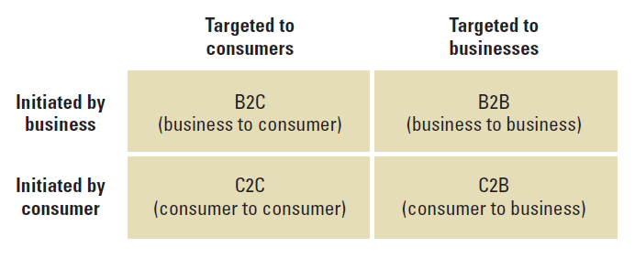

- Corporate (or brand) website – a website designed to build customer goodwill, collect customer feedback, and supplement other sales channels, rather than to sell the company’s products directly
- Marketing website – a website that engages consumers in interactions that will move them closer to a direct purchase or other marketing outcome

- Online advertising – advertising that appears while consumers are surfing the web, including display ads, search-related ads, online classifieds, and other forms
- Viral marketing – internet version of word-of-mouth marketing – websites, videos, email messages or other marketing events that are so infectious that customers will want to ass them along to friends
- Online social networks – online social communities – blogs, social networking websites, or even virtual worlds- where people socialize or exchange information and opinions
- Spam – unsolicited, unwanted commercial email messages

CHAPTER 19 – THE GLOBAL MARKETPLACE

Global marketing:
- Global firm – a firm that, by operating in more than one country, gains R&D, production, marketing, and financial advantages in its costs and reputation that are not available to purely domestic competitors
- Economic community – a group of nations organized to work toward common goals in the regulation of international trade
- Countertrade – international trade involving the direct or indirect exchange of goods for other foods instead of cash

Deciding how to enter the market:
- Exporting – entering a foreign market by selling goods produced in the company’s home country, often with little modification
- Joint venturing – entering foreign markets by joining with foreign companies to produce or market a product or service
  - Licensing – a method of entering a foreign market in which the company enters into an agreement with a licensee in the foreign market
  - Contract manufacturing – a joint venture in which a company contracts with manufacturers in a foreign market to produce its product or provide its service
  - Management contracting – a joint venture in which the domestic firm supplies the management know-how to a foreign company that supplies the capital; the domestic firm exports management services rather than products
  - Joint ownership – a joint venture in which a company joins investors in a foreign market to create a local business in which the company shares joint ownership and control
- Direct investment – entering a foreign market by developing foreign-based assembly or manufacturing facilities
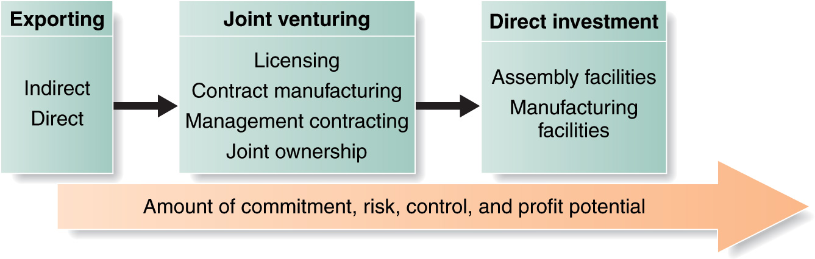
Deciding on the global marketing project:
- Standardized global marketing – an international marketing strategy for using basically the same marketing strategy and mix in all the company’s international markets
- Adapted global marketing – an international marketing strategy for adjusting the marketing strategy and mix elements to each international target market, bearing more costs but hoping for a larger market share and return
- Product:
  - Straight product extension – marketing a product in a foreign market without any change
  - Product adaptation – adapting a product to meet local conditions or wants in foreign markets
  - Product invention – creating new products or services for foreign markets
- Promotion:
  - Communication adaptation – a global communication strategy of fully adapting advertising messages to local markets
- Distribution channels:
  - Whole-channel view – designing international channels that take into account the entire global supply chain and marketing channel, forging an effective global value delivery network

