Chapter 4-Theories of Motivation
Thursday, February 25, 2016
1:17 PM

  - Motivation
    - The process that accounts for an individual's intensity , direction and persistence of effort toward reaching a goal
    - Intensity
      - How hard a person tries
    - Direction
      - High intensity is unlikely to lead to favorable job performance outcomes unless the effort is channeled in the right direction
    - Persistence
      - How long a person can maintain effort
  - Theory X
    - Negative
    - Employees dislike work
    - Will attempt to avoid it, must be coerced, controlled or threatened with punishment to achieve goals
  - Theory Y
    - Positive
    - Suggests that employees like work, are creative, seek responsibility and will exercise self-direction if they are committed to the objectives
  - Intrinsic Motivators
    - Internal desire to do something , due to such things as interest, challenge and personal satisfaction
    - When individuals care about their work, look for better ways to do it and are energized and fulfilled by doing it
    - Rewards come from the work itself
    - Theory Y
  - Extrinsic Motivators
    - Come from outside the person and include such things as pay, bonuses and other tangible rewards
    - Theory X
  - Needs Theories of Motivation
    - Fall into 2 categories
      - Needs theories
      - Process theories
    - Needs theories
      - Describe the types of needs that must be met to motivate individuals
      - Maslow's Hierarchy of Needs
        - Hierarchy of 5 needs
          - Physiological
            - Hunger, thirst, shelter, sex, and other bodily needs
          - Safety
            - Security, protection from physical and emotional harm
          - Social
            - Affection, belongingness, acceptance and friendship
          - Esteem
            - Internal esteem factors such as self-respect, autonomy, achievement
            - External esteem factors such as status, recognition and attention
          - Self-actualization
            - Growth, achieving potential, self-fulfillment
            - 
        - Lower-order needs
          - Physiological needs
          - Safety needs
          - Satisfied externally
          - Linked to positive self evaluation
        - Higher-order needs
          - Social belonging
          - Self-esteem
          - Self-actualization
          - Satisfied internally
          - Linked to enjoying life
      - Herzberg's motivation -hygiene theory (two factor theory)
        - Believing that an individual's relationship to work is basic and that attitude toward this work can very well determine success or failure
        - Removing dissatisfying aspects of a job does not make it satisfying
        - Proposed a dual continuum
          - Satisfaction and not satisfaction
          - Dissatisfaction and no dissatisfaction
        - Relates intrinsic factors to job satisfaction and associates extrinsic factors with dissatisfaction
        - Managers will seek to eliminate factors that create job dissatisfaction may bring about peace but not motivation
        - Hygiene factors
          - Quality of supervision, pay, company policy, physical working conditions, relationship with others and job security
          - When these factors are adequate people will not be dissatisfied but neither will they be satisfied
          - 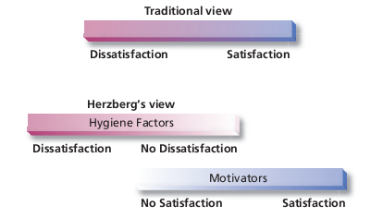
          - Critics
            - Limited to the reliance of self-reports
              - when things are going well, people take credit. When things are bad people blame extrinsic factors
            - Reliability is questionable
              - Have to make interpretations so they may contaminate the findings
            - No overall measure of satisfaction
              - A person may dislike a part of their job but like their job overall
            - Assumed that there is a relationship between satisfaction and productivity
              - Looked only at satisfaction
      - McClelland's theory of needs
        - Three needs
        - Need for achievement (nAch)
          - The drive to excel, to achieve in relation to a set of standards and to strive to succeed
        - Need for power (nPow)
          - Need to make others behave in a way that they would not have behaved otherwise
        - Needs for affiliation (nAff)
          - The desire for friendly and close interpersonal relationships
      - Criticized for not standing up to scientific review
      - Individuals have needs that when unsatisfied will result inmotivation
      - 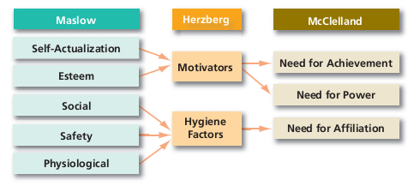

  - Process theories
    - Help us understand the actual ways in which we and others can be motivated
    - Expectancy Theory
      - Employees will be motivated to exert a high level of effort when they believe the following
        - That the effort will lead to good performance
        - That good performance will lead to organizational rewards such as salary increase or intrinsic rewards
        - That the rewards will satisfy employee's personal goals
      - Focuses on three relationships, expectancy, instrumentality and valence
      - 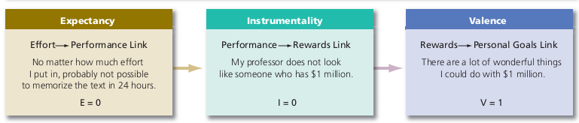
      - Effort-Performance Relationship
        - Expectancy
        - If a give max effort, will it be recognized in my performance appraisal?
        - People will only be motivated of they perceive a link between their effort and their performance
        - Expressed as a probability from 0-1
      - Performance-Rewards Relationship
        - Instrumentality
        - If I get a good performance appraisal, will it lead to organizational rewards?
        - Ranges from -1 to 1
        - A negative instrumentality indicates that high performance reduces the chances of getting the desired outcome
        - Instrumentality of 0 indicates that no relationship exists between performance and receiving the desired outcome
      - Rewards-Personal Goals Relationship
        - Valence
        - If I'm rewarded, are the rewards attractive to me?
        - Matching the reward to what the employee wants
        - Ranges from -1(very undesirable reward) to 1(very desirable reward)
      - 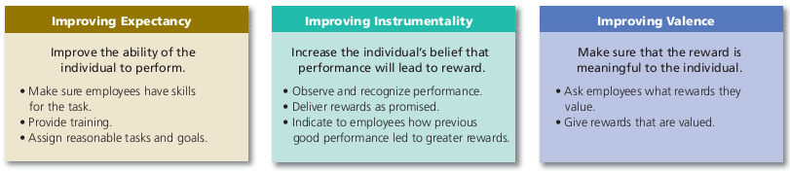

  - Goal Setting Theory
    - The impressive effects of goal specificity, challenge and feedback on performance
    - The intentions to work towards a goal are a major source of work motivation
    - Management by objectives (MBO)
      - Emphasizes participative set goals that are tangible, verifiable and measurable
      - Progress on goals is periodically reviewed and rewards are allocated on the basis of this progress
    - How does goal setting motivate?
      - Goals direct attention
        - Goals indicate where individuals should direct their efforts when they are choosing among thigs to do
      - Goals regulate effort
        - How much effort an individual should put into a given task
      - Goals increase persistence
        - Persistence represents the effort spent on a task over time
      - Goals encourage the development of strategies and action plans
        - Once goals are set, individuals can develop plans for achieving those goals
    - In order for goals to be effective, they should be SMART
      - S-Specific
        - Individuals know exactly what is to be achieved
      - M-Measurable
        - The goals proposed can be tracked and reviewed
      - A-Attainable
        - The goals, even if difficult are reasonable and achievable
      - R-Results-oriented
        - The goals should support the vision of the organization
      - T-Time-bound
        - The goals are to be achieved within a standard time
    - 2 Categories of people
      - Promotion focus
        - Strive for advancement and accomplishment and approach conditions that move them closer toward desired goals
      - Prevention focus
        - Strive to fulfill duties and obligations and avoid conditions that pull them away from desired goals
  - Self-efficacy theory
    - Social cognitive theory
    - Individuals' beliefs in their ability to perform a task influence their behavior
    - The higher your self-efficiency the more confidence you have in your ability to succeed at a task
    - Can create a positive spiral in which those with high efficiency become more engaged in their tasks and then in turn, increase performance which increases efficiency further
    - Goal setting theory and self-efficacy theory complement each other
    - 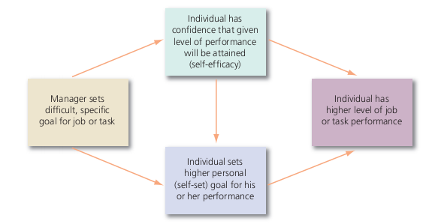
    - Ways self-efficacy can be increased
      - Enactive mastery
        - Gaining relevant experience with the task or job
      - Vicarious modelling
        - Becoming more confident because you see someone else doing the task
      - Verbal persuasion
        - Becoming more confident because someone convinces you that you have the skills necessary to be successful
        - Pygmalion Effect or the Galatea Effect
          - A form of self-fulfilling prophecy in which believing something can make it true
      - Arousal
        - An energized state, so the person gets "psyched up" and performs better
  - Reinforcement theory
    - Arguing that reinforcement conditions behavior
    - See behavior as environmentally caused
    - Behavior is a function of consequences
    - Ignores the inner state of the individual and concentrates solely on what happens when he/she takes some action
    - Operant Conditioning Theory
      - People can learn to behave to get something they want or to avoid something they don’t want
      - Influenced by the reinforcement or lack of reinforcement brought about by its consequences
      - Creating pleasant consequences to follow specific forms of behavior would increase the frequency of that behavior
      - Behaviorism
        - Asserts that behavior follows stimuli in a relatively unthinking manner
        - Rejects feelings, thoughts, and other states of mind as causes of behavior
      - Methods of Shaping Behavior
        - Can be shaped in 4 ways
          - Positive reinforcement
            - Following a response with something pleasant
          - Negative reinforcement
            - Following a result with the termination or withdrawal of something unpleasant
          - Punishment
            - Causing an unpleasant condition in an attempt to eliminate an undesirable behavior
          - Extinction
            - Eliminating any reinforcement that is maintaining a behavior
  - 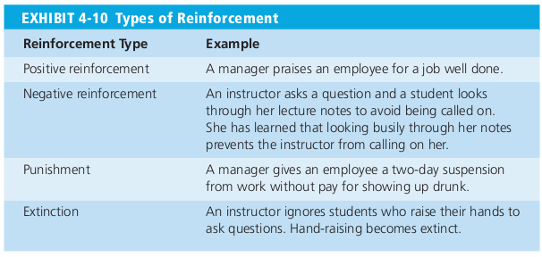
    - Intermittent Reinforcement
      - Schedule can be a ratio or interval type
      - Depends on how many responses a subject makes
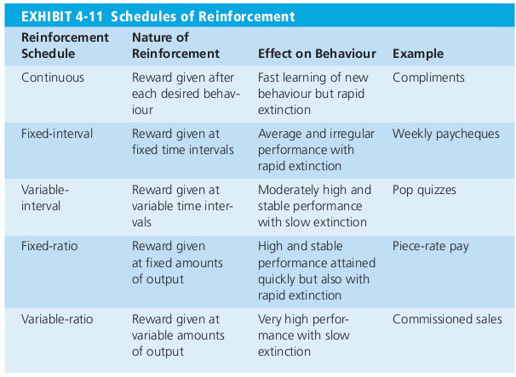
  - Equity Theory
    - Employees compare what they get for their job (their "outcomes" such as pay, promotions, recognition, or having a corner office) to what they put into it( their "inputs" such as effort, experience and education)
    - They take the ratio of their outcomes to their inputs and compare it to the ratio of others
    - 4 comparisons that an employee can use
      - Self-inside
        - An employee's experience in a different position inside his or her current organization
      - Self-outside
        - An employee's experiences in situation or position outside his or her current organization
      - Other-inside
        - Another individual or group of individuals inside the employees organization
      - Other-outside
        - Another individual or group individuals outside the employee's organization
    - Employees who perceive an inequality will make one of six choices
      - Change their inputs
        - Exert less effort it underpaid or more if overpaid
      - Change their outcomes
        - Individuals paid on a piece rate basis can increase their pay by producing a higher quantity of units of lower quality
      - Adjust perception of self
      - Adjust perception of others
      - Choosing a different referent
      - Leaving the field
  - Fair Process and Treatment
    - Organizational justice
      - Justice in the workplace
      - How employees feel authorities and decision-makers at work treat them
      - 4 dimensions of how employees are treated
        - Distributive justice
          - Concerned with the fairness of the outcomes that employees receive
        - Procedural Justice
          - Perceived fairness of process used to determine outcome
        - Informational justice
          - Perceived truthfulness of explanation for decisions
        - Interpersonal Justice
          - Perceived degree to which one is treated with dignity and respect
  - Self-Determination Theory
    - Proposes that people refer to feel they have control over their actions so anything that makes a previously enjoyed task feel more like an obligation than a freely chosen activity will undermine motivation
    - Cognitive evaluation theory
      - Hypothesizes that extrinsic rewards will reduce intrinsic interest in a task
    - Self-concordance
      - Considers how strongly people's reasons for pursuing goals are consistent with their interests and core values
      - If individuals pursue goals because of intrinsic interest, they are more likely to attain their goals and are happy even if they do not attain them
      - People who pursue goals because of extrinsic interest, are less likely to attain them
  - Increasing Intrinsic Motivation
    - Key rewards that increase an individual's extrinsic motivation
      - Sense of choice
        - The opportunity to select what one will do and perform the way one thinks best
      - Sense of competence
        - The feeling of accomplishment for doing a good job
      - Sense of meaningfulness
        - The opportunity to pursue worthwhile tasks
      - Sense of progress
        - The feeling of accomplishment that one is making progress on a task and that it is moving forward
    - 4 sets of behaviors managers can use to build intrinsic rewards
      - Leading for choice
        - Empowering employees and delegating tasks
      - Leading for competence
        - Supporting and coaching employees
      - Leading for meaningfulness
        - Inspiring employees and modeling desired behaviors
      - Leading for progress
        - Monitoring and rewarding employees

