COMM 226 – Final Exam Notes

Module 1 Chapter 1: The Importance of MIS (use glearning)

- What can intro to MIS help you Learn?
  - Non-Routine Skills
    - Abstract reasoning – deals with the use of models and being able to manipulate models in ways that provide insight into scenarios
    - Systems Thinking – The ability to model components of the system and connect the inputs and outputs that help define the systems as a whole
    - Collaboration – involves giving a receiving critical feedback in an effective manner
    - Ability to experiment – having the capability to use careful reasoned analysis of ideas and developing them into something with promise and value
- What is Management Information Systems (MIS)?
  - Using technology to achieve strategic business goals and objectives
  - A group of components that interact to achieve some purpose
    - An Information systems (IS) is a group of components that interact to produce information
  - Created to solve a business problem or optimize the business in some way
  - Think of Information Systems as a tool used to accomplish organizational goals.
    - Example: developing a website for the sake of having one doesn’t solve anything – always ask, what is the company’s need the system should address it. The newest/biggest/shiniest system will not always solve the issue
  - In order to understand MIS, we must understand processes, information systems, and information
    - Processes is a way of doing something
    - Information systems involves a collection of components producing information from data
    - Information is using data in a way that provides knowledge and empowers employees to do their jobs
  - Management of Information Systems - refers to the
    - 1)creation,
    - 2)monitoring, and
    - 3) adapting... of processes, information systems, and information
  - There are tasks and responsibilities associated with with the management of IS
    - Security of the information and systems
    - Having a back-up and recovery plans for system downtimes
  - Customer Relationship Management (CRM): systems that use algorithms and databases to predict customer behaviours
- Moore’s Law
  - Prediction that has become a reality. Made by Gordon Moore – Founder of Intel in 1965
  - “The number of transistors per square inch on an integrated chip doubles every 18 months” leads to:
    - 1) computer speed is increasing exponentially (not at a stable rate every 18 months, but is continuously increasing)
    - 2) the cost for a given computing speed decreases exponentially
    - 3) data storage and data communication costs are virtually $0
    - 4) Routine tasks can be outsourced cheaply – If your job can be automated, your job is not secure.
- How does MIS relate to Organizational Strategy?
  - Porter’s Five Forces that determine industry structure
    - Consists of 3 Competitive Forces and 2 Bargaining Power Forces
    - Competitive Forces:
      - Competition from substitutes: Introduction of products or services which can substitute for an organization’s products/services while retaining the same perceived value from customers
      - Competition from new entrants: Depends on the barriers of entry into the industry (capital, regulations…). If these barriers are low, there will be increased competition
      - Competition from existing rivals: price, quality, innovation all determine degree of rivalry
    - Bargaining Power Forces:
      - Bargaining power of suppliers: if supply is low and demand is high, suppliers have greater bargaining power and can demand higher prices
      - Bargaining power of customers: If customers have more choices, they’ll have more bargaining power (high supply relative to demand)
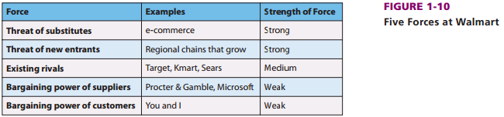
  - Ex:

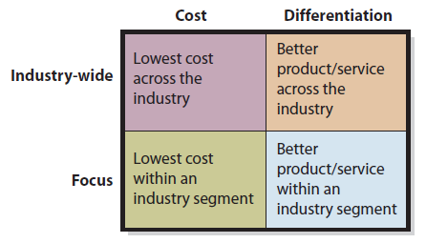
- What is Competitive Strategy?
  - Porter’s 4 factors of competitive strategy
    - Cost leader
    - Differentiation
    - Industry-Wide approach
    - Focused
  - Competitive Strategy determines the value chain
    - Value: the amount of money a customer is willing to pay for a resources/product/service
    - Margin: difference between the value an activity generates and the cost it generates
    - Value Chain: the network of value creating activities – primary and support
      - Primary activities:
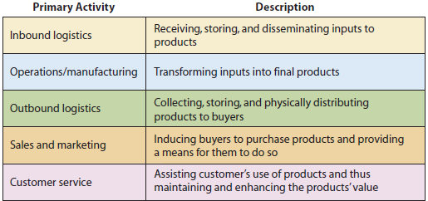

- Support Activities:
  - Procurement: selection of vendors and negotiations surrounding purchasing activities – Support Inbound logistics
  - Technology: includes things such as R&D
  - Human Resources: recruiting, compensation, training
  - Firm infrastructure: general management, finance, accounting, legal

- Value Chain Linkages
  - Interactions across value chain activities (ex: use of sales forecasts to generate production plants that result in a decrease of inventory costs)
    - Business Processes are driven by competitive strategy
    - All comprise a 5-componenet framework of computers hardware, software, data, procedures, people

Module 2 Chapter 4: Hardware and Software (read and glearning)
- Origins of Technology:
  - Early computers: ENIAC (1939-1952) came from the US government
  - Mainframes: (1952-now) Multiprocessing many could be on the same server at once
  - Microcomputers: (1975-now) were a lot smaller than the past devices and easy to hold in hand beginning of PC revolution
  - Mobile and Tablet computing: (late 1990s-now) lead to lower cost and all electronic devices grew common
- Hardware: The physical equipment used for the computer system.
  - The decision concerning the appropriate choice of hardware depends on the appropriateness for the task, speed and cost
  - Hardware is only as effective as the instructions your give it and those instructions are contained in the software
- Categories of Hardware:
  - Input Hardware: devices that input information into a computer, makes requests to the computer – ex: mouse, keyboard, scanner
  - Output Hardware: gives the user either a soft graphical representation of the content from the computer or hard copy – ex: printer, computer screen, speakers
  - Storage hardware: saves data and programs (USB keys, hard drives)
  - Processing: manipulates the data; performs logic and calculations – ex: CPU & RAM
    - The CPU = the brain of the computer
      - Performance measured in Hertz (Hz), kilohertz, megahertz, gigahertz
      - Compared based on: speed, function, cost
      - Part of the Processing component of hardware
      - Costly investment
      - Dual-processor = a computer with 2 processors, Quad-processor = computer with 4 processors
      - 32-bit VS 64-bit – 32-bit is less capable and cheaper than a 64-bit CPU

  - Main Memory: made up of RAM and ROM
    - RAM: Random Access Memory
      - Temporary (Volatile – you lose it after computer is shut down)
      - Runs programs when computer is on
      - Adding RAM lets you do more things at the same time (memory swapping)
    - ROM: Read Only Memory
      - Permanent (Non-Volatile – not deleted when computer is turned off)
      - Used to start the computer
      - Adding ROM has little impact on processing speed

- Measuring Computer Data
  - A computer talks to its different parts, as well as with itself, in Binary code (0s and 1s)
  - Each 1 or 0 = 1 bit
    - Bits are organized into groups of 8, called BYTES 8 BITS = 1 BYTE
      - Ex: 01101001
    - Each character is represented by a BYTE
    - Bits are used to represent computer data because they are easy to represent electronically (on/off, open/close)
  - Kilobyte (K) – 1024 BYTES – small files
  - Megabyte (MB) – 1024 Kilobytes (1024^2 bytes) – small programs, files, photos…
  - Gigabyte (GB) – 1024 Megabytes (1024^3 bytes) – large programs, files, photos,
  - Terabyte (TB) – 1024 Gigabytes (1024^4 bytes) – modern hard drives
  - Petabyte (PB) – 1024 Terabytes (1024^5 bytes) – used in large business
- Software:
  - Operating System (OS): controls the computer’s resources – ex: iOS, Android, Windows, Mac
    - 4 Major OS:
      - Windows
      - Mac
      - Linux
      - Unix

  - Applications Software: allows the user to perform a specific task– ex: Shazam, Calendar apps, Instagram, Facebook Messenger
    - made to run on certain operating systems – ex: Apple software like Keynote and Pages cannot be run on a Windows operating system
    - Operating systems are made to run on certain types of hardware – ex: you need an iPhone to run iOS
    - “Open-Source” means that the software was developed by a community of programmers who volunteer their time to develop it. It is often free and entirely maintained by the community
      - 3 successful open source project: Open Office, Firefox, MySQL
      - Open source is legitimate because it is low cost, quick implementation and can be edited
- Application Software Categories:
  - Horizontal Market Apps: Apps used across all organizations and industries (Word, Excel)
  - Vertical Market Apps: Apps designed for specific organizations and industries (Hotel Software, accounting programs)
  - One-Of-a-Kind Apps: applications designed for a very specific purpose (Software used by Canada Revenue Agency)
- Licensing vs. Owning Software
  - When you buy a copy of Windows/Mac OS, you DO NOT own it
  - You are provided with a license, the rights to use the program
  - Windows/Apple still own the software
  - They can technically withdraw your rights to use their program at any time
- Firmware:
  - Software that is installed into devices (printers, keyboards, etc)
  - All devices have bits of software (firmware) inside to help it talk with the computer
  - It is software for hardware (instead of for the user)
  - Helps the device turn itself on
    - For computers, this program is called BIOS (basic Input/output System)
    - Goes into the ROM and runs the instructions that turn the computer on
- Computers Interacting
  - Client: The local computer that you use
    - Run programs that the user need (Word, Photoshop)
  - Server: Computer physically located elsewhere that provides your computer with a service
    - Includes all programs that you access over the Internet (Email, Facebook)
    - Much faster, larger and costly than clients
    - Can also be a collection of computers running the same program (Server Farm)
Server
Client
Network

  - Cloud Computing: The server computer is not owned by those running the program
    - A certain space is rented
    - The network in the middle is usually the internet
    - Based on the concept of Grid Computing, meaning lots of computers are used to address a single problem (in this case, provide a service)
      - Ex – Facebook, Gmail, amazon, YouTube
  - Thin vs Thick Client Software
    - Thin Client: all you need to access the serve is a web browser (Facebook, Gmail)
      - Downside that they’re limited by capabilities of the browser
      - Advantage that no special software is required and only require a browser
    - Thick Client (native): programs other than a web browser are needed to access the server (outlook 2010)
      - Downside is that they only run on the operating system for which they’re programmed
  - Virtualization: the process where multiple operating systems share the same hardware
  - Characteristics of Quality mobile user experiences
    - User Interface (UI) – presentation format of an application (consists of windows, menus, icons, dialog boxes, toolbars, etc. as well as user content)
    - User experience (UX) – refers not only to the UI but also to the way the user responds to the application
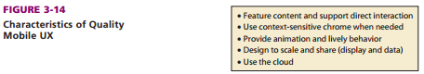

*Chrome: refers to the visual overhead in a computer display (windows, menus, other things)
- LAN – Local Area Network
  - Connects computers at a single location
  - Shared access to data, printers and other peripherals
  - Small office/Home office (SOHO LAN) connect multiple computers
  - If it’s a wired connection, the computers use a network interface card (NIC)
  - If it’s a wireless connection, they use a wireless network interface card (WNIC) - connect to an access point that receives the traffic and communicates with the wired switch
  - To connect a LAN to the internet you can use
    - ISP: Internet Service Provider – company pays for access to internet and charges clients to use this access
    - DSL: Digital Line Subscriber – line that operates over a telephone line
*When you you connect to the internet, you’re connecting to a WAN
- Processing on a Typical Web Server
  - Three-Tiered architecture
    - User Tier – computers, phones, and other devices with browsers that can request and access Web pages.
    - Server Tier – present the webpages. Web servers are the programs that run on the server tier and manage traffic, sending and receiving web pages to and from clients
      - Web page – a request from the user tier goes to the server tier, and the response is in the form of a webpage
      - Web farm – multiple web servers for a single web site
    - Database Tier – consists of computers that run a database management system which processes requests to retrieve and store data
  - Most common language for defining the structure and layout of Web pages = HTML (Hyper Text Markup Language)
  - The Cloud: elastic leasing of pooled computer resources over the internet
    - Elastic: (first used by Amazon.com) mean the amount of resources can be increased or decreased dynamically, programmatically, and in a short period of time.
      - Allows organizations to used and pay for only what they need
    - Pooled: when many different organizations use the same physical hardware – shared through visualization
    - Internet: the resources are accessed via internet protocols and standards

  - 3 Fundamental Cloud Types
    - Software as a Service (SaaS) – organizations can gain access to not only hardware infrastructure but also an operating system and application programs
    - Platform as a Service (Paas) – vendors provide hosted computers, an OS, and a DBMS to the consumer
    - Infrastructure as a Service (IaaS) – the Cloud hosting only a bare server computer or disk drive

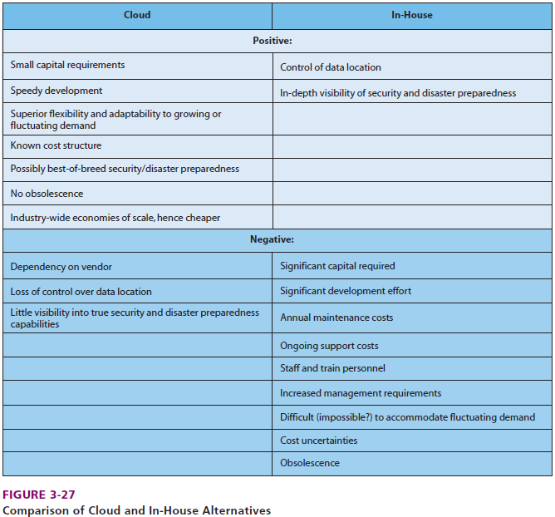
Pros and Cons of the Cloud

- Computer Security
  - Virus: a computer program that spreads across your computer doing unwanted thing – ex: deleting programs, sending files and emails
  - Payload: the code that causes the unwanted activity
  - Macro-Virus: viruses that attach themselves to documents
    - Starts the malicious activity when you open it – ex: downloading an infected word file
  - Worm: virus that spreads over the internet
    - they are made to spread across computers
    - an infected computer is called a zombie computer
    - a group of zombie computers is called a botnet
  - Preventing Viruses:
    - 1) Patches: program makers find holes in their programs that let viruses in, then modify the code to prevent this from happening – i.e. update your computer frequently
    - 2) Antivirus Software: scans your computer for viruses and gets rid of them – make sure you have one

- Questions for consideration:
  - Q1: explain how a computer works
  - A1: CPU takes info from the hard-drive and puts it into main memory. To execute and action, the instructions are taken from RAM to cache. RAM also has instructions for the OS, which is a program that controls the computer resources

  - Q2: Explain how a manager can use this knowledge of software and hardware
  - A2: managers must know what their employees need to accomplish in their daily tasks
    - how fast should their computers be
    - which programs will they need
    - which programs on the server do employees need to access
    - they must understand how computers work so that they can communicate with the IT-department

  - Q3: Why should you always save your work from time to time while using your computer?
  - A3: computers sometimes crash and that will cause all their data they have been working on to be lost (volatility). Most effective way is back up on external hard drive on online

  - Q4: What’s the difference between Client and Server computers? Explain the functions
  - A4:
    - Clients: are computers that do tasks such as word processing, spreadsheets, etc. These computers request information from servers and the server provides the client with the info they need
    - Servers: serve information to clients.
    - Clients have much lower storage requirements than servers

  - Q5: Describe the 3 ways that organizations can acquire software?
  - A5:
    - Off-the shelf – you buy from a store & hope it works
    - Off-the shelf with alterations software – you can make changes
    - Custom-developed – you have it made specifically for you

  - Q6: Define GNU and GPL
  - A6:
    - GNU (GNU Not Unix) for creating a free Unix-like operating system
    - GPL (General Public Licence) is one of the standard license agreements for open source software

  - Q7: Define opened source?
  - A7: anyone can obtain the source code from the open source project’s Web site

  - Q8: Define closed source?
  - A8: the source code is highly protected and only available to trusted employees and contractors

  - Q8: Define source code?
  - A8: Code written by humans and understandable by humans

Module 4 Chapter 2 & 5 – Business Processes (read + glearning)

- Business Process: a sequence of activities that serve to accomplish something – ex: taking orders & making sandwiches at Tim Horton’s
  - Activity: The tasks involved in completing a business process – ex: when making the sandwich, the tasks include adding chicken, cutting bread, toasting, etc.
  - Why Standardize Processes?
    - 1) Enforce policy
    - 2) Consistency – same results regardless of who performs them
    - 3) Scalable for change
    - 4) Reduces risk – reduces the risk that exists when employees do things differently

- BUSINESS PROCESS MODEL AND NOTATION (BPMN)
  - Global standard used to document business processes by creating an abstraction of the process using standardized techniques
  - Role: category of activities within the process performed by an actor (ex – cashier)
  - Actor: a human or computer that accomplishes certain tasks – ex: taking an order includes several sets of activities… cashier takes the order & deal with payment, other employee puts together your order with their own set of activities
  - Swimlanes: all of the activities in one role (thus one actor)
    - Can be drawn horizontally or vertically
  - Avoid ambiguity – include as many activities as required to avoid ambiguity
  - Information system:
    - System – Group of components interacting to achieve a purpose
    - Information systems – a system that interacts to produce information
    - Information: knowledge derived from data information is processed data presented in a meaningful context
      - 5 components of an information system
        - Hardware
        - Software
        - Data
        - Procedures
        - People
      - The 5-component model makes it easier to troubleshoot issues when they arise.
        - Allows you to think more completely and assess the impact of new technologies – better able to assess the scope of new systems
        - Lists components in a particular order – in order of ease of change and extent of organizational disruption – i.e. it’s easier and less disruptive to replace a computer with a new one than it is to replace a person

- Summary of Business Process Model and Notation Symbol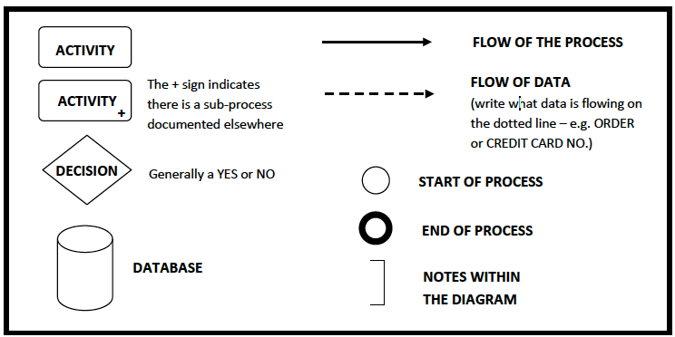
- Example:
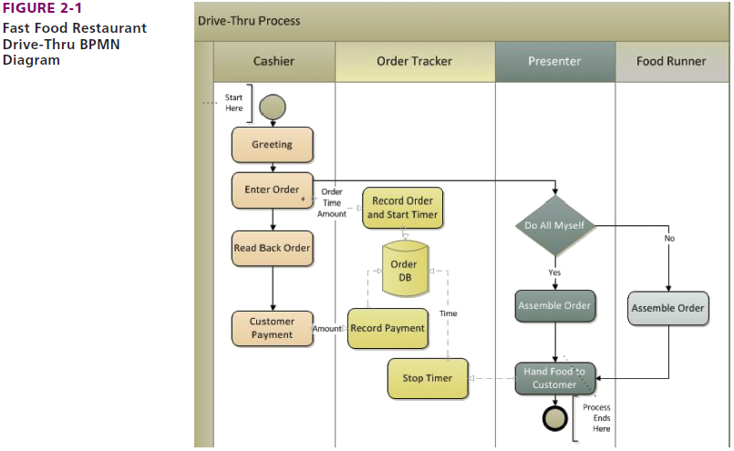

- 4 distinct roles – 3 performed by a person, only 1 (order tracker) performed by computer-based system
  - based on this we can say that this process is supported by a single Information System – Order tracker IS
- An information system can support several processes
  - For example, the Order tracker can also support Drive-Thru, In-store ordering, accounting total sales, reorder items
  - An information system will have a different procedure for each process it supports. Should the information system change, or the process change, the procedures will also change accordingly
- Structured vs. Dynamic Processes
  - Structure Processes: formal activities that don’t change from day-to-day
    - Ex: making coffee at Tim Horton’s – one way of doing it properly
  - Dynamic processes: Informal activities that aren’t always done the same way
    - Ex: a sales rep at future shop – experience differs depending on customer needs

 | Structured | Dynamic
Limitations | Many – there’s only one way of doing things | Few – more relaxed
Innovation | Not necessary | Very necessary
Control | Procedures are enforced by the company | Must adapt as you go
Efficiency | Very important – save time & money | Less important, more strategic

- Data vs Information:
  - Data: recorded facts and figures - Ex: number of houses on a street, number of tickets sold
    - 5 Necessary Data characteristics
      - Accurate - must be able to rely on what comes out of systems
      - Timely – need it in a timely fashion to make decision
      - Relevant – To context/subject – must be usable for the decision at hand
      - Just sufficient – you need enough to make proper decision
      - Worth its cost – data is expensive so the benefit must outweigh the cost
  - Information: the knowledge we gain from interpreting those facts (data) – provides meaning
    - When you sort, process, or interpret data, it becomes information – becomes meaningful
    - The meaning of information differs from one person to the next
      - Ex: 25 degrees outside is hot for me, but might be just right for you
  - Data vs. Information examples: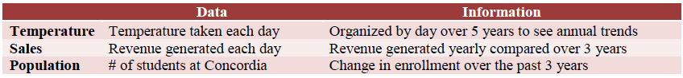

- Fundamental Types of Processes in Organizations
  - Strategic Processes: Executive Support Systems (ESS)
    - Solving broad, organization-wide issues
    - Direction of Company
    - Often made by executives
      - Ex: new product line, new menu items, outsourcing
  - Managerial Process: Management information systems (MIS)
    - Planning, analyzing, and managing resources in order to meet objectives
      - Ex: schedule maintenance, inventory management, financial statements
  - Operational Processes: Transaction Processing Systems (TPS)
    - Day-to-day tasks with structured process that focus on efficiency (i.e. front-line staff)
      - Ex: customer service agents, bookkeeping, software testing

- Each activity in the value chain has processes from each (i.e. strategic processes, managerial processes, operational processes)
  - Systems play a role in business processes (automation, recording, data storage)

- Process Improvement
  - Objectives
    - Defined by management
    - Must be properly communicated
  - Measures/Metrics
    - How are we doing at meeting the objectives set?
    - Indicates performance
    - Called Key Performance Indicators (KPI’s) by process improving experts
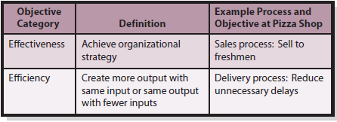

- Examples of common Business Processes
  - Inbound Logistics Processes: procurement, inventory management, supplier sourcing
  - Operations Processes: transform inputs into outputs – common for manufacturing organizations
  - Outbound logistics processes: revolve around distributing goods and services to buyers
  - Sales and Marketing processes: involve the means and incentives for customers to purchase a product/service
  - Service processes: provide post-sales support
  - Human resources processes: those which assess employees and assess adequate personnel
  - Technology and development processes: involves designing, testing, and developing of technologies that support primary activities in an organization
- 3 fundamental steps towards improving processes - OMIS Model
  - Objectives – Specify and improve
    - Classify objectives as effectiveness or efficiency
    - Make objectives explicit
    - Obtain agreement about objectives
    - Ensure that objectives are not vague or inappropriate
  - Measures –specify and improve (KPIs)
    - Ensure measures are:
      - Reasonable
      - Accurate
      - Consistent
  - Information Systems – implement IS improvements
    - Improvements can enhance
      - Activities – effectiveness or efficiency
      - Linkages among activities – impact of 1 activity on another
      - Control of an activity - control limits behaviour
- Processes can be improved without the use of IS – 2 basic ways
  - 1) add more resources to the process
  - 2) changing the structure of the process

- Six-Sigma
  - Goal is to remove causes of defects and minimize variability of the process – as a result, 99.99966 % of process outputs would be free from defects
***Process improvement is about changing the way we do things to better meet our objectives***
- Improve Activity - grill that heats up and cooks faster, fries made in major batches
- Improve Data Flow – screens that show cooks the order as its placed, tracker that sends message to manager when stock is low
- Improve Control – Burgers come with pre-chosen toppings instead of letting customers choose
- Improve Procedures – more training so employees work faster
- Automation – timers turn deep fryers on and off, drinks fill themselves to the right level

- Bottleneck: when an activity slows down the whole process – ex: fabric delivery takes too long
- Using BPNM in Process Improvement
  - As-is diagrams: the way the process currently looks
  - Ought-to-be diagrams: how the the process looks once its improved and re-mapped

- Can an IS Hinder a Process? - YES
  - Information Silos: exist when data exists in isolated information systems
    - Often isolated because they were designed for a functional purpose
      - as a result, you have data that is duplicated in various files and databases
      - results in inconsistent data
    - Information silos exist because database design involves user input as to what data they would like to have access to
      - users may request the same data but for different purposes resulting in information silos
      - They exist because departments find it more cost effective to have their own IS
- Services-Oriented Architecture (SOA)
  - Design approach that makes it easier to communicate and share data among process activities
    - Uses middleware – form of software

  - Services-oriented architecture improves processes with:
    - Service: Repeatable task that a business needs to perform
    - Encapsulation: hides data with containers so that services can communicate
    - Standards: Standardized formats for data exchange

- Module 5 Chapter 6 & 7 – ERPs and SAP (read +glearning)

- What are ERPs?
  - Enterprise Resource Planning (ERP): a system that centralizes data
    - 1) ONE database
    - 2) Integrated, industry-leading processes needed to use the system
  - Prevents information silos (when data is stored in separate systems)
    - if not prevented, departments work in isolation
  - Since ERP comes with processes, the organization must change the way it does things
    - These processes are called Inherent Processes or Process Blueprints
    - Gap analysis: uncovering differences between business needs and ERP’s ability
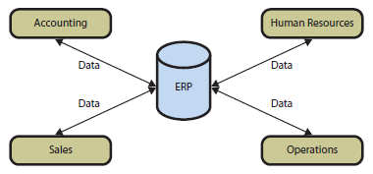
- When ERPs are too expensive:
  - Enterprise Application Integration (EAI): provides software that allows the separate databases to communicate with each other
    - enables communication – connects information silos via a new layer of software
    - departments maintain their own data but it can be integrated as needed
    - allows companies to gradually move to ERP
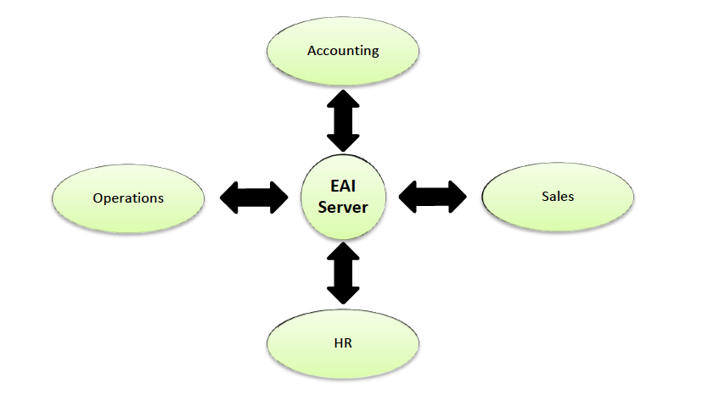

- Elements of ERP:
  - Integrated throughout all of the company’s activities (value chain)
- Inbound logistics OperationsOutbound logisticsMarketing and SalesService
  - Each function is called a module – Functions include
    - Purchasing
    - Materials management
    - Production and manufacturing
    - Sales and distribution
    - Customer relationship management (CRM)
    - Financials and costs
    - Human Resources
    - Asset Management
- ERPs were developed over time
  - Started with Materials Requirement Planning (MRP) then made its way through the value chain to integrate the whole business
  - Originally started in manufacturing companies

- ERP involves all 5 components of an IS:
  - Hardware
    - Purchase needed computers, servers, printers, network devices, etc.
  - Software
    - Configuration: the setup of the system on the company’s computers
    - Customization: Modifications to the ERP to meet specific needs
  - Data
    - Big empty databases that need to be converted
    - Old date needs to be moved into it
  - Procedures
    - Company chooses which ERP processes. It then must change its old way of doing things
  - People
    - Includes the following people:
      - 1) Users
      - 2) Systems Analysts
      - 3) Consultants from the vendor or a third party
  - Types of Data in an ERP
    - 1) Transactional data: day-to-day data collected from operations, changes by transaction
      - Ex: Sales made, items purchased
    - 2) Master Data: data that doesn’t change between transactions
      - Ex: Supplier names, addresses
    - 3) Organizational Data: data about the company
      - Ex: locations, warehouses, financial accounts
  - An ERP system must be able to integrate processes of:
    - 1) Supply chain management (SCM)
    - 2)Manufacturing (Just in Time (JIT), Manufacturing resource planning (MRPII)
    - 3) CRM – customer relationship management
    - 4) Human resources
    - 5) Accounting

- Benefits of ERP:
  - Suppliers are integrated – your system can talk with the supplier’s system
  - Access to more data for managers – Managers from around the world can see statistics from divisions around the world
  - No more silos – marketing can collaborate with operations since all data is together
  - Data is shared in real-time: when an update is made in the production in China, managers in the US can see it right away
  - Integrated processes based on best practices – the processes that come with the ERP are based on optimal ways of doing things
  - Information silo problem solved
- Implementation Challenges:
  - Vendor selection – SAP, Oracle, Microsoft?
  - Gap Analysis – Which modules do we integrate, which do we not
  - Configuration – The rules – order sizes, who approves new orders, who modifies
  - Data Issues – The way we stored data in our old databases may not be the same as the ERP
  - Cutover Process – when and how do we switch to the new system
- People Challenges:
  - Management
    - Not supporting it throughout – asks for change but then leaves it be
    - Oversells benefits – not the solution to all the company’s problems
    - Ignore cultural resistance – the way work gets done will change
  - Team
    - Lack of collaboration – the wrong configuration is set up because the end users are not consulted on their needs
  - Individual
    - Users don’t see benefit – using the new system makes it longer for them to place an order
- What types of Organizations use ERP?
  - Industry: used across all industries (Manufacturing, distribution, medical care, retail…)
  - Company Size: used by large organizations with revenues > $5 million
    - Smaller companies don’t need massive software
    - May not have the IT resources to implement it
  - Country: used around the world and in multi-national companies
    - Single instance: for whole company around the world
    - Multiple Instances: different installations in different regions
- ERP Vendors:
  - SAP:
    - Gold Standard
    - 22% Market share
  - Oracle:
    - High-quality technical staff
    - 15% market share
  - Infor:
    - Privately held corporation – small-large companies – many solutions
  - Microsoft Dynamics
    - All modules are acquired smaller companies
    - 10% market share
  - Smaller vendors focus on niche markets (i.e. advertising agencies, small companies, cloud)
  - Epicor: strong industry specific solutions (retail) configurable and cheaper
- SAP:
  - Built in Germany – founded in 1972
  - Used by more than 80% of Fortune 500 companies
  - First ERP designed to work at multiple companies
  - Offers training and consulting within its services
  - Most popular version is R/3 rebranded as SAP Business Suite
  - Runs on Netweaver, the operating system for SAP
  - ABAP is the programming language for SAP customization
  - Industry-Specific Platform Then configured based on needs of specific company

- Procurement Concepts:
  - Procurement: the process of acquiring goods and services from suppliers (ex: raw materials, machines, parts, ingredients
  - Purchase order (PO): a document that requests the delivery of a product + the quantity
  - Raw materials inventory: stock of materials used to make core products (ex: coffee beans, sugar for Starbucks)
  - Supplier Relationship Management (SRM): Interaction between supplier and company
    - Automated with the use of ERPs – ex place and order for coffee beans when there’s <5 bags
  - Returns Management Process: Getting defective products back to the supplier
  - Supplier Evaluation process: adding, removing, and approving new suppliers
  - Bullwhip effect: when a company orders more products than needed
    - Caused by a sudden change in demand
- Other concepts:
  - Train the trainer: the vendor trains super users, who then train others below and so on
    - Reduces cost of training
  - Access Controls – which part of the ERP a user can access
- Fundamentals of procurement process:
  - Procurement: operational process of obtaining goods and services
    - Main activities: Order, Receive, pay
    - Goals: save time & money
    - Ex: inbound logistics, operations, sales and marketing, customer service
  - Purchase order: written document requesting delivery of a specified quantity of a product or service in return for payment
- Problems with procurement before SAP:
  - Warehouse problems:
    - Growth in finished goods inventory reduces warehouse space for raw materials
    - Warehouse manager doesn’t have data on sales price discounts (didn’t know if a spike in sales were due to discounts
  - Accounting problems:
    - 3-way match discrepancies take time to correct (making sure that the data on the invoice matches the data in the purchase order and goods receipt)
    - time delays in updating accounting data
  - Purchasing problems:
    - Purchasing agents not centralized
    - Training, experience and motivation difference
    - Errors in data entry
    - Weak internal controls (pressure for greater financial controls)
- AFTER SAP:
  - Purchasing: each order will be seen and shared with the suppliers
    - New purchasing department centralized purchasing activities
    - Data entered in a single, shared database
    - Reduces errors
  - Warehouse: goods and received, immediate update to storage database
    - Goods receipts entered into the same database as purchase orders
    - SAP verifies the goods received against the purchase orders
    - Immediate update to inventory
    - Accounting impacts automatically updated in the same database
  - Accounting: can see at once if if invoice matches the purchase order
    - Three-way match completed by SAP
    - Less labor intensive
    - Accounting updated automatically by SAP
- Benefits to SAPSupply chain:
  - Single database
  - Shared information in real time
  - Reduction of errors
  - Improved financial controls
  - Increased responsiveness
- Procurement process with emerging technologies
  - Augmented Reality: computer graphics and data are overlaid into the physical environment
  - Radio-Frequency Identification (RFID): used to identify and track items in the supply chain chips broadcast data to receivers that can display and record the data
  - Sensors, robotics, 3-D printing technology

Module 6 Chapter 5, 5a,5b – Database Management (read)
- Content Defined
  - Content = Organization’s Property related to intellectual property (trademark, patent, copywrite)
    - All files, documents, web pages, videos, data collected, employee info, orders, etc.
    - Challenge: storing and managing all of this info collected – getting the right content to the right person in the right format at the right time
- Storage of Data:
  - Database Management System (DBMS)
    - Efficiently stores and indexes data (bytes) for later retrieval
    - For: Thechies, IT team
- Presentation of Data:
  - Content Management System (CMS)
  - Controls access to content, organizes it, web-based
  - For: End user
- What is a Database
  - It’s a collection of structured data tables + relationships among the rows in the those tables + metadata
  - Tables/files
  - Relationships among rows in tables
- Forms: used to modify, delete, read and insert data
- Reports: show data in structured context, may compute values
- Queries: means of getting answers from database data
- Application programs:
  - Process specific logic to business needs
  - Enables database processing over internet
    - Serves as an intermediary between web serve and database
    - Responds to events
    - Reads, inserts, modifies, deletes data

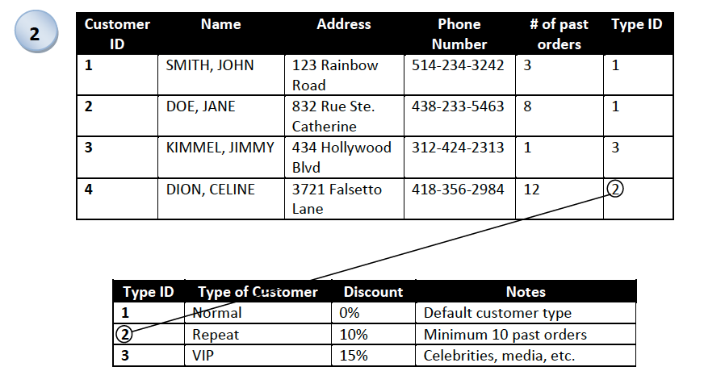
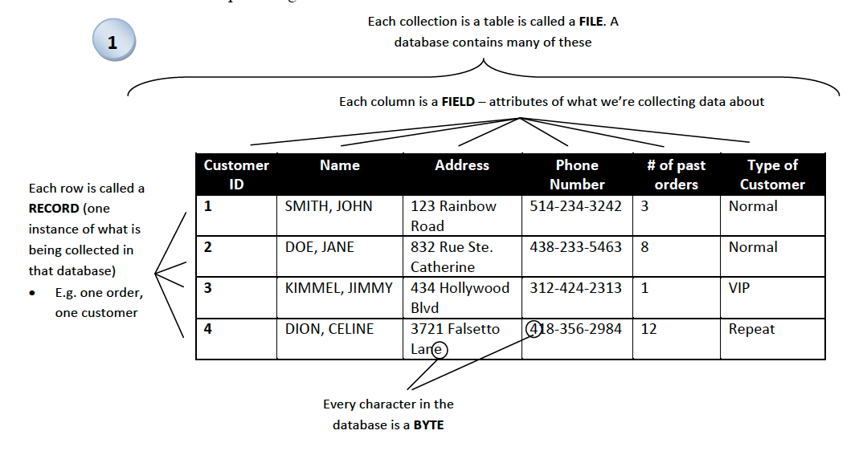

- Primary Key: A column (field) that contains unique data that identifies a row/record in a table
  - EX: Student ID, Customer ID, Employee No.
- Foreign Key: A column that refers to another table to form a relationship between the 2
  - Matches the primary key of another table
- Using this structure prevents us from storing the same data over and over
  - EX: Instead of storing all that information about each type of customer, each type is stored once in a separate table and referred to using the keys
- Metadata: data about the data
  - Answers the question of: what type of data are we storing in the column
    - EX: dates, numbers, characters, currency
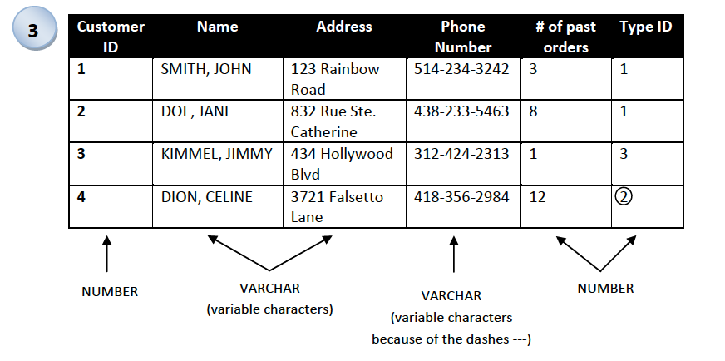

Databases VS Spreadsheets
Safer (access control) Easier to use
Multiple users can access it and edit at the Better for small amounts of data
same time from anywhere about a single theme

Can store larger quantities of data

Better data integrity (fewer errors, duplicates)

Easy to generate reports and find data

- Database Management Systems (DBMS)
  - Software that is used to create, process, and manage databases
  - Provides users with access to the database
  - Using DBMS, the data can be created, modified, deleted, read, and secured
  - Most popular DBMS programs: Access, SQL Server, MySQL, DB2
  - The language used to speak to databases is called Structured Query Language (SQL)
    - Made up of queries – questions that we ask the data to answer
- Database Applications
  - The tools that users use in the DBMS in order to interact with the database
    - Allows the user to interact without typing in SQL (code)
    - Includes: Reports, Forms, and Queries
  - Often allows multi-user processing – multiple people updating the DB simultaneously
    - Lost Update Problem: When two people open up the same file, edit it, and both save it…the person who saved last overwrites the other person
- Types of DBMS
  - Enterprise DBMS: used in organizations and large groups
  - Personal DBMS: used for small simple databases
    - Only remaining one is Microsoft access
    - Often used by fewer than 15 people
- Entity-Relationship Diagrams (ERD)
  - Data model: a visual representation of what the database will look like (a blueprint)
    - Shows the structure of how the data is stored and how everything is related
    - The most popular data model is the Entity Specific Diagram (ERD)
    - Second most popular is the Unified Model Language (UML)
  - Components of an ERD
    - Entities: something that we are collecting data about
      - Ex: Customer, orders
    - Attributes: characteristics about the entity
      - Ex: customer_name, order_quantity
    - Identifier: an attribute whose value is associated with ONE entity
    - Relationships: Common data between entities
      - Ex: customer places order
  - NOTE: All entities should have an identifier, something that distinguishes 1 row from another
    - This becomes the primary key when we want to make relationships
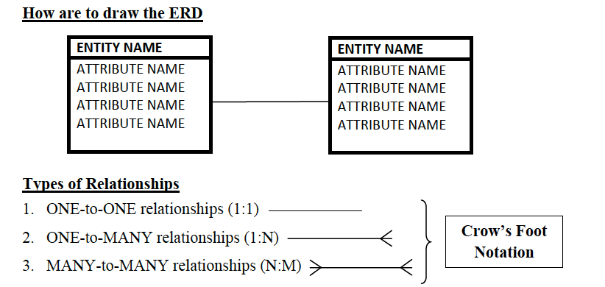

Each relationship must have a verb on it to describe the nature of said relationship

Ex: “is bought by”
- Cardinality
  - 1:N or N:M represent a relationship’s maximum cardinality
    - N and M represent variable numbers
    - Ex: a customer can place many (N) orders
  - Minimum cardinality is a constraint in the relationship, the minimum required
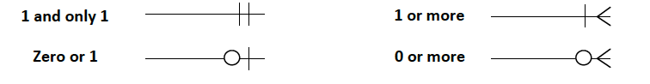
    - Ex: A customer must place at least 1 order to be in the system

Include a foreign key on the MANY side of each relationship

- Many-to-Many relationships
  - When you have a many-to-many (N:M) relationship, you need to break it apart
    - Add a table in between containing the names of both
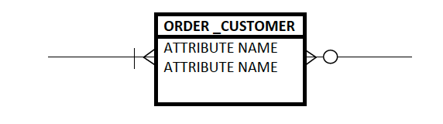

- Normalizing Data:
  - Breaking apart a poorly structured table into two or more well-structured one
    - Done to prevent data integrity problems
    - Occurs when data is duplicated throughout the database (hard to update)
      - Ex: if course name changes we’d have to update each student’s schedule
    - When you see duplicate data, eliminate it by placing it in a new table
      - Each table should only represent one theme/concept
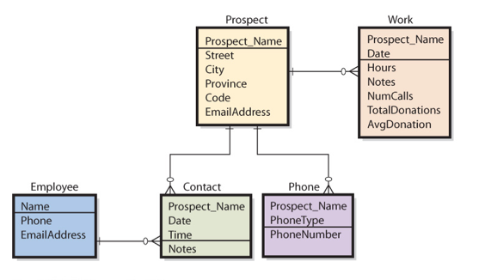
- ERD EXAMPLE:

Chapter 8 (glearning) – Decision Making and Business Intelligence
- Challenges managers face when making decisions:
  - Decision making process is much more complicated for 3 reasons:
    - 1) The concept of rationality is hard to define
    - 2) Good outcomes may occasionally result from irrational processes, and bad outcomes can result from good processes
    - 3) Humans intend to be rational, but there are limits on our cognitive capabilities
      - “Bounded rationality” – for a variety of reasons, we are not capable of thinking through all the various options and permutations that are available to us
        - instead of seeking the optimal solution, we choose the most reasonable and available solution rather than the perfect choice

  - Factors that make decision making challenging
    - Uncertainty and complexity surrounding decisions
    - Information overload
    - Data quantity – managers don’t know how much they need so they ask for as much as they can get – promotes info overload
      - The challenge is to find the appropriate data and incorporate them into their decision-making processes
  - Problems with Operational Data
    - Raw data usually unsuitable for sophisticated reporting or data mining
      - Dirty data
      - Values missing
      - Inconsistent data
      - Data not integrated
      - Data can be too fine or too course (granularity)
      - Too much data
        - Too many attributes (columns)
        - Too many data point (row)
- OLTP – support decision making
  - Online Transaction Processing (OLTP): system collects data electronically and processes the transactions online
  - OLTP systems – backbone of all functional, cross-functional, and interorganizational systems in an organization
  - OLTP systems support decision making by providing the raw information about transactions and status of for an organization
- Transaction Processing
  - Real-Time Processing
    - Transactions are entered and processed immediately upon entry (ex: airline reservations systems)
  - Batch Processing
    - System waits until it has a batch of transactions before the data are processed and the information is updated
- Online Analytic Processing (OLAP)
  - Systems focus on making OLTP-collected data useful for decision making
    - OLAP provides the ability to sum, count, average, and perform other simple arithmetic operations on groups of data
    - OLAP report has measures, or facts and dimensions
- BI systems
  - Business Intelligence (BI) system provides information for improving decision making
  - 5 Categories of BI systems:
    - 1) Group decision support systems (GDSS)
      - Allow multiple parties to participate in decision making and improve outcomes by reducing often inherent biases
      - Across different geographical locations and times
    - 2) Reporting systems:
      - Integrate data from multiple sources
      - Process data by sorting, grouping, summing…
      - Format results into reports improve decision making by providing right information to right user at right time
    - 3) Data-mining systems:
      - Process data using sophisticated statistical techniques
      - Regression/decision tree analysis
      - Look for patterns and relationships to anticipate or predict future outcomes
      - Unsupervised mining – hypothesis created only at the end of analysis to explain patterns found
    - 4) Knowledge-Management Systems
      - Create value from intellectual capital
      - Collect and share human knowledge supported by the 5 components of the information system
      - Fosters innovation, improves customer service, reduces cost
    - 5) Expert Systems
      - Encapsulate the knowledge of human experts in the form of if/then rules
        - If condition is true, then initiate procedure
        - Improve diagnosis and decision making in non-experts
- RFM Analysis:
  - Way of analyzing and ranking customers according to the purchase patterns
    - R: how Recently a customer has ordered
    - F: how Frequently a customer orders
    - M: how much Money the customer spends per order
- Data Warehouse
  - Used to extract and clean data from operational systems and other sources
  - Stores and catalogues data for processing by BI tools
  - Data-Warehouse DBMS
    - Stores data
    - May also include data from external sources
    - Extracts and provides data to BI tools
- Data Mart – data collection
  - Created to address particular needs
    - Business function/problem/opportunity
  - Smaller than data warehouse
- Big Data
  - Large amounts of varied data from a variety of sources over a period od time could be used to make better decisions
    - controversial
    - adds to excessive data collection
    - expensive
    - imprecise (overly vague/general)

- Module 8 - Chapter 9 – E-Commerce, Social Networking and Web 2.0 (read)

- E-Commerce:
  - E-Business: any business activity conducted electronically (Using IT)
    - This can include any business function such as looking at reviews before buying in store, checking the weather, customer support
  - E-Commerce: a sub-category of E-Business that involves a transaction (buying or selling) involving good/services over a network (public or private)
    - Merchant Companies: buy and sell their goods
      - Business-to-consumer (B2C) - amazon
      - Business-to-Business (B2B) – clothing store ordering from china
      - Business-to-Government (B2G) – QC gov buying dell computers
    - Non-Merchant Companies: facilitate sales but don’t own the goods “intermediaries”
      - Online auctions – eBay
- Pros and Cons of E-Commerce
  - Pros:
    - 1) Disintermediation – middle man is cut out
    - 2) Available info – look at reviews to make informed purchases
    - 3) Price Elasticity – better understanding of demand and supply through online tracking
    - 4) More feedback: the company and customer can interact easily
    - 5) Convenience: shop at home
  - Cons:
    - 1) Channel Conflict – artist sells CD straight to consumer HMV loses profits
    - 2) Price conflict – buying a book online is cheaper than going into the store
    - 3) Logistics expense – costly for amazon to ship many small orders rather than 1 big one
    - 4) Customer service - sales staff can’t show them how things work
    - 5) Showrooming: people go into stores to test it out and then buy it online
    - 6) Taxation: buying from US retailer do you pay CAD or US tax?
- Social Networking: process by which individuals use relationships to communicate with other in a social network
  - Web of related individuals and organizations
  - Social capital: the benefit derived from social networking
  - From the business’ perspective, the following capital exists:
    - 1) Physical Capital – Physical resources such as assembly lines, computers, machines
    - 2) Human Capital – knowledge and skills from your employees
    - 3) Social capital – social relationship between people (employees, customers)
- 4 Benefits to Social capital
  - Information: Shows opportunities, threats, problems, the way the customer is thinking
  - Social Credentials: social status helps to shape who you are and the business’ brand
  - Influence: your relationships with co-workers can influence their decision – customers influence others to buy (word or mouth)
  - Personal Reinforcement reinforce your professional image or position in an industry
- Weak vs. Strong Relationships
  - The people you know best (strong) tend to all know each other
    - This means your network won’t expand with them
  - The people you know the least (weak) contribute most to your network
    - They’ll introduce you to new people

- Social Networking Enabled by IT
  - You don’t need a computer to network, but Facebook has made it synonymous with the Internet – low cost
  - IT brings benefits that don’t exists in face-to-face networking
    - 1) sorting through data is easier with IT – you can find what you need
    - 2) tracking relationships is easier
    - 3) Network effects means that platforms like Facebook will grow as more people use them – your network keeps growing automatically
- Web 2.0
  - Started with the creating of smartphones, user-created content, social media, e-commerce – and not a specific change in technology (Ex: Google, Amazon, Ebay)

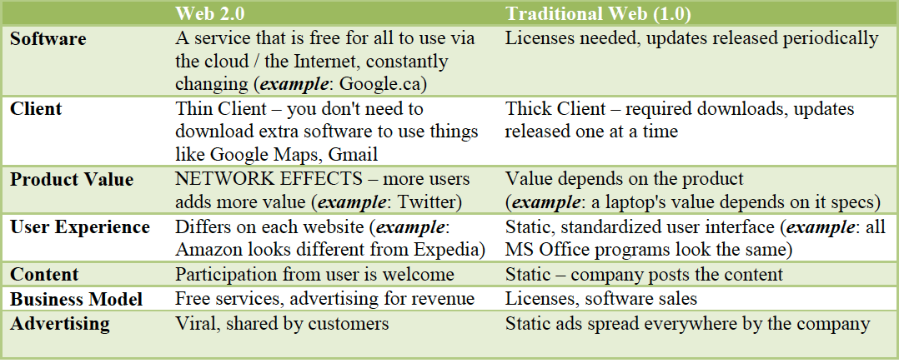

- Other terms:
  - User-Generated Content: the user adds value by creating content (ex: user reviews)
  - Crowdsourcing: new ideas are posted online and customers can pre-order thus contributing to the product actually coming to life
  - Mashups: taking services from a website and combining with another (google maps on a “contact us” page)
- How do companies Benefit:
  - Advertising: More targeted and focused
  - Mashups: more collaboration between business
  - Viral Marketing: new product features are released and vendors with for users to spread the news around
- 3 Pillars of Sociability
  - Affiliation – ensure that users want to be affiliated w/ your group (need to belong)
  - Participation - make sure they understand the rules of behaviour and conduct
  - Validation – Consider how to validate the user’s social experience, reinforcing the social utility of the website

- Module 9 - Chapter 10 – Acquiring IS through Projects (read)

- Project Management:
  - Standards put in place through the PMBOK (Project Management Book of Knowledge)
  - Developed and maintained by PMI (Project Management Institute)
  - People certified to manage projects are PMPs (Project Management Professionals)
  - ITPM (Information Technology Project Management) - techniques and methods used to better run projects used by all managers
    - If it involves technology, it becomes and IT project
      - Affects all 5 components of the systems (including people and procedures (hardware, software, data, procedures, people)
  - The Iron Triangle
    - ScopeTimeBudget
      - Almost impossible to get all 3 in balance
      - Only 16% of projects are completed on time within budget, and on scope
      - 30% of projects are cancelled before completion
  - the key to successful projects is good planning
- Operations vs. Projects
  - IT operations: the day-to-day tasks
    - Goal: keep things running efficiently, stable, predictable and securely
  - Projects: Implementing changes over a set period of time
    - Goal: Improve the business
  - ITIL (Information Technology Infrastructure library) = PMBOK for operations
    - Standards and procedures for driving value from operations framework for best practice approaches
    - People working in operations usually specialize (ex: website admin)
- Risks in Projects:
  - 1) Scope: IT is virtual can’t see what the project looks like when complete
  - 2) Costs: IT costs are constantly changing
  - 3) Time: How do we know how long each part will take?
  - Risks aren’t only related to the technology also human
    - Lack of knowledge/experience
    - Difficult to graphically represent
    - Unclear requirements/ lack of good model
    - Too complex
    - Lack of support form management
- Acquiring New Systems:
  - Buy it and use it as it (no customization off the shelf)
  - Buy it then customize (most common) does it fit our needs the best
  - Rent or Lease it which takes the least time
  - Develop it yourself do you have the skills needed to develop it?
  - Outsource development cheapest option?
  - Integrate Hardware & Software with existing programs and infrastructure
  - Integrate Data with current databases
  - Integrate Procedures & People with the way we do things
- Implementing New Systems
  - System Development Life Cycle (SDLC): a classic process for acquiring or developing Information Systems
  - Phase 1: System Definition
    - Define goals and purpose ex: help PepsiCo compete against a new competitor
    - Assess Feasibility
      - Cost – do benefits outweigh the costs?
      - Schedule – can it be completed in a reasonable amount of time
      - Technical – Can our existing systems work with the new systems
      - Organizational – Does it fit with the way we work cultural/legal
  - Phase 2: Requirement Analysis
    - It is the management of scope in an IT project
    - Best to involve the end users since they know what’s best for use
      - Ex: accountants know what they need to do their jobs better than IT does
    - Changing the requirements halfway through the project is always more costly than changing them at the start
    - Team consists of system analysts and business analysts in this phase
      - These people need to understand both IT and the business
  - Phase 3: Component Design:
    - If you choose to buy it there will always be discrepancies between what you need and what is offered
      - How to deal with discrepancies Customize the software OR Change how we do things OR Live with it
    - If you choose to build it, you need to design all 5 components of the Information System
      - Hardware: Pick computers, wires, servers needed to build the new IS
      - Software: Pick operating system and user interface
      - Data: design the database/modify as needed
      - Procedures: how to use the system, backups, recovery, documentation
      - People: Users need to be informed and trained
  - Phase 4: Implementation:
    - Once it’s all designed, the programmers come in a make it (coding)
    - If it’s purchased, this is when you would start hooking things up and installing the components
    - System Testing:
      - Test plan: list of actions users need to perform to test all parts of the system
      - Product quality assurance (same as testing)
      - Beta testing: allows users to try the system on their own before its fully released
    - Transitioning to the new System (conversion) 4 Options
      - Pilot: The whole system is implemented into 1 part of the business to see how users will react. Allows testing and improvement s before giving it to everyone
      - Phased: Different parts of the system are released to different parts of the organization at one time. This allows time to adapt and regional tweaking
      - Parallel: The old and the new system run at the same time for a short period of time very costly but provides a fallback in case of failure
      - Plunge: Unplug the old system, plug in the new one all in one shot
  - Phase 5: System Maintenance
    - Making modifications as needed after implementation
    - Patch or service packs fix the problems
    - Prioritize requests for changes (errors or suggested improvements)
- Weakness of System Development Life Cycles (SDLC)
  - 1) Considered a Waterfall Method once you go to the next phase there’s no going back
  - 2) Some projects are just too complicated (can you lit all the requirements to build an airplane all at once?)
    - analysis paralysis: when documentation and defining requirements goes on forever even when you have enough to move forward
- Outsourcing:
  - Having another organization perform and service for you (ex: manage your database)
    - If they’re on a different continent, it is known as off-shoring
  - Advantages:
    - IT isn’t everyone’s expertise
    - Less costly elsewhere (India, China)
    - Risk Reduction
  - Disadvantages
    - Loss of control
    - Tied to the developer they know the system better than you
    - If they mess up, you still pay
    - Expensive and difficult to change vendors
- Application Service Provides (ASPs)
  - Provides software and applications to the company for rental
  - The system is maintained by the ASP and is accessed through the internet

  - Risks:
    - No control over your data, stored abroad
    - If you lose internet connection, your whole system can’t be used
    - Can get locked-in make sure you can take your data if you switch vendors

- Module 10 - Chapter 11 – Structure, Governance, Ethics (read)
- IT department structure:
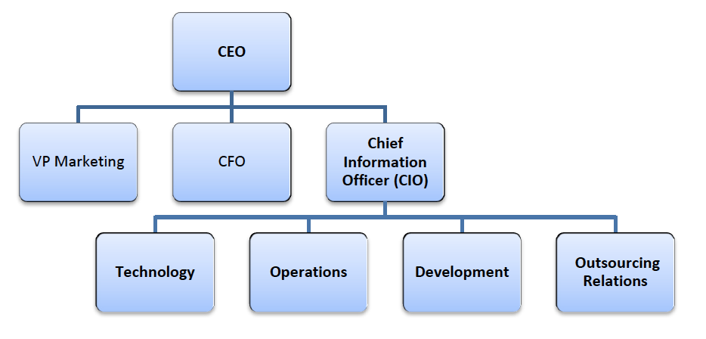

- Technology: lead by the Chief Technology Officer (CTO) – in charge of new tech and innovation
- Operations: day-to-day administration (network administrators, infrastructure, user support)
- Development: improve current system and implements the new ones
  - If the company develops in house: programmers, testers and project managers
  - If the company only buys: mostly business and system analysts
- Outsourcing Relations: Monitors relationships and service levels
- Most IT jobs require communication skills, business skills and interpersonal skills
- Web Design projects usually consist of:
  - Project manager: responsible for interacting with the client and moving the project successfully towards completion
  - Lead designer/analyst: responsible for understanding the clients needs and developing the overall look and feel of the site
  - Developer: responsible for taking the design and creating the functioning site
  - Technical architect: responsible for making decisions about technical issues related to the site, including server/ browser support
- Job in IT:
  - Must have interpersonal (communication and leadership) and technical skills all positions require business knowledge as well
  - Ex: Web designer, technical writer, project manager, developer

- IT Architecture: the plan for everything IT in the business
  - IT should contribute to the company’s strategy (ex: Wal-Mart invests heavily in IT to make logistics flawless lowers prices)
  - Plan for all computers when they’re bought, when they’re replaced, what software on which computers, networking, access controls etc.…
  - Enterprise architect: job title in large organization for person responsible for IT architecture
  - Zachman Framework: mode for IT architecture to help companies develop it as you do down the framework you get more specific
- Alignment: when the IT department’s mission, goals and plans overlap with the organization’s ones
  - Major challenge in business today
  - Requires constant communication between business and IT
  - Communication between business and IT executives is the most important indicator of alignment
- IT Governance:
  - Standard management policies and processes for IT services
  - Deals with sourcing, prioritizing IT investments, security and privacy
  - Recent laws have made this increasingly important for companies
    - 1) Budget Measures Act (Ontario)
    - 2) Sarbanes-Oxley Act (SOX)
      - Result of fraud in the early 2000s (Enron, WorldCom)
      - Key executives are now criminally liable
      - Requires companies to create controls to protect:
        - 1) Financial Statements
        - 2) Company Assets (databases, data collected)
  - Goals of Governance:
    - Better service quality
    - Reduce service costs and delivery time
    - Reduce IT risks
    - Alignment w/ business processes
- IT Audit:
  - Information systems audit: making sure that the IT systems that hold financial data are secured and that the data inside of them are reliable
  - Information systems and Control Association (ISACA): develops standards for IT governance and audit
    - Certified Information Systems Auditor (CISA): professional designation for people who do the IT audits
    - Control objectives for information and related technologies (COBIT): Frameworks and standards that help to align IT with the business
- Ethics and Green IT:
  - Computers don’t have ethics, it’s how humans use the data that causes the problem
    - Issues surround privacy of data and what we do with it
  - Green IT: understand the impact of tech on our environment
  - Triple-Bottom Line: not all about the money Profit, Planet, People
  - Energy Star: an international program that labels products that consume less power
  - E-Cycling: Recycling computers and devices
  - E-Waste: Disposing of computers and devices

- Module 11 - Chapter 12 – Managing Information Security and Privacy (read)
- Identity Theft and PIPEDA
  - Identity Theft: critical personal information is stolen and used to impersonate a person
  - One of the fastest growing crimes in Canada
  - Commonly Stole Information: SIN, name, address, credit card
- PIPEDA (Personal Information Protection and Electronic Documents Act)
  - Under this act, business must tell you:
    - 1) What they’re collecting (terms of service)
    - 2) What they’ll do with your information
    - 3) How they keep your information safe (upon request)

- Threats faced by Organizations:
  - 1) Human Error
  - 2) Malicious behaviour
  - 3) Natural events (non-human)
… these threats lead to 5 problems:
  - 1) Unauthorized data leak
  - 2) Incorrect Data Modification
  - 3) Faulty Service
  - 4) Denial of Service
  - 5) Infrastructure
- Types of security problems:
1) Unauthorized data disclosure
  - Pretexting: sating that you are someone you’re not to gain access to sensitive information (ex: someone calls pretending to be your bank and asks for your account number)
  - Spoofing: Hiding your identity to pretend to be someone you’re not (ex: caller also disguises their number as the bank’s)
- IT Specific
  - Phishing (Email Spoofing): Same as pretexting but done via email (ex: “Bank” emails and says click to change bank password)
  - IP Spoofing: when the website pretends to be another then directs you to yet another one
  - Sniffing: Intercepting communication to steal the data (ex: virus that makes a copy of all of the emails you send
  - Hacking: gaining unauthorized access to a system for malicious reasons (stealing, wreaking havoc)

2) Incorrect data modification: procedural mistakes, development and installation errors
- Ineffective accounting controls system errors
- Hacking, computer crime, incorrect recovery
3) Faulty service: Procedural mistakes, development and installation errors
- Computer crime, usurpations, service improperly restored
4) Denial of Service: Accidents/attacks that lead to service interruptions where customers cannot be served

5) Loss of infrastructure: accidents theft, terrorists, property loss

- As a result of all of these threats, management must create security procedure to manage risks:
  - Technical Safeguards (Hardware, Software)
  - Data Safeguards (Data)
  - Human Safeguards (Procedures, People)
- Technical safeguards:
  - Identification and Authentication: ways of determining who is accessing the computer and validating if it’s the right person
    - Ex: user name and password, smart cards, biometric authentication (eye)
  - Encryption and Firewalls: sending data safely between computers and networks
  - Malware Protection: Software programs and human actions used to prevent/remove viruses, worms, malware, spyware, etc.
    - Ex: antivirus and antispyware software, scan frequently, be careful with email attachments, install updates and patches
- Data Safeguards
  - 1) Database Administration: Policies and standards used to manage databases
    - Key escrow: copy of the encryption in case the first key gets lost
    - Backup copies
    - Physical security
    - 3rd party contracts
  - 2) Backups: Creating copies of the database in case it fails
  - 3) Physical Security: log who goes into the rooms where the databases are stored
- Human Safeguards
  - 1) For Employees:
    - Segregation of Duties: the person approving accesses should not be the same one granting them
    - Assign least possible privileges: only give employees the data they will need regularly
    - Document Accesses: allows companies to modify and remove access easily as needed
    - Security training: all new employees should be subject to training and shown the security policies
    - Enforcement: 3 components (RAC Responsible, Accountable, Comply)
    - Termination: access should be removed ASAP when someone quits/fired
    - Hire and screen carefully: be careful who you hire (sensitive information)
  - 2) For Non-Employees
    - Hardening: giving temporary employees and contractors very basic access
    - Protect Suppliers/Customers: makes sure the systems they use (your website) are safe
  - 3) Account Administration
    - Account management: giving/modifying/removing access Having unused accounts left in your system is extremely unsafe
    - Password Management: Require employees to choose safe passwords
      - Password Etiquette:
        - 1)Change password immediately when its created
        - 2)Change passwords frequently
        - 3)Don’t let users switch back and forth between passwords
        - 4) Require a mix of lower-case, uppercase numbers and special characters
    - Help-Desk Policies: Ex: when you call a bank they ask you a security question to make sure that it’s really you
    - Procedures and Operations:
      - 1) Normal: how to preform job properly
      - 2) Backup operations: how to make sure there are copies of everything and are prepared if something stops working
      - 3) Recovery operations: How to restore the system if it goes down
  - 4) Security Monitoring:
    - Check logs and investigate incidents
      - Systems log who accesses them, who performs operations etc. When something goes wrong, you need to use this data and patch your software or procedures are needed
- Disaster Recovery and Business Continuity Plans
Make sure the business keeps working if disaster strikes (human or natural)
- 1) Location: Make sure you know where the data is backed up and spread around
  - ex: if there’s an earthquake in California, apple must keep operating elsewhere
- 2) Mission Critical systems: the basics you need to keep running
  - ex: google has multiple servers for Gmail. If one goes down another will kick in
- 3) Hot Sites: third-party companies that keep backups at a fee
- 4) Cold Sites: office space to be used in the even of a disaster in your main locations

Just like in a fire drill, companies need to practice, have standards for speed, time, resource allocation, and plans in place to make sure that nothing can take down the companies IT or its daily operations

