Lecture 11: Stomata
November 24, 2013
8:58 AM
Gases enter and leave leaves through stomata pores (in the leaf surface)
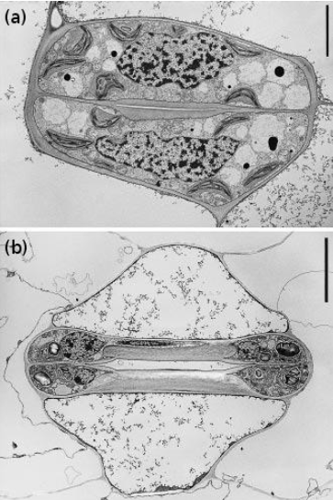
Can open or close
Represent more than 90% of all gas exchange in plants
Open is good for CO2 uptake, bad for water loss

Stomata control the exchange of Co2 and H2O between the biosphere and atmosphere
Stomates act as resistors

Top is a broad leafed species with a closed stomatal pore
Dumbell shaped stomata

Transpiration E = gleaf (wleaf-wair)
Rleaf = rstomata + rbl
B(mm) = 4mm s-1/2 (D/V)^.5

As stomatal conductance increases, transpiration increases linearly, photosynthesis increases non linearly, water use efficiency decreases non linearly

Stomates open when carbon uptake is maximized over water loss
Positive correlation with light and co2
Negative correlation with drought and VPD (vapour pressure deficit, ie difference between amount of moisture in the air and how much it could hold saturated

Stomatal regulation is mediated by external concentrations of co2, which cause elevated gs levels in cool temperatures
Water stress only affects stomatal conductance and the ability for co2 to get to rubisco (co2 diffusion rates), all other biochemical properties remain the same

Stomatal crypts in xerophytic (low water plants)
Bury stomata internally, creating a pocket of still air to modify the concentration gradient preventing water stress, normally used in dry environment plants
Trade off that co2 have to locate internal stomata, therefor lower photosynthesis rates

Triodia irritans have a rolled up leaf causing stomata to end of on the inside, has a tricomb still layer that co2 has to pass through
Stomata can be used to reconstruct past environments, as stomatal density and size increase, CO2 was decreasing in the atmosphere

Lecture 12: Isotopes
November 24, 2013
10:04 AM
Co2 is mostly 12C and 1% 13C and less than .1% 14C
Diffusion of 13 co2 is much slower than 12C, enzymes also discriminate against heavier isotope
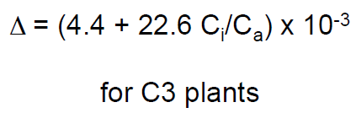
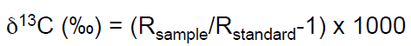
R is molar abundance ratio between 13 and 12, percentage per 1000
Standard is limestone from pee dee

Tells us about stomatal conductance, more negative values mean higher stomatal conductance, long term measurement
Isotopes tell us about ci to estimate water use efficiency
Higher stomatal conductance at more negative values mean lower water use efficiency

Heavier isotopes are harder to diffuse out, meaning that tissues from C4 and CAM plants have a less negative delta 13C because carbon being fixed goes through different pathways

Therefore for C4 the diffusion is the discrimination
For CAM delta shows how much of each type of photosynthesis occurs

Lecture 13: Water Transport
November 24, 2013
10:47 AM
Water movement is necessary to increase latent heat loss, transport nutrients, hormones and signals, maintaining turgor pressure, transporting photosynthates, must lose water to gain co2

Adhesion - hydrogen bonding between water molecules and polar groups of carbohydrate molecules
- Adhesion between water and soil particles anchors the water column in the soil
- Adhesion between water and cell walls anchors the water column at the site of evaporation in leaves

Cohesion - hydrogen bonding between water molecules maintains the water column
Air-water interface - surface of water where evaporation occurs
Water moves down a pressure gradient towards the lower water potential Ψ measured in Mpa

Water potentials must be more negative at the mesophyll cell wall than in the stem
More negative at the stem than at the root
And more negative at the root than in the soil
Water moves from soil to root to shoot to mesophyll cell wall in the leaf

Water gets drawn up through xylem pressure differences
Increased radius increases hydrostatic pressure

Energy from the sun breaks the hydrogen bonds at the air water interface, as the water in the pore at the air water interface evaporates, the radius of the water surface decreases which generates more negative water potentials that pull in water molecules due to cohesive forces

Apoplast is generally fixed and incompressible because of lignin and cellulose in cell walls, water must fill this extra volume so water must be replaced when evaporated

If water evaporates more quickly than it is replaced, fewer water molecules are in the apoplast, stretching the hydrogen bonds causing tension and decreasing both Ψ w and Ψ p

As both decrease, more water molecules are pulled in from the soil water, as they fill the apoplast the tension is relaxed and they both increase

The hydrogen bonds can withstand enormous amounts of tension before breaking
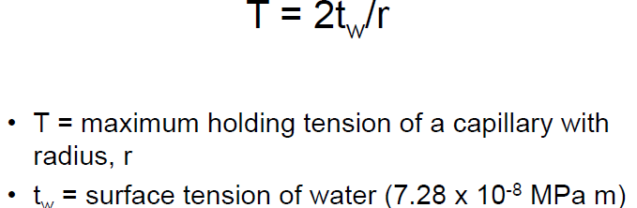

Capillary holding capacity
Hydrophyte – plant that grows only in or on water
Mesophyte – terrestrial plants adapted to moderate environments
Xerophyte – dry environment adapted plants
Halophyte – plant adapted to living in a saline environment

Lignin and cellulose make cell walls very strong, must resist implosion
Leaf water potentials are dynamic, when stomata open in the morning transpiration begins leaf water potentials decline, at midday stomata often close, leaf water potentials recover and equilibrate with soil by morning

Stomata are the first line of defense to maintain leaf water potentials
But if the water stress lasts too long, the water column continuity can be broken

Lecture 14: Cavitation
November 24, 2013
2:53 PM
Embolism or cavitation of the xylem prevent water movement by breaking the water column
Under water stress stomata are the 1st line of defense to maintain leaf water potentials

Evergreens don't rely on stomatal control as much instead use their large stem volume whereas annuals highly rely on them

Partly relies on plant capacitance
The ability to store water in tissues and decouple transpiration from soil and water supply

Xylem is under a lot of negative pressure
At these low pressures, the lowest energy state for water should be as a vapour, water in xylem is metastable
At a nucleus a bubble can spontaneously form (common cavitation occurrences)

Tracheids and vessel elements are connected by pits that have pores for water flow, which means water can move around cavitated xylem (embolism)
Air can also be pulled through these pits

Air seeding hypothesis - meniscus on the pit membrane in between vessel walls creates air bubbles more readily
Prevent air seeding by being able to withstand pressure based on radius of pit pore
Capillary holding capacity is t = 2 tw/r
T max holding tension of capillary tw surface tension of water

Perforation plates can hold an air bubble but only if compound and only at the end of a xylem vessel (angiosperms)

Tracheids only have pits (gymnosperms)

Size of pores in pits or perforation plates dictate the ability to prevent air seeding

Gymnosperms have torus extra trampoline acts like a plug to seal a pit and stop the flow of water

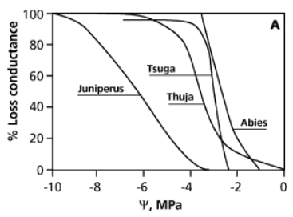
As water potential declines, no damage at first, as it declines further more vessels/tracheids become embolized, fewer intact paths for water to move through

As water potential becomes more negative an increase in loss of conductivity occurs (-3 is very heavy water stress) (vulnerability curves)

Characterized by their P50 or pressure where 50% of the hydraulic conductance is lost

Xylem throughout a plant should have different properties (leaf, stem, roots)
Leaves should embolize first

If a bubble forms in xylem functionality could be restored if xylem could be refilled, can be resolubilized if there is enough pressure on the air bubble
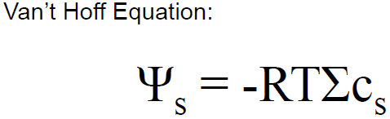
If solutes are concentrated in the root stele, positive pressure can resolubilize the air bubbles

Lecture 15: Ring Porous
December 6, 2013
10:47 PM
Safety efficiency tradeoff on xylem radius
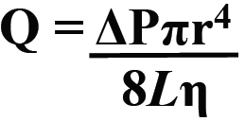
Large radius increases flow rate, but more xylem increases protection against cavitation causing a loss of flow rate

Oak are very efficient, maple is mixed (hardwood because there is more carbon in inbetween fibers)
Gymnosperm spruce has resin duct, and all small trachieds, much safer

Pine is a softwood with lots of inefficient trachieds causing low stability

Spruce is safer from freezing and thawing damage, air bubbles form causing cavitation in the ice

As diameter increases chance of embolism increases

Tropics don't freeze so large xylem are common in trees such as mahogany

Poplar and maples have mixed small number of larger xylem

Oak is highly vulnerable to freeze thaw, bubbles form in the large diameter vessels causing more damage to xylem and water transport

Maple is less damaged in the winter because air tends to dissolve back into the water, fewer xylem vessels cavitate

In spring maple trees have lots of small vessels with relatively high conductivity, use pressure from osmotica to pressurize xylem and refill embolized vessels
Maples can move water to the top of the tree supplying water and nutrients to grow new leaves and flowers

In spring, oak trees have lost all of their conductivity in the large vessels
Only have their very small xylem pipes from their summer wood
Cannot move much water, spend the first few weeks of spring growing new large xylem vessels
Then they can supply water to the canopy and grow leaves
Since maples don't need this recovery time, leaves come out 2-3 weeks earlier than oaks

Oaks are more productive in summer
Birch trees are white, decreases freeze thaw events and decreases cavitation

Lecture 16: Drought Tolerance
December 6, 2013
10:47 PM
4 different types of deserts
Subtropical - along tropic of cancer created by tropical hadley cells
Cool coastal - west cold ocean current in rain shadow
Rain shadow - leeward side of mountains
Continental - lacking water

Air warms at equator, rises and decreases ability to hold water as it cools, air is pulled in underneath so tropical rainforests get all of the rain and air comes down with no moisture in desert areas

Adiabatic cooling and precipitation of windward side leave leeward air masses dry

Dessert annuals avoid dry period by having a very short life cycle (6 weeks to reproduction)
Profligate water users, high photosynthesis and transpiration
Drought resistant seeds that sense water

Perennials need time to grow leaves

Phreatophytes, deep underground roots allow for constant water supply

Synthesizing salts lowers the osmotic potential and therefore the water potential
Turgor loss, wilt unless recovery

Solutes have decreased pressure increasing overall pressure through osmotic adjustments
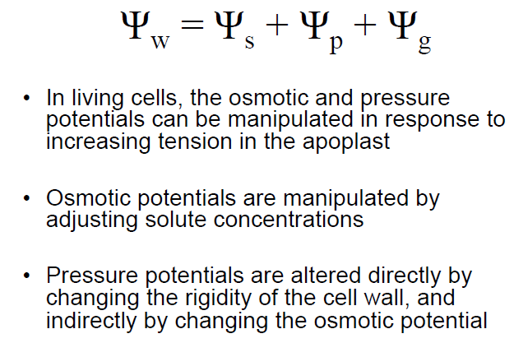
Riparian used to lots of water and decline rapidly without it Holding on to water creates safer xylem

Daily offshore fog events, organisms become dependent on these for dew accumulation in furrows, absorb directly or indirectly through condensation

Hydraulic lift by nurse plant draws water towards roots after rain

Lecture 17: Salinity Tolerance
December 6, 2013
10:48 PM
Many natural saline environments include estuaries and salt pans
Mangrove forests - can tolerate almost completely saline areas

Some sites are too salty for any vegetation, salar de uyuni bolivia

Earth is seeing global increases in saliniztion due to land use changes
As water depletes from lakes salt increases -> primary
Also in drying of agriculture land by humans -> secondary
Salts in soils can cause agriculture loss, where irrigation fails

Most of our species are glycophytes and are incapable of tolerating saline environments

Halo phytes have the ability to exclude salt
Salt bushes need some salt to grow
Salinity causes water stress, direct sodium toxicity

High solute concentration in soils leads to a very negative solute potential and water potential therefore making it hard for plants to extract water from soil

Competition between sodium and potassium and between nitrate and chloride as they use the same membrane carriers, can cause toxicity

Plants can exclude salt at the root or xylem through energy dependent transport based on a proton atpase coupled to an influx transporter pumps sodium into xylem sap

Casparian band in root cross section, prevents transferring to shoot

Can also actively pump salts into vacuole where salt is laid out over the leaf

Can also excrete salt through salt glands or bladders on the leaf
Salt bladders are specialized tricombs look like foil balloons
The degree of excretion varies
Salt glands are dicots Salt hair are monocots
Reduce radiative load, create salt barrier around leaves can act allelopathically

Lecture 18: Soil Adaptations
December 6, 2013
10:48 PM
Many edaphic traits in soil
Major distinction is pH

Ways to Enhance Nutrient Acquisition

• Increase absorptive surface area
• more root mass
• more fine roots
• more root hairs
• mycorrhizal symbiosis
• Increase uptake per unit root surface
• more high affinity carriers
• more H+-ATPases
• excrete chelators
• excrete hydrolytic enzymes
• move internal ions into the stele quickly to maintain
a strong concentration gradient
• Get nitrogen from other sources…

High affinity finds low amounts and brings them in
Acidification changes the amount of iron solubility by proton pumping
Acidic or basic environment affects the rhizosphere by changing the nitrogen content
Dicots and monocots acidify the rhizosphere when nutrients are low

Phytosiderophores - exuded by grasses, take up metals such as iron through two strategies

1 - iron chelated and reduced to 3+ at root surface then put into plant
2 - mas pumped out, surround metals and bind as a chelator to bring the metal inside the plant to be reduced

Energetically expensive, only use when defeciencies occur, not secreting incorporators at night because stomata aren't open, harder to get iron in with a lack of energy

Lupins produce proteioid/cluster roots
Look like bottle brushes, produced in phosphorous deficient soils
Acidification of soil in alkaline regions
Chelators citrate or malate for acidic soils to release adsorbed phosphate
Bump phosphorous off of things, break down small organisc materials
Basically mining acidic soil
Soil particles adsorb to complex root system

This is a non-mycorrhizal strategy, usually more effective at low phosphorous, then switch to mycorrhizal species at moderately low phosphorous

Tradeoffs for different soils

Al solubility
• In alkaline soils, little soluble Al
• In acidic soils, Al tends to be in high concentrations

Nitrogen source
• Soil N can be NH4+ or NO3-
• In acidic soils, NH4+ dominates, while NO3- dominates in alkaline soils
Ca+ availability
• In alkaline soils, high Ca+ concentrations
• In acidic soils, very little available Ca+

P, Fe and Zn availability
• In alkaline soils, bound to soil particles
• In acidic soils, tend to be soluble

• Calcicole: a chalk-dwelling species
• Calcifuge: a chalk-fleeing species
Can be very similar looking plants

Calcicole in alkaline soils
• Low tolerance for Al
• No need to evolve expensive Al tolerance strategies
• “Prefer” NO3- to NH4+
• In alkaline soils, NO3- is major N source
• Optimize root uptake, leaf enzymes for NO3-
• High tolerance for Ca+
• Must be able to deal with high concentrations
• Ability to access P, Fe and Zn through acidification or other methods
• Sufficient access to these nutrients
Calcifuge in acidic soils

• Generally tolerant of Al
• No Al toxicity
• “Prefer” NH4+ to NO3-
• In acidic soil, NH4+ is major N source
• Optimize root uptake, leaf enzymes for NH4+
• Low need for Ca+ and Ca+ scavenging traits
• Root adaptations for enhancing Ca+ uptake
• Low ability to solubilize P, Fe and Zn
• In acidic soils, no need to

Calcicole in acidic soil

• Low tolerance for Al
• Al toxicity
• “Prefer” NO3- to NH4+
• N deficiency
• High tolerance for Ca+
• Ca deficiency
• Ability to access P, Fe and Zn through acidification/other methods
• Can be “too successful”, potential toxicity
Calcifuge in alkaline soils
• Generally tolerant of Al
• No Al toxicity
• “Prefer” NH4+ to NO3-
• N deficient
• Low need for Ca+ and Ca+ scavenging traits
• Ca+ toxicity
• Low ability to solubilize P, Fe and Zn
• Deficiencies

Lecture 19: Metal Tolerance
December 6, 2013
10:48 PM
External | Internal
Change in pH (decrease increases metals | Chelation phytochelatins PC or organic acids to the plant
Organic matter (citrate malate) | Compartmentation (HMT1 gate to vacuole)
Cell wall (barrier/metal binding) | Cell wall (internal binding)
Oxidation (metal oxides) | Metal selectivity sychrotron x rays
pepC upregulated when cadmium is present

Industries are not the major source of cadmium
Batteries, red plastic or paint, cars, cigarettes phosphate fertilizer are attractive to metals when mined
Fertilizer is the largest source of cadmium in environment, not economical to remove, once not a problem but lots build up over a century

Some plants are hyper accumulators of metal

Food safety is a risk if plants have metals in the part that we eat
Metals must be in the water to be taken up by the plant

Transfer soil to plants, acidificaiton of rhizosphere and metal mobilization

Organic material content affects soil metal concentrations, high organic material = high metal concentration flatline
Exclude organic molecules and take up more metals

Protons can bump copper and metals off soil which is why low pH increases metal concentrations

Compost uality also affects metal concentrations
Humic acid vs fulvic acid proportions
In one environment more fulvic acid was favoured in the other it wasn't

Internal detoxification can occur through phytochelatins which surround the ion and make it unaccessible

Transporting it into a vacuole through HMT1 gate heavy metal transporter 1 where it will do no damage

Looking for genes that respond to metal uptake in arabidopsis
Cadmium induces changes in the pepc pathway

Lecture 20: Nitrogen and Carnivory
December 6, 2013
10:48 PM
Eutrofication is a main concern due to human impact
Nitrogen is the most abundant macronutrient

Mycorrhizal symbiosis are a common way to increase nutrient acquisition
Fungal hyphae extend further out than roots to acquire nutrients via a symbiotic relationship

Nitrogen gas is most abundant 78% atmosphere, but very hard to use because lots of energy is required to break the triple bond
Some plants such as legumes clover alders are nitrogen fixers although it is not the plants that fix the nitrogen

Bacterial symbiont rhizobium fixes n2 via nitrogenase which is inhibited by oxygen, therefore bacterial live in nodules of roots, where they are protected and have low oxygen concentrations
Plants produce leghemoglobin which has 10x affinity for oxygen and doesn't release it

Nodules are created by the release of flavenoides by roots which creates nod genes to produce a host specific signal from bacteria that the plant root can recognize then induction of nodulation occurs, rot hair curls around bacteria, carbon costly
Arbuscular mycchorizae do the same

Bogs are the biggest place for carnivorous plants
Have evolved several times through convergent evolution to have many different mechanisms such as eel trap, suction, snapping, pitcher, adhesive or movement

Eel trap is curled tube with hairs

Sundew has lots of sticky tricombs

Digesting these has a large effect on nutrient concentrations with flies

Pitcher plants drown bugs

Utricularia bladder worts senses prey opens trapdoor, bladder sucks in aquatic organisms with water

Venus flytrap has 1st contact with hair, action potential, trap closes, enzymatic secretion, digests, trap reopens in a few weeks
Dead flies wont be consumed

