KP 161 – A Motor Learning and Control
MWF 10.30am – 11.20am

Jan. 4 2016
Chapter ONE
Motor Skill Acquisition and Performance

The three separate entities of the Learner, the environment and, the task, all have some degree of overlap in terms of performance of a skill
- Performance: the act of executing a skill

Each of these entities can be singled out for adjustment to improve, or can be addressed together as a whole

Learner:
- possesses the underlying abilities to perform the task?
- developmentally ready to perform the task?
- any past experiences relevant to the task?
- motivated to learn task?
- individual differences that may influence the acquisition of the task?

Environment:
- context of the task being performed?
- predictable or unpredictable context?
- time limits?

Task:
- High perceptual component?
- required object manipulation?
- required body movement?
- task performed under a variety of conditions?
OR accurate and consistent replication of the movement pattern needed?

Learning – relatively permanent change in a person’s capability to execute a motor skill as a result of practice
- Through repeated observation, we can infer whether the individual has learned the skill – based on changes in the performance seen over time

Motor Learning vs. Motor Control

Motor Learning - study of the processes involved in acquiring and refining motor skills, considering the variables that may inhibit or promote that acquisition

Motor Control – focuses on the neural, physical, and behavioural aspects

Motor Skills are defined as being:
- Goal oriented (to achieve some objective)
- Body/limb movement required to accomplish goal
- Voluntary movement (involving the cortex of the brain)
- Learned skills (as a result of practice)

Jan. 6 2016
Motor Skill Breakdown

Skills are classified based on:
- precision
- nature of movement organizations
- predictability of the environment
- context in which the skills are performed
- action requirements of the skill

- Precision of the Movement – Fine vs Gross Motor Skill
Fine Motor Skill
- More Precise
- Smaller musculature

Gross Motor Skill
- Larger musculature
- Multi-limb movement

- Children tend to achieve gross motor skill proficiency first – fine motor skills develop later in life

- Nature of Movement Organization
Discrete Skill
- Beginning and end of a movement is clearly defined
- Example: swinging a golf club

Continuous Skill
- Beginning and end points of the skill occur arbitrary or as a result of some environmental factor
- repetitive in nature
- Example: cycling, working out

Serial Skills
- Collective sequences of multiple discrete skills

- Predictability of the Environment – closed vs open skill
Closed Skill
- Stable, predictable
- Action is known
- Performer decides when to execute action
- Skill dependant on movement time

Open Skill
- Unpredictable, changing
- Unknown action
- No control over when to perform action
- Skill must be matched with that of a teammate/opponent etc.

Multi-Dimensional Classification System

- Regulatory conditions
- Action requirements

Regulatory
- Environmental factors
- Specify movement characteristics necessary to perform a skill successfully

Are conditions stable?
Are conditions fixed or constantly changing?

Action Requirements

Is there a change in setting/location?
Is there manipulation needed of opponents and objects?

Table 1.1 in Textbook
- Simple to complex progression based on requirements
- Used to evaluate capabilities/limitations of individuals

Individual Differences:
- Height
- Body type
- Physiological make up
- Learning styles
- Movement experience
- Developmental level
- Attitude
- Confidence
Based on these differences, teaching strategies will not be equally as effective for all learners, practitioners must account for this variation and identify the best strategies to employ based on the needs of the individual specifically

Motor Abilities
- Genetic traits for performance
The degree to which learners could potentially develop proficiency in a particular motor skill depends on whether they possess the necessary underlying abilities

Initial Hypothesis - single general motor ability determines that an individual could excel in a variety of athletic situations based on inherited traits
Specificity Hypothesis – abilities are independent of one another; they are inherited traits that are not necessarily learned

Motor abilities are categorized based on the kind of task. There are two major categories:
- Perceptual motor abilities
- Physical proficiency abilities
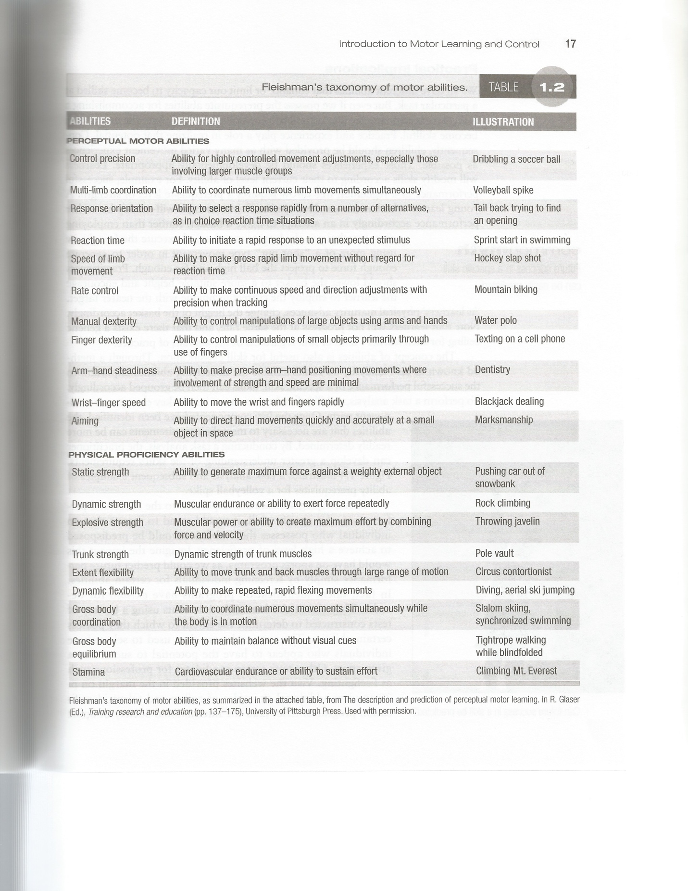

Practical Implications:
- We all have different abilities that enhance or limit our individual capacity to become skillful at a particular task
- Even if we possess specific abilities, there is no guarantee that we can become skillful – only that the potential is apparent
The concept of abilities is useful in skill classification using the method of Task Analysis.
- Task Analysis is used for determining the underlying abilities necessary for the performance of a specific skill/task
To perform a Task Analysis, the skill is broken down into its key elements. Once identified, the abilities required to be successful are more easily determined.

- Underlying Abilities
- Control precision
- Multi-limb coordination
- Rate control
- Aiming
- Explosive strength
- Trunk strength
- Dynamic flexibility

Chapter TWO Jan. 11 2016

Understanding Movement and Preparation
- The process of assessing and analyzing sensory information and utilizing the stimuli to initiate an appropriate response
- Perception: the recognition and interpretation of sensory stimuli
Two models that explain the nature of perception:
- Information Processing Model
- Ecological Approach to Perception

Information Processing Model

INPUT
- Situational factors
- Approach of opponent
- Object Trajectory Characteristics
FEEDBACK
DECISION MAKING
- perceive/interpret input
As movement is initiated, information is feedback to the performer – used to make adjustments/evaluate the action
- compare to existing memory/experiences
- decide where object is headed
- select response

EXECUTION
-organize and educate selected response

previous experience/exposure of a similar situation is imperative for success

Ecological Approach
- Involves the direct relationship between perception and action, interpreted directly in terms of affordances
- All information needed to succeed is directly available in the environment

Affordances: the action possibilities of the environment and task in relation to the perceiver’s own capabilities.
- Individual differences and various factors would suggest that several learners may not interpret the same number or type of reaction to the same situation/environment.

Perception Based on Affordances Action

- Response occurs quickly, and is more automatic
- Affordances, or opportunities for action may change and fluctuate over the courses of the activity – as a result of changes in the player’s action capability or playing conditions

Preparing a Response

Reaction Time: the brief lag between the stimulus being presented and the initiation of the response
- Not constant, depends on processing demands of the specific situation

Factors Influencing Reaction Time

- Number of Responses
The number and variation in options for responding to a certain stimulus

Hick’s Law – the Reaction Time (RT) variation is logirhythmically related to the number of response alternatives

- More choices for responses = longer RT duration

Movement Time (MT) – correlates with the number of responses
- Interval of time between the initiation and the completion of the task
Response Time = RT + MT

- Controlling the Levels of Uncertainty
increased uncertainty in a situation and how to respond to it will lead to delay or inaccuracy in response

- Practitioners should be aware of strategies to reduce uncertainty in learner’s
(i.e. reducing the number of possible responses)

- Anticipation
Advancement in information about the necessary response to a stimulus
- If you can anticipate the stimulus, it will increase the movement preparation, reducing the response delay
This involves predicting Event and Temporal Anticipation
- Noticing pre-cues, the environmental indications of how to respond

Practical Applications of Anticipation
- Practice – help learners better anticipate what will happen/when it will happen
- Scouting – watch/analyze opponents, learn techniques etc., how to beat them

- Fore-period Consistency
Learner’s preparation to respond to a situation – influencing response preparation time
- Presence of a warning signal, indicating the approach of the stimulus
- “On your marks, Get set, Go”
- Interval of time between fore-period and stimulus should be about 1-4 seconds
- Mere presence of a warning signal is not always enough for a performer to achieve optimal preparedness

- Psychological Refractory Period (Fake-Out)
Delay in response to a first movement, provides further delay in response to a second, actual movement

- Stimulus Response Compatibility (S-R)
The extent to which a stimulus and its required response are naturally related.
- Comparable to an automatic response to a stimulus
- When S-R is low (having little compatibility), additional time is needed to prepare – increasing the reaction time (RT)

Attention – the human brain can only pay attention to a limited number of of activities
- Attention is what we subconsciously choose to focus on

When the limit of what we can focus on is exceeded then a competition for resources occurs
- Processing speed reduces
- Quality is reduced
- Disregard for one activity, focus gets lost

As long as all resources are not being absorbed, multiple focuses are possible
- No competition, no problem
When processing a physical task and a cognitive task, no competition for resources is occurring, not exceeding attentional capacity.
If there are multiple tasks that are consuming more attentional space than is available, the level of performance may decline -> where two cognitive activities are occurring, performance may decline, or one task may receive more focus than the other

Factors Affecting Attentional Demands
Environmental and Task Complexity
- As the environment or task increases in complexity, the attentional demands will undergo a corresponding increase, reducing the amount of attentional space available for additional tasks.
Skill Level
- Lower skill levels at a particular task will decrease the performers ability to carry on multiple focuses
Number of Cues
- Attentional limitations are exceeded when a performer tries to think about too many things when learning or refining a motor skill. Teaching learners to attend selectively to relevant cues and ignore irrelevant ones will reduce the competition for attentional space.
Selective Attention
- Ability to attend to meaningful information that will increase performance success
Example: Cocktail Party Phenomenon

Attentional Focus
External

Broad Narrow

Internal
Broad-External
- Assesses external environment/situation
Narrow-External
- Focuses on one or two external cues to perform the motor response
Broad-Internal
- Used to analyze and plan strategy or the impending motor response
Narrow Internal
- Monitor internal cues and mentally rehearse an an upcoming

- Cannot assume a learner will be able to disregard irrelevant information
- Avoid causing learners to shift attentional focus in the wrong direction
- May be useful in distracting an opponent

Focus and Instruction
- Learners should focus on own body movement (internal)
- Focus on effects of their movements (external)
External – focus of attention, enhances learning and performance
Wording and instruction is imperative to successful learning/performing
- Effects on motor skill acquisition/performance

When learning, begin with primary external focus and transition to internal focus

Arousal
- General physiological and psychological activation
- Optimal levels of arousal exist for peak performance
The Inverted U-pattern
- Intersection between optimal arousal and performance
Yerkes Dodson Law (1908) – stating there is an optimal level of arousal for peak performance.
This level is not constant, it is dependant on the characteristics of the performer and task
- Increased complexity of a task, requiring fine motor skills, decision making and attentional requirements, then lower levels of arousal will be optimal.

Trait Anxiety – tendency to perceive threatening/non-threatening sensations or situations

Arousal and Movement Preparation
- Cue utilization
-Change in attentional focus related to arousal

Attentional focus narrows to task relevant cues as arousal approaches the optimal levels
- Zone of optimal functioning, “in the zone”
- Perceptual narrowing - attend to fewer factors
-Increase arousal levels

Practical Implications

Increase:
Rhythm of breathing
Music
Increase physical activity
Stay motivated

Decrease:
Slow, controlled breathing
Relax muscles
Thoughts
Positive outcome
Focus on performance, not end result

Jan. 18 2016
Chapter THREE
Behavioural Theories of Motor Control
Degrees of Freedom
- A number of different action possibilities for each motion the body makes

Coordination and Control
- Coordination – organizing a systems available degrees of freedom into an efficient movement pattern
- Control – manipulation of variables within a movement to meet demands of a given situation
Degrees of Freedom Problem
- Performing a skilled movement requires the coordination of the of the available degrees of freedom – controls the resulting movement
How we coordinate and control the available degrees of freedom to produce a movement is the Degree of Freedom Problem

How skilled movement is coordinated and controlled:

- Motor Program Theories
- Early Theories – suggested that a separate motor program exists for every movement and is stored in memory
Problems:
Storage
Novel Responses

- Generalized Motor Program (GMP)
- Every movement does not require a separate motor program
Belief that the motor program is more general
Invariant Features: Parameters:
Fixed Flexible
Define motor program Define the programs
Execution

Invariant Features:
Fixed factors, sequence of actions
Relative timing
- Treadmill Speed Test
Up to 6km/h – walking
Up to 8km/h – running
- Different systems
Relative Force

Parameters:
Parameter: easy modification allows for variation in motor response without altering the fundamental movement pattern
Flexible factors
Overall duration
Overall force
Movement direction
Muscle selection

Training with over-weight implements
- When an individual prepares for an activity by using equipment that is heavier/larger than the typical object used in that particular activity
- Involves variation in parameters

Schema
- Directs decision making in situations
Schema develops as the result of accumulated experiences within a class of actions
- Actions and experiences allow for the enhancement of pre-existing schema
Each attempt at an action gives the learner information about future attempts

Considerations:
- Initial conditions – present at start of movement
- Response specifications – parameter values used in execution
- Sensory consequence – response produced sensory info/feedback
- Response outcome – success of the obtained response, in relation to the initial goal that was intended

Two Variations of Schema
Recall Schema:
- Responsible for organizing the motor program that initiates and controls the desired movement.
- Based on the relationship between actual outcomes and response specifications that have developed through previous experiences with similar movements
- Performer determines specifications required to achieve the intended outcome, executing the motor program according to these parameter values

Recognition Schema:
- Evaluates movement attempts
- Formed on the relationships between initial conditions, past actual outcomes, and past sensory consequences
- Informs learner about errors of a particular movement

Executing the Motor Program
- Subconsciously retrieves appropriate generalized motor program based on memory
- Based on existing schema
- Estimates parameter values that will be required to achieve desired outcome

- Open Loop Control
Higher level generates action plans containing necessary info to complete a response
Carried out at the effector level (second level), by the limbs and muscles

Input Processing and Execution Output
Perception -> Decision Making -> Motor Program Initiation

- Closed Loop Control
Makes adjustments after motor program has been initiated
Function in an hierarchy system, however, closed loop allows for feedback to modify an on going action
Cycle continues until intended response is achieved

Input Processing and Execution Output
Perception -> Decision Making -> Motor Program Initiation

Jan. 20 2016
Evidence Supporting Motor Program Control
As a task increases in complexity, the amount of time needed to organize the motor program must also increase -> movements are planned in advance
- Deafferentation- technique in which sensory nerves are are surgically severed so that response-produced feedback cannot reach the Central Nervous System
- Experiments exploring the effects of a limb being unexpectedly blocked during movement

How Skilled Movement is Coordinated and Controlled

Motor Program Control Theory
- Schema Theory is an open loop theory that combines the idea of schema and the idea of generalized motor program
- For every movement we do, we call upon any similar experience we have had to execute the action
- Schema theory proposes that movements are generalized and run by complex rules
Dynamic Interaction Theory
- Suggests movement patterns emerge, or self organize
- From the dynamic interaction between the learner, the environment and the task

Learner

Movement Solution

Task
Environment

Individual Constraints
- Biological and functional characteristics
Body Attributes (shape, height, weight)
Personality (anxiety, motivation, confidence)
Fitness Variables (flexibility, power, strength)
Perceptual and Decision Making Skills

Environmental Constraints Task Constraints
Gravity > imposes constraints on motor skill
Temperature acquisition/performance
Natural Light
Wind/weather conditions

Emergence of Movement Patterns

Movement: function of a system self-organizing and compressing available degrees of freedom into a single unit designed to carry out a specific task

Movement Pattern: result of the constraints imposed by a given situation

Stability and Movement

Attractor: preferred state of stability in a system
- Strong attraction = increased stability

Control Parameter: variables, when changed, lead to corresponding changes in the over behaviour of a system

Rate Limiter: individual constraint that holds back/slows the emergence of a motor skill
- Example: injury

Changes in Movement Behaviour
Phase Shift: changes result from a series of transitions in a systems state of stability
- When an attractor state is shallow, a phase shift can occur abruptly (low stability)
- Deep attractor state: intervention strategies have to cause instability which leads to an increase in movement variability

Overtime the pattern will reorganize, the new technique will take over
Non-Linear Pedagogy and the Constraints-Led Approach
Non-Linear Pedagogy: learner searches through a range of potential movement solutions for the optimum strategy
- Interacting constraints that shape movement behaviour
- Perceptual motor work space – represents practice context for the learner
Process where perceptual information sources are explored along with considering the range of movement possibilities to discover task solutions; unique to the individual

Constraints-Led Approach: involves the purposeful manipulation of a key task, performer, and environment constraints
- Work on channeling acquisition of movement skills and decision making behaviours
- Hands off practitioner
Practical Implications
- Strategies for creating effective learning environments are limited by the practitioner’s imagination
- Emphasize game and context related skills
Chapter FOUR

Neural Mechanisms: Contribution and Control

The Nervous System
Central Nervous System – CNS
- Brain and spinal cord
- Sensory info is integrated, decisions are made
- Signals are generated and sent to effectors (to carry out response)

Peripheral Nervous System – PNS
- Consists of nerves extended from the brain to the spinal cord
- Relays info between body and CNS
- Afferent (sensory) and Efferent(motor) Nerves
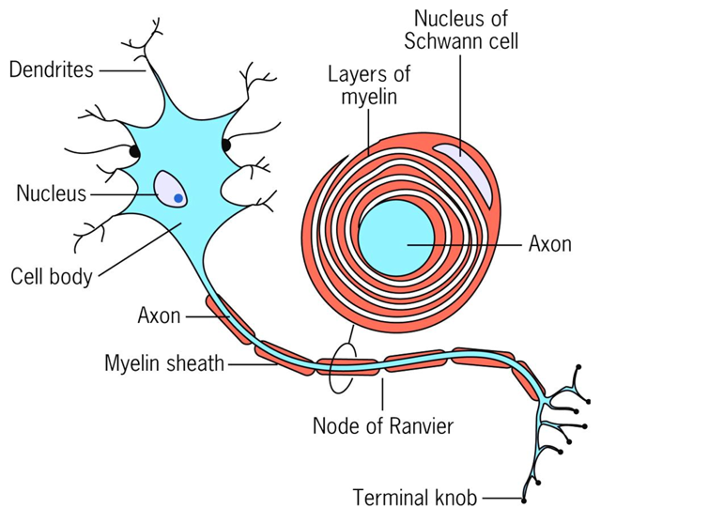

Neurons = Nerve Cells
- Pass along incoming information
- at rest, have a negative charge (Resting Potential)
- Excited neurons have a positive charge (Action Potential)
- Undershoot – Refractory Period
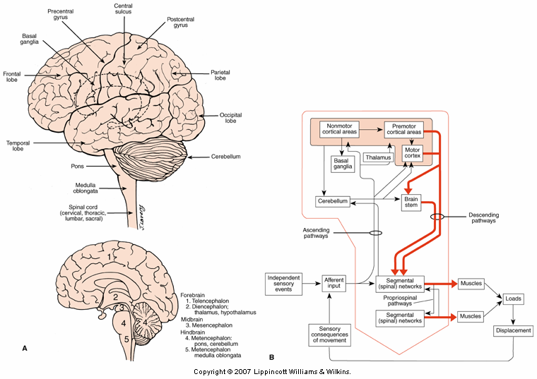
- The communication between neurons – synaptic transmission

Parts of the Brain
- Stem
- Diencephalon (top of brain stem)
- Cerebrum (above diencephalon)
- Cerebellum (hind brain)

Direction Cues
- Rostral = Superior, Up
- Caudal = Inferior, Down

Cerebral Cortex
- Sensory, motor, acquisition
Frontal Lobe – emotions, motor control
Parietal Lobe – sensory information
Temporal Lobe – language
Occipital Lobe – visual processing

Basal Ganglia
- Nuclei that work together deep in the cerebrum
- Loop of information flow relayed through thalamus
- Important in initiation and control of sub-conscious
- Gross body movements
Diseases that affect the Basal Ganglia:
- Huntington’s – overstimulation, uncontrollable jerking of limbs/face muscles
- Parkinson’s – slow, uncontrollable shaking, difficulty in voluntary movement

Cerebellum
- Monitors movement – detects and corrects
- Compares sensory info from proprioceptors/visual receptors to the expected sensory consequences
- Produces smooth movement with motor cortex
- Postural control and balance

Memory Systems
- Able to store and retrieve information
- Changes in the CNS must occur in order to store an experience as a memory
- Three memory systems – sensory, long-term, working memory

Types of Long Term Memory
Procedural – process; skills, actions, movements
Declarative – facts and events
- Episodic – personal experiences/events in a specific time or context (dates, birthdays)
- Semantic – general knowledge from experiences

Forgetting
- Decay theory – a result of time passing
- Interference theory – result of proactive or retroactive interference
- Retroactive Interference - when learning something new interferes with the retention of older memories

Practical Implications – Memory
- Keep instructions, cues, feedback short and simple
- Key points only
- Physical rehearsal
- New skills related to previously learned skills
- Group movement patterns together

Transmission of Info, via Spinal Cord
- Ascending
- Descending
Each nerve has the ability to bring in and output information
Sensory and Motor Pathway
Sensory (Ascending) – info travels up spinal cord; Spinothalamic pathway, Dorsal Column Pthwy
- Spinothalamic: Conducts impulses associated with pain, crude touch, temperature
- Dorsal Column – proprioception, light touch/pressure, vibrations
Motor (Descending) – transmit impulses to the muscles to execute movement
- Pyramidal – nerve impulses that control voluntary movement
- Extrapyramidal – nerve impulses for more subconscious movements of the body

Spinal Reflexes
- Automatic, involuntary response to stimuli
- Reflex arc – receptor -> sensory neuron -> interneuron -> motor neuron -> effector
- Types
-Monosynaptic -> one synapse
- Polysynaptic -> more than one synapse, influenced by multiple neurons, multiple interneurons

Damage to spinal cord
- Can result in loss of function or feeling/sensation
- Type and level of injury determine the effects
Spinal cord injuries may be classified as either complete or incomplete
- Complete, where function and sensation are lost below the level of injury
- Incomplete, where there is partial damage to the spinal cord, and effects depend on the area of the injury

Level of injury
- the higher up on the spinal cord = more severe

Sensory/Perceptual Systems
- stimulates reflex movement at the spinal cord
- modulates output of movement
- modulates movements resulting from commands originating in higher centers of the nervous system

Sensory Receptors
- Detects stimuli and provides information, relays info to CNS
- exteroceptors -> receives external stimuli
- interoceptors -> receives info from within the body
- proprioceptors -> provide info about joint angle, muscle tension, and muscle length
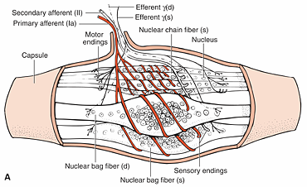
muscle spindle= type of proprioceptor

Vision
- Predominant sensory receptor
- 70% of all sensory receptors are located in the eyes
- 40% of the visual cortex is thought to be involved in processing visual information

Sports Vision
- investigates visual contributions to performance

Visual System
- exteroceptive sense
- visual proprioception
- photoreceptors (rods and cones)

The Eye
Basic Structures:
- iris
- lens
- cornea
- retina/fovea
- optic nerve (no photoreceptors, blind spot)

Photoreceptors:
- transform light waves into electrical impulses
- located in retina
- Types
- Rods: peripheral retina, responds to low lighting; shapes and movement
- Cones: located at fovea mostly, stimulated by high levels of illumination, colour

Pathway:
- Photoreceptors > optic nerve > optic chiasm > optic tract > LGN > Optic Radiation > V1

2 Visual System Processing Methods

Focal
- Center of visual field
- Linked to consciousness
- Voluntary control
- Hampered by low light

Ambient
- Subconscious
- Responsible for spatial localization and orientation
- Serves Central and Peripheral Vision Fields
- Not affected by light changes

Visual Traits and Motor Performance Development
- Visual acuity
- Degree of detail that can be seen
Static Visual Acuity – stationary objects
Dynamic Visual Acuity – moving objects
- Reflects CNS ability to estimate properties
- Ocular-motor system tracks and keeps image on fovea
Eye Movement – Occur to foveate objects

2 Types of Volitional Movement
- Conjugate – object moves at a distance and both eyes need to move in the same direction
- Vergence – eyes converge or diverge

6 Muscles in the Eye
Visual Acuity
- Exercise increases blood flow – bringing more Oxygen to the eye
- Visual acuity found to increase following exercise
-last 2 hours post exercise

Basketball field goal shooting
- Directly linked to dynamic visual acuity

Visual and Performance
- Eye dominance
- Spotting
- Visual search
- Locomotion

Eye Dominance
- One eye processes info
- Same side or cross dominance
Spotting
- Used in rotation skills
- Rotation of the head is delayed, relative to body’s rotation

Visual Search – strategies
- Quiet eye -> final fixation on a target before movement begins
- Targeting skills -> accurately propelling an object toward a target
- Interceptive skills -> tracking moving stimulus, to determine reaction response
- Tactical skills -> quick, accurate situation decision making

Locomotion
- Optic Flow – how close we are to certain objects, how quick we approach them
- Feed Forward – sends info ahead, prepare to adjust movement

Visual Practical Implications
- Be cautious when examining claims of visual-training programs
- Develop effective visual search strategies, pattern recognition, anticipation and decision making
- Somatosensory System
- Peripheral receptors
Muscle spindle senses muscle length
- 1A afferents
- Monosynaptic stretch reflex
Golgi tendon organs (in-between muscle and tendon)
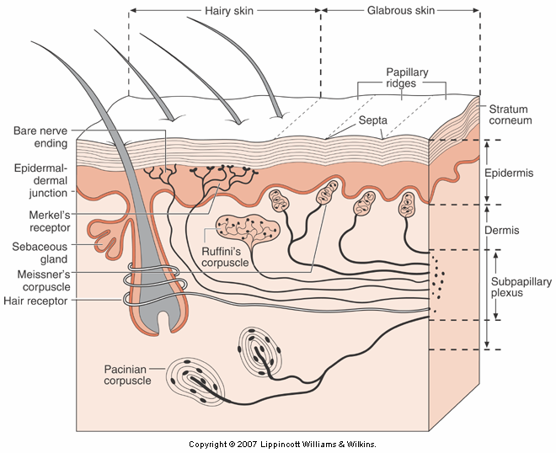
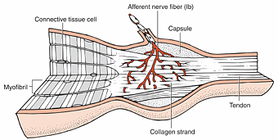

Joint Receptors
Cutaneous Receptors

Skin Receptors

Somatosensory system at spinal cord level
- Info from cutaneous, muscle and joint receptors, modify the the output of circuits that control basic activities
Sensory info modulates locomotor output

Performance
- Makes the motor control system more efficient/flexible
- Provides info about initial body and limb position
- Evaluates movement for correctness
Cortex
- Cross – modality
- Primary somatosensory cortex
- Secondary somatosensory cortex
- Association Cortices

Feb. 3 2016
Action Systems
- Perform processing essential to the coordination of movement

Primary Motor Cortex
- Controls absolute force and speed of movement
- There are many parallel pathways for carrying out an action sequence (Redundancy)

Supplementary Motor and Pre-Motor Areas
- Areas send projections to primary motor cortex and spinal cord
- Movements initiated internally
- Movements activated to external stimuli
- Two separate pathways from the Parietal Cortex to the pre-motor areas for control and grasping

Postural Control
- Multiple sensory inputs that tell the CNS where the body is in it’s surrounding space

Maintaining equilibrium; requires postural adjustments
- Compensatory – recovering after an unexpected stimulus
- Anticipatory – known ahead of time that the stimulus will occur

Traumatic Brain Injury
- Disruption of normal brain function as a result of an external mechanical force
- May result in temporary or lasting cognitive and/or cognitive impairments
Physical Therapies – design programs to help restore motor function, strength, coordination, balance etc.

Feb. 8 2016
Chapter Five – Stages of Learning

Consider:
- Transitions between learning stages can’t be delineated; each blends into the next stages
- A learner can be in different stages of the skill
- Stages are not dependent on age

Stage Models

Fitt’s and Posner’s Three Stage Model
- Learner’s pass through 3 distinct stages; each defined by the behavioural tendencies the learners display at various points throughout the learning process

Cognitive Stage
Development of basic movement pattern

Associative Stage
Refinement of movement pattern

Autonomous Stage
Performance/ movement is virtually automatic

Cognitive Stage
- Introduced to a new skill
- Develops understanding of movement requirements
- Attempts numerous techniques and strategies for learning
- Reformulates past techniques and strategies to solve movement problem
- Needs guidance from practitioner to detect and correct

Associative Stage
- Committed to refining one particular movement pattern
- Performs more consistently, with fewer errors
- Better at detecting errors and developing strategies to eliminate them
- Constructive pattern experiences; effective feed back

Autonomous Stage
- Perform skill proficiently
- Perform multiple tasks simultaneously
- Perform consistently and confidently – with few errors
- May become discouraged of proficiency comes slow
- Practitioner as motivator
With each stage, as the learner progresses, and develops as a result, the learner changes at each stage

Gentile’s Two Stage Model
Idea of Movement
Development of ability to discriminate between regulatory and non-regulatory conditions

Development of basic movement pattern

Fixation
Refinement of movement pattern

Diversification
Adaptation of movement to conform to ever-changing environmental demands
Closed Skill

Open Skill

Gentile
- Instruction and practice should facilitate the development of a basic movement pattern

Fixation/Diversification Stage
- Learner’s goal: refine skill
- Fixation – closed skill; fixed, stable environment
- Diversification – open skill; unpredictable environment

Feb. 10 2016

Performance Indicators
Learning has occurred if there are observable changes in:
- Movement pattern
- Attention
- Knowledge and memory
- Error detection and correction
- Self-confidence

Improvements in Motor Patterns
- Increase in coordination and control
- Fluid muscle activity (smooth movement)
-release of degrees of freedom
- efficient energy expenditure
- increased consistency (less errors)

Freezing and Freeing
- Degrees of freedom
There would be a difference in rigid movement compared to a smooth movement
Freezing – no degrees of freedom at joint
- Reducing weight
Freeing – increasing the degrees of freedom at joints
- Motion is smooth/action-fluid

Focusing Attention

Attention to skill execution
- Proficiency increases- need to attend to each aspect decreases
- Performance becomes almost automatic
- Learner can focus on other factors of performance

Allocation of visual attention
- Skilled performers direct attention to relevant areas
- Beginners have difficulty discriminating between relevant and irrelevant cues

It takes 100 milliseconds of attention/focus to process something

Knowledge and Memory
- Accomplished performers have more knowledge of a skill/movement

Declarative – rules, strategy pertaining to environment
Procedural – what to do in a given situation

Measuring Progress
- Performance curves; plotting and graphical representation of initial assessments
- Retention Rates; long term, inference that relatively permanent change in a performance has occurred
- Transfer Tests; other situations, measures the degree of freedom, to which a learner can adapt the practiced skill to a different situation

Limitations to Performance Curves
- Temporary effects
- Can’t establish relative performance
- Constructed from measurements obtained by calculating the mean of traits

Performance Plateau
Period of time during learning when no changes occur
- Transitional period
Factors:
- Anxiety
- Fatigue
- Motivation
- Limits type of performance measurement
Feb. 22 2016
Chapter Six – The Learner: Pre-institution Consideration

Learning Styles
- Unique preference for retrieving/processing information
- Should incorporate instructional strategies for all types of learners

Learning Styles Inventory (Dunn and Dunn)
- Determined by assessing five preferences
- Instructional Environment (Layout)
- Emotional (example: motivation)
- Sociological (example: pairs/individual)
- Physiological (perception)
- Psychological (analytical mode, hemisphericity, action)

Learning Profiles

Global Learners
- Big picture, prior to details
- Humour, anecdotes, creativity

Analytical Learners
- Step by step, sequential manner
- Rules, guidelines

Perceptual Mode
- Information received and processed; preferred perceptual mode

4 Types – preferred perceptual mode

- Visual (cue words, see, looking)
- Kinesthetic (feel of movement)
- Analytical (problem solving, steps)
- Auditory (sounds/rhythms)

Accommodating a variety of learners
- Learning style shift based of whether task is cognitive or motor
- Use various assessments to discover a learners preferred style
- Avoid using one presentation style
- Know own learning style
-make effort to incorporate strategies from other style
- Eclectic Approach

Transfer of Learning
Defined: learning/performing a new skill under new conditions
- Influenced by past experiences
- Cumulative past experiences influence one’s ability to learn new skills (positive/negative)

Types of Transfers
Positive: past experience with one skill facilitates learning a new skill
Negative: past experience has no effect on learning new skills
Zero Transfer: past experience has no effect on learning new skill

Transfer
Ideally capitalize on positive transfer
Negative transfer can occur
- Having to learn new response to well learned stimulus
- Usually temporary
- Overcome by practice

Theories of Transfer
- Aids in designing learning experiences and accounting for difficulties individuals may display as a result of negative transfer

Identical Elements Theory
- Thorndike (1914) – transfer based on the number of common elements between tasks
- More common elements = greater positive transfer

- Osgoode (1949) – similarities between stimulus and response conditions are fundamental

Transfer Appropriate Processing Theory
- Account for cognitive processing similarities
- Positive transfer practice conditions have problem solving processes that are similar to the criterion task
Variable practice: allows learner to engage in realistic cognitive processing

Transfer and Instructional Design
- Transfer helps with many instruction decisions
- Simplified skills, drills, and games serve as precursors to more complex versions introduced in the future
- Skill progressions (lead ups)
- Support for designing methods to capitalize on positive transfer

Feb. 24 2016
Fostering Positive Transfer
- Analyze the skill
- Determine the cost benefit trade off
-maximum output with minimum input
- Get to know learner
- Similarities and differences
- Make sure skills have been well-learned
- Use analogies
- Maximum similarities between practice and performance
-state dependency
- Consider skill level of learner

Analyze the Skill
- Examine sub-components of skills to determine degree of similarity -> positive transfer

- Fundamental movement pattern
- Strategic and conceptual aspects of game or task
- Perceptual elements (seeing the field)
- Temporal/spatial elements (racquet sports)

- familiarity with past motor skill abilities
- determine if similarities exist between number 1 and others

Cost-Benefit Trade Off
- measures based on amount of positive transfer
- purpose is to transfer learning to a functional context

Get to Know Learner
- past experiences influence ability to learn new skills
- past experiences can be used as comparator

Similarities and Differences
- once established, point them
- point out which aspects are similar/differences -> don’t assume they are known

Maximize Similarities Between Practice and Performance
- similar context
- provide variety of situations
- drills to simulate actual performance
-max positive transfer

Consider Skill Level of Learner
- transfer more beneficial for beginner than intermediate or expert
Motivation to Learn
- internal condition that incites and directs action or behaviour
- influences learners interest

Learner will:
- Explore
- Practice
- Think
- Attempt to Master Skill

Captivate learner’s interests
Lack of motivation hinders learning
Learners need a reason to learn a new skill
- Why is it important?
- Expose learners to elite role models and performances
- Create positive, supportive and challenging learning environment

Not all learners are motivated to learn the skills presented to them

Feb. 29 2016
Skill Presentation

Learner Preparation
- Practitioners can directly influence the learner in two ways:

- Capture learner’s individual attention, with minimal distractions
- Introduce the skill in a manner that stimulates interest

An Instructor Providing Effective Verbal Instruction
- Have a thorough understanding of the skill being taught and convey knowledge
- Clear effective instructions that don’t confuse
- Would an expert be an effective instructor? Some learners would prefer to not be taught by an expert

Considerations When Giving Verbal Instruction

- Task instructions
- Introduce – general idea of goal
- Develop and refine skills

- Introduce the Skill
- Focus on attention and elements of new motor skill
- Beginners have difficulty discriminating between relevant and irrelevant stimuli

- Amount of Information
- Short/simple
- Supply key elements
- Specifics can be addressed later

- Precise Language
- Provide enough information to relay concept while using developmentally appropriate terminology
- Lack of Specificity -> Misunderstanding

- Internal vs. External Focus

Internal
- Attention to own body
- May have a negative impact on acquiring/refining skills
External
- Effects of actions on the environment
- More effective

- Constrained Action Hypothesis
- When learners adopt an internal focus, they are consciously attempting to control the action -> disrupts natural flow
- Adopting an external focus of attention promotes more automatic control focus

- Awareness of Regulatory Conditions
Implicit Learning – no awareness
Explicit Learning – conscious operation

- Learning Styles
Visual
Kinesthetic

- Previously Learned Skills
Transfer
- Derive greater meaning from explanation if related to previous experience

- Verbal Cues
- Concise phrase that focuses attention
- Self – Talk; learners develop and use cues to guide themselves

Guidelines for Cues
- Concise
- Accurate
- Limited number repetition
Check for Understanding
- Instructions can elicit desired response only if they are understood
- Ask learners to restate key elements of skill

Demonstrations
- Showing, as opposed to explaining
Facilitates better learning

Preferred Instructional Method
- Modelling or observational learning

Mirror Neurons
- Neurons activated when:
Performing an action
Watch someone else perform same action

- Neural mechanism through which observational learning occurs

Theories of Observational Learning
- Social Cognitive Wheeling

When a learner observes modelling ; the learner processes information and transforms into a cognitive memory (watching)
- If background allow for building upon previous experiences

Dynamic Interpretation of Modelling
- Direct perception of key information

Designing Effective Demonstrations
- What should be demonstrated?
Coordination vs. Control
- Benefit from focus on a new pattern
Entire vs. Partial
- Entirety, then in steps
Real Time vs. Slow Motion

Understand “who” learner is?

Who demonstrates?
- Expert vs. learner
- Model observer similarity
- Alternative mediums – best tools to facilitates

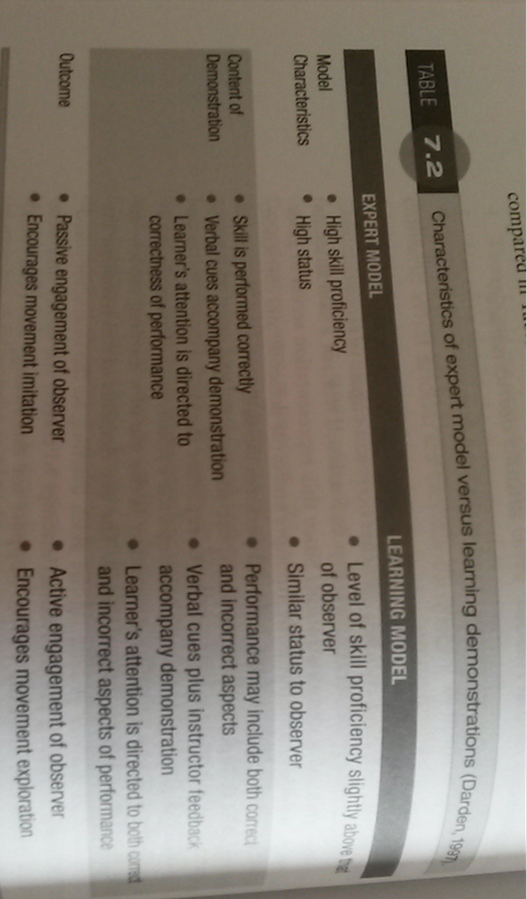
Expert Vs Learner Instruction/Demonstration

Demonstration Organization
- Use of appropriate formation
- Explain progression of demonstration
- Avoid product options
-design demonstration to facilitate one outcome

Distribution and Frequency
- When and how often
- When?
- several times before practicing
- interspersed through practice period

Discovery Learning
- Constraints-led approach
- Solve movement problem – explores task solutions
- Practitioners acts as facilitator
- Ice skating – example

Guided Discovery - variation of above
- Step by step process
- Practitioner asks questions – single correct response
- Learners discover:
- technique
- understanding why technique is used

Manual Guidance
- Practitioner or device moves learner through desired range of motion
- Safety Belt/ Golf Swing Ring

- Passively led is not ideal
Response produced feedback is different

Chapter Eight – Principles of Practice Design

Practice Design
“practice makes perfect” – not necessarily true, this is not guaranteed
- Careful practice design can lead to gains in skill proficiency

Consider the influence of:
- Learner
- Task
- Environment

Cerebral Challenge
Performance of one part of a skill favourably influences the next skill

Breaking Down Skills
- When should a skill be broken down into parts?
- When should it be practiced as a whole?
- How do speed and accuracy influence skill acquisition?
- How can one best learn skills that must be performed equally well on both the dominant and non-dominant?

Part-Practice Method
- Break down of the skill into natural parts; practice separately; integrate into entire task
- Most commonly used tactic
- May not be the most efficient

Advantages of Part Practice
- Simplifies
- Experience early success, and leads to increased motivation
- Practice on problem areas without wasting time on what has already been mastered

Decision: Whole vs. Part Practice
Ideally use a method that will lead to positive skill transfer
- Consider the nature of the skill

Effectiveness is dependent on 2 features of skill

Task Complexity
- How many sub-components?
- Many info-processing demands
Task Organization
- How much does the performance of each part of the skill depend of the component that precedes it?

Classifying Skills

Task Complexity
High Low
Jump Serve | Golf putt
Figure 8 Knot | Clap Hands
High

Low

Capability of Learner
- Component that should be considered
- Want to decrease frustration and increase motivation
- Part practice may be improved if:
- Learner has limited movement experiences
- Cognitive requirements exceed learner’s capabilities

Whole vs. Part Practice
- Want method that will lead to positive transfer, consider:
- nature of the skill
- learner’s capabilities

Part Practice Techniques
- Segmentation
- Fractionization
- Simplification

Segmentation
- Spatial and Temporal Elements
- Part-whole method
- Each part practiced separately then combines for whole

- Progressive part
- 2 parts separately then together until mastered then adds third and practiced separately
- then combined

- Repetitive part method
- Learned adds new components to previous parts and practiced together

Breaking Down
- Forward Chaining; presented and practiced in order from first to final part of skill
- Backward Chaining; sequence progresses in reverse order

Fractionization
- Skill components that are typically performed simultaneously are partitioned and practiced independently
- Effectiveness is questionable
- Whole practice is recommended for some tasks (those that require simultaneous use of arms and legs)

Simplification
- Reduces level of difficulty of task
- Modify Equipment; most useful way to decrease task difficulty
- Reduce Coordination Requirements; try stationary position or slower movements
- Change environment complexity; attentional demands (open skill or closed)
- Skill building activities; apply new skills controlled environment
- Sequence from simple to complex

Whole Vs. Part Practice
- Positive transfer
- Combine benefits of part and whole practice
- Direct attention to specific aspects of skill while performing it as a whole

Mar. 9 2016
Speed and Accuracy Trade-off
- The faster you do something, the less accurate you’ll be able to execute it
- Speed negatively affects accuracy

Fitt’s Law – MT = a + b [log2(2A/W)
- Found that performers had to slow their actions as the distance to be moved increased, or target size decreased if they wanted to perform accurately

Spatial Accuracy is governed by the speed-accuracy trade-off, whereas Temporal Accuracy is not
- Temporal: accuracy improves when a performer moves faster, or movement distance is decreased

Bilateral Transfer
- Ability to use both hands with equal proficiency is an advantage
Practice with one limb enhances skill acquisition on the same task using opposite hand
Why?
- Non-practiced limb uses the same GMP program as practiced limb
- One limb acquires the important cognitive information about the movement and transfers it to the other limb
How to Sequence Transfer;
- Greater degree of transfer occurs for preferred to non-preferred limb
- Greater performance when practicing with non-dominant to dominant limb

Psychological Strategies

- Motivation and Practice
- Loss of Motivation
- boredom
- frustration
To become motivated again:
- Fun and varied activities
- Feel some sense of success and achievement

- Goal Setting
- Purpose
- focus attention
- encourage development of new skills and strategies to improve performance
- provide means of monitoring progress
Types of Goals
- Outcome
- Concerned with the final result of a competition
- Performance
- Concerned with self-improvement
- Process
- Focuses on achieving some technical element during skill execution – outcome is not necessarily a concern in this goal situation

Well Constructed Goal
- S.M.A.R.T
S – Specific
M- Measurable
A – Achievable
R – Realistic
T – Timely

Mental Practice/Imagery
- Visualization or cognitive rehearsal of a movement in the absence of physical execution

Helpful Implications:
- Preparation strategy to enhance performance
- In reducing/controlling anxiety
- Rehabilitation

Theory of Mental Imagery
- Neuromuscular
-Involves the same motor pathways needed in performing the task
- Cognitive
-developing understanding of movement requirements, test solutions and develop strategies

Imagery Guidelines:
- Practice everyday
- Avoid distractions
- Focus on familiar situations
- Create positive, vivid, and controllable images
- Focus on success and goal attainment
- Incorporate all senses to replicate actual environment
March 14 2016
Chapter Nine - Practice Schedules

Practice Context
- Common belief- that one must master fundamentals
- What is more important: keeping conditions constant or to generalize skill to different situations
- Consider:
-Learner, task, environment

Variability should be the focus of practice
- In movement and context – necessary ingredient for skill development
- A learner should be able to generalize a skill to a variety of situations

Variability in Practice enhances the development of the learner’s schema (Schmidt)

Skill acquisition is best achieved through the modification of constraints

Force Producing Task
- Practice trials: constant practice group outperformed the variable practice group
Retention Learning – opposite effect

Greater learning gains are made by variable practice group

Cerebral Challenge
- An argument that is sometimes made for the use of variable practice, being that the same movement is never performed twice

Learning and Performance
- Learning: a relatively permanent change in a person’s ability to execute a motor skill, as a result of practice or experience
- Performance: variable practice has greater influence on learning

How to Implement Variability…

Variable Practice Guidelines:
- According to Gentile -> assess the nature of the skill being learned and the environment in which it will be performed
- Open vs. closed skill
Introduce variations in regulatory/non-regulatory conditions or both

Other areas where one can vary practice:
- Movement concepts: create movement variations by describing how skills are performed
Example: direction, time, force, pathways

Challenges: variations of task with a criterion attached that allows learners to test progress
- Ask questions

Constant Practice
- During initial stages of learning
- When developing an understanding of the task requirements (basic patterns)
- Allow success and gain confidence

Variable Practice:
- After the learner has acquired basic movement patterns

Long term retention of a motor skill is best if it can be varied in learning to develop it

Contextual Interference
- Results from:
- Switching from one skill to another
- Changing the context in which a task is practiced

Random or Blocked Practiced

High (Randomized)
Contextual interference

Low (blocked)

High contextual -> Random -> greater long term gains
Low contextual -> Blocked -> Superior short term performance (practice)

Contextual Interference Effect
- 2 possible explanations
- elaboration hypothesis – working memory houses multiple tasks, allowing distinctions between them to be more readily formulated
- action plan reconstruction hypothesis: causes temporary forgetting of task solutions between trials, and the learner is forced to regenerate solutions
-in blocked practice, regeneration occurs on first trial.

Application
- some investigations show no difference between blocked and random schedules
Possible reasons:
- nature of the task (same or different GMP needed)
- learner’s characteristics (age and skill level)

March 21 2016
Chapter Ten – Diagnosing Errors

Analyzing Skills
- Instructors must be able to:
Analyze performance accurately
Determine if an error exists
Determine its causes
Determine how to fix it

Limitations of comparing learner’s technique to that of another’s:
- Very natural tendency, however
Certain techniques may be more or less suitable
An observed flaw may have various underlying causes
Errors are not always the result of poor technique, but motor learning instead

- Instructors should be able to identify errors that are caused by poor technique but by problems related to motor learning and control

Planning and Observation
- Skill analysis begins with good observation
- Observational and analytical skills do not come naturally to instructors
- Good observations start with a plan

- Identify skills purpose and key elements
- critical features: specific observable body movements that affect performance
2. Determine the viewing perspective
- want to observe critical features unobstructed
3. Decide on the number of observations
- depends on: instructors experience, task complexity, and learner’s skill level
4. Consider video recording,
Advantages: multiple views, pause, slow motion
Disadvantages: perform self-consciously

Determining Cause of Error
- And its resolution
Ask why certain behaviours are observed
- May not be related to technique
** Identifying cause of errors is crucial to enhancing performance **

Sources of Error
- Constraint
- Comprehension errors
- Response of selection errors
- Execution errors
- Sensory errors

Errors Related Due to Motor Learning and Control

Errors due to Constraints:
- Developmental level
-equipment
-unwanted errors
- structure of task/skill
- changes in environment
- closed to open environment
- Fear
-injury or failure

Comprehension Errors:
- Learner does not understand requirements of the skill or what is expected
-instructions, attention span/capacity, motivation
Solution: pay attention to sensory consequences of the movement for error detection and correlation

Learner may understand error but is unable to implement correction
- Manual guidance or simulation

Response Selection Errors:
- Perceptual
- Decision making
- Recall

Perceptual Errors
- Cant read environmental cues
- Cant identify task relevant stimuli
-can identify, but fails to look at the information rich environmental areas where cues exist
- Incorrect attention focus
- Can be caused by level of arousal

Decision Making Errors
- Paying attention to task irrelevant stimuli
-delay in response
- Misinterpreting arousal of object, person, cue
-mistime initiation of movement

Solution: reducing number of possible responses

Recall Errors
- Caused by forgetting, not capability
- Learner forgets what to do or appropriate timing in a given situation

Execution Errors
- Selection of appropriate responses but not executed correctly
Reasoning: insufficient practice, movement performed too quickly

Errors in Neuromuscular Coordination
- Distinction between what one knows and can do
- Learner not practiced enough
- Learner doesn’t possess underlying abilities for skill proficiency
- Lack of physical prerequisites
- Learner may replace established movement pattern with new one -> negative transfer may be a result
- Learner makes automatic task conscious

Speed-Accuracy Trade-off – Fitts Law
- Slowing down movement will fix error
- Temporal accuracy: speeding up movement reduces errors

Telegraphing
- Want to increase uncertainty of situation
- Causes delay in opponent’s response
- Advantage lost if opponent guesses correctly

Sensory Errors

Visual Errors
- Result from visual demands exceeding what is physically possible
Reasons: mid-blink, shadows, poor vantage point

Proprioception Errors
- Inaccurate sensory feedback due to musculoskeletal pain or injury
Leads to impaired:
- Coordination
- Error detection
- Error correction

Should error be corrected?
Once the nature of the error is identified, consider;
- Is the learner capable of making the corrections?
- Must process necessary ability
- Change in ability will be unsuccessful is the learner does not have the physical requirements
- Cognitive capacity

- How much time is needed?
- Duration needed to learn to correct errors depends on type of corrections
Retry | Refine | Rebuild
- Simple modification of established pattern  - Easy to correct  - Little to no learning required  - Can be changed quickly  - Little or no adverse effect | - Improvement of established pattern  - Moderate effort  - Learning required  - Varying amounts of time  - Initial performance decrement | - New pattern  - Difficult to correct  - Extensive learning required  - A lot of time needed  - Negative initial impact  - Frustration

- Is learner motivated to make the correction?
- Practitioner must be certain that the learner is willing to undergo the changes and effort required

March 28 2016
Chapter Eleven – Correcting Errors

Feedback
- Information the learner receives about his or her own performance

Intrinsic Feedback

- Vision - Proprioception
- Hearing - Touch

Augmented Feedback

- Knowledge of Results (KR): provides info about the outcome of a response
- Knowledge of Performance (KP): information about specific characteristics of the performance that led to that outcome

Function
- Error correction; positive/negative aspects, why it occurred, and how to fix error
- Motivation; compare to pre-established goals to determine progress
- Reinforcement; encourage learners efforts

Sources of Feedback
- Auditory
- sounds resulting from the skill
- info about rhythm -> clapping/metronome
- buzzers/warnings
- Biofeedback
- physiological measures concurrently feedback to learner
- permits constant monitoring of physiological conditions during a response
- performers learn to alter actions
- Visual Displays
-video replay (understand aspects to look for, learn how to interpret mistakes/actions)
Stages of Learning – Video Feedback
- Shock
- Error Detection
- Error Correction
- Independence stage

- Equipment and Drills
-provide performance feedback
example: pedometer, heart rate monitor

Content of Augmented Feedback
- Telling learners what was done correctly and what errors occurred
- Should performance errors be described or would an explanation of how to execute skill be more useful?
Goal of Feedback
- If to facilitate skill acquisition, focus on error-based information
- Confirm learners progress, and encouragement is key -> highlight correct features

Feedback Sandwich
- Positive feedback
- Constructive feedback
- Positive feedback

Information to reinforce correct performance
Information to facilitate error correction
Encouragement to motivate the learner, incorporating recommendations

March 30 2016
Correcting Errors - Part Two

Descriptive Feedback – describes the nature of the error; learner should know how to correct the error

Prescriptive Error – suggestion to correct the error; less about the specific skill

Precision of Augmented Feedback – occurs in early stages of learning
- The feedback can be more general, while still being effective
- Utilized later in the learning process, when skills are being refined
- More precise information is useful, as long as the learner understands it
Degree of precision in the feedback depends on the learner’s capability of understanding

Myth: the more frequently augmented feedback is provided, the greater the gains
- Not true

Guidance Hypothesis
- Feedback can guide a learner into correcting errors
- To much feedback have a detrimental effect on skill acquisition – learner relies on it
- Children benefit from more consistent feedback
- When coaching children, one must be aware of cognitive effort during skill acquisition and adjust feedback frequency
Frequency of Feedback
- Strategies to reduce feedback frequency

- Faded feedback
- Provide learners with high frequency of feedback
- Once learners achieve basic proficiency, augmented feedback gradually decreases

- Bandwidth of Feedback
- Range of correctness is predetermined
- Augmented feedback provided is only on the trials where an error falls outside of this range (allowing some error, until acknowledged later)
Benefits:
- Feedback is systematically reduced according to learner’s level of proficiency
- Learner receives positive reinforcement

- Summary Feedback
- Providing a summary of the performance after the learner has completed a certain number of trials

- Average Feedback
- Learner receives augmented feedback after the completion of a certain number of attempts
- Feedback on average performance errors
Advantages
- Eliminates need to recount every error
- Focus on analysing the true errors and disregarding occasional variability
- Reduces overwhelming the learner

- Learner Regulated Feedback
- Learner controls when augmented feedback is given
Benefits:
- Focuses on specific aspects
- Develop error detection in learners – enhancing ability

Temporal Model of Augmented Feedback
- Inter-trial interval
- Time from the end of the first performance to the beginning of the 2nd attempt
- Feedback Delay
- Time from the end of the first performance attempt until augmented feedback is provided to learner
- Post Feedback Interval
- Time after augmented feedback delivery to the beginning of the 2nd attempt

If the feedback is provided too soon, the learner is prevented from evaluating their own actions, and the movement produced feedback (how the execution of action impacted environment)
- This hampers development of error detection and correction mechanisms in learner

Learners need sufficient time (generally, a few seconds) to process their own movement provided feedback
- Instructors should help by asking questions

Learners synthesize information they have received (internally and externally) and formulate a new movement plan.

Role of Instructors
- Encourage active processing for movement
- Modification – checking for understanding in the learner
- Observe how feedback has been proved to be helpful

Task and practice variables can be manipulated to shape movement patterns

