ADM3321
Consumer Behavior
Thursday, January 14, 2016
Lecture 1
CHAPTER 1: AN INTRODUCTION TO CONSUMER BEHAVIOR

All behaviors are fundamentally the same even over periods of time

True innovators are the consumers. The difference between Steve Jobs and other innovators is that his success is thanks to a strong consumer base. Consumers make the brand, the company, and the corporation therefore we recognize the innovator.

Marketing
- The best of efforts in product can come to naught with poor marketing..
- Marketing: a sequence of processes and activities that attempts to identify and match the needs of consumers (with products or services)
- Consumer: defines the marketer (and vice versa)
- Corporations are nothing without consumers
- Ex. Blackberry, Motorola etc.
- Relationship marketing: involves making an effort to interact with customers on a regular basis, in order for them to maintain a bond with the company over time

Marketing Giants and their Insights
- Peter Drucker (1909 – 2005)
  - The Knowledge Society: organizations struggled largely as a result of outdated ideas, poor understanding or a narrow conception of a problem or situation therefore…
  - Knowledge of a consumer is the key (“ the consumer is not a moron, she is your wife” –David Ogilvy)

- Bob Lauterborn (prof)
  - The only sustainable source of competitive advantage in the 1990s and beyond is superior knowledge of the consumer or prospect
  - It isn’t enough to have access to the same information, one brand must have greater knowledge than the other to attain a competitive advantage

- Theodore Levitt (1925 – 2006 Harvard business school)
  - What and why people buy?
  - Problem Solution
  - A consumer relates to a product or service as a cluster of value satisfactions attaching a value to the product or service depending on the ability of the product/service to solve his/her problem
  - Product Value resides in perceived benefits and not product features. Anything can be differentiated (ex. Cellphone services)

- Sidney Levy (prof)
  - Diverse buying motives:
    - Best choices made when synergized and harmonized with our goals, feelings and values
    - Symbols are appropriate when they integrate with or add or reinforce the way consumer thinks about himself
    - Integrate lifestyle and symbols
    - Consumers buy not necessarily for what things do, but what they mean to (ex. Coke vs. Pepsi)

- Ernest Ditcher (1907 – 1991)
  - Motivational research: buying impulses
    - Pioneered research techniques to understand consumers better
    - Deeper meanings of actions and motivations towards actions
    - Relationship between these actions and products
    - Consumer’s core values and lifestyles
    - Brand communication vested with symbolisms and appeal to the subconscious
    - Consumer behavior is the result of unconscious motives and that can be uncovered through research (Barbie, betty Crocker etc.)

- Bill Bernbach (1911 – 1982)
  - You can say the right thing about a product and nobody will listen. You’ve got to say it in such a way that people will feel it in their gut, because if they don’t feel it nothing will happen.
  - Advertising is fundamentally persuasion and persuasion happens to be not a science, but an art.

- Claude Hopkins (1866 – 1932)
  - A pioneer in “scientific advertising” believed advertising existed only to sell something and should be measured and justified by the results it produced

Consumer Behavior
- The study of the processes involved when individuals or groups select, purchase, use or dispose of products, services, ideas, or experiences to satisfy needs and desires
Consumer behavior is a process
- In the early stages of development it was referred to as buyer behavior reflecting the interaction between consumers and producers at the time of purchase
- It is a continuous process: the consumption process
  - Pre-purchase -
  - Purchase
  - Post-purchase
- The exchange: two or more organizations or people give and receive something of value in an integral part of marketing

Consumer Roles and Goals:
- User: performance, delivery of benefits, nostalgia, value
- Buyer: good service, pre and post convenience, ease of transaction, ease of buying
- Influencer: arbiter, thinker who organizes individual decision making, leverage contacts
- Payer: low cost ATM, easy transaction, maximize buying power

The Marketer Looks for:
- The opposite… (Of what the consumer looks for)
- Why, when, what motivates the consumers to buy
- How can ‘we’ resolve that at the lowest possible cost and continue to have him/her as our consumer?
- Understanding consumers is great business. Helps start, build and sustain brands and businesses over time. It is a competitive edge.
- It is all about information and data. About segmenting. About research.

Segmenting Consumers
Demographics:
Identifies groups of consumers who are similar to one another in one or more ways and then devises marketing strategies that appeal to one or more groups
- Age
- Gender
- Family Structure and Marital Status
- Social Class and Income
- Ethnicity
- Geography
Psychographics:
- Personalities
- Attitudes
- Values
- Lifestyles

Uncovering Information Research Methods:
- Primary
  - Survey research, focus groups, interviews, qualitative research, experimental research
- Secondary

Consumers
- Demographics
- Psychographics
- Values & Lifestyles
  - Culture
  - Relationship
  - Marketing
  - Digital, natives, participation, social, sharing
  - Virtual consumers and marketing B2B/B2C/C2C
  - Global consumers

Societal Reactions
- Consumerism: a movement that advocates protection of consumers
- The issue: are consumers vulnerable?
  - Concept of beauty, size zero, calorie rich food, tobacco, gambling etc.
  - Who can, and should protect consumers?

Points to Note:
- Consumers are vulnerable
- Laws and codes are in place to “protect”
- Even savvy consumer can be mislead
- Rationality and emotion go hand-in-hand in consumer decision making
- Ethical business is good business, even seemingly unethical
- The ubiquitous presence of Google

Consumer Activism
- Go green
- Buy nothing
No brands
- Earth day
- Bus day
- No credit Cards
- No animal cruelty

Protecting Consumers Role of Government
- Transport Canada
- Office of Consumer Affairs
- Health Canada
- Canadian Transport Agency
- Canadian Motor Vehicle Specification Standards
- Competition Bureau

Some ‘protection’
- Warning labels/ specification/ content

ADM3321
Consumer Behavior
Monday, January 19, 2016
Lecture 2

Chapter 14: CULTURAL INFLUENCES ON CONSUMER BEHAVIOR
1. I am society’s Personality
2. I am an accumulation of shared meanings, rituals, and norms
3. I impact products, impact evaluation of products and determine product priorities

Culture
- “May be thought of as society’s personality” or “lens through which people view products”
- Includes both abstract ideas, such as values and ethics, as well as the material objects and services that are produced or valued by a group of people such as cars, clothing, food, art and sports

Understanding Culture
Products and services that resonate with the priorities of a culture at any given time have a much better chance of being accepted by consumers
- Products & Culture:
  - The TV dinner, hinted changes in family structure
  - Cosmetics made without animal testing, reflected consumers apprehension about pollution, waste and animal rights
  - Pastel carrying cases for condoms for females, signaled changes in attitudes toward sexual responsibility

Aspects of Culture: Functional Areas
Continuously evolving and synthesizing old ideas with new ones
- Ecology: the way a system is adapted to habitat
  - In industrialized societies vs. developing countries
- Social Structure: the way orderly social life is maintained
  - Rules? Norms?
- Ideology: Mental make-up and characteristics of a person and how they relate to their environment and social groups
  - Beliefs and relationships
  - Worldview and ethos: shared ideas on morals and aesthetic principles

Cultural Values
Consumption choices best understood in cultural context
- Values: shared beliefs shaped by individual, social and cultural forces
- Universal values: family, health, happiness, wisdom etc.
- What sets cultures apart is which values are seen as being relatively more important
  - Identify the core values of each culture
    - USA- Americans value freedom, youthfulness and achievement
    - JAPAN – trade some independence for security
    - INDIA – collective over individual, family over self, sharing over individual
- A marketing message that is appealing in one culture may not be as appealing in another culture
Geert Hofstede
Psychologist & Social Researcher
Culture’s Consequences
Culture Impact Research
Assessing Cross Cultural Variability
- Power Distance: way members perceive differences in power when they form interpersonal relationships
- Uncertainty avoidance: Degree to which people feel threatened by ambiguous situations
  - A society’s tolerance for uncertainty. Ex countries like Arab countries are high uncertainty avoidance because they dislike situations which are unusual or uncertain
- Masculine Vs. Feminine: Degree to which sex roles are clearly delineated
  - Traditional societies most likely possess explicit rules about acceptable behaviors of men and women
- Individualism Vs. Collectivism: Extent to which culture values the welfare of the individual vs. that of the group
  - Collectivist culture: people subordinate their personal goals to those of a stable in-group
  - Individualist culture: attach more importance to personal goals, and are more likely to change memberships
- Long term Vs. Short term: long term orientation focuses on future rewards such as perseverance where as short term orientation values virtues related to the past and present such as respect for tradition.

Cultural Norms
- Norms: rules dictating what is right or wrong
- Enacted: explicitly acted upon, green means go and red means stop
- Crescive: embedded in culture and discovered only through interaction with culture
  - Custom: norms handed down from past
  - More: custom with strong moral overtone
  - Convention: everyday life norms
    - Tell us things like table etiquette, and appropriate apparel for dinner
Ex.
- Food culture: a pattern of food and beverage consumption that reflects values of a social group
- Lucky Numbers

Myths and Rituals
- Every culture develops practices that help its members make sense of the world
- Cultures’ myths/rituals can seem bizarre
- “Magical” products and interest in occult tend to be popular when members of a society feel overwhelmed and powerless
Myths: story containing symbolic elements that express shared emotions/ideals of a culture
- Conflict between opposing forces
- Outcome is moral guide for people
- Reduces anxiety
Marketers create and play upon myths
- Little red riding hood, the maid of the mist etc.
- Marketers pattern their strategies after mythic structures
Myths abound in popular culture
- In comic books, movies, holidays, and commercials
- Consumer fairy tales: Disney weddings
- Mono-myths: common to many cultures. A hero emerges to win over evil

Functions and Structure of Myths
Serve four interrelated functions in a culture
- Metaphysical: help explain origins of existence
- Cosmological: emphasize that all components of the universe are part of a single picture
- Sociological: maintain social order by authorizing a social code to be followed by members of a culture
- Psychological: provide models for personal conduct

Rituals: sets of multiple, symbolic behaviors that occur in a fixed sequence and tend to be repeated periodically
- Many consumer activities are ritualistic
- Rituals aren’t set in stone they can be modified and changed over time
- College campus rituals: ex. Tailgating at football games Carleton vs. UOttawa
- Ritual artifacts: items needed to perform rituals
  - Wedding ride, birthday candles, diplomas, diamond engagement ring
- Consumers often employ a ritual script: graduation programs, etiquette books etc.

Types of ritual Experience
- Cosmology: religious
- Cultural values: rites of passage
- Group learning: civic, group, family
- Individual aims and emotions: personal

Grooming Rituals
All consumers have private grooming rituals: sequences of behaviors that aid in the transition from the private self, to the public self
- Inspires confidence, cleanses body of dirt
- Before-and-after phenomenon
Private/public and work/leisure personal rituals
- Beauty rituals reflect transformations

Gift-Giving Rituals
- Gift-giving ritual: all about presentation. The perfect object, meticulously remove price tag, carefully wrap it and deliver
- Gift giving is a form of:
  - Economic exchange – giver transfers and item of value to a recipient, who is obligated to reciprocate
  - Symbolic exchange – giver is motivated by unselfish factors such as love or admiration, an doesn’t expect anything in return
  - Social expression – in early stages of a relationship
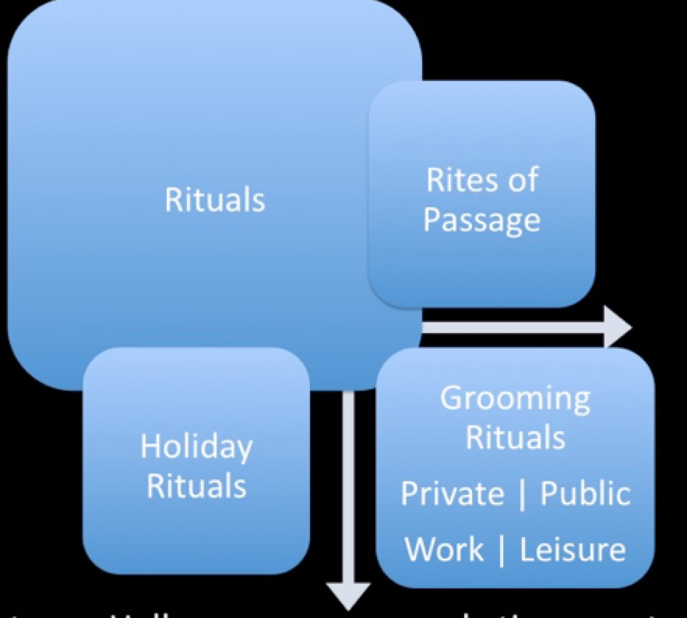
- Every culture prescribes certain occasions and ceremonies for giving gifts
- Business gifts define/maintain professional relationships, improve employee morale, and result in higher sales

- Stages of gift-giving ritual
  - 1. Gestation: giver is motivated by an event to procure a gift
    - Structural; holidays = in culture Vs. Emergent; personal motivation
  - 2. Presentation: process of gift exchange
  - 3. Reformulation: bonds between give r and receiver are adjusted (looser/tighter)
    - Reciprocity norm: obliges people to return the gesture with equal value

Cultural differences in Gift-Giving Rituals
- Japanese gift-giving rituals
  - Symbolic meaning of gift: duty to others
  - GIRI: giving is moral imperative
  - KOSAI: reciprocal gift-giving to relatives/friends
  - Do not open gift in front of giver

Consumption
1. Sacred: Involves objects and events that are set apart from normal activities that are treated with respect or awe
2. Profane: involves consumer objects and events that are ordinary and not special

Sacred Places
- Religious/mystical significance and country heritage
- Property of contamination: something sacred happened there, so it assumes sacred qualities
- Some profane (ordinary) places take on sacred qualities: Grauman’s chinese theater in Hollywood where stars eave their footprint in concrete for prosperity

Sacred People and Events
- Sacred people: idolizing certain people that are set apart from masses
  - Movie stars, rock stars, royalty
  - Contagion effect: belief that the individuals immaterial qualities or “essence” can be transferred to the object through physical contact
  - Ex. Princess Diana’s gowns
- Sacred events: public events, sports (Olympics), tourism
  - Souvenirs: Niagara falls souvenirs, pictorial images

Desacralization vs. Sacralization
- Desacralization: a sacred item/symbol is removed from a special place or is duplicated in mass quantities (becomes profane)
  - Souvenir reproductions (statue of liberty, Eiffel tower)
- Religion has somewhat become desacralized – ex. Crosses have become fashion
- Sacralization: ordinary objects, events, and people take on sacred meaning:
  - Olympic hockey, mother Theresa, Elvis Presley
- Objectification: occurs when sacred qualities are attributed to mundane items
  - Contamination: sacred events or people become sacred in their own right
  - Beatles memorabilia, Barbie dolls, Jackson
  - Collecting: systematic acquisition of a particular object of set of objects
  - Hoarding: unsystematic collecting

Language and Symbols
Language barriers across cultures = problems
Symbols – An object that is representative of something else
- Can cause problems if not appropriate for the target culture

Transferring Product meanings to other Cultures
- Innovations know no geographic boundaries
- Costly consequences of ignoring cultural sensitivities
- Ex. McDonalds
  - 1994: reprinting Saudi Arabian flag on disposable packaging
  - 2002: litigation settlement for mislabeling French fries as being vegetarian
  - 2003: cancellation of McAfrika
  - 2005: Prosperity Burger

Success = local strategy + global view
- Disney lessons in Asia… Transporting American ideas literally will not work
- McDonalds introduces the Vegetarian Menu 1st time in India. Full Vegetarian meal
- Strategy to embrace local culture embedding into marketing mainstream for that country critical

Does Global Marketing Work?
- Four Major Segments consumers in terms of how they evaluate global brands
  - Global citizens 55%: sees size and reach of global company as sign of success, but are concerned with re social and environmental responsibilities
  - Global dreamers 23% - see global brands as high quality
  - Antiglobals 13% - avoid transnational brands and companies
  - Global Agnostics 9% - evaluate all brands the same no matter origin

ADM3321
Consumer Behavior
Thursday, January 28, 2016
Lecture 3

CHAPTER 2: PERCEPTION
“Perception is the process by which sensations are selected and interpreted. Our world is a tapestry of stimulation”

Perception:
- The process by which an individual selects, organizes and interprets the information he or she receives from the environment.
- “Perception is reality”

Sensory Systems:
Sensory stimuli: sights, sounds, smells, tastes, and textures
Sensory receptors: eyes, ears, nose, mouth, and skin

Factors that Shape Perception
- Stimulus Characteristics
  - Perception is multi-sensory
  - Many sources of information in the environment
- Context
  - Consumer judgments are often influenced by the setting, situation and surrounding circumstances
- Consumer Characteristics
  - Shaped by personal knowledge and experiences
  - “We don’t see things as they are, we see them as we are” –Anais nin

Perceptual Filters
- Based on the consumers’ past experiences influence what they decide to process
- Perceptual vigilance: selective exposure, consumers are much more aware/conscious of information when they are “in the market”
- Perceptual defense: people see what they want to see- and they don’t see what they don’t want to see

Interpretation
- The process whereby meanings are assigned to stimuli
- Schema: an organized collection of beliefs and feelings represented in a cognitive category

Exposure: The process by which consumer comes into contact with the stimulus and has the potential to notice it

Psychographics: the science that focuses on how the physical environment is integrated into our personal subjective world

ADM3321
Consumer Behavior
Tuesday, February 9, 2016
Lecture 4

CHAPTER 3: LEARNING AND MEMORY

The learning process
A permanent change in behavior
- Products (reminders of life experiences)
- Products + memory (brand equity, loyalty)
- Learning (incidental, ongoing)

Behavioral Learning Theories
- Behavior learning theories – types of theories
- Classical conditioning – instrumental conditioning
- Types of learning outcomes
- Cognitive learning theory – memory & learning
- Encoding | systems | storage | retrieval|, products & memory

- Behavioral learning theories
  - Learning is a response to external events
  - Ex. Stimuli: bell – Response: alerts the dog – Stimuli paired with meat: salivating dog
- Classical Conditioning: a stimulus eliciting a response is paired with another stimulus that per se does not elicit a response (dog example) it results in learning.
- Unconditional stimuli & conditioned response: CS response
- Repetition increases learning. More exposure = more awareness
  - Excess exposure = wear out – less exposure = out of mind
- Instrumental conditioning (operant): the individual learns to perform behaviors that produce positive outcomes and avoiding those that yield negative outcomes
- It is deliberate behavior to obtain a goal
  - Positive reinforcement: customer reward, thank you letter, follow-ups
  - Negative reinforcement: downgrading, selective treatment
  - Punishment: penalties
  - Shaping: calibrated behavior learnt over time
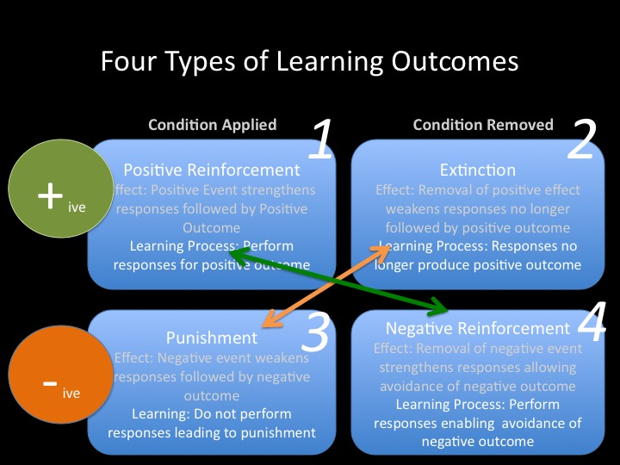

Cognitive Learning Theories: Observational Learning
- Internal mental processes
- Watching others and note reinforcements receive for behaviors
- Vicarious learning
- Socially desirable models/celebrities who use or do not use their products
- Modeling: imitating others’ behavior

ATTENTION RETENTION PRODUCTION PROCESS MOTIVATION OB. LEARNING
1: A= Focusing on model’s behavior
2: R = Retaining behavior in memory
3: P = ability to perform that behavior
4: M = situation where such behavior is useful
5: O= acquires and performs behavior demonstrated by the model

Memory in Learning
- Memory: acquiring information, storing it, will be available when required
- Information processing approach: mind as a computer
EXTERNAL INPUTS ENCODING STORAGE RETREIVAL
Encoding: encoding information to help us retain it
- SENSORY senses
- SEMANTIC symbolic
- PERSONAL RELEVANCE episodic/narrative

Memory Systems
Sensory memory attention short-term memory elaborative rehearsal Long-term memory

(High capacity) – (whatever passes through goes to STM) – (limited capacity) – (deep processing transferring to LTM) – (unlimited capacity, long or permanent)

Associative Networks
- Activation models of memory: associative network of related information
  - Knowledge structures of interconnected nodes
  - Hierarchical processing model
  - Ex. Escalating from one to other – perfume, cologne, Calvin Klein
- Meaning can be activated indirectly
- Chain reaction: one activated >> triggers others
- Meaning types of associated nodes:
  - Brand specific
  - Ad specific
  - Brand identification
  - Product category
  - Evaluative reactions

Knowledge levels: processing
- Individual nodes > meaning concepts
- Two or more propositions >> schema
- Two or more connected nodes >> propositions/ complex meanings

Analogical learning
- The marketer wants to inform the customer about a product and does so by using an analogy
- Effective because the consumer can integrate knowledge about the base into the schema for the target product

What influences ‘forgetting’?
- Decay, inference, retroactive vs. proactive, part-list cueing effect

Memory makers: products
- Furniture, visual art and photos call forth memories of the past
- Autobiographical memories
- Nostalgia
- Retro brands
Measuring memory for marketing stimuli
- Recognition vs. recall
- The starch test
- Problems with memory measures
  - Response biases
  - Memory lapses
  - Memory or facts vs. feelings

ADM3321
Consumer Behavior
Tuesday, January 26, 2016
Lecture 5

CHAPTER 4: MOTIVATION AND AFFECT

Motivation
- Process that leads people to behave as they do
- Forces/drives that drive us to buy/consume products
  - Goal: consumer’s end state
  - Want: manifestation of consumer need

Motivational Strength
The degree of willingness to expend/invest energy to reach a goal or a desired state
- Drive-theory: biological needs that produce unpleasant states of arousal (ex. Hunger)
- Homeostasis: a balanced state
- Expectancy theory: behavior is impacted by expectations to achieve a desirable end state
- Need vs. want

Need Types:
- Biogenic: air, water, food
- Psychogenic: status, power, affiliation
- Utilitarian: 3 hour battery, zero calorie coke
- Hedonic: excitement, fantasy, self-confidence

Motivational Conflicts
- Goal valence:
  - Positively valued goal: approach
  - Negatively valued goal: avoid
- Positive and negative motives often conflict with one another

Types of Motivational Conflict:
Two desirable alternatives - Cognitive dissonance (approach-approach)

Positive and negative aspects of desired product: guilt (approach – avoidance)

Facing a choice with two undesirable alternatives (avoid – avoid)

Needs & Buying Behavior:
- Need for achievement: value personal accomplishment and success. Places premium on products that signify success
- Need for Affiliation: values on products and services to alleviate loneliness
- Need for power: control one’s environment. Focus on products that have mastery over surroundings
- Need for uniqueness: asserting ones individual identity. Focuses on products that give differentiate with others.

MASLOW HIERARCHY OF NEEDS
- Self actualization (self-fulfillment, enriching experiences)
- Ego needs (accomplishments)
- Belongingness (love, friendship, acceptance)
- Safety (security, shelter)
- Physiological (water, sleep, food)

Motivation and Goal Fulfillment
- SMART goals can help consumers achieve what they want: Nike + running room
- Not unusual for consumers to decrease effort as they get closer to the goal
- Goals can be unconsciously activated: The Apple brand name activates the need for uniqueness in consumers

Consumer & Involvement
- Involvement: perceived relevance of an object based on one’s needs, values, and interests
  - We can get very attached to products
  - The motivation to process information

Involvement - Inertia and Flow State
- Inertia: consumption at the low end/ marginal level of involvement
  - Making decisions out of habit (lack of motivation)
- Flow state: true, real involvement with a product
  - Playfulness
  - Being in control
  - Concentration/ focused attention
  - Mental enjoyment of activity for its own sake
  - Distorted sense of time

Conceptualizing/ Visualizing Involvement
Antecedents of Involvement:
Person Factors
- Needs
- Importance
- Interest values

Object or stimulus factors:
- Differentiation of alternatives
- Source of communication
- Content of communication

Situational Factors
- Purchase/Use
- Occasion

Involvement = f (person, situation, object)
- The level of involvement may be influenced by one or more of these three factors. Interactions among person, situation, and object factors are likely to occur.

Product Involvement
- Product Involvement: consumer’s level of interest in a product. Out antenna is up!
- Sales promotions generally attempt to increase product involvement
- Mass customization enhances product involvement

Message Response Involvement/ Engagement
- Vigilante marketing: freelancers and fans make films/TVC’s for “their” brands and products
- Consumer’s interest in processing and getting involvement in marketing communication
- Novel ways to increase consumers’ involvement: games on websites, vote on Canadian Idol, reality shows, soaps, YouTube etc.

Purchase Situation Involvement
- Purchase situation involvement: differences that occur when buying the same object for different contexts
- Ex. Wedding gift for:
  - Boss: purchase expensive painting to show you want to impress
  - Not-so-favorite-cousin: purchase an inexpensive painting to show your “disinterest”

Measuring Involvement:
Scale: 1= Important – 10= not needed

Dimensions/Parameters of Involvement
Extent of consumer involvement depends on:
- Personal interest in product category
- Risk importance
- Probability of bad purchase
- Pleasure value of product category (gratification!)
- Sign value of product category (visible!)

Segmenting by Involvement Levels
- Hedonistic need appeal
- Use novel stimuli
- Prominent stimuli in TVC’s
- Celebrity endorsers
- Building consumer bonds

Types of Affective Responses
- Evaluations
- Valence (positive or negative) reactions to events and objects not accompanied by significant levels of arousal
- Moods
- Temporary positive or negative affective states accompanied by moderate levels of arousal
- Emotions
- Tending to be intense and related to a specific trigger/event

Social Media and Emotions
- Sentiment analysis: getting a feel of the mood
- Opinion mining current trends include extensive mining to gauge opinions
Discrete emotions:
- Happiness: mental state of well-being characterized by positive emotions
  - Materialism and happiness
  - Spending money on others vs. the self
  - Inward and outward
- Embarrassment: driven by a concern for what others thing
  - Unwanted events communicate undesired information about oneself to others
  - Can depend on product category
- Guilt: an individual’s unpleasant emotional state associated with possible objections to his or her actions, inaction, circumstances, or intentions
  - Guilt appeals- can backfire if too extreme
  - Internal
- Envy: negative emotion. Associated with the desire to bridge the gap between oneself and another perceived superior on some dimension
  - Benign vs. malicious envy
  - External: outward

The FCB Planning Model
High involvement
Thinking Cognitive Rational: Learn, Feel, Do
Feeling Affective Emotional: Feel, Learn, Do

Low Involvement:
Thinking Cognitive Rational: Do, Learn, Feel
Feeling Affective Emotional: Do, Feel, Learn

ADM3321
Consumer Behavior
Thursday, February 11, 2016
Lecture 5

CHAPTER 5: SELF

Perspectives: Self
- Buying products: highlighting/ hide aspects of the self
- Cultural perspective: eastern and western cultures see the self as inner private self and the outer public self
- Facebook and twitter: everyone is able to share their thoughts with friends and strangers… retaining uniqueness
- Behaving differently: individually and in group

What is self?
- Self concept: beliefs a person holds about his/her own attributes, self-evaluation of these qualities
- Attribute dimensions: content, positivity, intensity, stability over time, and accuracy
Products and consumption play a pivotal role in defining the self-concept

Self-Esteem
- Self-esteem: positivity of a person’s self-concept
  - Low self-esteem: ‘think’ they will not perform well
  - High self-esteem: ‘think’ they will perform well, and take risks
Advertising can trigger social comparison: celebrities/endorsers/models using products portraying certain look/feel/lifestyle

Real and Ideal Selves
- Ideal self: concept of how we would like to be
- Actual self: realistic appraisal of our qualities
- Products/brands can:
  - Help us move towards ideal self
  - Be consistent with actual self
- Pressure of images of the ‘ideal’ person in media
- Existence of multiple self concepts – one for attractiveness, work ethic, friend
- Impression management – strategically engaging/involving in products and behaviors to create an impression

Multiple Selves: Identification
- Each of us have many selves and roles
- Marketers leverage this by pitching products to facilitate active role identity

The www: virtual identity
- Avatars represent virtual identity (10 email ids, 5 Facebook accounts) second life.

Symbolic Interactionism
- Symbolic interactionism: relationships with others play a large part in forming the ‘self’
- Creating shared meanings in relation to others in a context/situation
- Pattern our behavior on the perceived expectation of others. This is self-fulfilling prophecy

Looking Glass Self
- Taking the role of the other
- Varies depending on …
  - Perspective’s we are taking (whose perspective)
  - Accuracy of our predictions – in terms of others evaluations of us
  - Self-fulfilling prophecy

Self-Consciousness
- Can be painfully aware of one-self
- Public self-consciousness
- Self-monitoring
  - High vs. low self-monitors

Consumption and Self-concept
- Identity marketing: consumers alter aspects of their selves to show off a branded product
- Product consumption = definition of self
- Product as extended self

You are what you Consume
- Social identity mirror individual consumption
- Inference of personality based on consumption
- Attach oneself to product to maintain self-concept
- Symbolic self-completion theory: those having an incomplete self-definition complete identity by acquiring and displaying associated symbols

Self/Product Congruence
- Self-image congruence models: we choose products when attributes matches the self
PRODUCT USAGE = SELF- IMAGE
The Extended Self
External objects considered a part of us,
- Levels of extended self:
  - Individual: personal possessions (cars, clothing)
  - Family: residence and furnishings
  - Community: your neighborhood or town
  - Group: social or other groups

Gender Differences
- Gender roles vary by culture, constantly evolving
- Most societies still expect traditional roles:
  - Agentic roles: men are expected to be assertive and have certain skills
  - Communal roles: women are taught to foster harmonious relationships
Gender vs. Sexual Identity
- Sex-typed traits: characteristics stereotypically associated with gender
- Sex-types products: masculine or feminine attributes
  - Pink princess telephones
  - Jack Daniels whisky
Androgyny
- Possession of both masculine and feminine traits
  - Androgynous people are comfortable and perform well in social situations
  - Sex-typed people: stereotypically masculine or feminine
  - Females generally detail oriented
  - Men view overall themes

Gender- Benders
- Gender bending products: selling a sex-typed item to the opposite sex
- Rubbermaid grooming tools such as tweezers and flippers for men
- Harley Davidson backed a world record attempt for female motorcycle riders

Body Image
- Body image: Consumer’s subjective evaluation of his/her physical self and a component of self-esteem
  - Body cathexis: person’s feelings and his/her own body
  - Strong body cathexis = frequent purchases of “preening” products

Ideals of Beauty
Exemplar of appearance
- Stereotype of “what is beautiful is good”
- Favorable physical features: attractive faces, good health and youth, balance/symmetry, feminine curves/hourglass shape

Male ideals of Beauty
- Strong, mocho, muscle
- Fashion houses models look like ‘regular guys’

The western Ideal
- Skin color and eye shape = status and sophistication, and social desirability
- Less powerful cultures adopt standards of beauty in waist-hip ratio dominant cultures
- Plastic surgery as a solution to obtain big round eyes, tiny waits, large breasts, blonde hair, and blue eyes

Concept of Fat in Society
- ‘You can never be too thin or too rick’
- Not so: healthy body image is the ideal
- Unilever (dove) has banned the size 0 in their ads

Evolving ideals of Beauty
Specific looks/ ideals of beauty
- Early 1800s: delicate, 18” waistline, looking pale
- 1890s: voluptuous lusty women
- Economy good vs. bad: mature features vs. baby features
- 1990s: waif look
- Today: high heels, waxing, eyelifts, liposuction
Media and marketing convey standards of beauty

Body image distortions… for beauty?
Body quality reflects self-worth (mostly for women) to some
- Distorted body image linked to eating disorders
- Body dysmorphic disorder (obsession with perceived flaws in appearance) becoming common
  - Steroid scandals

