Forensic Psychology

Overview and Brief History
Putting Things in Perspective
- “We live in a peaceful society” (first sentence in a book about the history of crime in Quebec) Why did he start the book this way? Relative to the events in the past, we live in the most peaceful time that we have ever lived in. As a proportion of the number of people who live at a given time, if you do the math…we just don’t die of violent means as much as we used to.
- The Better Angels of our Nature - Binker (looks at history of violence in all over the world) - Violence is decreasing.
- The number of people who died on September 11th is equivalent to the number of people who die on the road every three weeks in the States. Every 3 weeks, 3,000 people lose their weeks because of transportation. Do we talk about that? Are there psychological courses about safety on the road? We don’t do much about that compared to what we do about 9/11.
Overview
What is Crime?
2 Types of Crime
- Mala Prohibita: Wrong because it is prohibited - simply there because we don’t like this so we are going to criminalize it. We don’t find this fundamentally wrong. (Arbitrary) Ie: uploading PDF files on Blackboard, possessing marijuana
- Mala In Se: behaviours we consider fundamentally bad or wrong. Ie: pedophilia - the behaviour, murder (although- qualifications),
2 Types of Guilt
- Actus Reus: wrongful act is committed by somebody
- Mens Rea: guilt of the mind, an intention to commit the crime
Guilt implies free

Cashmore Article - Free Will
Cause in 3 different areas
- Genes
- Environment (experiences
- Stochasticsm - randomness

First Model (A) Traditional Model- free will is outside human behaviours we studied
- people have conscious thoughts influenced by genes and history but we do have free will that influences what we do and think
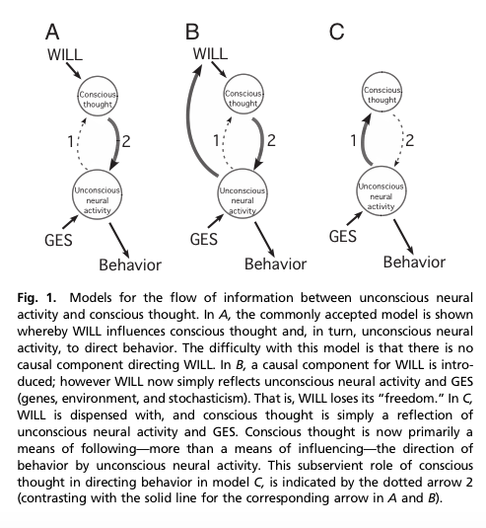
- trouble with this model because free will stands on its own…nothing causes free will (what causes the will?) In science nothing exists without a cause. This Model is not Acceptable
- unsatisfying because no cause
Model B
- revision. Free will comes from unconscious processes from the brain. It does not come from GOD or anything else in existence…it comes from your self. Brain is active and creates free will which influences behaviour
- Unhappy with this model because basically if we know something about peoples unconscious neural activity, you can go straight to conscious thought and will is a byproduct and unnecessary to explain behaviour
- People FEEL like they have free will but it is a feeling that emerges from neural activity
Model C
- we have the causes of behaviour and free will is unnecessary …. this is a more scientific and rational model.
Justice System believes in FREE WILL…something happens that makes people be able to decide what they will do.
Cashmore: feeling of free will is real but free will is an illusion (feels like we choose things but really our behaviour is predictable from our history)
- A lot of people don’t like that free will is just an illusion - mainly because what do we do with our criminal justice system … we punish them for doing bad things that they [chose to do]
- There are reasons why we make our choices (experience/history and personal tendencies…NOT free will)
- Justice system works in the way of free will/choice.
Scenario 1: Man chopping veggies and woman pushes him to stab the individual
- Scenario 2: Man is annoyed and stabs the individual
  - Clearly, scenario 2 the man is guilty. Scenario 1 lacks mens rea
- Cashmore: normal for our species to become jealous and upset and want to exert revenge (in fact natural selection has created our brains so that we won’t take it when our partners cheat on us) He argues that the response to being cheated on is explained through experience/genes Ie: if the individual has been cheated on all his life and that one night he found out his partner cheated on him and he stabbed Ted (the new guy) … there is an explainable cause other than free will.
  - It FELT like he chose to do this (he is upset) but from a CAUSAL perspective…there is no difference…we have no more free will than a bowl of sugar according to Cashmore
MANSLAUGHTER
- Someone dies because you have behaved recklessly: there is a form of guilt (MENS REA) because you chose to behave in such a way that you endangered someone else
Cashmore’s Proposal
- Need to modify the justice system
- People should be found guilty based strictly on Actus Reus and we should ignore the Mens Rea … if this was the case he would be guilty in Scenario 1 and Scenario 2
- Punishment based on circumstances of the act and entirely utilitarian - not about if someone CHOSE to do it, but it would be to maximize other things - impact on the offender, society and as a deterrent from future crimes
- Scenario 2: punishment needs to be severe because behaviour needs to be modified - the family of the victim would be more satisfied with the punishment and the punishment may have deterrent properties
- Elimination of the belief that individuals are in control in a manner other than genes and enviro/experience
- Things not worked out: we would have to figure out punishment applicable to all of the scenarios
- If free will is an illusion, how can we have a justice system that is entirely based on free will?
Some Common Definitions
- Crimes:
  - Universally condemned crimes involve intentionally injuring a fellow group member or depriving that person of property (when these acts happen they are considered a crime universally) - excludes self defence
  - Textbook: Criminal behaviour refers to intentional behaviour that violates the criminal Code. Essentially, a crime is a crime because we say it is a crime.
- Problem Behaviours: behaviours that break social norms (not illegal) Something that makes someone else feel uncomfortable. Ie: smoking as a teenager, walking the opposite direction on a sidewalk (used in studies with adolescents/juveniles and include behaviours like drinking underage and using substances, promiscuous sex, breaking curfews and skipping schools) Precocious sexual behaviour
- Antisocial Behaviours: behaviours that break social contracts (things that are clearly understood and most agree that it is not okay to do this) Notion of HURT in antisocial behaviour and it is done on purpose Ie: lying, making people cry on purpose, cheating on your partner
    - Key to antisocial behaviour: needs to be in the context of a social exchange…
    - used for both teenagers and adults, referring to things that people to do others that have the effect in hurting others.
- Criminal Behaviours: behaviours that are considered illegal
- Delinquent Behaviours: behaviours that are considered antisocial or illegal and engaged in by juveniles (reserved for adolescents and juveniles)
- Nonviolent Crimes: crimes against a person without direct physical contact or proximity, or crime with no specific victims
  - Stealing, prostitution, break and enter (when no one is home)
- Violent Crimes: crimes against a person with a direct physical contact or proximity, involving the threat of or actual serious harm
  - Sexual assault, murder, armed robbery (THREAT of harm)
- Felony Offence: all property and violent crimes
- Misdemeanours: all other crimes
- Index Offence: special category of offence in the USA that involves the MOST violent crimes: homicide, assault, rape and robbery
- Index offence in Canada: the offence that brought the person to the study
  - if this person is released, will they commit another crime? The offence that brought them there is the one bringing them in the study to see if they will commit another crime
- Forcible Rape: carnal knowledge (wanting to have sexual intercourse) of a female, forcible held against her will. It doesn’t count as forcible rape if it is a male victim. Based on the old idea that men cannot be forced to have sex

