Audits & Fraud
- Types of Audits
  - Tax (Sales, payroll, and income tax)
    - Permanent dif. = accounting income < taxable income
    - Temporary dif. = depreciation
  - Operational
  - Compliance
  - Financial Statement

Internal Auditing: offers an independent, objective view of the company

External Auditing: External professional auditors lend credibility to the financial information (all publicly traded companies need an external audit)
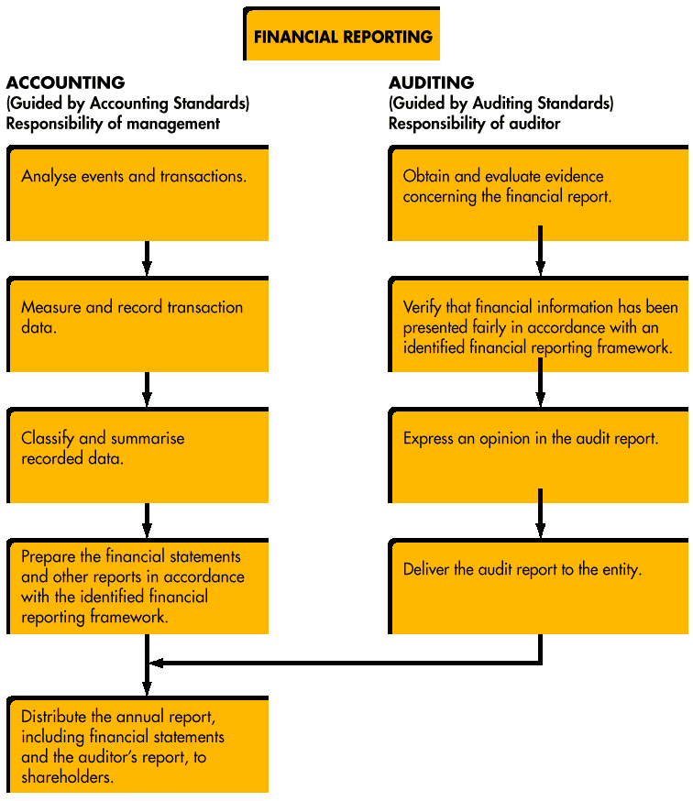

Business Risk

- Business risk is the risk that a company may fail to achieve its objectives due to:
  - economic changes,
  - technology changes
  - poor management decisions
  - bad luck.
Auditors do not report on business risk

Information Risk

- Information risk is the risk that the financial information fails to reflect economic substance of business activities (risk of financial information being unreliable)
- Two major categories
  - AUDIT RISK: the risk of insufficient evidence being gathered on the facts concerning the auditee’s economic circumstances. The auditor may express an inappropriate audit opinion
- Inherent Risk – The probability a material misstatement will occur in the financial statements.
- Control Risk - Material misstatements will not be prevented or detected by internal controls
- Detection Risk - Material misstatements will not be detected by the auditor
- AR = IR x CR x DR
  - ACCOUNTING RISK: the risk that errors associated with estimates used in GAAP accounting are not properly disclosed.

Canadian Audit Standards (CAS)
  - Competence (do they know what they’re doing)
  - Due Care (did they put in the effort)
  - Objectivity (the company pays them, tough to stay objective)

Examination Standards
- Planning and supervision.
- Need to understand the system of internal controls.
- The auditor is explicitly required to design procedures to detect fraud

- Auditors Role: The overall objective of a financial statement audit is to enable the auditor to express an opinion as to whether the financial statements are prepared, in all material respects, in conformity with an applicable framework, usually GAAP. An auditor performs work to obtain reasonable assurance that the information prepared by management is correct, not absolute assurance.

Every auditor must give an opinion that goes in the financial report.
- Unmodified (nothing misleading in the report)
- Qualified (they messed up in one area)
- Adverse (little errors add up to make a big deal)
- Disclaimer of Opinion (they didn’t let the auditor see anything)

FRAUD
-A deliberate deception practiced so as to secure unfair or unlawful gain

Elements of Fraud:
- A material false statement
- Knowledge the statement was false when it was uttered
- Reliance on the false statement by the victim
- Damages resulting from the victim’s reliance on the false statement

Related Financial Crimes:
- Larceny (theft)
- Conversion (sold stolen product)
- Embezzlement (using your job to take from the biz)
- Breach of Fiduciary Duty (board member being aware of theft and doing nothing)

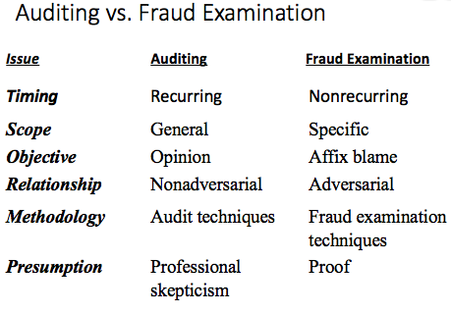

Fraud Theory Approach
- Analyze available data
- Create a hypothesis
- Test the hypothesis
- Refine and amend the hypothesis

- Document Analysis (get a tip)
- Neutral Third-Party Witness (ask the customer)
- Corroborative Witness (ask someone who can help out)
- Co-Conspirators (
- Target

Fraud Examination Methodology
- Predication (reason to look into something)
  - Fraud examinations must be based on predication.

Edwin H. Sutherland: -coined “white-collar crime”
-crime is learned and not genetic

Donald Cressey: -the fraud triangle
- Pressure (financial need)
- Opportunity (knowledge of the job, ability to commit violation)
- Rationalization (“they owe me”)
-all 3 of these must be apparent in order for there to be fraud
- Offender Types
1. Independent businessmen
  - “Borrowing”
  - Funds really theirs
2. Long-term violators
  - “Borrowing”
  - Protect family
  - Company cheating them
3. Absconders
  - Take the money and run
  - Usually unmarried, loners
  - Blame “outside influences”

Dr. Steve Albrecht: -the “fraud scale” (#1 indicator is person committing the fraud giving out red flags (driving a lambo))
- Situational Pressures
- Perceived Opportunities
- Personal Integrity

Hollinger-Clark Study: -employee perception of controls is critical (best deterrent to fraud)
ABUSE = calling in sick for work to go to a ballgame

