- Two classes of decision makers
  - External Decision Makers (whether to invest, lend money, calculate taxes owed)
  - Internal Decision Makers (whether to run promotion, what to buy, who to hire)
Process of Management:
- Strategy Formulation (company vision and game plan)
- Planning (identify alternatives and select the one that best furthers the organization’s objectives)
- Directing and Motivating (managing day-to-day activities)
- Decision Making
- Control (ensures that plans are being followed, getting feedback)

-Variance = difference between actual cost and budgeted cost
-Budgets = Detailed plan that sets out, in monetary terms, plans for income and expenditures in a future period (star with SALES budget, build up MASTER budget)

Sequence of budgetary process
- Communicate objectives and strategy.
- Communicate procedures.
- Prepare an initial set of budgets.
- Negotiate budgets with line managers.
- Coordinate and review budgets.
- Accept budgets in final form.
- Ongoing review.

- Bottom-up budget is started by inviting those who will implement the budget to be involved in setting the budget.
- Top-down budget is set by management and imposed on those who will implement the budget.
Four-step Framework for Decisions:
Step 1 Specify the decision problem, including the decision maker’s goals
Step 2 Identify options
Step 3 Measure benefits (advantages) and costs (disadvantages) to determine the value (benefits reaped less costs incurred) of each option (qualitative = quantitative)
Step 4 Make the decision, choosing the option with the highest value (Effective decisions require that we identify goals clearly and understand the factors that influence goals and their relative importance)

Conflict in Goals
- Divergence between organizational and individual goals (what is best for employee is not always best for business)
- Goal Congruence = ways to align goals that benefit both the employee and biz

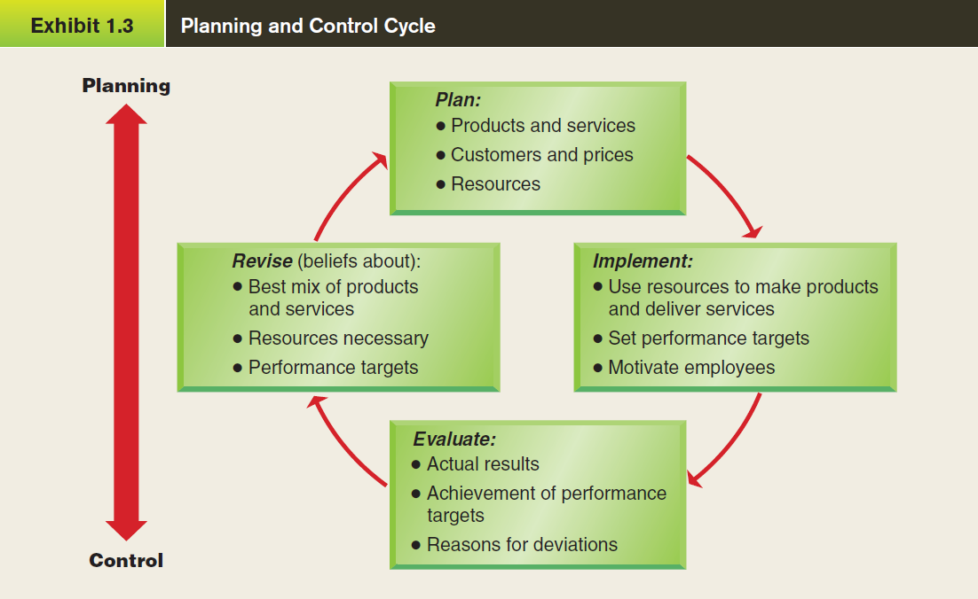

- Ethics influence every step of the framework
  - Step 1 - How we define goals
  - Step 2 - What options to consider
  - Step 3 - Unethical choices have high costs
  - Step 4 - Quit before making an unethical decision

Key Players in Organizations
- Board of Directors
- In the Corporate offices
  - Chief Executive Officer
  - Chief Financial Officer
  - Chief Internal Auditor
- Other accounting functions
  - Controller (bookkeeper)
  - Treasurer
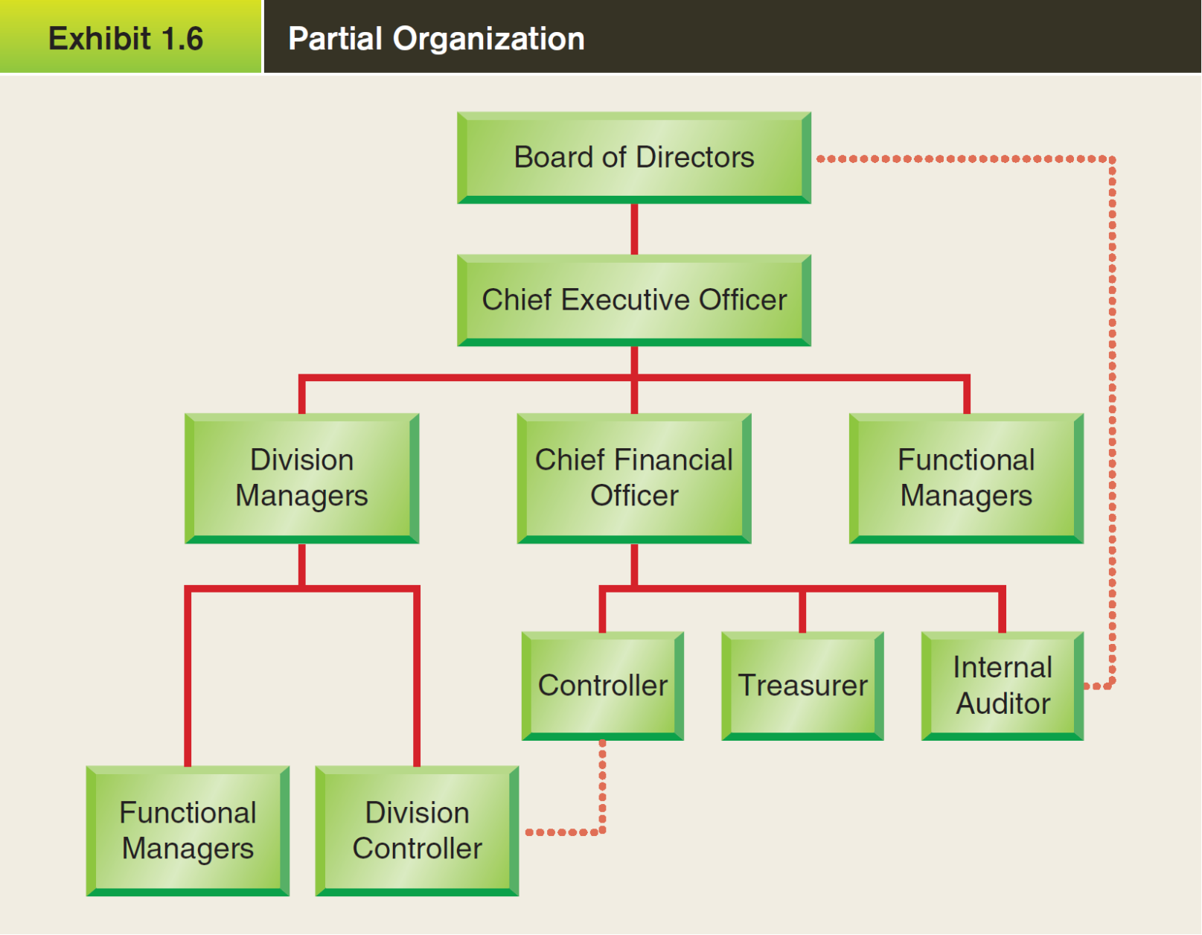
Cost Concepts and Terminology
- Function (product cost/inventory cost or period cost)
- Behaviour (how a cost will react to changes in the level of biz activity)
- Traceability
- Controllability
- Relevance

FUNCTION
Balance Sheet of a Manufacturer
- Raw Materials
- Work in Progress
- Finished Goods

Income Statement of a Manufacturer
Merchandiser  -Beginning Merchandise Inv.  +  -Cost of Goods Purchased  +  -Ending Merchandise Inv.  =  -COGS | Manufacturer  Beginning Finished Goods Inv.  +  -Cost of Goods Manufactured  +  -Ending Finished Goods Inv.  =  -COGS

Manufacturing Costs: (anything to do with labour is a product cost)
- Direct Material = Cost of raw material to finish product
- Direct Labour = Cost of salaries for ppl working on making a product
- Manufacturing Overhead:
  - Indirect Material = Materials used to support the production process
  - Indirect Labour = Cost of ppl who don’t work directly on the product
  - Other Costs = depreciation, taxes, insurance, utilities

Cost Allocations & Cost Flows:
- Overhead costs are not traceable to specific products
- But they are part of product cost for individual products
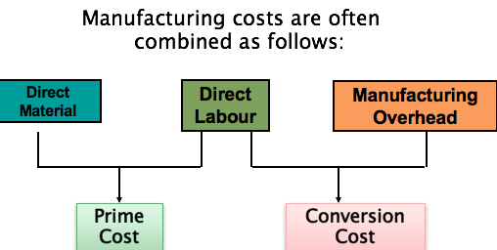
CHECK SLIDE 42
BEHAVIOUR
Types of Fixed Costs
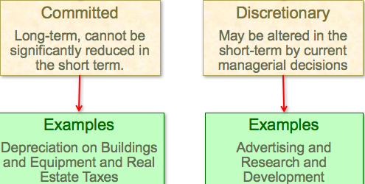

Classification by Traceability
Direct costs  - Costs traceable to a single cost object.  - Examples: material and labor cost for a product. | Indirect costs  - Costs that cannot be traced to a single cost object.  - Example: maintenance expenditures benefiting two or more departments.

Classification by Controllability
A controllable cost is a cost which is capable of being regulated by a manager | A non-controllable cost is one which is not capable of being regulated by a manager

Relevant
In order for something to be relevant, there must #1 be a future cost/benefit & #2 the future cash flow must change. (differ means relevant)
  - Sunk costs (costs incurred in the past) should not be considered in decisions.
  - Out-of-pocket costs (what will you spend in the future) should be considered in decisions.

Decentralization: the delegation of freedom to make decisions (the lower in the biz that freedom exists, the more decentralization)
Benefits of Decentralization  -lower-level managers gain exp in decision making  -lower-level decision often based on better info  -top mngt free to concentrate on strategy  -decision-making authority increases job satisfaction  -lower level managers can respond quickly to customers | Disadvantages of Decentralization  -duplication of costs and efforts  -lower-level managers make decisions without seeing the big picture  -lower-level managers objectives may differ from the biz’s  -may be a lack of coordination among autonomous managers  -may be difficult to spread innovative ideas in the biz

Responsibility Accounting: check textbook
- Cost Centre (only responsible for costs)
    - Discretionary cost center
    - Engineering cost center
- Revenue Centre (responsible for sales)
- Profit Centre (responsible for both revenue and expenses)
- Investment Centre (does it all)

Return on Investment Ratios

Margin = (Operating Income(EBIT)) ÷ (Sales)

Turnover = (Sales) ÷ (Avg Operating Assets)

ROI = (Operating Income(EBIT)) ÷ (Avg Operating Assets)

- To increase ROI
  - Increase Sales
  - Reduce Expenses
  - Reduce Assets
Advantages of ROI  - The most widely used measure of divisional performance.  - Easily understood.  - Encourages managers to concentrate on projects which make best use of resources. | Disadvantages of ROI  - Problems of defining the amount of investment funding.  - Problems of defining the profit controllable by the division.  - Manager of one division may avoid a project, which lowers the average ROI for that division but would be of benefit to the organization as a whole.

