Accounting Information System

Accounting information system:
  - The system of collecting and processing transaction data and communicating financial information

Accounting Transactions:
- Transactions are economic events that must be recorded in the financial statements
- Not all events are recorded and reported as accounting transactions:
  - Only those that change assets, liabilities or shareholders’ equity

Debits (DR) and Credits (CR):
- Debit means left side, Credit means right side
- If debit amounts exceed credit amounts, account has a debit balance
- If credit amounts exceed debit amounts, account has a credit balance

The T Account
Title of Account

Debit Credit

- Assets, Expenses, and Dividends typically have debit balances.
- Liabilities and Shareholder’s Equity typically have credit balances.
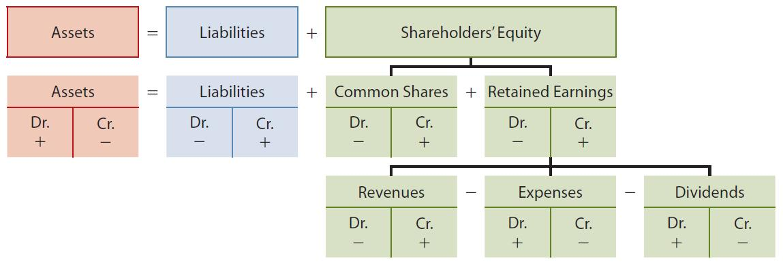

ACCOUNTING CYCLE:
- Analyze Business Transaction
- evidence of transaction is source document

- Journalize the Transaction in Chronological Order
- in the general journal

- Post to General Ledger Accounts
- posting is the process of transferring info from the general journal to the general ledger accounts
- list of accounts is called a chart of accounts

- Prepare a Trial Balance (main source for preparation of financial statements)
- List of all the accounts and their balances at a specific time
- Serves to periodically test whether the Gen. Ledger is in balance

ONE ACCOUNT IS DEBITED, THE OTHER IS CREDITED
(DOUBLE ENTRY ACCOUNTING)

Posting to The General Ledger
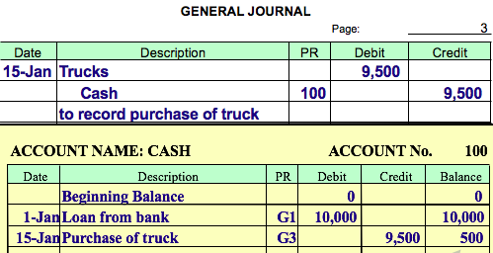

Trial Balance – Example
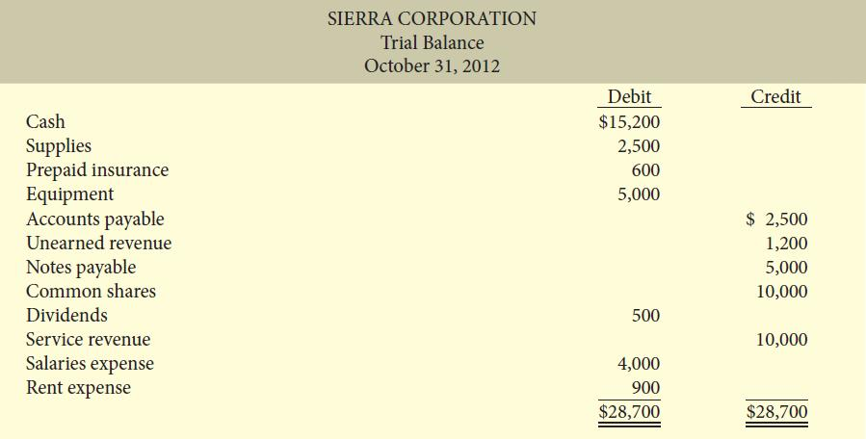
Adjusting Entries:
- Adjusting entries are made to adjust or update accounts at the end of the accounting period
- Required because the trial balance may not contain complete and up-to-date data
  - Some items are not recorded daily
  - Some costs are not recorded during the accounting period, as they expire due to the passage of time
  - Some items may be unrecorded

- Examples of Adjusting Entries:

PREPAYMENTS
  - Prepaid expenses: paid for in cash before use, adjusting entry increases expense account and decreases the asset (prepaid) account

  - Unearned revenues: cash has been received before revenue is earned, adjusting entry decreases the liability (unearned revenue) and increases a revenue account

ACCRUALS (not recognized at all until an adjustment is made)
  - Accrued revenues: revenue that has been earned but not received in cash, adjusting entry increases both an asset and a revenue account

  - Accrued expenses: expense that have been incurred, but not yet paid or recorded, adjusting entry increases both an expense and liability account
Summary of Adjusting Entries
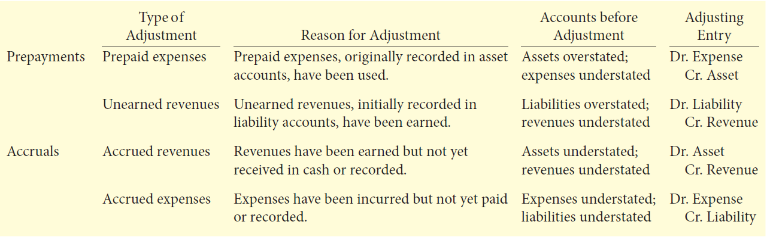
Closing the Books:
- Revenue and Expense accounts are subdivisions of retained earning (temporary accounts)

- Assets, Liabilities, and Shareholder’s Equity accounts carry forward into the future (permanent accounts)

- Closing Entries
  - Temporary account balances are transferred to Retained Earnings
  - Produce a zero balance in the temporary accounts to prepare for the next fiscal period
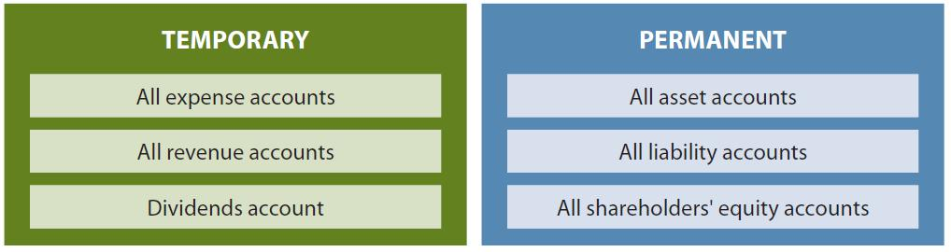

The Closing Process
- Close revenue accounts:
  - Debit each revenue account for its balance and credit Income Summary
- Close expense accounts:
  - Debit Income Summary and credit each expense account for its balance
- Close Income Summary:
  - Debit (or credit) Income Summary for the balance in the account and credit (debit) Retained Earnings
- Close Dividends account:
  - Debit Retained Earnings and credit Dividends account for the balance

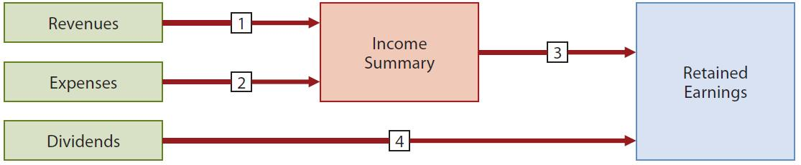

Summary of the Accounting Cycle


