Financial Statements

Conceptual Framework: GAAPs, enhances comparability of financial statements of different companies
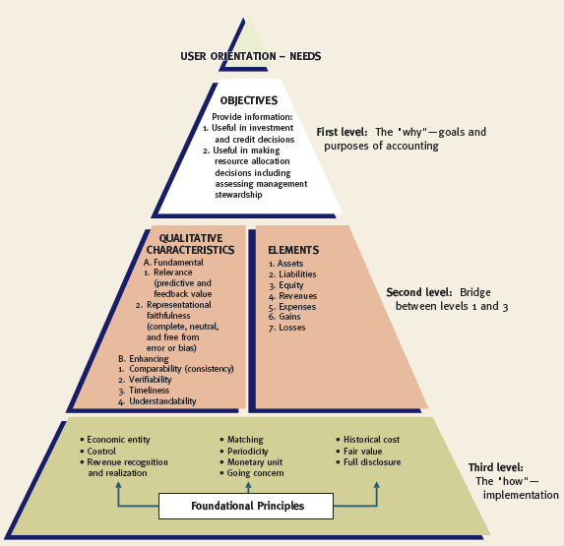

Objective of Financial Reporting
The overall objective of financial reporting is to provide information that is:
  - useful to users (e.g. Investors, creditors), and
  - decision relevant (resource allocation)

The Fundamental Qualitative Characteristics are:
- Relevance
  - Makes a difference in a decision
  - Has predictive and feedback/confirmatory value
  - Includes all material information (i.e. information that makes a difference to the decision-maker)
- Representational Faithfulness (Reliable)
  - Complete
  - Neutral
  - Free from material (important) error
  - Substance over form (ensure the financial statements give a complete, relevant, and accurate picture of transactions and events)

Enhancing Qualitative Characteristics
- Comparability
  - Allows users to identify real economic similarities and differences (company to company, and year to year)
- Verifiability
  - Similar results achieved if same methods are used (consensus)
- Timeliness
- Understandability
  - Provides enough info so that it is clear to reasonably informed users

Tradeoffs and Constraints
- Trade-Offs
  - It is not always possible to have all fundamental and enhancing qualitative characteristics
  - Trade-offs happen when one qualitative characteristics is sacrificed for another
- Constraints
  - Materiality
    - If leaving or including information would influence/change the judgement of a reasonable person, then that information is considered material
    - Quantitative guidelines for materiality – professional judgement
  - Cost versus Benefits
    - Benefits of using the information should outweigh the costs of providing that information

Elements of Financial Statements
  - Assets
  - Liabilities
  - Equity (represents residual (what’s left) interest in assets, after liabilities are deducted)
  - Revenues
  - Expenses
  - Gains (incidental transactions, eg: flower company sells their delivery van)
  - Losses (incidental transactions, eg: building burns down)

Foundational Principles
- Foundational concepts and constraints help explain which, when, and how financial elements and events should be recognized/derecognized, measured, and presented/disclosed
- Recognition
  - Process of including an item on entity’s balance sheet or income statement
  - Elements of financial statements have historically been recognized when:
    - they meet the definition of an element (e.g. asset)
    - they are probable, and
    - they are reliably measurable
- Derecognition
  - Process of ‘removing’ something from the balance sheet or income statement
Economic Entity Assumption
  - The business activity is separate and distinct from its owners (and any other business unit)
  - An accounting principle/guideline that allows the accountant to keep the sole proprietor's business transactions separate from the owner's personal transactions even though a sole proprietorship is not legally separate from the owner.
Control
- Important factor in determining entities to be consolidated and included in the economic entity
- Some concepts of control include:
    - Having power over investee
    - Exposure, or rights, to variable returns from involvement with investee; and
    - Ability to use power over investee to affect amount of investor’s returns
Management Discussion and Analysis (MD&A)
- Management’s explanation of the financial information and the significance of the information
- Five key elements that should be included:
  - Company’s vision, core businesses, and strategy
  - Key performance drivers
  - Capital and other resources
  - Historical and prospective results
  - Risks

Accrual Accounting
- Records items on the books when purchases or sales are made, not when money is paid or received
- Revenue Recognition Principle (usually paid off in cash, but not always)
- Matching Principle (match the expense with the revenue they help earn)
slide 19-22
Examples:

- Depreciation
- Bad debt expense
- Warranty expense
- Salary expense

Because of accrual accounting, many elements of financial statements require the use of estimates (and include uncertainty)
- Therefore, we must
  - determine the level of uncertainty that is acceptable for recognition
  - use appropriate measurement tools, and
  - disclose sufficient information to indicate/describe the uncertainty
Periodicity Assumption
  - Economic activity of an entity can be divided into artificial time periods for reporting purposes (public companies must report quarterly and annually)
Monetary Unit Assumption
  - Money is the common unit of measure of economic transactions
  - Use of a monetary unit is relevant, simple and understandable, universally available, and useful
  - In Canada and the United States, the dollar is assumed to remain relatively stable in value (effects of inflation/deflation are ignored)
Going Concern Assumption
  - Assumption that a business enterprise will continue to operate in the foreseeable future (at least the next 12 months)
  - If liquidation of the company is assumed to be likely, use liquidation accounting (at net realizable value)
Historical Cost Principle
  - Three basic assumptions of historical cost (what you paid for it)
    - Represents a value at a point in time
    - Results from a reciprocal exchange
(i.e. a two-way exchange)
    - Exchange includes an outside arm’s-length (not related) party
Fair Value Principle
- Fair value has been defined (under IFRS) as
  - “the price that would be received to sell an asset or paid to transfer a liability in an orderly transaction between market participants at the measurement date”
- Fair value is often considered more relevant for certain assets/liabilities

Full Disclosure Principle
  - Anything that is relevant to users’ decisions should be included in financial statements
  - Disclosure may be made:
    - Within the main body of the financial statements
    - As notes to the financial statements
    - As supplementary information, including Management Discussion and Analysis (MD&A)

Importance of GAAP’s (principle based)
- Legally structuring transactions so that they meet the company’s financial reporting objectives (while complying with GAAP) is known as financial engineering
- When pressures for reaching specific financial reporting objectives are high, risk of fraudulent financial reporting increases
Principle based: (American’s use rule based)
  - Key objectives of good reporting
  - Subject area provides guidance
  - Explains the objectives
  - Relates to common examples
  - Some rules exist, however the intent is not to have a rule for every situation
  - When in doubt – go back to the principles

Classified Balance Sheet (in order of liquidity)
Assets
- Current assets (marketable securities, prepaid exp. and inv.)
- Long-term investments (investments in the debt or equity securities of other corps)
- Property, plant, and equipment
- Intangible assets (goodwill, patents, copyrights, trademarks, licenses)
Liabilities
- Current liabilities (interest payable, notes payable, accrued liabilities, deferred rev.)
- investments
- Long-term liabilities (bonds payable, notes payable)

Shareholders’ Equity - Share capital (investment in the business by the shareholders in exchange for preferred or common shares) - Retained earnings (earnings kept for use in the business)

Financial Statement Analysis
- To have a means of comparative analysis across time in terms of:
  - Intracompany basis (within the company itself)
  - Intercompany basis (between companies)
  - Industry Averages (against that particular industry’s averages)
Financial Ratios

Profitability Ratios:
3 elements of the profitability analysis:
- Analysing on sales and cost of goods sold
  - focus on gross profit
- Analysing on the control of expenses
  - focus on net profit
- Assessing the return on assets and return on equity

- Gross Profit % = (Gross Profit ÷ Net Sales) *100

- Net Profit % = (Net Profit ÷ Net Sales) * 100

- Return on Assets = (Net profit ÷ Average Total Assets) *100

- Earnings Per Share = (Net Profit After Tax ÷ # of Common Shares)

- Price Earnings Ratio = (Market Price Per Share ÷ Earnings Per Share)

Liquidity Ratios:
  - Measure the short-term ability of the company to pay its maturing obligations and to meet unexpected needs for cash

- Working Capital = (Current Assets – Current Liabilities)
- Current Ratio = (Current Assets ÷ Current Liabilities)
- Quick Ratio or Acid Test = (Cash+MS+AR) ÷ (Current Liabilities)

Solvency Ratios:
- The ability for an organization to pay interest on their obligations and repay debt upon maturity
- Measures the ability for a company to survive over a long period of time

- Debt to Total Assets = (Total Liabilities ÷ Total Assets) * 100
- Free Cash Flow = Net cash provided (used) by operating activities less dividends less net capital expenditures

Efficiency Ratios:
- Receivables Turnover = (Revenue ÷ A/R)
- Average Collection Period = (365÷ Receivable Turnover)
- Inventory Turnover = (COGS ÷ Inventory)
- Days in Inventory = (365 ÷ Inventory Turnover)

